Recovering from bushfires

Lesson: Communities working together for recovery

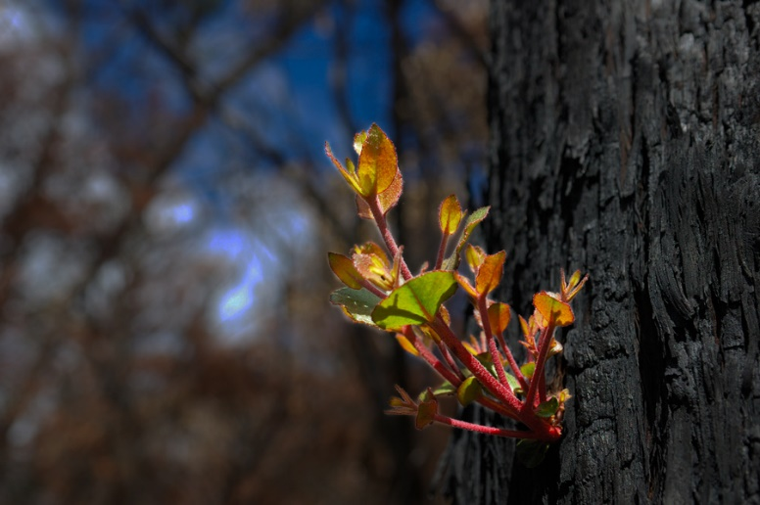
Overview
Curriculum levels: 1 and 2
Time: 50 minutes (approximately)
Links to the Victorian Curriculum F–10:
English, Level 2
Reading and Viewing
Use comprehension strategies to build literal and inferred meaning and begin to analyse texts by drawing on growing knowledge of context, language and visual features and print and multimodal text structures (VCELY222)
Geography, Foundation to Level 2
Geographical Concepts and Skills
Identify and describe the features of places at a local scale and how they change, recognising that people describe the features of places differently (VCGGC057)
Identify how people are connected to different places (VCGGC059)
Geographical Knowledge
Reasons why some places are special and some places are important to people and how they can be looked after (VCGGK069)
Learning intention:
Students will explore what a community is and how people in communities care for each other. They will then use this understanding to view examples showing the recovery required after a community has been affected by bushfire.
Suggested resources:
- Whiteboard, IWB or poster paper and appropriate markers
- Materials as selected for recording student responses, e.g. workbooks and markers, tablets, recording devices
- Online resources such as the images and linked resources listed in the Resources section of the VCAA Bushfire Education webpages

Activities

Starting
Pose the question:
- What is a community?
Ask the class to come up with a working definition, and record students’ suggestions and the areas discussed on a whiteboard, IWB or poster paper, to be referred back to throughout this session.
Refer to a dictionary or online resource to further assist with this definition.
The community definition needs to include the notions of:
- people interacting in close proximity
- people sharing common values.

Exploring
Have the class view the video clip Behind the News: Fire aftermath.
This shows the very beginning of recovery, just days after the Black Saturday bushfire.
With the class, discuss and record key points that demonstrate the importance of community.
Refer back to the thoughts recorded earlier on the meaning of community and identify any linked or similar ideas.

Bringing it together
Working in pairs or small groups, students can create a list, table or flow chart describing the different ways in which people support each other, their environment and their community. Students should include a reference to the values that each action demonstrates.
Please note: All educators need to be aware that there is potential for discomfort or distress among some students when talking, viewing and reading about bushfires. Teachers need to preview, adapt and manage the teaching and learning activities and resources with respect to the particular needs and backgrounds of their students. For more information and support, see the Department of Education and Training’s Mental health support after an emergency.

Extending

What needs to be done after a bushfire?
Consider the needs of people after a bushfire (e.g. housing, clothing, toys, schools). Create a detailed list of the types of action a community needs to take in order to begin rebuilding their town and people’s lives.

