Recovering from bushfires

Lesson: Communities working together for recovery

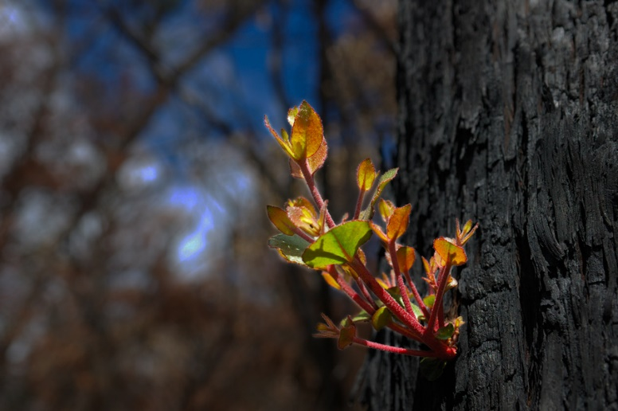
Overview
Curriculum levels: 5 and 6
Time: 50 minutes (approximately)
Links to the Victorian Curriculum F–10:
Civics and Citizenship, Levels 5 and 6
Citizenship, Diversity and Identity
Investigate how people with shared beliefs and values work together to achieve their goals and plan for action (VCCCC016)
English, Level 5
Reading and Viewing
Use comprehension strategies to analyse information, integrating and linking ideas from a variety of print and digital sources (VCELY319)
Learning intention:
Students will explore what a community is and how it cares for each of its members. Students will explore how a community recovers after it has been affected by bushfire. Students will also consider community services and supports that need to be rebuilt to allow people to recover in the aftermath of a serious bushfire.
Suggested resources:
- Whiteboard, IWB or poster paper, and appropriate markers
- Materials as selected for recording student responses, e.g. workbooks and markers, tablets, recording devices
- Online resources such as the images and linked resources listed in the Resources section of the VCAA Bushfire Education webpages

Activities

Starting
Pose the question:
- What is a community?
Ask the class to come up with ideas and a working definition of community. Record the key areas discussed on a whiteboard, IWB or poster paper to be referred back to throughout this session.
Refer to a dictionary or online resource to further assist with this definition.
The community definition needs to include the notions of:
- people interacting in close proximity
- people sharing common values.
Have students consider:
- a family that has lost their home and possessions in a bushfire. What kinds of support do they need?
- how individuals and communities can help families who are experiencing loss and hardship.
As a class, discuss and share student responses. Sort the responses into categories:
- material support
- social support
- emotional support
- spiritual support.
Ask:
- Who can provide the support the family needs?
- How might support lead to greater optimism?

Exploring
Have the class view the video clip Behind the News: Fire Aftermath. This shows the very beginning of recovery, just days after a bushfire.
With the class, discuss the main points in the clip that demonstrate the importance of community.
Refer back to the original thoughts recorded on the meaning of community to look for linked or similar ideas.

Bringing it together
As a class, create a table to record students’ responses about ways to support communities after a bushfire. For example, see the following sample table (partially completed) of bushfire survivor needs:
Immediate needs | Who can help? | Longer-term needs | Who can help?
Food | Local community donations, local families, Red Cross | Buying, storing and cooking food | Family and friends, donations from the broader community, agencies (Red Cross, Salvation Army)
Money and finances | Government departments, local and state-wide charities,  local fundraising | Obtaining employment or returning to work, sourcing bank loans, making  insurance claims | Centrelink, government departments, banks, accountants
Clothing | Local community clothing or opportunity shops, local families | Purchasing replacement clothes | Family and friends,  donations from the broader community
Shelter | Temporary emergency accommodation (Red Cross), local families, friends | Rebuilding or relocating | Family and friends,  local council, charities
Medical services and first aid | Ambulance Victoria, CFA, St John Ambulance, local nurses and doctors, family members | Getting care for long-term health conditions | Hospitals, doctors, rehabilitation
Communication | Local contacts, local media, friends and family, CFA, Police, Red Cross | Obtaining mobile and internet services
Trauma counselling | Hospitals, health department, local counsellors, religious ministers | Receiving ongoing counselling

Extending

After the Victorian bushfires in 2009
Have students conduct research to find out how Australian and Victorian communities raised funds after the 2009 bushfires by investigating the Red Cross’s initiatives and the Sound Relief benefit concerts.
To support students’ research, provide scaffolding questions such as:
- What fundraising activities were used?
- Who conducted the fundraising activities?
- How much money was raised?
- How has the money been used and distributed?

