Recovering from bushfires

Lesson: How art helped children with their feelings after a bushfire

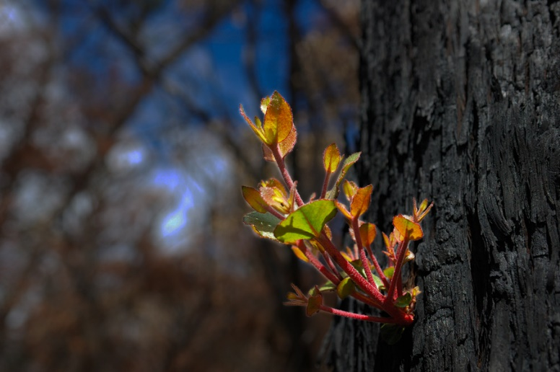
Overview
Curriculum levels: 1 and 2
Time: 50 minutes (approximately)
Links to the Victorian Curriculum F–10:
Personal and Social Capability, Levels 1 and 2
Self-Awareness and Management
Extend their vocabulary through which to recognise and describe emotions and when, how and with whom it is appropriate to share emotions (VCPSCSE008)
Visual Arts, Levels 1 and 2
Explore and Express Ideas
Explore ideas, experiences, observations and imagination and express them through subject matter in visual artworks they create (VCAVAE021)
Respond and Interpret
Respond to visual artworks, including artworks by local Aboriginal and Torres Strait Islander peoples, by describing subject matter and ideas (VCAVAR024)
Learning intention:
This lesson allows students to look at artwork created by children to convey their feelings after experiencing a bushfire. Students are encouraged to look carefully and consider the art and how it helped people heal after the bushfires.
Note: Educators should carefully consider the themes and sessions that are most appropriate for their students, communities and contexts, and adapt session content and resources accordingly. For example, ‘Recovering from bushfires’ may be more relevant in particular contexts, e.g. bushfire prone areas, where students have directly experienced planning for bushfires, actual bushfires and/or what happens after a bushfire. In these contexts, students are more likely to have prior knowledge and understanding about key concepts.
Suggested resources:
- Materials for recording art response, e.g. Poster paper and markers, IWB, paints, paper
- Online resources such as the images and linked resources listed in the Resources section of the VCAA Bushfire Education webpages

Activities

Starting
Provide a selection of hard copies or electronic access to allow students to view a range of artwork from the Yarra Glen Primary School Student Art collection.
Encourage students to look carefully and slowly at each piece, and to think about and notice:
- What is the artwork showing?
- What is it made with (the art medium)? e.g. coal, paint
- What sorts of colours are used? e.g. dark, bright
- Who may have created this art? Why do you think this?
- How does it make you feel?
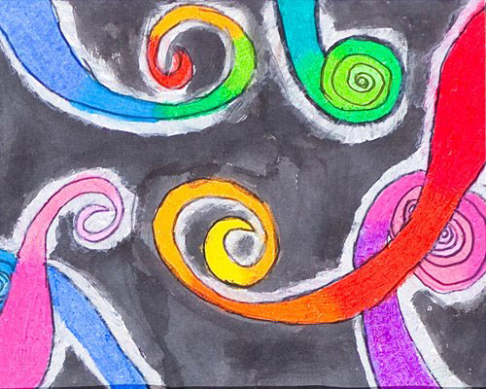
Illustration: Tessa Lynne Walton, Middle Kinglake Primary School

Exploring
Introduce a reflective strategy such as ‘see, think, wonder’.
Record students’ responses to being asked:
- what they see in the artwork
- what they think of the artwork
- what the artwork makes them wonder about.
Invite students to share how they feel when they look at the paintings.
Inform the students that this artwork was created by children after experiencing a bushfire in 2009.
As a class, discuss what the pictures tell us about how people and places recover from bushfires.
Ask students to consider:
- How might the children who created the artwork be feeling now, long after the bushfire?
- What would they say to the children?

Bringing it together
Have students select one particular piece of artwork and write/record their thoughts about it. They could also create their own artwork inspired by their selected painting.

Extending
Read the following extract to the class, about a teacher’s experience in the tiny town of Cockatoo in the Dandenong Ranges, which was devastated by the 1983 Ash Wednesday fires.
Early in the morning after the fire, there was a very brief and very light shower of rain – little more than a few spots. But the result was a beautiful rainbow which stretched over the blackened town.
Cockatoo school was opened soon after the fire. It was something for the children to do, something to occupy their minds. Like their elders, they couldn’t concentrate for long.
They suffered alternating moods of vivacity and quiet introspection. For days they drew and drew − bushfire, bushfire, getting it all out of their minds and emotions.
Then teacher Val McLeod said to them, ‘Look, let’s all forget the fire for a while. Let’s just be happy. Let’s draw something bright and happy. Everybody draw something bright and happy.’
She moved between the rows of children to see what they were drawing. She smiled at the first few and nodded. But the smile faded. A feeling of awe grew, and a little shiver of the uncanny.
Independent of each other’s promptings, each other’s example, each child had drawn a symbol of the bright and the happy.
Each had drawn Cockatoo’s rainbow, spanning the night sky at the end of Ash Wednesday.
(Extract from Cockatoo Ash Wednesday 1983: The People's Story by Edward Mundie, Hyland House, Melbourne, 1983)
Ask students:
- What does this extract suggest the children were feeling?
- What might the children have needed to recover from their experience of the fire?
Ask students to consider:
- Why do you think the Cockatoo teacher got her students to do drawing after their bushfire experience?
- What other ways could the teacher have helped the Cockatoo children recover from their experience?

