Recovering from bushfires

Lesson: Living with bushfires

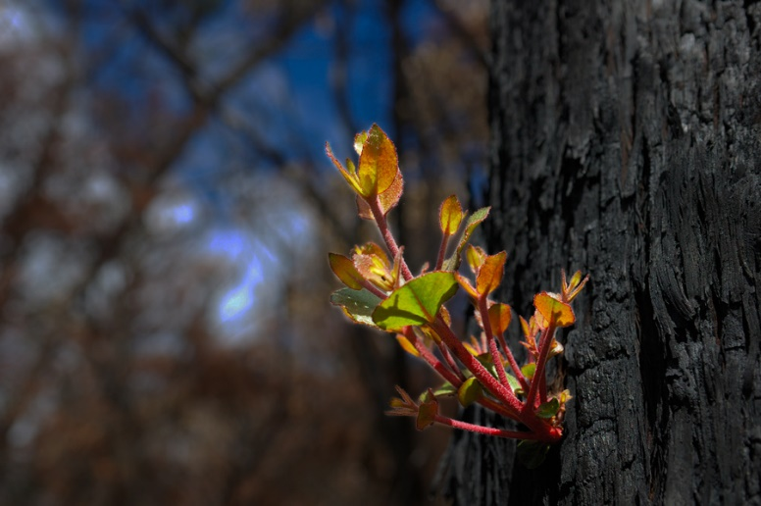
Overview
Curriculum levels: 5 and 6
Time: 50 minutes (approximately)
Links to the Victorian Curriculum F–10:
English, Level 5
Speaking and Listening
Participate in informal debates and plan, rehearse and deliver presentations for defined audiences and purposes incorporating accurate and sequenced content and multimodal elements (VCELY338)
Critical and Creative Thinking, Levels 5 and 6
Questions and Possibilities
Identify and form links and patterns from multiple information sources to generate non-routine ideas and possibilities (VCCCTQ023)
Reasoning
Consider the importance of giving reasons and evidence and how the strength of these can be evaluated (VCCCTR025)
Science, Levels 5 and 6
Science Understanding
Scientific understandings, discoveries and inventions are used to inform personal and community decisions and to solve problems that directly affect people’s lives (VCSSU073)
Geography, Levels 5 and 6
Geographical Concepts and Skills
Identify and describe locations and describe and explain spatial distributions and patterns (VCGGC086)
Impacts of bushfires or floods on environments and communities, and how people can respond (VCGGK095)
Learning intention:
Students consider what they know about bushfires, actions that will increase their safety and reduce their risk in a bushfire, and how people respond to and recover from fires. They will bring together the ideas developed throughout this inquiry and use them to promote bushfire safety messages.

Suggested resources:
- Materials as selected for recording student responses, e.g. workbooks and markers, tablets, recording devices
- Online resources such as the images and linked resources listed in the Resources section of the VCAA Bushfire Education webpages

Activities

Starting
Discuss the following to recall the main concepts of sessions and modules covered.
Learning about bushfires:
- The elements that a fire needs to burn (the Fire Triangle)
- Radiant heat during bushfires
- The Fire Danger Rating system
- Causes and effects of bushfires
- Victoria’s bushfire history
Preparing for bushfires:
- Learning about bushfire risks is for all Victorians
- Preparing for the bushfire season
- Bushfire survival plans
- Local agencies and emergency agencies helping to prepare for bushfires
Responding to bushfires:
- Reporting an emergency to Triple Zero (000)
- Fighting bushfires
Recovering from bushfires:
- Coping with feelings after a bushfire
- Communities working together for recovery
- Commemorating Black Saturday
To assist with this, you may refer to class brainstorms, students’ work and all items generated within this area of study.

Exploring
Hold a classroom conference on bushfire education. The conference will feature short verbal presentations by pairs or small groups on the key ideas and understandings covered throughout this bushfire education enquiry.
For example:
- Bushfires are influenced by several factors.
- Why is it often difficult to predict the path of a bushfire?
- Why are major bushfires difficult to control?
- Refer to the elements that influence fire behaviour.

- Homes can be made safer by making relevant preparations.
- Discuss ways in which students’ homes can be made safer by reducing the bushfire risk.
- Identify some key actions that can be carried out, when they should be performed and why they are important.
- Discuss increased building regulations and materials available.
- A ‘Leaving Early’ bushfire plan can help you remember what needs to be done during a crisis.
- Describe key elements of a bushfire plan.
- Why it is important to have a plan?
- The Fire Danger Ratings predict how a fire would behave if one started and how difficult it would be to put out.
- The higher the rating, the more dangerous the conditions.
- Fire danger ratings provide us with triggers to act.
- Discuss different approaches to bushfire readiness and why leaving early is the safest option on days of high fire risk.
- Refer to the Fire Danger Ratings and note when leaving early is the safest option.
- A bushfire kit is an essential part of a bushfire plan.
- What equipment should be included in a home bushfire kit?
- Review a list of the important equipment that a family should prepare and take.
- Knowing who to contact in a bushfire emergency can help save lives.
- Who should you contact in case of a bushfire?
- What information will you need to provide?
- Role-play a bushfire emergency, with students taking on the role of home owner or fire brigade staff.
- Radiant heat is a killer in bushfires.
- Discuss the ways firefighters protect themselves from radiant heat.
- What danger does radiant heat pose to you and your home in a bushfire?
- How do you protect yourself from radiant heat?
- Support is available to help people recover from bushfires.
- What helps people recover from bushfires?
- Refer to individuals, family and the broader community.
Allow each pair or group time to plan their response to their set topic.
The following resources may be helpful for the educator:
- CFA Plan & Prepare
- CFA Total Fire Bans and Ratings
- CFA How to prepare your property
- CFA Radiant Heat
- Resources section of the VCAA Bushfire Education webpages

Bringing it together
Formally conduct the bushfire education conference, featuring each pair or group’s presentation.

Extending

Community engagement
Invite students to think about how they could inform the school community about what they have learnt about bushfires.
The information could be developed along a theme, such as:
- ‘Leaving Early’ bushfire survival plans:
- what they are
- what they do
- how to make one
- preparing our community for a bushfire
- helping people, communities and the environment recover from bushfires
- learning to live with the threat of bushfires.
Ways to engage the community could include:
- a poster displayed in a prominent location in the school, such as near the school office
- small group presentations to other classes, parent associations or school assemblies
- a dramatic play about a family developing a bushfire plan and bushfire kit
- a dedicated parents’ evening to discuss the work on bushfires with their local brigade
- conducting a survey about preparing for bushfires and presenting the data to the community, highlighting key messages.

