Recovering from bushfires

Lesson: People recovering from bushfires

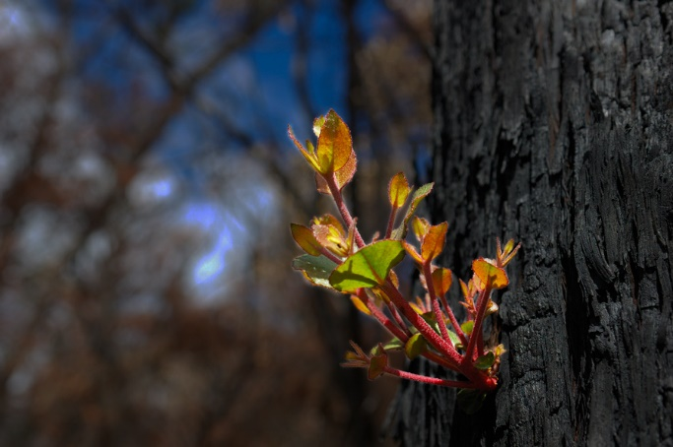
Overview
Curriculum levels: 7 and 8
Time: 50–100 minutes (approximately)
Links to the Victorian Curriculum F–10:
Geography, Levels 7 and 8
Geographical Concepts and Skills
Identify, analyse and explain interconnections within places and between places and identify and explain changes resulting from these interconnections (VCGGC101)
Geographical Knowledge
Factors that influence the decisions people make about where to live and their perceptions of the liveability of places (VCGGK111)
Influence of social connectedness and community identity on the liveability of places (VCGGK114)
Health and Physical Education, Levels 7 and 8
Personal, Social and Community Health
Investigate the benefits of relationships and examine their impact on their own and others’ health and wellbeing (VCHPEP127)
Analyse factors that influence emotions, and develop strategies to demonstrate empathy and sensitivity (VCHPEP128)
Learning intention:
Students learn that individuals recover from bushfires in different ways and at different rates, and people can be supported in many different ways.
Please note: Teachers are advised that some students may find aspects of the following activities personally disturbing. Teachers ought to review all materials prior to use and carefully choose and/or adapt the activities and resources that are the most appropriate for the context, background and experience of students in their particular classroom.
Suggested resources:
- Online resources such as the linked resources listed below

Activities

Starting
Have students view three or four photographs that show the immediate aftermath of a bushfire on a community, e.g. burnt-out homes and shops, a burnt-out car, trees across a road, shocked survivors and firefighters (available in the ‘Images’ section under Resources on the Bushfire Education website). You could also use online images of the initial stages of recovery after the 2019–20 bushfires, such as images from:
- Sifting through the ashes: Mallacoota residents after the bushfires – in pictures, The Guardian
- Exclusive: First look at the road to Mallacoota since the bushfires, 10 Daily News
- A month on from the devastating bushfire, Mallacoota is beginning its recovery, ABC News.
In small groups, students brainstorm the recovery tasks that would have to be undertaken immediately after a major bushfire – such as Black Saturday 2009, Ash Wednesday 1983 or the bushfires of 2019–20 – to support those who had survived the fires.
After brainstorming, groups report their findings to the whole class and a joint ‘Recovery tasks list’ is built up. The tasks are grouped into the different types of recovery support people need. For example, material support (such as clothing, food and shelter), emotional support, financial support, short-term support and long-term support.
Explain that after Black Saturday, people affected by the fires had to return to what the Chairperson of the Victorian Bushfire Reconstruction and Recovery Authority referred to as ‘the new normal’. Ask students what they think was meant by this, making it clear that both physical and emotional recovery was involved.
Read the following two quotes from people seriously affected by the fires, then ask students to comment on what these quotes imply about people recovering from bushfires.
Quote 1:
‘What we know here in the community of Flowerdale now is that for all of us it’s [just] that far under the surface for all of us − and we don’t know what it is and we don’t know what’s going to drag it out and we don’t know what we’re going to do when it does come out. The only way round it is for all of us to be able to express what’s going on for us all the time.’
Quote 2
‘The recovery process is not something that is necessarily governed by a strict time line – it’s governed by the emotional ability of the people involved to participate.’

Exploring

One year on
In groups, students view the following sources. Each video clip is approximately 7.5–10 minutes long.
- One Year On – The People
- One Year On – The Challenges
- One Year On – The Recovery
- One Year On – The Future
- Teenagers in Fire Zones, a booklet developed by the students of Broadford Secondary College in 2010. Ask students to read pages 30–31 and 39–42.
- The challenges of recovering from Black Saturday Bushfires – witness statements from the Victorian 2009 Bushfire Royal Commission.
- Witness 1: Anne Leadbeater (Kinglake), paragraphs 98 and 99
- Witness 2: Vicki Ruhr (Kinglake), paragraphs 95 and 96
- Witness 3: Helen Kenny (St Andrews), paragraph 35
- Witness 4: Peta Whitford (Steels Creek), paragraph 60
Note: Witness statements from the 2009 Victorian Bushfires Royal Commission final report can be accessed via the archived version of the 2009 Victorian Bushfires Royal Commission webpages held by the National Library of Australia.
Have students identify in these accounts the actions and attitudes that were/are helpful in people’s recovery. Compare these with the list produced during the earlier brainstorm and discuss any differences.
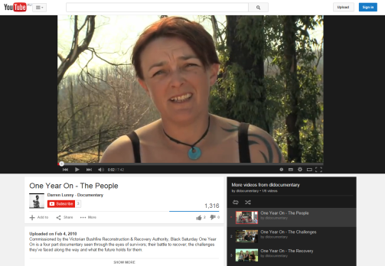

Bringing it together
Bring the groups together for a plenary session to produce an amended list of necessary recovery actions in the wake of a bushfire.

Extending
Students refer to the amended list and work individually to produce a written report.

