Recovering from bushfires

Lesson: People’s feelings after experiencing a bushfire

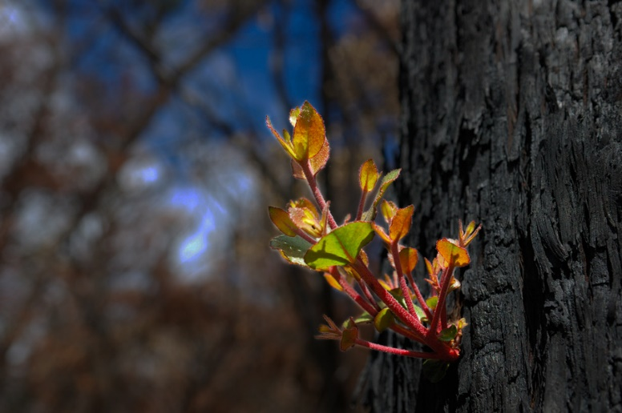
Overview
Curriculum levels: 1 and 2
Time: 50 minutes (approximately)
Links to the Victorian Curriculum F–10:
English, Level 2
Speaking and Listening
Identify language that can be used for appreciating texts and the qualities of people and things (VCELA236)
Personal and Social Capability, Levels 1 and 2
Self-awareness and Management
Extend their vocabulary through which to recognise and describe emotions and when, how and with whom it is appropriate to share emotions (VCPSCSE008)
Social Awareness and Management
Listen to others’ ideas, and recognise that others may see things differently (VCPSCSO012)
Learning intention:
This lesson introduces students to the concept that people need time and support to recover after experiencing a bushfire. Students explore and predict some feelings and actions taken by people in this situation by looking at a series of images from real bushfires.
Note: Educators should carefully consider the themes and sessions that are most appropriate for their students, communities and contexts and adapt session content and resources accordingly. For example, ‘Recovering from bushfires’ may be more relevant in particular contexts, e.g. bushfire prone areas, where students have directly experienced planning for bushfires, actual bushfires and/or what happens after a bushfire. In these contexts, students are more likely to have prior knowledge and understanding about key concepts.
Suggested resources:
- Whiteboard, IWB or poster paper and appropriate markers
- Materials as selected for recording student responses, e.g. workbooks and markers, tablets, recording devices
- Materials for recording the word splash (Bringing it together), e.g. poster paper and markers, IWB
- Online resources such as the images and linked resources listed in the Resources section of the VCAA Bushfire Education webpages, including relevant images from ‘Recovering from’ within this section.

Activities

Starting
Ask students to share times when they felt sad or upset. Ask:
- What helped them to feel better?
- Who do they talk to when they are sad or upset?
Revisit earlier discussions about bushfires. Guide students to think about people returning to their homes and communities after a bushfire.
- What feelings might they have?
- How might people help each other return to their homes, rebuild if necessary and support each other in the community?
Discuss students’ ideas and answer any questions they might have.

Exploring
Introduce the theme of ‘recovering from a bushfire’.
- Tell students they are going to view some images of bushfire recovery (select appropriate images from the ‘Recovering from’ section, under ‘Images’ on the Resources page of the VCAA Bushfire Education webpages).
- Encourage predictions about what kinds of things or ideas the images might include.
- View and discuss the images.
This could be done in various ways as appropriate for your students.
For example:
- View photographs and guide students through a picture talk.
- Ask students to describe what they see and what the images make them think about.
Welcome their ideas and answer any questions that arise.

Bringing it together
In groups or as a class, generate a word splash for selected photos, with the photo in the middle surrounded by the students’ ideas and contributions of words and phrases that go with the photo.
Students’ suggestions may include:
- what people in the photos might be feeling
- what happened before or after the scenes depicted.
Throughout this brainstorm and discussion, emphasise the ideas of people helping and supporting each other.

Extending
Use bushfire images to tell a story:
In pairs or groups, students create their own text or story for the photos. Students could use PowerPoint or similar software to create new albums or a slideshow about recovering from bushfires, with their own selection of images from the Resources page of the VCAA Bushfire Education webpages or other sources and their own text.
Please note: All educators need to be aware that there is potential for discomfort or distress among some students when talking, viewing and reading about bushfires. Teachers need to preview, adapt and manage the teaching and learning activities and resources with respect to the particular needs and backgrounds of their students. For more information and support, see the Department of Education and Training’s Mental health support after an emergency.

