Responding to bushfires

Lesson: Communicating about bushfire emergencies

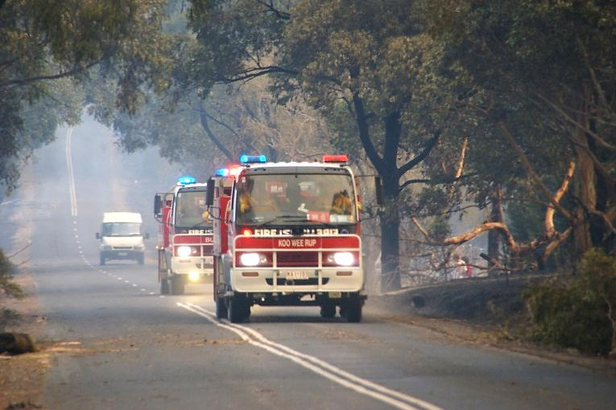
Overview
Image: CFA Strategic Communications

Curriculum levels: 7 and 8
Time: 50 minutes (approximately)
Links to the Victorian Curriculum F–10:
Health and Physical Education, Levels 7 and 8
Personal, Social and Community Health
Investigate and select strategies to promote health, safety and wellbeing (VCHPEP126)
Plan and use strategies and resources to enhance the health, safety and wellbeing of their communities (VCHPEP130)
Learning intention:
Understanding the Fire Danger Ratings and their safety message is essential. Students should know the aspects of a Triple Zero (000) emergency services call, and how to use other communications and media to stay aware, informed and safe in bushfire emergencies.
Suggested resources:
- Online resources such as the images and linked resources listed in the Resources section of the VCAA Bushfire Education webpages

Activities

Starting
Begin a general discussion about the fact that communication is a critical aspect of a bushfire emergency response. Students should consider:
- who needs to actively communicate about bushfires and to whom
- what different sorts of information need to be communicated
- when this information should be communicated
- why this information is important for those people at that time
- how this information is best communicated to those people at that time.

Exploring
Firefighters, members of the local community and the general public need to be aware of the bushfire situation during the fire season so they can respond appropriately and stay safe. In witness statements from the 2009 Victorian Bushfires Royal Commission, many people from bushfire-affected areas said that they lacked detailed and up-to-date communication during the emergency.
Have students read the following extracts of witness statements:
- Chris Casey (Long Gully, Bendigo), paragraphs 7, 8 and 15
- Penny Jewell (Drouin), paragraph 18
- Wayne Haggar (Kinglake), paragraphs 26 and 31.
Note: Witness statements from the 2009 Victorian Bushfires Royal Commission final report can be accessed via the archived version of the 2009 Victorian Bushfires Royal Commission webpages held by the National Library of Australia.
Ask, ‘What do these witness statements tell you about the challenges of communications in a bushfire emergency for both the emergency authorities and for people who face bushfire situations?’
Have students work in pairs to brainstorm answers to the following questions:
- If individuals see fire in the country or are threatened by bushfire, who can they contact in the first instance for assistance and how can they contact them?
- How can households and members of the public obtain information about Total Fire Ban days, fire danger ratings and current bushfire activity in their area?
- If you are living or travelling in a high fire-risk area during the fire season, what communication devices should you have to ensure you can remain aware of bushfire activity and/or inform others of your situation?
As a class, discuss responses to each question. Use the following short activities to further develop student knowledge of the warnings and communications that support safety in times of bushfire threats and emergencies.

Understanding fire danger ratings
Have the students review the CFA’s About Fire Danger Ratings webpage. Divide the class into five groups and assign each group one of the following warning levels to research and analyse:
- Low–Moderate and High
- Very High
- Severe
- Extreme
- Code Red
Each group should provide a short, informative and engaging presentation to the rest of the class on what this warning means and its key safety message.
To guide their research, have students use the following search questions:
- Who is responsible for generating the warnings?
- What are the warnings based on?
- When are the warnings generated?
- How are the warnings communicated to the public?
- What does this warning level mean? How does it differ from the ones before and after it?
- What precautions should be taken in response to the warning?
- How does the safe action in response to a Code Red warning differ from a response to all the other warnings?

Dial Triple Zero (000)
Have several students role-play a situation of dialling Triple Zero (000) to seek assistance from emergency services in response to a bushfire. Highlight the essential information that a caller needs to provide to the operator. Explain that they need to make the call from a safe place, away from the fire, and remain on the phone until the operator tells them they may hang up. To prepare the role-play, have students consider the following questions that an operator would ask a caller:
- What emergency assistance do you need: police, fire or ambulance?
- Where are you and where is the emergency? (Give your location by town or area with the street name, house number and nearest cross street. In rural areas, give the full address, distances from landmarks and roads, and the property name.)
- What is the type of fire incident? (For example, building fire, home fire, grassfire, bushfire.)
- How many other people are involved? Are there people in the house or car?
- Is other assistance required? (For example, ambulance or police.)
- What are your name and contact details, specifically your address and telephone number? (Provide contact details in case emergency services need to contact you later.)
Visit the Triple Zero (000) website for further information.

What is going on in my fire danger rating district and are there any Total Fire Bans in place?
Have students identify their local fire danger rating district, and if there are any Total Fire Bans in place, on the CFA website. Students should then report current Total Fire Bans, fire danger ratings and fire incidents to the class.
Ask students to explore the CFA website further to find out what additional information is available through the VicEmergency Hotline at 1800 226 226 and the VicEmergency website. Have students explain why they think VicEmergency is a valuable supplementary source of information on bushfire warnings.

Getting the message – ways of staying informed
Ask the class what media and information sources they would use to stay informed in a bushfire emergency. List the different media and information services that are available, including:
- CFA and the Department of Environment, Land, Water & Planning (DELWP) websites
- CFA VicEmergency app
- VicEmergency Hotline (1800 226 226)
- Standard Emergency Warning Signal (SEWS)
- ABC Radio and other commercial radio stations
- television news
- social media such as Twitter and Facebook.
Use the ‘Bushfire emergency student survey’ (available in ‘Video and Interactives’ in the Resources section of the Bushfire Education website) to survey students on the media they would most likely use in a bushfire emergency. Analyse the results with students, and discuss ways to improve awareness of bushfire threats and emergencies among their age group and the implications of doing so.
Have students explore the CFA News and Media website see how they can be connected to the CFA through SMS warnings, as well as social media networks such as Facebook, Twitter and YouTube. Also refer to the CFA Warnings and Restrictions and the VicEmergency website.

Bringing it together
Individually or in small groups, have students create a poster or brochure that clearly explains how to access emergency services and how to use other communications and media to stay aware, informed and safe in bushfire emergencies.

Extending
Students present their findings to the whole school community in the form of an oral presentation or newsletter article.

