Responding to bushfires

Lesson: Fighting bushfires

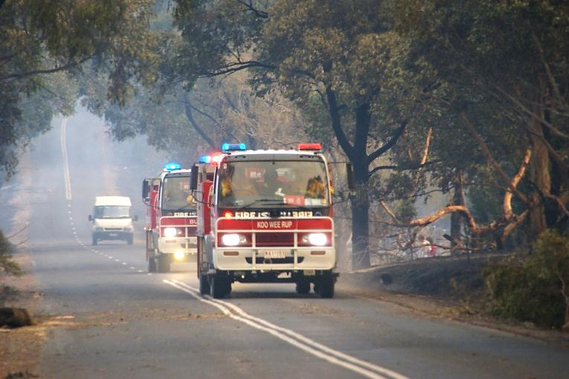
Overview
Image: CFA Strategic Communications

Curriculum levels: 5 and 6
Time: 50 minutes (approximately)
Links to the Victorian Curriculum F–10:
Geography, Levels 5 and 6
Geographical Knowledge
Impacts of bushfires or floods on environments and communities, and how people can respond (VCGGK095)
Science, Levels 5 and 6
Science Understanding
Scientific understandings, discoveries and inventions are used to inform personal and community decisions and to solve problems that directly affect people’s lives (VCSSU073)
English, Level 5
Reading and Viewing
Use comprehension strategies to analyse information, integrating and linking ideas from a variety of print and digital sources (VCELY319)
Learning intention:
Students look at historical and modern ways bushfires are fought. They also consider the safety equipment used in the modern approach to fighting bushfires.
Suggested resources:
- Materials as selected for recording student responses, e.g. workbooks and markers, tablets, recording devices
- Online resources such as the images and linked resources listed in the Resources section of the VCAA Bushfire Education webpages

Activities

Starting
Begin with these multiple-choice quiz questions to prompt students’ thinking and explore their existing knowledge.
- Which of the following is the most effective hand tool to fight a fire with?
a) a long handle rake, hoe or shovel
- a green-leaved tree branch
- a plastic rake
- When fighting a fire, you should wear:
- thongs
- gumboots
- leather boots
- The people who fight bushfires are mostly:
- professional firefighters
- volunteers from the community
- local farmers
- Which of the following methods is not used to fight bushfires?
- explosives to clear the bush
- chemicals dropped by helicopter
- fire to reduce the bush
Please note: Responses to these questions will be reviewed later in this session.

Exploring
Examine how firefighting methods have changed over time, and try to find the key thing that determines the success of firefighting by watching and comparing the following videos:
- ‘On Our Selection’
This excerpt is from a black-and-white, silent feature film from the 1920s called ‘On Our Selection’. The film is based on a story about pioneer farmers in the late 1860s fighting a bushfire in Victoria. While it is a work of fiction, the film accurately depicts how bushfires were fought in Victoria nearly 150 years ago.
- ‘Woodend bushfire 2009’
This video details factual information about the CFA’s notification, resources and specific action taken to coordinate and manage a bushfire situation at Woodend in Victoria in 2009.
Discuss the differences in firefighting methods shown in the two videos and address any language or concepts presented that the students did not understand.

Bringing it together
Working in small groups, with a partner or individually, have the students explore the clips in detail. Allow students to view the clips again to find out the required information.
Students should respond to the following questions:
- In each resource, what are the means mentioned or used to fight the fire depicted?
- Are there firefighting methods that would have been appropriate to fight the fires depicted that were not mentioned or shown? Why do you think these methods were not used?
- How does the clothing worn in each film differ? What are the reasons for these differences?
- Which of the three sides of the Fire Triangle (see ‘Images’ in the Resources section of the VCAA Bushfire Education webpages) is being targeted by each of the methods you have identified?
- In the ‘Woodend bushfire 2009’ video clip, what developments are shown or mentioned that have improved our safety and our ability to fight bushfires today?
Share responses to these focus questions and revisit the opening quiz responses. Students may wish to change their answers now that they have more information to correctly respond to the initial quiz questions.

Extending

Modern firefighting equipment
Construct an electronic display of modern firefighting equipment and procedures using a power point or similar digital tool that will enable students to assemble, organise and link images, video, audio, weblinks and text.
Search online for fire equipment that is currently available for firefighting.

