Professional learning activity: Teachers as learners
Activity suggested duration: 30 minutes
Activity description: Participants experience an introductory activity about categorising contemporary issues as a learner. This is an activity that participants can then implement with students in their own classrooms.
Required resources: sticky notes, a whiteboard and paper/devices to complete charts

Activity steps
- The learning leader asks each participant to nominate a contemporary issue that is of interest and relevance to them. Participants write their issue on a sticky note. (2 minutes)
- Participants categorise their issue as being predominantly local, state, national or global by placing it on the mind map on the whiteboard. (5 minutes)
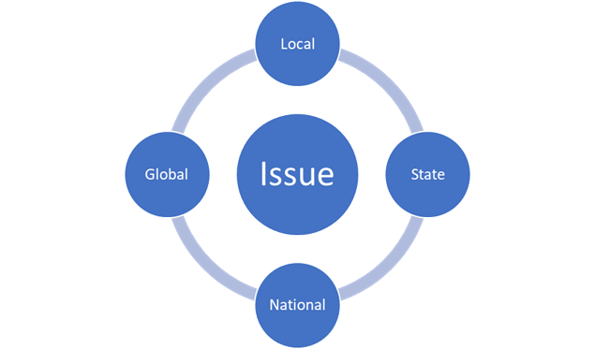

- Participants then complete a PESTLE (political, economic, social, technological, legal, environmental) analysis of their issue by completing the following template and considering the different elements involved. Both a blank template and an example has been provided below. (10 minutes)
PESTLE | Element
Political
Economic
Social
Technological
Legal
Environmental
Example issue: Climate change
PESTLE | Element
Political | carbon tax
Economic | cost of more frequent natural disasters
Social | displacement of people
Technological | carbon capture technology
Legal | insurance cases
Environmental | changing rainfall

- Participants then complete a KWL reflection about this activity: what they know, what they still want to know, and what they learned. They consider how easy or difficult it was to choose an issue, categorise it, and determine the elements involved in the issue. (13 minutes)
What I know
What else I want to know
What I learned

