Professional learning activity: Developing student voice, agency and leadership through responding to a contemporary issue
Activity suggested duration: 30 minutes
Activity description: This is a read, reflect and discuss activity where participants read through a classroom activities sample then consider and discuss implications for their own teaching.
Learning leader preparation:
- Ask participants to pre-read one of the following classroom activities, which have been designed for a Civics and Citizenship classroom.
Participant preparation:
- Participants choose a curriculum band to focus on that is relevant to their context (Levels 3 and 4, Levels 5 and 6, Levels 7 and 8 or Levels 9 and 10) and read the classroom activity for that band.

Activity steps
- In small groups, participants read through one of the following learning activities for a relevant level. (10 minutes)
- Participants think, pair, share about the following questions. (20 minutes)
- Would you use these learning activities in your classroom?
- What would you use, discard, adapt or change?
- What opportunities and challenges do you foresee in putting students at the centre of contemporary issues learning?
Note: Participants may find it helpful to look at other curriculum level activities too.

Classroom activities sample

Levels 3 and 4
Curriculum link:
- Government and Democracy
- Identify how and why decisions are made democratically in communities (VCCCG002)

Discussion questions:
- How are rules and decisions made in your classroom? In your school?
- Are schools democratic institutions?
- How are decisions made at local community organisations such as Scouts, sporting associations and community groups?
- Do you think everyone should have to vote? Why or why not?
Examples:
- School elections for positions of responsibility
- Student Representative Councils
- Student members of employment panels in schools
- Local, state and federal elections
Activity:
Topic: The history of voting in Australia
- Watch the following BTN episode and then complete a PMI table about the history of voting in Australia:
- ABC, 'History of Voting’, Behind the News, 24 May 2016.
Plus | Minus | Interesting

Levels 5 and 6
Curriculum link:
- Citizenship, Diversity and Identity
- Identify different points of view on a contemporary issue relating to democracy and citizenship (VCCCC015)
Discussion questions:
- Are all viewpoints equally valid?
- What evidence is required to support your point of view?
- Can there be multiple ‘correct’ viewpoints about an issue?
Examples:
- Gambling advertising during sporting events
- E-scooters on footpaths
- Sugar tax on soft drinks
Activity:
Topic: ‘Nature strip gardening should be banned.’
- Each person in the group takes on the perspective of a stakeholder: a young person, a business owner, an elderly person, a local councillor and a member of a local environmental group.

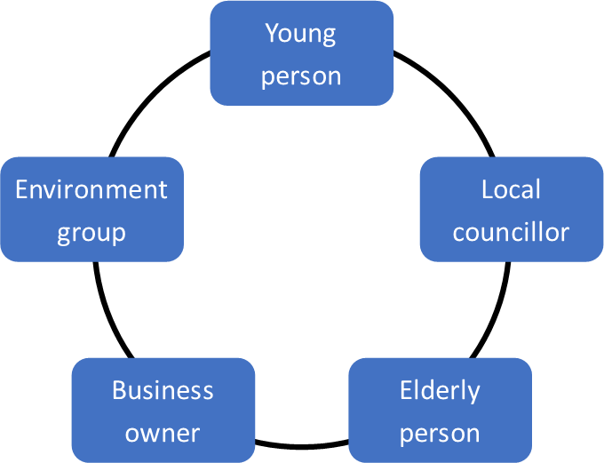
Resource:
Backhouse M 'Nature strip gardening enthusiasm grows, but new guidelines dampen cheer'’, The Age, 24 December 2021.

Levels 7 and 8
Curriculum link:
- Government and Democracy:
- Explain how citizens can participate in Australia’s democracy, including the use of the electoral system, contact with their elected representatives, use of lobby groups, interest groups and direct action (VCCCG020)
Questions:
- How can young people be involved in Australia’s democracy even though they are too young to vote?
- How can you contact your local, state and federal elected representative?
- What influence do lobby groups and interest groups have on decision-makers?
Examples:
- Letters to the editor
- Talkback radio
- Petitions
Activity:
Topic: ‘Sixteen-year-olds should be able to vote in Australian elections’. Discuss.
- Use a four-corners debate to present different arguments about this topic.
Disagree | Agree
Strongly disagree | Strongly agree
Resource:
Petrova S, Berents H, Gagnon J, Hill L, Phillips L and Collin P 'Should Australia lower the voting age to 16? We asked five experts', The Conversation, 27 March 2019.

Levels 9 and 10
Curriculum link:
- Government and Democracy
- Explain the Australian government’s roles and responsibilities at a global level, including provision of foreign aid, peacekeeping and the United Nations (VCCCG031)
Activity:
Australia is a signatory to the United Nations Convention on the Rights of the Child (1989). Article 12(1) states that:
States Parties shall assure to the child who is capable of forming his or her own views the right to express those views freely in all matters affecting the child, the views of the child being given due weight in accordance with the age and maturity of the child.
- Write a paragraph outlining why you think there is a special convention to recognise the rights of children.
Resource:
UNICEF Australia, Learn about Children’s Rights.

