Crazy Boot Scootin’

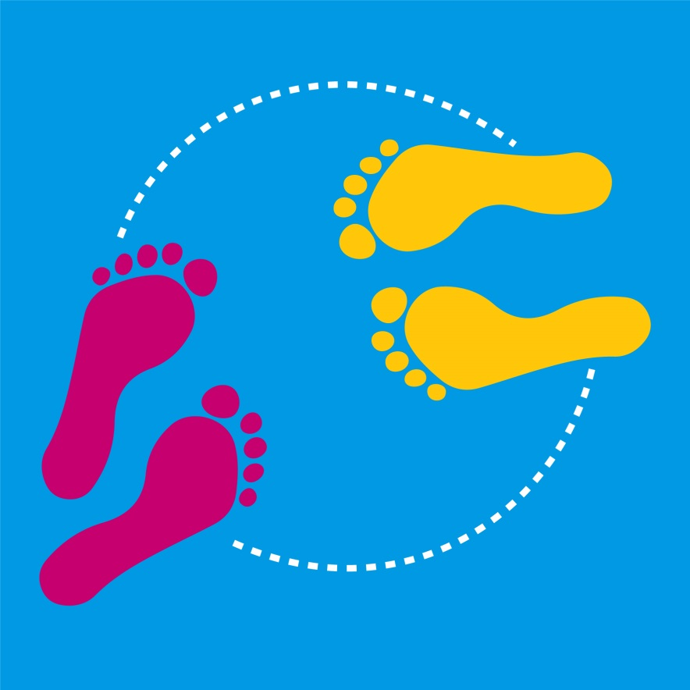
Levels 3 and 4

Authorised and published by the Victorian Curriculum and Assessment Authority
Level 7, 2 Lonsdale Street
Melbourne VIC 3000
© Victorian Curriculum and Assessment Authority [2017]

No part of this publication may be reproduced except as specified under the Copyright Act 1968 or by permission from the VCAA. Excepting third-party elements, schools may use this resource in accordance with the VCAA educational allowance. For more information go to: www.vcaa.vic.edu.au/Pages/aboutus/policies/policy-copyright.aspx.
The VCAA provides the only official, up-to-date versions of VCAA publications. Details of updates can be found on the VCAA website: www.vcaa.vic.edu.au.
This publication may contain copyright material belonging to a third party. Every effort has been made to contact all copyright owners. If you believe that material in this publication is an infringement of your copyright, please email the Copyright Officer: vcaa.copyright@edumail.vic.gov.au
Copyright in materials appearing at any sites linked to this document rests with the copyright owner/s of those materials, subject to the Copyright Act. The VCAA recommends you refer to copyright statements at linked sites before using such materials.
The VCAA logo is a registered trademark of the Victorian Curriculum and Assessment Authority.

Topic: Crazy Boot Scootin’

Level: 3 and 4

Victorian Curriculum

Health and Physical Education

Content Descriptions
Practice and refine fundamental movement skills in different movement situations in indoor, outdoor and aquatic settings (VCHPEM097)
Perform movement sequences which link fundamental movement skills (VCHPEM098)
Examine the benefits of physical activity and physical fitness to health and wellbeing (VCHPEM100)
Combine the elements of effort, space, time, objects and people when performing movement sequences (VCHPEM101)

Achievement Standards (extract only)
By the end of Level 4, students …understand the benefits of being fit and physically active. They create and perform movement sequences using fundamental movement skills and the elements of movement.

The Arts - Dance

Content Descriptions
Improvise and structure movement ideas for dance sequences using safe dance practice, the elements of dance and choreographic devices (VCADAE025)
Use choreographic devices to organise dance sequences, and practise body actions and technical skills (VCADAD026)
Identify how the elements of dance and production elements express ideas in dance they make, perform and view (VCADAR028)

Achievement Standards (extract only)
By the end of Level 4, students structure movements into dance sequences and use the elements of dance and choreographic devices to communicate their ideas and intentions. They make dances and perform safely with control, accuracy, projection and focus.
Students describe and discuss similarities and differences between dances they make, perform and view.

Teaching and learning activities
The following teaching and learning activities are designed to teach knowledge, skills and understandings relating to dance in Health and Physical Education and The Arts: Dance for Level 3-4.

Activity 1: Warm up (5 to10 minutes)
Conduct an activity to enable students to warm up and prepare their body and mind for their dance. For example the bean game where students move around the room jogging or walking. The teacher calls out a type of bean, for example french bean, jumping bean, Mr Bean, broad bean, jelly bean, beans on toast, baked bean, chilli bean etc. Students are to react to different names and create different shapes, movements or stretches to represent the type of bean named.

Activity 2: Line Dancing (30 minutes)
Introduce students to the concept of line dancing as a form of social dance. One of the benefits of line dancing is that many people can participate in a simple repetitive routine as part of a social gathering without requiring a partner. Another benefit of line dancing is that because the dance is performed in a line, participants only need to learn the steps without having to think about moving from the place that they are dancing. Some line dances do require the participants to change direction whilst still remaining in their own personal dance space.
Crazy boot scootin’
Introduce students to the following four crazy boot scootin’ moves (see Resources for a description of each move):
- heel and toe shuffle
- lasso gallop
- cowboy jump and march
- gallop on spot with ¼ turn to the left
Introduce the four moves without turning by allowing students to repeat all four moves facing the front of the room a number of times before adding a quarter turn to the left.
When the students are confident to perform each move, start to teach the dance sequence:
- complete the four moves
- quarter turn to the left
- repeat the four moves
- quarter turn to the left
- repeat until the routine has been performed facing all four wall of the room.
These sixteen sets of steps and three turns equal ‘one full rotation of the dance’.
Group practice
Allow students to safely:
- work in groups of 3 or 4 to practice the line dance routine.
- assist others in their group by helping with counts and the timing of the turn.
- present one full rotation of the crazy boot scootin line dance in their groups.

Activity 3: Fun and Fitness (30 minutes)
Before students begin the session ask them to notice how they are breathing and how their bodies are feeling.
As a class have students perform two full rotations of the Crazy Boot Scootin’ Line Dance and then have students identify how their bodies are feeling.
Develop a class discussion around what they are feeling in the following parts of their bodies:
- heart
- lungs
- muscle groups.
Talk about how and why line dancing is beneficial to developing cardiovascular fitness. For example, it is a fun way to exercise over a period of time without getting too tired. Repetitive dances allow for the same steps and intensity of movement to be repeated many times. It also allows for movement of specific muscles groups that are used when performing the steps. Line dancing can also provide social opportunities to participate in group fitness.
Discuss with the class other dances they can think of that are fun, repetitive and can help people be active.
Boot scootin’ fitness routine
Have students reform their groups from the previous session and explain that they will be transforming the crazy boot scootin’ line dance into a fitness routine. Most line dances focus on the muscles of the legs to generate movement in the body.
As a group they will need to work co-operatively with each other to safely:
- add a new arm movement to the first step (Heel and toe shuffle) focusing on arm movements that allow for effective muscle movement
- perform two full rotations of their boot scootin’ fitness routine.
Complete the session by having each group contribute 2 ideas to a list of health related benefits of their boot scootin’ fitness routine.

Activity 4: Create your own line dance (40 to 60 minutes)
Using the crazy boot scootin’ steps as a base, students now work with their group to make a new line dance.
Without changing the last step (gallop on spot with quarter turn to the left) students will need to work together in their groups to develop ideas and make decisions to safely:
- replace one step with a new step chosen by the group
- add a start and finishing pose to the dance
- practice their new dance with one full rotation.
Discuss the assessment criteria and discuss qualities for the different levels of achievement.
Introduce students to some basic choreographic devices such as:
- repetition
- changing level or direction.
Allow students time to work on their new routines. If the activity is completed over more than one session, make time for students to document their ideas (for example they could create a story board or record their ideas using a mobile device).

Activity 5: Performing and responding to line dances (30 minutes)
Once students have practiced and refined their dances, they will perform their line dance to another group who will then perform in return.
Discuss with students the characteristics expected of a good audience member. Remind students that they will only be providing feedback that is relevant to the set criteria when viewing group dances.
Have groups perform one full rotation of their line dance and ask the audience to respond by providing feedback based on the criteria. Provide one sheet per group (see Summative assessment). Groups then swap over. At the end ask each group to provide feedback on one other group. Students then individually reflect on their dance-making, improved fitness and working in a group.

Activity 6: Cool down (10 minutes)
After each practical session provide an opportunity for students to cool down by focusing on slow movements and stretching followed by a period of relaxation. For example lead students through a series of on the spot activities (for example, walk or skip).Explain to students that they will complete the activities at three different speeds, when you hold your arm:
- down low it means very slow
- out straight it means moderate or medium speed
- up high in the air it means very fast.
Complete the activity so that students slowly decrease their heart rate by moving through a variety of differing speeds, ending up with a slow movement.
Ask students to reflect on:
- what they enjoyed or learnt about dance in the session?
- what was easy or hard to learn?
- how do their heart, lungs or muscles feel?

Assessment ideas

Pre-assessment
Ask students to consider the role of the audience in dance performance. Brainstorm ‘audience etiquette’ for the class.
Refer to the assessment rubric on pages 7-8 to identify where students are located on the Victorian Curriculum continuum.

Ongoing formative assessment
Students create a dance that demonstrates understanding of the key elements of a line dance and explain how dancing can be used to develop fitness. Students share other dances they know of and indicate with the use of thumbs up, thumbs down to indicate if they perceive the dance to be fun, repetitive and increase physical activity.

Summative Assessment
Provide students with a peer assessment tool that the audience group will use to respond to the line dance created in Activity 3. Students reflect on the feedback provided to demonstrate their understanding of how to use different choreographic devices in the construction of a line dance.

Criteria
- the new step

- the step that has been replaced
- the beginning and ending poses
Student reflection

Use the assessment rubric on pages 7-8 to identify where students are located on the Victorian Curriculum continuum.

Resources

Suggested music
5,6,7,8 (Steps, Best of Steps, 2002), which can be accessed from iTunes or YouTube

Teacher information
Ausdance, Safe Dance factsheets contain basic information about a creating safe dance environment and strategies for minimising the risk of accident and injury.
Australian Sports Commission, Move to dance booklet provides information about teaching dance, including information about safety, equipment and strategies for conducting dance lessons.

Crazy boot scootin moves
Step | Description | Arm/body movements | Total counts
Heel and toe shuffle | Perform heel and toe x 2 with right foot, take 2 steps to the right = 8 counts  Perform heel and toe x 2 with left foot, take 2 steps to the left= 8 counts | Hands holding onto pretend braces | 16
Lasso gallop | Gallop to the right = 8 counts  Gallop to the Left = 8 counts | Right arm moves like a lasso  Left arm moves like a lasso | 16
Cowboy jump and march | Jumping jack x 2, March on spot x 4 = 8 counts  Jumping jack x 2, March on spot x 4 = 8 counts | Arms on hips during Jumping Jacks and swing in opposition to legs during march | 16
Gallop on spot with quarter turn | Gallop on the spot = 8 counts  Gallop whilst completing a quarter turn to the left = 8 counts | Wave cowboy hat above head. | 16

Repeat all x 4: One full rotation of the dance includes performing the routine facing each of the four walls of the room.

Assessment Rubric - Crazy boot scootin’ (Level 3 – 4)
 | Relevant element of the Achievement Standards
 | Level 2 |  |  |  | Level 4 |  |  | Level 6
 | Health and Physical Education
 | By the end of Level 2, students … demonstrate fundamental movement skills in different movement situations and test alternatives to solve movement challenges. They perform movement sequences that incorporate the elements of movement. |  |  | By the end of Level 4, students … understand the benefits of being fit and physically active. They create and perform movement sequences using fundamental movement skills and the elements of movement. |  |  |  |  | By the end of Level 6, students … perform specialised movement skills and propose and combine movement concepts and strategies to achieve movement outcomes. They apply the elements of movement when composing and creating movement sequences.
 | The Arts - Dance
 | By the end of Level 2, students …communicate about dances they make, perform and view, and discuss where and why people dance. |  |  | By the end of Level 4, students… structure movements into dance sequences. They make dances and perform safely with control, accuracy, projection and focus. Students describe and discuss similarities and differences between dances they make, perform and view. |  |  |  |  | By the end of Level 6, students…structure movements in dance sequences and use elements of dance and choreographic devices to make dances that communicate ideas and intentions. They perform dances for audiences, demonstrating technical and expressive skills and safe dance practice.

 | Assessment Rubric
Category | At level 2 students can: | When progressing towards level 4 students can: | At level 4 students can: | When progressing towards level 6 students can: | At level 6 students can:
Link movement skills to perform a movement sequence | - construct and perform imaginative and original movement sequences in response to stimuli | - perform imaginative and original movement sequences which link fundamental movement skills | - combine imaginative and original movements to create more complicated movement patterns and sequences. | - assess and refine strategies to persist and perform new and challenging movement skills and sequences | - refine and further develop a wide range of fundamental movement skills in more complex movement patterns
Demonstrates a new routine based on previously learnt movements | - select and organise movement ideas and create and practise dance sequences | - explore the use of choreographic devices to organise dance sequences, and practise required body actions and technical skills | - make dances, practice and refine required body actions and technical skills and perform safely with control, accuracy, projection and focus. | - develop their technical and expressive skills in fundamental movements and body actions and use selected choreographic devices to create dance sequences | - structure movements in dance sequences and use elements of dance and choreographic devices to make dances that communicate ideas and intentions  - demonstrate their ability to manipulate the elements of dance and use compositional devices to sequence ideas for a line dance.
Respond to dance independently and as an audience | - communicate about dances they make, perform and view. | - identify features of dances they make and view | - respond to dance independently, collaboratively with peers and teachers, and as an audience for other dancers’ work | - describe movements they have created | - use appropriate vocabulary to provide constructive feedback about dances they have observed
Significance of dancing on health and wellbeing | - identify some changes to their body after dancing | - describe how different parts of their body feel after dancing | - identify the benefits of dancing for physical health | - identify the benefits of dancing for physical, social and emotional health and wellbeing | - describe the features cardiovascular fitness and benefits of dancing to enhance health and wellbeing

