Sport mob

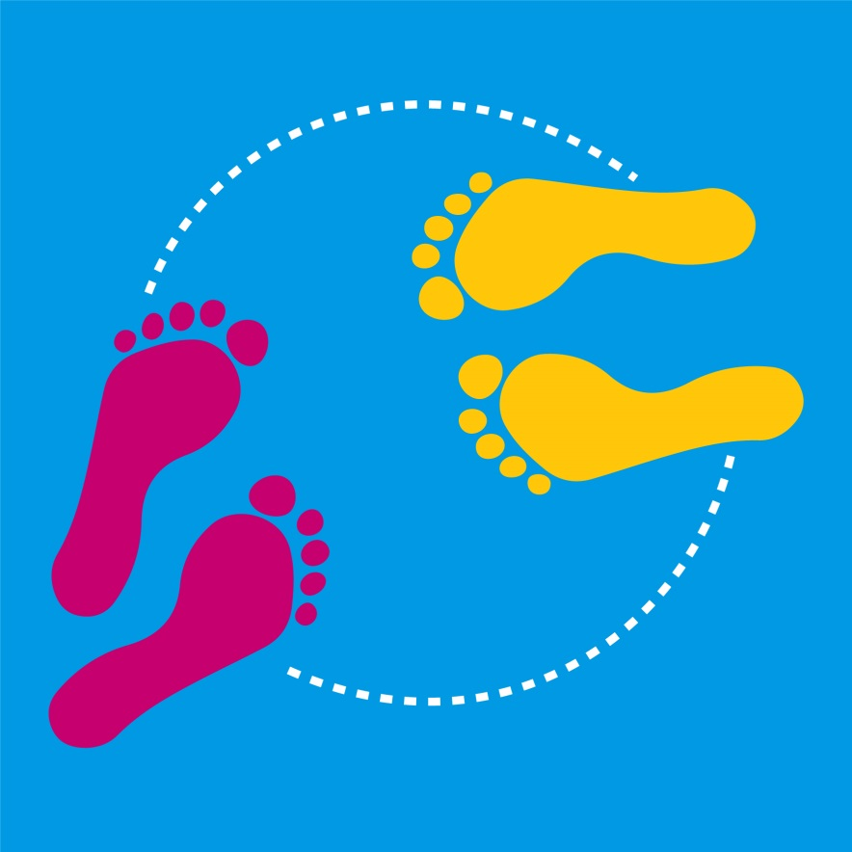
Levels 5 and 6

Authorised and published by the Victorian Curriculum and Assessment Authority
Level 7, 2 Lonsdale Street
Melbourne VIC 3000
© Victorian Curriculum and Assessment Authority [2017]

No part of this publication may be reproduced except as specified under the Copyright Act 1968 or by permission from the VCAA. Excepting third-party elements, schools may use this resource in accordance with the VCAA educational allowance. For more information go to: www.vcaa.vic.edu.au/Pages/aboutus/policies/policy-copyright.aspx.
The VCAA provides the only official, up-to-date versions of VCAA publications. Details of updates can be found on the VCAA website: www.vcaa.vic.edu.au.
This publication may contain copyright material belonging to a third party. Every effort has been made to contact all copyright owners. If you believe that material in this publication is an infringement of your copyright, please email the Copyright Officer: vcaa.copyright@edumail.vic.gov.au
Copyright in materials appearing at any sites linked to this document rests with the copyright owner/s of those materials, subject to the Copyright Act. The VCAA recommends you refer to copyright statements at linked sites before using such materials.
The VCAA logo is a registered trademark of the Victorian Curriculum and Assessment Authority.

Topic: Sport mob

Level: 5 and 6

Victorian Curriculum

Health and Physical Education

Content Descriptions
Design and perform a variety of movement sequences (VCHPEM116)
Participate in physical activities designed to enhance fitness, and discuss the impact of regular participation on health and wellbeing (VCHPEM118)
Manipulate and modify the elements of effort, space, time, objects and people to perform movement sequences (VCHPEM119)

Achievement Standards (extract only)
By the end of Level 6, students… describe the key features of health-related fitness and the significance of physical activity participation to health and wellbeing. …
They perform specialised movement skills and propose and combine movement concepts and strategies to achieve movement outcomes and solve movement challenges. They apply the elements of movement when composing and creating movement sequences.

The Arts: Dance

Content Descriptions

Explore movement possibilities and choreographic devices using safe dance practice and the elements of dance to create movement ideas, sequences, and phrases (VCADAE029)

Develop technical and expressive skills in fundamental movements and body actions and use choreographic devices to create dance sequences (VCADAD030)

Perform dance with technical competence, using expressive skills to communicate a choreographer’s ideas (VCADAP031)

Explain how the elements of dance and production elements communicate ideas in dances from different contexts they make, perform and view (VCADAR032)

Achievement Standards (extract only)
By the end of Level 6, students structure movements in dance sequences and use elements of dance and choreographic devices to make dances that communicate ideas and intentions. They perform dances for audiences, demonstrating technical and expressive skills and safe dance practice.
Students explain how the elements of dance, choreographic devices and production elements communicate ideas and intentions in dances they make, perform and view.

Teaching and learning activities
The following teaching and learning activities are designed to teach knowledge, skills and understandings relating to dance in Health and Physical Education and The Arts: Dance for Levels 5 and 6.

Activity 1: Introduction – What is a flash/dance mob? (10 minutes)
A Flash Mob is an organised dance routine that appears as a random and spontaneous dance where people join in to the pre-choreographed movements and then disperse at the end of the dance.
Show students some examples of a flash/dance mob (see Resources)
Develop a discussion about:
- Why are flash/dance mobs fun and how can they help people be active?
- What are the benefits to health and wellbeing by participating in a flash/dance mob?
Explain to students that they will be creating a flash/dance mob with a twist! They will present it to the school or another grade level of their choice. It will consist of a base routine that they can all perform as a class and then they will work with a small team to change the base routine into a sport mob routine to present in a small team and then finish with base routine at the end. Their flash/dance mob will be called a sport mob and hopefully be an exciting way to introduce and motivate other students in the school to enjoy dancing for fun and fitness.

Activity 2: Warm up (5 to 10 minutes)

Conduct an activity to enable students to warm up to prepare their body and mind for their dance. For example play a game of musical statues (see Move to Dance page 13) where students skip to music around the room, when the music stops the teacher call out a scenario and children must perform this on the spot, for example a tree blowing in the wind. Select scenarios that could include a range of movements and muscle groups. Some scenarios could link to the sport mob theme such as throwing a javelin or bouncing a basketball, etc.

Activity 3: Base routine (30 – 40 minutes)
Introduce students to the base routine moves one at a time:
- step 1- The walk (walk 4 steps forward and 4 steps back)
- step 2- The grapevine (see footage Hip-Hop Workout/ How to do a grapevine )
- step 3-The step touch (step to the right and touch left foot to right, then step to the left and touch right foot to left)
- step 4-The shuffle (see footage Hip-hop How-to / Running man Melbourne Shuffle ).
Students perform the 4 steps of the base routine together using 16 counts for each step.
- the walk x 4 =16 counts
- the grapevine x 4= 16 counts
- the step touch x8=16 counts
- the shuffle x16=16counts
Students select peer groups of 3 or 4 students to practice the:
- base routine with the 16 beat step count.
- base routine adding in a formation or spatial pattern for their team to present in. For example a diagonal line, box or star formation. For information on spatial patterns see Move to Dance page 7)
Students then perform their base routine in formation to another peer group.

Activity 4: Creating team sport mob (40 - 60 minutes)
Have students think about how dance moves can mirror or emulate other movements we use in our daily lives. For example if we took the first step of the base routine and added an arm movement that simulated bouncing a basketball we would have a movement that could be called basketball bounce. Have students try walking forward and backward pretending to bounce a basketball.
In groups students discuss the criteria they could use to assess their dance, for example maintaining rhythm or beat, high level of energy, accuracy in performing the routine etc. Each group should share their ideas with the class. As a class agree on the three criteria that will be used to assess each groups sport mob routine.
Encourage students to safely:
- practice their base routine in formation
- identify and discuss two possible sport moves that could be substituted into their team routine.
- experiment with sport moves using a 16 beat count for each step.
Encourage students to take turns with idea sharing and to be democratic in their decision making process. Remind students that their sport movements are only a mime and therefore they require no equipment and must not involve any body contact with other students.
- choose 2 steps from the base routine to take out of the routine and substitute the sport moves
- practice the team sport mob routine in formation
- perform the team sport mob routine in formation to another group.
At the end of each group’s performance ask the group that observed their performance to provide feedback using the agreed criteria. Encourage groups to discuss how they could improve their routine.

Activity 5: Presenting the sport mob (30 minutes)
Now the class has a base routine and each group has a sport mob routine it is time to put it all together, practice it and make some decisions about who the sport mob will be presented to, when and where.
Develop a class discussion to make a decision about:
- Who will the sport mob be presented to? Ideas could include the Foundation students or the Year 3 students or it could be to the whole school.
- When will it be performed? Ideas could include an assembly time, recess or lunch time.
- Where will it be performed? Ideas to consider are spaces that allow for safe dance practices such as a large working space or a suitable surface, set up of music, costumes.
- Can the audience be involved in the base routine at the end of the dance? Is there enough safe space or a suitable surface? Will all students be able to perform the base routine moves? How will dances transition from one section of the dance to another?
Once the above decisions have been made encourage students to safely:
- practice the base routine
- practice their team sport mob routine
Give each team sport mob routine a number and explain that the class will now perform the class sport mob together. This will consist of everyone performing the base routine together spread out in a free space and then each team coming to the forward according to their number and performing their team sport mob. The class will need to discuss and then practice how this will happen. Then everyone reforms in a free space to perform the base routine again. The final base routine can be repeated a few times if the class choose to have their audience participate at the end.
Have students safely perform the class sport mob. This can be practiced as many times as necessary for the class to feel comfortable to present. Set the assigned date to present to their chosen audience.

Activity 6: Cool down (5 to 10 minutes)
After each practical session provide opportunity for students to cool down by focusing on slow movements and stretching followed by a period of relaxation. For example a game of follow the leader could include slow movements such as:
- walking on the spot with arms swinging
- reaching up trying to touch the sky
- slow skipping on the spot
- touching head, shoulders and toes.
Ask students to lie on the floor with their eyes closed and to breath evenly (in and out). Have students think about and move different parts of their body that they used during their dance, for example lift your right arm, shake your left legs etc.

Assessment ideas

Pre-assessment

Conjure, Cluster, Categorise: Provide each student with a stack of sticky notes. Ask students to generate (conjure) a set of curiosities, questions, and predicted challenges for creating and performing a flash/ dance mob. Students write one curiosity, question, or predicted challenge per sticky note. Cluster the notes that are relevant to one another, and create categories for the clusters. These can inform your teaching points and the criteria that student develop.
- What is a flash/dance mob?
- What characterises these dances from other types of dance?
- What are the health benefits of participating in a flash/dance mob – physical , social, emotional?
- Are there any perceived barriers to participation in a flash/dance mob?

Use this task to assess students’ ability to describe the key features of health-related fitness and the significance of physical activity participation to health and wellbeing and their understanding of the requirements needed to perform dances for audiences, demonstrating technical and expressive skills and safe dance practice.
Refer to the rubric on page 7 and 8 to identify where students are located on the Victorian Curriculum continuum.

Ongoing formative assessment
In the last few minutes of each session, ask students to complete a ‘skill check’ to reflect on their progress in the base routine activity.
Skill check
Name:
Skill: Base routine

- In three sentences summarise the skill you have learned about today.

- Do you need more instruction or assistance about this skill? If yes, please explain.

- What will you do next lesson to progress?

Source: https://www.eduweb.vic.gov.au/edulibrary/public/teachlearn/student/progresspass.pdf

Summative Assessment
Use Activity 4: Presenting the sport mob to assess students in relation the Victorian Curriculum Achievement Standards. Refer to the rubric on page 7 and 8 to identify where students are located on the Victorian Curriculum continuum.

Resources

Suggested music
Classic (2013) by MKTO
Can’t Stop The Feeling! (Original Song from DreamWorks Animation's "Trolls") (2016)
Artist: Justin Timberlake
RCA Records Label

Or any appropriate dance music on continuous play loop/ repeat.

Online video

Examples of flash/dance mobs
Best Flash mob
Antwerp train station, do re mi
Riverdance flash mob, Sydney Central station
Michael Jackson tribute Stockholm
Puttin’ on the Ritz, Moscow

Teaching dance steps
How to do the grapevine
How to do the Shuffle

Teacher information
Ausdance, Safe Dance factsheets contain basic information about a creating safe dance environment and strategies for minimising the risk of accident and injury.
Australian Sports Commission, Move to dance booklet provides information about teaching dance, including information about safety, equipment and strategies for conducting dance lessons.

Assessment Rubric – Sport mob (Level 5-6) 1 of 2

 | Relevant element of the Achievement Standards
 | Level 4 |  | Level 6 |  | Level 8
 | Health and Physical Education
 | By the end of Level 4, students ... … understand the benefits of being fit and physically active. They create and perform movement sequences using fundamental movement skills and the elements of movement. |  | By the end of Level 6, students ... … perform specialised movement skills and propose and combine movement concepts and strategies to achieve movement outcomes. They apply the elements of movement when composing and creating movement sequences. |  | By the end of Level 8, students ... investigate and apply movement concepts and strategies to achieve movement and fitness outcomes. Students demonstrate control and accuracy when performing specialised movement skills. They apply the elements of movement to compose and perform movement sequences.
 | The Arts - Dance
 | By the end of Level 4, students… structure movements into dance sequences. They make dances and perform safely with control, accuracy, projection and focus. Students describe and discuss similarities and differences between dances they make, perform and view. |  | By the end of Level 6, students…structure movements in dance sequences and use elements of dance and choreographic devices to make dances that communicate ideas and intentions. They perform dances for audiences, demonstrating technical and expressive skills and safe dance practice.  Students explain how the elements of dance, choreographic devices and production elements communicate ideas and intentions in dances they make, perform and view. |  | By the end of Level 8, students ... choreograph and perform dances to communicate ideas and intentions. They improvise movement and select and organise the elements of dance, choreographic devices and form to communicate choreographic intent. Students learn, rehearse and perform dances, demonstrating technical and expressive skills appropriate to the dance style and safe dance practice.  Students identify and analyse the elements of dance, choreographic devices and production elements of dances in different styles and apply this knowledge to dances they make and perform.

Assessment Rubric – Sport mob (Level 5-6) 2 of 2

 | Assessment Rubric
Category | At level 4 students can: | When progression towards level 6 students can: | At level 6 students can: | When progressing towards level 8 students can: | At level 8 students can:
Perform four base routine movement skills | - perform all four base routine movement skills in a set order | - perform all four base routine movement skills in a sequence that demonstrates technical competence and some expressive skills | - perform all four base routine movement skills in a repeating sequence demonstrating technical competence and expressive skills | - perform all four base routine movement skills in a repeating sequence demonstrating technical competence, expressive skills and correct timing. | - demonstrate control, accuracy and timing when performing specialised movement skills (four base routine movement skills).
Perform dance safely with control, accuracy, projection and focus. | - performs base movements in complete class sport mob routine at correct times to intended audience. | - performs base movements and additional material for class sport mob routine to intended audience with some degree of safety, control, and accuracy | - performs base movements and additional material for class sport mob routine to intended audience safely with control, accuracy, projection and focus. | - rehearse and refine skills required for base movements, additional material and transitions needed to perform sport mob routine, demonstrating technical and expressive skills. | - rehearse, refine skills required for base movements, additional material and transitions and perform dances, demonstrating technical and expressive skills appropriate to the dance style and safe dance practice.
Respond to dance independently and as an audience member | - respond to dance independently, collaboratively with peers and teachers, and as an audience for other dancers’ work | - describe movements they have created and movements they have observed in the work of their peers | - use appropriate vocabulary to provide constructive feedback about dances they have observed | - use appropriate vocabulary to develop criteria for providing constructive feedback about a sport mob dance they have observed | - apply criteria to identify personal dance skills they have developed and reflect on skills requiring further development
Significance of dancing on health and wellbeing | - identify the benefits of dancing for physical health | - identify the benefits of dancing for physical, social and emotional health and wellbeing | - describe the significance of dancing to enhance health and wellbeing | - identify specific fitness outcomes linked to dancing | - describe how dancing contributes to specific fitness outcomes

