DIGITAL TECHNOLOGIES:
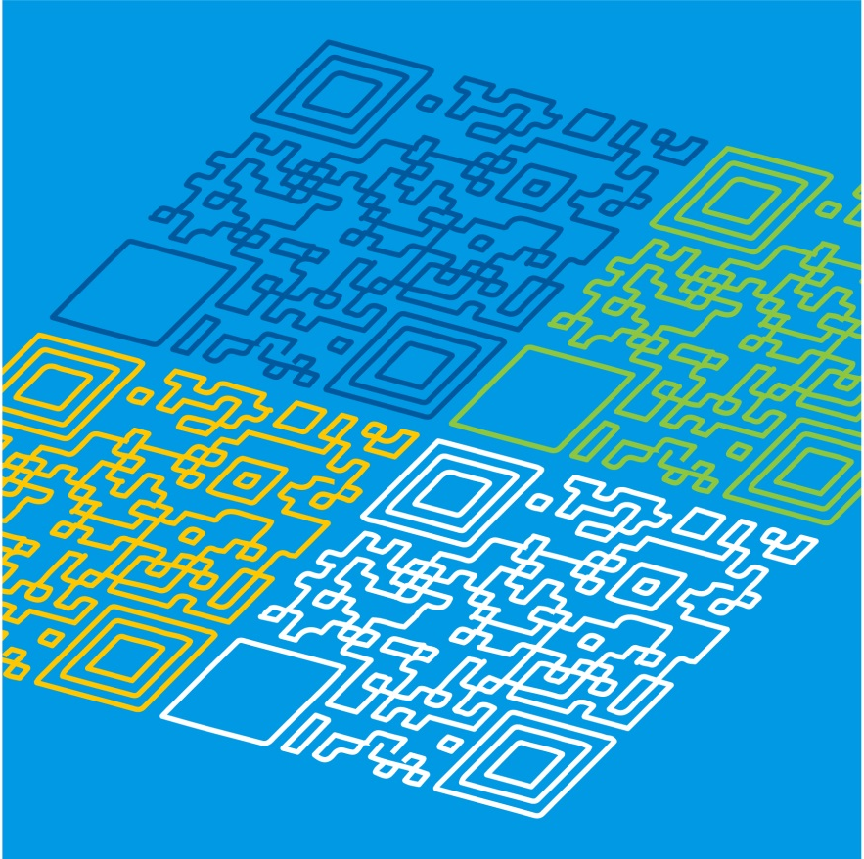
UNPACKING THE CONTENT DESCRIPTIONS
PLEASE NOTE:
This pack does not contain all content descriptions for Level 3-4, but can be used as a guide to develop your own lesson plans
Digital Technologies: Unpacking the Content Descriptions

Strand | Digital Systems |  | Sample activities
Content Description | Explore a range of digital systems with peripheral devices for different purposes, and transmit different types of data |  | - introduce and discuss the term peripheral devices, identifying the difference between input and output devices  - creating a table of known peripheral devices, their uses and what data each transmits or receives through input and output  - discussing and identifying how different users have different needs and require different peripheral devices  - creating a table of how and where different types of data are stored, for example computer memory (hard drive), USB, server and cloud  - identifying different types of data (text, images, video, sounds) that can be transmitted by different peripheral devices  - selecting and using an appropriate peripheral device to perform a task and explaining the reasoning for selecting that device, for example a student explaining why they chose a digital camera to take a photo rather than using the camera on a tablet
Related extract from Achievement Standard | Students describe how a range of digital systems and their peripheral devices can be used for different purposes.
Suggested focus | Lessons may focus on:  - purpose of a peripheral device, for example a digital camera or a printer  - peripheral devices performing input and output functions  - storing data on digital system components and peripheral devices  - transmitting different types of data to and from peripheral devices

Digital Technologies: Unpacking the Content Descriptions
Strand | Creating Digital Solutions |  | Sample activities
Content Description | Define simple problems, and describe and follow a sequence of steps and decisions involving branching and user input (algorithms) needed to solve them |  | - exploring examples of algorithms and step-by-step sequences  - creating a sequence of steps used to solve a problem using text, images or symbols  - giving another student a set of instructions involving some decisions (yes or no conditions) to follow  - defining algorithms in terms of input, processing and output  - describing decisions involving branching in an algorithm based on a condition (user input) and explain what happens if the condition is met or if the condition is not met  - writing algorithms and testing them to ensure they function as anticipated
Related extract from Achievement Standard | Students define simple problems, and design and develop digital solutions using algorithms that involve decision-making and user input.
Suggested focus | Lessons may focus on:  - identifying simple problems and describing steps  - user interaction with algorithms  - creating simple algorithms as text  - creating simple algorithms representing them diagrammatically  - making decisions involving branching  - testing algorithms for accuracy

Digital Technologies: Unpacking the Content Descriptions
Strand | Creating Digital Solutions |  | Sample activities
Content Description | Develop simple solutions as visual programs |  | - introducing the class to Scratch (available on eduSTAR) or another visual programming language  - comparing similar blocks of code from different visual programming languages  - creating a program to move an object around the screen in response to user input  - creating a simple program to accept user input and display it as output to the user  - creating a simple program to create a response of true or false to a question  - creating a simple arcade game incorporating keyboard controls by using ‘if’ blocks  - creating a simple program to respond to a user clicking on sprites  - programming a robotic device to move around the classroom and respond appropriately to different situations, such as detecting an object
Related extract from Achievement Standard | Students define simple problems, and design and develop digital solutions using algorithms that involve decision-making and user input.
Suggested focus | Lessons may focus on:  - introduction to visual programming languages and what they are  - creating blocks of instructions  - investigating user interfaces and why they are important  - explaining how programs make decisions following different paths based on decisions  - using a simple algorithm to create a program in a visual programming language  - using a visual programming language to program a simple robotic device that could respond to collisions or obstacles  - investigating decision making and user input in a visual programming language

Digital Technologies: Unpacking the Content Descriptions
Strand | Data and Information |  | Sample activities
Content Description | Collect, access and present different types of data using simple software to create information and solve problems |  | - collecting and recording student data, for example student favourite colour, student eye colour, local car traffic, getting to school and rubbish free lunches  - sorting data, for example birthdays, game scores, spelling results  - conducting a class survey and recording results by converting numbers to fractions or decimals  - performing calculations with data involving adding, subtracting and multiplying  - using a calculator or a spreadsheet to convert a numeric result to a decimal or a percentage  - formatting tables to make data sets easier to read and interpret  - using different charts or graphs to present data in different ways  - using sensors to collect environmental data, for example temperature, light levels, noise in the classroom  - using a spreadsheet to create charts or graphs using data in tables  - analysing data to draw conclusions, for example the most common method for students in a class to get to school
Related extract from Achievement Standard | They collect and manipulate different data when creating information and digital solutions.
Suggested focus | Lessons may focus on:  - looking at different data types and sources of data  - considering how information is presented for different audiences  - formatting data  - collecting, calculating and sorting data (including tables and lists)  - presenting data by creating charts or graphs  interpreting data and drawing conclusions to solve problems

