DIGITAL TECHNOLOGIES:
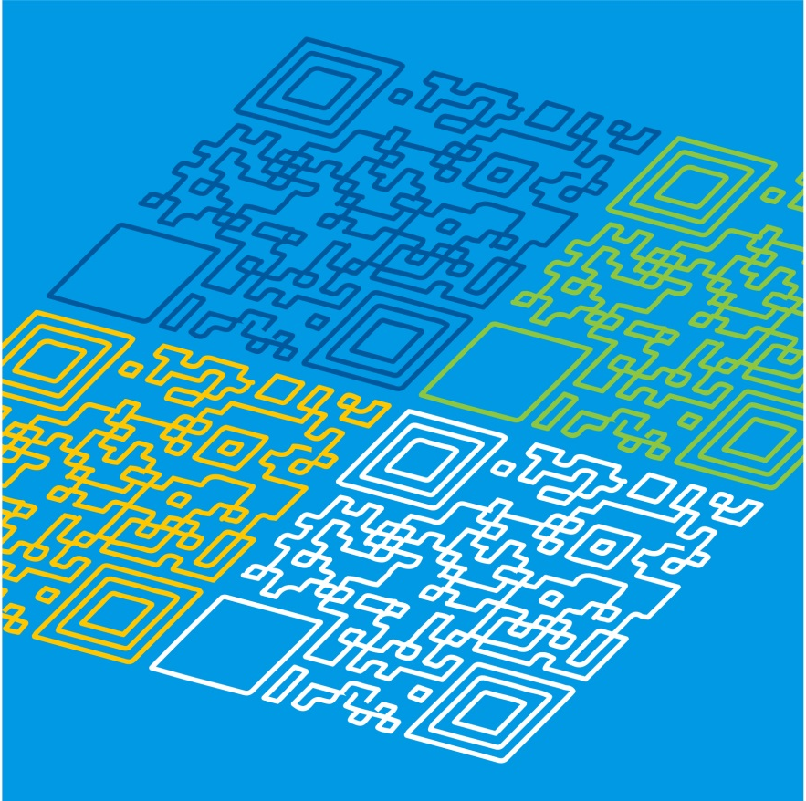
UNPACKING THE CONTENT DESCRIPTIONS
PLEASE NOTE:
This pack does not contain all content descriptions for Levels 5 and 6, but can be used as a guide to develop your own lesson plans
Digital Technologies: Unpacking the Content Descriptions

Strand | Creating Digital Solutions |  | Sample activities
Content Description | Design a user interface for a digital system, generating and considering alternative design ideas |  | - explore commonly used websites/games on a variety of devices with differently sized screens  - attempting to use a web resource or app with one hand and discussing the positive and negative experiences  - gathering information about different types of menu layouts and navigation from games, apps and websites  - highlighting layout differences such as horizontal, vertical, sidebar and visibility differences, such as dropdown lists and submenus  - explore options for games and websites to be inclusive regardless of the language spoken by the user
Related extract from Achievement Standard | They incorporate decision-making, repetition and user interface design into their designs and develop their digital solutions, including a visual program.
Suggested focus | Lessons may focus on:  - investigating a range of websites with different menu layouts, fonts and colours  - investigating the layout of a variety of games on a touchscreen  - exploring the same games and websites on a variety of devices with different-sized screens and methods of providing input, such as mouse or touch-screens  - investigating design requirements  - tools used to design user interfaces  - creating simple storyboards or mock-ups representing design of user interfaces  - developing alternative design ideas with annotated designs

Digital Technologies: Unpacking the Content Descriptions
Strand | Creating Digital Solutions |  | Sample activities
Content Description | Explain how student-developed solutions and existing information systems meet current and future community and sustainability needs |  | - incorporating an energy saving function in an information system, for example to turn a device off when not in use  - evaluate the cost of producing common digital devices and the impact on the environment  - conduct an energy survey of the amount of power consumed by the school to run school-provided equipment and make recommendations to the school leadership to reduce them  - investigate different countries across the world to find out the restrictions in place, if any, regarding access to typical social media and/or browsing sites  - devise a test of the school’s servers to determine how much energy is required to keep the school’s information secure  - compare the economic, environmental and social impacts of shopping in a store and shopping online
Related extract from Achievement Standard | Students explain how information systems and their developed solutions meet current and future needs taking sustainability into account.
Suggested focus | Lessons may focus on:  - developing criteria to explain how a student-developed solution meets current and future needs  - developing criteria to explain how a student-developed solution meets requirements  - understanding how people interact with touch systems, for example touch input devices require less dexterity and are designed to be accessible through the use of icons  - understanding how information systems are developed to meet a community need in terms of economic, environmental and social sustainability  - exploring how ethics and management practices impact on the use of communication networks  - understanding sustainability when considering various practices to save resources when using information systems

Digital Technologies: Unpacking the Content Descriptions
Strand | Data and Information |  | Sample activities
Content Description | Examine how whole numbers are used as the basis for representing all types of data in digital systems |  | - investigate the use of binary  - how binary relates to the control of digital devices  - exploring binary numbers  - representing decimal numbers and converting decimal to binary  - patterns in binary when counting  - representing letters in binary then moving onto words and phrases  - representing other types of data, for example on/off pictures in binary  - identifying common digital systems/devices that use binary
Related extract from Achievement Standard | Students explain how digital systems use whole numbers as a basis for representing a variety of data types.
Suggested focus | Lessons may focus on:  - understanding binary as two states, for example on or off and voltage or no voltage  - comparing number systems with different bases, for example binary and decimal  - representing numbers and text as binary  - purpose of binary numbers  - how binary is used to store and transmit different types of data

