Differentiating existing learning sequences for English as an Additional Language students

Mathematics, Level 5, for EAL learners at Level B3
Existing learning sequences linked to particular learning areas in the Victorian Curriculum F–10 can be adapted to support differentiated teaching for English as an Additional Language (EAL) students. Teachers can adapt, remove or add to elements of their learning sequences in order to cater for all students in their classrooms.

1. Identify an existing learning sequence
Existing learning sequence: Take a (random) walk – Computational and algorithmic thinking in Mathematics
Curriculum area and levels: Mathematics, Level 5

2. Identify the level of language learning of your students
The EAL curriculum is a continuum structured as three EAL pathways (A, B, C). Each pathway describes a different stage of English-language learning (early, mid and late), and each pathway is divided into different levels of language learning (A1, A2, BL, B1, B2, B3, CL, C1, C2, C3, C4).
While the implementation of the EAL curriculum is the responsibility of all teachers, the EAL specialist plays a leading role in its delivery, as the expert in the field. Your EAL specialist will determine the most appropriate pathway for each EAL learner in your classroom and advise you of their current level of learning.
The differentiation suggestions provided in this document are for students working at Level B3 of the EAL curriculum.
EAL learners at Level B3 will typically be able to:
- understand the essential meaning of unfamiliar topics expressed in familiar spoken English, and extract specific information
- use accessible English dictionaries to check the meanings of new words
- respond to a sequence of instructions
- use a range of key vocabulary appropriately.

3. Adapt the learning sequence to differentiate for EAL students
Existing learning sequence | Differentiated teaching for EAL learners at Level B3
Overview | Overview
Learning intentions:  - Students will link the probability outcomes when rolling a die or flipping a coin to outcomes in a simulation  - Students will describe the process of a random walk  - Students will use technology to simulate a random walk (optional)  - Students will explain the application of random walks in the world around them (extension) | Learning intentions:  - Students will use language effectively to link the probability outcomes when rolling a die or flipping a coin to outcomes in a simulation  - Students will use language effectively to describe the process of a random walk  - Students will use language effectively to use technology to simulate a random walk (optional)
Relevant content descriptions in Mathematics, Level 5:  Follow a mathematical algorithm involving branching and repetition (iteration) (VCMNA194) | Additional EAL Level B3 content descriptions:  Understand a new topic delivered with extensive contextual and teacher support (VCEALC406)  Make own translation of specific words and help other home language speakers to check context or match concepts (VCEALA411)  Respond to a sequence of instructions (VCEALL420)  Identify unfamiliar cultural references (VCEALA433)  Use an accessible English dictionary to check the meaning of new words, and/or check meanings in a home language–English bilingual dictionary (VCEALA436)
Relevant achievement standard:  Students solve simple problems involving the four operations using a range of strategies including digital technology. They estimate to check the reasonableness of answers … | Relevant achievement standard:  At Level B3 students … understand the essential meaning of unfamiliar topics expressed in familiar spoken English, and extract specific information … They use accessible English dictionaries to check the meanings of new words …

Existing learning sequence | Differentiated teaching for EAL learners at Level B3
Teaching and learning activities | Teaching and learning activities  Differentiated teaching is required to support EAL learners with the following learning activities.
Activity 1: Walk the plank (in the classroom)  This activity is great for kinaesthetic learning. Each student will need a coin to flip.  Students complete this activity in the classroom.  - Mark a line with masking tape down the middle of the classroom. Have one wall in front represent the safety of the pirate ship and the wall behind represent the sea full of sharks.  - Students start on the line and take one step forward or one step backwards as they flip a coin (heads = forward, tails = backwards).  - Students sit down when they reach either safety or sea.  This experiential activity demonstrates where students end up and, as the activity progresses, how their random coin flips place them all in different positions. You might like to have students standing up at each end of the room so they can see the distribution of outcomes (no need for a class tally or graph).  Discussion prompts:  - Does this look like the outcome you predicted?  - Why do you think it does or doesn’t?  - What do you think would happen if you continued this simulation for longer (more trials)? What would the graph look like then? | Activity 1: Walk the plank (in the classroom)  Use Activity 1 as an engaging way to model a simple random walk and teach the skills and knowledge that students need to do more advanced random walks in Activities 2 and 3.  See Appendix 1 – Vocabulary reference table for a helpful vocabulary table that you can refer to and add to throughout the learning activities. You may need to pre-teach some of this vocabulary to students.  Pre-teach the words ‘pirate’, ‘ship’, ‘sharks’ and ‘sea’ by showing the following visuals and eliciting students’ responses to the following questions.  Encourage the use of bilingual dictionaries and ask students to write down the words in English and their meanings in their home languages in their books.  Teacher: Who is this?  Students: A pirate.  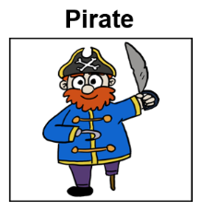  Teacher: Do you know any pirates? What do they do?  Students: They steal from other ships.  Teacher: Where does a pirate live?  Students: On a pirate ship.  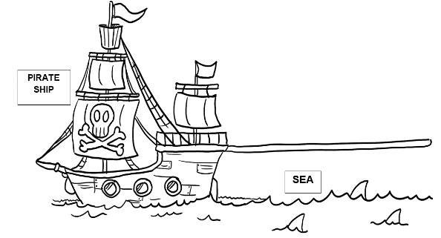  Teacher: Where can you find a pirate ship?  Students: In the sea.  Teacher: What can you see in the sea there?  Students: Sharks.  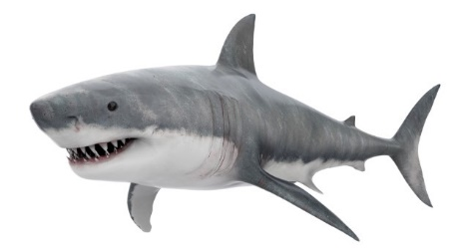  Teacher: Yes, sharks are dangerous and scary. People can get eaten by sharks.  Prepare the room:  - Mark a line with masking tape down the middle of the classroom.  - Stick a picture of the pirate ship with the word ‘Safety’ on one wall in front.  - Stick a picture of the sea full of sharks with the word ‘Danger’ on the wall behind (see visuals below).  - While sticking the pictures on the wall, explain the words ‘safety’ and ‘danger’: For example:  - When you reach the sea, you are in danger; you can be eaten by sharks, or you can drown in the sea. When you reach the ship, you are safe; there is no danger for a pirate in the ship.  To reinforce understanding, encourage EAL students to use bilingual dictionaries and turn to a peer from the same home language background to discuss these concepts.  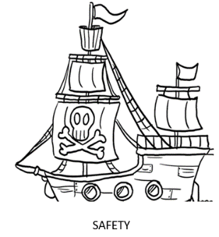  Ask all students to stand at the line and face the picture of the ship. Give each student a die and explain the word ‘die’. Use the board to explain that the word has different meanings. You could start with asking students:  - Does anyone know what the word ‘die’ means?  Students (or you) may say, for example:  - When someone dies, they stop living. Their body can’t breathe and move anymore …  Explain that in this activity, the word ‘die’ has a different meaning. It means the object in their hand (showing a die to the whole class). Explain that they may have heard this object referred to as a ‘dice’; however, dice is the plural form and die is singular.  Model ‘roll a die’ and explain the movement rules using the visual below. Model some movements.  Roll a 2, 4 or 6 (even numbers). Move one step forward to the ship.  Roll a 1, 3 or 5 (odd numbers). Move one step backwards to the sea.  Once students are familiar with rolling and moving, start the activity. Use the oral instructions ‘Roll’ and ‘Move' and give students 30 seconds to finish each roll and move. Monitor the activity and provide prompts where necessary. For example:  - What number was that? So which way are you moving? That’s right.  Ask students to sit down once they reach either wall and wait for others to reach the walls.  After all students have reached one wall or the other, ask everyone to stand up. Ask a student to count the number of students on each end before starting the whole-class discussion below, eliciting answers to each question from several students.  Discussion prompts:  - Does this look like the place you wanted to be?  - Why do you think it does or does not?  - Roll the die one more time. What happens? (Students either stand still or move back a step closer to the line.)  Explain the concept of ‘random walk’ by referring to the activity students just did. For example:  Teacher: Were you able to predict which direction you would move?  Students: No.  Teacher: Why couldn’t you predict your movement?  Students: Because it depended on the rolling of the die.  Tell students that this is an example of a ‘random walk’ because the movement follows steps that are decided by the rolling of a die.
Activity 2: Walk the plank (on the number line)  Students work in groups of two or three.  Provide students with Appendix 3 – Random walk the plank printed resource.  Students start with a Pirate Pete counter at number 5 on their number line plank. This is the middle of the plank. They will carry out a random walk by rolling a die. Depending on the outcome of the walk, Pirate Pete will move backwards along the plank to the safety of the pirate ship or walk off the plank to be eaten by sharks.  The first random walk will use a random number generator with an equal probability of Pirate Pete moving from his starting point and travelling left or right. Students use the die to determine each step Pirate Pete takes.  Students use the following instructions:  Outcome Movement  Roll a 2, 4 or 6 (even numbers). Take one step to the right.  Roll a 1, 3 or 5 (odd numbers). Take one step to the left. | Activity 2: Walk the plank (on the number line)  Use Activity 2 to provide an opportunity to practise a random walk on a number line in small groups.  Divide the class into pairs.  Give each pair Appendix 3 – Random walk the plank in A3 paper size. This resource includes a Pirate Pete counter for printing.  Tip: Where possible, pair two students with the same home language and encourage the use of home languages in the pair work.  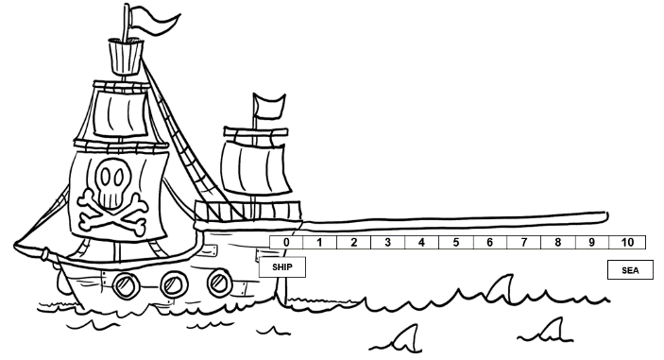  Model placing Pirate Pete on number 5 on the number line plank using the two resources above (see Appendix 3). Ask groups to do the same with the resources they have been given. Remind the students of the rules discussed in the previous activity, in both oral and print forms:  - Ship = Safety  - Sea = Danger  Show and explain the following rules. You can model rolling a die and moving Pirate Pete on the number line plank according to the outcome of your roll. Ask a volunteer to roll the die and another student to move the pirate, to reinforce students’ understanding of the rules.  Roll a 2, 4 or 6 (even numbers). Move one step towards the sea.  Roll a 1, 3 or 5 (odd numbers). Move one step towards the ship.  Ask students to discuss in their pairs, then elicit some answers:  - How many pirates in the classroom will get to safety?  - How many will be eaten by sharks?  - Will these numbers be equal? Why?  Ask students in pairs to take turns rolling the die and moving the pirate along the number line plank. Ask them shout out when their group reaches either 0 (ship) or 10 (sea).  During this time, you can monitor and provide feedback, such as when a student makes an incorrect movement.  At the end of the activity, ask each pair whether their pirate has reached the ship or the sea. As you do this, model tallying using the following table on the board or screen:  Ship tally Sea tally  |||  Total: 8 Total: 5  Teach the words ‘tally’, ‘trial’ and ‘simulation’ by using the definitions below (and bilingual dictionaries if necessary) and referring to the activity the class has just done.  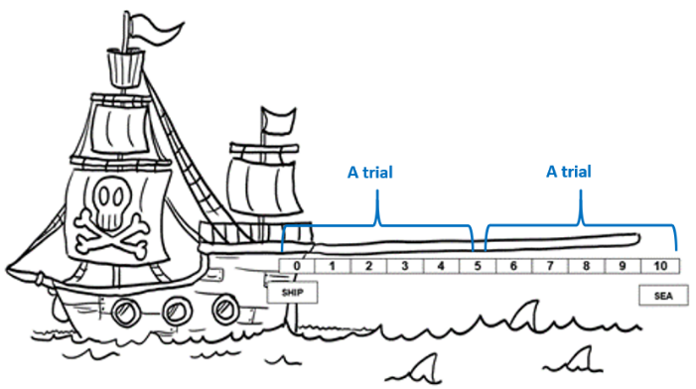  - Trial: each time the pirate reaches the ship or the sea. You could illustrate this on the number line plank as follows:  - Tally: a count of the number of trials, such as the number of times the pirate reaches the ship or the number of times he reaches the sea. Refer to the tally done earlier on the board or screen:  Ship tally Sea tally  |||  Total: 8 Total: 5  - Simulation: the whole activity from the first die roll to the last movement. There can be a number of trials in a simulation.  Start a whole-class discussion following the prompts below. Elicit several answers for each question.  - Did the pirate reach the place you wanted?  - Why do you think he did or did not?  - Roll the die one more time. What happens? (The pirate either stands still or moves back a step closer to number 5.)  Explore the idea that with additional trials, the tallies for ship and sea would be closer to equal.
Activity 3: Random walk on a grid  In this activity, students help Pirate Pete find treasure he buried on Iteration Island. He has forgotten where he buried it, but he left a map!  Students will follow a similar algorithm for generating the random walk as in Activity 2, but this time in two dimensions on triangular grid paper (see Appendix 2). This is Pirate Pete’s treasure map. There are a number of ‘X’ marks on the grid where Pirate Pete hid treasure.  Students can work on this activity individually. To move, each student needs to roll a die and then refer to the compass in the top corner of the grid paper (see below).  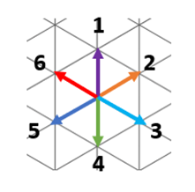  Ask the students to follow these instructions:  - Choose one colour to draw with.  - Start your journey at the black dot in the middle of the page.  - Roll the die.  - Move one length in the direction that corresponds to the die outcome.  - Sometimes, you may move back over existing parts of the path. That’s okay.  - If you reach the edge of the paper, keep rolling until you can move back on the grid again.  - Every 10 steps, change colour so you can keep track of how the random walk develops.  After an allocated time, see if any students found treasure. They might like to keep track of how many steps it took them to find the treasure.  An example random walk on the triangular grid is shown below. It took 41 steps to find an X on the grid in this walk. Every 10 steps, the colour was changed.  Discussion prompts (small groups or whole class):  - What does this random walk look like? Is there any pattern to it? Why or why not?  - In a random walk, do you move more often in any one direction? Why or why not?  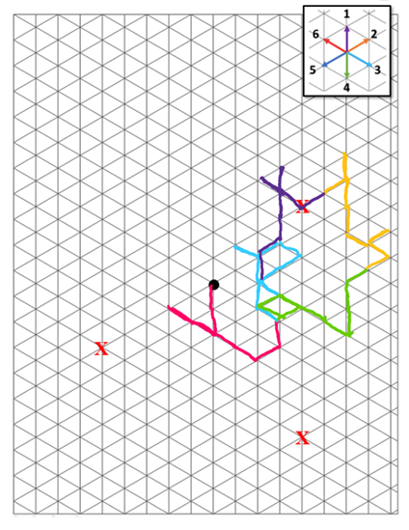 | Activity 3: Random walk on a grid  Show the word ‘pirate’ together with the picture below on the board and ask students: ‘Who remembers what this word means?’ Ask them to refer to the notes from the earlier activity and a bilingual dictionary if necessary.  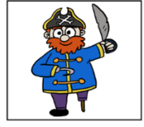  pirate  Show the word ‘treasure’ with its illustration below. Ask students: ‘What does treasure mean?’ (a collection of valuable objects such as gold and gems). Allow them to use a bilingual dictionary to check meaning if necessary and ask them to explain in their home language to a peer sharing the language, if possible.  treasure  Ask students to find an example of a map on their device or in the classroom and show it to the class. Check that students understand the word and have correct examples. Show an example of a map and tell students that pirates use a map to find their treasure.  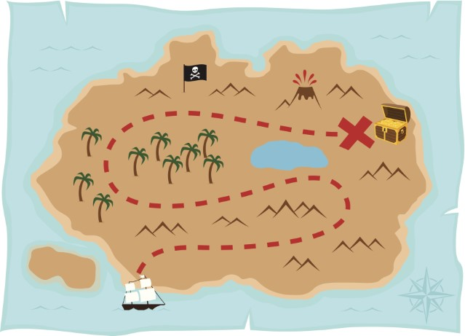  map  Tip: This is an opportunity for students from a range of linguistic and cultural backgrounds to relate the lesson to books, graphic novels or movies about pirates and treasure in their home languages.  Introduce Pirate Pete’s treasure map, below (see Appendix 2). Tell students that there are a number of ‘X’ marks on the map where Pirate Pete hid treasure. You may need to write the word ‘hid’ on the board and explain it. You can do this by hiding a pen under a book and saying, ‘I hid the pen under the book. Can you see the pen now?’  Draw students’ attention to the compass at the top of the map. Ask students if they know what it is. Show them the following short video to reinforce their understanding of the word ‘compass’:  - How To Find Directions Using A Compass Needle? (The Tomorrow Beckons, YouTube)  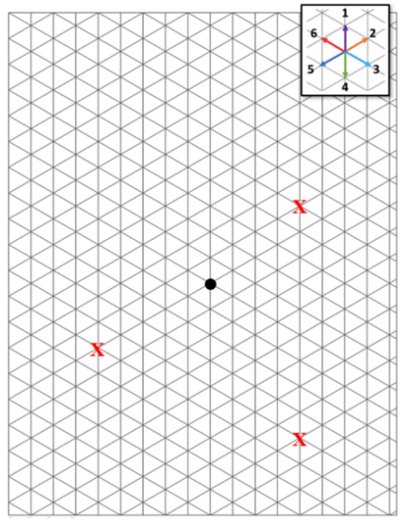  Stick an A3 copy of the map above (see Appendix 2) in front of the class. Show the following instructions on the board or screen and explain verbally:  - Choose one colour to draw with.  - Start your journey at the black dot in the middle of the page.  - Roll the die.  - Move one length in the direction that corresponds to the die outcome.  - Sometimes, you may move back. That’s okay.  - If you reach the edge (end) of the paper, keep rolling until you can move back on the map again.  - Every 10 steps, change colour so you can see how the random walk develops.  - When you find the treasure, count the number of steps and say ‘Found’.  As you explain the first four steps of the instructions, model placing the pirate on the black dot on the map. Roll a die, then draw students’ attention to the compass on top of the map (see below) to decide which way to move the pirate. For example, if your die outcome is 4, model finding number 4 on the compass and move the pirate in the direction of the green arrow. Model using a pen to draw a line according to the movement.  Roll the die one more time, tell students what number you got and ask: ‘Which way should I move the pirate?’ Then, model moving the pirate and drawing a line according to a correct response from students.  Show an example of a finished random walk below:  Give each student an A4 printed copy of the map (Appendix 2) and a die. Give them a duration (for example, five minutes) to complete the activity.  Monitor students and provide feedback during the activity:  - What number have you got on the die?  - Which way does the compass tell you to move? Can you draw a line there? Good work!  - Is that the right way to move for number 6? Are you sure? Look at the compass again. That’s it! Well done!  After time is up, hold a class discussion. Ask students:  - What does your random walk look like?  - Do you move more often in any one direction?  Why or why not?  At this point, you could introduce the concept of ‘pattern’ by pointing to repeated directions on some of the students’ maps.

Additional resources
You can access the EAL curriculum on the Victorian Curriculum F–10 website.
You can access a range of resources to assist with implementing the EAL curriculum on the VCAA English as an Additional Language webpage, including profiles of EAL learners, sample progressions through the EAL pathways, a language and learning interview, FAQs, professional learning opportunities and links to external resources.

Appendices

Appendix 1 – Vocabulary reference table
Content-specific vocabulary | Linguistic-specific vocabulary  (verbs of instruction) | Language for interaction | Language for clarification
pirate  pirate ship  sharks  sea  safety  danger  die  random walk  tally  trial  simulation  treasure  map  pattern | Place …  Roll …  Move …  Draw …  Discuss … | First you …  Then …  Okay, now you have to … | Can you say that again, please?  What was the step again?  I don’t understand.

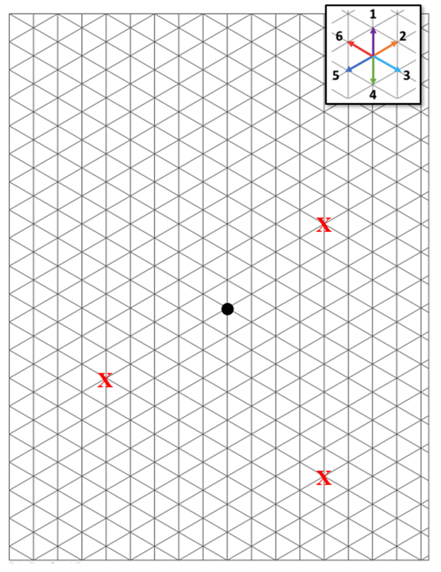
Appendix 2 – Triangular grid for a random walk

Appendix 3 – Random walk the plank
- Start Pirate Pete on the number 5.
- Flip a coin. Heads, Pete moves one space right. Tails, Pete moves one space left. Repeat until Pete
reaches either the number 1 or 10.
- Pirate Pete is safe when he reaches the ship and lands on number 1.
- Pirate Pete falls in the sea when he lands on number 10. Oh dear! Poor Pirate Pete!

0 | 1 | 2 | 3 | 4 | 5 | 6 | 7 | 8 | 9 | 10

SHIP
SEA

