Differentiating existing learning sequences for English as an Additional Language students

Health and Physical Education, Levels 1 and 2, for EAL learners at Level A2
Existing learning sequences linked to particular learning areas in the Victorian Curriculum F–10 can be adapted to support differentiated teaching for English as an Additional Language (EAL) students. Teachers can adapt, remove or add to elements of their learning sequences in order to cater for all students in their classrooms.

1. Identify an existing learning sequence
Existing learning sequence: Day at the beach
Curriculum area and levels: Health and Physical Education, Levels 1 and 2

2. Identify the level of language learning of your students
The EAL curriculum is a continuum structured as three EAL pathways (A, B, C). Each pathway describes a different stage of English-language learning (early, mid and late), and each pathway is divided into different levels of language learning (A1, A2, BL, B1, B2, B3, CL, C1, C2, C3, C4).
While the implementation of the EAL curriculum is the responsibility of all teachers, the EAL specialist plays a leading role in its delivery, as the expert in the field. Your EAL specialist will determine the most appropriate pathway for each EAL learner in your classroom and advise you of their current level of learning.
The differentiation suggestions provided in this document are for students working at Level A2 of the EAL curriculum.
EAL learners at Level A2 will typically be able to:
- express ideas and understand key information about familiar topics
- express ideas and understand key information about new topics when supported by visuals and modelling of new language
- construct simple and coherent sentences using formulas, basic structures and well-known vocabulary, as well as attempting to construct some original sentences with varying accuracy
- sustain communication by turn-taking and asking for clarification from teacher or peers.

3. Adapt the learning sequence to differentiate for EAL students
Existing learning sequence | Differentiated teaching for EAL learners at Level A2
Overview | Overview
Learning intentions:  - Students will know how to warm up before doing physical activity  - Students will be able to imagine what they can do for fun when they go to the beach  - Students will be able to imagine what they can do to be safe when they are at the beach  - Students will understand how they can use their body to help them when they are surfing | Learning intentions:  - Students will know how to warm up before doing physical activity  - Students will be able to imagine what they can do for fun when they go to the beach  - Students will know what they need to do to be safe when they are at the beach  - Students will understand how they can use their body to help them when they are surfing  Language focus:  - Students will learn, understand and use a range of active verbs
Relevant content descriptions in Health and Physical Education, Levels 1 and 2:  Perform fundamental movement skills in different movement situations in indoor, outdoor and aquatic settings (VCHPEM080)  Construct and perform imaginative and original movement sequences in response to stimuli (VCHPEM081)  Incorporate elements of effort, space, time, objects and people in performing simple movement sequences (VCHPEM084) | Additional EAL Level A2 content descriptions:  Respond appropriately in a range of common social and classroom situations (VCEALC084)  Follow a short sequence of instructions related to classroom procedures or learning activities (VCEALC088)  Construct a small range of sentence forms (VCEALL101)  Identify key words and ideas from short, familiar spoken texts supported by context (VCEALL107)  Repeat or modify a sentence or phrase, modelling rhythm, intonation and pronunciation on the speech of others (VCEALL109)
Relevant achievement standard:  By the end of Level 2, students … demonstrate fundamental movement skills in different movement situations … They perform movement sequences that incorporate the elements of movement. | Relevant achievement standard:  At Level A2 students … express ideas and identify key points of information in classroom discussions about … new topics when they are well supported by visual material, an appropriate pace of delivery, and discussion that links their prior knowledge to the new context. They follow a short sequence of instructions … [and] negotiate familiar social and learning situations, using English appropriate to the situation.

Existing learning sequence | Differentiated teaching for EAL learners at Level A2
Teaching and learning activities | Teaching and learning activities  Differentiated teaching is required to support EAL learners with the following learning activities.
Activity 1: Warm-up  Conduct an activity to enable students to warm up and prepare their bodies and minds for their dance. For example, play music with a strong beat and guide students through a series of movements in time with the beat. Call out movements, such as eight counts of:  - marching on the spot  - marching eight steps forwards  - swinging arms backwards and forwards while standing still, followed by swinging arms while sitting with legs extended  - twisting their bodies halfway round and back again while their feet remain in the same place on the floor, using a focus point to assist in maintaining balance  - marching on the spot while swinging their arms  - jumping up and down on the spot lightly, followed by jumping with more force.  Encourage students to complete the actions in time with the music; this could include assisting the students by counting the beat. The movements can be completed individually or paired, for example marching on the spot for eight counts and then marching forwards eight counts. | Activity 1: Warm-up  Tip: The language focus of this sequence is action verbs. Note how the action verbs are explicitly taught alongside the actions in these activities.  See Appendix 1 – Vocabulary reference table for a helpful vocabulary table that you can refer to and add to throughout the learning activities. You may need to pre-teach some of this vocabulary to students.  When introducing vocabulary to EAL learners, it can be helpful to focus on one word at a time, and to slowly build up meaning by adding additional elements. This way, EAL learners can practise and process one element before moving on to the next. For example:  Swing! × 4 >  Swing your arms! × 4 >  Swing your arms backwards and forwards! × 4 > Swing your arms around! × 4  Pre-teach the vocabulary for each of the movements in the warm-up. Focus on one word and one action at a time.  - Teacher states the action. For example, ‘March!’  - Teacher or student demonstrates the action.  - Encourage the group to repeat the action eight times while repeating the name of the action in unison. For example, ‘March, march, march, march, 1, 2, 3, 4!’  - Instruct students to march with added direction, and demonstrate the movement. Have students complete the action eight times and repeat the name of the movement in unison. For example:  March on the spot! March, march, march, march, 1, 2, 3, 4. March forwards! March, march, march, march, 1, 2, 3, 4. March backwards! March, march, march, march, 1, 2, 3, 4. March around! March, march, march, march, 1, 2, 3, 4.  Tip: Initially encouraging students to repeat in unison can help reluctant speakers to practise before having to voice the words or phrases independently.  - Repeat for each action in the warm-up. For example, ‘swing’ (your arms – backwards and forwards, around), ‘twist’ (your body – around) and ‘jump’ (on the spot, backwards, forwards, around).  Tip: Students are more likely to retain new vocabulary if there is an action associated with the word, and if they are given the opportunity to repeat both the word and the action several times.  Once the vocabulary for the actions and the directions have been taught, play the music and guide students through the movements in time with the beat. EAL learners at Level A2 will be able to count the movements as instructed.  Call out movements, such as eight counts of:  - marching on the spot  - marching eight steps forwards  - swinging arms backwards and forwards while standing still, followed by swinging arms while sitting with legs extended  - twisting their bodies halfway round and back again while their feet remain in the same place on the floor, using a focus point to assist in maintaining balance  - marching on the spot while swinging their arms  - jumping up and down on the spot lightly, followed by jumping with more force.
Activity 2: Introduction to the beach  Tip: Check first with students to find out how many students have experienced visiting the beach.  Read one of the recommended texts (See You Next Year, Goose at the Beach, Magic Beach – see Resources) or another age-appropriate story about a day at the beach to students. | Activity 2: Introduction to the beach  Tip: Provide relevant visuals (such as photographs, sketches, graphic organisers, diagrams, videos, 3D models and/or real objects) to set the context at the beginning of the lesson. This helps EAL learners make sense of what is being taught in the curriculum. In this activity, examples of real objects could include sunscreen, a towel, rash vest, bathers and surfboard.  Read one of these recommended texts: See You Next Year, Goose at the Beach, Magic Beach, or another age-appropriate story about a day at the beach to students.  Show the cover of the book and ask: ‘What do you think the story is going to be about?’ (the beach). Ask: ‘Who has ever been to the beach?’  Tip: Check first with students to find out how many students have experienced visiting the beach.  Use the story and the real-life objects to teach new vocabulary by pointing at each word and its associated picture in the storybook to make the connection clear. For example: ‘sand’, ‘umbrella’, ‘beach towel’, ‘beach chair’, ‘sun’, ‘sunscreen’, ‘wave’, ‘bathers’, ‘lifesaver’, ‘flags’, ‘surfer’, ‘surfboard’, ‘sunburn’, ‘seagull’, ‘sandcastle’, ‘rockpool’.  Tip: When introducing new vocabulary, it is important to make sure that students:  - clearly hear the word spoken aloud  - are given the opportunity to repeat it in unison  - see it written down  - repeat it aloud again  - consolidate learning of the new word by using it in speech or writing.  Consolidate new vocabulary through completing a labelling and/or matching activity. Have EAL learners use the words in the vocabulary list and other online resources (such as Google Images) to complete the labelling task. See Appendix 2.  Other images and printable worksheets can be found at:  - Vocabulary: At the beach 321 (Learn English)  - Beach Scene Writing Stimulus Picture Worksheet (Twinkl)  Tip: EAL learners may like to share some of the equivalent words in their home languages. Their non-EAL peers can try to pronounce the words correctly and use them later in the lesson. Allowing EAL learners to share aspects of their home language can foster the curiosity and interest of others in the classroom. It can help develop a respect for and value of other languages and experiences. It can also help to create empathy and understanding for those who are learning a new language.  Encourage students to keep an ongoing vocabulary list that can be built upon each lesson. Definitions of the new words can take many forms, including hand-drawn images, a translation from their home language, synonyms and labelled diagrams.
Have students close their eyes and imagine what fun things they might do on a day’s outing to the beach. Have students share their ideas with a partner. | Use the visual from the labelling task to prompt answers to the simple question:  What can we do for fun at the beach?  Tip: As there is no pre-teaching of vocabulary for this activity, students will need to rely on existing vocabulary. This can give the teacher a good insight into pre-existing knowledge and the students’ ability to transfer vocabulary to different contexts.  Demonstrate how to use sentence stems to express ideas:  - Write the sentence stem on the board: We can …  - Read it aloud and elicit answers from students.  - Use a student’s answer to complete the written sentence on the board. Use a different colour to complete the sentence.  - Encourage EAL learners to create three sentences using this sentence stem. Allow learners time to think about their sentences independently before sharing them with a partner. For example:  We can … [swim in the sea, play cricket, read a book, listen to music …]
Ask students to imagine that they have just arrived at the beach. Use a variety of question stems (‘what’, ‘how’, ‘when’, ‘why’) to develop a class discussion around what might happen first, before they can do any of their planned activities. For example, students might set up their spot on the beach for the day by laying out their towel, chair, beach umbrella and any play equipment they are planning to use. Encourage responses around being safe and SunSmart, such as:  - always visit the beach with an adult  - check for warning signs  - swim between the flags  - protect yourself from the sun by putting on a hat, sunscreen and sunglasses.  Use these questions and discussion as stimulus for students to create their own movement sequence to show how they set up for their day at the beach, including the placement of equipment and how they apply SunSmart procedures.  Tip: It is important to remind students that the following activities are imaginary or pretend, and when actually visiting the beach they must always be with an adult, as safety around water is always of the highest priority. This activity provides an opportunity to explore or to revise key water safety and SunSmart messages related to visiting the beach.  Frolicking on the sand: Ask students think about how they like to play on the sand when they are visiting the beach. Allow students to discuss whether they like to build things with the sand, play sports on the sand or explore different ways to move on the sand, such as galloping, jumping or hopping from foot to foot. Encourage students to safely:  - explore how they would move on the sand during their day at the beach. They can experiment with different ways to move on the sand, such as running, skipping, sliding, twirling, leaping, hopping from one foot to the other  - explore galloping across the sand from their spot on the beach  - practise how they might perform the gallop movement so that only the balls of the feet touch the sand  - attempt a side gallop without kicking up too much sand.  Have students discuss the qualities of their movements and describe how they land lightly (balls of the feet, elevation, giving with the knees and ankles when landing).  Partner frolic: Have students choose a partner and work together to create a movement sequence that includes:  - moving from their beach towels to the sand  - frolicking in the sand together  - a side gallop with a light landing. | Ask students to imagine that they are at the beach. Have students create their own movement sequence to show three activities they can do for fun at the beach.  Tip: Classroom activities that involve play and movement can help EAL learners participate fully despite the limitations of language.  Provide the context by showing a teacher-selected video about beach safety. Ask the simple question:  What do we need to do to be safe at the beach?  Provide students with a sentence stem to use for this task, written on the board for reference: We need to … Read it aloud and elicit answers from students. Accompany each answer with an action and encourage students to copy the action. Have students repeat each action at least twice, with emphasis on correct pronunciation and intonation.  Encourage EAL learners to create three sentences using this sentence stem. Allow learners time to think about their sentences independently before sharing them with a partner.  For example:  What do we need to do to be safe at the beach?  We need to … [put on sunscreen, check the signs, swim between the flags, put on a hat, be with an adult, sit under the umbrella …]  Tip: Safety is important for all students, but particularly for EAL learners who may not have experienced the varied conditions of Australian beaches. This activity can used to reinforce water safety and SunSmart messages.  Ask students to imagine that they are at the beach. Have students create their own movement sequence to demonstrate three actions they can take to be safe at the beach.
Activity 3: Surf’s up!  Using a Y chart, ask students to describe what it might be like to ride a wave.  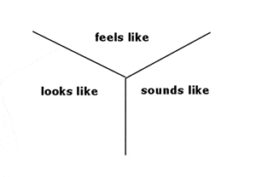  Riding a wave: Have students pretend they are having a surfing lesson on the beach. Ask students to:  - lie on their surfboard, boogie board or surf mat  - pretend to paddle using their arms  - explore how to push themselves into a crouch position on their pretend board or mat  - pretend to ride their board or mat.  Have students think about how their bodies move to keep their balance. Discuss and explore what part or parts of the body assist balance, such as feet, ankles, knees, torso and arms.  Ask each student to imagine that a big wave has come along while they are riding their surfboard or mat and they crumble down into the water. Have students explore safe ways to collapse or fold their body down.  Have students improvise their own sequence of movements to the following ideas:  - lie down on their beach towel  - collect their surfboard  - paddle out  - crouch down  - ride their surfboard  - collapse into the waves  - get back on their board  - paddle back to shore  - return to their beach towel. | Activity 3: Surf’s up!  Provide context for the task by showing a teacher-selected surfing video. Keep the video running (with the volume off) while students complete the task.  Repeat the process used to pre-teach new vocabulary in Activity 1: Warm-up. This time introduce the new vocabulary, including ‘lie down’, ‘paddle (out or back)’, ‘push up’, ‘crouch down’, ‘jump (on the spot/up)’, ‘ride’, ‘balance’, ‘fall down’, ‘get up’.  As in Activity 1, introduce and practise the action (and where appropriate, introduce the direction later as per the example below). Repeat the action aloud in unison and count as per warm up activity. For example:  Paddle! Paddle, paddle, paddle, paddle, 1, 2, 3, 4.  Paddle out! Paddle, paddle, paddle, paddle, 1, 2, 3, 4.  Paddle back! Paddle, paddle, paddle, paddle, 1, 2, 3, 4.  Lie down! 1, 2, 3, 4, 5, 6, 7, 8.  Push up! Push, push, push, push, 1, 2, 3, 4.  Crouch down! Couch, crouch, crouch, crouch, 1, 2, 3, 4.  Tip: Repeating the process of Activity 1: Warm-up gives EAL learners the chance to consolidate their learning and focus on the new vocabulary, rather than learning how to do a new task.  Demonstrate – or ask a student with surfing knowledge to demonstrate – how to surf, using real objects such as a beach towel and/or a cardboard surfboard. Demonstrate the sequence below while stating the action. Have students observe first, then copy the action while repeating the phrase. Note that action verbs are indicated in bold with a star (*).  First, lie down(*) on your beach towel.  Second, get(*) your surfboard.  Third, walk(*) to the water.  Then, paddle out(*).  Next, crouch down(*).  Ride(*) your surfboard.  Balance(*), balance, balance …  Oh no! Fall down(*) into the waves.  Get up(*)! Back on your board!  Paddle back(*).  Go(*) to your beach towel.  Tip: While EAL learners may only be able to form short sentences in this unfamiliar context, it can be helpful to provide them with words that can be used in different contexts and tasks (first, second, third, then, next) – so that students can begin to recognise them.  Have students work in pairs and take turns giving each other instructions using the new vocabulary as modelled above. Students at this level may only be able to use the verbs indicated above to give the instructions. Pair EAL students with non-EAL peers.

Additional resources
You can access the EAL curriculum on the Victorian Curriculum F–10 website.
You can access a range of resources to assist with implementing the EAL curriculum on the VCAA English as an Additional Language webpage, including profiles of EAL learners, sample progressions through the EAL pathways, a language and learning interview, FAQs, professional learning opportunities and links to external resources.

Appendices

Appendix 1 – Vocabulary reference table
Content-specific vocabulary | Linguistic-specific vocabulary  (verbs of instruction) | Language for interaction | Language for clarification
beach  sand  sea  ocean  umbrella  beach towel  beach chair  sun  cloud  sunscreen  rash vest (rashie)  water  wave  bathers  lifesaver  flags  rip  to swim  to surf  surfer  surfboard  sunburn  suntan  warning signs  seagull  sandcastle  rock pool  on the spot  forwards  backwards  around  out/in  up/down | March.  Swing.  Twist.  Jump.  Lie down.  Paddle.  Push.  Crouch down.  Ride.  Balance.  Fall down.  Get up.  Listen to me.  Say it after me.  Repeat the word.  Do what I do.  Repeat the action.  Write it down.  Write or draw your definition.  Label the parts.  Copy the words …  Choose a partner.  Share your ideas.  Take turns.  Give instructions. | Can I see?  Can I have a look at …?  What’s next?  Not like that.  Like this …  What’s this? | Say it again please.  I don’t understand.  Please help me.  Am I finished?  Like this …?  What do we do next?  How do I do it?  Is this right?  What’s the word for this?

Appendix 2 – The beach
Task 1: Label the picture.
surfboard surfer tree
lifesaver wave bathers
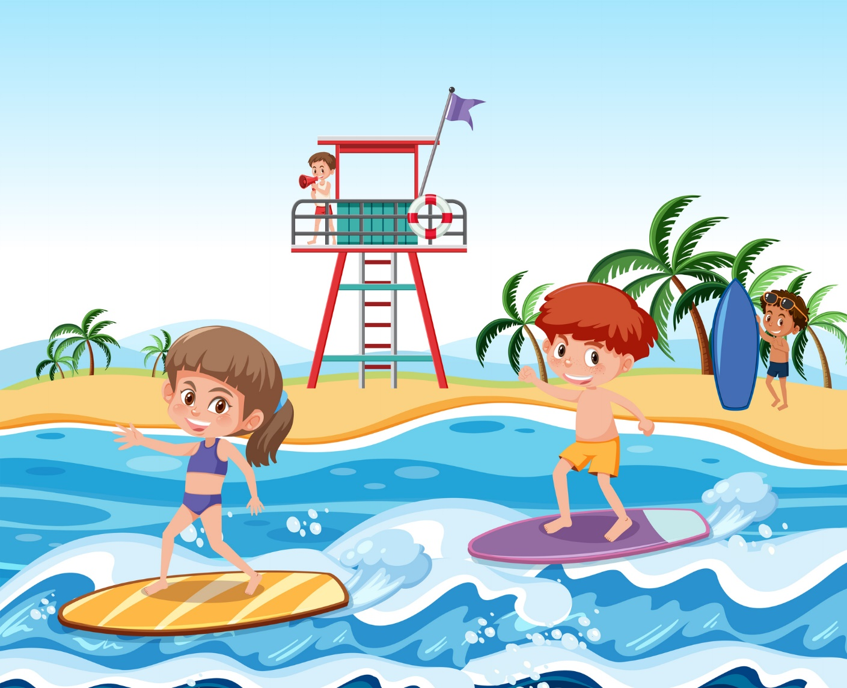
water sand flag

Task 2: Write three sentences in each column.
What can we do for fun at the beach? | What do we need to do to be safe at the beach?

