Consumer Fads,
Levels 5 and 6

Teacher resources

The following resources have been provided in this document.

Session 2
11 fads
Product work flow chart
Resource classification table

Session 3
Sustainable statements
Designing a consumer fad

Session 4
Profit and Not for Profit signs
Consumer fad SWOT analysis

Session 6
What job am I?

Session 2 resource

11 fads

Hula
hoops

Pet
rocks

Razor
scooter

Tamagotchi

Yo-yo

Cabbage Patch Kids

Pogo
sticks

Rubik’s
cube

Pokémon
Go

Loom
bands

Fidget
spinners

Session 2 resource

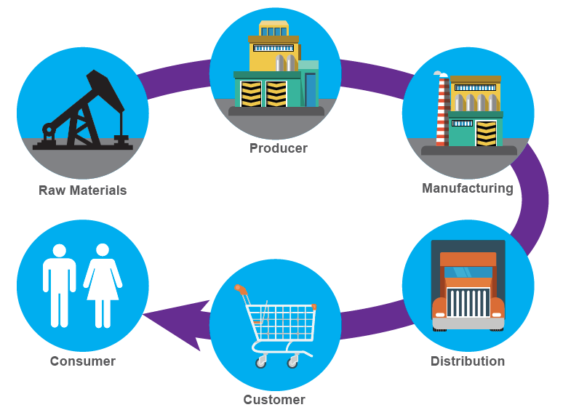
Product work flow chart

Session 2 resource

Resource classification table
Name of product | Natural resources (grown or taken directly from the environment or earth; goes into creating the product) | Human resources (people who work to create the product) | Capital resources (anything human-made that helps create the product)
Example:  Cup of coffee | Example:  Coffee beans  Milk  Sugar | Example:  Coffee bean plantation workers  Delivery drivers  Barista  Dairy farmer  Sugar refinery workers | Example:  Milking machine  Machinery for harvesting  Delivery vans  Expresso coffee machine  Grinder  Refrigerator

Name of product | Natural resources (grown or taken directly from the environment or earth; goes into creating the product) | Human resources (people who work to create the product) | Capital resources (anything human-made that helps create the product)

Name of product | Natural resources (grown or taken directly from the environment or earth; goes into creating the product) | Human resources (people who work to create the product) | Capital resources (anything human-made that helps create the product)

Name of product | Natural resources (grown or taken directly from the environment or earth; goes into creating the product) | Human resources (people who work to create the product) | Capital resources (anything human-made that helps create the product)

Session 3 resource

Sustainable statements

Shopping at a second-hand clothing store

Buying groceries at a local shop instead of a large supermarket

Purchasing products that only require a small amount of packaging

Buying products from businesses that use recycled products

Buying products that are made using sustainable practices

Session 3 resource

Designing a consumer fad
You are the managers of a business trying to create the next big consumer fad. You need to consider several factors:
- the product you design must be something people will want to buy. Think about current trends and fashions and what you learnt about fads in Session 1. Begin by listing the key features of a fad.
- consider the possible environmental effect of making and distributing your product. For example, will it use renewable resources? Consider energy usage, possible emissions and the potential environmental impact of the packaging.
- will the product need to be moved and distributed over long distances?
Questions to ask before designing a product as a potential consumer fad:
- Apply your knowledge of historical fads and trends and think about the qualities and properties that made them so popular. What are the elements of a fad or trend?
- Have you considered how elements of a fad or trend have changed with the evolution of technology? (Think: How are the current fads different to those of the 1970s and 1980s?)

Session 4 resource

Profit and Not for profit signs

For profit

Not for
profit

Session 4 resource

Consumer fad SWOT analysis
Strengths  What is the best thing about this product?  What are you doing really well? | Weaknesses  What could you improve?  What could lose you customers?
Opportunities  Is there anyone that could help you with this product? | Threats  Are any competitors working on a similar product?  What else could stop your product from being successful?

Session 6 resource

What job am I?
One student from each group is nominated and secretly given a job by the other members of the group. They should choose a job that has been listed on a sticky note during Session 6. The nominated student should not be told what job they have been given.
The nominated student asks the group questions to determine which job they have been given.
The student may ask questions such as:
- Is it an outdoor job?
- Is it in the farming industry?
The objective is to ask as few questions as possible before correctly guessing the job.

