LITERACY IN THE EARLY YEARS
THIS IS OUR HOUSE

Victorian Curriculum English F-10: Early Years Literacy: A Three Mode Unit in the Strand of Literature
Unit Overview: This is an F-2 five lesson sequence that covers content descriptions across all three English Modes in the Strand of Literature. The assessment activity applies to elements of the Speaking and Listening Achievement Standards but can be adapted to include assessment of other Modes if required. The lessons can be carried out as the explicit teaching element of each Literacy session over a week or taught as a unit of work within a Literacy block. Lessons will take 30 – 50 minutes depending on the amount of time allowed for discussion.
Synopsis  This Is Our House’ is set in a playground where the most popular place to be is a cardboard box house.  When George decides that the house belongs to him he begins to invent reasons to keep others from entering. Being too small, a twin, wearing glasses or enjoying building tunnels are all reasons to be excluded – according to George.  Inevitably George is forced to leave the house to go to the toilet. When he returns the other children have all climbed in. George faces a choice between being isolated himself or joining his playmates and sharing the house.  ‘This Is Our House’ provides content for the teaching and learning of character, setting and plot while exploring themes of sharing, tolerance, discrimination and diversity.  Possible Literature Links:  The Mine-O-Saur by Sudipta Quallen  Clancy The Courageous Cow by Lachie Hume  Family Forest by Kim Kane  Little Lunch: The Monkey Bars: Series 1 Episode 4 ABC TV |  |  |  |  | 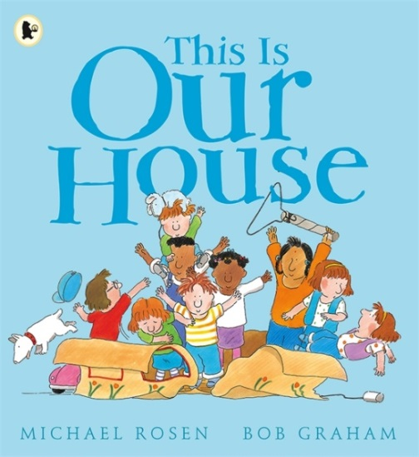
Content Descriptions
Speaking and Listening - Literature  Responding to Literature |  |  | Reading and Viewing - Literature  Examining Literature | Writing – Literature  Creating Literature
Foundation: Share feelings and thoughts about the events and characters in texts (VCELT171) |  |  | Foundation: Identify some features of texts including events and characters and retell events from a text (VCELT150) | Foundation: Retell familiar texts through performance, use of illustrations and images (VCELT159)
Level 1: Discuss characters and events in a range of literary texts and share personal responses to these texts, making connections with own experiences (VCELT207) |  |  |  | Level 1: Build on familiar texts by using similar characters, repetitive patterns or vocabulary (VCELT193)
Level 2: Compare opinions about characters, events and settings in and between texts (VCELT242) |  |  | Level 2: Discuss the characters and settings of different texts and explore how language is used to present these features in different ways (VCELT219) | Level 2: Build on familiar texts by experimenting with character, setting or plot (VCELT229)
Lesson | Tuning In | Activity |  |  |  | Reflection
1  R&V | In this lesson our learning goal is to practise identifying characters, settings and events.  Talk with your turn-and-talk partner about what characters / settings / events are. | Shared Reading:  Discuss the cover illustration and inside cover illustration.  Who might the characters be? Why might the book be called ‘This Is Our House’?  Talk to your partner about a time you made a cubby house.  Where might the book be set? What makes you think so? Is this similar or different to where you live?  Read the book stopping periodically to discuss what is happening, who it is happening to and what might happen next. |  |  |  | In a sharing circle select students to reflect on success statements:  - I can name some characters.  - I can describe the setting.  - I can recall some events.
2  S&L | In this lesson our learning goal is to practise talking about characters and how we feel about them.  Talk to your turn-and-talk partner about some of the characters you remember from the story. | Examining Characters:  Discuss the characters on the cover.  Which characters did you like / dislike? Which character reminded you of someone you know? Which character reminded you of a character from another book?  Read the book stopping periodically to discuss the characters and the words and images that are being used to portray them.  Work with turn-and-talk partner to complete sentences: ‘I liked/disliked…because…’ ‘…reminded me of…because…’ ‘…is like the character in…because…’ Share responses. |  |  |  | Reflect on success statements.  - I can describe characters I like/dislike.  - I can compare characters to people I know.  - I can compare characters from texts.
3  W | In this lesson our learning goal is to practise retelling and adapting familiar stories through performance.  Revise meaning of character, setting and events and ask students to tune in to these during re-read of book. | Retelling Through Performance:  Ask students to recall characters, setting and events and record them on a class chart.  Students work in groups (these may be mixed ability or ability based) to prepare and rehearse a performance of a retell or adaptation of ‘This Is Our House’ using the chart as a guide.  Each group presents their performance. |  |  |  | Ask each group to choose the success statement that best describes their work and justify.  - I can retell a familiar story.  - I can build on a familiar story.  - I can adapt a familiar story.
4  S&L | In this lesson our learning goal is to practise describing and comparing texts.  Read ‘Clancy The Courageous Cow’ by Lachie Hume.  Talk to your turn-and-talk partner about your text-to-text thoughts. | Making Connections:  Students draw and caption a character they like or dislike from either ‘This Is Our House’ or ‘Clancy The Courageous Cow’.  Students draw an event or character from the book they enjoyed the most and write a sentence to explain their choice. |  |  |  | Students look at their work and give a thumbs-up for the success criteria they feel they have met.  - I can identify likes and dislikes about familiar texts.  - I can describe characters in texts.  - I can compare texts.
5  S&L | In this lesson our goal is to demonstrate our learning from this week by presenting and explaining our work from the last lesson.  Teacher models an oral presentation based on drawings and captions from Lesson 4. | Oral Presentation:  Show students assessment rubric for oral presentations and discuss the success criteria.  Allow students time to rehearse their presentations using their work from Lesson 4 as a prompt and supporting imagery.  Students present as teacher uses rubric to assess. |  |  |  | Students use their own rubric to self-assess.  (See teacher assessment and self-assessment rubrics below).

Teacher Assessment Rubric – Speaking and Listening F-2
Name: Date:
Foundation | Level 1 | Level 2
Students identify and describe likes and dislikes about familiar texts. | Students describe characters, settings and events in different types of literature. | Students explain their preference for aspects of texts using other texts as comparisons.
 | Students make short presentations with:  - clear speech  - appropriate voice and pace | Students deliver short presentations with:  - clear speech  - varying tone  - varying volume and pace

Student Self-Assessment Rubric – Speaking and Listening F-2
Name: Date:
I can draw and talk about characters I like or dislike. |  | I can describe characters in stories. |  | I can compare texts and talk about my preferences.
Yes | Not yet | Yes | Not yet | Yes | Not yet

