Themes

Authorised and published by the Victorian Curriculum and Assessment Authority
Level 7, 2 Lonsdale Street
Melbourne VIC 3000
© Victorian Curriculum and Assessment Authority 2018

No part of this publication may be reproduced except as specified under the Copyright Act 1968 or by permission from the VCAA. Excepting third-party elements, schools may use this resource in accordance with the VCAA educational allowance. For more information go to: www.vcaa.vic.edu.au/Pages/aboutus/policies/policy-copyright.aspx.
The VCAA provides the only official, up-to-date versions of VCAA publications. Details of updates can be found on the VCAA website: www.vcaa.vic.edu.au.
This publication may contain copyright material belonging to a third party. Every effort has been made to contact all copyright owners. If you believe that material in this publication is an infringement of your copyright, please email the Copyright Officer: vcaa.copyright@edumail.vic.gov.au
Copyright in materials appearing at any sites linked to this document rests with the copyright owner/s of those materials, subject to the Copyright Act. The VCAA recommends you refer to copyright statements at linked sites before using such materials.

The VCAA logo is a registered trademark of the Victorian Curriculum and Assessment Authority.

Content Descriptions liking to Ethical Capability across the Victorian Curriculum 7-10

What does this resource provide?
Content descriptions across a range of curriculum areas link to ethical capability.
Some content relates to ethical issues. Some of these issues share a common theme but are explored through different contexts, while others are specific to a particular learning area.
Other content descriptions concern ethics, in that students could engage with the content more deeply with support from Ethical Capability, but do not necessarily require analysis and evaluation of an ethical issue.
This resource identifies:
- content descriptions from a range of learning areas that could be contextualised for a range of ethical issues.
- common themes across a number of learning areas and specific content descriptions linked to each of them from different learning areas.
- content descriptions from a range of learning areas that link to ethical capability but are not directly concerned with ethical issues.

What is an ethical issue?
An ethical issue arises in situations where there are competing alternatives – where the right thing to do is not clear. An issue is an ethical issue when actions themselves and/or outcomes can be judged in terms of good, bad, right, wrong, better or worse and in the background is a concern about these kinds of questions: ‘How ought I/we to live?’ ‘What kind of society should we have?’ ‘How should we treat others?’ ‘How should we treat other living things?’ ‘How should we interact with our environment?’
An ethical issue becomes an ethical dilemma when there are conflicts between ways to act, usually involving contravention of an ethical principle/s that is normally held – for example when acting to keep a promise may entail lying and the person normally would not lie.

Curriculum mapping according to broad content descriptions
Some learning areas can involve analysis and evaluation of a range of ethical issues depending on the text selected or the selected learning context.
Following are content descriptions from a range of curriculum areas that could be contextualised for different ethical issues.
This mapping is not exhaustive and teachers may be able to identify further teaching and learning opportunities.

Ethical issues - Curriculum mapping according to broad themes
This shows a range of examples of different themes that can be found across learning areas. These themes are concerned with a range of ethical issues depending on context.
This mapping is not exhaustive and teachers may be able to identify further teaching and learning opportunities.

Theme: Human wellbeing
This is expressed in learning areas at the scale of individuals or groups. Emphases across different learning areas variously include issues concerning:
- social cohesiveness
- welfare
- distribution of income and wealth
- needs and wants
The Ethical Capability curriculum can assist students to understand and analyse the concept of human wellbeing and to evaluate contestable positions related to its importance. Students could consider a range of key questions such as what we mean by wellbeing, why we should value the wellbeing of others, and how human wellbeing should be measured. These general points can be adapted for different curriculum area contexts. The Teaching Ethical Issues: Planning tool on the Victorian Curriculum: F-10 Ethical Capability teaching resources page can assist with identifying Ethical Capability content descriptions that require explicit teaching in response to student needs.

Theme: Freedom of expression

The key issue related to this theme is: To what extent should expression be constrained and who should do the constraining (the person or group themselves or an external source of constraint such as government?). Expression could be through speech, symbols, dance, visual arts and so on.
The Ethical Capability curriculum can assist students to understand what we mean by freedom and free choice, and to analyse the social and personal value we place on the concept of freedom. Students could consider a range of key questions such as how and why institutions enable or interfere with people’s freedom, how we manage circumstances where people’s freedoms come into conflict, and whether we would ever be justified to restrict the freedom of people or groups. These general points can be adapted for different curriculum areas.
The Teaching Ethical Issues: Planning tool on the Victorian Curriculum: F-10 Ethical Capability teaching resources page can assist with identifying Ethical Capability content descriptions that require explicit teaching in response to student needs.

Theme: Freedom of choice

The key issue associated with this theme is to what extent choice should be constrained and who should do the constraining (the person or group themselves or an external source of constraint such as government). For the purposes of this resource freedom of choice is distinct from freedom of expression (which is a separate theme) referring instead to other choices such as consumption of alcohol or voluntary euthanasia.
The Ethical Capability curriculum can assist students to understand what we mean by freedom and free choice, and to analyse the social and personal value we place on the concept of freedom. Students could consider a range of key questions such as how and why institutions enable or interfere with people’s freedom, how we manage circumstances where people’s freedoms come into conflict, and whether we would ever be justified to restrict the freedom of people or groups. These general points can be adapted for different curriculum areas.
The Teaching Ethical Issues: Planning tool on the Victorian Curriculum: F-10 Ethical Capability teaching resources page can assist with identifying Ethical Capability content descriptions that require explicit teaching in response to student needs.

Theme: Equality

This is expressed in learning areas at the scale of individuals or groups and can involve consideration of different kinds of equality such as regarding income, political power, work opportunities or cultural acceptance. Emphases across different learning areas variously include issues concerning:
- development of empathy and sensitivity
- influence of equality or inequality (for example of income) on wellbeing of communities
- discrimination, and acceptance of diversity
- human rights
The Ethical Capability curriculum can help students understand why equality may or should be valued and to consider a range of key questions such as what kinds of equality we should value and the distinction between equality and fairness (are some kinds of inequality fair?). These general points can be adapted to different curriculum area contexts.
The Teaching Ethical Issues: Planning tool on the Victorian Curriculum: F-10 Ethical Capability teaching resources page can assist with identifying Ethical Capability content descriptions that require explicit teaching in response to student needs.

Theme: Exploitation

Emphasis across learning areas with regard to this theme includes emphasis on exploitation of one or more of:
- environment
- animals
- humans
The Ethical Capability curriculum can help students understand the various kinds of exploitation that may occur. Students could consider a range of key questions such as what constitutes exploitation, whether there is an ethical distinction between exploiting people and exploiting other resources, whether exploitation of the few could ever be justified on the basis of the greater good, and the justification for regulation of exploitative practices. These general points can be adapted for different curriculum area contexts.
The Teaching Ethical Issues: Planning tool on the Victorian Curriculum: F-10 Ethical Capability teaching resources page can assist with identifying Ethical Capability content descriptions that require explicit teaching in response to student needs.

Theme: REGULATION

This theme concerns external controls and how they shape decisions and actions, and across learning areas it is concerned with one or more of:
- Ethical protocols
- Regulatory compliance
- Legal responsibilities
The Teaching Ethical Issues: Planning tool on the Victorian Curriculum: F-10 Ethical Capability teaching resources page can assist with identifying Ethical Capability content descriptions that require explicit teaching in response to student needs.

Additional
Other content descriptions from a range of learning areas that link to Ethical Capability.
These content descriptions concern ethics but do necessarily concern an ethical issue, concerning instead the contested meaning of an ethical concept for example. Linking to ethical capability will support students to engage with the content of the learning area more deeply.
This mapping is not exhaustive and teachers may be able to identify further teaching and learning opportunities.

Navigating the map
The attached Ethical Capability mapping document can be navigated in multiple ways to see where curriculum area content descriptions overlap with Ethical themes.

Themes
SORT:
Use this button to sort the curriculum areas, or select curriculum areas to review.

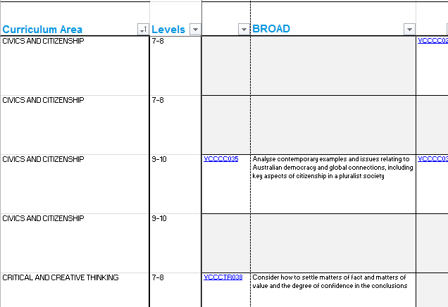
Curriculum Areas
LINK:
Clickable links connected to content descriptions on the Victorian Curriculum website.
SORT:
Use this button to sort the content descriptions, and to remove blank boxes.

