Guide to

Formative Assessment

Rubrics

Victorian Curriculum F–10

The Victorian Curriculum and Assessment Authority acknowledges the contribution of Pam Robertson, Jason Pietzner and Narelle English, Assessment Research Centre, University of Melbourne, in the development of this guide.

Authorised and published by the Victorian Curriculum and Assessment Authority
Level 7, 2 Lonsdale Street
Melbourne VIC 3000
ISBN: 978-1-925676-95-2
© Victorian Curriculum and Assessment Authority 2019.
Exposure draft published for trialling and feedback July 2018.

No part of this publication may be reproduced except as specified under the Copyright Act 1968 or by permission from the VCAA. Excepting third-party elements, schools may use this resource in accordance with the VCAA educational allowance. For more information go to: www.vcaa.vic.edu.au/Pages/aboutus/policies/policy-copyright.aspx.
The VCAA provides the only official, up-to-date versions of VCAA publications. Details of updates can be found on the VCAA website: www.vcaa.vic.edu.au.
This publication may contain copyright material belonging to a third party. Every effort has been made to contact all copyright owners. If you believe that material in this publication is an infringement of your copyright, please email the Copyright Officer: vcaa.copyright@edumail.vic.gov.au
Copyright in materials appearing at any sites linked to this document rests with the copyright owner/s of those materials, subject to the Copyright Act. The VCAA recommends you refer to copyright statements at linked sites before using such materials.

The VCAA logo is a registered trademark of the Victorian Curriculum and Assessment Authority.

Contents
Introduction 1
Student learning and assessment 1
What is formative assessment? 2
Purpose of the guide 2
Structure of the guide 3
Part 1: Describing a learning continuum 4
What is a learning continuum and why is it needed? 4
What is a curriculum continuum? 5
Using the Victorian Curriculum F–10 as a learning continuum 6
Using professional expertise to develop a more granular learning continuum 7
Part 1 summary 10
Part 2: Developing a formative assessment rubric 11
What makes up the rubric structure and how does this assist in describing increasing sophistication? 11
Refining the rubric to support consistent assessment 15
Communicating learning expectations to intended users 15
Part 3: Collecting, interpreting and using evidence to plan for teaching and learning 17
Collecting evidence of student learning 17
Interpreting evidence of student learning 17
Using formative assessment to plan for teaching and learning 18
Part 4: Formative assessment rubrics in practice 19
Worked example: Literacy 19
Worked example: Numeracy 21
Next steps for schools 23
Glossary 24
Further reading 25
Appendix: Victorian Curriculum F–10 structure 26

Introduction

Student learning and assessment
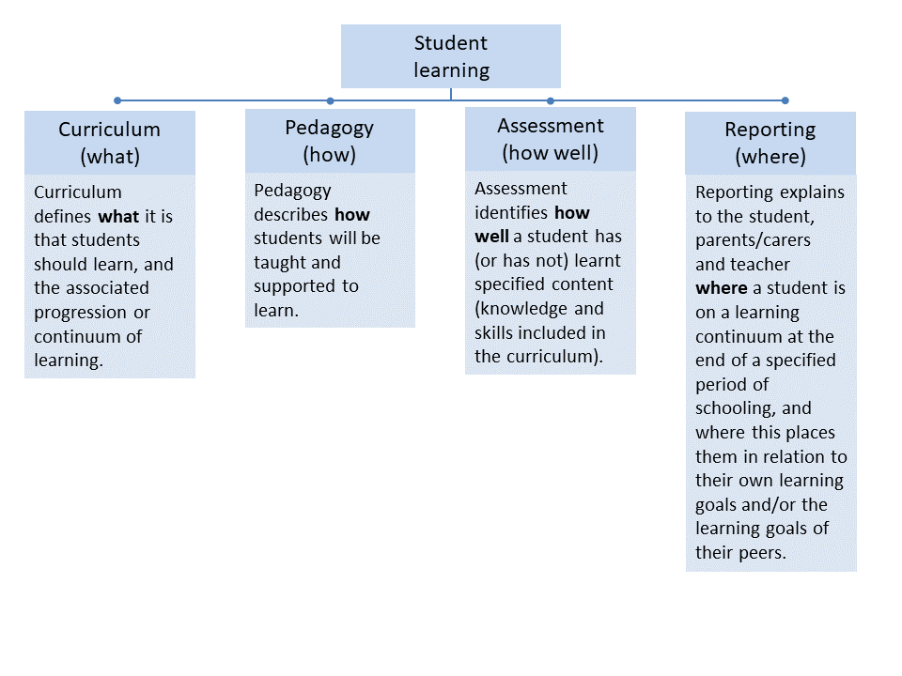
Student learning is produced, shaped and affected by four connected components. Each component plays a distinct role in the process of student learning and is interconnected with all of the others. The four components of student learning include the what, how, how well and where of student learning:
The Victorian Curriculum F–10 is a set of progressions that define increasingly complex knowledge, skills and concepts grouped and defined by learning areas and capabilities.
The Victorian Curriculum F–10 is not set out according to nominal school year levels but
to developmental levels on a continuum of learning, which allows a teacher to point to current levels of achievement for every student and allows for appropriate planning for
expected levels of achievement.
Because of this structure, the Victorian Curriculum F–10 facilitates an increased focus in Victorian schools on the development of personalised learning programs for all students, where curriculum delivery is planned in relation to the actual learning level of each student rather than their assumed level of learning. This is consistent with Vygotsky’s now widely cited concept of the ‘zone of proximal development’. This concept is picked up in the Revised Curriculum Planning and Reporting Guidelines (VCAA 2015) with a quotation from Australian Council for Educational Research Chief Executive Officer Geoff Masters:
It is well understood at the level of the classroom that successful learning is more likely when individual learners are given learning opportunities appropriate to their current levels of achievement and learning needs.

What is formative assessment?
Formative assessment is any assessment that is used to improve teaching and learning. Best-practice formative assessment uses a rigorous approach in which each step of the assessment process is carefully thought through.
Assessment is a three-step process by which evidence is collected, interpreted and used.
By definition, the final step of formative assessment requires a use that improves teaching and learning.
For the best results, teachers can work together to interrogate the curriculum and use their professional expertise and knowledge of their students to outline a learning continuum including a rubric of measurable, user-friendly descriptions of skills and knowledge. Once this planning work is completed and there is explicit detail about what progress might look like in their classroom, teachers can draw on this learning continuum and rubric to collect evidence of current competence for each student. This evidence is evaluated and the learning continuum and rubric is then used to provide formative feedback and describe the learning expectations for all students in the class, tailored
to individual needs.
Key messages
- The Victorian Curriculum F–10 is written as a continuum and this structure supports formative assessment.
- Formative assessment enables teachers to collect evidence about what a student can currently do and to plan the next steps to progress student learning.
- Formative assessment helps teachers identify learning intentions/goals for each student.
- A formative assessment rubric assists students and teachers
to have a consistent understanding of the next phase in learning.
- Formative assessment is an integral part of the teaching and learning cycle.

Teachers can then use this learning continuum to determine the best evidence-based pedagogy to teach the knowledge and skills and progress student learning. Teachers should also consider where it is useful for students to receive timely and detailed feedback to support progress within a task, learning activity or unit of work.
The Guide to Formative Assessment
Rubrics outlines how to develop a formative assessment rubric to collect, interpret and use evidence of student learning to plan teaching and learning. Adopting the practices outlined
in this guide will help teachers to decide what students know and can do and will assist
them to identify what students are ready to learn next.

Purpose of the guide
The primary purpose of this guide is to provide advice to teachers about how to develop formative assessment rubrics, which assist teachers to identify the actual learning level of each student based on evidence of what students know and can do and to understand what students are ready to learn next.
Specifically, the guide provides advice about:
- determining learning intentions/goals using the Victorian Curriculum F–10
- designing formative assessment rubrics
- using information from formative assessment rubrics to plan teaching and learning.
This guide does not provide detailed information about student agency, feedback, moderation processes, evidence-based pedagogical approaches or reporting; however, these are important teacher considerations when undertaking formative assessment within the classroom.

Structure of the guide
The guide consists of four parts:
Part 1: Describing a learning continuum
Part 2: Developing a formative assessment rubric
Part 3: Collecting, interpreting and using evidence to plan for teaching and learning
Part 4: Formative assessment rubrics in practice.
A note on terminology:
Key terms are defined as they appear in the text and have been included in a glossary. Common alternatives are also indicated.

Picture of practice
Emma is a primary school teacher who uses rubrics as a formative assessment tool with her Year 6 writing class. Emma developed the rubric prior to commencing the persuasive writing unit. Emma gets her students to initially use it to self-assess their writing ability and to develop learning goals. Most students work with a partner to confirm judgments about their persuasive writing ability but Emma also works with some students individually.
During the planning, writing and editing stages of their work, students refer to the rubric both as a reminder of task requirements, and to target essential writing features and improvements. Students also use the rubric as a tool for giving peer-to-peer feedback, enabling them to target their feedback to the specific task requirements and goals the students created for themselves. This feedback is recorded using the rubrics.
Throughout the persuasive writing unit, Emma uses the rubric to plan learning activities based on her students’ needs, and to keep conferencing discussions focused and oriented towards student learning. Emma uses the recorded peer- and self-assessments during the unit as a basis for discussions about progress as well as future goals.

Part 1: Describing a learning continuum

What is a learning continuum and why is it needed?
When planning a teaching and learning program, it helps to understand the typical developmental phases students go through in their learning. These are known as a
‘learning continuum’.
When using a learning continuum, teachers can:
Terminology
Learning continuum
A progression of knowledge and skills derived from a curriculum. This can be developed by teachers and may consist of a selection of parts from a curriculum continuum, sometimes with more detail added.
Phases
The increments in a learning continuum that detail the development typically seen in students as they become more proficient. Phase descriptions help teachers to recognise students at different points along the continuum.
Granularity
The level of detail of knowledge and skills provided in a learning continuum.
- collect evidence of learning because the phases indicate what to look for
- interpret the evidence collected against the phases to identify what students are ready
to learn next
- use the information to design teaching and learning activities that help students to progress along the continuum.
A learning continuum can be developed in two ways:
- solely using the Victorian Curriculum F–10 content descriptions and achievement standards
- using the Victorian Curriculum F–10 in combination with teacher expertise to describe more granular phases between achievement standards or more complex knowledge
and/or skills.
When creating formative assessment rubrics, it is important to use a learning continuum that breaks learning down into phases that are the right granularity to support lesson-to-lesson decisions or activity-to-activity decisions and to support student learning progression.

What is a curriculum continuum?
The Victorian Curriculum F–10 is structured as a curriculum continuum, describing the knowledge and skills that every student should learn during their first 11 years of schooling. The Victorian Curriculum F–10 sets out a single, coherent and comprehensive set of content descriptions and associated achievement standards to enable teachers to plan, monitor and assess the learning achievement of every student.
Terminology
Curriculum continuum
A progression of knowledge and skills organised into learning areas and capabilities. The Victorian Curriculum F–10 contains multiple curriculum continuums.
Content descriptions
Specific and discrete information identifying what teachers are expected to teach and students
are expected to learn.
Achievement standards
Statements that describe what students are typically able to understand and do, and that are the basis for reporting student achievement.

The Victorian Curriculum F–10 is structured as a continuum across levels of learning achievement, not years of schooling. This enables the development of targeted learning programs for all students, where the curriculum is used to plan in relation to the actual learning level of each student rather than their assumed level of learning based on school year level and age.
Each learning area and capability includes content descriptions explaining what is to be taught and achievement standards describing what students are able to understand and do at different levels of learning. The achievement standards are provided in 11 levels for English and Mathematics and in five or six bands for all the other learning areas and capabilities. Refer to the Appendix for an outline of the structure of the Victorian Curriculum F–10 and the location of the achievement standards.

Using the Victorian Curriculum F–10 as a learning continuum
Sometimes, the phases described in the curriculum continuum are the right granularity to inform teaching and learning and can be used directly as a learning continuum.

Example 1: Using part of the curriculum continuum
Example 1 demonstrates a situation where content descriptions and specific statements from the achievement standards provide sufficient detail to enable a teacher to establish the phases of a learning continuum and set clear learning intentions and goals for students. It is easy to see how a student would move from one phase to another.
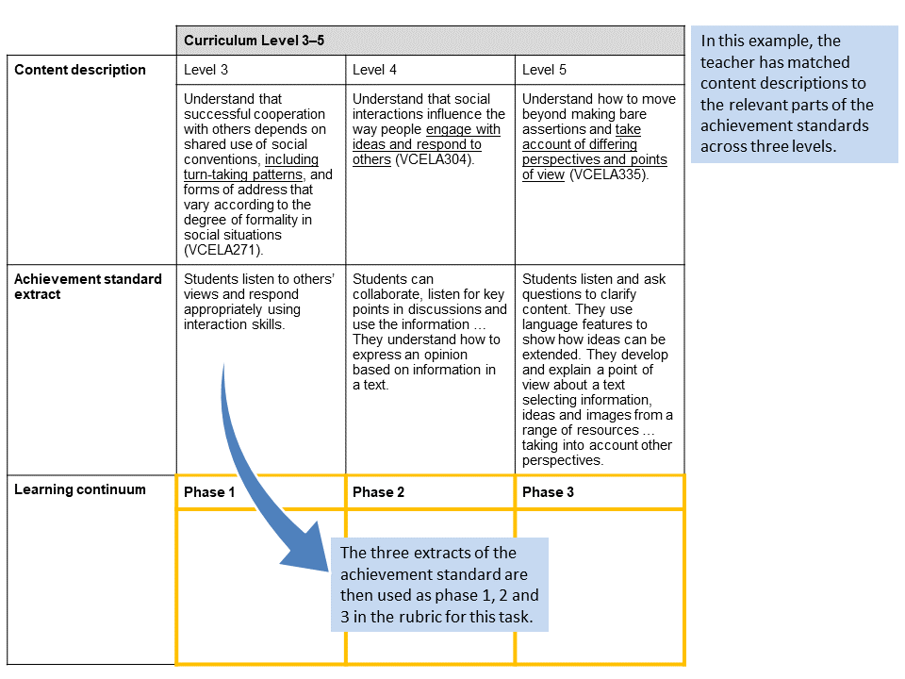
English: Speaking and Listening mode, Language for interaction sub-strand
Tip:
- Teachers can check if the Victorian Curriculum F–10 continuum provides the right granularity to inform teaching and learning by considering whether they can place all students within a recently taught class on this continuum. If not, teachers will need to take one of the following approaches.

Using professional expertise to develop a more granular learning continuum
Teachers may need to use a more granular continuum than is provided by the curriculum. This need for more granular information can occur when teaching complex skills or knowledge. More detail is helpful for both teachers and students as it articulates progression in smaller, more achievable phases. This supports teachers and students to identify the current level of achievement, enabling targeted and effective teaching to be provided. Additional detail can support teacher decision-making, on a lesson-to-lesson or activity-to-activity basis.
Typically, teachers may want to write their own learning continuums for the following reasons:
- to clarify the development phases within one content description or a small extract from the achievement standard within the curriculum (Example 2, below)
- to span the gap between adjacent curriculum levels and/or bands (Example 3)
- to combine several content descriptions to focus on a particular situation or context.
Teachers can develop a learning continuum with more granularity by writing their own descriptions of the typical phases in learning. This can be done:
- from experience, such as where the teacher notices the knowledge and skills are complex
Terminology
Developmental taxonomy
A research-derived classification that describes developmental stages in generic skills and knowledge. For example: Bloom’s taxonomy, SOLO.

- by collaborating with other teachers
- by adapting a developmental taxonomy such as Structure of the Observed Learning Outcome (SOLO)
- by examining student work samples and identifying the phases demonstrated.
Tips:
- While a teacher working alone can describe learning continuums, the best continuums usually come from teachers working collaboratively to write statements for each phase.
- Student work samples can assist in identifying and describing phases.
- Careful consideration should be given to the purpose, intended use and time commitment required to develop a high-quality formative assessment rubric.

Example 2: Using professional expertise to develop a learning continuum within a curriculum level
Example 2 describes a learning continuum that articulates the phases within one content description and one statement extracted from an achievement standard from the Victorian Curriculum F–10. This example also recognises the importance of extending students.
This level of granularity supports teachers to know what they are looking for as evidence of learning, helping them to target their teaching to the needs of each student. This learning continuum supports students to know what comes next.

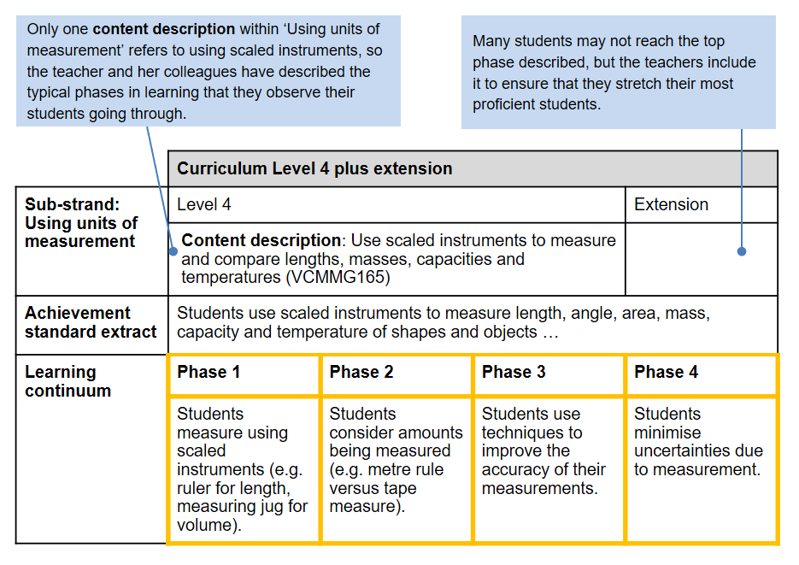
Mathematics: Measurement and Geometry
Tip:
- Giving students a copy of a formative assessment rubric allows them to see examples
of the phases and identify their learning goals, supporting them to see how far they might progress. It also provides an aspirational extension, which can remove unintentional barriers to their learning.

Example 3: Using professional expertise to develop a learning continuum to span the gap between adjacent achievement standards
Example 3 focuses on texts in group discussions across three levels of the Victorian Curriculum F–10: English. The number of levels covered does not have to correlate with the number of phases that teachers identify to support this learning.
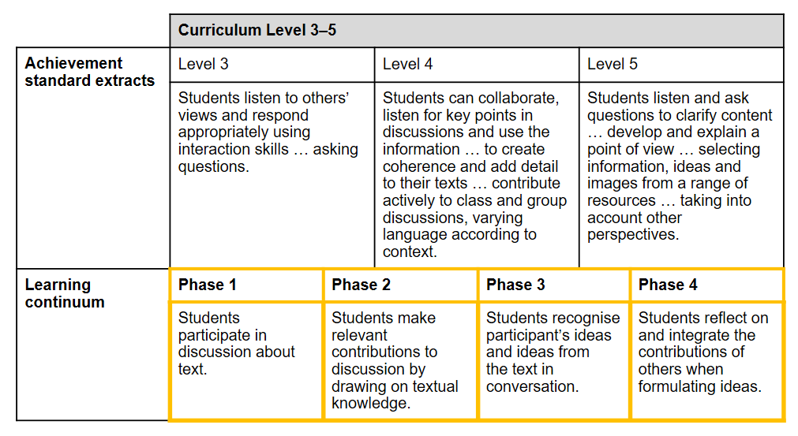
English: Speaking and Listening mode, focusing on texts in group discussions
Tip:
- Greater detail or granularity supports better observation of student learning within a mixed-ability classroom. Additional phases should be based on professional expertise and observation.

Part 1 summary
Describing a learning continuum helps teachers to know the typical phases students go through in their learning, and this supports them to articulate development, scaffold learning and target their teaching. The process described here ensures that the learning continuum used as the basis for the formative assessment rubric is clearly linked to the Victorian Curriculum F–10.
As outlined, the development of the learning continuum should be drawn from either:
- the Victorian Curriculum F–10 – in instances where the curriculum provides enough granularity to describe typical learning
- the Victorian Curriculum F–10 and professional expertise – in instances where additional granularity is required to describe typical learning, for example, where a teacher identifies an aspirational extension to stretch students or where examples of additional learning phases are used to support learning across adjacent achievement standards.
Teachers will need to make judgments about the level of granularity they will require to support lesson-to-lesson decisions or activity-to-activity decisions, and enable teaching and learning plans to be developed to support progress in student learning.
Describing a learning continuum is just the first part of developing a rubric to support high-quality formative assessment. In Part 2, you will find out how to take this learning continuum and add it to a grid to begin creating a rubric.

Part 2: Developing a formative assessment rubric
The learning continuum described in Part 1 is now taken and placed above the grid that will become the formative assessment rubric.
Terminology
Rubric
An arrangement (usually in grid formation) of quality criteria according to actions that classify the development of competence in a complex set of skills and/or knowledge.
The three main aims in developing a formative assessment rubric are to:
- describe increasing sophistication as a student’s learning progresses
- support consistent assessment practices
- communicate to intended users, including students, other teachers and possibly parents/carers.
The rubric template that is described in this section is specifically designed for formative assessment, as it is focused on articulating the fine-grained phases and teases apart what
is being taught and learned.
In some cases, the learning continuum that is being used might focus on complex learning that is made up of many different parts. In these situations, a rubric provides a useful tool to break up complex learning into smaller segments that describe the increasing sophistication of what a student can do, say, make or write, which align to the learning continuum.
The process for developing a high-quality formative assessment rubric that achieves these three aims is outlined in this part of the guide.

What makes up the rubric structure and how does this assist in describing increasing sophistication?
A rubric splits a complex learning continuum, as described in Part 1, into a series of more specific continuums describing increasing sophistication. Three examples are provided:
- a blank formative assessment rubric with each column and row described (Example 4)
- an explanation of the relationship between learning continuum phases and the quality criteria (Example 5)
- a completed formative assessment rubric (Example 6).
When writing a formative assessment rubric, it is best to focus first on making sure the rubric describes increasing sophistication. Sophistication relates to how well something is done, not how often an action is done correctly or how far through a process a student got. Each subsequent cell within a row describes a better way to perform the action, or a higher level of quality. For this reason, each cell can be called a quality criterion.
Each quality criterion describes something a student can do, say, make or write, which aligns to a phase in the learning continuum being assessed. Together, the quality criteria make up the fine-grained, very focused learning continuum. For this reason, taxonomies like SOLO are helpful for writing quality criteria.
Tips:
- A good way to check if the rubric has described increasing sophistication is to think of a teaching/learning activity to help students move from one phase to the next.
- When using a formative assessment rubric, consider whether the task or activity provides multiple opportunities for students to demonstrate their learning.
Example 4: Blank formative assessment rubric (annotated) | 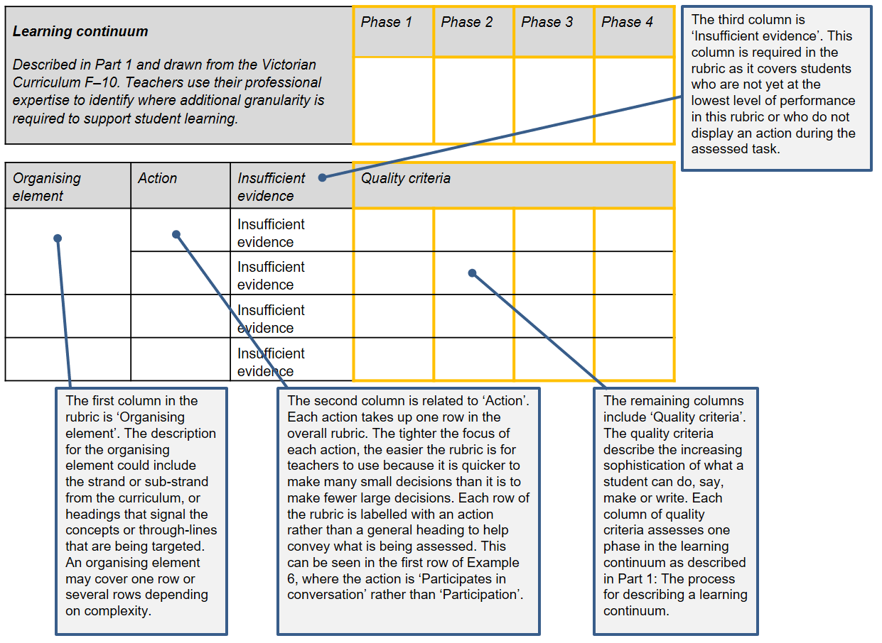
Terminology
Action
A categorisation of what a student can do, say, make or write in demonstration of a particular knowledge and/or skill.
Organising elements
Strands are key organising elements within each curriculum area. Sub-strands are supplementary organising elements within some curriculum areas. Modes and focus areas may also be used as organising elements.

Example 5: Explanation of the relationship between the learning continuum phases and the quality criteria |  | 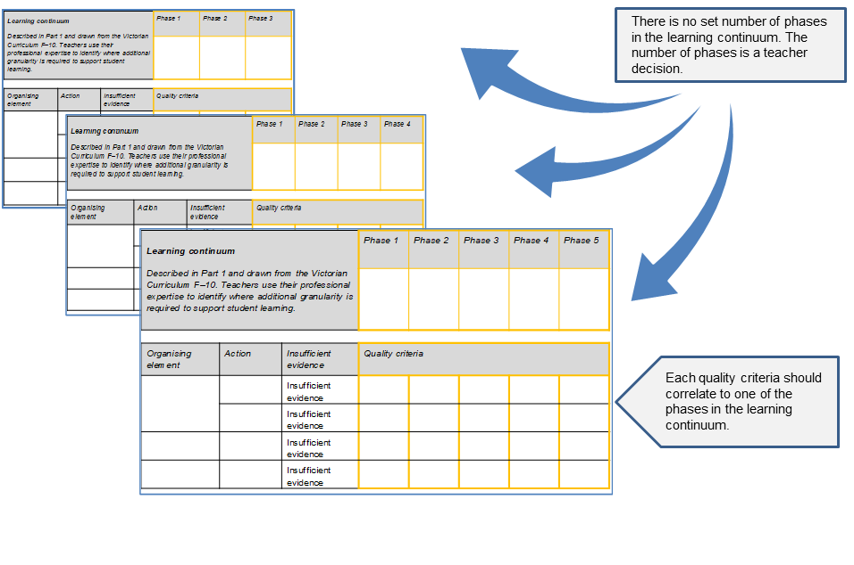
Example 6: Completed formative assessment rubric | 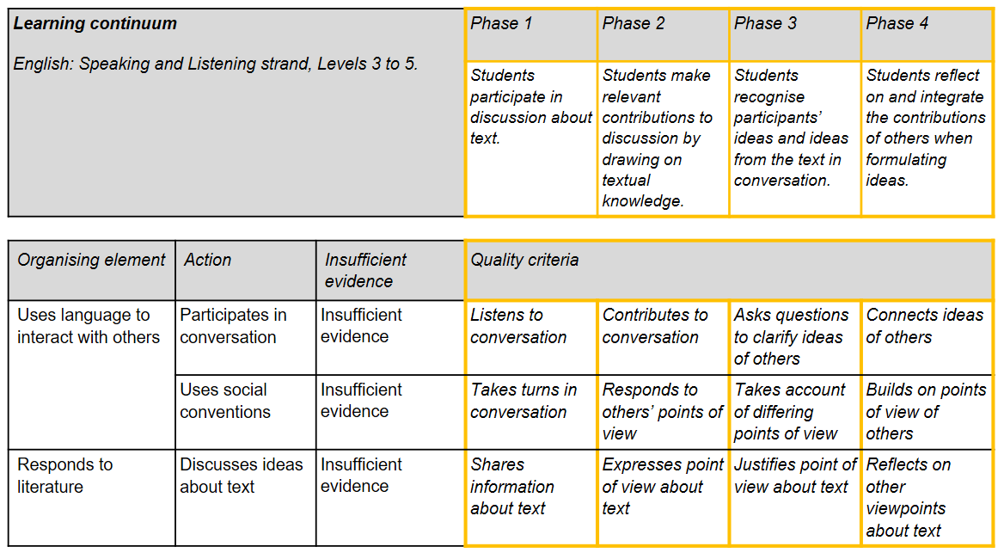  Tip:  - It is a good idea to write no more than four quality criteria for each action. This helps make sure there is a clear difference between each criterion, which makes assessment quicker and easier.

Refining the rubric to support consistent assessment
Once the rubric describes increasing sophistication, it can be refined further to facilitate consistent assessment. To do this, remove adverbs and adjectives and focus on verbs to describe the differences between phases. Sometimes, it is not possible to describe a quality criterion for an action matched to each phase within a learning continuum. In those cases, it is fine to leave a cell blank. This can be seen in Example 7.
Terminology
Quality criteria
The quality criteria describe the increasing sophistication of what
a student can do, say, make or write, which aligns to the learning continuum.

Restricting each quality criterion to just one central idea supports consistent assessment because it avoids the situation where a teacher is unsure how to assess a student who achieves one part of a criterion and not the other part. If you are tempted to place more than one idea in a criterion, think about whether you need to add another action to cater for the additional idea.

Communicating learning expectations to intended users
The final aim of a rubric is that it will clearly communicate learning expectations to all the intended users. Teachers will use the rubric to inform their observations of what student can say, make, do or write, and students can use it for peer- and/or self-assessment. Sometimes parents/carers are users of assessment rubrics too, especially rubrics for young students. The language that is used needs to be easily understood by all users. If specific terms related to the subject matter are used, they should be those terms that are taught and used within the classroom. If parents/carers are to use the rubric, terms could be included in an accompanying glossary.
Formative assessment rubrics also convey important messages about what is valued in a classroom. To send the message that all learning is valued, all quality criteria should be positively framed. A student who previously had been assessed at ‘Insufficient evidence’ for ‘Uses social conventions’ (per Example 6), and who achieves ‘Takes turns in conversation’ for the first time is much more likely to feel positive about their learning than if the criterion was ‘Ignores others’ points of view’. Anything a student cannot yet achieve should be included in the higher criteria, so it is seen as aspirational – in this case, ‘Responds to others’ points of view’ is the next criterion.
Tips:
- Once the rubric has been developed, talk it over with students. Giving students an opportunity to clearly understand the next phase in their learning will support them to set personal goals.
- If you cannot think of how to express a criterion positively, think about how you would congratulate a student who has finally achieved the criterion after working long and hard on it. Those words of congratulations often indicate what is positive without focusing on what has not yet been learned.

Example 7: A formative assessment rubric with gaps
Notice the empty cells in this rubric. It may not be possible or necessary for every quality criteria cell to be described for each action. The gaps help make clear the distinctions between quality criteria.
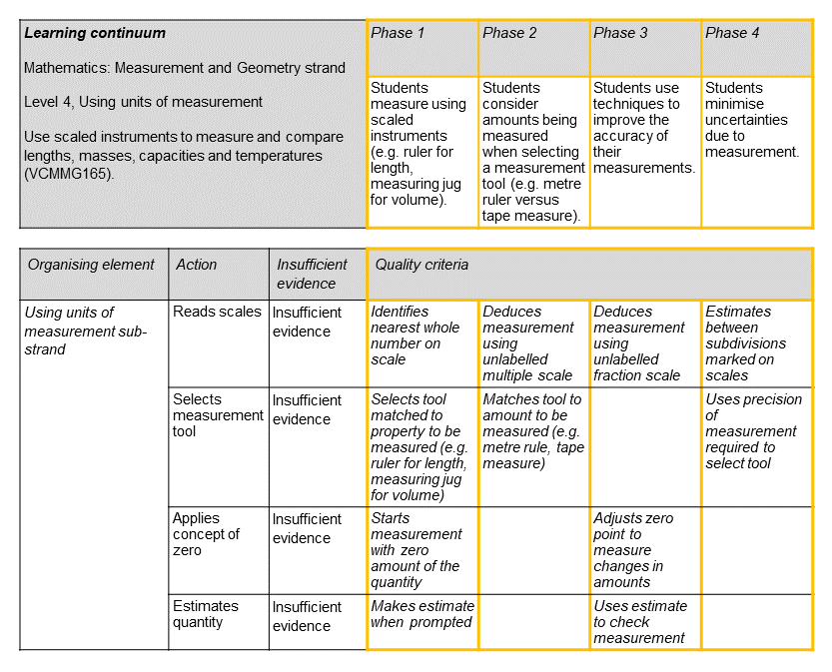

Part 3: Collecting, interpreting and using evidence to plan for teaching and learning

Collecting evidence of student learning
Once the formative assessment rubric – including the learning continuum – is described, plans can be made for collecting evidence of student learning in order to work out which phase(s) students have achieved and which they are ready to learn. Many methods can be used. These include:
- performances | - self-assessment | - work samples
- presentations | - assignments | - peer assessment
- responses to questions | - products | - observations
- assessment conversations.
The key is to make sure that the chosen method will elicit evidence matched to the formative assessment rubric. An advantage of using a rubric to frame student learning is that it is easy to adapt this to a wide range of assessment types. The rubric is the starting point for gathering evidence. The task that best elicits the evidence should be decided upon next, not the other way around. If teachers write rubrics using the procedure in this guide, the assessment process becomes transparent, increasing opportunities for students to have input into how they are assessed.
Terminology
Achieved
The phase of a learning continuum at which a student can independently and consistently demonstrate skills and knowledge. Alternative term: Vygotsky’s Zone of Actual Development.
Ready to learn
The phase of a learning continuum at which a student requires scaffolding to acquire skills and knowledge. Alternative term: Vygotsky’s Zone of Proximal Development.
Not yet ready to learn
The phase of a learning continuum for which a student does not have the required foundational knowledge or skills. Acquisition of these skills is required before teaching of this phase should be attempted.

Recording the evidence using the rubric helps ensure interpretations are evidence-based and not swayed by previous judgments.

Interpreting evidence of student learning
Collected evidence can be compared against the rubric to decide which quality criteria – and thus which phases – a student:
- has achieved
- is ready to learn
- is not yet ready to learn.
The evidence is interpreted by considering each phase within the learning continuum and considering whether the student has:
- undertaken and completed an activity with or without assistance
- demonstrated the knowledge and/or skill in a range of situations or in different contexts
- covered all parts of the learning continuum in the rubric or if there are areas that need further attention.
Typically, students within a class will be spread across different phases of learning. If students are recorded at the highest phase described by the learning continuum, an additional phase will need to be added to stretch those students.
Tips:
- If a student’s pattern of progression is irregular, more assessment evidence may need to be collected. Sometimes performance is influenced by outside factors such as tiredness, attention or method of assessment, and a greater pool of evidence will indicate the true pattern of progression.
- If many students have an irregular pattern of progression, it is likely that the learning continuum or rubric is problematic and requires revision. This does not mean the whole rubric needs revision; it may simply be that the quality criterion for one action needs adjusting.

Using formative assessment to plan for teaching and learning
Formative assessment is an opportunity to work with students to set and clarify learning intentions, and to explore a range of activities that can be used to progress learning.
The formative assessment rubric supports teachers to plan the activities/tasks to progress student learning, ensuring their learning is scaffolded, while setting high expectations for all students.
Terminology
Scaffolding
The help and support given to a learner that is tailored to their needs and goals.
The phases within a learning continuum can be used to identify learning intentions and classroom activities for students. This helps teachers target their teaching. During activities where learning is complex and the teacher has chosen to support students by using a rubric, students will usually spend some time working on the phases they are ready to learn and also spend time consolidating phases they have recently achieved.
The formative assessment rubric supports teachers to give feedback. Giving feedback is essential to help progress learning. Feedback should:
- be timely
- be in a form that encourages effort
- support students to see what they have learned
- enable students to identify strategies they can use to progress further.

Part 4: Formative assessment rubrics in practice

Worked example: Literacy
Setting the scene
Carlos and his team of primary teachers plan to teach a Year 4 literature unit with an emphasis on Speaking and Listening skills. When looking at the relevant Victorian Curriculum F–10 section, they recognise that within each of their classes there are abilities that range across several levels.
Parts 1 and 2: Describing a learning continuum and developing a formative assessment rubric
The team’s first job is to develop a learning continuum that is based on Levels 3 to 5 of the English curriculum and integrates aspects of the Speaking and Listening ‘Language’ and ‘Literature’ elements. The development of the continuum takes into account the content descriptions and achievement standards of Levels 3 to 5 and works them together into a rubric. In writing the rubric, the team ensures that it describes phases of increasing sophistication and that quality criteria are written in language students will understand. The rubric Carlos and his team produce is shown in Example 3.
Part 3: Collecting, interpreting and using evidence to plan for teaching and learning
After familiarising his students with the rubric, Carlos collects evidence about each student’s current achievement level by observing students during a group discussion activity. He decides to use the rubric as a framework for his observations, only recording a criterion as achieved if he observes a student consistently demonstrating the skill. To make this decision, Carlos needs to make a judgment as to whether the student has sufficient ability to move forward or whether the student needs a targeted intervention before moving on. Because the class is large, he is not able to observe all the students during one lesson, so he splits the class. Half the students do the discussion activity one day while the remainder complete an independent reading activity. In the following lesson, the students switch activities. During these two lessons, Carlos is able to observe all the students and record their results against the rubric.
Interpreting evidence of learning
Carlos uses the results from the rubric to work out the phase(s) on the learning continuum that each student has achieved and identifies what they are ready to learn.
After working through these results together, Carlos and his team can see that there are several groups of students with different needs. While all students are able to listen to and take turns in a conversation, and most can respond to and express points of view about a text, there is a group of students who are finding it difficult to share any thoughts about a text, placing them at phase 1 of the learning continuum.
The rubric for one of these students is shown in Example 8. The cells shaded in blue show the criteria achieved by the student and noted by Carlos during his observations. Because some, but not all, of the phase 1 criteria have been achieved, the student is ready to learn phase 1 on the learning continuum (shown in green). Phases 2 to 4 are unshaded and represent what the student is not yet ready to learn.

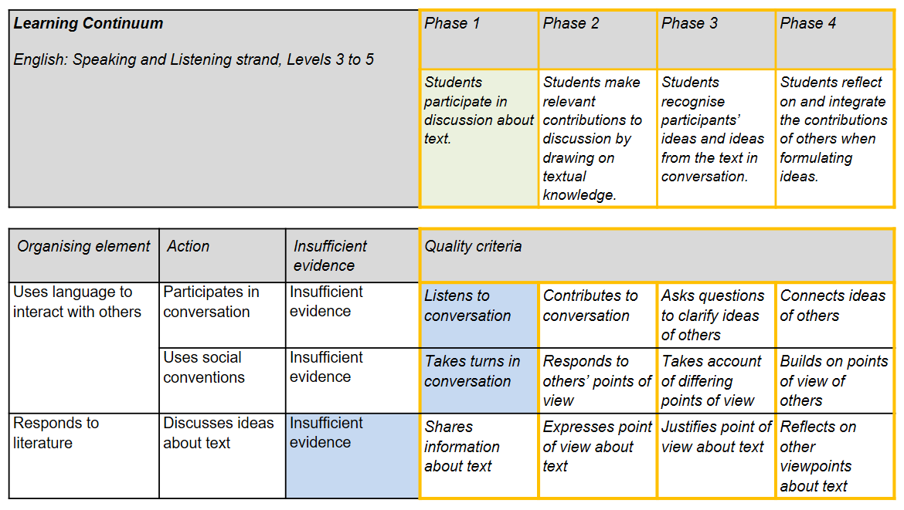
Example 8: Worked example: Literacy
Using evidence to plan for teaching and learning
Focusing on the students who are finding it difficult to share thoughts about a text, Carlos and his team decide that the learning intention for this group will be ‘to share information about the text’.
While the rest of the class completes self-guided activities, Carlos gathers this group on a weekly basis and together they read familiar stories. While they do so, Carlos asks questions of the students and gradually is able to scaffold their ability to share information about the texts under discussion.
After several weeks these students are reassessed in group discussion activities and their ability to share information has noticeably improved. This enables Carlos to assess the students as having met the learning intention and progressed on the learning continuum to having achieved phase 1. At this point, new learning intentions and activities based on phase 2 can be developed using the rubric.

Worked example: Numeracy
Setting the scene
Sarah is starting the measurement topic with her class. Initially, she wants to focus on how her students use scaled instruments. Sarah’s topic is based on content description ‘Use scaled instruments to measure and compare lengths, masses, capacities and temperatures’ (VCMMG165) from Level 4 of the Mathematics curriculum.
Parts 1 and 2: Describing a learning continuum and developing a formative assessment rubric
Last year, Sarah and her team developed a learning continuum and rubric for ‘using scaled instruments’. This is shown in Example 2. Sarah decides to reuse it again this year. She plans to start by using the learning continuum during the first lesson only, because all she needs at that stage is a broad idea of the starting points of her students. Once these starting points are established, she will use the detail within the rubric to help plan subsequent teaching and learning.
Part 3: Collecting, interpreting and using evidence to plan for teaching and learning
Sarah plans the first lesson of the topic so that students rotate through a number of hands-on activities, each aligned to a phase on the learning continuum. For example:
- Phase 2 activity: Students measure the lengths of different objects ranging from very small objects to very large ones. They have access to a 15cm ruler with 1mm markings, a 30cm ruler with 5mm markings, a metre ruler with 1cm markings, and a trundle wheel with 10cm markings. Students record the length of each object and the instrument used.
- Phase 3 activity: Students are asked to find the mass of large bags of rice, dried beans and chickpeas. The balance (scale) they are provided with has a maximum that is less than the mass of each of the bags. Students record the method they use to determine the mass as well as the final mass of the contents of each bag.
Students record their answers for each activity on a worksheet that Sarah collects at the end of the lesson.
Interpreting evidence of learning
After the first lesson, Sarah goes through the worksheets and decides the phases on the learning continuum that each student has achieved and is ready to learn, based on the frequency of correct answers associated with each phase.
When she gets to Jake’s worksheet, she notices that while he got all the answers correct for the phase 1 and 2 activities, he got all the answers incorrect for the phase 3 activity with the bags. At first glance, this looks like Jake has achieved phases 1 and 2 and is ready to learn phase 3. Looking closely, Sarah notices that Jake has used the expected method for the phase 3 activity and has split each large bag up, weighed the smaller amounts and then added them together to get the overall mass of each bag. She notices that all his measurements are correct, but he has made mistakes with the addition. This means that Jake has also achieved phase 3 (shown in blue) and is ready to be challenged and extended with learning activities based on phase 4 (shown in green). Sarah also notes down Jake’s problem with addition so she can address that another day.

Example 9: Worked example: Numeracy
Using evidence to plan for teaching and learning
Sarah structures the next week of lessons based on her formative assessment data for the class. In the first lesson, she groups students ready to learn phase 2 with students who have already achieved phase 2. These students have the following learning intentions, taken from the rubric:
- Students ready to learn phase 2: To learn to match the tool to the amount to be measured
- Students who have achieved phase 2: To quickly and accurately match the tool to the amount to be measured.
Sarah gets them to work collaboratively on a task measuring volumes with different volume-measuring tools. The grouping will give the students who are ready to learn phase 2 the opportunity to learn from the others and will give the students who have achieved phase 2 a chance to practise and automate the process. Students know the learning intention they are working on and what they will be expected to demonstrate at the end of the lesson to show that the goal has been achieved.
While this takes place, Sarah works with the students who are ready to learn phase 1, to support them to learn to select measuring tools matched to the property to be measured.
The students who are ready to be challenged and extended to learn phase 4 undertake an additional activity about how to improve the precision of their measurements.

Next steps for schools
Teachers and school leadership teams may use the following questions to guide their discussions around formative assessment and to support decisions about embedding formative assessment rubrics into school practice.

- Is best-practice formative assessment being undertaken in the classroom, in which
learning progression is explicitly articulated?
- Are the formative assessment practices outlined in this guide being developed and implemented in the classroom?
- Are there areas of the teaching and learning program where students are learning more complex skills or knowledge and where developing a more fine-grained description of learning progression would be useful?
- Is there a consistent approach to assessment in the school, supporting all teachers to gather and use evidence to support learning?
- Is there a collaborative process that embeds discussion and feedback on formative assessment practices?

Glossary
Achieved: The phase of a learning continuum at which a student can independently and consistently demonstrate skills and knowledge. Alternative term: Vygotsky’s Zone of Actual Development (ZAD).
Achievement standards: Statements that describe what students are typically able to understand and do, and that are the basis for reporting student achievement.
Action: A categorisation of what a student can do, say, make or write in demonstration of a particular knowledge and/or skill.
Content descriptions: Specific and discrete information identifying what teachers are expected to teach and students are expected to learn.
Curriculum continuum: A progression of knowledge and skills organised into learning areas and capabilities. The Victorian Curriculum F–10 contains multiple curriculum continuums.
Developmental taxonomy: A research-derived classification that describes developmental stages in generic skills and knowledge. For example: Bloom’s taxonomy, Structure of the Observed Learning Outcome (SOLO).
Granularity: The level of detail of knowledge and skills provided in a learning continuum.
Learning continuum: A progression of knowledge and skills derived from a curriculum. This can be developed by teachers and may consist of a selection of parts from a curriculum continuum, sometimes with more detail added.
Learning intentions: A brief statement that explicitly describes what students should know, understand and be able to do as a result of the learning and teaching.
Not yet ready to learn: The phase of a learning continuum for which a student does not have the required foundational knowledge or skills. Acquisition of these skills is required before the teaching of this phase should be attempted.
Organising elements: Strands are key organising elements within each curriculum area. Sub-strands are supplementary organising elements within some curriculum areas. Modes and focus areas may also be used as organising elements.
Phases: The increments in a learning continuum that detail the development typically seen in students as they become more proficient. Phase descriptions help teachers to recognise students at different points along the continuum.
Quality criteria: Criteria that describe the increasing sophistication of what a student can do, say, make or write, which align to the learning continuum.
Ready to learn: The phase of a learning continuum at which a student requires scaffolding to acquire skills and knowledge. Alternative term: Vygotsky’s Zone of Proximal Development (ZPD).
Rubric: An arrangement (usually in grid formation) of quality criteria according to actions that classify the development of competence in a complex set of skills and/or knowledge.
Scaffolding: The help and support given to a learner that is tailored to their needs and goals.

Further reading
Black, P 2012, ‘Paul Black describes peer and self assessment’. Retrieved from youtube.com/watch?v=NnqHERCFsWM

Department of Education and Training Victoria n.d., Professional practice Note 6 – Formative assessment. Retrieved from education.vic.gov.au/Documents/school/teachers/teachingresources/practice/Professional_practice_note_6_formative_assessment.pdf

Goss, P, Hunter, J, Romanes, D, Parsonage, H 2015, Targeted teaching: How better use of data can improve student learning. Grattan Institute, Melbourne. Retrieved from grattan.edu.au/wp-content/uploads/2015/07/827-Targeted-Teaching.pdf

Griffin, P 2018, Assessment for teaching. Port Melbourne, Vic. Cambridge University Press.

Masters, G 2013, Reforming educational assessment: Imperatives, principles and challenges (Australian Education Review No. 57). Retrieved from research.acer.edu.au/aer/12/

Maxwell, GS 2001, Teacher observation in student assessment. Queensland School Curriculum Council. Retrieved from qcaa.qld.edu.au/downloads/publications/research_qscc_assess_report_4.pdf

Reliable Rubrics n.d., Developing rubrics that really work. Retrieved from reliablerubrics.com/

WestEd n.d., Five evidence gathering routines. Retrieved from oregon.gov/ode/educator-resources/assessment/Documents/five_evidence_gathering_routines.pdf

Wiliam, D 2016, ‘Dylan Wiliam: Formative assessment’. Education Scotland. Retrieved from youtube.com/watch?v=sYdVe5O7KBE

Appendix: Victorian Curriculum F–10 structure | 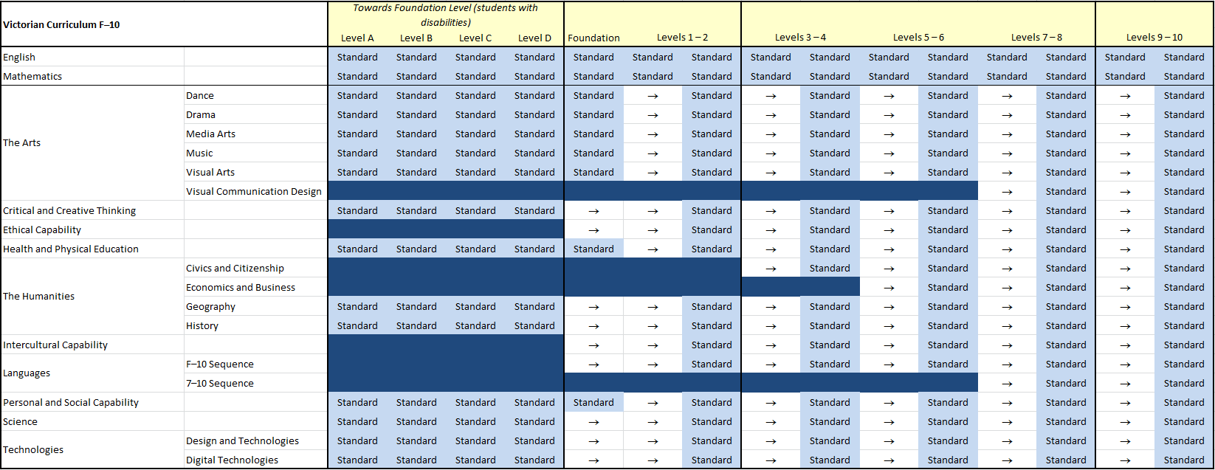 | Note: Achievement standard is referred to as ‘standard’ in this table.

