**Using formative assessment rubrics in Digital Technologies**



Digital Systems

Levels 7 and 8

Authorised and published by the Victorian Curriculum and Assessment Authority  
Level 7, 2 Lonsdale Street  
Melbourne VIC 3000

© Victorian Curriculum and Assessment Authority 2019.

No part of this publication may be reproduced except as specified under the *Copyright Act 1968* or by permission from the VCAA. Excepting third-party elements, schools may use this resource in accordance with the [VCAA educational allowance](https://www.vcaa.vic.edu.au/Footer/Pages/Copyright.aspx#schools). For more information go to: <https://www.vcaa.vic.edu.au/Footer/Pages/Copyright.aspx>.

The VCAA provides the only official, up-to-date versions of VCAA publications. Details of updates can be found on the VCAA website: [www.vcaa.vic.edu.au](http://www.vcaa.vic.edu.au).

This publication may contain copyright material belonging to a third party. Every effort has been made to contact all copyright owners. If you believe that material in this publication is an infringement of your copyright, please email the Copyright Officer: [vcaa.copyright@edumail.vic.gov.au](mailto:vcaa.copyright@edumail.vic.gov.au)

Copyright in materials appearing at any sites linked to this document rests with the copyright owner/s of those materials, subject to the Copyright Act. The VCAA recommends you refer to copyright statements at linked sites before using such materials.

At the time of publication the hyperlinked URLs (website addresses) in this document were checked for accuracy and appropriateness of content; however, due to the transient nature of material placed on the web, their continuing accuracy cannot be verified.

The VCAA logo is a registered trademark of the Victorian Curriculum and Assessment Authority.

**Contents**

What is formative assessment? 4

Using formative assessment rubrics in schools 4

The formative assessment rubric 5

Links to the Victorian Curriculum F–10 5

The formative assessment task 7

Description of the tasks (administration guidelines) 7

Evidence collected from the tasks 8

Interpreting evidence of student learning 9

Setting the scene 9

Sample 1 10

Any feedback given 12

Sample 2 13

Any feedback given 16

Sample 3 17

Sample 3: Evidence of student learning 20

Any feedback given 20

Sample 4 21

Sample 4: Evidence of student learning 25

Sample 5 26

Sample 5: Evidence of student learning 30

Any feedback given 30

Teacher reflections 31

What is formative assessment?

Formative assessment is any assessment that is used to improve teaching and learning. Best-practice formative assessment uses a rigorous approach in which each step of the assessment process is carefully thought through.

Assessment is a three-step process by which evidence is collected, interpreted and used. By definition, the final step of formative assessment requires a use that improves teaching and learning.

For the best results, teachers can work together to interrogate the curriculum and use their professional expertise and knowledge of their students to outline a learning continuum including a rubric of measurable, user-friendly descriptions of skills and knowledge. Teachers can draw on this learning continuum and rubric to collect evidence of each student’s current learning in order to provide formative feedback and understand what they are ready to learn next.

The VCAA’s *Guide to Formative Assessment Rubrics* outlines how to develop a formative assessment rubric to collect, interpret and use evidence of student learning to plan teaching and learning. For more information about formative assessment and to access a copy of the guide, please go to the [Formative Assessment section](https://www.vcaa.vic.edu.au/foundation10/Pages/viccurriculum/formative_assessment.aspx) of the VCAA website.

Using formative assessment rubrics in schools

This document is based on the material developed by one group of teachers in the 2019 Formative Assessment Rubrics project. The VCAA acknowledges the valuable contribution to this resource of the following teachers: Daryl Croke (Mount Ridley P-12 College) and Mark Addison (Mount Ridley P-12 College). The Victorian Curriculum and Assessment Authority partnered with the Assessment Research Centre, University of Melbourne, to provide professional learning for teachers interested in strengthening their understanding and use or formative assessment rubrics.

This resource includes a sample formative assessment rubric and task and describes how the teachers implemented the task in their schools and also includes representative student work samples.

Schools have flexibility in how they choose to use this resource, including as:

* a model that they adapt to suit their own teaching and learning plans
* a resource to support them as they develop their own formative assessment rubrics and tasks.

This resource is not an exemplar. Schools are advised to consider whether the sample formative assessment rubric and task meet the needs of their student cohort and is appropriate in the context of their whole-school teaching and learning plan. Additional support and advice on high-quality curriculum planning is available from the [Curriculum Planning Resource](http://curriculumplanning.vcaa.vic.edu.au/).

The formative assessment rubric

The rubric in this document was developed to help inform teaching and learning in Digital Technologies. This rubric supports the explicit teaching of the following aspects of Digital Systems including:

* how digital devices can form wired, wireless and mobile networks
* how computers can form networks
* how devices transmit data in networks
* how devices access networks by identifying key components
* the differences between networks
* why different networks are designed or used
* how networks and components meet the needs of users.

Please note this rubric does not include the assessment of network security, protocols or advanced topology.

Links to the Victorian Curriculum F–10

**Curriculum area:** Digital Technologies

Strand: Digital Systems

**Levels/Bands:** Levels 7 and 8

**Achievement standard/s extract:** Level 5 and 6:

By the end of Level 6, students explain the functions of digital systems components and how digital systems are connected to form networks and transmit data

Levels 7 and 8:

By the end of Level 8, students distinguish between different types of networks and their suitability in meeting defined purposes.

**Content Description/s:** Level 5 and 6

Examine the main components of common digital systems, and how such digital systems may connect together to form networks to transmit data [(VCDTDS026)](https://victoriancurriculum.vcaa.vic.edu.au/Curriculum/ContentDescription/VCDTDS026).

Level 7 and 8:

Investigate how data is transmitted and secured in wired, wireless and mobile networks [(VCDTDS035)](https://victoriancurriculum.vcaa.vic.edu.au/Curriculum/ContentDescription/VCDTDS035).

|  |  |  |  |  |  |  |
| --- | --- | --- | --- | --- | --- | --- |
| **Learning continuum**  Digital Technologies  Digital Systems  Levels 7 and 8 | | | **Phase 1** | **Phase 2** | **Phase 3** | **Phase 4** |
| Students identify and describe how computers and components connect together to form a network. | Students explore different types of networks. | Students describe a range of network components and network types. | Students investigate the suitability of networks and components to meet a defined purpose. |
|  | | | | | | |
| **Organising element** | **Action** | **Insufficient evidence** | **Quality criteria** | | | |
| Understands how computers and components form a network. | 1. Describes a network | 1.0 Insufficient evidence | 1.1 Describes how computers connect to form a network. | 1.2 Draws diagrams to illustrate different types of networks. | 1.3 Describes the differences between wired, wireless and mobile networks. |  |
| 2. Describes the use of components in a network | 2.0 Insufficient evidence | 2.1 Describes how different devices connect to form a network. |  |  | 2.2 Investigates how different types of components can access different networks. |
| User needs | 3. Describes how different components will meet different needs in a network | 3.0 Insufficient evidence |  |  | 3.1 Explains why different types of networks are designed or used. | 3.2 Investigates how different components and networks can meet the needs of users. |

The formative assessment task

The following formative assessment task was developed to elicit evidence of each student’s current learning and what they are ready to learn next.

Description of the tasks (administration guidelines)

**Pre-requisite skills**

Students require prior knowledge of the following Information Communication Technologies (ICT) skills:

* using a simple drawing program to generate a network diagram made up of simple shapes and lines
* ability to copy and paste a drawing into a word document
* creating a folder on a network drive or personal device
* ability to save and upload a file into a folder.

**Instructions**

There a series of tasks designed to enable the student to demonstrate their understanding of digital systems. These are undertaken throughout a unit of work comprising 6 one hour lessons.

The students were provided with the tasks in an electronic format.

|  |  |
| --- | --- |
| **Action 1: Describes a network** | |
| **Task 1**: A written description and/or a basic diagram showing how computers can connect to create a network. | * 1.1 Describes how computers connect to form a network. (Phase 1) |
| **Task 2**: Students show a mobile network, a wireless network and a wired network. The diagram includes central components such as a cell tower (mobile network), a wireless router or Wireless Access Point (wireless network) and a wired router or switch (wired network). The diagram also shows some understanding of how data is transmitted. For example, a dotted line for radio waves or a solid line indicating cables in a wired network.  The students can use a drawing program, such as MS Visio, to draw a simple computer network. | * 1.2 Draws diagrams to illustrate different types of networks (Phase 2). |
| **Task 3**: This could take the form of a written response identifying key components and some explanation of transmission. It could also be a diagram showing the differences between networks, for example, a Venn diagram. | * 1.3 Describes the differences between wired, wireless and mobile networks.(Phase 3) |

|  |  |
| --- | --- |
| **Action 2: Describes the use of components in a network** | |
| **Task 4**: An explanation of key components in a network and their relationship. For example, in wireless networks laptops transmit data to a wireless router via radio waves | * 2.1 Describes how different devices connect to form a network.(Phase 1) |
| **Task 5**: Students identify key components that allow devices to access various networks. For example, stating that an antenna in a mobile phone allows the transmission of radio waves to a cell tower in a mobile network, or that a Network Interface Card in a desktop computer sends a signal via a cable to a switch in a wired network. | * 2.2 Investigates how different types of components can access different networks.(Phase 4) |
| **Action 3: Describes how different components will meet different needs in a network** | |
| **Task 6**\*: This may take the form of a response to a case study or scenarios where students explain the best network and devices in response to a need. For example, explaining the type of networks that would best support a junior class using tablets to draw simple diagrams, or what type of network and devices would best support a senior media class needing to use powerful video editing software. | * 3.1 Explains why different types of networks are designed or used. (Phase 3) |
| **Task 7**\*: Students might investigate and describe simple methods of allowing devices to have access to networks. Students may also be able to explain some basic strategies, such as the need for usernames, passwords and device identification. | * 3.2 Investigates how different components and networks can meet the needs of users.(Phase 4) |

* The last two tasks were designed to extend some students with their higher-order thinking skills.

Evidence collected from the tasks

* A written description of a network and/or a drawing of a simple network
* A drawing of different types of networks
* mobile networks
* wireless networks
* wired networks
* A description of the differences between different types of networks in the form of a diagram or a written description
* An explanation of how different devices connect to form a network
* An explanation of how different components can access different networks
* An explanation of why different types of networks are used
* An explanation of how different networks and components meet the needs of users

Interpreting evidence of student learning

Evidence collected from each student was mapped against the rubric:

The quality criteria that were achieved was shaded in blue.

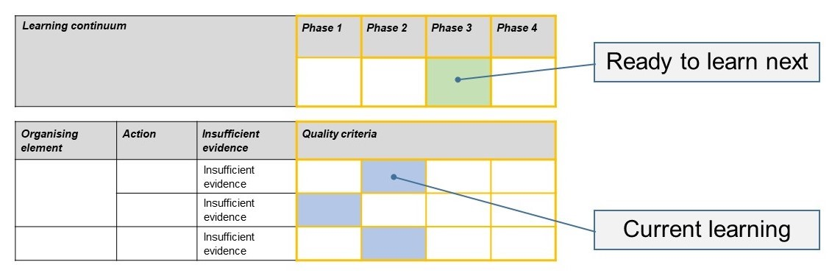The phase that the student is ready to learn next was shaded in green.

Please note, the following annotated student work samples are representative examples only.

Setting the scene

The following work samples were collected from a large Prep to Year 12 public school (2500 students) in a growth area on the outskirts of Melbourne. The school has a large English as an Additional Language (EAL) and refugee population. Adjustments were made to cater for EAL students, for example, assisting them to develop definitions by using key words. Diagrams were also used to demonstrate the understanding of concepts.

The tasks were given to Year 8 students using a dedicated subject website in a one-to-one desktop computer lab. The teacher uses verbal, written, visual instructions and short videos to explicitly teach concepts. Students used Office 365 to submit work online. Diagrams were created using online drawing tools.

The classes took place at the beginning of a semester-long subject. For many students, this was their first introduction to learning in Digital Technologies so time was taken to cover ICT skills, an understanding of computer concepts, and to familiarise students with the online learning environment.

The school has a priority of improving literacy and numeracy outcomes. Therefore there was a focus using on precise vocabulary to develop a greater understanding and to promote literacy in general.

The following samples do not always include all seven tasks. They include the tasks where a student provided:

* evidence of understanding and their attempt at the next task for the specific action
* insufficient evidence on the task designed to elicit understanding at the lowest level for the action e.g. 1.1, 2.1, and 3.1.

Sample 1

**Focus**  
Investigate wired, wireless and mobile networks.

**Task 1**  
Describe a computer network in your own words.

A computer network is a network that collects information and shares it to others. For example, From one computer, to a router to another computer. So, it’s a distributed network

Use draw.io to create a diagram of a very simple computer network (copy and paste illustration below)

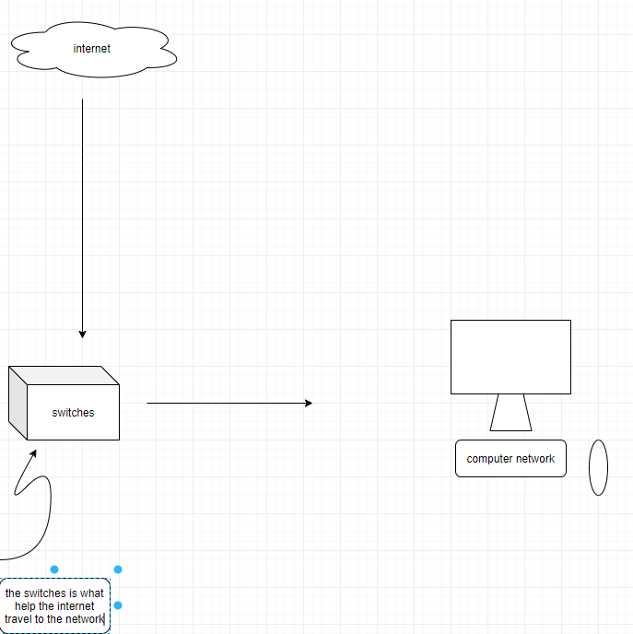

[Teacher annotation: 1.1 – Student described computer networks using key words and using a network diagram.

**Task 2**

Draw diagrams to illustrate different types of networks (wired, wireless and mobile)



[Teacher annotation: 1.2 Although the student identified many network components, there is no indication of how the networks could share data or the type of networks.]

**Task 3 – not included**

**Task 4**

Describe how different devices connect to form a network

Distributed network

Centralized network

[Teacher annotation: 2.1 Student did not give any explanation of how devices could form a network.]

**Task 5 – not included**

**Task 6**

Explain why different types of networks are designed or used.

To collect/share information

Entertainment

[Teacher annotation: 3.1 Not sufficient evidence in this response. The student is starting to understand the purposes of information but not demonstrating **why** networks are **designed** or **used**.]

Sample 1: Evidence of student learning

What is the student ready to learn next?

Student has only satisfied the first criterion for Action 1, although they attempted tasks for the other two Actions. Whilst this student may be ready to progress to Phase 2 within Action 1 they have shown insufficient evidence for Action 2. It is important that this student is supported to consolidate their understanding of the simpler concepts before progressing.

Any feedback given

The student responses were discussed with the student explaining the need to be clear about how networks operate. They have been encouraged to explain terminology and add connections between diagrams to demonstrate their understanding.

Sample 2

**Focus**  
Investigate wired, wireless and mobile networks

**Task 1**  
Describe a computer network in your own words.

(No written response provided by the student)

Use draw.io to create a diagram of a very simple computer network (copy and paste illustration below)

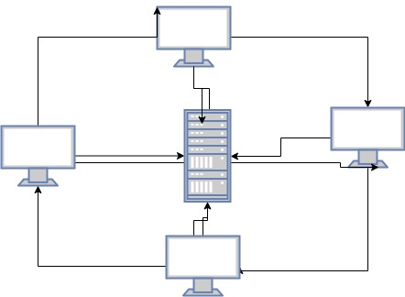

[Teacher annotation: 1.2 Student described a computer network using a simple diagram.]

**Task 2**

Draw diagrams to illustrate different types of networks (wired, wireless and mobile)

[Teacher annotation: No diagram was submitted by the student, but they did attempt Task 3.]

**Task 3**

Draw diagrams to illustrate different types of networks (wired, wireless and mobile)

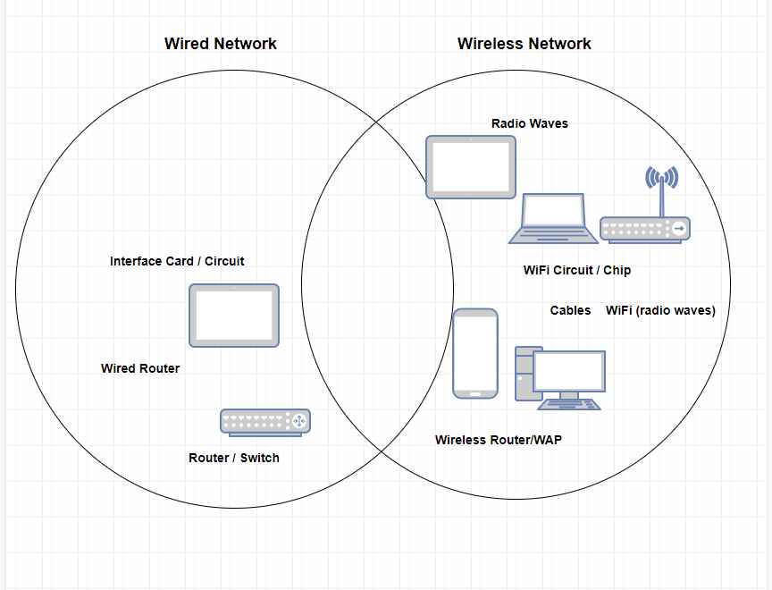

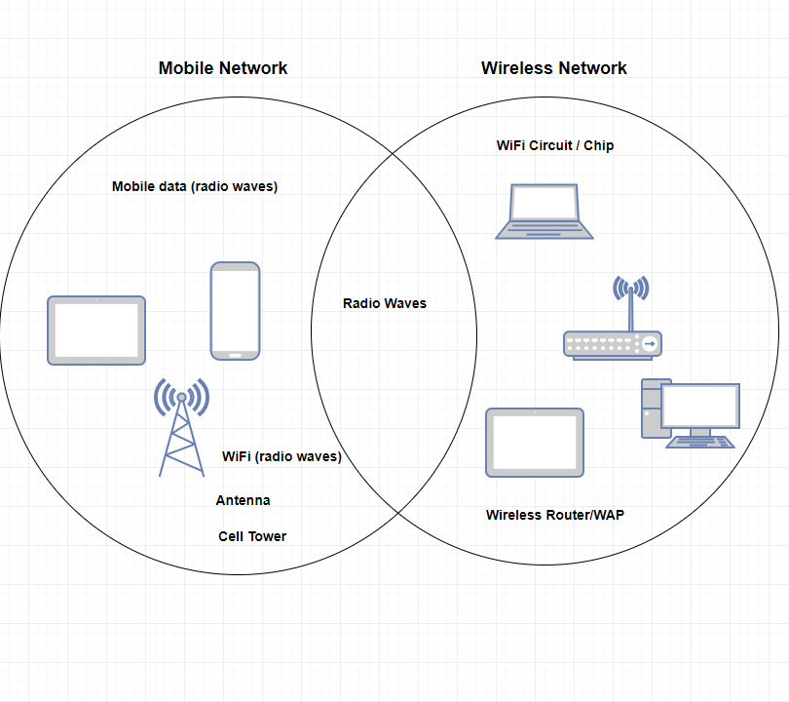

[Teacher annotation: 1.3 – Student demonstrated the differences between different types of networks by using Venn diagrams. Whilst a diagram was not supplied to show different network types (Task 2) the above responses provided sufficient evidence of achieving 1.2 and 1.3. ]

**Task 4**

Describe the differences between wired, wireless and mobile networks

A wireless network requires multiple layers of encryption.

A wired network is used to carry different forms of electrical signals from one end to the other.

A mobile network

[Teacher annotation: 2.1 – The descriptions supplied are incomplete and do not explain the differences between the network types.

This student did not submit responses to any further tasks.

**Sample 2: Evidence of student learning**

What is the student ready to learn next?

The student was able to describe the differences between wired, wireless and mobile nextworks using a Venn diagram and this is Phase 3 in Action 1. Whilst Phase 1 has been identified as what this student is ready to learn next, they need to be given the opportunity to achieve the earlier phase in Action 2. Missing this understanding will make their next learning steps difficult.

Any feedback given

Positive feedback provided to the student about their ability to describe networks and explained this is a good basis for describing the components of networks and how networks meet different needs. The completion of the other tasks will enable the teacher to gather evidence of understanding.

Sample 3

**Focus**  
Investigate wired, wireless and mobile networks

**Task 1**

Describe a computer network in your own words.

A network is a collection of devices that are connected together to share Data.

Use draw.io to create a diagram of a very simple computer network (copy and paste illustration below)

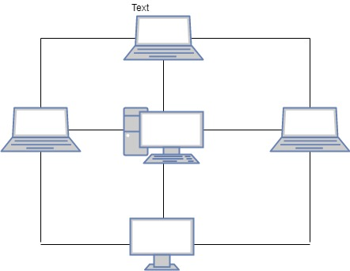

[Teacher annotation: 1.1 Student described computer networks in their own words and by using a diagram.]

**Task 2**

Draw diagrams to illustrate different types of networks (wired, wireless and mobile)

[Teacher annotation: No diagram was submitted by the student, but they did attempt Task 3.]

**Task 3**

Describe the differences between wired, wireless and mobile networks

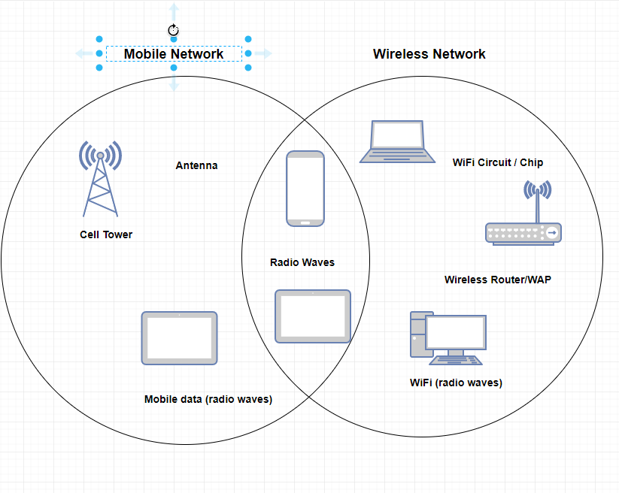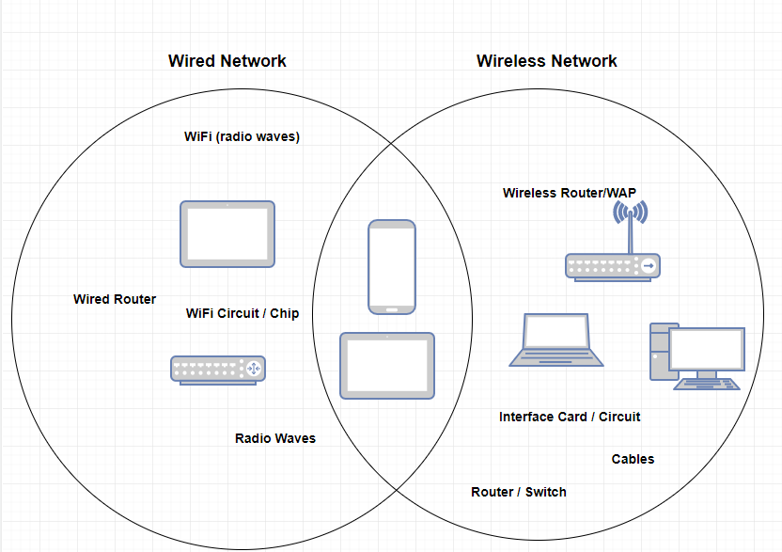

Teacher annotation: 1.3 Student clearly demonstrated the differences between different types of networks by using Venn diagrams. Whilst a diagram was not supplied to show different network types (Task 2) the above responses provided sufficient evidence of achieving 1.2 and 1.3. ]

**Task 4**

Describe how different devices connect to form a network

A mobile network is made up of Ipad , cell tower and a phone.

A wireless network is made up of laptop, router and computer.

[Teacher annotation: 2.1 Student described how different devices connect to form a network.]

**Task 5**

Investigate how different types of components can access different networks

Laptop is internal by Wifi chip to transmits by radio waves to wireless

Router or switch Desktop is internel by wifi circuit , transmit by radio waves to wireless router or a wirless

[Teacher annotation: 2.2 Student clearly explained how components access different networks by identifying the network interface and transmission media. For example, the student identifies a Wi-Fi chip and radio waves for a wireless network.]

**Task 6**

Explain why different types of networks are designed or used.

Mobile network only use for Ipad and phone.

Wirless Network only use for laptop and computer.

[Teacher annotation: 3.1 Insufficient evidence. The student identified different networks but did not explain why they were used or designed.]

Sample 3: Evidence of student learning

What is the student ready to learn next?

This student is ready to learn Phase 3, focusing on Action 3.1.

Any feedback given

Being able to describe a network and a sound understanding of the components access different networks will support you to explore how different networks can meet user needs.

Sample 4

**Focus**  
Investigate wired, wireless and mobile networks

**Task 1**

Describe a computer network in your own words.

A network is arrangement of interecting that are connection to the device together to share data.

Use draw.io to create a diagram of a very simple computer network (copy and paste illustration below)

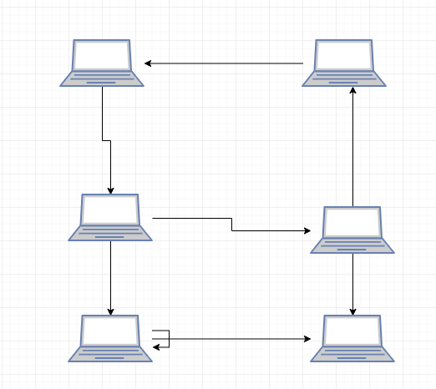

[Teacher annotation: 1.1 The student has described a computer network in words and with a diagram.]

**Task 2**

Draw diagrams to illustrate different types of networks (wired, wireless and mobile)

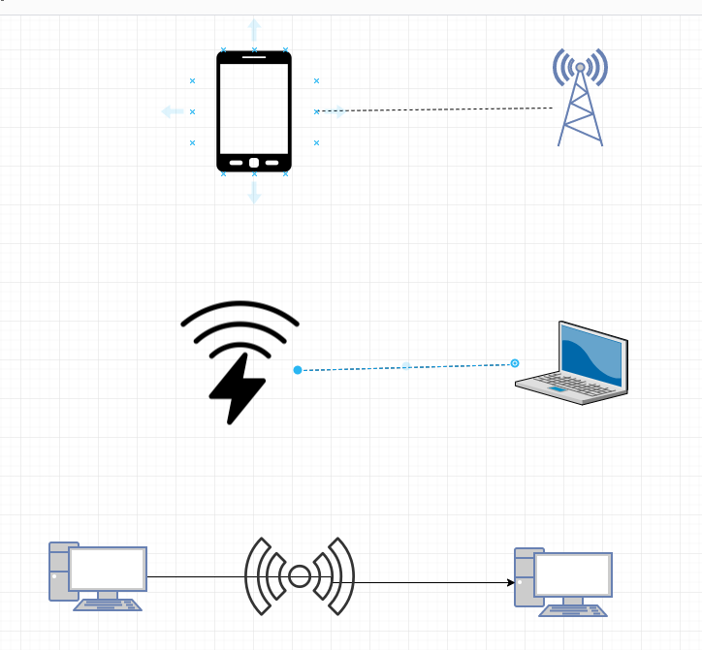

[Teacher annotation: 1.2 – Although the student did not show wired, wireless and mobile networks in the diagram above, they previously created a diagram of a wired network.]

**Task 3**

Describe the differences between wired, wireless and mobile networks

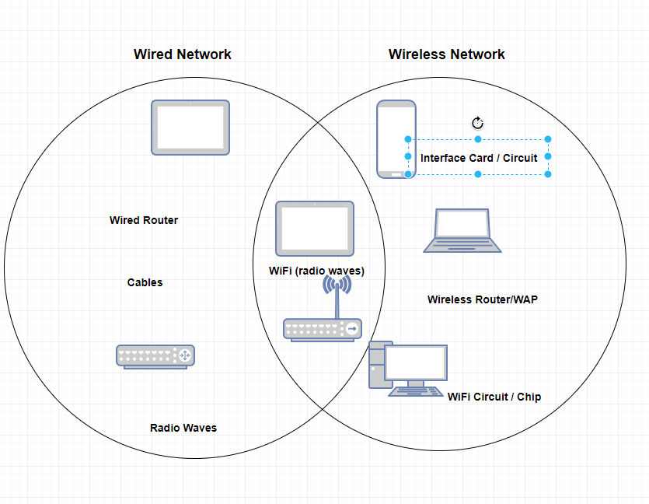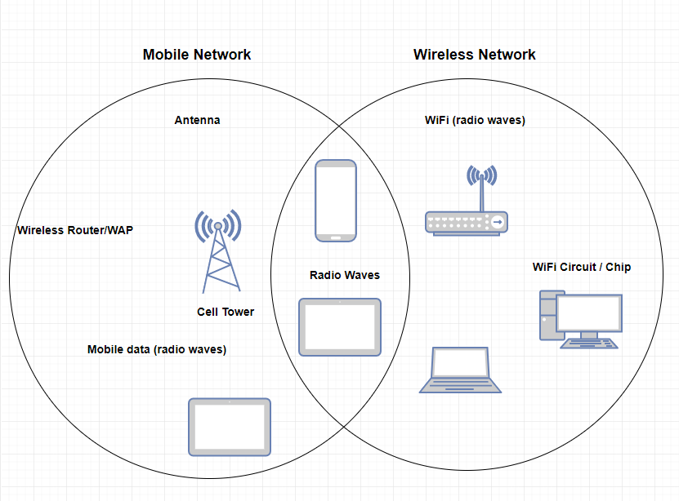

[Teacher annotation: 1.3 – Using a Venn diagram the student clearly showed the differences between wireless networks and mobile networks.

**Task 4**

Describe how different devices connect to form a network

A mobile network is made up of Ipad, cell tower and a phone.

A wireless network is made up of and, laptop , router and an computer.

[Teacher annotation: 2.1 – The student described how different components connect to form networks. They identified the user device and the key sharing components, for example cell tower or router.

**Task 5**

Investigate how different types of components can access different networks

Laptop is internal by WiFi chip transmits by radio waves to wireless router or switch.

Desktop is internal by WiFi circuit , transmit by radio waves to wireless router or a Wireless

Access Point.

[Teacher annotation: 2.2 – Student clearly described how different components could access different networks. For example, they identified a Wi-Fi chip in a laptop, and radio waves to connect to a wireless router.]

**Task 6**

Explain why different types of networks are designed or used.

Mobile network is only used for Ipad and Phone.

Wireless network is only used for Laptop and Computer.

[Teacher annotation: 3.1 – Student did not clearly explain why different networks are designed or used.]

**Task 7**

Investigate how different components and networks can meet the needs of users

We use computer when we have digitech subject. We use Ipads when we are in normal subject like mathes or English etc. we used laptop when we are need to research our work our do something alse in any subject. But all of those we used it to research and write some note from the teacher with a permition , not without a permition

[Teacher annotation: 3.2 – Although they provided examples in their answer, the student did not articulate how different networks and devices combined can meet the needs of users.]

Sample 4: Evidence of student learning

What is the student ready to learn next?

This student has achieved most of the criteria, but this student will need to show understanding of Action 3.

**Any feedback given**

The next step is to explain why different networks are designed and used and how different networks can meet user needs. When this is achieved the student will be encouraged to move on to investigate and explain how data is secured in networks.

Sample 5

**Focus**

Investigate wired, wireless and mobile networks

**Task 1**  
Describe a computer network in your own words.

A linked network to transfer data from a collection of digital systems.

Use draw.io to create a diagram of a very simple computer network (copy and paste illustration below)

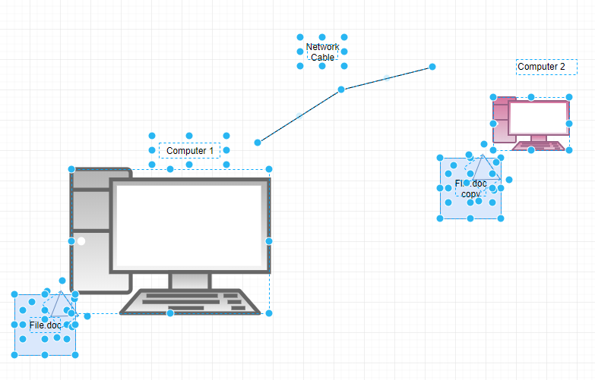

[Teacher annotation: 1.1 – Student described computer networks in words and using a diagram.]

**Task 2**

Draw diagrams to illustrate different types of networks (wired, wireless and mobile)

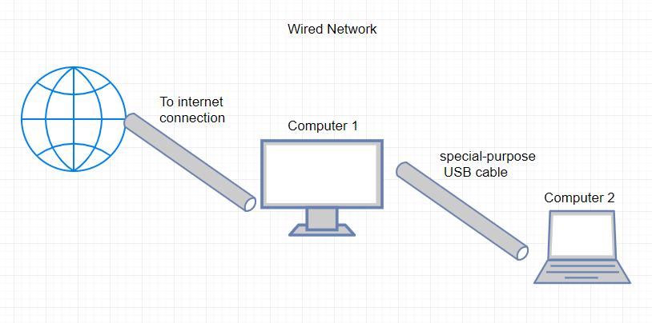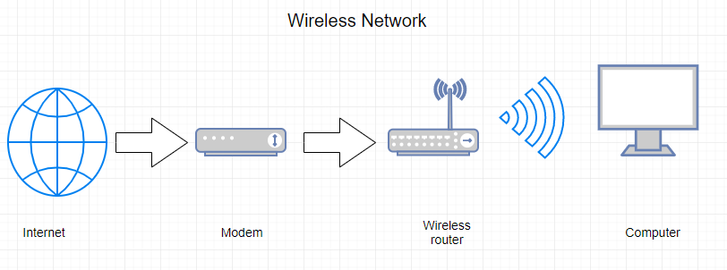

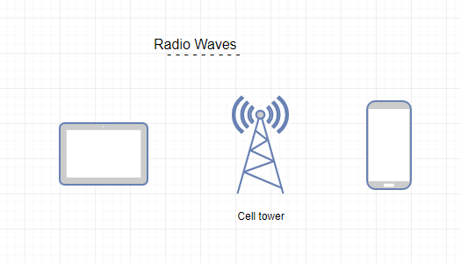

[Teacher annotation: 1.2 – Student showed mobile, wired and wireless networks using diagrams.]

**Task 3**

Describe the differences between wired, wireless and mobile networks

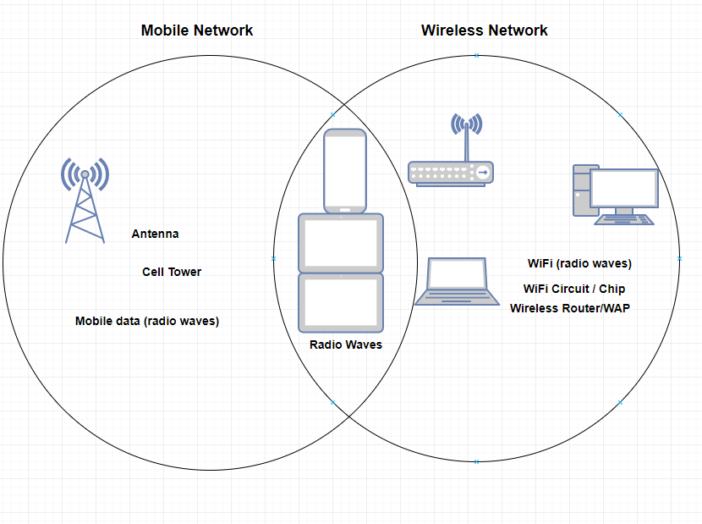

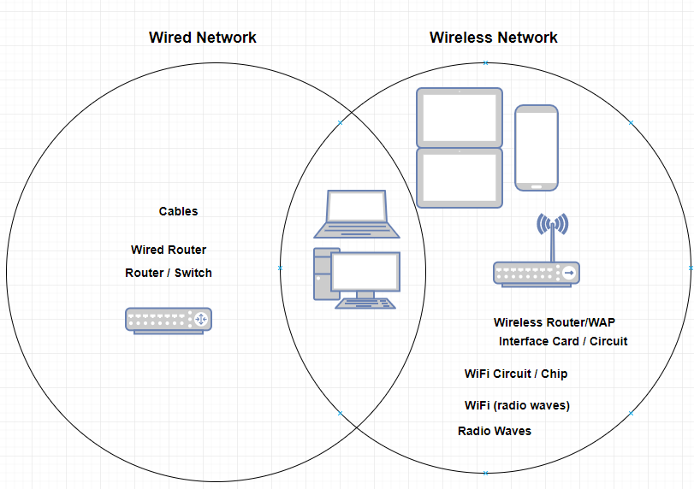

[Teacher annotation: 1.3 Using a Venn diagrams the student clearly showed the differences between wired networks, wireless networks and the differences between wireless networks and mobile networks.]

**Task 4**

Describe how different devices connect to form a network

For Mobile networks, you need a mobile to transmit radio waves to connect to the cell tower.

For Wireless networks, you need to connect your computer to a wireless router which then connects to a modem. The modem connects you to the internet

For Wired networks, you need to plug in a wire to your computer to access the internet. If you want to connect to another computer, you must use a special-purpose USB cable

[Teacher annotation: 2.1 Student clearly described how different components connect to form a network.]

**Task 5**

Investigate how different types of components can access different networks

A wired network uses wires to connect to the internet and other computers, while wireless networks need you to a wireless router that can connect to a modem. Mobile networks use radio waves to connect to cell towers to contact other mobile phones

[Teacher annotation: 2.2 Although the student provided a lengthy answer, they did not adequately explain how the device itself could connect to a network. For example they didn’t identify any network cards, WiFi circuits or antennas.]

**Task 6**

Explain why different types of networks are designed or used.

Mobile networks are used so that you can easily send messages and do calls.

Wireless networks are used so you don’t have to plug in your computer to access internet.

Wired networks are used so you can access the internet easily.

[Teacher annotation: 3.1 Student clearly explained why different networks are used.]

**Task 7**

Investigate how different components and networks can meet the needs of users

A mobile network example is, if you are in an emergency and there are no emergency phones nearby, you can make an emergency call from your mobile phone. The phone will contact the nearest cell tower to make your call go through to the emergency services.

A wireless network example is, if you want to connect to the Wi-Fi, but do not have a connection to the internet, you can find out if there is a wireless router and modem in the building to connect without having to use wires.

A wired network example is, if you need to connect your desktop to the internet but there are no modems or wireless router near you, you can plug your computer into a wire that connects you to the internet.

[Teacher annotation: 3.2 Student clearly investigated how different components and networks can meet the needs of users by providing scenarios showing mobile networks, wireless networks and wired networks.]

Sample 5: Evidence of student learning

What is the student ready to learn next?

This student has demonstrated nearly all the criteria and is ready to learn Phase 4, in Action 2.

Any feedback given

The next step would be to identify the network interface components inside devices, for example, a WIFI circuit inside a laptop. This student can then move on to investigate and explain how data is secured in networks.

Teacher reflections

The next time I teach this unit and use this rubric, I will revisit the way I explain the differences between networks and how devices access networks. In addition, a range of activities could be developed to target this area. For example using different devices to physically make a network.

I would also consider providing additional time to focus on developing the background ICT skills using explicit teaching, modelling and vocabulary.

The data demonstrated that many students don’t learn in a linear way. There were gaps in their understanding and some students attempted the task without the necessary skills or knowledge.

A formative assessment rubric could be used to support learning in other introduction units in Digital Technologies, such as an introduction to algorithms or creating visuals design and applying basics design principles.

With careful scaffolding, EAL students can develop an adequate understanding of computer networks using correct terminology. However, many students still struggle with the use of technology and English to adequately demonstrate an understanding of the differences between different computer networks. Consideration of the time needed, the amount of content and the best instructional practice are vital to progress student learning.