Using formative assessment rubrics in History

Continuity and change

Levels 9–10

Authorised and published by the Victorian Curriculum and Assessment Authority
Level 7, 2 Lonsdale Street
Melbourne VIC 3000
© Victorian Curriculum and Assessment Authority 2020.

No part of this publication may be reproduced except as specified under the Copyright Act 1968 or by permission from the VCAA. Excepting third-party elements, schools may use this resource in accordance with the VCAA educational allowance. For more information go to: https://www.vcaa.vic.edu.au/Footer/Pages/Copyright.aspx.
The VCAA provides the only official, up-to-date versions of VCAA publications. Details of updates can be found on the VCAA website: www.vcaa.vic.edu.au.
This publication may contain copyright material belonging to a third party. Every effort has been made to contact all copyright owners. If you believe that material in this publication is an infringement of your copyright, please email the Copyright Officer: vcaa.copyright@edumail.vic.gov.au
Copyright in materials appearing at any sites linked to this document rests with the copyright owner/s of those materials, subject to the Copyright Act. The VCAA recommends you refer to copyright statements at linked sites before using such materials.
At the time of publication the hyperlinked URLs (website addresses) in this document were checked for accuracy and appropriateness of content; however, due to the transient nature of material placed on the web, their continuing accuracy cannot be verified.

The VCAA logo is a registered trademark of the Victorian Curriculum and Assessment Authority.

Contents
What is formative assessment? 4
Using formative assessment rubrics in schools 4
The formative assessment rubric 5
Links to the Victorian Curriculum F–10 5
The formative assessment task 7
Description of the task (administration guidelines) 7
Evidence collected from this task 7
Interpreting evidence of student learning 8
Setting the scene 8
Sample 1 9
Sample 1: Evidence of student learning 10
Any feedback given 10
Sample 2 11
Sample 2: Evidence of student learning 13
Any feedback given 13
Using evidence to plan for future teaching and learning 14
Teacher reflections 14
Appendix 1: Templates 15
Appendix 2: Rights & Freedoms Timeline 17

What is formative assessment?
Formative assessment is any assessment that is used to improve teaching and learning. Best-practice formative assessment uses a rigorous approach in which each step of the assessment process is carefully thought through.
Assessment is a three-step process by which evidence is collected, interpreted and used. By definition, the final step of formative assessment requires a use that improves teaching and learning.
For the best results, teachers can work together to interrogate the curriculum and use their professional expertise and knowledge of their students to outline a learning continuum including a rubric of measurable, user-friendly descriptions of skills and knowledge. Teachers can draw on this learning continuum and rubric to collect evidence of each student’s current learning in order to provide formative feedback and understand what they are ready to learn next.
The VCAA’s Guide to Formative Assessment Rubrics outlines how to develop a formative assessment rubric to collect, interpret and use evidence of student learning to plan teaching and learning. For more information about formative assessment and to access a copy of the guide, please go to the Formative Assessment section of the VCAA website.

Using formative assessment rubrics in schools
This document is based on the material developed by one group of teachers in the 2019 Formative Assessment Rubrics project. The VCAA acknowledges the valuable contribution to this resource of the following teachers: Chevelle Alderton (Ashwood High School) and Jessica Fischmann (Brighton Secondary College). The Victorian Curriculum and Assessment Authority partnered with the Assessment Research Centre, University of Melbourne, to provide professional learning for teachers interested in strengthening their understanding and use or formative assessment rubrics.
This resource includes a sample formative assessment rubric and task and describes how the teachers implemented the task in their schools and also includes representative student work samples.
Schools have flexibility in how they choose to use this resource, including as:
- a model that they adapt to suit their own teaching and learning plans
- a resource to support them as they develop their own formative assessment rubrics and tasks.
This resource is not an exemplar.
Additional support and advice on high-quality curriculum planning is available from the Curriculum Planning Resource.

The formative assessment rubric
The rubric in this document was developed to help inform teaching and learning in the Humanities: History. This rubric supports the explicit teaching of continuity and change including:
- recognising and describing continuity, when something has remained the same over time and the reasons for continuities and there impacts
- recognising and describing change, when and why change occurred, the reasons for change and its impacts

Links to the Victorian Curriculum F–10

Curriculum area: Humanities: History
Strands: Historical Knowledge, and Historical Concepts and Skills
Sub-strands: The modern world and Australia, Chronology, Continuity and Change
Levels/Bands: Levels 9 and 10
Achievement standard/s extract: Students identify and evaluate the patterns of change and continuity over time…
Students sequence events and developments within a chronological framework, and identify relationships between events across different places and periods of time …They evaluate different historical interpretations and contested debates. Students construct and communicate an argument about the past using a range of reliable sources of evidence.
Content Description/s: Analyse and evaluate the broad patterns of change over the period 1750–present (VCHHC122).
Identify and evaluate patterns of continuity and change in the development of the modern world and Australia (VCHHC126).
Continuity and change for Aboriginal and Torres Strait Islander peoples in securing and achieving civil rights and freedoms in Australia (VCHHK156).

Learning continuum  History  Levels 9 and 10  Sub-strands: The modern world and Australia, Chronology, Continuity and Change |  |  | Phase 1 | Phase 2 | Phase 3 | Phase 4
 |  |  | Students recognise continuity and change. | Students describe continuity and change. | Students identify reasons for continuity and change. | Students explain the impacts of continuity and change.
Organising element | Action | Insufficient evidence | Quality criteria
1 Identifying continuity and change | 1 Identifying continuity | 1.0 Insufficient evidence | 1.1 Recognise examples of continuity. | 1.2 Describe a continuity. | 1.3 Identify the reasons for continuity. | 1.4. Explain the impacts of continuity.
 | 2 Identifying change | 2.0 Insufficient evidence | .2.1 Recognise examples of change. | 2.2 Describe a change. | 2.3 Identify the reasons for change. | 2.4 Explain the impacts of change.

The formative assessment task
The following formative assessment task was developed to elicit evidence of each student’s current learning and what they are ready to learn next in relation to identifying and evaluating patterns of change and continuity over time.

Description of the task (administration guidelines)

This task requires making a continuity and change timeline and responding to an evaluation question (see Appendix 1). There are three steps. Teachers are advised to print the resource in A3 so students will have as much room as possible to record their responses.
Step 1: Plotting events on the timeline
- Provide students with the ‘Rights and Freedoms’ timeline’. Explain that the timeline includes the terms ‘progress’ and ‘decline’ and unpack the two examples provided.
- Ask students to decide where they will place their events on the timeline considering when it occurred and whether it provides an example of progress or decline.
Step 2: Adding annotations
- Students add annotations to justify their placements of events on the timeline.
- Ask students to demonstrate in their annotations how each placement is an example of change or continuity.
Step 3: Answering an evaluation question
- Ask students to respond to the question: ‘Using your notes, evaluate to what extent this period represented ‘continuity’ and to what extent this period represented ‘change’.
- Teachers reinforce what is required in an evaluation question (making a judgement).
- Provide students at least 15 minutes to respond

Evidence collected from this task
- Student worksheets

Interpreting evidence of student learning
Evidence collected from each student was mapped against the rubric:
- The quality criteria that were achieved was shaded in blue.
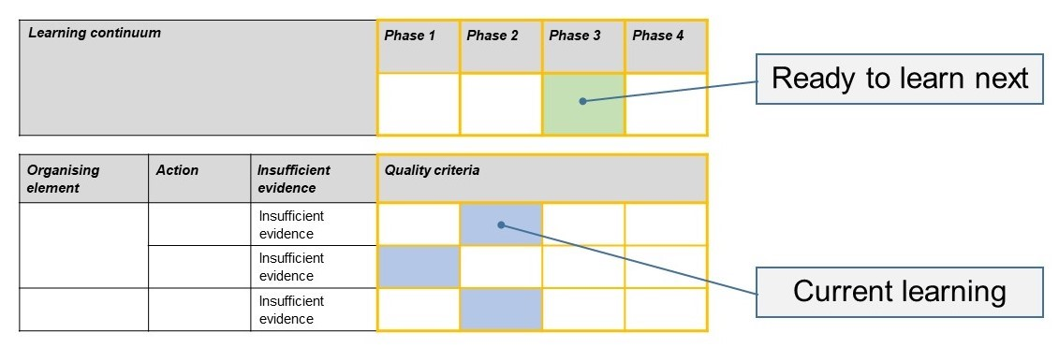
- The phase that the student is ready to learn next was shaded in green.

Please note, the following annotated student work samples are representative examples only.

Setting the scene
This timeline and extended response task was taught in a co-educational Victorian public high school. It was taught in a Year 10 Humanities class about half-way through a ‘Rights and Freedoms’ unit. Students had already learnt about many of the events in lessons on the Stolen Generations, the Day of Mourning, and about pre-1967 rights as well as a week investigating a comparison between the African-American civil rights movement and the Aboriginal and Torres Strait Islander peoples’ civil rights movement. The school emphasises real-world skills and the opportunity to discuss the implications of history, not only to describe what happened in the past.
The task was described as a diagnostic tool to assess the student’s understanding of the concept of continuity and change using a timeline of events and their knowledge so far.
The task provides information about how students apply historical concepts and asks them to justify their response.
The task took place in a 60-minute lesson, and this allowed for a 15-minute reflection in which the class did a ‘vote-with-your-feet’ activity to identify certain events as examples of continuities and changes.

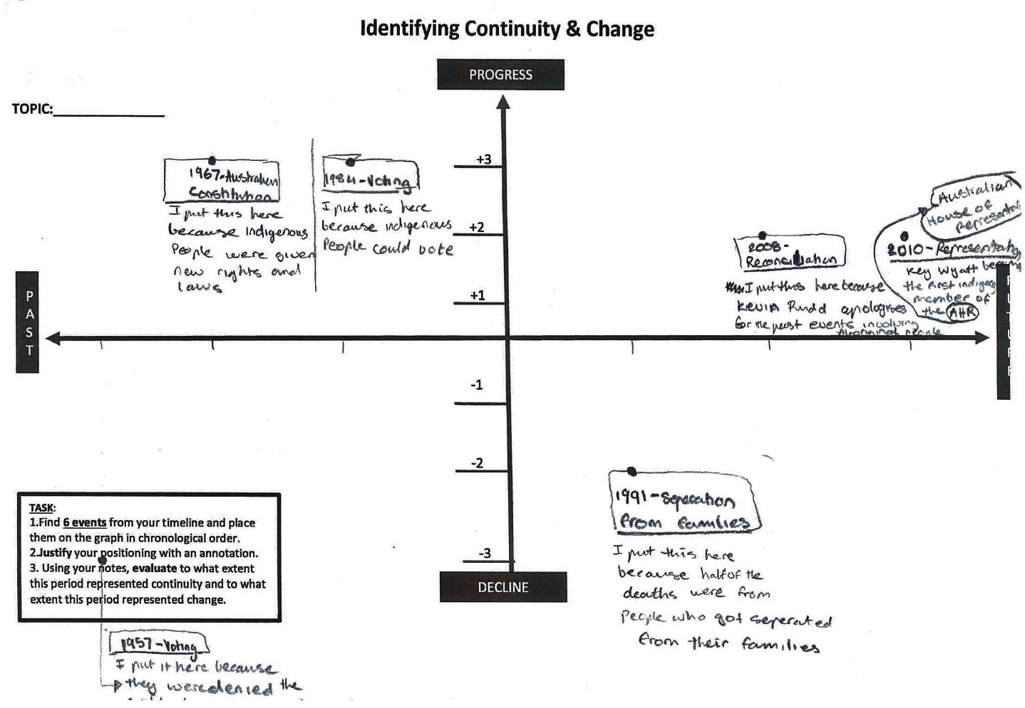
Sample 1
Note that the student did not complete the evaluation question.

Sample 1: Evidence of student learning

Annotations
- 1.2 Student described a continuity by placing separation of families as an example of continuity, and identifying that it was put there because ‘half of the deaths were from people who got separated from their families’.
- 2.2 Student described a change by placing the 1967 referendum as an example of change in the past, and identifying that it was put there because ‘Indigenous people were given new rights laws’.

What is the student ready to learn next?
The student was able to annotate the timeline to describe what happened and why these events may have been positive or negative. The student did not attempt the extended response task. Phase 3 is the next step in learning and activities will focus on providing reasons why a certain event or period was an example of continuity or change.

Any feedback given
The timeline shows me that you can demonstrate the difference between continuities and changes, as well as progress and decline. Your annotations showed understanding of a range of important events related to Aboriginal and Torres Strait Islander history. In similar activities in future, try to tell the reader why you think these things are examples of continuity or change.

Sample 2
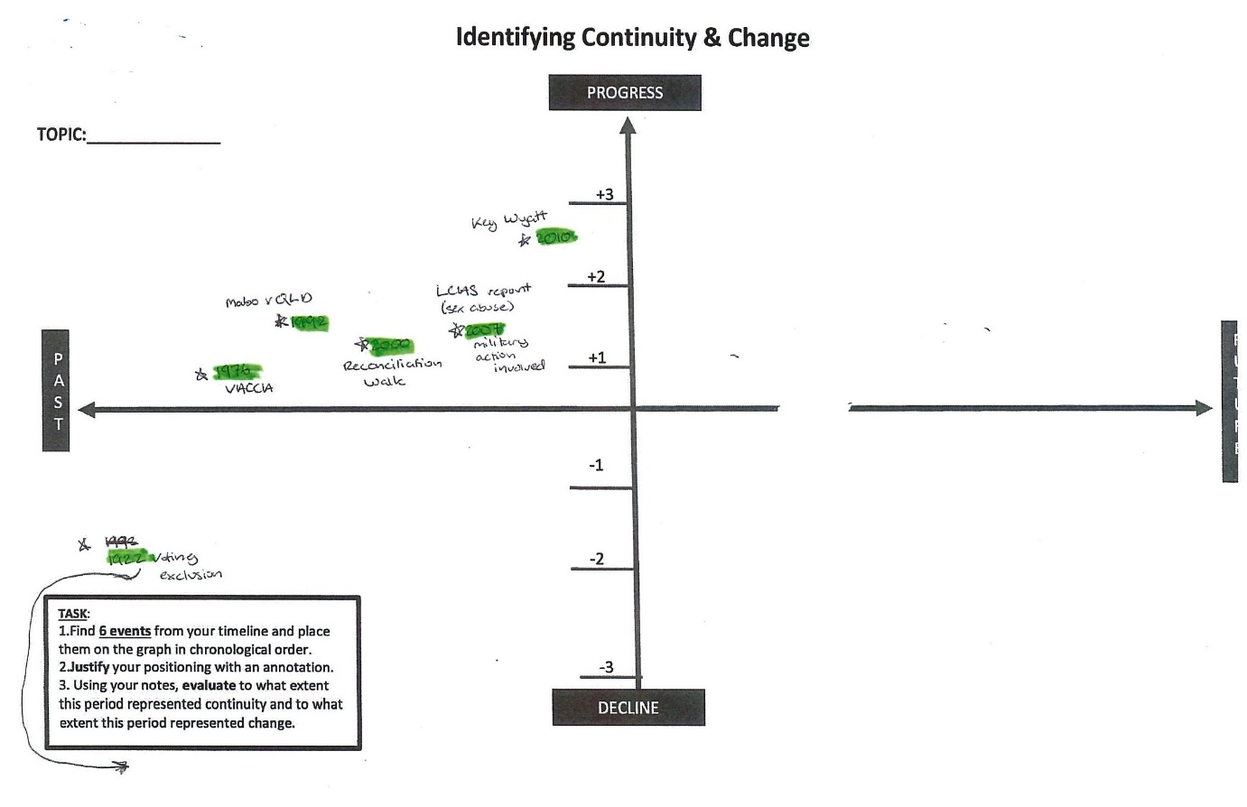

Sample 2: Evidence of student learning

Annotations
- 1.0 Student was unable to recognise an example of a continuity, but this was a problem with the task as the words ‘continuities’ and ‘changes’ should have been more explicit in the learning activity.
- 2.1 Student recognised examples of change by highlighting key events that show ‘progress’ as change with events such as Mabo v Queensland and the Reconciliation Walk.

What is the student ready to learn next?
Phase 1 is next with a focus on developing annotations to describe continuities and changes. Modelled learning activities about how to use a timeline to identify noticeable patterns of change could help this student to develop evaluative responses.

Any feedback given
The events you chose for your continuity and change timeline showed progress for indigenous Australians during the twentieth century. The next step is to try to find continuity between events and to describe in detail things that have changed and things that have stayed the same (continuity).

Using evidence to plan for future teaching and learning
- The data revealed that the learning activity needed to more explicitly match to the rubric. The leap from ‘progress and decline’ to ‘change and continuity’ in the first and second parts of the task was too challenging for many students.
- In subsequent lessons, a micro-teaching activity was used to scaffold students who needed to learn how an element of popular culture could be used an example of continuity or change. This allowed students the time to consider reasons why change or continuity occur.

Teacher reflections
- The task template was edited to include a worked example of change and continuity on the timeline. This is provided in Appendix 1.
- The collaborative element of writing a formative assessment rubric was valuable and highlighted how two teachers can interpret a word in a rubric in different ways and that this can impact how student performance is assessed.
- The variety of student levels in the classroom requires consideration of the curriculum as a learning continuum, and may need to include learning related to the band below Levels 7 and 8. Returning to my school, my adjustments to the rubric would include incorporating actions related to learning at lower levels to allow students to appropriately move through each developmental stage of progression in their history concepts and skills.

Appendix 1: Templates
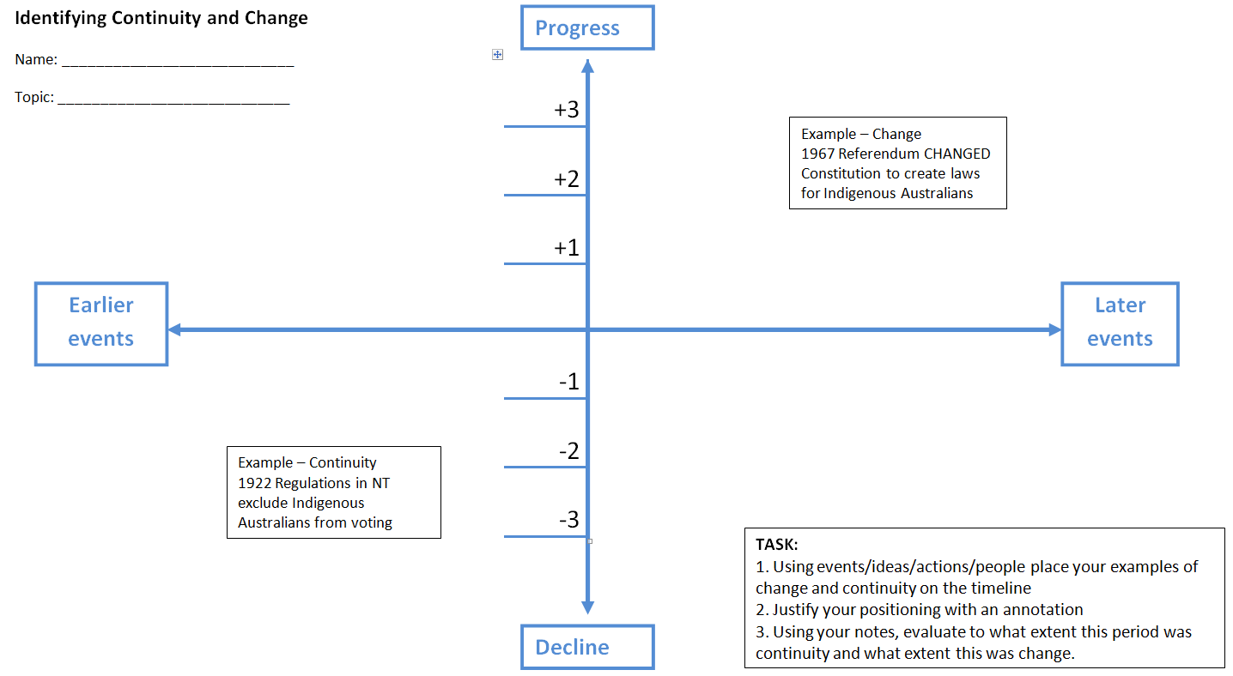

Appendix 2: Rights & Freedoms Timeline
YEAR | EVENT
1922 | Voting - Regulations in NT exclude Indigenous people from voting
1940 | Voting - The Aborigines Friends Association and others agitate for Indigenous voting rights
1957 | Voting - Under the Northern Territory Welfare Ordinance, almost all Indigenous people in NT are declared ‘wards of the state’ and denied the vote
1966 | Economic Inequality - Wave Hill Walk Off. Aboriginal workers walked off their cattle station jobs to protest wage inequality and poor working conditions.
1967 | Australian Constitution - 90% of Australians vote ‘yes’ in a referendum to change the constitution to include Indigenous people in the Commonwealth census and to create laws for Indigenous Australians
1976 | Social - The Victorian Aboriginal Child Care Agency is established
1984 | Voting - Compulsory enrolment and voting for Indigenous peoples comes into effect
1991 | Separation from families -The Royal Commission into Aboriginal Deaths in Custody reports to the Federal Government finding that almost half of those were from people separated from their families.
1992 | Land Rights - Mabo v Queensland states that native title can exist and that Australia was never terra nullius (unoccupied land).
1995 | Separation from families -The National Inquiry into the Separation of ATSI Children from their Families is established in response to efforts made by key Aboriginal agencies and communities.
1996 | Land Rights - Wik Peoples v Queensland decision, the High Court finds that in some circumstances pastoral leases outweigh native title.

1997 | Separation from families – The National Inquiry into the Separation of ATSI Children from Their Families releases its report ‘Bringing Them Home’. The report finds that Indigenous Australians ‘have endured gross violations of their human rights’.
2000 | Separation from families – Australia is criticised by the UN Committee on the Elimination of Racial Discrimination for its inadequate response to the Bringing Them Home Report.
2000 | Reconciliation – More than 300,000 people take part in the People’s Walk for Reconciliation across the Sydney Harbour Bridge.
2007 | Separation from families – The Little Children are Sacred report is released, identifying ‘widespread sex abuse’ of children throughout Aboriginal communities in NT. The report leads the Howard Government to mount a military-style intervention into NT communities.
2008 | Reconciliation – the first Welcome to Country at an opening of Parliament is led by Matilda House.
2008 | Reconciliation – Kevin Rudd apologises to Australia’s ATSI peoples on behalf of the Australian government for its previous policies.
2010 | Representation - Key Wyatt becomes the first Indigenous member of the Australian House of Representatives.

