**Using formative assessment rubrics in Performing Arts**

Music Practices Strand

Levels 5 – 8



Authorised and published by the Victorian Curriculum and Assessment Authority  
Level 7, 2 Lonsdale Street  
Melbourne VIC 3000

© Victorian Curriculum and Assessment Authority 2019.

No part of this publication may be reproduced except as specified under the *Copyright Act 1968* or by permission from the VCAA. Excepting third-party elements, schools may use this resource in accordance with the [VCAA educational allowance](https://www.vcaa.vic.edu.au/Footer/Pages/Copyright.aspx#schools). For more information go to: <https://www.vcaa.vic.edu.au/Footer/Pages/Copyright.aspx>.

The VCAA provides the only official, up-to-date versions of VCAA publications. Details of updates can be found on the VCAA website: [www.vcaa.vic.edu.au](http://www.vcaa.vic.edu.au).

This publication may contain copyright material belonging to a third party. Every effort has been made to contact all copyright owners. If you believe that material in this publication is an infringement of your copyright, please email the Copyright Officer: [vcaa.copyright@edumail.vic.gov.au](mailto:vcaa.copyright@edumail.vic.gov.au)

Copyright in materials appearing at any sites linked to this document rests with the copyright owner/s of those materials, subject to the Copyright Act. The VCAA recommends you refer to copyright statements at linked sites before using such materials.

At the time of publication the hyperlinked URLs (website addresses) in this document were checked for accuracy and appropriateness of content; however, due to the transient nature of material placed on the web, their continuing accuracy cannot be verified.

The VCAA logo is a registered trademark of the Victorian Curriculum and Assessment Authority.

**Contents**

What is formative assessment? 4

Using formative assessment rubrics in schools 4

The formative assessment rubric 5

Links to the Victorian Curriculum F–10 5

The formative assessment task 8

Description of the task (administration guidelines) 8

Evidence collected from this task 9

Interpreting evidence of student learning 10

Setting the scene 10

Sample 1 11

Sample 1: Evidence of student learning 12

Any feedback given 12

Sample 2 13

Sample 2: Evidence of student learning 14

Any feedback given 14

Sample 3 15

Sample 3: Evidence of student learning 15

Any feedback given 16

Sample 4 17

Sample 4: Evidence of student learning 17

Any feedback given 18

Sample 5 19

Sample 5: Evidence of student learning 19

Sample 6 21

Sample 6: Evidence of student learning 21

Any feedback given 22

Using evidence to plan for future teaching and learning 23

Teacher reflections 23

Appendices 24

Appendix 1: Worksheet 1 (graphic notation) 24

Appendix 2: Worksheet 2 (traditional notation) 25

What is formative assessment?

Formative assessment is any assessment that is used to improve teaching and learning. Best-practice formative assessment uses a rigorous approach in which each step of the assessment process is carefully thought through.

Assessment is a three-step process by which evidence is collected, interpreted and used. By definition, the final step of formative assessment requires a use that improves teaching and learning.

For the best results, teachers can work together to interrogate the curriculum and use their professional expertise and knowledge of their students to outline a learning continuum including a rubric of measurable, user-friendly descriptions of skills and knowledge. Teachers can draw on this learning continuum and rubric to decide how to collect evidence of each student’s current learning in order to provide formative feedback and understand what they are ready to learn next.

The VCAA’s *Guide to Formative Assessment Rubrics* outlines how to develop a formative assessment rubric to collect, interpret and use evidence of student learning to plan teaching and learning. For more information about formative assessment and to access a copy of the guide, please go to the [Formative Assessment section](https://www.vcaa.vic.edu.au/foundation10/Pages/viccurriculum/formative_assessment.aspx) of the VCAA website.

Using formative assessment rubrics in schools

This document is based on the material developed by one group of teachers in the 2019 Formative Assessment Rubrics project. The VCAA acknowledges the valuable contribution to this resource of the following teachers: Jen Skate (Methodist Ladies' College) and Sally Walsh (Specialist teacher). The Victorian Curriculum and Assessment Authority partnered with the Assessment Research Centre, University of Melbourne, to provide professional learning for teachers interested in strengthening their understanding and use of formative assessment rubrics.

This resource includes a sample formative assessment rubric, a description of a task/activity undertaken to gather evidence of learning, and annotated student work samples.

Schools have flexibility in how they choose to use this resource, including as:

* a model that they adapt to suit their own teaching and learning plans
* a resource to support them as they develop their own formative assessment rubrics and tasks.

This resource is not an exemplar.

Additional support and advice on high-quality curriculum planning is available from the [Curriculum Planning Resource](http://curriculumplanning.vcaa.vic.edu.au/).

The formative assessment rubric

The rubric in this document was developed to help inform teaching and learning in The Arts – Music. This rubric supports the explicit teaching of rhythm, focusing on composition and performance with an increasing complexity of rhythm.

Links to the Victorian Curriculum F–10

**Curriculum area:** The Arts – Music

Strand: Music Practices

**Levels/Bands:** Levels 5 – 8

**Achievement standard/s extract:** Levels 5 and 6:

By the end of Level 6, students use the elements of music, their voices, instruments and technologies to improvise, arrange, compose and perform music.

Level 7 and 8:

By the end of Level 8, students manipulate the elements of music and stylistic conventions to improvise, compose and perform music.

**Content Description/s:** Levels 5 and 6:

Develop and practise technical skills and use of expressive elements of music in singing, playing instruments, improvising, arranging and composing [(VCAMUM030)](https://victoriancurriculum.vcaa.vic.edu.au/Curriculum/ContentDescription/VCAMUM030)

Level 7 and 8:

Experiment with elements of music, in isolation and in combination, using listening skills, voice, instruments and technologies to find ways to create and manipulate effects [(VCAMUE033)](https://victoriancurriculum.vcaa.vic.edu.au/Curriculum/ContentDescription/VCAMUE033)

Develop music ideas through improvisation, composition and performance, combining and manipulating the elements of music (VCAMUE034)

|  |  |  |  |  |  |  |  |
| --- | --- | --- | --- | --- | --- | --- | --- |
| **Learning continuum**  Strand: Music  Sub-strand: Music Practices  Level 5 – 8 | | | **Phase 1** | **Phase 2** | **Phase 3** | **Phase 4** | **Phase 5** |
| Students compose rhythm patterns for performance using crotchets, minims and quavers. | Students compose rhythm patterns for performance using crotchets, minims and quavers and some associated rests. | Students compose rhythm patterns for performance using semiquavers and/or dotted crotchets and/or associated rests. | Students compose rhythm patterns for performance using rhythms such as triplets, tied notes and dotted notes. | Students perform rhythm patterns including a range of conventions in two or more parts. |
|  | | | | | | | |
| **Organising element** | **Action** | **Insufficient evidence** | **Quality criteria** | | | | |
| Rhythm | 1. Demonstrates understanding of note duration | 1.0 Insufficient evidence | 1.1 Composes using crotchets, minims and quavers with accuracy. | 1.2 Composes using crotchets, minims and quavers and some associated rests. | 1.3 Composes using semiquavers and/or dotted crotchets and/or associated rests. | 1.4 Composes using rhythms such as triplets, tied notes, dotted notes. |  |
| 2. Notates music | 2.0 Insufficient evidence | 2.1 Uses graphic notation. | 2.2 Uses traditional notation. |  |  |  |
| 3. Performs | 3.0 Insufficient evidence | 3.1 Performs their own composition or that of their peers using mostly crotchets, minims and quavers. |  | 3.2 Performs their own composition or that of their peers using mostly semiquavers and/or dotted crotchets and/or associated rests. | 3.3 Performs including a range of sophisticated conventions. | 3.4 Performs in two or more parts including a range of sophisticated conventions. |

The formative assessment task

The following formative assessment task was developed to elicit evidence of each student’s current learning and what they are ready to learn next.

Description of the task (administration guidelines)

* Students will be given a task to demonstrate their understanding of note duration as they compose and perform.
* Students compose a rhythm composition, using their knowledge of note duration.
* Students perform their composition or that of their peers.

**Instructions**

* The task is designed to assess understanding at any point in a unit or teaching sequence.
* Familiarise yourself with the rubric.
* Provide students with access to resource material such as note duration pyramids, rhythm flash cards and/or note value charts that will assist them with the task.
* Revise rhythmic reading with flashcards as a group activity.
* Explain the task. A suggested introduction to the task might be:

*‘When we compose music, we are working with the elements of music. This task is asking us to compose music using only rhythm. You can choose how complex your composition is when you are planning your work. The first stage of your composition will be written using graphic notation. Stage two is to transfer your rhythms to a traditional notation template. Remember, we are all on different stages along the learning continuum. Your final composition needs to be written clearly so other students can perform it.’*

* Students plan to decide the rhythm set (which note values/ rests they will work with).
* Provide students with access to examples of rhythm compositions in different written formats. Play examples as a class. Such as clapping, body percussion, un-tuned percussion.
* Discuss the graphic notation template (Appendix 1). Each square represents one crotchet beat, each line represents a bar of common time. Using this, a student could illustrate their sounds for each beat of four bars.
* Discuss the traditional notation template (Appendix 2). This provides enough space for up to six bars of notated rhythm.
* Provide students with both notation templates to use with their composition. Students may be encouraged work on whichever template they feel they can complete most accurately.
* Students complete task. Teacher will need to consider how to collect video and/or audio evidence of performance.
* Use the rubrics to identify students’ level of competency using the collected work sample including any video and/or audio and notations.
* Undertake any in-school moderation of work samples to support consistency of judgement and provide feedback to students in a timely way.

Evidence collected from this task

* Video and/or audio
* Notations.

Interpreting evidence of student learning

Evidence collected from each student was mapped against the rubric:

* The quality criteria that were achieved was shaded in blue.
* 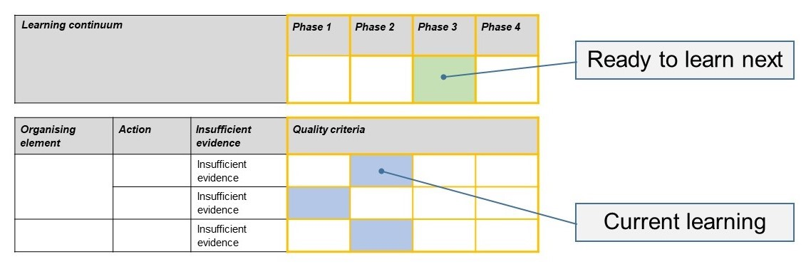The phase that the student is ready to learn next was shaded in green.

Please note, the following annotated student work samples are representative examples only.

Setting the scene

The student work samples were collected from two different schools and teaching contexts:

* Samples 1, 2 and 4 were collected from a Grade 6 music class in a Government Primary School on the Mornington Peninsula. The students had prior learning in both composition and performing written rhythms. The notation aspect of the task was undertaken during an hour-long session, with the performance being undertaken in another session. The students were given access to examples of rhythm compositions in different written formats and then played some examples as a class using clapping, body percussion and un-tuned percussion.
* Samples 3, 5 and 6 were collected from Year 7 music classes at an independent girls’ school. The task was undertaken in one 70-minute lesson. The teacher had little prior knowledge of the student cohort and used this task to gain a deeper understanding of the range of abilities within the class.

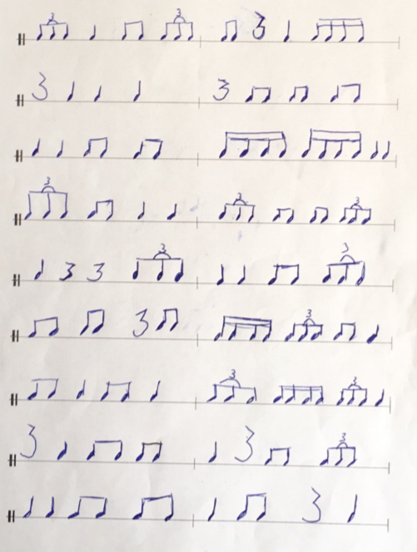Sample 1

Sample 1: Evidence of student learning

Annotations

* 1.4 The student used triplets and semiquavers.
* 2.2 The student used traditional notation.

Indirect evidence:

* 3.3 The student was able to perform her own composition and that of others. The student performance indicated that performing in three parts was challenging.

What is the student ready to learn next?

The student has demonstrated that she could compose and perform complex rhythm patterns and is now ready to perform sophisticated rhythms in two or more parts.

Any feedback given

After targeted feedback and a discussion of the phases, the student was keen to move to the next phase and introduce more sophisticated conventions into her next composition. We also discussed the support she would need to do this. The student was able to articulate what she would need to do to move to the next stage of her learning.

Sample 2

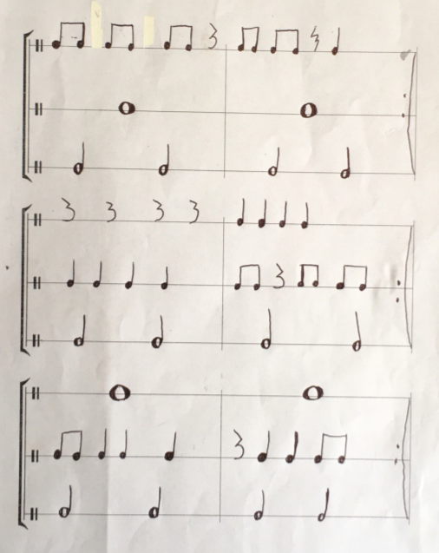

Sample 2: Evidence of student learning

Annotations

* 1.2 The student was able to use quavers, crotchets minims and rests.
* 2.2 The student used traditional notation.

Indirect evidence:

* 3.1 The student was able to perform her own composition and that of others.

What is the student ready to learn next?

The student demonstrated that she could compose and perform simple rhythm patterns and is now ready to add an extra level of complexity using more sophisticated rhythms aligned with learning in Phase 3.

Any feedback given

After targeted feedback and a discussion of the phases, the student was keen to move to the next phase and introduce more sophisticated conventions into her next composition. We also discussed the support she would need to do this. We discussed the way she could modify her current composition to include some dotted crotchets with a quaver or quaver rest in place of some of her existing patterns, focusing on a single line rather than all three parts in the first instance, and practicing performing these.

Sample 3

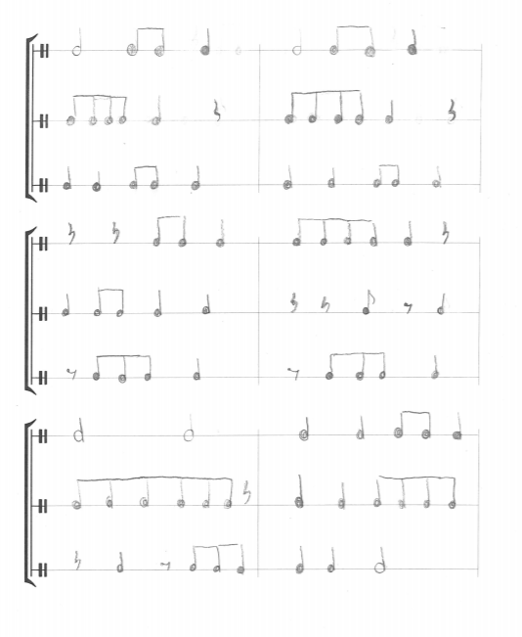Sample 3: Evidence of student learning

Annotations

* 1.2 The student used crotchets, minims and quavers and most of the associated rests. Some of her bars did not add up to four beats to the bar, indicating that she had some gaps with her understanding of either time signature, or some confusions with value (or perhaps just made a mistake).
* 2.2 The student demonstrated a good layout of her rhythms and that she has had good scaffolding.

Insufficient evidence:

* 3.0 This student was not assessed with a performance task.

What is the student ready to learn next?

This student was able to demonstrate a good understanding of the rhythms she used for her composition. She could focus next on acquiring experience with playing rhythms using semiquavers and dotted crotchets, moving towards being able to include these in a future composition.

Any feedback given

The rubric was used to help set up future learning goals and to find the appropriate support material. In this case, note pyramids and short tasks to develop further understanding of rhythm duration will be used in follow up lessons.

Sample 4

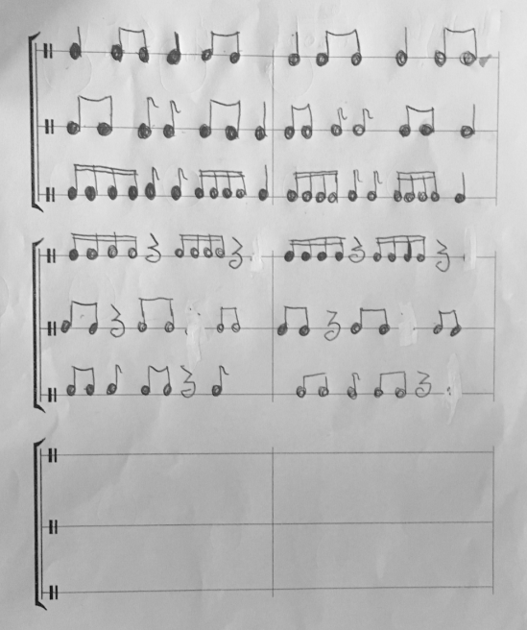Sample 4: Evidence of student learning

Annotations

* 1.2 The student’s use of quavers, crotchets minims and rests was accurate.
* 2.2 The student was able to use ttraditional notation.

The student also completed a composition in graphic notation.

Indirect evidence:

* 3.1 The student was able to perform her own composition and some of her peers and that of others.

What is the student ready to learn next?

The student demonstrated that she could compose and perform simple rhythm patterns and is now ready to add an extra level of complexity using more sophisticated rhythms aligned with learning at Phase 3.

Any feedback given

After targeted feedback and a discussion of the phases, the student was keen to move to the next phase and introduce more sophisticated conventions into her next composition. We also discussed the support she would need to do this. This student was keen to develop more variety in her next composition, so we discussed ways of understanding semiquavers, and dotted crotchets, using time-names (eg ti-ka-ti-ka), and accurately playing them on one line, with a constant crotchet beat on a second line, before trying to compose new multi-part rhythms.

Sample 5

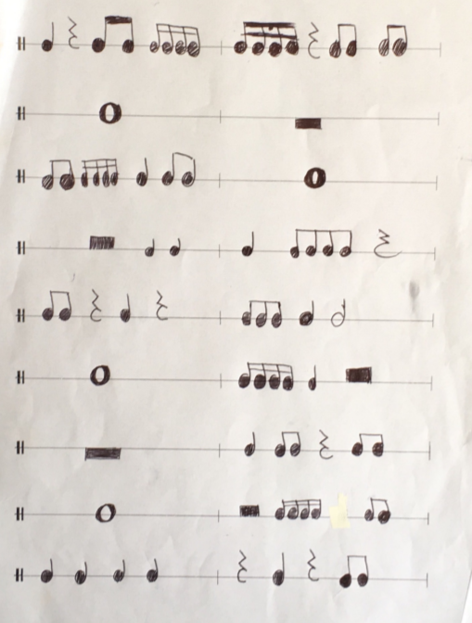Sample 5: Evidence of student learning

Annotations

* 1.3 The student was able to use semiquavers.
* 2.2 The student used traditional notation.

Indirect evidence:

* 3.2 The student was able to perform her own composition and that of others.

What is the student ready to learn next?

The student demonstrated that the ability to compose and perform rhythm patterns with some level of complexity and is now ready to add an extra level of complexity adding more sophisticated rhythms, including triplets and tied notes referred to in Phase 4, to future compositions.

Any feedback given

After targeted feedback and a discussion of the phases, the student was able to say what they had already learnt and was able to understand where she would go next in her learning.

Sample 6

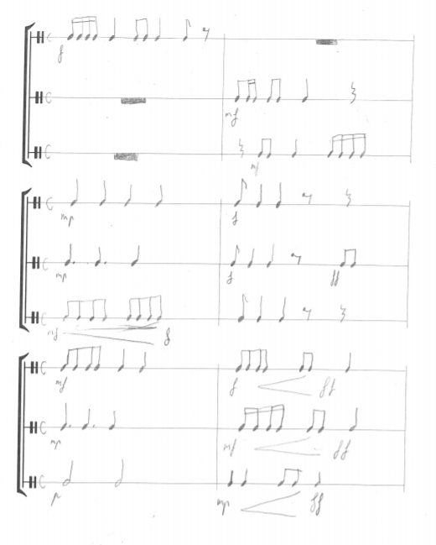Sample 6: Evidence of student learning

Annotations

* 1.4 The student used many sophisticated rhythms as well as additional music language (placed accurately) such as dynamics and performance instructions
* 2.2 The student demonstrated she clearly understood the conventions of writing rhythms using traditional notation, and beyond

Insufficient evidence:

* 3.0 This student was not assessed with a performance task.

What is the student ready to learn next?

This student was able to demonstrate a very good understanding of all rhythms using dotted rhythms, all associated rests and included sophisticated performance instructions. The student is ready to learn Phase 5.

Any feedback given

The rubric was used to help set up future learning goals and to find the appropriate support material such as note pyramids and short tasks to develop further understanding of rhythm duration.

Using evidence to plan for future teaching and learning

* This student data was very useful for seeing the spread of student data across levels 5 to 7 and this information could be used to plan a subsequent learning activity for the class for this area of the curriculum. The data clearly showed where the students have been, where they are all at, and where they are to go next. Most of the students in the cohort showed a good understanding of note values and layout of rhythms. Scaffolding needs to happen more regularly and we think the next step is to plan several ‘tasks’ across the learning continuum that students can self-select based on what they are ready to learn next.

Teacher reflections

* I would like to introduce the learning from this whole experience across the department at school. I am looking forward to embedding these tools more within my teaching programs. There is a lot to be learned from being thrown in the deep end and to put formative assessment rubrics into practice in new school: I experienced challenges but the data was rich and useful which only makes me want to do it again.
* This style of formative assessment rubric and task could be modified for all areas of the Music curriculum and in all other areas of the school.

Appendices

Appendix 1: Worksheet 1 (graphic notation)

|  |  |  |  |
| --- | --- | --- | --- |
|  |  |  |  |
|  |  |  |  |
|  |  |  |  |
|  |  |  |  |
|  |  |  |  |
|  |  |  |  |
|  |  |  |  |

Appendix 2: Worksheet 2 (traditional notation)

