Using formative assessment rubrics in Visual Arts

Express and Explore Ideas

Levels 5 and 6

Authorised and published by the Victorian Curriculum and Assessment Authority
Level 7, 2 Lonsdale Street
Melbourne VIC 3000
© Victorian Curriculum and Assessment Authority 2020.

No part of this publication may be reproduced except as specified under the Copyright Act 1968 or by permission from the VCAA. Excepting third-party elements, schools may use this resource in accordance with the VCAA educational allowance. For more information go to: https://www.vcaa.vic.edu.au/Footer/Pages/Copyright.aspx.
The VCAA provides the only official, up-to-date versions of VCAA publications. Details of updates can be found on the VCAA website: www.vcaa.vic.edu.au.
This publication may contain copyright material belonging to a third party. Every effort has been made to contact all copyright owners. If you believe that material in this publication is an infringement of your copyright, please email the Copyright Officer: vcaa.copyright@edumail.vic.gov.au
Copyright in materials appearing at any sites linked to this document rests with the copyright owner/s of those materials, subject to the Copyright Act. The VCAA recommends you refer to copyright statements at linked sites before using such materials.
At the time of publication the hyperlinked URLs (website addresses) in this document were checked for accuracy and appropriateness of content; however, due to the transient nature of material placed on the web, their continuing accuracy cannot be verified.

The VCAA logo is a registered trademark of the Victorian Curriculum and Assessment Authority.

Contents
What is formative assessment? 4
Using formative assessment rubrics in schools 4
The formative assessment rubric 5
Links to the Victorian Curriculum F–10 5
The formative assessment task 7
Description of the task (administration guidelines) 7
Evidence collected from this task 8
Interpreting evidence of student learning 9
Setting the scene 9
Reference materials 9
Sample 1 10
Sample 1: Evidence of student learning 10
Sample 2 11
Sample 2: Evidence of student learning 11
Any feedback given 11
Using evidence to plan for future teaching and learning 12
Teacher reflections 12

What is formative assessment?
Formative assessment is any assessment that is used to improve teaching and learning. Best-practice formative assessment uses a rigorous approach in which each step of the assessment process is carefully thought through.
Assessment is a three-step process by which evidence is collected, interpreted and used. By definition, the final step of formative assessment requires a use that improves teaching and learning.
For the best results, teachers can work together to interrogate the curriculum and use their professional expertise and knowledge of their students to outline a learning continuum including a rubric of measurable, user-friendly descriptions of skills and knowledge. Teachers can draw on this learning continuum and rubric to decide how to collect evidence of each student’s current learning in order to provide formative feedback and understand what they are ready to learn next.
The VCAA’s Guide to Formative Assessment Rubrics outlines how to develop a formative assessment rubric to collect, interpret and use evidence of student learning to plan teaching and learning. For more information about formative assessment and to access a copy of the guide, please go to the Formative Assessment section of the VCAA website.

Using formative assessment rubrics in schools
This document is based on the material developed by one group of teachers in the 2019 Formative Assessment Rubrics project. The VCAA acknowledges the valuable contribution to this resource of the following teachers: Laura Russell (Newport Lakes Primary School) and Georgie Green (Skipton Primary School). The Victorian Curriculum and Assessment Authority partnered with the Assessment Research Centre, University of Melbourne, to provide professional learning for teachers interested in strengthening their understanding and use of formative assessment rubrics.
This resource includes a sample formative assessment rubric, a description of a task/activity undertaken to gather evidence of learning, and annotated student work samples.
Schools have flexibility in how they choose to use this resource, including as:
- a model that they adapt to suit their own teaching and learning plans
- a resource to support them as they develop their own formative assessment rubrics and tasks.
This resource is not an exemplar.
Additional support and advice on high-quality curriculum planning is available from the Curriculum Planning Resource.

The formative assessment rubric
The rubric in this document was developed to help inform teaching and learning in Visual Arts. This rubric supports the explicit teaching of students’ ability to analyse art practice including the visual conventions, materials, techniques and processes used to make and express ideas in artworks.

Links to the Victorian Curriculum F–10

Curriculum area: Visual Art
Strand: Express and Explore Ideas
Levels/Bands: Levels 5 and 6
Achievement standard/s extract: By the end of Level 6, students explain how ideas are expressed in artworks they make and view. They demonstrate the use of different techniques and processes in planning and making artworks. They use visual conventions and visual arts practices to express ideas, themes and concepts.
Content Description/s: Explore visual arts practices as inspiration to create artworks that express different ideas and beliefs (VCAVAE029).

Learning continuum  Visual Arts  Levels 5 and 6  Explore and Express Ideas |  |  | Phase 1 | Phase 2 | Phase 3 | Phase 4
 |  |  | Students identify the visual conventions, materials, techniques/processes and ideas they view in artworks. | Students describe the visual conventions, materials, techniques/processes and ideas they view in artworks. | Students analyse with evidence to make connections between the visual conventions, materials, techniques/processes and ideas they view in artworks. | Students evaluate the connections between visual conventions, materials, techniques/processes and ideas in the artworks they view.
Organising element | Action | Insufficient evidence | Quality criteria
Use of the visual conventions, materials, techniques, processes in response to the ideas they view in artworks. | 1 Visual Conventions | 1.0 Insufficient evidence | 1.1 Identifies the visual conventions used in artworks they view. | 1.2 Describes the visual conventions used in artworks they view. | 1.3 Analyses with evidence connections between the ideas and the use of visual conventions in artworks they view. | 1.4 Evaluates the connections between ideas and the use of visual conventions in the artworks they view
 | 2 Materials | 2.0 Insufficient evidence | 2.1 Identifies the materials used in artworks they view. | 2.2 Describes the characteristics of materials used in artworks they view. | 2.3 Analyses the connections between the ideas and the use of materials drawing on evidence in the artworks they view. | 2.4 Evaluates the use of materials connections between the ideas and materials in the artworks they view.
 | 3 Techniques and process | 3.0 Insufficient evidence | 3.1 Identifies the techniques and processes used in artworks they view. | 3.2 Describes the techniques and processes used in artworks they view. | 3.3 Analyses the connections between the ideas and use of techniques and processes drawing on evidence in the artworks they view. | 3.4 Evaluates the techniques and processes used to make connections between the ideas and techniques and processes in the artworks they view.
 | 4 Ideas | 4.0 Insufficient  evidence | 4.1 Identifies the subject matter in artworks they view. | 4.2 Describes the ideas in artworks they view. | 4.3 Analyses the ideas in the artworks they view and make connections between techniques/processes, visual conventions and materials. | 4.4 Evaluates ideas in an artwork they view by making connections between the techniques/processes, visual conventions and materials in the artworks they view.

The formative assessment task
The following formative assessment task was developed to elicit evidence of each student’s current learning and what they are ready to learn next.

Description of the task (administration guidelines)

Selecting and presenting artists and artworks to the students
- Select two artists with similar or related art practices where a connection between the two artists is evident. For example, artists that use similar materials or techniques, or express similar ideas in their artwork such as MC Escher and Hokusai or Aly de Groot and Mirarr Weavers.
- Select three to four artworks by each artist that have similar subject matter, visual conventions, use of materials or techniques and processes. For example, a landscape print by MC Escher and a landscape print by Hokusai.
- Present images of artists’ work to students. For example, on a TV screen. If technology is not available, use large (A3) high resolution colour photocopies.
- Seat students in an environment suitable for viewing and discussing artworks. For example, sitting on the floor facing the TV or display board.
- A video or images that present the artist’s practice may also be helpful. For example: images of the artist working in their studio or an interview with the artist discussing their work
- Establish positive expectations before starting the class discussion. For example, all views and ideas are valid, listen respectfully to the person talking, and take it in turns to talk.
- Begin class discussion about the artists, the artwork and their art practice by posing questions to students.
Questions
The following questions could be asked to prompt class discussion:
- What is going on in this artwork, what can you see?
- What lines, shapes, patterns or colours has the artist used in this artwork?
- Does the artwork have a focal point or symmetry?
- How has the artist used lines, shapes, pattern or colour? Why do you think the artist did that?
- What ideas do you think the artist is expressing in this artwork? What makes you say that?
- What is the artist trying to represent in this artwork?
- What is this artwork about?
- What is the artwork made from?
- What process or technique has the artist used to make this artwork?
- Why do you think the artist has chosen these materials?
Extension questions:
- What makes you say that?
- Can you explain your thinking?
- Can you point out an area in the artwork that shows that?
Considerations
- Ensure the images you select can be provided to students in high resolution. You may wish to use Wikiart or other image resources.
Formative assessment activity
After student have viewed and discussed the artworks, students work in pair to create a short video of themselves as Art Critics. Note that whilst this is a paired activity, for formative assessment purposes, you will need to assess students on their individual knowledge of the artists and their art practice.
- Explain to students they will be art critics, they will be discussing the artworks and their personal views or opinions about the artworks.
- Students will be working in pairs to create a video on an iPad.
- Similar to the whole class discussion, students will be explaining the art practice and the artworks of the focus artists.
- Students select the artworks they wish to talk about in their video, they need to take notes and plan what they are going to discuss.
- When students have planned their videos, they can record their presentation on an iPad in a suitable application.
- Students upload their video to the online, cloud storage application used by that school or teacher. For example, Google Classroom.

Evidence collected from this task
- Student video
- Students planning and written notes for video
- Teacher notes taken from the whole class discussion.

Interpreting evidence of student learning
Evidence collected from each student was mapped against the rubric:
- The quality criteria that were achieved was shaded in blue.
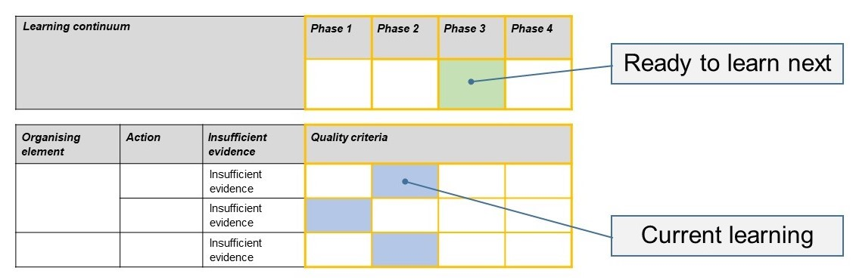
- The phase that the student is ready to learn next was shaded in green.

Please note, the following annotated student work samples are representative examples only.

Setting the scene
These student work samples were collected from a primary school.
Students participated in a whole class discussion where they viewed three videos. The first showed how the Mirrar elders collect and prepare materials for weaving. The next two explored the art practice of Aly de Groot. Students were provided with six photographs of woven works by the Mirrar people and six photographs of woven works by Aly de Groot. The discussion and viewing took 40 minutes. Afterwards, the class discussed the role of an art critic and came up with an agreed definition of what they do. Well known food critic Matt Preston as a reference point for exploring ideas about how critics might use dress and their personality and knowledge as part of their role.
In pairs, the students then organised the images of the 12 artworks to make notes and scripts for their role as an art critic for the ‘Art Weekly’ news report. This task took 45 minutes.
In the remaining 45 minutes, students chose dress-up props and acted as an audience as each pair performed and filmed their report. No rehearsal time was provided.
Student feedback on the task indicated they would have liked the opportunity to rehearse their reports.

Reference materials
Aly de Groot: https://northhome.org/blogs/journal/aly-de-groot
Mirarr People: http://www.mirarr.net/pages/mirarr

Sample 1
Student Work Sample 1: Art critics https://vimeo.com/369466434

Sample 1: Evidence of student learning

Annotations
The following annotations relate to evidence provided by the student responding the questions in the video.
- 1.3 The student was able to list and describe how art conventions look in the art works and gave a simple analysis of how they were used to express the artists ideas.
- 2.3 The student could list materials used and their properties. The student explained how the properties of materials related to the subject matter and ideas of the artist.
- 3.1 The student named the techniques the artist used; however, was unable to meaningfully describe the techniques and processes used.
- 4.3 The student was able to give simple description and analysis with understanding of the artists subject matter and ideas.

What is the student ready to learn next?
The student is ready to learn Phase 4 of the learning continuum as they are able to analyse the use of visual conventions, and how they have used them to communicate ideas. The student will need some additional opportunities to develop their ability to describe and analyse techniques and processes used by the artist and connect them to the meaning of the work.
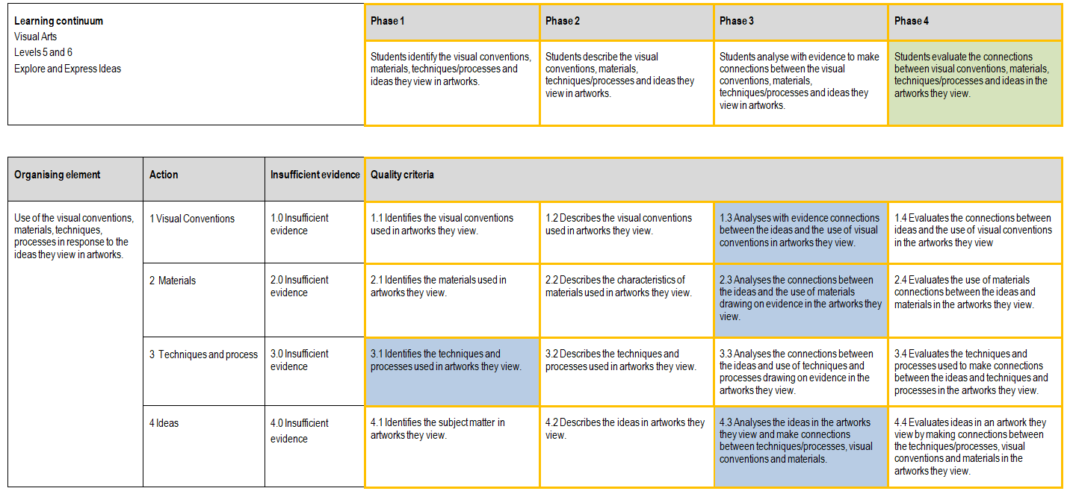

Any feedback given
I spoke to this student about making sure they think about the questions:
- Why do or don’t you like this?
- This is/is not successful because .....
- One thing I/the artist did well was?
- One thing I/ the artist could do better is?
Sample 2
Student Work Sample 2: Art critics https://vimeo.com/369465929

Sample 2: Evidence of student learning

Annotations
The following annotations relate to evidence provided by the student responding the questions in the video.
- 1.2 The student was able to list and describe how visual conventions look in the art works; however, the student did not specifically refer to their use in expressing the artists ideas.
- 2.3 The student provided a comprehensive list of materials used and their properties. Student explained how the properties and source of materials related to the subject matter and ideas of the artist.
- 3.3 The student could name the techniques the artist used; however, they were unable to meaningfully describe the techniques and processes used. The student achieved 3.3 because they were able to describe how the artist used weaving to express ideas and subject matter
- 4.3 The student was able to comprehensively describe and analyse the artists’ subject matter and ideas.

What is the student ready to learn next?
The student is ready to learn Phase 4 of the learning continuum as they are able to list and describe the use of visual conventions, and analyse the use of materials, techniques, processes to link them to ideas. Follow up activities will provide opportunities for the student to analyse the use of visual conventions in an artwork, evaluate the use of materials, techniques and processes, and express a personal opinion to delve further into the connections between the ideas.
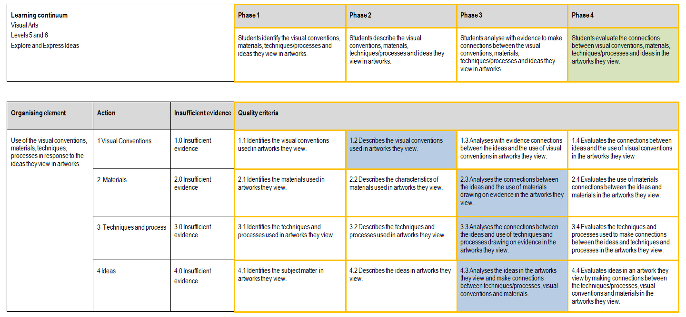

Using evidence to plan for future teaching and learning
- The student data revealed students ability to analyse the materials and ideas in an artwork. Data also revealed students ability to use visual arts specific language to name and offer basic descriptions of visual conventions to discuss artworks.
- Data revealed students had limited or no understanding or knowledge of the techniques and processes involved in weaving. The techniques and processes of weaving was not discussed, viewed or scaffolded for students prior to the task.
- Data also revealed a lack of evaluation of artworks, explicitly scaffolded questions should be asked that enable the student to evaluate the artwork.
- Given the results of the data subsequent learning will involve explicit teaching and
- demonstration of the, techniques and processes of weaving using a range of formats and materials.
- At the conclusion of the unit we will also take time to explicitly evaluate the finished works.

Teacher reflections
- The formative assessment rubric will also be used at the end of the unit of work to assess students’ development in the analysis and evaluation of visual conventions and to evaluate artworks. Students’ understanding and knowledge of techniques and process of weaving will also be explicitly assessed as well.
- The rubric could also be used as an example for other teachers in our school developing rubrics across different curriculum areas.
- I believe the rubric is effective at assessing students understanding and knowledge of visual arts practice strand of the Victorian Curriculum F–10.

