Levels 9 and 10: Historical Sources as Evidence – Student Handout

Activity: Evaluating and comparing historical sources

Use the 5 Ws from Slides 6 to 10 and the concept map from Slide 11 to evaluate the two sources below.

Use the following questions to guide you:

1. In what ways are the two sources similar or different?
2. Do these two sources corroborate each other about how the Australian people and/or government view war? Or do they show different perspectives on war that suggest opinions were divided? Explain your answer.

You may need to undertake additional research on each source to find out the information you need.

* For the written source ‘War’ by Mary Gilmore, you can access further information with online search terms such as ‘Mary Gilmore’, ‘Under the Wilgas’ and ‘Australian war poetry’.
* For the visual source, you can research using search terms such as ‘Australian World War I posters’, ‘Australian War Memorial posters’ and ‘Defend your homes, your women and children’.
* Remember to use the 5 Ws questions to help you.

**Source A: Written**

‘War’ by Mary Gilmore

*Find Mary Gilmore’s poem ‘War’ online and use the graphic below to evaluate the poem as a historical source.*

Mind map showing nine ovals each connected by a thin line to a central oval labelled: 'War' by Mary Gilmore. Beginning from the top left and reading clockwise, the peripheral circles are labelled: Validity; Author/creator? Date created? Meaning? Audience? Bias? Purpose? Context? Motivation? 

**Source B: Visual**

World War I poster

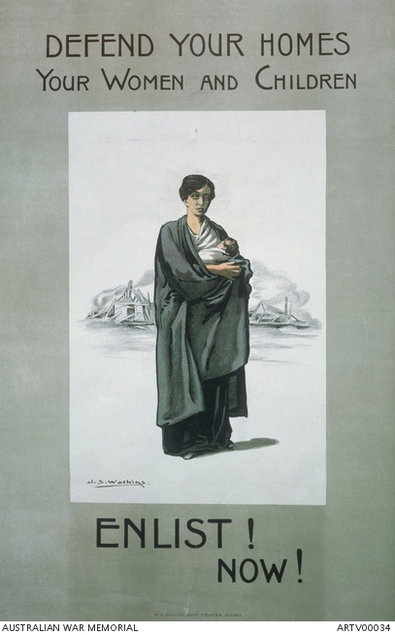

Australian First World War recruitment poster; made by John Samuel Watkins for the NSW Government; printed by W.A. Gullick, Government Printers,   
c. 1916–1918

*Use the graphic below to evaluate the poster as a historical source.*

Mind map showing nine ovals each connected by a thin line to a central oval labelled: World War One posters. Beginning from the top left and reading clockwise, the peripheral circles are labelled: Validity; Author/creator? Date created? Meaning? Audience? Bias? Purpose? Context? Motivation? 