Kitchen garden, Levels 3 and 4

Annotated student work samples

Assessment task
- Students were asked to develop a nutritious recipe (design idea) for a main meal or snack product to be sold in the school canteen and evaluate their recipe against provided criteria. To be successful, student recipes were required to: align with the principles of the Australian Guide to Healthy Eating (AGHE), including the use of at least three of the AGHE food groups
- include two or more additional ingredients that would be available from the school/community/home garden
- be able to be prepared within one hour, using ingredients and equipment that are likely to be available in a school canteen
- appeal to both students and teachers in terms of flavour, texture and ease of eating.
The task asked students to:
- provide a drawing of the final product with a technical description of key features
- provide an assessment of the recipe against the criteria for success (for example, the drawing could be annotated against criteria)
- document the production process/method to prepare the recipe
- provide details on the equipment used to produce the recipe and the importance of this equipment, which helps ensure the recipe can be followed by those with different levels of cooking ability
- document safe work practices for producing the recipe.
The task allowed students to draw, write or say their responses.
Student work was then assessed against an associated assessment rubric explicitly linked to the Design and Technologies and Health and Physical Education curriculum areas of the Victorian Curriculum F–10.
To access the sample unit of work and sample assessment task (including assessment rubric) associated with these student work samples, see the Home Economics teaching resources webpage on the VCAA website.

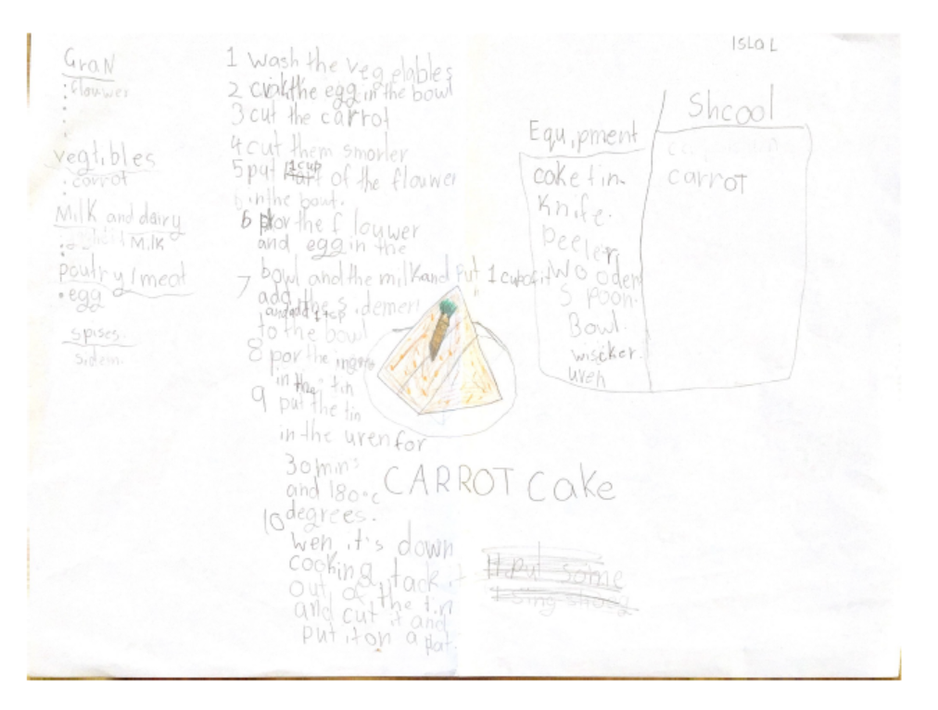
Student work sample 1

Student work sample 1 – assessment rubric

Relevant elements of the achievement standards
Design and Technologies
By the end of Level 2, students:  - identify the features and uses of some technologies for each of the prescribed technologies contexts [Food specialisations]  - describe given needs or opportunities  - … evaluate their ideas … based on personal preferences  - communicate design ideas for their designed solutions, using modelling and simple drawings  - following sequenced steps, ... demonstrate safe use of tools and equipment when producing designed solutions |  | By the end of Level 4, students:  - describe how the features of technologies can be used to create designed solutions for each of the prescribed technologies contexts [Food specialisations]  - explain needs or opportunities  - … evaluate ideas … against identified criteria for success, including sustainability considerations  - develop and expand design ideas and communicate these using models and drawings including annotations and symbols  - plan and sequence major steps in design and production  - identify appropriate technologies and techniques and demonstrate safe work practices when producing designed solutions. |  | By the end of Level 6, students:  - explain how the features of technologies impact on designed solutions for each of the prescribed technologies contexts [Food specialisations]  - suggest criteria for success, including sustainability considerations and use these to evaluate their ideas …  - combine design ideas and communicate these to audiences using graphical representation techniques and technical terms  - record project plans including production processes  - select and use appropriate technologies and techniques correctly and safely to produce designed solutions.
Health and Physical Education
By the end of Level 2, students:  - examine messages related to health decisions and describe how to help keep themselves and others healthy, safe and physically active. |  | By the end of Level 4, students:  - interpret health messages and discuss the influences on healthy and safe choices. |  | By the end of Level 6, students:  - describe their own and others’ contributions to health, physical activity, safety and wellbeing.

Assessment rubric
Organising element | Performance descriptions
 | At Level 2 students can: | When progressing towards Level 4, students can: | At Level 4 students can: | When progressing towards Level 6, students can: | At Level 6 students can:
Communication of design idea (final recipe) | Use simple drawing to communicate a design  idea. | Use simple drawing with annotations or symbols to communicate a design idea. | Use drawing with annotations and symbols to communicate a design idea. | Use drawing with annotations and symbols with technical terms to communicate a design idea. | Use graphical representation techniques and technical terms to communicate combined ideas to present a design idea.
Design brief specification | Evaluate the design idea according to personal preferences. | Identify how the design idea aligns with the design brief criteria for success. | Outline how the design idea aligns with the design brief criteria for success. | Describe the design idea according to the design brief criteria for success. | Evaluate the design idea according to the design brief criteria for success.
Alignment of the design idea (recipe) with the Australian Guide to Healthy Eating | Identify key nutritional features of the recipe. | Outline how the recipe aligns with the principles of a healthy diet. | Describe how the recipe aligns with the principles of a healthy diet. | Outline how the recipe contributes to health and wellbeing. | Describe how the recipe contributes to health and wellbeing.
Steps to produce the design idea (recipe) | With guidance, identify the major steps to produce the recipe. | Identify the major steps to produce the recipe. | Plan and sequence major steps in the production of the recipe. | With guidance, develop a project plan for the production of the recipe that includes the major production steps. | Develop a project plan for the production of the recipe that includes the major production steps.
Equipment required to produce the design idea (recipe) | With guidance, identify equipment required to produce the recipe. | Identify equipment required to produce the recipe. | Describe the features of the equipment required to produce the recipe. | With guidance, explain how the features of the equipment required to produce the recipe have an impact on the final product. | Explain how the features of the equipment required to produce the recipe have an impact on the final product.
Safe work practices for producing the design idea (recipe) | With guidance, identify safe work practices. | Identify safe work practices. | Identify safe work practices to produce the recipe. | Describe safe work practices to produce the recipe. | Justify safe work practices to produce the recipe.

Student work sample 1 – evidence of learning
Isla was able to draw a picture of a carrot cake cut up on a plate to communicate her design idea. She did not include annotations or symbols to communicate this design idea. Isla placed flour in the Grains food group, carrots in the Vegetable and legumes food group, eggs in the Meat/poultry food group and milk in the Dairy food group. Although cake belongs in the eat ‘only sometimes and in small amounts’ category (because of its high fat and sugar content) and would not be regarded as ‘nutritious’, Isla identified the use of ingredients in the recipe from at least three of the Australian Guide to Healthy Eating food groups as specified as a criterion for success in the design brief.
Isla verbally identified to the teacher that carrots grew in the school garden. Isla was also able to verbally say that lemon and lime grew in the school garden. With prompting from the teacher, Isla said that these foods could be used in the cake, thereby identifying two additional ingredients that would be available from the school garden; this was one of the criteria for success for the design brief. Isla was able to explain verbally to the teacher that the cake could be purchased by students and teachers in the canteen as a snack food.
Isla identified equipment required to make the cake by listing a cake tin, knife, peeler, wooden spoon, cup, bowl, whisk and an oven on the handout. She was also able to verbally say that when she makes cakes at home, she takes the cake out the oven with oven mitts, identifying a safety consideration. She was able to identify major steps in the production of the recipe by listing the ingredients on the handout and verbally explaining the method of preparing the cake using the following ingredients: eggs, flour, milk, carrot and cinnamon. However, the sugar and butter were overlooked in the sequencing of the method. Isla also identified that the cake was cooked at 180 degrees for 30 minutes, aligning with the design brief. Using the assessment rubric, Isla has been assessed as:
- at Level 2 for Communication of design idea (final recipe)
- at Level 4 for Design brief specification
- at Level 2 for Alignment of the design idea (recipe) with the Australian Guide to Healthy Eating
- progressing towards Level 4 for Steps to produce the design idea (recipe)
- progressing towards Level 4 for Equipment required to produce the design idea (recipe)
- progressing towards Level 4 for Safe work practices for producing the design idea (recipe).
This assessment demonstrates that Isla can:
- ‘communicate design ideas for their designed solutions, using modelling and simple drawings’
- (Design and Technologies, Foundation to Level 2 achievement standard)
- ‘describe given needs or opportunities’ (Design and Technologies, Foundation to Level 2 achievement standard)
- ‘… evaluate their ideas … based on personal preferences’ (Design and Technologies, Foundation to Level 2 achievement standard)
- ‘communicate design ideas for their designed solutions, using modelling and simple drawings’ (Design and Technologies, Foundation to Level 2 achievement standard)
- ‘plan and sequence major steps in design and production’ (Design and Technologies, Levels 3 to 4 achievement standard)
- ‘following sequenced steps, ... demonstrate safe use of tools and equipment when producing designed solutions’ (Design and Technologies, Foundation to Level 2 achievement standard)
- ‘examine messages related to health decisions and describe how to help keep themselves and others healthy, safe and physically active’ (Health and Physical Education, Levels 1 to 2 achievement standard).

What is the student ready to learn next?
Isla is now ready to learn to:
- ‘describe how the features of technologies can be used to create designed solutions for each of the prescribed technologies contexts [Food specialisations]’ (Design and Technologies, Levels 3 to 4 achievement standard)
- ‘suggest criteria for success, including sustainability considerations and use these to evaluate their ideas …’ (Design and Technologies, Levels 5 to 6 achievement standard)
- ‘develop and expand design ideas and communicate these using models and drawings including annotations and symbols’ (Design and Technologies, Levels 3 to 4 achievement standard)
- ‘plan and sequence major steps in design and production’ (Design and Technologies, Levels 3 to 4 achievement standard)
- ‘identify appropriate technologies and techniques and demonstrate safe work practices when producing designed solutions’ (Design and Technologies, Levels 3 to 4 achievement standard)
- ‘interpret health messages and discuss the influences on healthy and safe choices’ (Health and Physical Education, Levels 3 to 4 achievement standard).

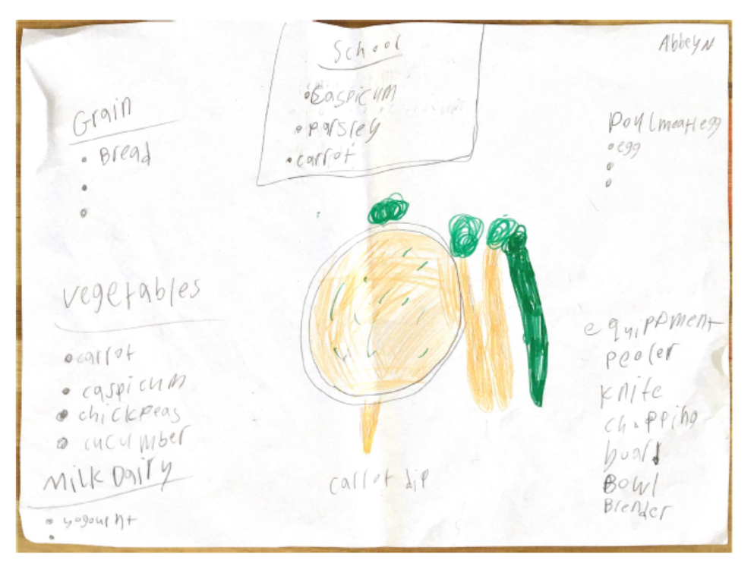
Student work sample 2

Student work sample 2 – assessment rubric

Relevant elements of the achievement standards
Design and Technologies
By the end of Level 2, students:  - identify the features and uses of some technologies for each of the prescribed technologies contexts [Food specialisations]  - describe given needs or opportunities  - … evaluate their ideas … based on personal preferences  - communicate design ideas for their designed solutions, using modelling and simple drawings  - following sequenced steps, ... demonstrate safe use of tools and equipment when producing designed solutions |  | By the end of Level 4, students:  - describe how the features of technologies can be used to create designed solutions for each of the prescribed technologies contexts [Food specialisations]  - explain needs or opportunities  - … evaluate ideas … against identified criteria for success, including sustainability considerations  - develop and expand design ideas and communicate these using models and drawings including annotations and symbols  - plan and sequence major steps in design and production  - identify appropriate technologies and techniques and demonstrate safe work practices when producing designed solutions. |  | By the end of Level 6, students:  - explain how the features of technologies impact on designed solutions for each of the prescribed technologies contexts [Food specialisations]  - suggest criteria for success, including sustainability considerations and use these to evaluate their ideas …  - combine design ideas and communicate these to audiences using graphical representation techniques and technical terms  - record project plans including production processes  - select and use appropriate technologies and techniques correctly and safely to produce designed solutions.
Health and Physical Education
By the end of Level 2, students:  - examine messages related to health decisions and describe how to help keep themselves and others healthy, safe and physically active. |  | By the end of Level 4, students:  - interpret health messages and discuss the influences on healthy and safe choices. |  | By the end of Level 6, students:  - describe their own and others’ contributions to health, physical activity, safety and wellbeing.

Assessment rubric
Organising element | Performance descriptions
 | At Level 2 students can: | When progressing towards Level 4, students can: | At Level 4 students can: | When progressing towards Level 6, students can: | At Level 6 students can:
Communication of design idea (final recipe) | Use simple drawing to communicate a design  idea. | Use simple drawing with annotations or symbols to communicate a design idea. | Use drawing with annotations and symbols to communicate a design idea. | Use drawing with annotations and symbols with technical terms to communicate a design idea. | Use graphical representation techniques and technical terms to communicate combined ideas to present a design idea.
Design brief specification | Evaluate the design idea according to personal preferences. | Identify how the design idea aligns with the design brief criteria for success. | Outline how the design idea aligns with the design brief criteria for success. | Describe the design idea according to the design brief criteria for success. | Evaluate the design idea according to the design brief criteria for success.
Alignment of the design idea (recipe) with the Australian Guide to Healthy Eating | Identify key nutritional features of the recipe. | Outline how the recipe aligns with the principles of a healthy diet. | Describe how the recipe aligns with the principles of a healthy diet. | Outline how the recipe contributes to health and wellbeing. | Describe how the recipe contributes to health and wellbeing.
Steps to produce the design idea (recipe) | With guidance, identify the major steps to produce the recipe. | Identify the major steps to produce the recipe. | Plan and sequence major steps in the production of the recipe. | With guidance, develop a project plan for the production of the recipe that includes the major production steps. | Develop a project plan for the production of the recipe that includes the major production steps.
Equipment required to produce the design idea (recipe) | With guidance, identify equipment required to produce the recipe. | Identify equipment required to produce the recipe. | Describe the features of the equipment required to produce the recipe. | With guidance, explain how the features of the equipment required to produce the recipe have an impact on the final product. | Explain how the features of the equipment required to produce the recipe have an impact on the final product.
Safe work practices for producing the design idea (recipe) | With guidance, identify safe work practices. | Identify safe work practices. | Identify safe work practices to produce the recipe. | Describe safe work practices to produce the recipe. | Justify safe work practices to produce the recipe.

Student work sample 2 – evidence of learning
Abbey drew a picture of carrot dip to demonstrate using simple drawings to communicate a design idea for a recipe. Abbey did not annotate or use symbols to communicate the design idea for the recipe, making it challenging to identify the other ingredients in her drawing of the carrot dip. However, she did write the actions required to make the dip, identifying the major steps to produce the recipe. In addition, Abbey told the teacher that the method to make the dip involved placing the vegetables in the blender with the yoghurt and whisking for two minutes. Abbey also identified the equipment required to produce the dip by listing peeler, knife, chopping board, bowl and blender. Although initially unable to identify the safety requirement for using the identified equipment, with guidance Abbey was able to identify the safety considerations for using the blender.
The carrot dip recipe written by Abbey referred to ‘vegetables’ and ‘yoghurt’ as ingredients in the dip, served with ‘bread’ and ‘cucumber’. Abbey placed carrots, cucumber and chickpeas in the Vegetables and legumes food group, yoghurt in the Dairy food group and bread in the Grains food group, identifying the use of ingredients from at least three of the Australian Guide to Healthy Eating food groups as specified as a criterion for success in the design brief. Abbey did identify eggs in the Meat/poultry food group, but it was not referenced in the recipe for the carrot dip.
Another criterion for success was that two or more additional ingredients would be available from the school/community/home garden. Abbey identified how the recipe aligned with this design brief criterion for success by verbally stating to the teacher that carrots, capsicum and cucumber were available from the school garden. In addition, Abbey verbally stated to the teacher that the dip could be purchased by students and teachers in the canteen as a snack food and identified that vegetables were healthy for you. Therefore, Abbey was able to identify how the carrot dip recipe aligned with the four listed criteria for success for the design brief.
Using the assessment rubric, Abbey has been assessed as:
- at Level 2 for Communication of design idea (final recipe)
- progressing towards Level 4 for Design brief specification
- at Level 2 for Alignment of the design idea (recipe) with the Australian Guide to Healthy Eating
- progressing towards Level 4 for Steps to produce the design idea (recipe)
- progressing towards Level 4 for Equipment required to produce the design idea (recipe)
- at Level 2 for Safe work practices for producing the design idea (recipe).
This assessment demonstrates that Abbey can:
- ‘identify the features and uses of some technologies for each of the prescribed technologies contexts [Food specialisations]’ (Design and Technologies, Foundation to Level 2 achievement standard)
- ‘describe given needs or opportunities’ (Design and Technologies, Foundation to Level 2 achievement standard)
- ‘… evaluate their ideas … based on personal preferences’ (Design and Technologies, Foundation to Level 2 achievement standard)
- ‘communicate design ideas for their designed solutions, using modelling and simple drawings’ (Design and Technologies, Foundation to Level 2 achievement standard)
- ‘following sequenced steps, ... demonstrate safe use of tools and equipment when producing designed solutions’ (Design and Technologies, Foundation to Level 2 achievement standard)
- ‘examine messages related to health decisions and describe how to help keep themselves and others healthy, safe and physically active’ (Health and Physical Education, Level 1 to 2 achievement standard).

What is the student ready to learn next?
Abbey is now ready to learn to:
- ‘describe how the features of technologies can be used to create designed solutions for each of the prescribed technologies contexts [Food specialisations]’ (Design and Technologies, Levels 3 to 4 achievement standard)
- ‘explain needs or opportunities’ (Design and Technologies, Levels 3 to 4 achievement standard)
- ‘… evaluate ideas … against identified criteria for success, including sustainability considerations’ (Design and Technologies, Levels 3 to 4 achievement standard)
- ‘develop and expand design ideas and communicate these using models and drawings including annotations and symbols’ (Design and Technologies, Levels 3 to 4 achievement standard)
- ‘plan and sequence major steps in design and production’ (Design and Technologies, Levels 3 to 4 achievement standard)
- ‘identify appropriate technologies and techniques and demonstrate safe work practices when producing designed solutions’ (Design and Technologies, Levels 3 to 4 achievement standard)
- ‘interpret health messages and discuss the influences on healthy and safe choices’ (Health and Physical Education, Levels 3 to 4 achievement standard).

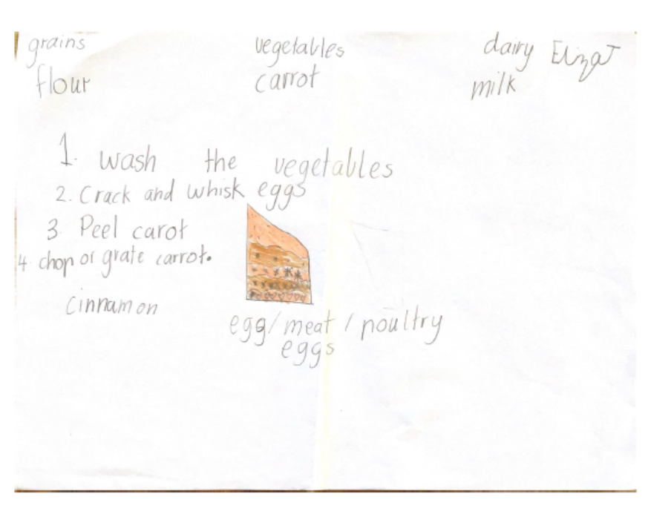
Student work sample 3

Student work sample 3 – assessment rubric
Relevant elements of the achievement standards
Design and Technologies
By the end of Level 2, students:  - identify the features and uses of some technologies for each of the prescribed technologies contexts [Food specialisations]  - describe given needs or opportunities  - … evaluate their ideas … based on personal preferences  - communicate design ideas for their designed solutions, using modelling and simple drawings  - following sequenced steps, ... demonstrate safe use of tools and equipment when producing designed solutions |  | By the end of Level 4, students:  - describe how the features of technologies can be used to create designed solutions for each of the prescribed technologies contexts [Food specialisations]  - explain needs or opportunities  - … evaluate ideas … against identified criteria for success, including sustainability considerations  - develop and expand design ideas and communicate these using models and drawings including annotations and symbols  - plan and sequence major steps in design and production  - identify appropriate technologies and techniques and demonstrate safe work practices when producing designed solutions. |  | By the end of Level 6, students:  - explain how the features of technologies impact on designed solutions for each of the prescribed technologies contexts [Food specialisations]  - suggest criteria for success, including sustainability considerations and use these to evaluate their ideas …  - combine design ideas and communicate these to audiences using graphical representation techniques and technical terms  - record project plans including production processes  - select and use appropriate technologies and techniques correctly and safely to produce designed solutions.
Health and Physical Education
By the end of Level 2, students:  - examine messages related to health decisions and describe how to help keep themselves and others healthy, safe and physically active. |  | By the end of Level 4, students:  - interpret health messages and discuss the influences on healthy and safe choices. |  | By the end of Level 6, students:  - describe their own and others’ contributions to health, physical activity, safety and wellbeing.

Assessment rubric
Organising element | Performance descriptions
 | At Level 2 students can: | When progressing towards Level 4, students can: | At Level 4 students can: | When progressing towards Level 6, students can: | At Level 6 students can:
Communication of design idea (final recipe) | Use simple drawing to communicate a design  idea. | Use simple drawing with annotations or symbols to communicate a design idea. | Use drawing with annotations and symbols to communicate a design idea. | Use drawing with annotations and symbols with technical terms to communicate a design idea. | Use graphical representation techniques and technical terms to communicate combined ideas to present a design idea.
Design brief specification | Evaluate the design idea according to personal preferences. | Identify how the design idea aligns with the design brief criteria for success. | Outline how the design idea aligns with the design brief criteria for success. | Describe the design idea according to the design brief criteria for success. | Evaluate the design idea according to the design brief criteria for success.
Alignment of the design idea (recipe) with the Australian Guide to Healthy Eating | Identify key nutritional features of the recipe. | Outline how the recipe aligns with the principles of a healthy diet. | Describe how the recipe aligns with the principles of a healthy diet. | Outline how the recipe contributes to health and wellbeing. | Describe how the recipe contributes to health and wellbeing.
Steps to produce the design idea (recipe) | With guidance, identify the major steps to produce the recipe. | Identify the major steps to produce the recipe. | Plan and sequence major steps in the production of the recipe. | With guidance, develop a project plan for the production of the recipe that includes the major production steps. | Develop a project plan for the production of the recipe that includes the major production steps.
Equipment required to produce the design idea (recipe) | With guidance, identify equipment required to produce the recipe. | Identify equipment required to produce the recipe. | Describe the features of the equipment required to produce the recipe. | With guidance, explain how the features of the equipment required to produce the recipe have an impact on the final product. | Explain how the features of the equipment required to produce the recipe have an impact on the final product.
Safe work practices for producing the design idea (recipe) | With guidance, identify safe work practices. | Identify safe work practices. | Identify safe work practices to produce the recipe. | Describe safe work practices to produce the recipe. | Justify safe work practices to produce the recipe.

Student work sample 3 – evidence of learning
Eliza drew a picture of a carrot cake to demonstrate using simple drawings to communicate a design idea for a recipe. She did not provide evidence of annotations or symbols to communicate this design idea. Eliza was able to identify equipment required to produce the recipe by verbally listing a knife, peeler, bowl and a wooden spoon to the teacher. She was able to independently state some steps required to make the cake, focusing on preparation of the carrots (washing, peeling, chopping and grating) and eggs (cracking and whisking). Eliza required guidance from the teacher to identify other major steps required to produce the recipe. With guidance, Eliza was able to identify safe work practices by verbally stating ‘not to cut yourself with the knife’ when prompted by the teacher.
Eliza identified key nutritional features of the carrot cake recipe. She placed carrots in the Vegetables and legumes food group, milk in the Dairy food group, eggs in the Meat/poultry food group and flour in the Grains food group. Although cake belongs in the eat ‘only sometimes and in small amounts’ category (because of its high fat and sugar content) and would not be regarded as ‘nutritious’, Eliza identified the use of ingredients in the recipe from at least three of the Australian Guide to Healthy Eating food groups as specified as a criterion for success in the design brief. With guidance, Eliza was able to verbally state that the cake could be purchased by students and teachers in the canteen as a snack food and identified that carrots were healthy for you. Therefore, Eliza was able to identify how the carrot cake recipe aligned with another criterion for success for the design brief.
Another criterion for success was that two or more additional ingredients would be available from the school/community/home garden. Eliza verbally stated to the teacher that carrots were available from the school garden but did not state another ingredient as required to meet this criterion for success. She was able to evaluate the design idea according to personal preferences but did not provide evidence that she could identify how the carrot cake design idea aligned with the design brief criteria for success.
Using the assessment rubric, Eliza has been assessed as:
- at Level 2 for Communication of design idea (final recipe)
- at Level 2 for Design brief specification
- at Level 2 for Alignment of the design idea (recipe) with the Australian Guide to Healthy Eating
- at Level 2 for Steps to produce the design idea (recipe)
- progressing towards Level 4 for Equipment required to produce the design idea (recipe)
- at Level 2 for Safe work practices for producing the design idea (recipe).
This assessment demonstrates that Eliza can:
- ‘identify the features and uses of some technologies for each of the prescribed technologies contexts [Food specialisations]’ (Design and Technologies, Foundation to Level 2 achievement standard)
- ‘describe given needs or opportunities’ (Design and Technologies, Foundation to Level 2 achievement standard)
- ‘… evaluate their ideas … based on personal preferences’ (Design and Technologies, Foundation to Level 2 achievement standard)
- ‘communicate design ideas for their designed solutions, using modelling and simple drawings’ (Design and Technologies, Foundation to Level 2 achievement standard)
- ‘following sequenced steps, ... demonstrate safe use of tools and equipment when producing designed solutions’ (Design and Technologies, Foundation to Level 2 achievement standard)
- ‘examine messages related to health decisions and describe how to help keep themselves and others healthy, safe and physically active’ (Health and Physical Education, Level 1 to 2 achievement standard)

What is the student ready to learn next?
Eliza is now ready to learn to:
- ‘describe how the features of technologies can be used to create designed solutions for each of the prescribed technologies contexts [Food specialisations]’ (Design and Technologies, Levels 3 to 4 achievement standard)
- ‘explain needs or opportunities’ (Design and Technologies, Levels 3 to 4 achievement standard)
- ‘… evaluate ideas … against identified criteria for success, including sustainability considerations’ (Design and Technologies, Levels 3 to 4 achievement standard)
- ‘develop and expand design ideas and communicate these using models and drawings including annotations and symbols’ (Design and Technologies, Levels 3 to 4 achievement standard)
- ‘plan and sequence major steps in design and production’ (Design and Technologies, Levels 3 to 4 achievement standard)
- ‘identify appropriate technologies and techniques and demonstrate safe work practices when producing designed solutions’ (Design and Technologies, Levels 3 to 4 achievement standard)
- ‘interpret health messages and discuss the influences on healthy and safe choices’ (Health and Physical Education, Levels 3 to 4 achievement standard).

