Intercultural Capability: Unit plan, Levels 3 and 4

Cultural practices and their significance

Authorised and published by the Victorian Curriculum and Assessment Authority
Level 7, 2 Lonsdale Street
Melbourne VIC 3000
© Victorian Curriculum and Assessment Authority 2019

No part of this publication may be reproduced except as specified under the Copyright Act 1968 or by permission from the VCAA. Excepting third-party elements, schools may use this resource in accordance with the VCAA educational allowance. More copyright information.
The VCAA provides the only official, up-to-date versions of VCAA publications. Details of updates can be found on the VCAA website.
This publication may contain copyright material belonging to a third party. Every effort has been made to contact all copyright owners. If you believe that material in this publication is an infringement of your copyright, please email the Copyright Officer: vcaa.copyright@edumail.vic.gov.au.
Copyright in materials appearing at any sites linked to this document rests with the copyright owner/s of those materials, subject to the Copyright Act. The VCAA recommends you refer to copyright statements at linked sites before using such materials. URLs were correct at the time of publication.

The VCAA logo is a registered trademark of the Victorian Curriculum and Assessment Authority.

Contents

The Intercultural Capability project 4
Safety and wellbeing 4
About this unit 5
Context 5
Overview 5
Formative assessment rubric 6
Unit lesson plans 7
Lesson 1 – Our cultural practices 7
Lesson 2 – The meaning of our cultural practices 8
Lesson 3 – Connections between different cultural practices 9
Lessons 4 and 5 – Researching a cultural practice 10
Lessons 6 to 8 – Presentation of findings 11
Appendix 1 12
Appendix 2 13
Work samples 14
Sample 1 a) 14
Sample 1 b) 15
Sample 1 c) 16
Sample 2 a) 18
Sample 2 b) 19
Teacher reflections 21

The Intercultural Capability project
This unit is based on material developed with schools participating in the 2018 Intercultural Capability project. The project was conducted by the Victorian Curriculum and Assessment Authority in partnership with the International Education Division at the Department of Education and Training. The units of work target the explicit teaching of the Victorian Curriculum: F-10 Intercultural Capability. They include formative assessment rubrics that the teachers designed to describe progression of student learning in Intercultural Capability and to provide guidance to students on how to progress their learning. This unit provides one example of how a school might plan for the explicit teaching of Intercultural Capability. It is not published as an exemplar.

Safety and wellbeing
Teachers must exercise their duty of care in ensuring that the safety and wellbeing of students is maintained during the study of this Intercultural Capability unit. In addition to the usual pastoral care and health needs of students, teachers should bear in mind cultural sensitivities and the potential for disagreement or conflict over cultural/racial issues. Students should be given the opportunity to provide depersonalised responses or exempt themselves from activities of a potentially sensitive nature and should not be asked to speak on behalf of others. Harmful language or behaviour towards others on the basis of culture or race should not be tolerated. Where appropriate students should be counselled and/or debriefed. For further advice on navigating race and culture issues in the classroom, see the VCAA’s Teacher Guide.

About this unit
Unit title: Cultural practices and their significance
Band: Levels 3 and 4
Teaching time: 8 x 45 minutes

Context
- This unit was developed in a new and highly diverse school in a south-eastern suburb of Melbourne.
- The teacher used resources from FUSE and the school library to create a sequence of lessons; the picture book Mirror by Jeannie Baker was a key resource along with other storybooks.
- The class had not been taught the Intercultural Capability curriculum prior to the unit.

Overview
The intention of the unit was for students to learn how to compare and contrast a range of cultural practices and explain their significance.
The unit was created in association with a formative assessment rubric (see below) which was used to plan lessons to help students progress their learning. The lessons address the three actions in the rubric:
- Investigates own cultural practices
- Explores cultural practices of others
- Finds connections between different cultural practices.
In the sequence of eight lessons, students define culture and cultural practices before sharing some of their own cultural practices with fellow students. They explain/show the nature of a fellow student’s cultural practices and the nature and origins/significance of their own practices. Students then examine a range of storybooks to find similarities and differences between a range of cultures and the common values and significance of cultural practices. The unit culminates with a presentation, based on research, on multiple aspects of a chosen cultural practice.
The unit and associated rubric target the following parts of the Victorian Curriculum: F–10 Intercultural Capability curriculum:
Band: Levels 3 and 4
Strand: Cultural Practices
Content descriptions: Compare their own and others cultural practices, showing how these may influence the ways people relate to each other (VCICCB005)
Achievement Standard: By the end of Level 4, students are able to compare a range of cultural practices and explain their influence on people’s relationships. They explain what they have learnt about themselves and others from intercultural experiences. Students explain the role of cultural traditions in the development of various identities. They develop critical perspective on and respect for their own and others’ cultures.

Formative assessment rubric
The formative assessment rubric below was used to help identify the steps in learning, to collect evidence of learning and as a basis for providing feedback. The lesson plans that follow specify which part of the rubric was targeted in each lesson.
The rubric was developed using the relevant Intercultural Capability achievement standard/s and the Guide to Formative Assessment Rubrics. More information about the terminology and structure of the rubric can be found in the Guide.
 |  |  | Intercultural Capability, Levels 3 and 4
 |  |  | Phase 1 | Phase 2 | Phase 3 | Phase 4
 |  |  | Students in this phase can identify cultural practices | Students in this phase can describe and compare the nature of cultural practices | Students in this phase can explain the origins, purpose and/or significance of cultural practices | Students in this phase can examine how cultural practices affect relationships
Organising Element/s | Action |  | Quality Criteria
Cultural Practices strand | 1. Investigates own cultural practices | Insufficient evidence | 1.1 Identifies own cultural practices | 1.2 Describes nature of own cultural practices | 1.3 Explains origins, purpose and/or significance of cultural practices within own culture/s
 | 2. Explores cultural practices of others | Insufficient evidence | 2.1 Identifies cultural practices of others | 2.2 Describes nature of cultural practices of others | 2.3 Explains origins, purpose and/or significance of cultural practices within another culture
 | 3. Finds connections between different cultural practices | Insufficient evidence |  | 3.1 Identifies similarities and differences between cultural practices |  | 3.2 Explains how cultural practices affect people’s relationships

Unit lesson plans
The following lessons were created to progress student learning. Each lesson is linked to a particular action/s in the formative assessment rubric and the associated quality criteria. Teachers should give students ongoing feedback on the next steps in their learning and provide opportunities to progress their understanding of the targeted area of the curriculum.

Lesson 1 – Our cultural practices

Rubric areas targeted:
- 1.1 Identifies own cultural practices
- 1.2 Describes nature of own cultural practices
- 2.1 Identifies cultural practices of others
- 2.2 Describes nature of cultural practices of others

Before the lesson: Advise parents/carers in a letter (see Appendix 1) that the class will be studying culture and cultural practices and that they should discuss their own culture with their child in readiness for the unit. They should share with their child the part/s of the world they come from, what culture/s they identify with, details of significant practices of their culture/s and what their culture means to them.
Pose the question to students: What is culture? Have students think–pair–share the question and write up their responses on the board. Repeat for cultural practices. Develop working definitions that the class understands based on the definitions within the Intercultural Capability Glossary.
Working individually, have students choose a cultural practice from their own culture and describe the nature of the practice, e.g. when/how often it occurs, who practises it, what activities are involved, and whether it is linked with a religion. They might like to draw a picture of the practice as a starting point and then annotate it. Students then get into groups of 4–6 and share their responses with each other.
Ask students to choose one cultural practice shared by a student in their group and show the nature of that practice in writing or an annotated drawing. (The practice should not be from their own culture/s.)

Resources:
Sample letter to parents/carers (Appendix 1)
Intercultural Capability Glossary

Lesson 2 – The meaning of our cultural practices

Rubric areas targeted:
- 1.3 Explains origins, purpose and/or significance of cultural practices within own culture/s

After recapping the last lesson, explain that you will now look at the origins, purpose and significance of cultural practices. Give some examples, such as the following:
- In Australia and other Western cultures, people traditionally shake hands when meeting for the first time. This practice dates back to ancient Greece when it is thought to have been a gesture of peace (by showing that the hand was free of a weapon); the practice is significant in Australian culture because it signals respect, goodwill and equality between people who don’t know each other.
- In Chinese culture, the New Year is celebrated in February and, along with celebrating renewal, is associated with fortune and luck; one New Year practice is cleaning one’s home to remove the bad luck of the past and make way for good luck. This reflects the traditional Chinese belief in fate and fortune as driving factors in one’s life.
Invite students to give examples of their own.
Have students research the origins, purpose and/or significance of at least one cultural practice from their own culture/s in the school library and/or at websites such as:
- The significance of cultural practices
- Australia
- African countries
- Asian countries (general)
- China
- Europe
- India
- Islamic countries
- Polynesia
Have students present their findings in a format of choice.

Lesson 3 – Connections between different cultural practices

Rubric areas targeted:
- 2.3 Explains origins, purpose and/or significance of cultural practices within another culture
- 3.2 Explains how cultural practices affect people’s relationships

Read aloud two or more storybooks showing different cultural practices (see examples in Resources).
Explore with the class the following questions:
- What cultural practices are shown in the books?
- Which practices are familiar and unfamiliar?
- What purpose or significance do the practices seem to have?
- How do cultural practices seem to affect people’s relationships? (e.g. bringing people together, passing on knowledge/values, connecting with ancestors/the dead)
Note: When discussing cultural practices, if students raise basic human activities such as ‘working’ or ‘shopping’, assist them to focus on the cultural aspects of these activities, e.g. where they are shopping, what they are buying and why.
Select some of the questions above and ask students to respond to them to show their understanding of the significance of cultural practices and how they affect people’s relationships. For example, they might interview someone about their cultural practices and write an article, write a general reflection or annotate an image from a storybook (for the latter, provide a colour photocopy). Prompt students with feedback to ensure that they consider the deeper significance of cultural practices, not just their obvious features.
Share responses as a class.

Resources:
Examples of storybooks exploring cultural practices:
- Ernie Dances to the Didgeridoo by Alison Lester
- Bringing In the New Year by Roseanne Thong and Grace Lin
- Under the Love Umbrella by Davina Bell and Allison Colpoys
- I Remember Abuelito: A Day of the Dead Story by Janice levy and Loretta Lopez
- Mirror by Jeannie Baker

Lessons 4 and 5 – Researching a cultural practice

Rubric areas targeted:
- 2.1 Identifies cultural practices of others
- 2.2 Describes nature of cultural practices of others
- 2.3 Explains origins, purpose and/or significance of cultural practices within another culture
- 3.1 Identifies similarities and differences between cultural practices

Explain to the students that in these lessons they are going to research a cultural practice of a culture other than their own more deeply. The Research Findings table asks them to collect the following information:
- Features of the practice
- Countries/groups that observe the practice
- The origins, purpose or significance of the practice
- A few similarities and differences between the chosen cultural practice and your own practices
- References used.

Model how to complete the table and explain that it is the first step in creating their major piece of work for the unit, which will be explained later.
Have students conduct their research in the school library and/or using the websites such as those listed in Lesson 2 as a starting point. To assist in comparison, they could research the same cultural practice that they researched for their own culture in Lesson 2.
As students complete their tables, circulate and listen for gaps in understanding; give regular prompts and feedback to progress their learning.

Resources:
Research Findings table (Appendix 2)
Information on cultural practices (see suggested websites in Lesson 2)

Lessons 6 to 8 – Presentation of findings

Rubric areas targeted:
- 1.2 Describes nature of own cultural practices
- 1.3 Explains origins, purpose and/or significance of cultural practices within own culture/s
- 2.1 Identifies cultural practices of others
- 2.2 Describes nature of cultural practices of others
- 2.3 Explains origins, purpose and/or significance of cultural practices within another culture
- 3.1 Identifies similarities and differences between cultural practices

Now that they have completed their research on a cultural practice, explain to students that they will draw their findings together to be shared with the class. They need to respond to at least four of the headings in their Research Findings table (see previous lesson) and present their responses in one of the following formats:
- Slideshow
- Poster or poster-sized graphic organiser/infographic
- Video/audio presentation
- Pamphlet
- Script/performance
- Other.
Students should work individually, with ongoing prompts and feedback to progress their learning.
Have students share their presentations/displays with the class. You might invite parents/carers into school on that day and invite them to offer their own reflections on cultural practices and to give feedback on the students’ work.

Resources:
How to make a pamphlet in Word

Appendix 1

Dear parents/carers,

Our class is currently studying culture as part of the Victorian Curriculum: F-10 Intercultural Capability. We will be talking to students about where their families come from in the world, and what cultural practices they traditionally observe.
Could you please do the following to assist your child in their learning:
- Read about culture and cultural practices below. This explains concepts being taught as part of this unit.
- Share with your child the following information so that they can bring this back to class:
- The country/countries where your family came from. If you were born in Australia and are not Aboriginal or Torres Strait Islander, state the country/countries your ancestors came from. If you are Aboriginal or Torres Strait Islander, share where in Australia your ancestors came from, for example which Aboriginal nation/s.
- The country/countries of origin the family identifies with (e.g. Australian, Indian and Australian, Chinese, Korean and British, Somali).
- Some cultural practices the family observes (e.g. celebrating a religious holiday, wearing certain clothing, cooking or avoiding certain food) and why these practices are special or significant to you.

Culture and cultural practices
Culture is made up of ‘cultural practices’ that relate to the ways a group of people live. Some cultural practices often involve material objects such as clothing or musical instruments but also non-material things such as language, customs and social roles.
Different cultural groups can have different practices, such as the food they eat and how it is made, the language they speak, the clothes they wear, the music and arts they create and the religious tradition they observe.
Cultural practices become traditional when they are regularly passed down to different members of the family and community through experiences and stories.
Cultural practices are guided by cultural values. For example, in Australia it is a common view that everyone should have a ‘fair go’, meaning that all people should have similar opportunities. Cultural groups often share similar values – such as fairness, politeness or respect for elders – even if they dress, worship or celebrate in different ways.

Appendix 2
Research Findings
Chosen cultural practice: ___________________________________________________________________________________ Student name/s: ___________________________________________
Research and note down the key aspects of your chosen cultural practice below. Use at least two sources of information for each heading and record the source details under ‘References used’.

Features of the practice | Countries/groups that observe  the practice | Origins, purpose or significance  of the practice
A few similarities and differences between the practice and one of your own cultural practices

References used

Work samples
Samples have not been corrected for expression or accuracy.

Sample 1 a)
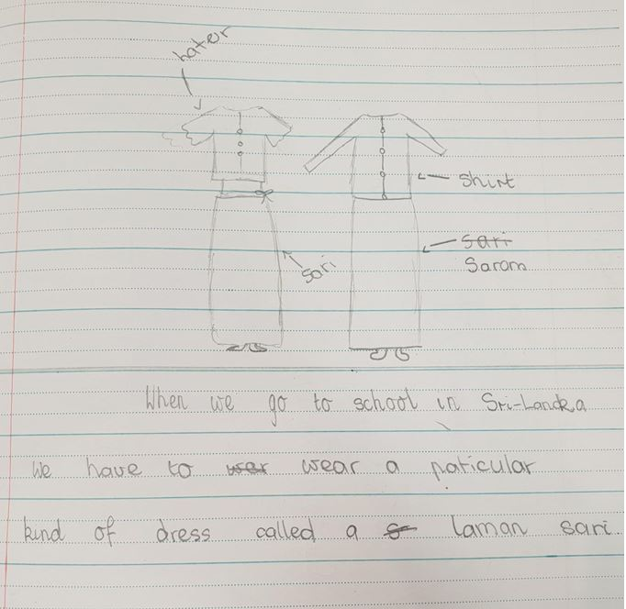

This sample demonstrated the following actions in the rubric:
1.1 Identifies own cultural practices
1.2 Describes nature of own cultural practices
Progression:
The next step for the student would be to explain why Sri Lankan girls wear a sari to school, or compare the clothing with what girls wear to school in Australia.

Sample 1 b)
A comparison of Australia and Morocco, as depicted in Mirror by Jeannie Baker.
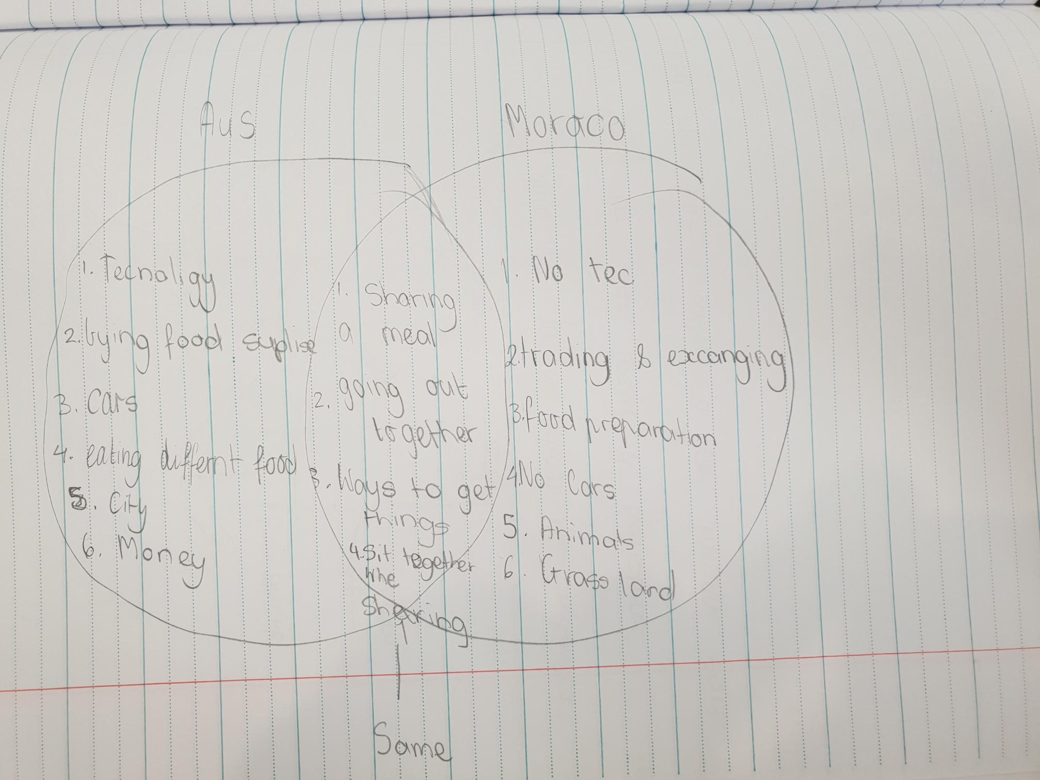
This sample demonstrated the following actions in the rubric:

Progress 3.1 Identifies similarities and differences between cultural practices
Progress towards 3.2 Identifies common values connecting the practices of different cultures

Progression:
The next step for the student would be to give more examples of people’s cultural practices (rather than features of the society) and of common values between cultures that underpin cultural practices such as sharing a meal together.

Sample 1 c)
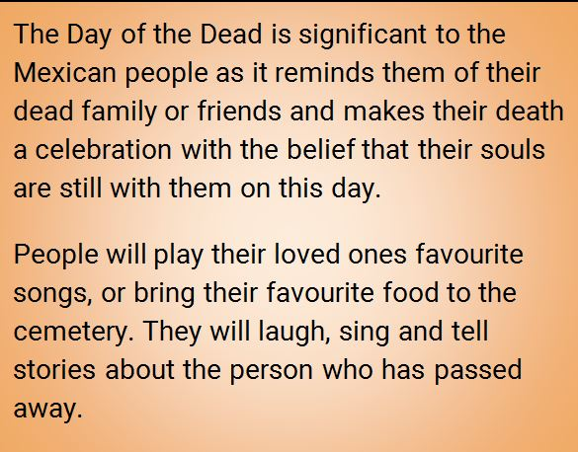
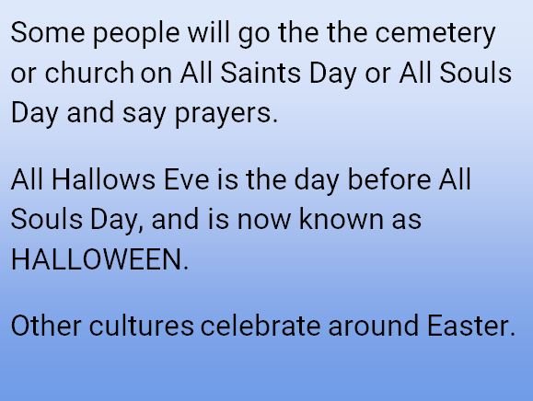
This sample demonstrated the following actions in the rubric:
2.3 Explains origins, purpose and/or significance of cultural practices within another culture
Progress towards 3.1 Identifies similarities and differences between cultural practices
Progress towards 3.2 Explains how cultural practices affect people’s relationships
Progression: The next step for the student would be to identify differences between cultural practices, e.g. the Day of the Dead and her own culture, or to explain more specifically how cultural practices affect relationships.

 |  | Sample 1 | Intercultural Capability, Levels 3 and 4
 |  |  | Phase 1 | Phase 2 | Phase 3 | Phase 4
 |  |  | Students in this phase can identify cultural practices | Students in this phase can describe the nature of cultural practices | Students in this phase can explain the origins, purpose and/or significance of cultural practices | Students in this phase can examine how cultural practices affect relationships
Organising Element/s | Action |  | Quality Criteria
Cultural Practices strand | 1. Investigates own cultural practices | Insufficient evidence | 1.1 Identifies own cultural practices | 1.2 Describes nature of own cultural practices | 1.3 Explains origins, purpose and/or significance of cultural practices within own culture/s
 | 2. Explores cultural practices of others | Insufficient evidence | 2.1 Identifies cultural practices of others | 2.2 Describes nature of cultural practices of others | 2.3 Explains origins, purpose and/or significance of cultural practices within another culture
 | 3. Finds connections between different cultural practices | Insufficient evidence |  | 3.1 Identifies similarities and differences between cultural practices |  | 3.2 Explains how cultural practices affect people’s relationships

Sample 2 a)
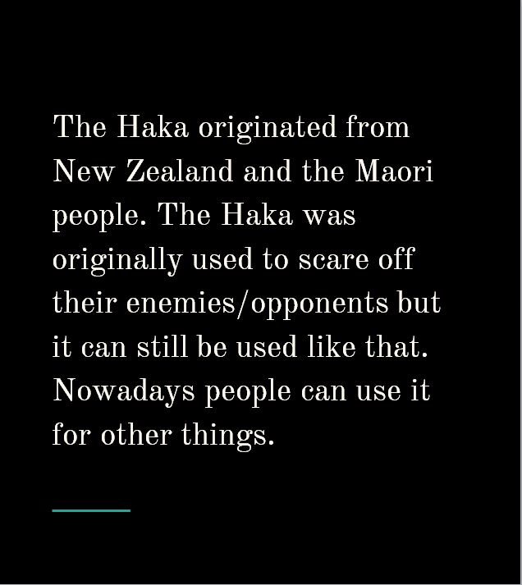
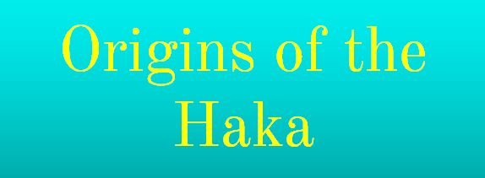
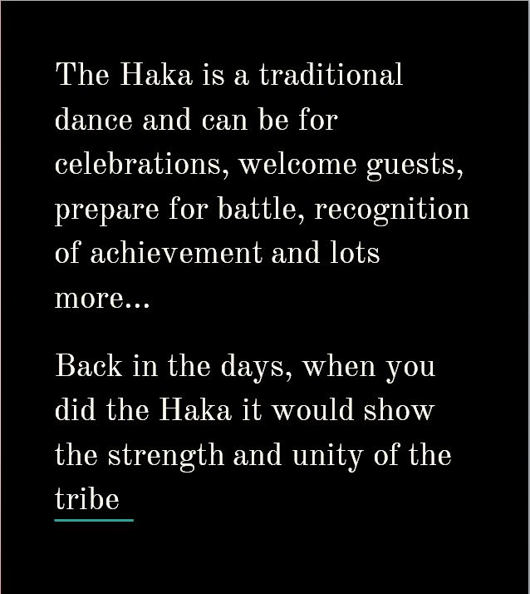
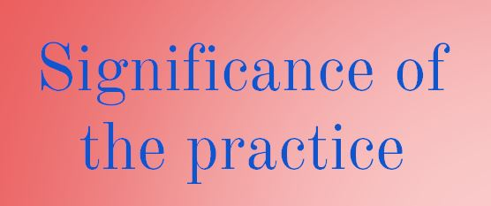

This sample demonstrated the following actions in the rubric:
2.1 Identifies cultural practices of others
Progress towards 2.2 Describes nature of cultural practices of others
2.3 Explains origins, purpose and/or significance of cultural practices within another culture
Progression: The next step for the student would be to describe more fully the features of the cultural practice.

Sample 2 b)
Similarities Differences

My cultural practice: The Tinikling
Other cultural practice: The Haka
Difference:
The Haka is traditional but the Tinikling
is folk. The Tinikling is more of storytelling where the Haka is more of a dance.
My cultural practice: The Tinikling
Other cultural practice: The Haka
Similarity:
They are both a cultural dance performed by a group of people – the Haka can only be performed by a New Zealander and the Tinikling can only be done by Filipinos.

This sample demonstrated the following actions in the rubric:
1.1 Identifies own cultural practices
Progress towards 1.2 Describes nature of own cultural practices
2.1 Identifies cultural practices of others
Progress towards 2.2 Describes nature of cultural practices of others
3.1 Identifies similarities and differences between cultural practices
Progression: The next step for the student would be to expand on the nature and features of each cultural practice.

 |  | Sample 2 | Intercultural Capability, Levels 3 and 4
 |  |  | Phase 1 | Phase 2 | Phase 3 | Phase 4
 |  |  | Students in this phase can identify cultural practices | Students in this phase can describe the nature of cultural practices | Students in this phase can explain the origins, purpose and/or significance of cultural practices | Students in this phase can examine how cultural practices affect relationships
Organising Element/s | Action |  | Quality Criteria
Cultural Practices strand | 1. Investigates own cultural practices | Insufficient evidence | 1.1 Identifies own cultural practices | 1.2 Describes nature of own cultural practices | 1.3 Explains origins, purpose and/or significance of cultural practices within own culture/s
 | 2. Explores cultural practices of others | Insufficient evidence | 2.1 Identifies cultural practices of others | 2.2 Describes nature of cultural practices of others | 2.3 Explains origins, purpose and/or significance of cultural practices within another culture
 | 3. Finds connections between different cultural practices | Insufficient evidence |  | 3.1 Identifies similarities and differences between cultural practices |  | 3.2 Explains how cultural practices affect people’s relationships

Teacher reflections
Teachers involved in the Intercultural Capability Project were invited to reflect on their curriculum planning and teaching experience.
The teacher of this unit stated:
Students were very engaged in the topic and the class had many rich conversations. The main challenge was that the class had no prior experience with the Intercultural Capability curriculum; however it was pleasing to see how enthusiastically the unit was received.

