Intercultural Capability: Unit plan,
Foundation to Level 2

Embracing who we are

Authorised and published by the Victorian Curriculum and Assessment Authority
Level 7, 2 Lonsdale Street
Melbourne VIC 3000
© Victorian Curriculum and Assessment Authority 2019

No part of this publication may be reproduced except as specified under the Copyright Act 1968 or by permission from the VCAA. Excepting third-party elements, schools may use this resource in accordance with the VCAA educational allowance. More copyright information.
The VCAA provides the only official, up-to-date versions of VCAA publications. Details of updates can be found on the VCAA website.
This publication may contain copyright material belonging to a third party. Every effort has been made to contact all copyright owners. If you believe that material in this publication is an infringement of your copyright, please email the Copyright Officer: vcaa.copyright@edumail.vic.gov.au.
Copyright in materials appearing at any sites linked to this document rests with the copyright owner/s of those materials, subject to the Copyright Act. The VCAA recommends you refer to copyright statements at linked sites before using such materials. URLs were correct at the time of publication.

The VCAA logo is a registered trademark of the Victorian Curriculum and Assessment Authority.

Contents
The Intercultural Capability project 4
About this unit 5
Context 5
Overview 5
Formative assessment rubric 7
Unit lesson plans 8
Appendix 1 13
Work samples 15
Sample 1 a) 15
Sample 1 b) 16
Sample 1 c) 17
Sample 2 a) 19
Sample 2 b) 20
Teacher reflections 22

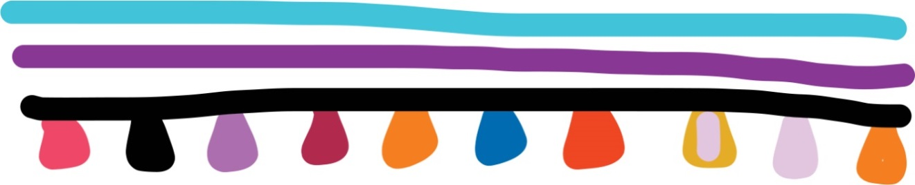

The Intercultural Capability project
This unit is based on material developed with schools participating in the 2018 Intercultural Capability project. The project was conducted by the Victorian Curriculum and Assessment Authority in partnership with the International Education Division at the Department of Education and Training. The units of work target the explicit teaching of the Victorian Curriculum: F-10 Intercultural Capability. They include formative assessment rubrics that the teachers designed to describe progression of student learning in Intercultural Capability and to provide guidance to students on how to make progress in their learning. This unit provides one example of how a school might plan for the explicit teaching of Intercultural Capability. It is not published as an exemplar.

Safety and wellbeing
Teachers must exercise their duty of care in ensuring that the safety and wellbeing of students is maintained during the study of this Intercultural Capability unit. In addition to the usual pastoral care and health needs of students, teachers should bear in mind cultural sensitivities and the potential for disagreement or conflict over cultural/racial issues. Students should be given the opportunity to provide depersonalised responses or exempt themselves from activities of a potentially sensitive nature and should not be asked to speak on behalf of others. Harmful language or behaviour towards others on the basis of culture or race should not be tolerated. Where appropriate students should be counselled and/or debriefed. For further advice on navigating race and culture issues in the classroom, see the VCAA’s Teacher Guide.

About this unit
Unit title: Embracing who we are
Band: Foundation to Level 2
Teaching time: 6 x 30 minutes

Context
- This unit was developed in a multicultural Catholic primary school in a low socio-economic suburb in Melbourne’s west. Approximately 70 per cent of the students come from an EAL (English as an Additional Language) background.

- The teachers used the following storybooks and other resources (see lessons) as source materials for the sequence of lessons:

- Rice and Rocks by Sandra L Richards

- Dumpling Soup by Jama Kim Rattigan

- I’m Australian Too by Mem Fox.

Overview
The unit was created in association with a formative assessment rubric (see below) which was used to plan teaching and learning activities to facilitate progress in student learning. The lessons address the three actions in the rubric:
- Examines own cultural practices

- Investigates cultural practices of others

- Explores similarities and differences between their own and other cultures.
In the sequence of six lessons, students discuss their own culture/s after first speaking with their family about where they come from and finding an item of importance to the culture. They explore both surface-level and deeper aspects of culture. The class examines three storybooks (Rice and Rocks, Dumpling Soup and I’m Australian Too) as a springboard to exploring similarities and differences between cultures and to sharing cultural food together. Parents and carers are invited to share in the concluding presentations that reflect on similarities and differences between cultures and the values that underpin many cultural practices around the world.
The unit and accompanying rubric to support a progression in student learning target the following part of the Victorian Curriculum: F–10 Intercultural Capability curriculum:

Band: Foundation to Level 2
Strand: Cultural Practices
Content descriptions: Identify what is familiar and what is different in the ways culturally diverse individuals and families live (VCICCB001)
Strand: Cultural Diversity
Content descriptions: Identify and discuss cultural diversity in the school and/or community (VCICCD003)
Describe their experiences of intercultural encounters in which they have been involved (VCICCB002)
Achievement Standard: By the end of Level 2, students begin to distinguish what is familiar and different in the ways culturally diverse individuals and families live. They describe their experiences of intercultural encounters, and identify cultural diversity in their school and/or community. Students explain how they might respond in different cultural situations

Formative assessment rubric
The formative assessment rubric below was used to help identify the steps in learning, to collect evidence of learning and as a basis for providing feedback. The lesson plans that follow specify which part of the rubric was targeted in each lesson.
The rubric was developed using the relevant Intercultural Capability achievement standard/s and the Guide to Formative Assessment Rubrics. More information about the terminology and structure of the rubric can be found in the Guide.
 |  |  | Intercultural Capability, Foundation to Level 2
 |  |  | Phase 1 | Phase 2 | Phase 3 | Phase 4
 |  |  | Students in this phase can identify their family's culture/s and cultural practices | Students in this phase can identify some other cultures and cultural practices | Students in this phase can explore how culturally diverse individuals and families live | Students in this phase can identify common values or practices among different cultural groups
Organising Element/s | Action |  | Quality Criteria
Cultural Practices and Cultural Diversity strands | 1. Examines own cultural practices | Insufficient evidence | 1.1 Describes or shows own cultural practices |  |  | 1.2 Identifies values underlying own cultural practices
 | 2. Investigates cultural practices of others | Insufficient evidence |  | 2.1 Identifies cultural practices of others | 2.2 Describes/shows/  participates in others’ cultural practices
 | 3. Explores similarities and differences between their own and other cultures | Insufficient evidence |  | 3.1 Describes similarities and differences between their own and another culture | 3.2 Explains similarities and differences between their own and another culture | 3.3 Identifies values or practices shared by people from different parts of the world

Unit lesson plans
The following lessons were created to facilitate progress in student learning. Each lesson was linked to a particular action/s in the formative assessment rubric and the associated quality criteria. Teachers should give students ongoing feedback on the next steps in their learning and provide opportunities for them to make progress in their understanding of the targeted area of the curriculum. Student names referred to in the unit and samples are fictitious.

Lesson 1 – Our own cultures and cultural practices

Rubric areas targeted:
- 1.1 Describes or shows own cultural practices
- 1.2 Identifies values underlying own cultural practices
- 3.3 Identifies values or practices shared by people from different parts of the world

Before the lesson: Send home a letter asking parents/carers to give their child a picture/item representing an aspect of their family’s culture to bring to the next lesson, and to complete a simple reflection sheet about the item (see Appendix 1). If possible, have the letter and sheet translated for the families.
The letter contains definitions of culture and cultural practices adapted from the Victorian Curriculum F–10 Intercultural Capability Glossary. In class, explain these terms in more simple language for the students and give concrete examples before beginning the next activity. For example, draw on objects from your own culture and/or images/objects representing different cultures collected before the lesson.
Circle time: Invite students to share their responses to the ‘My Culture’ sheet completed at home. While they are sharing, show the class the places of origin on a world map or globe.
After discussing with students the basic features of each cultural item shared, encourage students to think about their deeper significance. For example:
Maria brought in a photo of her father making tomato sauce. Many Italians put aside a day to make their own tomato sauce. The day is not only about creating bottles of tomato sauce to be used throughout the year, but it is also a time for family to gather together and work together. Tomato day is often filled with mess, laughter and older people passing on their knowledge to younger members of the family. The tomato sauce nourishes the body and the experience of making it together nourishes the sense of family and togetherness.
Ask students to offer ideas on the deeper significance of items shared by other members of the class and record these on the board. Listen for gaps in their understanding and give feedback and prompts to improve their learning.

Resources:
Letter to parents/carers and ‘My Culture’ sheet (Appendix 1)
Glossary of Intercultural Capability terms
World map (print/electronic) or globe

Lesson 2 – Cultural practices around the world

Rubric areas targeted:
- 1.1 Describes or shows own cultural practices
- 2.1 Identifies cultural practices of others
- 3.3 Identifies values or practices shared by people from different parts of the world

Read aloud the storybook Rice and Rocks by Sandra L Richards.
During a second reading, note with the students the location on a map or globe of each country Giovanni visits and the food he discovers there.
Give each student a paper plate and ask them to draw/describe one food from their own culture and one unfamiliar food from the book that they would like to try.
After sharing responses, discuss the messages conveyed by the book about the value of celebrating your culture and the ways in which cultures are alike despite their differences on the surface.

Resources:
Rice and Rocks by Sandra L Richards
World map or globe
Paper plates
Crayons/pencils/textas

Lessons 3 and 4 – Sharing culture together

Rubric areas targeted:
- 2.2 Describes/shows/participates in others’ cultural practices
- 3.1 Describes similarities and differences between their own and another culture

Before the lesson: Purchase ingredients and find recipes so that the class can prepare a few dishes from the students’ cultural groups. Invite parents/carers to visit the class to assist with preparing the food, and/or to prepare some parts of the recipe beforehand.
Read the story Dumpling Soup by Jama Kim Rattigan and ask students which culture/s are represented in the book. Then share more information about the author’s culture and family history from her blog.
Ask students whether their culture has a soup or other food similar to the one in the book.
Before preparing the food, explain to students that you will cook and eat a few cultural dishes together; although you do not have time to cook everyone’s cultural food, you will share a few examples to represent all the different foods cooked around the world.
Prepare and share a few dishes, noting similarities and differences with students’ own cultural foods as you go. Using examples from your own life, encourage students to share stories of cooking/eating with family and friends to remind them of the deeper significance of food.
Note: Students need not try all of the dishes; some may prefer to describe a dish from another culture, using respectful language. Ensure that you prepare the food in accordance with school policies.
After the meal, ask students to note down some comments reflecting on what they noticed or learnt from their intercultural experience of sharing different cultural foods.
Resources:
Dumpling Soup by Jama Kim Rattigan
Jama Kim Rattigan’s blog about Dumpling Soup
Recipes and ingredients for a few dishes from students’ cultural groups

Lesson 5 – I’m Australian Too

Rubric areas targeted:
- 3.1 Describes similarities and differences between their own and another culture
- 3.2 Explains similarities and differences between their own and other cultures
- 3.3 Identifies values or practices shared by people from different parts of the world

Introduce the storybook I’m Australian Too by Mem Fox. Begin by taking a ‘picture walk’ through the book, focusing on the pictures only so that students gain a sense of the story as a whole and infer meaning from the imagery. Then tell the students, ‘When we read the story fully I want you to think about the different children you see and what makes their cultural practices similar and different to each other.’
After reading the book, break students into small groups. Give each group a sheet of butcher’s paper with the following column headings:
- ‘My cultural practices are similar to those of the character ________ in the story because _______.’
- ‘My cultural practices are different from those of the character ______ in the story because ______.’
Circulate to assist each group to fill in the sheet. (Ask strong writers to assist their group members until you are available.) Then share responses as a class.
Prompt students to consider that Australia is made up of people from many different parts of the world and with a variety of cultural practices – i.e. it is culturally diverse – but that we all share the country together. Have students reflect on this in writing or annotated pictures.

Resources:
I’m Australian Too by Mem Fox
Butcher’s paper and markers

Lesson 6 – Comparing cultures

Rubric areas targeted:
- 3.1 Describes similarities and differences between their own and another culture
- 3.2 Explains similarities and differences between their own and another culture
- 3.3 Identifies values or practices shared by people from different parts of the world

Using graphic organisers or other formats of choice, ask students to present/display at last one similarity and at least one difference between their own and another culture. Encourage students to consider:
- visible cultural practices, e.g. behaviour easily observed such as wearing cultural clothing or celebrating certain events
- values underlying those practices, e.g. wearing cultural clothing might show that you value where you came from, or celebrating birthdays might show that you value individuality
- values or practices that are shared by more than one culture, e.g. commemorating religious figures, welcoming a new season, sharing special food or gifts.
In their response, encourage students to refer to one or more of the following:
- storybooks studied in the unit
- an interview with someone from another culture
- cultural images/objects shared in the unit
- further research, guided by the teacher.
Invite parents/carers in to view the presentations/displays and invite their comments and reflections on culture. You could swap the order of activities so that parents come in to share the cultural meals and view the presentations on the same day.

Appendix 1

Celebrating Our Cultures
Dear parents and carers,
We are currently learning all about the different cultures in our class. See below for a description of culture and cultural practices. To celebrate our diversity and to help understand culture, we are inviting each child to bring in something special from their family’s culture/s to be shared with peers e.g. a photograph, a special item of clothing etc.
We also ask that you please complete the attached sheet (My Culture) together with your child. This will ensure that your child is more confident in sharing information about their culture.
Please let your child’s teacher know if you have any questions.
Many thanks.

Culture and cultural practices
Culture is made up of ‘cultural practices’ that relate to the ways a group of people live. Some cultural practices often involve material objects such as clothing or musical instruments but also non-material things such as language, customs and social roles.
Different cultural groups can have different practices, such as the food they eat and how it is made, the language they speak, the clothes they wear, the music and arts they create and the religious tradition they observe.
Cultural practices become traditional when they are regularly passed down to different members of the family and community through experiences and stories.
Cultural practices are guided by cultural values. For example, in Australia it is a common view that everyone should have a ‘fair go’, meaning that all people should have similar opportunities. Cultural groups often share similar values – such as fairness, politeness or respect for elders – even if they dress, worship or celebrate in different ways.

(See attached for ‘My Culture’ worksheet.)
My Culture
Please fill in this information with your family. It will help you prepare for sharing your special item with the class.
Child’s name:
__________________________________________________________________
The country or countries where your family came from: (If you were born in Australia and are not Aboriginal or Torres Strait Islander, state the country/ies your ancestors came from. If you are Aboriginal or Torres Strait Islander, share where in Australia your ancestors came from, for example which Aboriginal nation/s)
______________________________________________________________________________________________________________________________________
The country or countries of origin that your family identifies with: (e.g. Australia, India and Australia, China, Korea and Britain, Somalia)
______________________________________________________________________________________________________________________________________
A special item from your culture: (name and draw the item – then bring it in to school)

The importance of the item in your culture:
______________________________________________________________________________________________________________________________________

Work samples
Samples have not been corrected for grammar, expression or accuracy.

Sample 1 a)
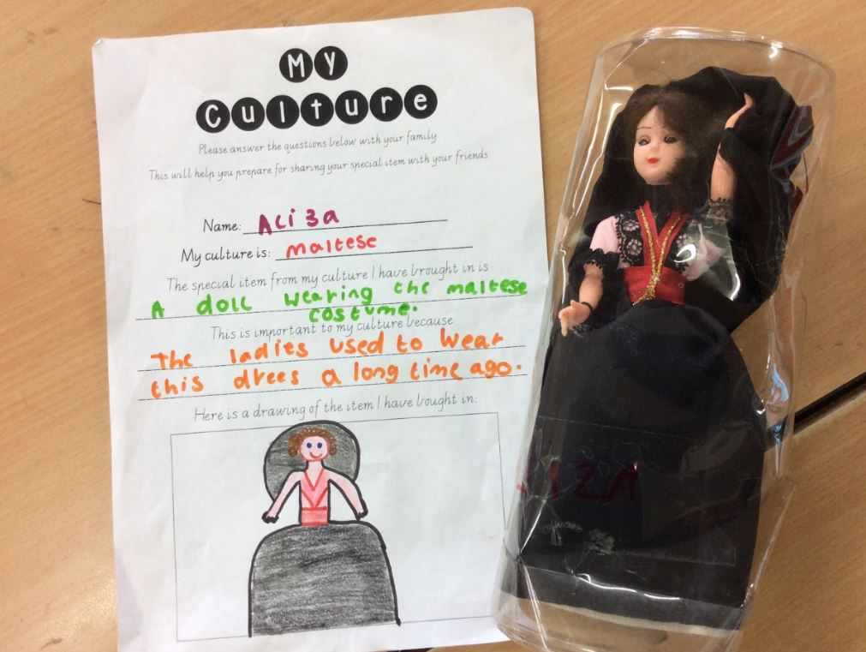
This sample demonstrated the following actions in the rubric:

1.1 Describes or shows own cultural practices
(in class, the student stated that long ago, ladies wore the dress on a regular basis but that nowadays they do so only on special occasions such as festivals)

Progression: The next step for the student would be to identify values underlying her own cultural practices.

Sample 1 b)
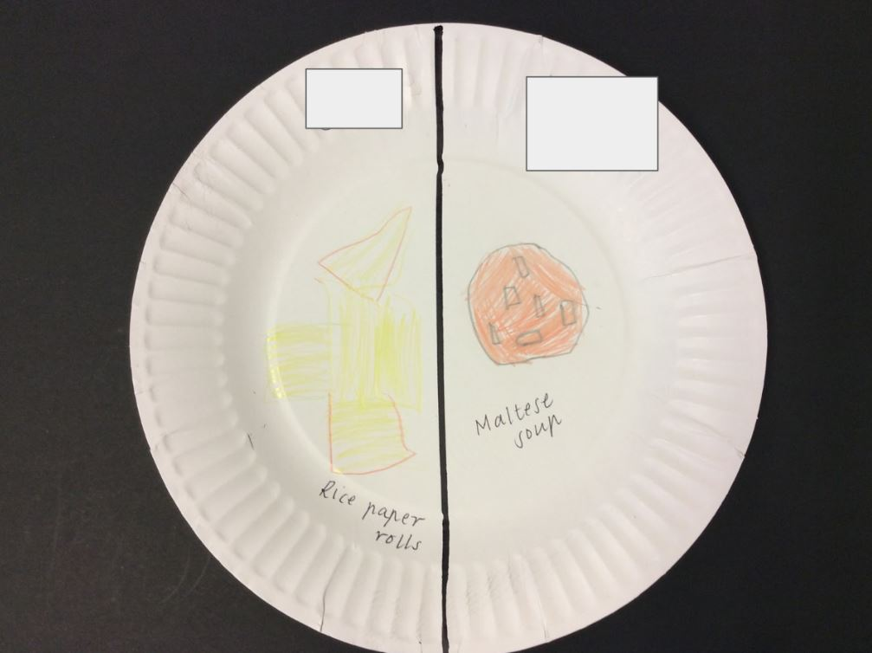
This sample demonstrated the following actions in the rubric:

Progress towards 3.1 Describes similarities and differences between their own and another culture

Progression: The next step for the student would be to identify more than one difference between the two cultures and to identify some similarities.

Sample 1 c)

In my culture we speak … Maltese.
In my friend’s culture they speak … Spanish.
In my other friend’s culture they speak … Vietnamese.

We communicate in different ways. Some people can come from the same country but speak different languages. Both my family and John’s family can speak Maltese.

This sample demonstrated the following actions in the rubric:

Progress towards 1.1 Describes or shows own cultural practices
Progress towards 3.1 Describes similarities and differences between their own and another culture

Progression: The next step for the student would be to give more examples of their own and others’ cultural practices and values.

 |  | Sample 1 | Intercultural Capability, Foundation to Level 2
 |  |  | Phase 1 | Phase 2 | Phase 3 | Phase 4
 |  |  | Students in this phase can identify their family's culture/s and cultural practices | Students in this phase can identify some other cultures and cultural practices | Students in this phase can explore how culturally diverse individuals and families live | Students in this phase can identify common values or practices among different cultural groups
Organising Element/s | Action |  | Quality Criteria
Cultural Practices strand | 1. Examines own cultural practices | Insufficient evidence | 1.1 Describes or shows own cultural practices |  |  | 1.2 Identifies values underlying own cultural practices
 | 2. Investigates cultural practices of others | Insufficient evidence |  | 2.1 Identifies cultural practices of others | 2.2 Describes/shows/  participates in others’ cultural practices
 | 3. Explores similarities and differences between their own and other cultures | Insufficient evidence |  | 3.1 Describes similarities and differences between their own and another culture | 3.2 Explains similarities and differences between their own and another culture | 3.3 Identifies values or practices shared by people from different parts of the world

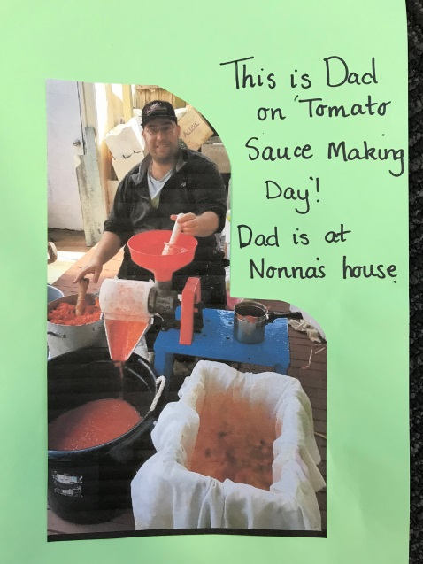
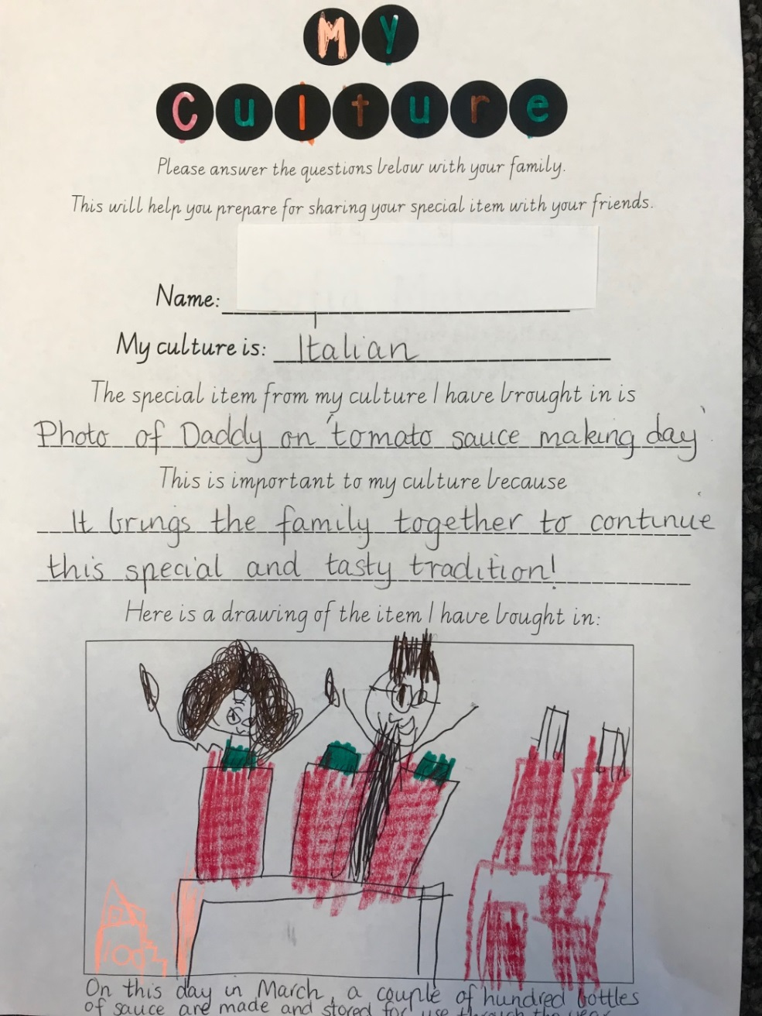
Sample 2 a)
This sample demonstrated the following actions in the rubric:

1.1 Describes or shows own cultural practices
1.2 Identifies values underlying own cultural practices

Progression: The next step for the student would be to look at similar practices in other cultures that bring families together.

Sample 2 b)
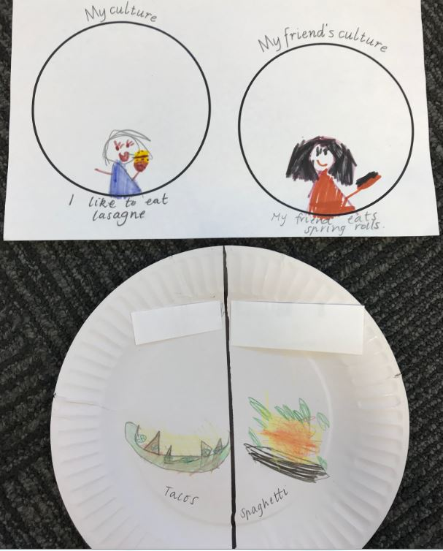
This sample demonstrated the following actions in the rubric:
  - Describes or shows own cultural practices
2.1 Identifies cultural practices of others
Progress towards 3.1 Describes similarities and differences between their own and another culture
Progression: The next step for the student would be to explain the similarities/differences.
 |  | Sample 2 | Intercultural Capability, Foundation to Level 2
 |  |  | Phase 1 | Phase 2 | Phase 3 | Phase 4
 |  |  | Students in this phase can identify their family's culture/s and cultural practices | Students in this phase can identify some other cultures and cultural practices | Students in this phase can explore how culturally diverse individuals and families live | Students in this phase can identify common values or practices among different cultural groups
Organising Element/s | Action |  | Quality Criteria
Cultural Practices strand | 1. Examines own cultural practices | Insufficient evidence | 1.1 Describes or shows own cultural practices |  |  | 1.2 Identifies values underlying own cultural practices
 | 2. Investigates cultural practices of others | Insufficient evidence |  | 2.1 Identifies cultural practices of others | 2.2 Describes/shows/  participates in others’ cultural practices
 | 3. Explores similarities and differences between their own and other cultures | Insufficient evidence |  | 3.1 Describes similarities and differences between their own and another culture | 3.2 Explains similarities and differences between their own and another culture | 3.3 Identifies values or practices shared by people from different parts of the world

Teacher reflections
Teachers involved in the Intercultural Capability Project were invited to reflect on their curriculum planning and teaching experience.
The teachers of this unit stated:
The most successful parts of the unit when we taught it were the cooking, reading picture books and using world maps. The challenges we faced were finding sufficient time to teach the unit and having to purchase our own books and cooking ingredients.

