Intercultural Capability: Unit plan, Foundation to Levels 3 and 4

Exploring culture in our school community

Authorised and published by the Victorian Curriculum and Assessment Authority
Level 7, 2 Lonsdale Street
Melbourne VIC 3000
© Victorian Curriculum and Assessment Authority 2019

No part of this publication may be reproduced except as specified under the Copyright Act 1968 or by permission from the VCAA. Excepting third-party elements, schools may use this resource in accordance with the VCAA educational allowance. More copyright information.
The VCAA provides the only official, up-to-date versions of VCAA publications. Details of updates can be found on the VCAA website.
This publication may contain copyright material belonging to a third party. Every effort has been made to contact all copyright owners. If you believe that material in this publication is an infringement of your copyright, please email the Copyright Officer: vcaa.copyright@edumail.vic.gov.au.
Copyright in materials appearing at any sites linked to this document rests with the copyright owner/s of those materials, subject to the Copyright Act. The VCAA recommends you refer to copyright statements at linked sites before using such materials. URLs were correct at the time of publication.

The VCAA logo is a registered trademark of the Victorian Curriculum and Assessment Authority.
Contents
The Intercultural Capability project 3
Safety and wellbeing 4
About this unit 5
Context 5
Overview 5
Links to other curriculum areas 6
Formative assessment rubric 7
Unit lesson plans 9
Appendix 1 16
Appendix 2 17
Work samples 18
Sample 1 a) 18
Sample 1 b) 19
Sample 1 c) 20
Sample 2 a) 22
Sample 2 b) 23
Sample 2 c) 24
Teacher reflections 26

The Intercultural Capability project
This unit is based on material developed with schools participating in the 2018 Intercultural Capability project. The project was conducted by the Victorian Curriculum and Assessment Authority in partnership with the International Education Division at the Department of Education and Training. The units of work target the explicit teaching of the Victorian Curriculum: F-10 Intercultural Capability. They include formative assessment rubrics that the teachers designed to describe progression of student learning in Intercultural Capability and to provide guidance to students on how to make progress in their learning. This unit provides one example of how a school might plan for the explicit teaching of Intercultural Capability. It is not published as an exemplar.

Safety and wellbeing
Teachers must exercise their duty of care in ensuring that the safety and wellbeing of students is maintained during the study of this Intercultural Capability unit. In addition to the usual pastoral care and health needs of students, teachers should bear in mind cultural sensitivities and the potential for disagreement or conflict over cultural/racial issues. Students should be given the opportunity to provide depersonalised responses or exempt themselves from activities of a potentially sensitive nature and should not be asked to speak on behalf of others. Harmful language or behaviour towards others on the basis of culture or race should not be tolerated. Where appropriate students should be counselled and/or debriefed. For further advice on navigating race and culture issues in the classroom, see the VCAA’s Teacher Guide.

About this unit
Unit title: Exploring culture in our school community
Band: Foundation to Levels 3 and 4
Teaching time: 5 x 60 minutes

Context
This unit was taught in a highly diverse primary school in an outer western suburb of Melbourne. The class had previously studied Personal and Social Capability but not Intercultural Capability. The unit followed a study of Harmony Day.

Overview
The unit was created in association with a formative assessment rubric (see below) which was used to plan lessons to facilitate progress in student learning. The lessons address the four actions in the rubric:
- Defines and explains the significance of culture and cultural characteristics
- Compares a range of cultural practices (characteristics only)
- Develops critical perspective on and respect for their own and others’ cultures
- Explores the diversity of cultural origins and how this affects the community.
In the sequence of 5 lessons, students begin by defining key terms including ‘culture’ and ‘cultural practices’. They draw on information from parents/carers about their cultural background to comment on what culture means to them and their family. Students then use world maps to investigate where their families originally came from and represent this visually. After exploring the need for respectful communication regarding culture, students compare aspects of their own culture with those of other students and consider how culture can unite people.
The rubric and associated unit target the following part of the Victorian Curriculum: F–10 Intercultural Capability curriculum:
Band: Foundation to Level 2
Strand: Cultural Practices
Content descriptions: Identify what is familiar and what is different in the ways culturally diverse individuals and families live (VCICCB001)
Strand: Cultural Diversity
Content descriptions: Identify and discuss cultural diversity in the school and/or community (VCICCD003)
Achievement Standard: By the end of Level 2, students begin to distinguish what is familiar and different in the ways culturally diverse individuals and families live. They describe their experiences of intercultural encounters, and identify cultural diversity in their school and/or community. Students explain how they might respond in different cultural situations.

Band: Levels 3 and 4
Strand: Cultural Practices
Content descriptions: Compare their own and others’ cultural practices (VCICCB005)
Strand: Cultural Diversity
Content descriptions: Identify how understandings between culturally diverse groups can be encouraged and achieved (VCICCD008)
Explain the role of cultural traditions in the development of personal, group and national identities (VCICCD007)
Achievement Standard: By the end of Level 4, students are able to compare a range of cultural practices and explain their influence on people’s relationships. They explain what they have learnt about themselves and others from intercultural experiences. Students explain the role of cultural traditions in the development of various identities. They develop critical perspective on and respect for their own and others’ cultures.

Links to other curriculum areas
Lesson 3 involves investigation of world maps/globes and Lesson 4 involves discussion of language – some teachers may wish to refer to the Geography curriculum and/or the Languages curriculum.

Formative assessment rubric
The formative assessment rubric below was used to help identify the steps in learning, to collect evidence of learning and as a basis for providing feedback. The lesson plans that follow specify which part of the rubric was targeted in each lesson.
The rubric was developed using the relevant Intercultural Capability achievement standard/s and the Guide to Formative Assessment Rubrics. More information about the terminology and structure of the rubric can be found in the Guide.

 |  |  | Intercultural Capability, Foundation to Levels 3 and 4
 |  |  | Phase 1 | Phase 2 | Phase 3 | Phase 4
 |  |  | Students in this phase can define and compare cultural practices and identify family cultural origins | Students in this phase can explain cultural practices and the need for respect between cultures | Students in this phase can explore the nature and effects of diversity in cultural origins | Students in this phase can explain the significance of culture and diversity
Organising Element/s | Action |  | Quality Criteria (SC)
Cultural Practices strand | 1. Defines and explains the significance of culture and cultural practices | Insufficient evidence | 1.1 Lists own cultural practices | 1.2 Explains nature of own cultural practices |  | 1.3 Gives reasons for the significance of the cultural practices within their own culture
 | 2. Compares a range of cultural practices | Insufficient evidence | 2.1 Lists similarities and differences in cultural practices between their own culture and a range of other cultures | 2.2 Explains the nature of their own cultural practices through comparison with a range of other cultures
Cultural Diversity strand | 3. Develops critical perspective on and respect for their own and others’ cultures | Insufficient evidence | 3.1 Shows examples of respectful communication between cultures | 3.2 Explains why respectful communication between cultures is important | 3.3 Identifies a similarity between culturally diverse people that may unite them
 | 4. Explores the diversity of cultural origins and how this affects the community | Insufficient evidence | 4.1 Maps current location and family origins |  | 4.2 Discusses diversity of cultural origins in the school using geographical language | 4.3 Discusses how cultural diversity affects the community

Unit lesson plans
The following lessons were created to facilitate progress in student learning. Each lesson is linked to a particular action/s in the formative assessment rubric and the associated quality criteria. Teachers should give students ongoing feedback on the next steps in their learning and provide opportunities for them to make progress in their understanding of the targeted area of the curriculum.

Lessons 1 and 2 – Cultural practices and what they mean to us

Rubric areas targeted:
- 1.1 Lists own cultural practices
- 1.2 Explains nature of own cultural practices
- 1.3 Gives reasons for the significance of the cultural practices within their own culture

Before the lesson: Ask each student to take home the letter to parents/carers. The letter requests them to bring in information about their family and a photo of themselves, for use in Lessons 1–3.
Tell students the next two lessons will be successful if they learn how to:
- Define ‘culture’, ‘cultural practices’, and ‘cultural values’
- Discuss their culture with another person
- Name cultural practices, for example food and how it is prepared and eaten, religious traditions, traditional dress, language and other ways of behaving
- Name examples of cultural values
- Tell someone why a cultural practice is significant.
Using examples of digital images, objects brought to class, or role play, explain to the class the concepts of culture, cultural practices and cultural values. For example:
Culture is made up of ‘cultural practices’ that relate to the ways a group of people live. Some cultural practices often involve material objects such as clothing or musical instruments but also non-material things such as language, customs and social roles.
Different cultural groups can have different practices, such as the food they eat and how it is made, the language they speak, the clothes they wear, the music and arts they create and the religious tradition they observe.
Cultural practices become traditional when they are regularly passed down to different members of the family and community through experiences and stories.
Cultural practices are guided by cultural values. For example, in Australia it is a common view that everyone should have a ‘fair go’, meaning that all people should have similar opportunities. Cultural groups often share similar values – such as fairness, politeness or respect for elders – even if they dress, worship or celebrate in different ways.
Model how to use a Frayer chart by sticking pictures in the appropriate sections of the chart. Talk about which cultural practice the pictures show. For example:
This picture of me cooking with my Nonna is an example of an Italian cultural practice about how ways of cooking food are often passed down through families.
Students then share cultural practices from their culture with a turn-and-talk partner.
With the class, link cultural practices to cultural values. For example:
In Italy, families often cook something together to share. This is a way that people show a cultural value – that they care for each other. We can now see why the cultural practice of sharing food is significant. It shows a way to care for each other.
Students then explain why their cultural practice is significant by sharing cultural values that guide cultural practices from their culture with a turn-and-talk partner.
Give each student their own Frayer chart and ask them to plot their own cultural practices on the chart, either by drawing a picture or writing under the correct heading (differentiate based on writing abilities).
Students should leave their own chart on their table and go on a gallery walk around the classroom, looking at their peers’ charts. Ask if anyone had questions about what they saw on someone else’s chart.
Note: In all lessons, listen out for evidence of learning and understanding in the comments students make. Give feedback about what they are able to do, and what to focus on next.

Resources:
Letter to parents/carers (see Appendix 1)
Frayer chart with example pictures for each area (see Appendix 2)
A range of digital images or objects related to cultural practices

Lesson 3 – Where our families originally came from

Rubric areas targeted:
- 4.1 Maps current location and family origins
- 4.2 Discusses diversity of cultural origins in the school using geographical language

Explain that today the class will be learning about countries across the world, and that the lesson will be successful if students learn how to:
- Understand that a map represents what we can see on the earth, for example the shapes of land and sea and their names.
- Find their current location on a map/globe
- Identify where their family originally came from and find it on a map/globe
- Represent their cultural origins by connecting points on a map/globe.
Use a globe to show students a representation of the world. Point out that the world is spherical (shaped like a ball), show where Australia is and note that there are many other countries in the world. For example:
The world is spherical (shaped like a ball). As the world moves you can see some different big land shapes. These are continents and are called Australia, Africa, the Americas, Antarctica, Asia and Europe. Within these continents we have lots of countries, cities, towns and villages. If we cut this globe and pushed it flat it would look roughly like this map. Lots of maps look like this because it is easier to see all the places when it is flat, but our world is ball-shaped.
Show students where the city/town they currently live in is on the map and give a sense of how large and varied the world is. For example:
When we look around we see lots of space and it feels really big, but when we look on a map we are tiny compared to the rest of the world. The world is full of lots of people. These people are all different from each other, just as we are different from each other within this class. Our differences are what make us special. People in different countries have different cultural practices, such as the games they play, the food they eat, the clothes they wear and the ways they behave. But despite the differences there are many things that people share.
Draw on personal experiences to discuss migration to Australia. For example:
I have always lived in Australia. Often people move to different countries or go to other countries for a visit. Some of you might even remember living in a different country and coming here. Some of my ancestors, my great grandparents, came from Scotland and England [show on map] and they travelled all the way to Australia.
Remind students about traditional cultural practices and link these with migration. For example:
My ancestors brought some Scottish and English traditional cultural practices with them when they came to Australia. They shared some of these cultural traditions with family members growing up in Australia. For example, on New Year’s Eve we still sing the song ‘Auld Lang Syne’ which reminds us that it is important to remember old friends and times.
Ask students to turn and talk to their buddy and tell them which country/ies their ancestors came from. (This information was requested in the letter to parents/carers – see Appendix 1.)
Give each student a world map and a piece of string and ask them to get out their photo/s of themselves. They should fasten their string to Australia and connect it with the country their ancestors came from, placing their photo where their ancestors came from. If their ancestors came from more than one country, they should connect the string to the different countries and place a photo on each. Aboriginal or Torres Strait Islander students should fasten their photo to Australia. If they wish, they can make connections within Australia, for example to Aboriginal nations that represent their ancestry.

Reflection:
Have students display their maps on the wall and discuss together. Note similarities and differences between the maps, the fact that Australia is connected to many other countries due to migration, and the fact that we are all here in a shared community despite coming from different places.

Resources:
World map or globe
Interactive world map such as echalk
Photos of students (requested in letter to parents/carers, Appendix 1)
Individual copies of a world map
Coloured string or wool

Lesson 4 – Respect for culture and cultural differences

Rubric areas targeted:
- 3.1 Shows examples of respectful communication between cultures
- 3.2 Explains why respectful communication between cultures is important

Explain that the class will be learning about similarities and differences between cultures in the next lesson. Firstly it is important to learn how to treat each other politely and respectfully when discussing each other’s cultures. Therefore the lesson will be successful if students learn to:
- Identify why it is important to be respectful about culture
- Identify respectful and disrespectful language/body language
- Give examples of how to question someone respectfully about their culture.
With the class note that: While there are differences between cultures within families that make up the school community, we work together as one school community. Working together means that we help each other to grow as people. Needing to grow as people is something we all share. If applicable, use your school logo or motto to illustrate the point.
Explain that being respectful means being considerate and valuing other people, even if they do things differently from you. For example:
Before you comment on someone else’s cultural practices, ask yourself how you would feel if someone made a similar comment to you. If someone said, ‘My special cultural food is yummy but yours is yucky and smells bad!’ you would probably feel sad and hurt. So, try to ask questions rather than make judgments that something is bad just because it is different. Cultural practices are personal because they are connected to family and the way we see ourselves, so it can be hurtful if someone is disrespectful about our cultural practices.
Have students write respectful questions to ask each other about culture. (Differentiate based on the number of questions they have to ask.) Ask them to interview each other and video/record the responses, and then share their interviews with the class.
Listen for evidence of student understanding and use the formative assessment rubric to provide feedback on progress and next steps in learning.

Reflection:
Review what has been learnt about discussing culture and cultural practices and why respectful language is important. Ask students to suggest alternative phrases or synonyms that could be used if they hear a student being disrespectful about someone else’s culture.

Resources:
iPads/recording devices
Whiteboards and markers

Lesson 5 – Comparing cultural practices
Rubric areas targeted:
- 2.1 Lists similarities and differences in cultural practices between their own culture and a range of other cultures
- 2.2 Explains the nature of their own cultural practices through comparison with a range of other cultures
- 3.3 Identifies a similarity between culturally diverse people that may unite them
- 4.3 Discusses how cultural diversity affects the community

Remind students of the need for respectful language as the class discusses similarities and differences between cultures. Explain that the lesson will be successful if they learn to:
- Name similarities and differences between their culture and other cultures
- Explain their own cultural practices through comparison with a range of other cultures
- Appreciate that people in the school have different cultures/cultural practices but that there are things that unite us.
Ask a volunteer to come to the front of the class. Referring to the student’s Frayer chart (Lesson 1), work with the class to identify some similarities and differences between the student’s and the teacher’s cultural practices.
Place students into groups of 6. Ask students to identify and record through respectful questioning at least one similarity and one difference between the cultural practices and the values that guide the practices of people within the group.
Each group should present to the class one or more similarities that unite them. Prompt students to reflect on how cultural diversity affects the community and offer feedback that will facilitate progress in their understanding.
As a class, find out more about cultural diversity and how it is celebrated on Harmony Day (see Resources).

Reflection/conclusion:
Review what has been learnt and prompt students to consider that:
- In this class, we love learning and try our best to achieve our goals. Regardless of our different ways of learning, we unite together to learn and support each other in a respectful way.
- Although people in our Australian communities come from different places and have different cultural practices, we all unite so that we can live together peacefully.

Resources:
Whiteboards or sheets of butcher paper
Whiteboard markers
Cultural diversity in Australia
Harmony Day

Appendix 1
Dear parents/carers,

Our class is currently studying culture as part of the Victorian Curriculum: F-10 Intercultural Capability. We will be talking to students about where their families come from in the world, and what cultural practices they traditionally observe.
Could you please do the following to assist your child in their learning:
- Read about culture below. This explains concepts being taught as part of this unit.
- Share with your child the following information so that they can bring this back to class:
- The country/countries where your family came from. If you were born in Australia and are not Aboriginal or Torres Strait Islander, state the country/countries your ancestors came from. If you are Aboriginal or Torres Strait Islander, share where in Australia your ancestors came from, for example which Aboriginal nation/s.
- The country/countries of origin the family identifies with (e.g. Australian, Indian and Australian, Chinese, Korean and British, Somali).
- Some cultural practices the family observes (e.g. celebrating a religious holiday, wearing certain clothing, cooking or avoiding certain food) and whether any can be traced back to a country of origin.
- A value held in your culture (e.g. respecting elders, individual freedom, having a close connection to the land) and one or more examples of how this value is shown in a cultural practice. For example, a special word in language might show respect for elders.
- Please provide a photo of your child for us to display on a map of the world.

Culture and cultural practices
Culture is made up of ‘cultural practices’ that relate to the ways a group of people live. Some cultural practices often involve material objects such as clothing or musical instruments but also non-material things such as language, customs and social roles.
Different cultural groups can have different practices, such as the food they eat and how it is made, the language they speak, the clothes they wear, the music and arts they create and the religious tradition they observe.
Cultural practices become traditional when they are regularly passed down to different members of the family and community through experiences and stories.
Cultural practices are guided by cultural values. For example, in Australia it is a common view that everyone should have a ‘fair go’, meaning that all people should have similar opportunities. Cultural groups often share similar values – such as fairness, politeness or respect for elders – even if they dress, worship or celebrate in different ways.

Appendix 2

Traditional Clothing
Foods

Culture

Beliefs/values

Languages

Work samples
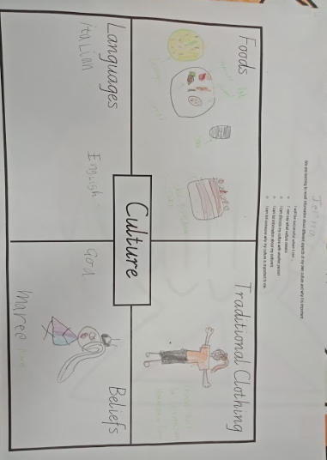
Samples have not been corrected for expression or accuracy.

Sample 1 a)

This sample demonstrated the following actions in the rubric:

1.1 Lists own cultural practices
4.3 Discusses how cultural diversity affects the community (the student said she drew herself wearing an orange T-shirt to represent herself on Harmony Day and mentioned that wearing orange on Harmony Day shows respect for each other)

Progression:
The next step for the student would be to explain the practices listed and why they are significant to her culture.

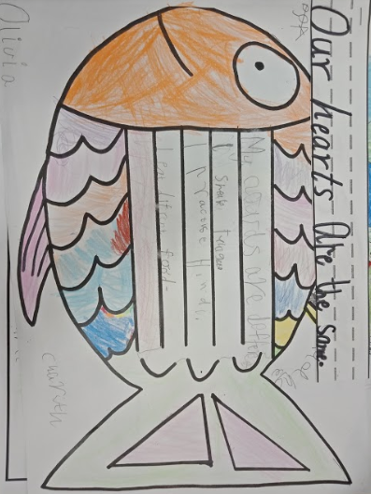
Sample 1 b)

This sample demonstrated the following actions in the rubric:
3.3 Identifies a similarity between culturally diverse people that may unite them (the student identified a similarity between herself and her group by writing, ‘Our hearts are the same’ and shared what this meant with the class)
2.1 Lists similarities and differences in cultural practices between their own culture and a range of other cultures
3.1 Shows examples of respectful communication between cultures (in class, the student was able to discuss a visible difference in a respectful manner)

Progression:
The next step for the student would be to explain why respectful communication is important.

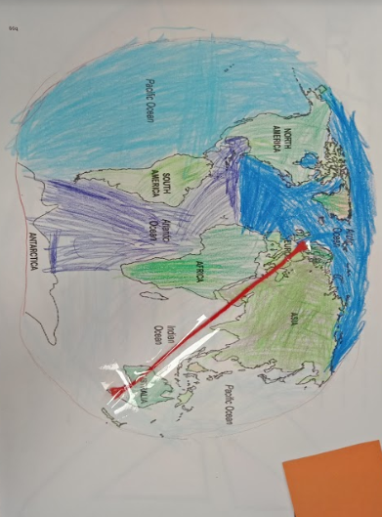
Sample 1 c)

This sample demonstrated the following actions in the rubric:
4.1 Maps current location and family origins

4.2 Discusses diversity of cultural origins in the school using geographical language (in class, the student identified that even though her parents were born in Australia, her family originates from Europe, and discussed the geographical differences between herself and her peers when the class compared maps)

Progression:
The next step for the student would be to explain how diversity affects the school community.

 |  | Sample 1 | Intercultural Capability, Foundation to Levels 3 and 4
 |  |  | Phase 1 | Phase 2 | Phase 3 | Phase 4
 |  |  | Students in this phase can define and compare cultural practices and identify family cultural origins | Students in this phase can explain cultural practices and the need for respect between cultures | Students in this phase can explore the nature and effects of diversity in cultural origins | Students in this phase can explain the significance of culture and diversity
Organising Element/s | Action |  | Quality Criteria (SC)
Cultural Practices strand | 1. Defines and explains the significance of culture and cultural practices | Insufficient evidence | 1.1 Lists own cultural practices | 1.2 Explains nature of own cultural practices |  | 1.3 Gives reasons for the significance of the cultural practices within their own culture
 | 2. Compares a range of cultural practices | Insufficient evidence | 2.1 Lists similarities and differences in cultural practices between their own culture and a range of other cultures | 2.2 Explains the nature of their own cultural practices through comparison with a range of other cultures
Cultural Diversity strand | 3. Develops critical perspective on and respect for their own and others’ cultures | Insufficient evidence | 3.1 Shows examples of respectful communication between cultures | 3.2 Explains why respectful communication between cultures is important | 3.3 Identifies a similarity between culturally diverse people that may unite them
 | 4. Explores the diversity of cultural origins and how this affects the community | Insufficient evidence | 4.1 Maps current location and family origins |  | 4.2 Discusses diversity of cultural origins in the school using geographical language | 4.3 Discusses how cultural diversity affects the community

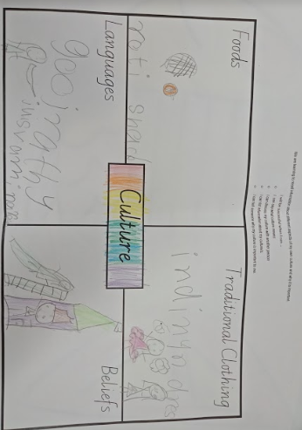
Sample 2 a)

This sample demonstrated the following actions in the rubric:
1.1 Lists own cultural practices

Progression:
The next step for the student would be to list/draw more than one example of each practice and to be able to explain in more detail the cultural practices listed.

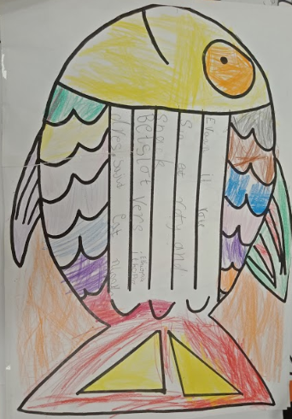
Sample 2 b)
This sample demonstrated the following actions in the rubric:
3.1 Shows examples of respectful communication between cultures (in class, the student communicated respectfully with peers from diverse cultural backgrounds to identify a similarity and a difference between them)

3.3 Identifies a similarity between culturally diverse people that may unite them and 4.3 Discusses how cultural diversity affects the community (in class, the student said, ‘We are the same because we are all kind and we all love being students in Prep’).

Writing reads: [Child 1] eats roti. [Child 2] eats roti and snack. [Child 3] wears Ethiopian dress. [Child 4] eats noodles.

Progression:
The next step for the student would be to explain why finding similarities between diverse people is unifying.

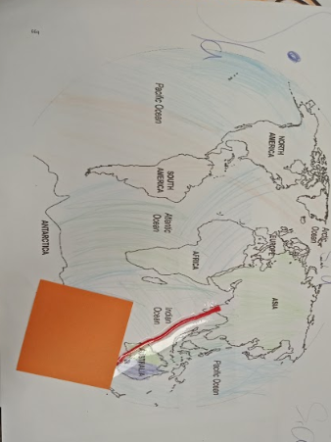
Sample 2 c)

This sample demonstrated the following actions in the rubric:

4.1 Maps current location and family origins

Progression:
The next step for the student would be to use geographical language to describe the diversity of cultural origins among her classmates.

(Box covers student name)

 |  | Sample 2 | Intercultural Capability, Foundation to Levels 3 and 4
 |  |  | Phase 1 | Phase 2 | Phase 3 | Phase 4
 |  |  | Students in this phase can define and compare cultural practices and identify family cultural origins | Students in this phase can explain cultural practices and the need for respect between cultures | Students in this phase can explore the nature and effects of diversity in cultural origins | Students in this phase can explain the significance of culture and diversity
Organising Element/s | Action |  | Quality Criteria (SC)
Cultural Practices strand | 1. Defines and explains the significance of culture and cultural practices | Insufficient evidence | 1.1 Lists own cultural practices | 1.2 Explains nature of own cultural practices |  | 1.3 Gives reasons for the significance of the cultural practices within their own culture
 | 2. Compares a range of cultural practices | Insufficient evidence | 2.1 Lists similarities and differences in cultural practices between their own culture and a range of other cultures | 2.2 Explains the nature of their own cultural practices through comparison with a range of other cultures
Cultural Diversity strand | 3. Develops critical perspective on and respect for their own and others’ cultures | Insufficient evidence | 3.1 Shows examples of respectful communication between cultures | 3.2 Explains why respectful communication between cultures is important | 3.3 Identifies a similarity between culturally diverse people that may unite them
 | 4. Explores the diversity of cultural origins and how this affects the community | Insufficient evidence | 4.1 Maps current location and family origins |  | 4.2 Discusses diversity of cultural origins in the school using geographical language | 4.3 Discusses how cultural diversity affects the community

Teacher reflections
Teachers involved in the Intercultural Capability Project were invited to reflect on their curriculum planning and teaching experience.
The teachers of this unit stated:
Teaching Intercultural Capability is paramount in developing respectful relationships and self-discovery. During this unit students learnt about the importance of thoughtful conversations in relation to culture – it was good to see them asking each other respectful questions without prompting. Students enjoyed mapping where their families originated and became fascinated in the world and its geographical features, leading to further incidental teaching of geography. This unit aimed to involve all families in the class in communicating aspects of their culture with their child. Unfortunately, some families were not able to do this, making it difficult for some children to explore their own culture. In future we would start the planning earlier, meet with parents and unpack the vocabulary more for students and families. We would include families in the learning by holding intercultural events and writing newsletter articles.
Months after we taught the unit, a parent and her six-year-old child told us that a student from another school had made a comment about her child’s cultural appearance and that her child had responded, ‘We are all different but our hearts are the same.’ This was only one example of how powerful the unit was in developing self-worth and resilience in the students.

