Intercultural Capability: Year 5 unit plan

Intercultural capability

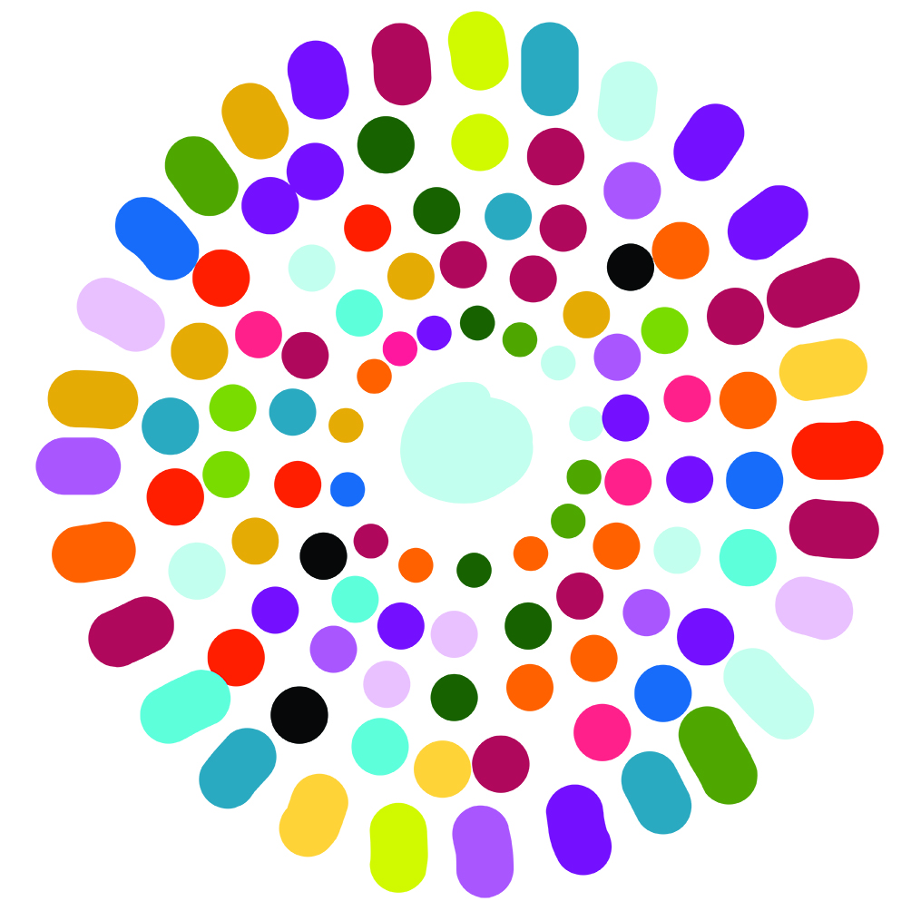

Authorised and published by the Victorian Curriculum and Assessment Authority
Level 7, 2 Lonsdale Street
Melbourne VIC 3000
© Victorian Curriculum and Assessment Authority [year]

No part of this publication may be reproduced except as specified under the Copyright Act 1968 or by permission from the VCAA. Excepting third-party elements, schools may use this resource in accordance with the VCAA educational allowance. For more information go to: www.vcaa.vic.edu.au/Pages/aboutus/policies/policy-copyright.aspx.
The VCAA provides the only official, up-to-date versions of VCAA publications. Details of updates can be found on the VCAA website: www.vcaa.vic.edu.au.
This publication may contain copyright material belonging to a third party. Every effort has been made to contact all copyright owners. If you believe that material in this publication is an infringement of your copyright, please email the Copyright Officer: vcaa.copyright@edumail.vic.gov.au
Copyright in materials appearing at any sites linked to this document rests with the copyright owner/s of those materials, subject to the Copyright Act. The VCAA recommends you refer to copyright statements at linked sites before using such materials.

The VCAA logo is a registered trademark of the Victorian Curriculum and Assessment Authority.

Contents
The Intercultural Capability project 1
About this unit 2
Lesson plans 4
The concept of the cultural iceberg 10

The Intercultural Capability project
This unit plan is based on material developed with schools participating in the 2017 Intercultural Capability project. The Victorian Curriculum and Assessment Authority, in partnership with the International Education Division at the Department of Education and Training of Victoria, conducted an action-research project with nineteen schools from the Government, Catholic and Independent sectors.
This unit plan provides an example of how a school might plan for the explicit teaching of Intercultural Capability knowledge and skills. It is not an exemplar. Schools are advised to consider whether this plan meets the needs of their student cohort and is appropriate in the context of their whole-school teaching and learning plan. Additional support and advice on high-quality curriculum planning is available from the Curriculum Planning Resource.
Schools have flexibility in how they choose to use this resource, including as:
- a model that they adapt to suit their own teaching and learning plans
- a resource to help decide on their approach.
Print and web-based resources
Some of the print resources contained in this list may be out of print. They have been included because they may still be available from libraries, bookshops and private collections.
At the time of publication the URLs (website addresses) cited were checked for accuracy and appropriateness of content. However, due to the transient nature of material placed on the web, their continuing accuracy cannot be verified. Teachers are strongly advised to prepare their own indexes of sites that are suitable and applicable to the courses they teach, and to check these addresses prior to allowing student access.

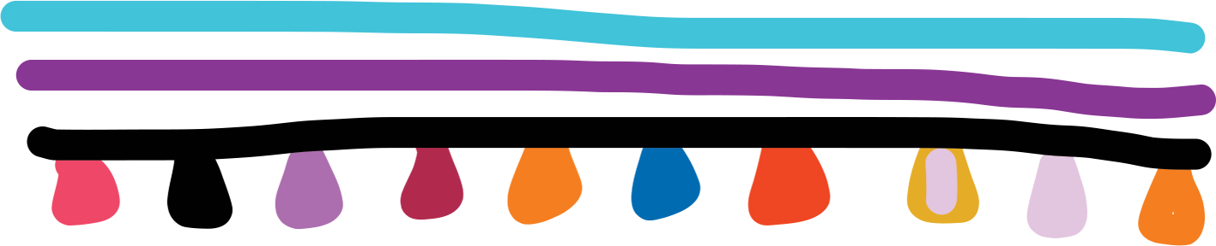

About this unit
Unit title | Grade | Total teaching hours
Intercultural capability | 5 | 7  Tip: Lessons are nominally designed to take 1 hour, however you may wish to adjust time to meet local needs.

- This unit was developed by a school in a regional setting.
- The teacher used resources currently available in FUSE and the Difference Differently website to create a sequence of lessons.

This unit of work encourages students to:
- think about diversity, particularly in relation to people, groups and their cultures
- affirm and celebrate difference
- use their understanding of diversity to act with respect, empathy and trust.

To achieve this, students need to:
- reflect on their personal intercultural experiences and how these have influenced their attitudes, values and beliefs.
- recognise the important roles that understanding, acceptance and appreciation of cultural diversity play in creating a cohesive community.

Content descriptions
Levels 3 and 4 | Levels 5 and 6
Cultural Practices
Describe what they have learnt about themselves and others from intercultural experiences including a critical perspective on and respect for their own and others cultures (VCICCB006) | Analyse how aspects of their own and others lifestyle, behavior, attitudes and beliefs can be culturally influenced (VCICCB009)  Explain how intercultural experiences can influence beliefs and behaviours, including developing a critical perspective on and respect for their own and others cultures (VCICCB010)
Cultural Diversity
Explain the role of cultural traditions in the development of personal, group and national identities (VCICCD007)
Achievement Standards
Level 4 | Level 6
By the end of Level 4, students are able to compare a range of cultural practices and explain their influence on people’s relationships. They explain what they have learnt about themselves and others from intercultural experiences.  Students explain the role of cultural traditions in the development of various identities. They develop critical perspective on and respect for their own and others cultures. | By the end of Level 6, students demonstrate an understanding how beliefs and practices can be influenced by culture and explain how intercultural experiences can influence beliefs and behaviors.  Students identify the barriers to and means of reaching understandings within and between culturally diverse groups and the ways in which effective engagement with those groups is promoted or inhibited.

This Year 5 plan has been developed in relation to the actual learning level of each student rather than their assumed level of learning based on age. For this class, some students required scaffolding from Levels 3 and 4, whilst other students were extending their learning into Levels 5 and 6.

Lesson plans

Lesson Focus | Teaching activity | Resources
Lesson 1:  - Recognising pre-assessment knowledge, experiences and common misconceptions  - Vocabulary wall  - Big questions | Prior knowledge:  Three posters are placed at different areas of the room. They all have different titles:  - What is culture?  - Have you ever had an Intercultural experience? Explain.  - Do you believe Australia is multicultural?  Students are given time to write their responses on a sticky note/s and place it on each poster. Note: It’s important for students to name their responses as they will be collated in a document for future reference.  Vocabulary Wall:  Create a space in the classroom to create a word wall/glossary. Progressively throughout the unit/lessons, remind students to add words and their meaning to the wall.  Big question:  A space in the classroom is set aside for the students’ big question display. They print their school photo with a speech bubble attached containing their big question. Their big question can be anything to do with multiculturalism, culture or belief. These will be revisited towards the end of the unit. | - Poster paper with headings  - Sticky notes (variety of different colours)
Lesson 2:  - Introduce students to different cultural practices, expectations.  - Provide insight into the life of children around the world. | In a short paragraph, students write about their day-to-day life as an eleven year old. Some of these questions may be used as prompts:  - What are some activities they engage in for entertainment?  - Who/what provide positive influences in their life?  - How do they feel about being at home and spending time with their family?  - What are the biggest challenges they are faced with?  Watch the documentary: I am Eleven. Students then complete the reflection sheet (part of licensing fee). The sheet is retained as support evidence for assessment.  The teacher guides a whole-class reflection about individual feelings post documentary. Students can list some of the difference between themselves and the children in the documentary. Encourage students to show how their feelings and/or outlook has changed after the viewing (through written reflection). | A copy/link to ‘I am Eleven’ and student reflection sheet.  Note this commercial product incurs a licensing fee for use. Teachers are advised to consider this cost, or to seek alternative resources. Consider adapting alternative resources if necessary, such as:  Cultural Differences National Geographic – A short video about a group of Sudanese who travel to the United States. Cultural differences are discussed from the Sudanese perspective. Alter the discussion prompts:  - What cultural differences were highlighted in the video?  - What did you learn about Sudanese culture?  - How would you feel if you were suddenly living in a new country? Would you want to be with your friends?  Donkeys cannot fly on planes, Kids Own Publishing – A collection of 25 true stories of survival written by young South Sudanese refugees who, with their families, have found a new home in Australia.
Lesson 3:  - Students explore the influence the media has on racial stereotyping and/or profiling.  - Does the media provide a balanced view? | The class undertakes this ‘gap’ activity twice. The first attempt is done prior to doing any research and the second attempt is done after the students have been given the opportunity to undertake research.  In pairs or small groups, students are to research news articles that identify an individual's or group’s race or religious belief in the title as well as some that involve people but do not identify the race or religion. Students share their findings. Collate titles on the board/work document. Discuss:  - What is the first thing that comes to mind when reading the title?  Teacher lead: Complete the Difference Differently: Fill in the gaps activity as a whole class. You may use an interactive whiteboard or equivalent. The class reflects on whether the exposure to the news headlines changed their strength of feeling about the group that would fill the gap, compared to their first go attempt.  Whole-class discussion or written response to follow the activity. Prompts may include:  - Why do you think ‘groups’ are mentioned in the headlines?  - Do you think the headline demonstrates a biased opinion?  - How do you think this influences the reader? | Difference Differently: Fill in the gaps  Students complete a news headline by guessing which group name is missing from the headline (FUSE ID: D8FMXS)
Lesson 4:  - Cultural iceberg  - Students explore their own cultural identity and compare it with others in the class. | Introduce the students to the cultural iceberg concept. Discuss the differences between ‘Visual culture’ and ‘Hidden culture’. Students use personal examples to create their own iceberg.  Once the students have completed the ‘visual’ section of their iceberg they then need to find people who may have a common ‘visual identity’ (same food, favorite sport, dress sense, taste in music) and list their names on the back.  Students then complete the ‘hidden culture’’ section of their iceberg. They then pair up with the same people they matched with ‘visually’ and compare their ‘hidden culture’ and record their findings. Students respond to the following questions, their responses are collected for evidence/assessment:  - Have you ever made an assumption about someone based on their appearance?  - In your own words, explain the difference between ‘visual’ and ‘hidden’ cultural identity?  - Do you know someone’s ‘hidden culture’ by ‘assessing’ their ‘visual culture’?  - Why do you think it is important to be aware of deep cultural characteristics when we meet and interact with others? | Difference Differently: Exploring your cultural iceberg  Students explore how cultural background shapes their identity (FUSE ID: P4R8DH)  Cultural Iceberg (FUSE ID: 79JTSZ)  Note there are a range of other examples available online or you may wish to provide the class with a copy of the cultural iceberg teaching concept provided in this document.
Lesson 5:  - Interconnection web: Participants find out more about each other, their sense of place, and their connections to one another. | Students sit/stand in a circle for this activity. Students are guided to acknowledge that they are all grounded in the particulars of our own lives, but all of us have roots that intertwine with the roots of others. These interconnected roots give us strength, support and a sense of belonging that empowers us to act in the world. This activity will explore these connections between all the students in the classroom.  Choose a student to start the activity. They do this by wrapping the string around their wrist. They then share something about their ‘visual’ or ‘hidden’ culture with the group. Students who share this aspect of their culture identify themselves, and the string is then passed around to each of them. When a student receives the string they are to wrap it around their wrist and pass it to the next student. The last student to receive the string then shares something different about their ‘visual’ or ‘hidden’ culture and so on.  Teachers are advised to ensure all students are connected before finishing this activity.  When a substantial ‘web’ is created you can then have a discussion in relation to:  - How everyone is connected?  - In what ways does this string represent various relationships in the group?  - Did you learn anything about an individual in this activity?  - What did you learn/get out of this activity? | A large ball of string/yarn
Lesson 6:  - Stereotypes and grouping individuals.  - Group membership: opinions and attitudes. | Have the word ‘stereotype’ displayed at the beginning of the class. Students are given two minutes to discuss what this word means, their experiences and examples. Lead a discussion:  - Is it a positive or negative thing?  - Have you ever felt stereotyped?  - What do people consider when stereotyping an individual or a group?  - Is this ‘visual’ or ‘hidden’ culture?  Watch a short (comical) clip about stereotyping: Cultural Diversity Examples: Avoid Stereotypes while communicating  Students then complete the activity: Group membership: opinions and attitudes. During this activity, students meet a group of Australians and find out about their backgrounds. Students then group them according to their interests, local and national concerns. Explore other ways to group the people, what are some questions students could ask them to find out more about them? Describe how such groups can be a useful way to understand a community. Consider how some people may belong to more than one group or have characteristics that are not obvious.  Teachers assist students to draw distinctions between cultural generalisations and cultural stereotypes. Verbal and written reflection to follow this activity. Use questions as prompts such as:  - What did you know about ‘stereotypes’ before this activity?  - Did this activity change you point of view/opinion at all?  - Would you say your past experiences with stereotypes/stereotyping have been positive or negative?  - Have they had an impact on others around you? | Cultural Diversity Examples: Avoid Stereotypes while communicating (FUSE ID: QF2LZM)  Group memberships: Opinions and attitudes (FUSE ID: A3VUFT).
Lesson 7:  - Multicultural me  - Creating profiles for individuals | Revisit the Big Questions: Hold a class discussion interrogating their ‘Big questions’.  - What questions can they now answer? What questions did they identify that are left unanswered?  Students split into groups of 2–4. Each group is given a Multicultural me sheet (see Resource link). Students color each character and create profiles for each character: Name, age, place of birth, religion, interest, favourites type of music, favourite food, values, beliefs, hobbies, passions, likes and dislikes. Students can research ideas for their character’s profile.  Students then compare their profiles with other groups within the class. They then create a ‘character groups’ poster based on like interests, dislikes, passions, values etc. The teacher guides students to note the differences within each group of different coloured characters. | Multicultural me (FUSE ID: NTRDQ7)

The concept of the cultural iceberg
