Intercultural Capability: Prep year unit plan

One land, many families

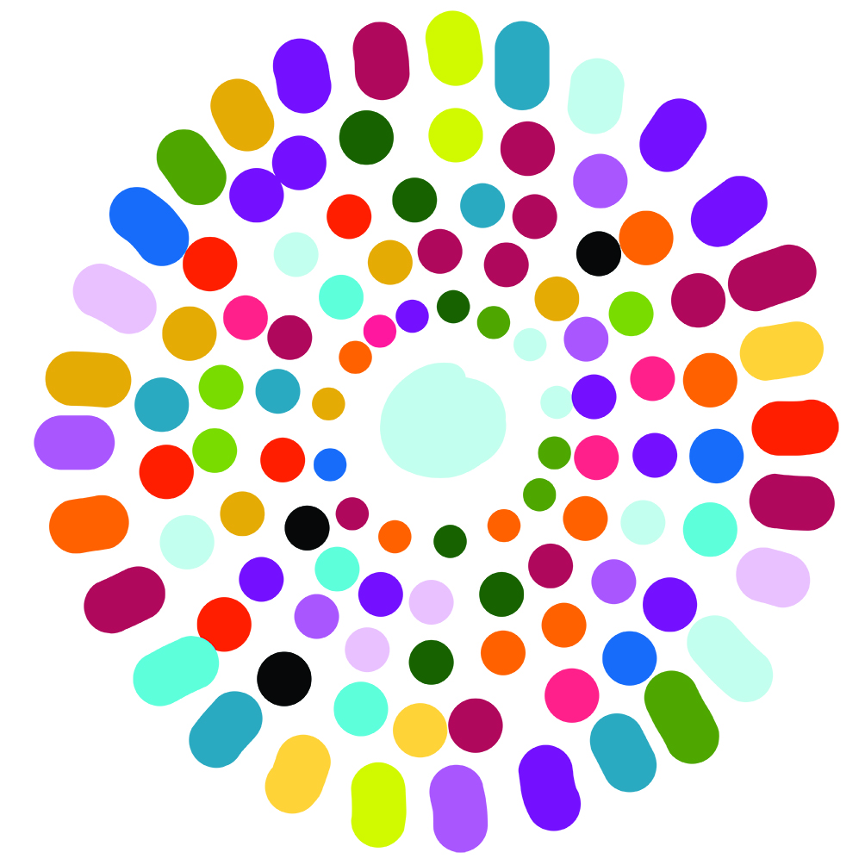

Authorised and published by the Victorian Curriculum and Assessment Authority
Level 7, 2 Lonsdale Street
Melbourne VIC 3000
© Victorian Curriculum and Assessment Authority [year]

No part of this publication may be reproduced except as specified under the Copyright Act 1968 or by permission from the VCAA. Excepting third-party elements, schools may use this resource in accordance with the VCAA educational allowance. For more information go to: www.vcaa.vic.edu.au/Pages/aboutus/policies/policy-copyright.aspx.
The VCAA provides the only official, up-to-date versions of VCAA publications. Details of updates can be found on the VCAA website: www.vcaa.vic.edu.au.
This publication may contain copyright material belonging to a third party. Every effort has been made to contact all copyright owners. If you believe that material in this publication is an infringement of your copyright, please email the Copyright Officer: vcaa.copyright@edumail.vic.gov.au
Copyright in materials appearing at any sites linked to this document rests with the copyright owner/s of those materials, subject to the Copyright Act. The VCAA recommends you refer to copyright statements at linked sites before using such materials.

The VCAA logo is a registered trademark of the Victorian Curriculum and Assessment Authority.
Contents
The Intercultural Capability project 4
About this unit 5
Sequence of lessons 6
Instructions 14
Template: Family tree 15
Student work sample 16

The Intercultural Capability project
This unit plan is based on material developed with schools participating in the 2017 Intercultural Capability project. The Victorian Curriculum and Assessment Authority, in partnership with the International Education Division at the Department of Education and Training of Victoria, conducted an action-research project with nineteen schools from the Government, Catholic and Independent sectors.
This unit plan provides an example of how a school might plan for the explicit teaching of Intercultural Capability knowledge and skills. It is not an exemplar. Schools are advised to consider whether this plan meets the needs of their student cohort and is appropriate in the context of their whole-school teaching and learning plan. Additional support and advice on high-quality curriculum planning is available from the Curriculum Planning Resource.
Schools have flexibility in how they choose to use this resource, including as:
- a model that they adapt to suit their own teaching and learning plans
- a resource to help decide on their approach.
Print and web-based resources
Some of the print resources contained in this list may be out of print. They have been included because they may still be available from libraries, bookshops and private collections.
At the time of publication the URLs (website addresses) cited were checked for accuracy and appropriateness of content. However, due to the transient nature of material placed on the web, their continuing accuracy cannot be verified. Teachers are strongly advised to prepare their own indexes of sites that are suitable and applicable to the courses they teach, and to check these addresses prior to allowing student access.

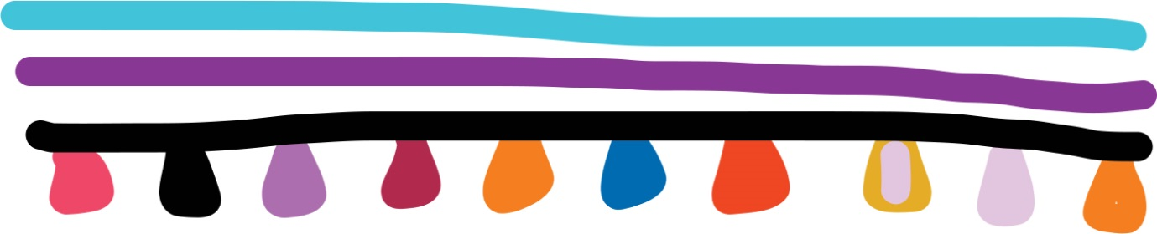

About this unit
Unit title | Year | Total teaching hours
One land: Many families | Prep | 12 lessons  Tip: Lessons are nominally designed to take 1 hour, however you may wish to adjust time to meet local needs.
- This is an integrated unit that includes elements of Intercultural Capability with History and Geography. The focus of this unit plan is Intercultural Capability.
- This unit was delivered to Prep students in a metropolitan school. More than 50 different language groups are represented within the school community and student demographic.
- The school is using a two-year cycle for their whole-school plan.
- In the unit, the parents/carers were invited to the school to celebrate the students’ first 100 days. Teacher reflection on the unit indicated that they would strengthen the unit by inviting guest speakers from the school community to present on aspects of their culture as well as history.
Content descriptions
Intercultural capability
Cultural Practices: Identify what is familiar and what is different in the ways culturally diverse individuals and families live (VCICCB001).
Cultural Diversity: Identify and discuss cultural diversity in the school and/or community (VCICCD003).
Achievement standard (unit focus in Italics) | Guiding questions
By the end of Level 2, students begin to distinguish what is familiar and different in the ways culturally diverse individuals and families live. They describe their experiences of intercultural encounters, and identify cultural diversity in their school and/or community.  Students explain how they might respond in different cultural situations. | - Where does your family come from?  - Where do they live now?  - What does culture mean?  - What does diversity mean?  - What does cultural diversity mean?  - What makes Australia culturally diverse?
Teaching approach
Each lesson outlines the learning intentions (WALT: we are learning today) and the success criteria (WILF: what I am looking for).

Sequence of lessons

Lesson 1
Learning intentions and success criteria | Activity | Resources
WALT:  Identify people in your family  WILF:  I can say, write or draw who is in my family | Read: Little Elliot Big Family by Mike Curato  Activity: Ask students to brainstorm different types of family members and roles. Encourage students to share the names of these roles in their own language.  Watch: Kids vocabulary - Family - family members & tree  Explain: Students will be creating their own family in a house.  Teachers may wish to provide a template of family members or allow students to draw their own. Students, with teacher assistance, label family members. Students then cut and paste their family into a house made from popsticks.  Reflect and share: Students explain their family home (in pairs, or to class). | Little Elliot Big Family by Mike Curato  Kids vocabulary - Family - family members & tree, English Singsing FUSE ID: 9TSS8H  Teachers may select a range of books on parents/carers and grandparents to reinforce lesson.

Lesson 2
Learning intentions and success criteria | Activity | Resources
WALT:  Understand why a family is important  WILF:  I can say what makes a family  I can say why my family is important | Use: Photocards in Family Members to label the different family types and family members and display these in the classroom. Photocards include:  - nuclear family  - blended family  - foster family  - single parent.  Watch: Sesame Street: What is a family.  Discuss the following questions and record their ideas on a mind map:  What makes you a family? For example, Mum, Dad, brother, sister  What does family mean to you? For example, we do things together, they take me swimming, they play with me  Why is your family important to you? For example, encourage responses like they want me to learn, they love me, they care for me, we have a home, they feed me. Leading to concept of support.  Class activity: Create a mind map of why our family is important to us. | Family Members by Debbie Gallagher  Sesame Street: What is a family FUSE ID: T4ZT42  FUSE includes a number of mind map tools, such as:  - Popplet mind mapping (FUSE ID: 7C77ZC)  Mind42 (FUSE ID: 2RSLJF)

Lesson 3
Learning intentions and success criteria | Activity | Resources
WALT:  Identify how families support each other  WILF:  I can say, write or draw how families support each other | Recap: Previous lesson with mind map and reinforce the notion of support.  Read: Family Forest  Watch: The Family Book. The class discusses and records ways that families support each other.  Teachers are advised to adjust this activity if family support is a potential issue for their students.  Individual activity: Students create their own mind map about how their family supports them. They may use pictures and the teacher may assist labeling. | Family Forest by Kim Lane  The Family Book by Todd Parr, read by Sherry FUSE ID: JK97HG

Lesson 4
Learning intentions and success criteria | Activity | Resources
WALT:  Identify different types of families  WILF:  I can say, write or draw the different types of families | Read: Who’s got a normal family? By Belinda Nowell.  Class activity: Provide students with a three-column chart with pictures from the story representing the different types of families: extended, nuclear, blended. Students draw on their learning in Lesson 2.  Discuss each picture: Who makes up this family? Teacher to record the ideas and responses of students.  Explain that we all belong to different types of families.  Ask students: What kind of family do they belong to?  Introduce the concept of generation. This will help students to complete a family tree.  Create: A class collage of different types of families using magazines.  Homework/parent participation: Family tree  Provide students with a family tree template and instructions to complete at home with parental assistance. Tip: You may wish to give students a number of days to complete the family tree task.  Instructions and a family tree template are provided in this unit plan. | Who’s got a normal family? By Belinda Nowell  Just the way we are by Jessica Shirvington

Lesson 5
Learning intentions and success criteria | Activity | Resources
WALT:  Identify that they belong to a family  WILF:  I can name some of my family members | Share: Students bring in their completed family trees. As a whole class, students share their family trees.  Question: Encourage students to ask questions of each other about the different members of each family, such as:  - The family member’s name  - What country their family comes from  - Where they live  - Where they were born  - What language they speak  - What they like to do  Class activity: As students share their family trees and create a list of countries where family members come from.  Create a visual display of this information, for example, a bar chart. Display in class.  Once complete, ask students to make statements about the data presentation focusing on Intercultural Capability learning and reflection. | Just Dance – We are Family FUSE ID: 847FQH

Lesson 6
Learning intentions and success criteria | Activity | Resources
WALT:  Explain the meaning of culture and diversity  WILF:  I can tell you what cultural diversity means | Teacher show and tell: Teacher brings a cultural artefact to share with class and models simple language used to talk about cultural objects, such as:  - Where the object came from  - What its used for  - What it represents for them  Show and tell activity: Explain to students that they can bring a cultural artefact to class to share. Tip: Spreading this activity out over a number of subsequent lessons will reinforce learning about each student’s culture. The teacher may want to provide some take-home instructions so that parents understand this request.  Read: I am Australian Too by Mem Fox.  Discuss where the characters in the book come from and create a list.  Identify what is similar and what is different, for example all characters live in Australia and that different families come from different countries.  Remind students that, like the characters in the story, we all live in Australia now but we might have family members that come from another country as well.  This is what’s called ‘cultural diversity’. Class to come up with a definition of what they think this means. The teacher helps students to resolve any misunderstandings. Display class meaning in the classroom.  Tip: Students can add or revise definition over lessons. | I am Australian Too by Mem Fox  The following texts may be included as part of this activity:  Mirror by Jeannie Baker  Side by side by Janet King

Lesson 7
Learning intentions and success criteria | Activity | Resources
WALT:  Find the country/ies our families were born in  WILF:  I can show where I was born and I can show where my parents/carers were born | Define: Explain to students what a country is.  Introduce: A world globe to students. Ask them what they know about world globes and maps. Then show the globe represented as a map on the wall. Research suggests that student understanding is strengthened when they see a globe first, before introducing maps.  Class activity: Using previously gathered information as a reference, undertake a teacher-guided activity to identify and label countries were parents/carers and students were born and place student image with string and pins. | Tip: You will need a globe and a large world map for display, labeled pictures of each student, string and pins.

Lesson 8
Learning intentions and success criteria | Activity | Resources
WALT:  Identify my cultural background  WILF:  I can locate the country I was born in  I can locate the country/ies my parents/carers were born in | Class activity: Students sit in a circle with a world globe and finish the following statements:  - I was born in…  - My parents/carers were born in…  - My cultural background is…  Tip: The purpose of this lesson is for students to make the connections that although we all now live in Australia, some of our families come from a different country. This is their cultural background. Note that there may be more than one cultural background identified by a student.  Assessment: Teacher to interview and record student responses and understanding of their own and other students’ cultural backgrounds.  Revisit: Ask students if they have anything to add or change about the ‘Cultural Diversity’ definition display.  Individual activity: Students create a poster and draw a picture of themselves. They complete the statements:  - I was born in…  - My parents/carers were born in…  - My cultural background is…  A student work sample is provided for this activity. | World globe

Lesson 9
Learning intentions and success criteria | Activity | Resources
WALT:  Identify cultural diversity in my community/Australia  WILF:  I can remember a story that is similar to my cultural background  I can remember a story that is different to my cultural background  I can show curiosity by asking questions | Ask: What is a tradition? For example, an activity, action or celebration that is passed down from one generation to another over many years. Discuss whether the students can identify traditions from their own family, or from Australia or another country.  Choose: Explore a number of videos in the ABC Splash resource.  Ask: Encourage students to think about questions they could ask to learn more about the families in these videos. For example, what type of family are they? Where do you think they were born? Where do they live? What languages do they speak? What activities do they share together, such as traditions and celebrations? How are they similar or different to you?  Explain: Over the previous lessons, we have looked at different family types and the countries and cultures they come from. Revisit definition of cultural diversity and work with students to incorporate cultural practices into their definition of cultural diversity. | ABC Splash topic: Family life and history FUSE ID: 87ZFWJ  Tip: This topic includes a range of materials to support learning.

Lesson 10
Learning intentions and success criteria | Activity | Resources
WALT:  Identify what happens in celebrations  WILF:  I can say what a celebration is  I can tell how the family celebrated | Watch: When the relatives came  Discuss what the family was doing in the story.  Class activity: Use a graphic organiser such as a mind map to explore a family reunion or celebration.  Ask students:  - What did the families do at the celebration?  - What happened?  - What made it special?  - Why did it happen?  - How did it make you feel?  For example, greeting each other, decorations, sharing food, playing music, dancing, sharing stories and memories. | When the relatives came by Cynthia Rylant, Grandma Annii FUSE ID:  SG7BFY  An alternative resource: Family get together with the Bernstein Bears FUSE ID: CH9FNY

Lesson 11 Tip: This lesson can be completed over 1 or 2 lessons
Learning intentions and success criteria | Activity | Resources
WALT:  Identify similarities and differences between celebrations  WILF:  I can name a celebration  I can identify what is the same between two different celebrations  I can identify what is different about two celebrations  I can identify some things we celebrate at school | Discuss: Pose a series of questions ‘What is a celebration?’ and ‘What is one thing your family celebrates?’  For example, a moment of personal pride or happiness, a family gathering, a party with friends, a festival or community gathering, a national holiday or feast.  Class activity: Keep a list of celebrations. Select two different celebrations for students to compare. Using two different coloured textas/pens, teacher to complete a graphic organiser (mind map). Class discusses similarities and differences. Teacher scribes responses drawing out a range of similarities and differences in how, what, why and when something is celebrated.  Explore: Ask student to name special days or celebrations that occur at the school. For example, sports days, assembly, and Harmony day. There may be opportunities to align this exploration activity with particular school events to make it more meaningful.  Independent activity: Students complete their own ‘Let’s celebrate mind map’.

Lesson 12
Learning intentions and success criteria | Activity | Resources
WALT:  Listen to information about celebrations from another culture  WILF:  I can say what […] celebrates  I can say why it is special for them  I can show curiosity by asking questions | Assessment:  Students can talk/draw about someone else’s celebration.  Students can say why it is important to them.  Model: Teacher to select a student to help model this Think/Pair/Share activity. Teacher and student share their mind map form previous lesson.  Teacher assists students to complete a graphic organiser using images or words of what they learnt about their partner’s celebration, and how it is similar and different to another celebration they know of.

Instructions
As part of our Inquiry Unit this term, ‘One land, many families’, we will be exploring the concept of a family, culture and traditions. We encourage students to find out more about their family history as they will be sharing their stories with each other. We have three activities to do:
- Students are invited to bring in a photograph. This can show the different members of their family and some of the things they do together, such a birthday celebrations.
- We encourage students to bring along a small object or photograph that is treasured by their family (or a copy). For example, this could be a medal, an old toy, an artwork, a piece of jewellery, a decorative object.
- Provide students with a template of a family tree. You can write the names of the members of your family, such as cousins, aunts, uncles, grandparents and other relatives. You do not need to fill out all the spaces, or you may wish to add more people by writing their name around the tree.

Template: Family tree

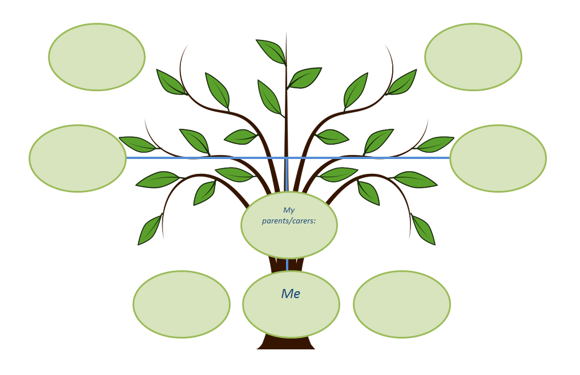

Student work sample

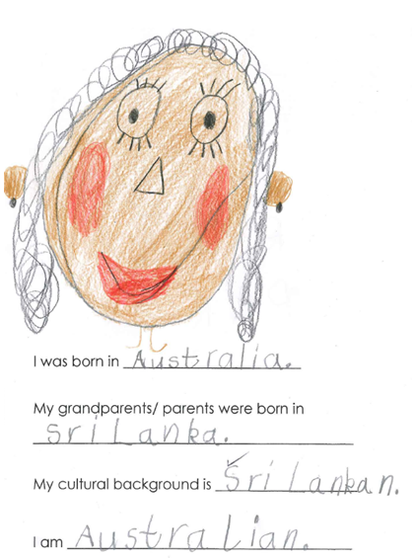
Annotation: This student is able to identify their location of birth and the birthplace of their grandparents/parents/carers. They are able to identify their cultural background and to distinguish this from their nationality.

