Computational and
algorithmic thinking
in Mathematics

Unpacking the content descriptions

Level 4

Authorised and published by the Victorian Curriculum and Assessment Authority
Level 7, 2 Lonsdale Street
Melbourne VIC 3000
© Victorian Curriculum and Assessment Authority 2019

No part of this publication may be reproduced except as specified under the Copyright Act 1968 or by permission from the VCAA. Excepting third-party elements, schools may use this resource in accordance with the VCAA educational allowance. For more information go to: https://www.vcaa.vic.edu.au/Footer/Pages/Copyright.aspx.
The VCAA provides the only official, up-to-date versions of VCAA publications. Details of updates can be found on the VCAA website: www.vcaa.vic.edu.au.
This publication may contain copyright material belonging to a third party. Every effort has been made to contact all copyright owners. If you believe that material in this publication is an infringement of your copyright, please email the Copyright Officer: vcaa.copyright@edumail.vic.gov.au
Copyright in materials appearing at any sites linked to this document rests with the copyright owner/s of those materials, subject to the Copyright Act. The VCAA recommends you refer to copyright statements at linked sites before using such materials.

The VCAA logo is a registered trademark of the Victorian Curriculum and Assessment Authority.

Acknowledgements:
Images of Australian coins reproduced by permission, © the Royal Australian Mint; banknote images reproduced © RBA, subject to conditions. Designers of coins: Stuart Devlin and ($2) Bertram Ainslie Roberts/Horst Hahne. Australian banknote designers Bruce Stewart (1992, 1996); Max Robinson (1993); Gary Emery (1994); Brian Sadgrove (1995) and emerystudio (2016–2020).

Contents
Explicitly teaching computational and algorithmic thinking 4
Overview of the resource 5
More money, more problems 6
Additional teaching resources 10
Appendix 1 11
Appendix 2 12
Appendix 3 14
Appendix 4 16

Explicitly teaching computational and
algorithmic thinking
The Computational and algorithmic thinking – Unpacking the content descriptions resources unpack the Victorian Curriculum F–10 Mathematics content descriptions that address computational thinking and algorithms at each level in the Patterns and algebra sub-strand of the Number and Algebra strand.
Each resource provides teachers with links between one Mathematics content description and extract from the achievement standard related to computational and algorithmic thinking and a teaching and learning activity that is designed to develop computational thinking and problem-solving skills and produce corresponding algorithms in a mathematical context. Teachers can also find excerpts from the Victorian Curriculum Mathematics and Digital Technologies glossaries in Appendix 3.
The resources have been developed with respect to teaching in the Mathematics learning area of the Victorian Curriculum and they also include suggestions how these activities could be extended to the Critical and Creating Thinking and Digital Technologies curriculums.
Teachers will find detailed ideas about how to integrate Mathematics with one or both of Digital Technologies and Critical and Creating Thinking in Appendix 1 and Appendix 2 respectively.

Overview of the resource

Curriculum area and level: Mathematics, Level 4
Strand and sub-strand: Number and Algebra, Patterns and algebra
Content description: Define a simple class of problems and solve them using an effective algorithm that involves a short sequence of steps and decisions (VCMNA164)
Achievement standard (extract): [Students] choose appropriate strategies for calculations … for the context.

Title: More money, more problems
Timing: 1 or 2 lessons (approx. 50–100 minutes)
Description: Students order coins by denomination on coin sorting mats.
Learning objectives: Students can:
create an algorithm for sorting coins by denomination (value).
Printable materials: These printable materials are included as Appendix 4:
printable coins and notes
set of coin sorting mats
Tip: You might like to use real coins instead.

More money, more problems
As a background to conducting Activity 1 with the class, the teacher should watch the video Sorting Algorithms.
Students work in groups of two or three to order coins by denomination. Give each group of students a set of printable resources (Appendix 4), use your own plastic coin and notes, or use resources such as at ASIC’s Moneysmart teaching resources.
Students start with one of each coin: 5, 10, 20 and 50 cents, $1 and $2.

Activity 1 – the two-coin sort
As a warm-up to this activity, first complete one of the interactive sorting algorithms from this video with the class.
Now ask students to select any two coins and line them up on the two-coin sorting mat.
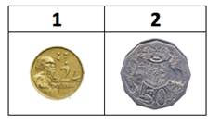
For example:
Students develop and describe a clear and logical step-by-step process (algorithm) for ordering their set from smallest to largest value in the most efficient way possible (least steps). They could ask one question at a time or compare two coins at a time.
Tip: This process (set of instructions) is called an algorithm. Remember that there are many ways students can solve these sorting problems using an algorithm of their own design. The key is to encourage students to revisit their algorithms and processes to improve their efficiency and accuracy.
One possible method students might find for sorting two coins is as follows.
- Compare coins 1 and 2.
- Place the largest value coin on the right.
- Coins are now sorted from smallest to largest value.
This would look like:
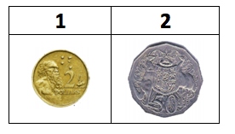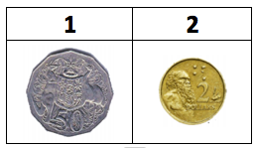

Discussion prompts
- Is your algorithm the only way to solve this problem? How else could you have solved this problem?
- Challenge students to come up with more than one way to solve this problem.
- Is this the most efficient way? (Does it use the least moves?)

Students record their algorithms so they can be repeated. They could do this, for example, by:
- creating a flowchart
- using pictures or diagrams
- using words or creating a story
- making a video.
At this point, encourage groups to share their algorithms with the class. Students could decide which algorithms seem to be the most efficient, or the simplest to follow.
► Cross-curricular links
See Appendix 1 and Appendix 2 for ways to link this activity to the explicit teaching of Digital Technologies and Critical and Creative Thinking.

Activity 2 – the three-coin sort
Students now select any three coins and line them up on the three-coin sorting mat.
For example:
1 | 2 | 3
Students need to come up with a process (algorithm) for ordering their set from smallest to largest value in the most efficient way.
Discussion prompts
Can you modify your first algorithm to work here? Why/why not?
One possible method students might find for sorting three coins is as follows.
- Compare coins 1 and 2.
- The largest value coin goes on the right.
- Compare coins 2 and 3.
- The largest value coin goes on the right.
- Compare coins 1 and 2 again.
- The largest value coin goes on the right.
- Coins are now sorted from smallest to largest value.
This algorithm in practice would look like this:

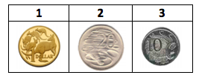
Step 1

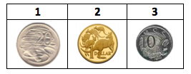
Step 2

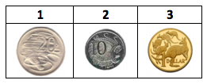
Step 3

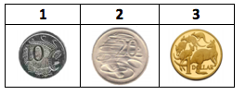
Step 4

Discussion prompts
Again, challenge students to come up with more than one way to solve this problem.
- Is this the most efficient way? (Does it use the least moves?)
- How could you use your previous algorithm here? Did it work? Why/why not?
- Test your algorithm using other starting coins on your three-coin mat. Does it still work? What needs to be fixed?
At this point, compare strategies between small groups so students can appreciate other solution methods and corresponding algorithms.
► Cross-curricular links
See Appendix 1 and Appendix 2 for ways to link this activity to the explicit teaching of Digital Technologies and Critical and Creative Thinking.

Activity 3 – the four-, five- and six-coin sorts
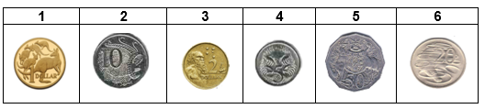
Students now use the appropriate sorting mats to efficiently sort four, five and six random coins. For example, six coins randomly set out in the six-coin sorting mat could look like the image below.
Students might like to race other small groups to see who has the most efficient sorting algorithm.
Again, prompt students to demonstrate their algorithmic thinking (logical process). Encourage students to work collaboratively and check that their algorithms work.
Tips:
Encourage students to identify where they can re-use or re-purpose their previous algorithms, if possible, with modification for this new problem.
Show students the following videos and encourage them to make connections with their thinking:
- video of an animated robot using the Bubble Sort algorithm to sort coloured balls. This video also demonstrates the Quick Sort algorithm vs Bubble Sort
- video of a robot demonstrating the Merge Sort algorithm and racing another robot using the Quick Sort algorithm.

► Cross-curricular links
See Appendix 1 and Appendix 2 for ways to link this activity to the explicit teaching of Digital Technologies and Critical and Creative Thinking.

Challenge and extend
Give students some other criteria to sort by. They should start with smaller numbers of coins first as they build and test their algorithms, as they did before. When giving this instruction, ask students why they think it is best to start with smaller numbers of items first.
Some possible categories students could use to sort coins are:
- value (from largest to smallest value)
- size (from smallest to largest)
- colour (silver then gold)
- shape (circle then non-circle).
Students could also add notes to their money pile and try sorting random coins and notes.
Ask students: Can you re-use any of your sorting algorithms for these problems? Why/why not?

Reflection
With the class or small groups, ask students to discuss the difficulties they encountered and discuss different strategies that they used to overcome these. Students share the strategies and solutions they used to work through each of the three activities.
Ask students:
- What does ‘efficient’ mean for an algorithm?
- Is your algorithm as efficient as possible?
- What does it do well?
- What doesn’t work so well?
- How could you improve it?
- What do you think was the purpose of this task?
Tip: Reflection is an important aspect of any computational-thinking focused activity because it encourages students to consider the different aspects of the task, such as defining the problem and breaking the task down, selecting tools and processes, problem-solving, teamwork and verifying their solution. This helps students reflect on the process of their own learning (meta-learning) and how the skills they have used might transfer to other contexts.

Additional teaching resources
This Code.org unplugged lesson on tangrams (a Chinese geometric puzzle) and paper folding is an interesting application of algorithms with a focus on geometry. It includes an introductory video and classroom resources. The lesson encourages students to be exact in their instructions when describing tangrams, and to consider different ways of solving the problem of equally dividing up a piece of paper into 16 equal rectangles.
To work through this lesson, students may need the following additional materials:
- a free set of Tangram pieces to print: Tangram channel
- printable graph paper.
This lesson is part of a larger sequence of lessons exploring algorithmic thinking that you might like to also explore.

Appendix 1

Suggestions for explicitly teaching Digital Technologies (stimulus only)

Curriculum area: Digital Technologies
Strand: Creating Digitial Solutions
Band: Levels 3 and 4
Content description: Define simple problems, and describe and follow a sequence of steps and decisions involving branching and user input (algorithms) needed to solve them (VCDTCD023)
Achievement standard (extract): Students define simple problems … using algorithms that involve decision-making and user input.
Suggestions that extend Activities 1–3:
- describing – using drawings, pictures and text – the sequence of steps and decisions in a solution, for example preparing a chart to show the order of events in a game and the decisions that a player must make
- creating a sequence of steps used to solve a problem using text, images or symbols
- giving another student a set of instructions involving some decisions (yes or no conditions) to follow

See also Unpacking Digital Technologies Content Descriptions for Levels 3 and 4.

Appendix 2

Suggestions for explicitly teaching Critical and Creative Thinking (stimulus only)

Curriculum area: Critical and Creative Thinking
Strand: Questions and Possibilities
Band: Levels 3 and 4

Content description: Investigate different techniques to sort facts and extend known ideas to generate novel and imaginative ideas (VCCCTQ012)
Achievement standard (extract): Students select and apply techniques to generate a range of ideas that extend how problems are solved.
Suggestions that link to Activities 1–3:
- Trying a range of different strategies to sort the coins and notes, and asking students who identified less common strategies to share their approaches and solutions

Curriculum area: Critical and Creative Thinking
Strand: Reasoning
Band: Levels 3 and 4
Content description: Explore distinctions when organising and sorting information and ideas from a range of sources (VCCCTR017)
Achievement standard (extract): They identify the need to make distinctions and apply strategies to make these.
Suggestions that link to Activity 1:
- Discussing what things have in common and what is different, identifying the differences as distinctions to help with the sorting process, and then discussing other contexts in which making distinctions can be helpful.
- Identifying the category that the objects have in common, using a graphic organiser (flowchart, diagram) to show this, and then identifying the differences within the category and using these distinctions to sort the objects further.

Curriculum area: Critical and Creative Thinking
Strand: Meta-Cognition
Band: Levels 3 and 4
Content description: Consider concrete and pictorial models to facilitate thinking, including a range of visualisation strategies (VCCCTM018)
Achievement standard (extract): Students use concrete and pictorial models to facilitate thinking, including a range of visualisation strategies.

Suggestions that link to Activity 1:
- As part of the reflection, prompting students to understand that the sorting map is a way that we can see our thinking while we are trying out different ideas and that this is an example of a visualisation strategy, and then discussing other contexts where this visualisation strategy could be used.

Curriculum area: Critical and Creative Thinking
Strand: Meta-Cognition
Band: Levels 3 and 4
Content description: Investigate a range of problem-solving strategies, including brainstorming, identifying, comparing and selecting options, and developing and testing hypotheses (VCCCTM020)
Achievement standard (extract): Students select and apply a range of problem-solving strategies.
Suggestions that link to Activity 2:
- Explicitly identifying the problem that requires solving, for example, ‘finding an efficient algorithm’ and noting how creating different algorithms and then comparing them is a problem-solving strategy. Students can be prompted to identify problems from other contexts where creating a range of options and then comparing them would be an appropriate strategy.

Appendix 3

Excerpts from the Victorian Curriculum Mathematics and Digital Technologies glossaries
There are some commonalities in the terms used when explicitly teaching computational and algorithmic thinking in Mathematics and Digital Technologies; however, there are also some subtle but important differences in the definitions of terms. Some of these common terms and their definitions are listed below, under the two different curriculum areas.
If you are going to explicitly teach Mathematics, please refer to the Victorian Curriculum Mathematics Glossary. If you are also going to explicitly teach Digital Technologies, refer to the Victorian Curriculum Digital Technologies Glossary.

Mathematics

Algorithm
An algorithm is a process that can be carried out mechanically, using a well-defined set of instructions, to perform a particular task or solve a type of problem. Examples of mathematical algorithms include processes for tasks such as ordering a set of numbers from smallest to largest, multiplying many-digit decimal numbers, factorising linear expressions, determining which of two fractions is larger, bisecting an angle, or calculating the mean of a set of numbers.

Algorithmic thinking
Algorithmic thinking is the type of thinking required to design, test and evaluate problem-solving processes in a systematic way, using algorithms.

Coding
A process by which algorithms are represented for implementation. For computers, this is done using a coding language such as block coding, C++, JavaScript, Python, Wolfram Language.

Computational thinking
In this context, computational thinking is considered to be linked to algorithmic thinking. This type of thinking is usually considered specific to computers which involves solving problems, designing systems and implementation.

Sequence (number)
A sequence is an ordered set of elements such as numbers, instructions or objects. From an algorithmic point of view, a sequence is an ordered set of instructions or actions.

Unplugged
A commonly used term for computational thinking activities carried out without digital technology. “Unplugged” representations of algorithms may include structured mathematical processes, English representations (steps) or flowcharts.

Digital Technologies

Algorithm
A description of the steps and decisions required to solve a problem. For example, to find the largest number in a list of positive numbers:
- Note the first number as the largest
- Look through the remaining numbers, in turn, and if a number is larger than the number found in 1, note it as the largest.
- Repeat this process until complete. The last noted number is the largest in the list.
Flowcharts are often useful in visualising an algorithm.

Computational thinking
A problem-solving method that involves various techniques and strategies in order to solve problems that can be implemented by digital systems, such as organising data logically, breaking down problems into components, and the design and use of algorithms, patterns and models.

Appendix 4

Australian coins and notes
You may wish to print these on cardboard and/or laminate them. Printing the notes and coins in colour will allow students to use ‘colour’ as a sorting category.

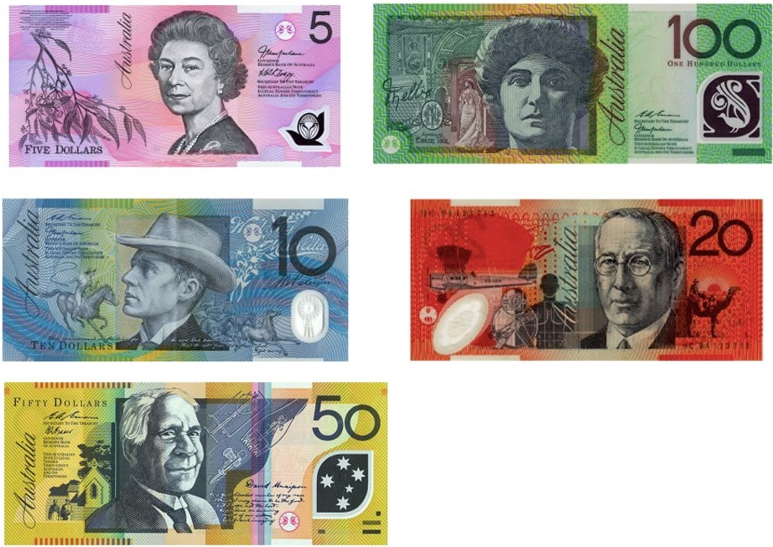

Coin sorting mats
Students can place their sorted coins in the coin slots (empty boxes) in each mat.

Two-coin sorting mat Three-coin sorting mat
1 | 2 |  | 1 | 2 | 3

Four-coin sorting mat
1 | 2 | 3 | 4

Five-coin sorting mat
1 | 2 | 3 | 4 | 5

Six-coin sorting mat
1 | 2 | 3 | 4 | 5 | 6

