Foundation Level – Number and Algebra

Overview
Task name Making connections
Learning intention To use counting strategies to solve simple problems
Duration 60 minutes
Background: Discuss words that are used to talk about equality, order, addition and subtraction:
- equals – makes altogether, gives
- ordering – more than, less than, smaller, larger
- addition – add, plus, more than, increase
- subtraction – minus, take away, less than, decrease.

Links to Victorian Curriculum
These work samples are linked to Foundation Level of the Mathematics curriculum.

Extract from achievement standard
Students connect number names and numerals with sets of up to 20 … and use counting strategies to solve problems that involve comparing, combining and separating these sets.

Relevant content descriptions
- Compare, order and make correspondences between collections, initially to 20, and explain reasoning (VCMNA072)
- Represent practical situations to model addition and subtraction (VCMNA073)

Student work samples − Number collections
These work samples were created by students working at
Foundation Level. Evidence of student achievement has been annotated.
Victorian Curriculum link
Compare, order and make correspondences between collections, initially to 20, and explain reasoning (VCMNA072)

Circle the group of fruit that has the least.
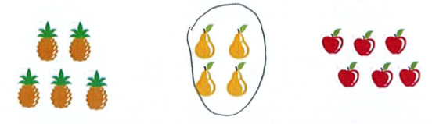

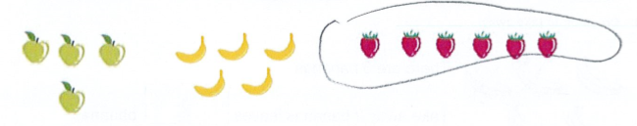
Circle the group of fruit that has the most.

Student work samples − Addition
These work samples were created by students working at
Foundation Level. Evidence of student achievement has been annotated.
Victorian Curriculum link
Represent practical situations to model addition and subtraction (VCMNA073)
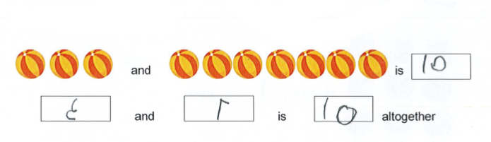
How many altogether?

Identifies the smallest set of fruit

Identifies the largest set of fruit

Counts each collection and records amounts of 3 and 7, with the numerals written in reverse, identifying 10 altogether

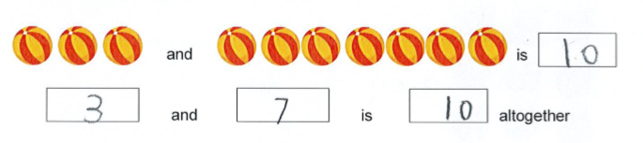

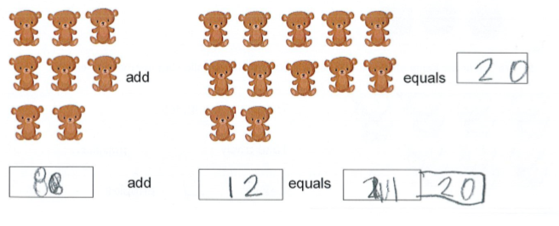

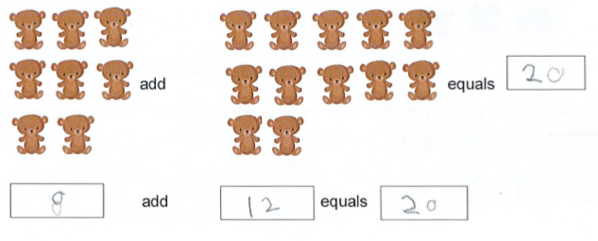

Counts each collection, records amounts of 3 and 7, and identifies 10 altogether

Records 8 and 12 as amounts that add to equal 20, with some corrections

Records 8 and 12 as amounts that add to equal 20

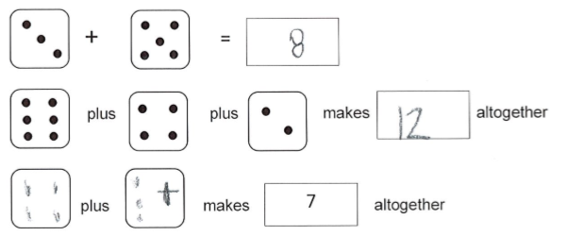

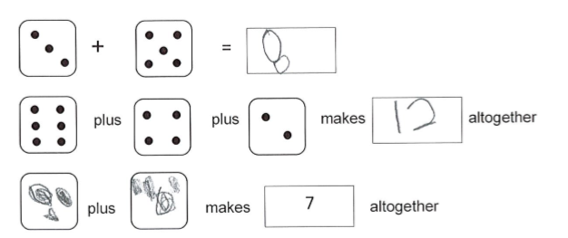

Adds two single-digit amounts and gives numerical answer

Adds three single-digit amounts and gives a numerical answer with a total less than 20

Attempts to use ‘+’ symbol

Adds two single-digit amounts and gives numerical answer

Adds three single-digit amounts and gives a numerical answer with a total less than 20

Constructs example for 3 plus 4 makes 7 altogether

Student work samples − Subtraction
These work samples were created by students working at
Foundation Level. Evidence of student achievement has been annotated.
Victorian Curriculum link
Represent practical situations to model addition and subtraction (VCMNA073)

Cross off to take away.
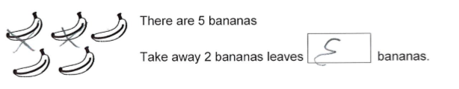

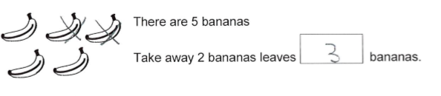

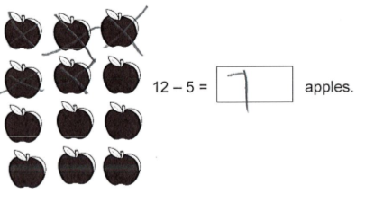

Crosses off 2 bananas and records remaining amount of 3, with numeral written in reverse

Crosses off 2 bananas and records remaining amount of 3

Represents subtraction by crossing off 5 apples and records the answer of 7 apples

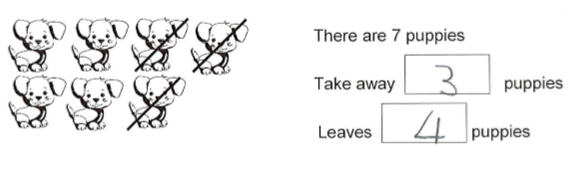
Complete the following number sentences.

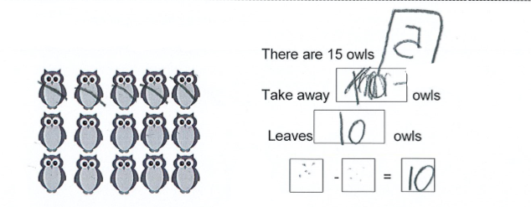
Make your own number sentence below.

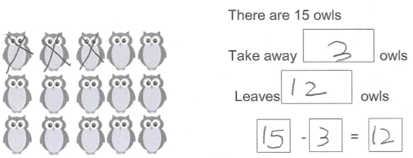

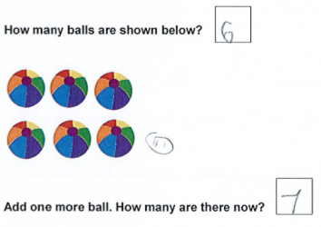

Models subtraction by taking away (crossing off) 3 puppies and identifies there are 4 puppies remaining

Initially just writes answer, then erases and records 5 owls taken away (with numeral written in reverse) and records answer of 10 remaining owls
Attempts, but does not complete, a number sentence

Models subtraction and develops a matching number sentence

Records the number of balls in the picture as 6

Draws an additional ball and records new total of 7 balls

How many more boats to make 10 boats in total?
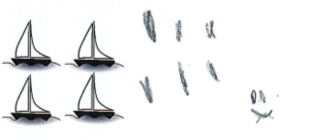

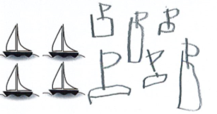

How many more stars make 18 stars in total?

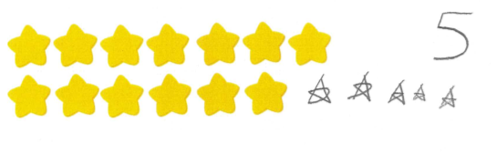

Uses a tally to represent an additional 6 boats in order to represent 10 boats in total

Draws an additional 6 boats to represent 10 boats in total

Draws an additional 5 stars so that there is a total of 13 + 5 = 18 stars

Where to next for the teacher?
When the task on which these annotated student work samples is based has been used as a classroom activity, there is opportunity to gather data on student achievement to help inform further teaching.
An analysis of student responses, on an individual, group or whole class basis, can be used to develop and direct student learning with respect to the following content.

For students needing to review underpinning knowledge and skills at Level D
- Model practical situations involving ‘adding to’ or ‘taking away’ with collections of up to five objects (VCMNA056)

For students consolidating knowledge and skills at Foundation Level
- Establish understanding of the language and processes of counting by naming numbers in sequences, initially to and from 20, moving from any starting point (VCMNA069)
- Connect number names, numerals and quantities, including zero, initially up to 10 and then beyond (VCMNA070)

For students moving on to new knowledge and skills at Level 1
- Count collections to 100 by partitioning numbers using place value (VCMNA088)
- Represent and solve simple addition and subtraction problems using a range of strategies including counting on, partitioning and rearranging parts (VCMNA089)

Resources
- Numeracy Learning Progressions, Victorian Curriculum and Assessment Authority (VCAA) –The Numeracy Learning Progressions amplify, extend and build on the numeracy skills in the Victorian Curriculum F–10: Mathematics and support the application of numeracy learning within other learning areas.
- FUSE, Victorian Department of Education and Training (DET) – The FUSE website provides access to digital resources that support the implementation of the Victorian Curriculum F–10, including an extensive range of activities and other resources for Primary Mathematics and Secondary Mathematics.
- Mathematics Curriculum Companion, Victorian Department of Education and Training (DET)
- Aligned Australian Curriculum Resources (Mathematics), Australian Curriculum, Assessment and Reporting Authority (ACARA)

