Mathematics: Teacher Guide
Implementing the Victorian Curriculum F–10 Version 2.0 Mathematics

Authorised and published by the Victorian Curriculum and Assessment Authority
Level 7, 2 Lonsdale Street
Melbourne VIC 3000
© Victorian Curriculum and Assessment Authority 2023

No part of this publication may be reproduced except as specified under the Copyright Act 1968 or by permission from the VCAA. Excepting third-party elements, schools may use this resource in accordance with the VCAA educational allowance. For more information go to https://www.vcaa.vic.edu.au/Footer/Pages/Copyright.aspx.
The VCAA provides the only official, up-to-date versions of VCAA publications. Details of updates can be found on the VCAA website at www.vcaa.vic.edu.au.
This publication may contain copyright material belonging to a third party. Every effort has been made to contact all copyright owners. If you believe that material in this publication is an infringement of your copyright, please email the Copyright Officer vcaa.copyright@edumail.vic.gov.au
Copyright in materials appearing at any sites linked to this document rests with the copyright owner/s of those materials, subject to the Copyright Act. The VCAA recommends you refer to copyright statements at linked sites before using such materials.
The VCAA logo is a registered trademark of the Victorian Curriculum and Assessment Authority.

Contact us if you need this information in an accessible format - for example, large print or audio.
Telephone (03) 9032 1635 or email vcaa.media.publications@edumail.vic.gov.au

Contents
About this guide 1
Introduction 1
Timeline 2
Levels F–10: Curriculum revisions 2
High level overview of Levels F–10 revisions 2
Prepare for implementation 3
Familiarise yourself with the curriculum 3
Plan for curriculum implementation 5
VCAA curriculum planning resources 5
VCAA curriculum planning resources for Mathematics Version 2.0 7
Additional VCAA resources for Mathematics Version 2.0 7
Using the VCAA resources and templates 7

About this guide
The Mathematics: Teacher Guide provides information about the key revisions between the Victorian Curriculum F–10 Version 1.0 Mathematics (Mathematics Version 1.0) and the Victorian Curriculum F–10 Version 2.0 Mathematics (Mathematics Version 2.0).
It outlines the VCAA curriculum planning documents that are available and how they can be used to support the process of updating current curriculum documentation in your school.
Note, the term ‘unit’ is used throughout the VCAA curriculum planning documents to refer to a Mathematics topic being studied, for example, ‘Linear functions and graphs’ or ‘Objects, surface area and volume’.

Introduction
The Mathematics Version 2.0 curriculum is based on findings and recommendations from some of Victoria’s educational leaders and experts and Mathematics specialists and teachers. It reflects feedback from the VCAA’s formal monitoring conducted over the past 5 years; the significant consultation conducted by the Australian Curriculum, Assessment and Reporting Authority (ACARA) in reviewing the Australian Curriculum Foundation to Year 10; and advice provided by members of the VCAA’s Curriculum Area Reference Panels.
It offers a simple and manageable structure that:
- embeds the proficiencies in the content descriptions and achievement standards
- organises content under 6 strands – Number, Algebra, Measurement, Space, Statistics and Probability (from Level 3) – with no sub-strands
- increases scope to make connections across the Mathematics curriculum
- includes clearer content descriptions and better-aligned achievement standards
- provides improved sequencing of concepts, with stronger links across strands
- provides enhanced clarity through:
- level descriptions that outline in greater detail the content, skills and expected outcomes at each level
- content descriptions with clearer articulation of the essential mathematical facts, procedures and skill
- elaborations with more examples
- has stronger alignment with the Victorian Early Years Learning and Development Framework (VEYLDF) and senior secondary pathways, which creates a continuum of learning from birth to 18-plus.
Mathematics Version 2.0 is currently available on the Victorian Curriculum F–10 website. In 2024, the curriculum will be transferred to a new website offering increased functionality.

Timeline
Mathematics Version 2.0 will have a phased familiarisation and implementation across 2023–2025 as follows:
 | 2023 |  | 2024 | 2025
Mathematics |  | Familiarisation | Familiarisation | Full Implementation
 |  |  | Start Implementation
Government and Catholic schools can implement the revised curriculum from 2024, with full implementation in 2025. Implementation in independent schools is at the discretion of each school in the sector.

Levels F–10: Curriculum revisions
This section outlines the high level whole-of-curriculum revisions for Mathematics Version 2.0 Foundation to Level 10.
Refer to the Mathematics comparison of curriculums document (Version 1.0 to Version 2.0) document on the VCAA website for more detailed revisions by level.

High level overview of Levels F–10 revisions
- Content is now organised under 6 strands – Number, Algebra, Measurement, Space (formerly Geometry), Statistics and Probability – with no sub-strands.
- There are clearer connections between the content descriptions and the achievement standards.
- The 4 proficiencies of Understanding, Fluency, Reasoning and Problem-solving have been embedded into the content descriptions and achievement standards, which now more clearly articulate the proficiencies.

Levels F–6 revisions
- The Probability strand commences at Level 3.
- There is greater emphasis on the processes of mathematical modelling and, from Level 3, statistical investigation and conducting repeated chance experiments.
- There is a continued focus on computational and algorithmic thinking.
- Content has been resequenced to provide students with increased opportunity to consolidate and master key skills.
- Play- and exploration-based content is included across Foundation to Level 2.

Levels 7–10 revisions
- There is greater emphasis on the processes of mathematical modelling, statistical investigation, probability simulations and estimation, while retaining key foundational knowledge and skills as students approach senior secondary pathways.
- There is a continued focus on computational and algorithmic thinking, including provision for pseudocode to support teachers who do not have background familiarity with simple coding languages.
- There are a small number of new content descriptions that extend the scope of learning:
- Level 8: inclusion of 3-dimensional mapping
- Level 10: inclusion of planar graphs (networks)
- Level 10: inclusion of logarithmic scales (not equations or laws).

Level 10A
Level 10A continues to provide students and teachers with a set of content that is cognitively positioned between Level 10 and Units 1 and 2 VCE. Level 10A is:
- designed to complement Level 10 content, for those students who may benefit from extending their study in particular strand content
- not a standalone level (there is no additional achievement standard)
- not required content for access to any of the VCE Mathematics suite of studies.

Prepare for implementation

Familiarise yourself with the curriculum
It is important to familiarise yourself with the revised curriculum before updating any of your documentation. Typically, the Mathematics Learning Area Leader will work with the Mathematics team to facilitate a familiarisation process, through a series of planned meetings, discussions and activities complemented by VCAA professional learning and reading of key VCAA documents.
Here are some activities that can be undertaken individually to facilitate the familiarisation process.

Related documents
Related VCAA content and documents can be found on the Victorian Curriculum F–10 website and the VCAA website:
- Victorian Curriculum Mathematics F–10 Version 2.0
- Mathematics – comparison of curriculums document (Version 1.0 to Version 2.0)
- Mathematics Version 2.0 scope and sequence documents by strand, from Foundation to Level 10A

Activity 1: Understand the structure of the revised Mathematics curriculum
- Identify the components of the revised curriculum structure and understand their relationship to each other, for example how the proficiencies have been incorporated into the content descriptions and achievement standards.
- Consider how the revised curriculum structure provides further opportunity for connections between strands.
- Take a closer look at the revised curriculum content for the year levels you will be teaching. Identify any key revisions and consider what implications, if any, they will have on unit sequencing, strengthening connections between and across concepts, teaching approaches, the use of digital tools, and assessment.

Activity 2: Explore the mathematical processes and their role in the curriculum
- Refer to the Learning in Mathematics Version 2.0 section of the curriculum to review how the 4 mathematical processes (mathematical modelling, computational thinking and simulations, statistical investigation, and probability experiments and simulations) are embedded in and emerge through the curriculum content.
- Identify how the 4 mathematical processes provide a new focus in the revised curriculum.
- Refer to the scope and sequence documents to see the progressive development of the 4 mathematical processes across levels and strands.
- How can the 4 processes be addressed within the year levels you teach?
- What digital tools could be used to support the development of these processes, and how might they be used?
- Identify where the processes are addressed in the achievement standards and how they might be assessed.

Plan for curriculum implementation
The VCAA has developed a suite of curriculum planning templates and examples to support schools with implementing the revised Victorian Curriculum F–10. It has also produced completed examples for Mathematics Version 2.0 and additional support materials for Mathematics Version 2.0.

VCAA curriculum planning resources
The table below outlines the key elements in the VCAA curriculum planning resources. It is followed by a diagram that illustrates the relationships between them.
Curriculum planning element | Format(s) | Audience(s)
Whole-school curriculum plan  A curriculum implementation plan for an individual school. Covers each learning area and discipline (along with the capabilities and cross-curriculum priorities). | - Templates  - Completed examples  Note: These will be published after the entire Version 2.0 curriculum has been published. | School Curriculum Leaders
Year level plan  A subset of the whole-school curriculum plan. Covers the curriculum implementation of each learning area and discipline by individual year levels. | - Templates  - Completed examples  Note: These will be published after the entire Version 2.0 curriculum has been published. | Year Level Coordinators
Curriculum area plan  A primary, secondary or whole-school (P–10) plan for a single curriculum area. Offers a snapshot of the topics or teaching and learning units across Semester 1 and Semester 2. | - Template  - Completed examples | Learning Area Leaders
Curriculum area map  Identifies where the content descriptions and achievement standards are explicitly addressed in the teaching and learning units for a year level. | - Templates (one per curriculum level or band)  - Completed examples | Learning Area Leaders
Teaching and learning unit  Provides a guide to the delivery of a series of lessons on a topic or theme that maps to content descriptions and achievement standards, including cohort considerations and a detailed lesson sequence. | - Template  - Completed examples | Learning Area Leaders  Year Level Teachers
Lesson plan  Expands on the information provided in a teaching and learning unit. Includes curriculum-aligned learning goals/intentions, the content to be addressed, and the pedagogical approaches, activities and resources to be used for a classroom session. | Not supplied by the VCAA | Year Level Teachers

In the following diagram, the cells shaded in orange highlight the documentation that Year Level Teachers would be involved in completing. The cells with an orange border highlight the documentation Year Level Teachers would refer to when completing them.
Figure 2: Curriculum planning architecture – Year Level Teachers
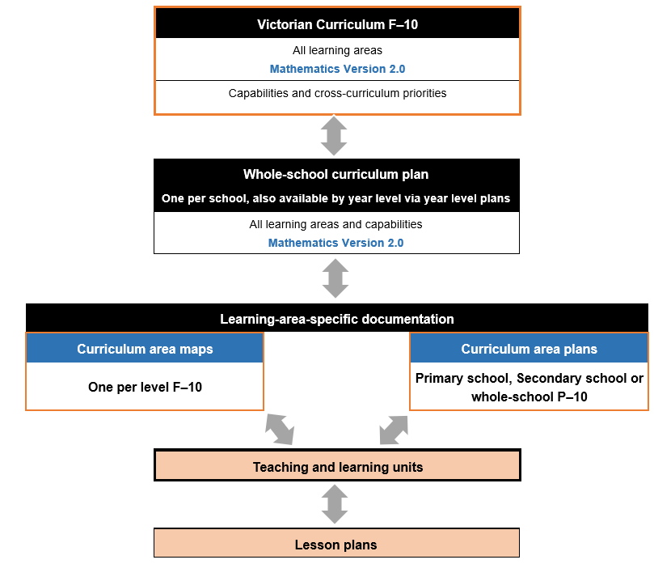

VCAA curriculum planning resources for Mathematics Version 2.0
The following resources are available to support curriculum planning for Mathematics Version 2.0:
- example curriculum area plans for P–6 and 7–10, plus a template
- example curriculum area maps for Level 3 and Level 8, plus templates for each level that include Version 2.0 curriculum content
- example teaching and learning units for Level 3 and Level 8, plus a template.

Additional VCAA resources for Mathematics Version 2.0
The following additional resources are available to support planning for the implementation of Mathematics Version 2.0:
- 2 exemplar VCAA assessment tasks addressing specific aspects of the revised achievement standards for Level 3 and Level 8
- Mathematics glossary
- Introducing Mathematics Version 2.0
- Mathematics – comparison of curriculums document (Version 1.0 to Version 2.0)
- Mathematics Version 2.0 scope and sequence documents by strand, from Foundation to Level 10A
- Mathematics Version 2.0 – transitional advice (for first year of implementation only).

Using the VCAA resources and templates

Develop a new teaching and learning unit
Planning for a unit of work can be completed individually or in collaboration with colleagues.

Related documents
The following VCAA and school documents can be drawn on when developing a teaching and learning unit for Mathematics Version 2.0:
- the school’s completed curriculum area map for the level at which the unit of work is being developed (e.g. Mathematics Levels 5 map)
- Victorian Curriculum F–10 Mathematics Version 2.0
- Mathematics – comparison of curriculums document (Version 1.0 to Version 2.0)
- Mathematics Version 2.0 scope and sequence documents by strand, from Foundation to Level 10A
- teaching and learning unit template
- an example VCAA teaching and learning unit for Level 3 or Level 8
- Mathematics glossary.

Steps, considerations and actions
Step | Considerations and actions
1 | Review the related curriculum area map and, in the teaching and learning unit template, identify the achievement standard sentences this unit of work should be addressing.  Look at preceding and subsequent related units of work.  What prior knowledge will students bring into this unit?  What relevant student data is available to refer to?  What learning and understanding does this unit of work lead into?  What new terminology might students need to be introduced to?  Refer to the glossary.
2 | Review the relevant achievement standards, content descriptions and elaborations in the Victorian Curriculum F–10 Mathematics Version 2.0 to gain a measure of the breadth and depth of content to be covered.  Use the comparison of curriculums document (Version 1.0 to Version 2.0) to familiarise yourself with any revisions that are applicable to this unit.
3 | Consider the mathematical concepts, knowledge and skills this unit of work is addressing.  What are some essential questions that can be used to foster inquiry, understanding and transfer of learning within this unit?  What common errors and misconceptions might need to be addressed?  What might students find challenging when learning this content?  What opportunities are there for real-world connections?  Refer to the relevant scope and sequence document to see the related developmental progression across levels.
4 | Use the insights obtained from Step 3 to consider how teaching could be differentiated to support or extend learning in this unit to meet the needs of the cohort.  How could you do this? For example, look at the level below and above.  How can you support students that do not yet have the skills to access the learning?
5 | Consider what cross-curriculum priorities and capabilities could be addressed in this unit in the future.
6 | Review the assessments for this unit outlined in the curriculum area map.  What other assessment activities might be valuable to include within the unit?  When will they occur in the unit?
7 | Based on the considerations from Steps 1–6, develop a learning sequence that includes:  learning intentions and success criteria  school-specific framework for teaching and learning and related approaches  support for differentiated teaching (e.g. potential adaptations to key activities, enabling and extending prompts) and/or individualisation requirements for specific students  timing of each assessment task  supporting resources.
8 | During, and at the end of the unit, evaluate the teaching and learning unit and refine and adjust as necessary.
The diagram below connects each section of the template with the corresponding step.
Figure 3: Teaching and learning unit template and corresponding steps
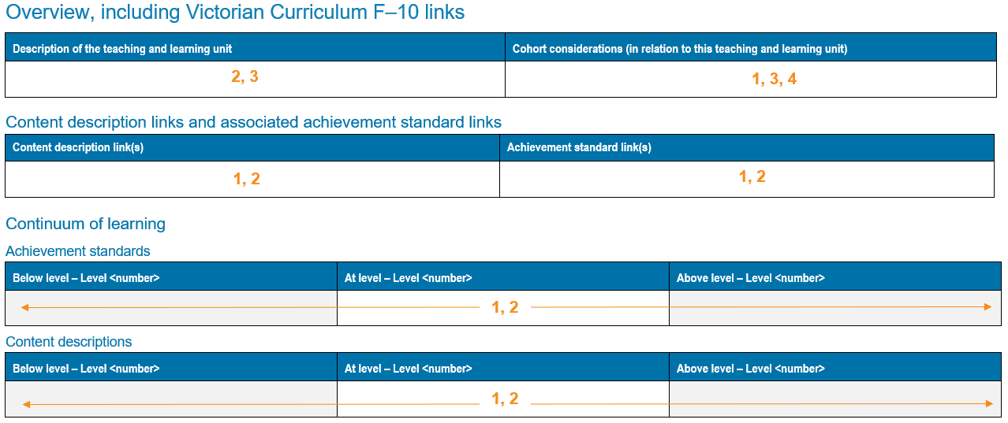
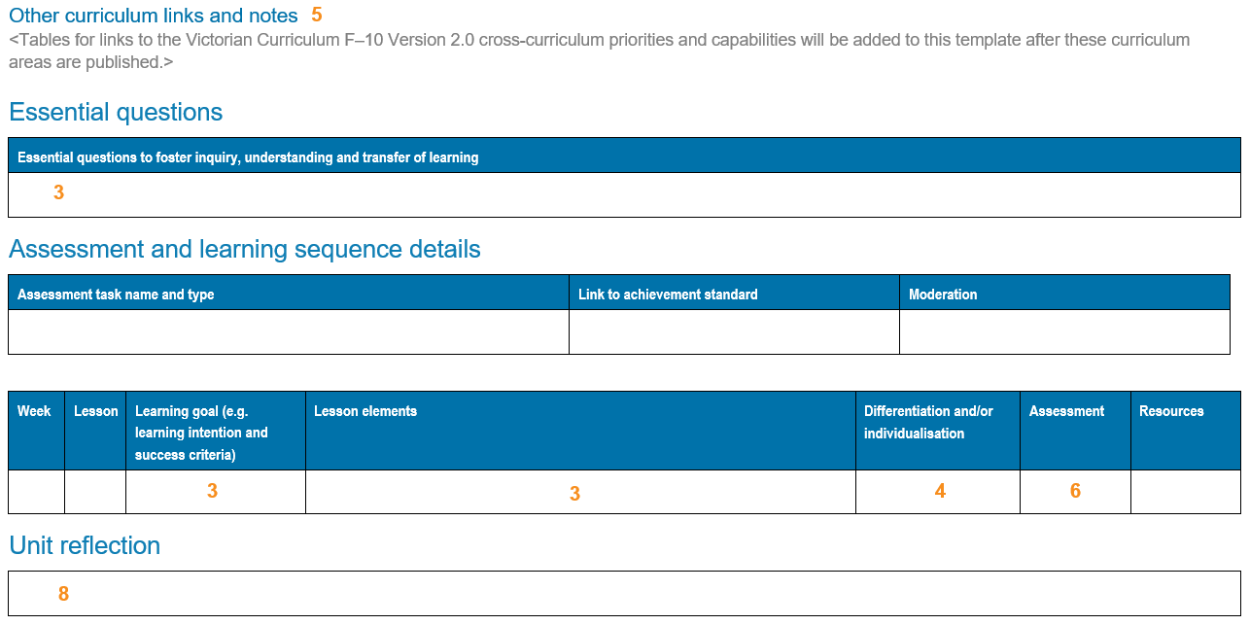

Lesson plans
Lesson plans follow and expand on the sequence and information contained within a teaching and learning unit. They can be developed individually or in collaboration with colleagues.

Related documents
The following documentation supports the planning of lessons associated with a teaching and learning unit:
- completed teaching and learning unit
- Victorian Curriculum F–10 Mathematics Version 2.0
- Mathematics Version 2.0 scope and sequence documents by strand, from Foundation to Level 10A
- Mathematics glossary
- example VCAA assessment tasks addressing specific aspects of the revised achievement standards for Level 3 and Level 8.

