Level 5 – Measurement and Geometry

Overview
Task name Shape up!
Learning intention To make connections between two-dimensional and three-dimensional shapes, including faces and nets
Duration 30 minutes

Links to Victorian Curriculum
These work samples are linked to Level 5 of the Mathematics curriculum.

Extract from achievement standard
Students connect three-dimensional objects with their two-dimensional representations.

Relevant content description
- Connect three-dimensional objects with their nets and other two-dimensional representations (VCMMG198)

Links to NAPLAN

Minimum standards – numeracy
Year 5: Space – Classification and properties of shapes
Students identify common properties of 2D shapes or 3D objects and use the correct mathematical terms to describe them. For example, students can generally:
- identify features of common shapes and objects
- summarise features of groups of common shapes or objects
- interpret the spatial language used in describing common shapes and objects.
Students recognise common shapes and objects presented in drawings and diagrams. For example, students can generally:
- interpret drawings of shapes or objects that reflect the size and significant features
- recognise different orientations of a shape or different perspectives of an object
- identify shapes or objects with given features
- visualise simple objects made of unit cubes.

Student work samples – Describing properties
These work samples were created by students working at
Level 5. Evidence of student achievement has been annotated.
Victorian Curriculum links
Connect three-dimensional objects with their nets and other two-dimensional representations (VCMMG198)
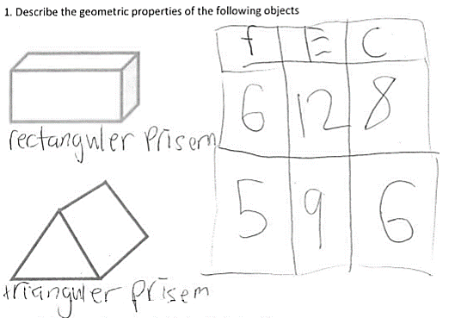

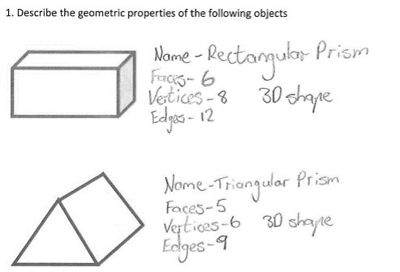

Records the number of faces, edges and corners (vertices) using a table

Labels the objects

Labels the objects and identifies the geometric properties, including the faces, edges and vertices, of the rectangular and triangular prisms

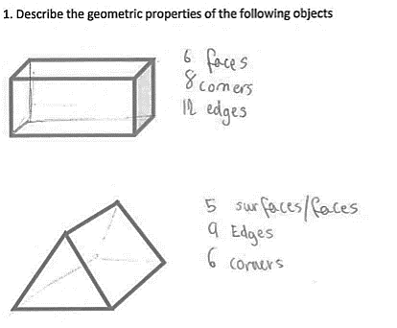

Identifies geometric properties of each object

Sketches missing elements to assist with identifying properties of each object

Student work samples – Matching nets
These work samples were created by students working at
Level 5. Evidence of student achievement has been annotated.

Victorian Curriculum links
Connect three-dimensional objects with their nets and other two-dimensional representations (VCMMG198)
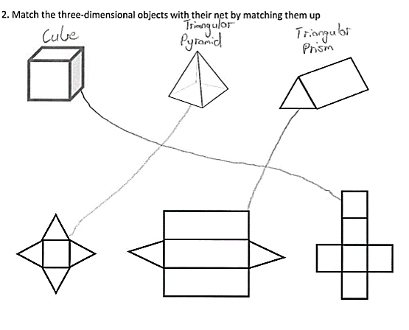

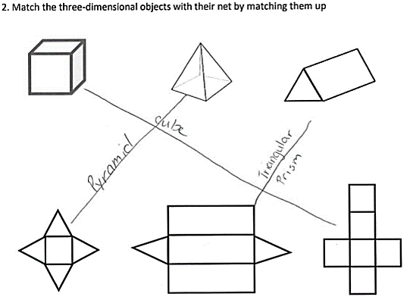

Identifies objects as cube, ‘triangular’ pyramid (square-based) and triangular prism

Connects three-dimensional objects with their nets

Labels the objects

Connects objects with their nets

Student work samples – Drawing nets
These work samples were created by students working at
Level 5. Evidence of student achievement has been annotated.

Victorian Curriculum links
Connect three-dimensional objects with their nets and other two-dimensional representations (VCMMG198)
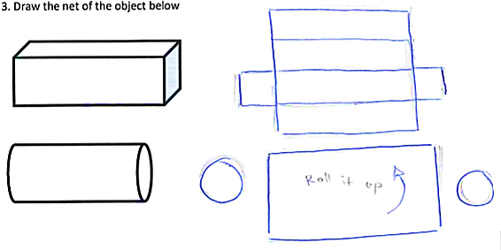

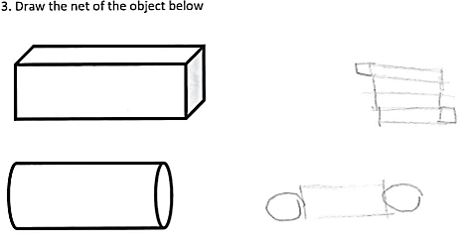

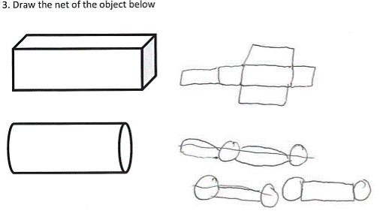

Identifies and draws a common net of a rectangular prism

Identifies and draws a net of a cylinder in three parts, with recognition of relative rectangular length and width compared with circumference

Identifies and draws a net of a rectangular prism

Identifies and draws a net of a cylinder

Identifies and draws a net of a rectangular prism

Identifies and draws a net of a cylinder after several attempts

Student work samples – Linking 2D shapes
These work samples were created by students working at
Level 5. Evidence of student achievement has been annotated.

Victorian Curriculum links
Connect three-dimensional objects with their nets and other two-dimensional representations (VCMMG198)
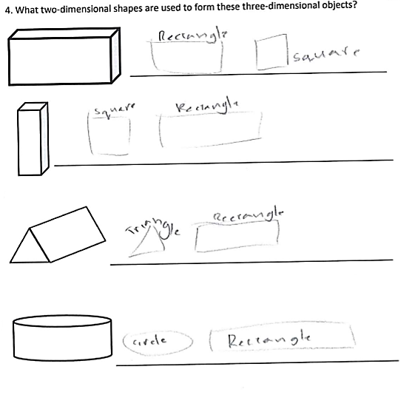

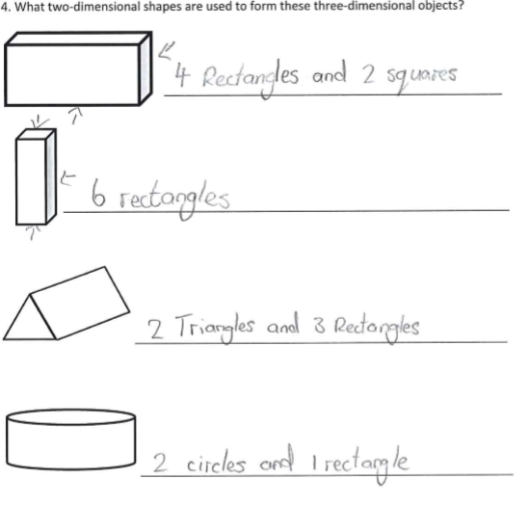

Identifies and labels the shapes required to form the objects

Identifies and labels the shapes required to form the objects

Identifies the shapes required for each object and how many of them are required

Where to next for the teacher?
When the task on which these annotated student work samples is based has been used as a classroom activity, there is opportunity to gather data on student achievement to help inform further teaching.
An analysis of student responses, on an individual, group or whole class basis, can be used to develop and direct student learning with respect to the following content.

For students needing to review underpinning knowledge and skills at Level 4
- Compare and describe two-dimensional shapes that result from combining and splitting common shapes, with and without the use of digital technologies (VCMMG170)
- Explain and compare the geometric properties of two-dimensional shapes and three-dimensional objects (VCMMG171)

For students consolidating knowledge and skills at Level 5
- Connect three-dimensional objects with their nets and other two-dimensional representations (VCMMG198)

For students moving on to new knowledge and skills at Level 6
- Construct simple prisms and pyramids (VCMMG228)

Resources
- Mathematics Sample Programs, Victorian Curriculum and Assessment Authority (VCAA) – This set of sample programs covering the Victorian Curriculum Mathematics: F–10 were developed as examples to illustrate how the Mathematics curriculum could be organised into yearly teaching and learning programs.
- Numeracy Learning Progressions, Victorian Curriculum and Assessment Authority (VCAA) – The Numeracy Learning Progressions amplify, extend and build on the numeracy skills in the Victorian Curriculum Mathematics F–10 and support the application of numeracy learning within other learning areas.
- FUSE, Victorian Department of Education and Training (DET) – The FUSE website provides access to digital resources that support the implementation of the Victorian Curriculum F–10, including an extensive range of activities and other resources for Primary Mathematics and Secondary Mathematics.
- Mathematics Teaching Toolkit, Victorian Department of Education and Training (DET)
- Mathematics Curriculum Companion, Victorian Department of Education and Training (DET)
- Victorian Numeracy Portal, Victorian Department of Education and Training (DET)
- Aligned Australian Curriculum Resources (Mathematics), Australian Curriculum, Assessment and Reporting Authority (ACARA)

