Finding areas
Introduction: This task involves finding the areas of rectangles, triangles and parallelograms.

Part 1
Find the area of the triangle shown below and explain how this was obtained.

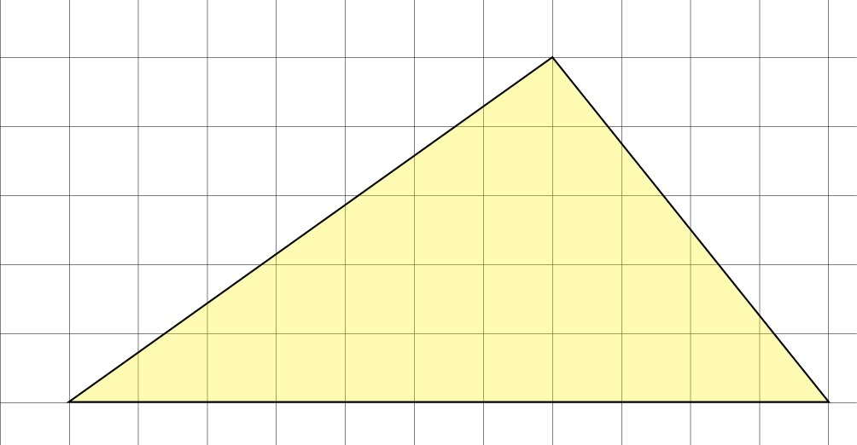

Part 2
Find the area of the parallelogram shown below and explain how this was obtained.

Part 3
Explain why the larger triangle formed by the blue and green triangles and the larger triangle formed by the green and yellow triangles have the same area.
