Respectful Relationships:
Stress Management

Levels 1–2

Topic: Stress Management

Levels 1-2

Victorian Curriculum F–10

Personal and Social Capability

Content Descriptions
Extend their vocabulary through which to recognise and describe emotions and when, how and with whom it is appropriate to share emotions (VCPSCSE008)
Explain how being prepared to try new things can help identify strategies when faced with unfamiliar or challenging situations (VCPSCSE010)

Achievement Standards (excerpt only)
By the end of Level 2, students… show an awareness of the feelings and needs of others. They recognise the importance of persisting when faced with new and challenging tasks.

Health and Physical Education

Content Descriptions
Practise strategies they can use when they need help with a task, problem or situation at home and/or at school (VCHPEP073)
Identify and practise emotional responses that account for own and others’ feelings (VCHPEP076)

Achievement Standards (excerpt only)
By the end of Level 2, students… understand how emotional responses impact on others’ feelings. They select strategies at home and/or school to keep themselves healthy and safe and are able to ask for help with tasks or problems.

Teaching and learning activities
The Department of Education and Training have developed Level 1-2 Resilience, Rights and Respectful Relationships teaching and learning materials. The following teaching and learning activities are designed to teach the knowledge, skills and understandings relating to stress management for Level 1-2. The following activities are located on pages 30-42 of the online resource.
Activity 1: The slow motion game for a calmer classroom
Activity 2: What is stress?
Activity 3: Coping with stress
Activity 4: Relaxation techniques
Activity 5: Helping letters

Assessment ideas

Pre-assessment
Students brainstorm words associated with stress, using the words in the anchor chart below as prompts. Students then cut up magazine pictures featuring facial expressions of different emotions and glue them onto the anchor chart.
WORRIED | SCARED
AFRAID | EXCITED
anxious | ANGRY

Refer to the Assessment Rubric on pages 3-4 to identify where students are located on the Victorian Curriculum F–10 continuum.

Ongoing formative assessment
Students complete Activity 2: What is stress? Assess student’s ability to recognise and describe various emotions associated with stress. Students draw their own ‘Wibbly’ in a feelings journal and answer the following questions from the activity:
- How does Wibbly look?
- What do you think Wibbly means when Wibbly says ‘feeling stressed’?
- What emotions do you think Wibbly is feeling?

Summative Assessment
Ask students to suggest some examples of coping and cheering strategies that can be used to help others when they are scared, angry or worried. List these on the board and then ask students to choose their favourite strategy for calming down and cheering up and to draw the strategy in the balloon template from Activity 3: Coping with stress, as shown below.

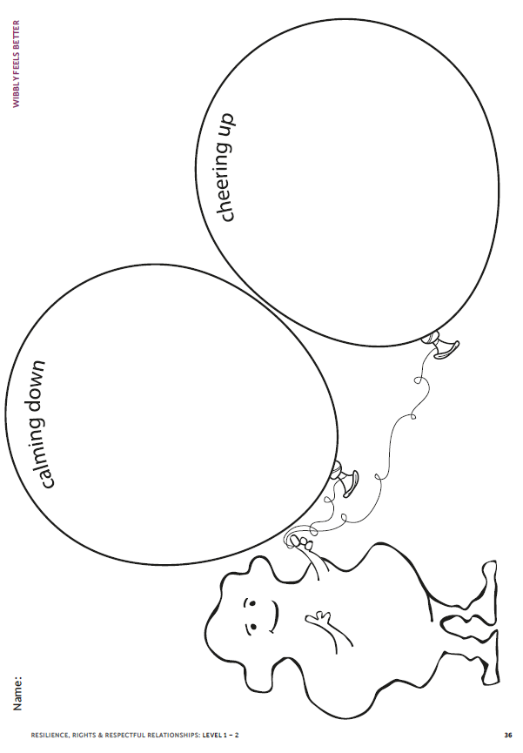

Encourage students to add key words to the drawing to enhance the message they are conveying. Display the student balloons in the classroom and encourage students to share the strategies with their parents or carers.
As an extension task, students can create their own relaxation technique (see examples in Activity 4). Students can add music and make an instructional video for their technique.

Refer to the Assessment Rubric on pages 3-4 to identify where students are located on the Victorian Curriculum F–10 continuum.

Stress management assessment rubric – Levels 1-2
 | Relevant element of the Achievement Standards
 | Foundation |  | Level 2 |  | Level 4
 | Personal and Social Capability
 | By the end of Foundation Level, students … identify and express a range of emotions in their interactions with others. They recognise that attempting new and challenging tasks are an important part of their development. |  | By the end of Level 2, students…show an awareness of the feelings and needs of others. They recognise the importance of persisting when faced with new and challenging tasks. |  | By the end of Level 4,  students… explain the consequences of emotional responses in a range of social situations. They suggest strategies for coping with difficult situations. They persist with tasks when faced with challenges and adapt their approach when first attempts are not successful.
 | Health and Physical Education
 | By the end of Foundation Level, students … identify and describe the different emotions people experience. They identify actions that keep them safe and physically active. |  | By the end of Level 2, students … understand how emotional responses impact on others’ feelings. They select strategies at home and/or school to keep themselves healthy and safe and are able to ask for help with tasks or problems. |  | By the end of Level 4, students … investigate how emotional responses vary and understand how to interact positively with others in different situations including in physical activities. They select and demonstrate strategies that help them stay safe, healthy and active at home, at school and in the community.

 | Assessment Rubric
Category | At Foundation Level students can: | When progressing towards Level 2 students can: | At Level 2 students can: | When progressing towards Level 4 students can: | At Level 4 students can:
Recognising emotions | - describe how they feel when experiencing stressful situations | - identify how emotional responses can affect interactions with other people | - recognise the impact of their own emotional responses on others’ feelings | - describe how emotional responses can impact on interactions with others | - investigate varying emotional responses to different situations
Calming and cheering strategies | - identify strategies they use to calm down or cheer up | - describe calming and cheering strategies they use in the home or at school | - demonstrate calming and cheering strategies when interacting with and caring for others at home or at school | select calming and cheering strategies to deal with emotions such as fear, anger and/or sadness in a variety of contexts | - demonstrate a range of strategies to manage a range of emotional responses

