2024 VCE Music Repertoire Performance written external assessment report

General comments
In 2024, the Victorian Curriculum and Assessment Authority produced an examination based on the VCE Music Study Design for 2023–2027 for Music Repertoire Performance. The examination was of one-hour duration and consisted of two sections: Sections A and B. The majority of students attempted all questions.
Section A – Listening and Interpretation involved listening to three previously unheard works and analysing the ways in which the performers used the elements of music. A comprehensive understanding of the elements of music (duration, pitch, tone colour, texture, structure, dynamics and articulation) and of compositional devices (repetition, transition, variation and contrast) was required. The ability to explain, describe and compare the interpretative decisions made by the performers and/or conductors was also required, together with knowledge of the resultant musical character or expressive intentions of the work.
Students did not need to repeat the question as an opening statement. High-scoring responses tended to use subheadings to refer to the specific elements of music, as well as dot points to keep their answers concise. The highest-scoring responses demonstrated a sophisticated understanding of the way the elements were used, using musical evidence and appropriate music terminology.
In Question 1, students were asked to explain how at least two elements of music were used. Generally, this question was correctly answered, with higher-scoring responses mentioning the use of syncopation, the military tone colours of the brass and the march-like feel that was maintained by the percussion. Many students wrote about more than two elements but chose elements that did not yield the best information to suit the question. In discussions of texture, students should be very careful when using the terms monophonic, heterophonic, homophonic and polyphonic. These were almost always used incorrectly, indicating a lack of understanding of these terms, as students often forced the music into one of these categories rather than describing the layers of sound and how they interacted with each other. Similarly, articulation is a much-misunderstood element and many students wrote about it in terms of attack and decay only, or legato and staccato only, without reference to the instrumental/vocal techniques that provide expression. Teachers and students are encouraged to explore all the articulations of different instruments, how to describe them and the character or expression that they convey. There was some confusion between the elements of music and compositional devices, which unfortunately meant that some responses wandered off topic. The differences should be clearly taught and understood by students. ‘Expressive outcomes’ was excluded from this question, but some responses used the generic term, which lacked specific reference to the question and made the writing appear formulaic.
In Question 2, students were asked to describe how contrast is achieved between Interpretation A and Interpretation B, referencing three of the four elements listed: tone colour, texture, duration and articulation. High-scoring responses successfully described the contrast between these interpretations (rather than within them), while demonstrating the student’s understanding of three of the listed elements. Most students were able to identify the faster tempo of Interpretation B, the different tone colour of the voices and the instrumental accompaniments, and the use of rubato for dramatic effect. Students who used very specific musical examples from the excerpts to support their writing achieved higher results. High-scoring responses used columns to divide the page and address the elements, which made the response clearer. Handwriting is still an issue in this section. Students are reminded to make their handwriting as legible as possible.
Section B – Music Language was correctly answered by most students. The timing of aural examples and written theory questions worked well for most students, who made good use of the extra time at the end to check their work. Handwritten music notation indicated students’ understanding of the importance of accuracy, a sharp pencil (as listed on the front cover of the examination) and care with accidentals, clefs, notation, stem direction and rhythmic grouping. Where notes written as semibreves but coloured in appeared, these responses could not receive full marks. Students are encouraged to make use of the blank manuscript provided throughout the examination paper for rough work. In the 2024 examination, the staff size was enlarged, particularly to assist with the correct placement of accidentals.

Specific information
Student responses reproduced in this report have not been corrected for grammar, spelling or factual information.
This report provides sample answers or an indication of what answers may have included. Unless otherwise stated, these are not intended to be exemplary or complete responses.
The statistics in this report may be subject to rounding resulting in a total more or less than 100 per cent.

Section A – Listening and interpretation

Question 1
Mark | 0 | 1 | 2 | 3 | 4 | 5 | 6 | 7 | 8 | Average
% | 0 | 0 | 1 | 7 | 16 | 23 | 25 | 20 | 8 | 5.6
This question required students to explain how the arrangement used at least two elements of music to create a sense of power and excitement. The musical excerpt was ‘The Raiders March’ from Raiders of the Lost Ark by John Williams.
Most students focused on dynamics, tone colour and articulation. Many students answered this question well, clearly explaining how two elements created a sense of power and excitement. Some higher-scoring responses explained how the melodic use of brass instruments in fanfare style produced the sensation of authority, and how the military-style snare drum provided the march tempo and feel. Many responses mentioned the contrasting string articulation in a lyrical middle section, before the final climax. Many also identified that the opening ostinato in low brass created a feeling of anticipation. Responses that focused mainly on dynamic build did not score as highly.
The following are examples of relevant points.
Duration
- distinctive brass ostinato
- majestic and march-like trumpet theme
- tempo is march speed, in simple quadruple
- syncopation in trumpet theme and in timpani and cymbal accompaniment
- timpani, bass and snare play on every beat – rhythmic drive and excitement
Pitch
- mid-range tessitura of trumpet melody, upward contour of melody
- melody has strong emphasis on tonic and dominant – equals strength and power
- brass ostinato in chordal harmony – acts as a drone under melody
Tone colour
- brass dominated – militaristic flavour and feeling of power
- trumpet theme – powerful statement in fanfare style
- cymbals and timpani add intensity
- strings theme in a warmer, lyrical tone colour but still maintains majestic feel
- flute and harp decorations add feeling of excitement and intrigue
Dynamics
- opening brass decrescendo to trumpet entry
- generally, a strong, loud dynamic gives a feeling of power
- string theme is softer in tone colour – provides small contrast
- textural dynamics used – fuller sound with addition of woodwind
- snare drum on every beat – increase in dynamic and intensity
Articulation
- brass ostinato is clipped and marcato
- trumpet theme accented on syncopated beat – power and momentum
- string articulation is also well marked, but lyrical with some sustained notes, and well-defined semiquavers
- harp glissando in background – creates excitement
Texture
- thin texture to begin, homophonic – trumpet theme with brass ostinato accompaniment
- builds to include woodwind and strings – texture is thickened, with smoother feel of momentum
- melody/accompaniment roles are maintained but texture is thicker with full orchestra and interest in decorative figures in background (flute and harp)
Structure
- introduction brass ostinato
- trumpet solo main theme
- trumpet theme repeated with orchestral accompaniment, including percussion
- theme 2 – strings, new melody with harp and flute in accompaniment, timpani on every beat
- final statement of theme with full orchestral accompaniment
Many very effective responses used subheadings to address elements separately.

The following are good examples of an integrated approach that references the question:
… Power is created within the gradual increase in textural density, particularly in the percussion section, which grows in both dynamics and rhythm. The brief interlude played by the strings is of a joyous and innocent mood, which becomes more heroic as the dynamics move to a forte level, with the introduction of the rumbling timpani …
The orchestral piece begins with a solo trumpet accompanied by brass and strings playing a rhythmic ostinato. The driving nature of the ostinato elicits excitement of the listener as it builds in volume throughout. The solo trumpet plays the melody in a sharp, staccato fashion which accomplishes a sense of power …
… the snare drum begins playing a marching rhythm which propels the music forward due to the powerful nature of the drum. The dynamics build in volume throughout the piece which reflects the excitement. The accompanying harmony after the trumpet solo is fuller thanks to counter-melodies played by woodwind and harp …

Question 2
Mark | 0 | 1 | 2 | 3 | 4 | 5 | 6 | 7 | 8 | 9 | 10 | 11 | 12 | Average
% | 0 | 0 | 1 | 2 | 5 | 11 | 17 | 17 | 17 | 11 | 9 | 8 | 2 | 7.4
This question required students to refer to three of the following: tone colour, texture, duration and articulation. It also required students to describe how contrast was achieved between the two interpretations. The musical excerpt was ‘O Better Far to Live and Die’ from Pirates of Penzance by Gilbert and Sullivan.
Interpretation A – Kevin Kline 1983
Interpretation B – Jon English 1994
Most students were able to identify the immediate differences in vocal tone colour and accompaniment between the two interpretations. Students commented effectively on the different uses of vibrato in the two interpretations.
Not all students recognised that Interpretation B was a live recording that included audience laughter, as the music stopped and started in order to follow the hijinks occurring on stage. But the use of dramatic rubato and pause was well recognised, as was the more traditional lyrical style of Kevin Kline and the shorter, chopped phrase lengths of Jon English.
Students who divided their page with the elements addressed in both interpretations generally scored highly. Students who did not score so highly divided their page but did not compare like for like in their exploration of the elements. Some higher-scoring responses used a full text conversational style, comparing the two interpretations and commenting on the contrast achieved and the different resulting styles and characters. Again, the most successful responses used musical evidence to support each point, as well as correct musical terminology.
The following are examples of relevant points for Question 2.
Tone colour
Interpretation A
- male vocal, exaggerated operatic vibrato, gruff shouts
- sung and shouted interjections of male chorus
- delicate interjections of flute, glockenspiel and strings heighten comedy
Interpretation B
- male vocal, rougher in tone and uses sung speech
- less exaggerated vibrato
- shouted rough interjections of male chorus
- accompaniment – keyboard strings
Duration
Interpretation A
- moderate tempo
- dotted rhythm ‘bouncing’ accompaniment
- use of pause and rubato for dramatic purpose
- soloist’s tenuto on high dramatic notes
Interpretation B
- faster tempo
- phrases chopped in semi-spoken style
- soloist’s tenuto not as long
- many pauses by soloist, accommodated by accompaniment
- bouncing dotted rhythm faster and less pronounced
- orchestral interjections are rushed
Texture
Interpretation A
- solo voice is dominant line
- orchestral accompaniment including keyboard
- male chorus interjecting
Interpretation B
- solo voice is dominant line
- keyboard accompaniment with some orchestral involvement
- male chorus interjecting
Articulation
Interpretation A
- male vocal – slides, glissando and exaggerated vibrato
- ‘English’-style clipped delivery
- generous use of rubato and tenuto
- elongated vowel shape (humorous)
- marcato dotted rhythm accompaniment
Interpretation B
- male vocal well-articulated lyrics but not as exaggerated or stilted
- some semi-spoken lines
- vocal glissando between notes
- ends of phrases cut short
- soloist often focuses on final consonant rather than vowel

Section B – Music language

Question 3
Mark | 0 | 1 | 2 | Average
% | 34 | 33 | 33 | 1.0
Melody 1 – iii
Melody 2 – vi
This question required recognition of a melodic line presented in letter names, rather than contour lines. The reading time was useful in allowing students to analyse the alternatives and mentally note the differences and similarities. Some students used sparklines to replicate the contour of the melodies; others highlighted or circled the common note of the melodies or the differences between them. These were all valid techniques.
Students are encouraged to transcribe simple melodies that are within the range of an octave in many different ways, for example, using line shapes, graphic notation, letter names or staff notation, to better equip themselves for this type of question. Any transcription of solo or ensemble music will assist with aural skill development.

Question 4a.
Mark | 0 | 1 | Average
% | 19 | 81 | 0.8
Answer: Lydian mode.
This question was answered correctly by most students.

Question 4b.
Mark | 0 | 1 | 2 | 3 | Average
% | 14 | 22 | 10 | 55 | 2.1
Answer:
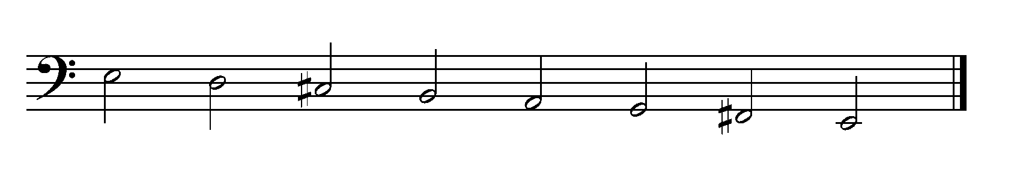
Clefs must begin on the line that they are defining. The clef determines the pitch of the line it begins on. The G clef (treble clef) begins on the G line, and the F clef (bass clef) begins on the F line. The iconic dots on the bass clef further serve to define the F line.
Responses included many interpretations of what a bass clef should look like. Provided that a response defined the F line to make the printed scale E Dorian mode (with the addition of the correct accidentals), it was marked correct. However, the responses to this question did demonstrate a lack of knowledge of this basic notational skill.

Question 4c.
Mark | 0 | 1 | 2 | Average
% | 4 | 32 | 61 | 1.6
Answer:
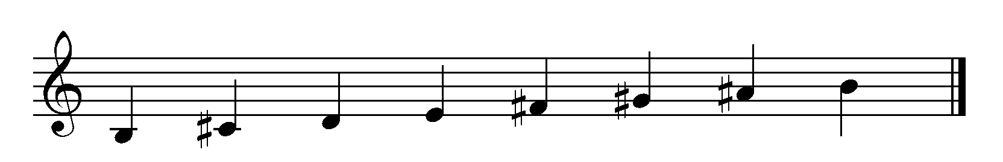
This question was answered correctly by most students, who added the correct accidentals and wrote ascending crotchets.

Question 5a.
Mark | 0 | 1 | 2 | 3 | 4 | 5 | 6 | 7 | Average
% | 6 | 12 | 11 | 10 | 9 | 11 | 10 | 31 | 4.3
Answer:
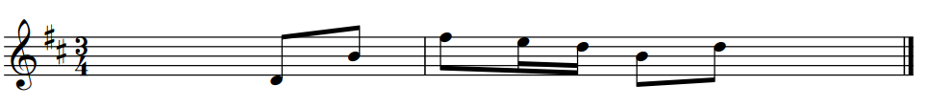
Most students were able to recognise that the first note to transcribe was the same note as the end of bar 1 and that the opening interval had already been heard in bar 1 and the beginning of bar 2.

Question 5b.
Mark | 0 | 1 | 2 | Average
% | 3 | 15 | 81 | 1.8
Answer:
Bar 1 – Perfect octave
Bar 4 – Major 6th
This question answered correctly by most students. Responses that scored full marks identified both the quality and the size of the interval.

Question 5c.
Mark | 0 | 1 | Average
% | 23 | 77 | 0.8
Answer: D Major pentatonic

Question 6
Mark | 0 | 1 | 2 | 3 | Average
% | 2 | 4 | 15 | 79 | 2.7
Answer:
This question was answered by correctly by most students, with almost all placing the accidentals correctly.

Question 7
Mark | 0 | 1 | 2 | 3 | 4 | Average
% | 4 | 4 | 9 | 22 | 61 | 3.3
Answer:
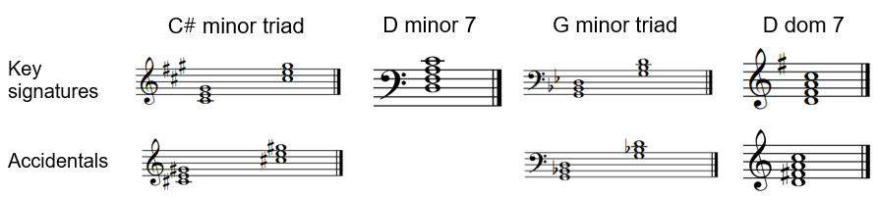
This question was generally answered correctly. Students and teachers should note that 7th chords must contain four notes – the three-note triad plus the 7th. Triad chords can contain four notes if they have the tonic note doubled at the octave, creating the fourth note. In this examination, there was no need to double the tonic in a triad, as this could cause confusion.

Question 8a.
Mark | 0 | 1 | 2 | 3 | 4 | 5 | 6 | Average
% | 5 | 13 | 16 | 14 | 16 | 12 | 25 | 3.6
Answer:
 | 1 | 2 | 3 | 4 | 5 | 6 | 7 | 8
Bass note | A | B | D | E | A | D | E | F#
Quality | Major | Minor 7th | Major | Dom 7th | Major | Major | Major | Minor
There were few high-scoring responses to this question. Many students did not recognise the E Dominant 7th chord or the difference between a 7th chord and a triad. Students need to practise chord recognition and bass-line recognition.

Question 8b.
Mark | 0 | 1 | Average
% | 27 | 73 | 0.8
Answer: Interrupted cadence
Most students correctly identified the bass note E rising to F# in the last chord.
Alternative names of Deceptive, Disruptive and False cadence were accepted.

Question 9
Mark | 0 | 1 | 2 | 3 | 4 | 5 | 6 | 7 | 8 | Average
% | 4 | 8 | 9 | 10 | 7 | 9 | 9 | 13 | 30 | 5.2
Answer:
Rhythmic transcription was correctly answered by many students. The first two beats were correctly identified by most students, but beats 3 and 4 proved difficult for some. Many students demonstrated their ability to keep counting and correctly identified the first beat of the next bar as three quavers. The duplet was also identified correctly by most students. The final note was a dotted crotchet but many responses omitted the dot.
Students would benefit from regular practice with groupings in compound time. When answering this type of question, it is also useful to look at other groupings and notes used in surrounding parts, as they may be used in the transcription part.

