2024 VCE VET Furnishing external assessment report

Specific information
Note: The statistics in this report may be subject to rounding, resulting in a total of more or less than 100 per cent.

Section A – Multiple-choice questions
The table below indicates the percentage of students who chose each option. Bold font and grey shading indicate the correct response.
Question | Correct answer | % A | % B | % C | % D | Comments
1 | A | 72 | 15 | 0 | 13
2 | A | 73 | 6 | 13 | 7
3 | D | 15 | 19 | 19 | 46
4 | B | 10 | 49 | 34 | 6 | The use of images assisted students with this question.
5 | B | 27 | 46 | 18 | 9
6 | D | 43 | 16 | 0 | 40 | Students needed to show an understanding of how a bench hook is used.
7 | C | 3 | 22 | 57 | 18 | The use of an image assisted students with this question.
8 | A | 72 | 19 | 9 | 0 | This question was answered well. Students were aware of the tenon saw and measurements.
9 | C | 28 | 36 | 33 | 3
10 | C | 4 | 4 | 87 | 4 | The use of images assisted students with this question.
11 | A | 25 | 51 | 6 | 18 | The clearance hole is the first bit of timber that the screw goes into. Because it is timber, there should not be any friction on the first piece for maximum pulling strength to join the second piece of timber.
12 | D | 1 | 6 | 6 | 87
13 | A | 79 | 16 | 0 | 3
14 | C | 7 | 3 | 87 | 3
15 | D | 7 | 15 | 16 | 61
16 | A | 48 | 19 | 15 | 18
17 | B | 12 | 27 | 36 | 25 | The top size is 580 mm in diameter; that is the height and width. Then students had to calculate how many tables per sheet and then how many sheets for 20 tables.  This question had a number of calculations for students to complete to achieve the correct answer.
18 | D | 1 | 1 | 6 | 91 | This calculation question was answered well.
19 | C | 6 | 27 | 64 | 3
20 | B | 34 | 40 | 22 | 3 | Students should familiarise themselves with commonly used acronyms.

Section B – Short-answer questions
This report provides sample answers or an indication of what answers may have included. Unless otherwise stated, these are not intended to be exemplary or complete responses.

Question 1
Mark | 0 | 1 | 2 | 3 | 4 | 5 | 6 | Average
% | 1 | 1 | 3 | 11 | 4 | 20 | 61 | 5.1

Measurement tool | Use | Limitation
tape measure | taking internal and external measurements | not appropriate for very small measurements
combination square | measures 90-degree angles | not appropriate to measure angled increments, only measures 45- or 90-degree angles
300 mm ruler | taking measurements no greater than 300 mm | not appropriate for large measurements
One mark was awarded for each correct response in the six table cells.
It is important for students to ensure they read the question carefully. Responses needed to refer to a limitation of the tool, rather than describing the material or an additional feature/function of the tool.

Question 2
Mark | 0 | 1 | 2 | 3 | Average
% | 50 | 11 | 15 | 23 | 1.1

maximum width | 2
maximum length | 5
maximum number of chairs | 14
Many students subtracted only one length and one edge from the size of the boardroom. All four sides needed to be subtracted to arrive at the correct answer.

Question 3
Mark | 0 | 1 | 2 | 3 | 4 | 5 | 6 | Average
% | 3 | 5 | 20 | 19 | 18 | 0 | 35 | 3.8
Students needed to show an understanding of the correct sequence of sharpening a chisel.
Responses with the order of steps shown in Table A or Table B (below) were marked correct.

Step no. | Description of step
6 | Inspect the cutting edge prior to use.
5 | Using a strop or clean piece of timber, remove the excess burr.
4 | Hone the cutting angle of the chisel on the sharpening stone using a figure-8 motion.
1 | Check the rest and wheel of the bench grinder, including coolant.
2 | Grind the chisel, without overheating, to an angle of 25°.
3 | Hone the back of the chisel on the sharpening stone, keeping it perfectly flat.

Question 4
Mark | 0 | 1 | 2 | 3 | 4 | Average
% | 24 | 30 | 35 | 11 | 1 | 1.4
- density
- figure/aesthetics/grain
- colour
- durability/hardness
The following responses were not correct: price/cost; grain direction; moisture; hardwood/softwood (unless explained in terms of density).

Question 5
Mark | 0 | 1 | 2 | 3 | 4 | Average
% | 87 | 5 | 8 | 0 | 0 | 0.2
Any two of the following factors were advantages of using solid timber over manufactured boards:
- end grain: better appearance and better strength
- dints can be ironed out
- in drawers, dovetail joints are stronger
- no veneer to sand through
- easy to apply oil or wax
- environmental: fewer chemicals
Responses that referred only to strength or hitting timber were not accepted, as the advantages had to be related to making furniture.

Question 6
Mark | 0 | 1 | 2 | Average
% | 16 | 63 | 21 | 1.1
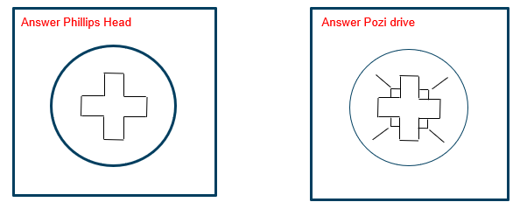
No marks were awarded for stars, suns and so on.

Question 7
Mark | 0 | 1 | 2 | Average
% | 31 | 24 | 46 | 1.2
The depth of the blade is extended too far out so it tears.
One mark was awarded for referring to depth/angle; another mark was awarded for referring to the plane being too far out.

Question 8a.
Mark | 0 | 1 | Average
% | 68 | 32 | 0.4
The end of the tape measure hooks onto or is pressed against a surface.

Question 8b.
Mark | 0 | 1 | 2 | Average
% | 82 | 12 | 6 | 0.3
For internal measurement work, the inside with the tip should be pulled all the way out to zero on the inside face. / For internal measurements, the tip should be pressed in, again making sure that the face of the tip is at zero.
Hold tape measure at 100 mm to start the measuring, then subtract 100 mm from the final measurement.

Question 9a.
Mark | 0 | 1 | 2 | 3 | Average
% | 36 | 35 | 17 | 12 | 1.1
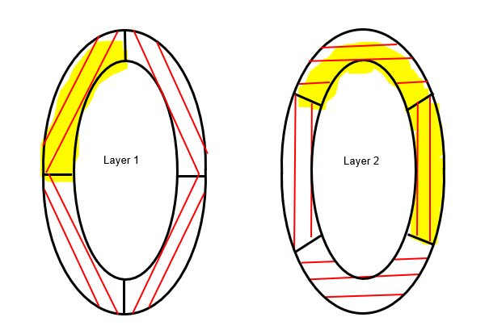
Layer 1 – all line directions needed to be correct for 1 mark.
Layer 2 – 1 mark was awarded for having left and right correct, and 1 mark was awarded for having the top and bottom correct.
Students should remember that lines/arrows do not go around corners.

Question 9b.
Mark | 0 | 1 | Average
% | 54 | 46 | 0.5
Butt joint, domino/loose tenon were all acceptable responses.
Domino/loose tenon (timber is 12 mm, could be a 4 mm thick domino, 4 mm on each side, layering the frames on top of each other will give it structure) are a similar joint, so both were accepted.
No marks were awarded for biscuit joints.

Question 10
Mark | 0 | 1 | 2 | 3 | 4 | 5 | 6 | Average
% | 25 | 20 | 31 | 10 | 9 | 5 | 1 | 1.8

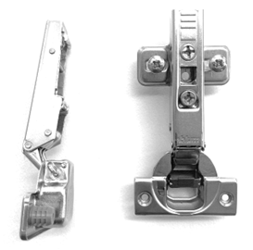 | 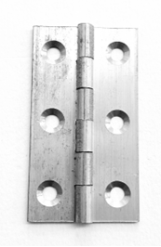
Name  Concealed hinge | Name  Butt hinge
Advantage  Adjustable / Concealed / Self-closing | Advantage  Traditional / Reliable / Doesn’t take up space in cabinet
Disadvantage  Cost / Ugly / Projects into cabinet | Disadvantage  Not adjustable (limited adjustment / hard to adjust) / Complex to install
One mark was awarded for one correct response in each of the six table cells.
No marks were awarded for the following responses: overlay hinges; butt hinge is not simple; range of opening degree.

Question 11
Mark | 0 | 1 | 2 | Average
% | 20 | 44 | 37 | 1.2
The key concepts were recycle, reuse and storage.
Place all your usable offcuts of solid wood and particle board on the storage shelf.
Place all smaller unusable offcuts in the appropriate bins, after separating both solid wood and manufactured boards.
Marks were awarded as follows:
- 1 mark for identifying
- 1 mark for describing.

Question 12
Mark | 0 | 1 | 2 | 3 | 4 | Average
% | 15 | 5 | 27 | 13 | 41 | 2.5
File and sandpaper
- Use a file on a very slight angle, not flat, with the face pushing the file forward. The file sands the edge, removing the excess. Then give the edge a light sand with a sanding block and fine sandpaper.
Cabinet scraper and sandpaper
- Use a cabinet scraper in a drawing motion, removing the excess. Then give the edge a light sand with a sanding block and fine sandpaper.
Marks for the two parts of this question were awarded as follows:
- 1 mark for a basic or general description
- 1 mark for an explanation.

Question 13a.
Mark | 0 | 1 | Average
% | 67 | 33 | 0.4
A cabinet scraper thickness or close to 1.5–2 mm.

Question 13b.
Mark | 0 | 1 | Average
% | 58 | 42 | 0.4
A drawer gap thickness or close to 1–2 mm.
Students need to be familiar with the increments of millimetres.

Section C – Case study

Question 1
Mark | 0 | 1 | 2 | 3 | 4 | 5 | Average
% | 1 | 0 | 4 | 12 | 34 | 48 | 4.2
Item 2 ─ back panel. Length = 960
Item 5 ─ shelf. Material = kauri pine
Item 9 ─ front rail. Length = 1000
Item 14 ─ drawer front. Thickness = 20
Item 21 ─ drawer bottom. Material = plywood

Question 2
Mark | 0 | 1 | 2 | Average
% | 86 | 5 | 10 | 0.2
Name: stopped dovetail housing joint /dovetail housing joint OR stopped housing joint / housing joint
Explanation: Greater gluing surface with the added strength of the dovetail locking in the socket (housing).

Question 3
Mark | 0 | 1 | 2 | Average
% | 28 | 58 | 14 | 0.9
Two of the following:
- leg and rail
- mitred corner joint
- butt joint
- door frame
- drawer sides
No marks were awarded for widening joints.

Question 4
Mark | 0 | 1 | 2 | 3 | 4 | 5 | Average
% | 54 | 19 | 14 | 10 | 3 | 0 | 1.0

Step no. | Description of step
1 | Mark out tenon using a pencil, ruler, try square and marking gauge.
2 | Using a bench hook and tenon saw, cut across the rail creating what will become the shoulder.
3 | On the second face, using a bench hock and tenon saw, cut across the rail creating what will become the shoulder.
4 | Using the vice and tenon saw, cut down the face of the tenon until you remove the waste material.
5 | Using the vice and tenon saw, cut down the second face of the tenon until you remove the waste material.
6 | Using a hand router (grannies’ tooth), clean up both faces of the tenon.
7 | Using a chisel, guide block, wooden mallet, square up the two shoulders.
It was acceptable to have a step that repeats the process again; for example, clamp work.
No marks were awarded for sanding the tenon; tenons need to be cleaned up by using a chisel or hand router.
No marks were awarded for testing to see if the tenon fits because in Step 7 the tenon has not been completed. (Fitting the tenon is after Step 7.)

Question 5
Mark | 0 | 1 | 2 | 3 | Average
% | 3 | 18 | 42 | 37 | 2.1
Name: drop saw / compound mitre saw / mitre saw
Reason 1: The drop saw can be set to the correct angle.
Reason 2: It has a fence to hold the beading against for safety and accuracy.
Alternative reasons:
- clean cut
- quick to use
- easy to use.

Question 6a.
Mark | 0 | 1 | 2 | 3 | 4 | Average
% | 1 | 10 | 40 | 49 | 0 | 2.4
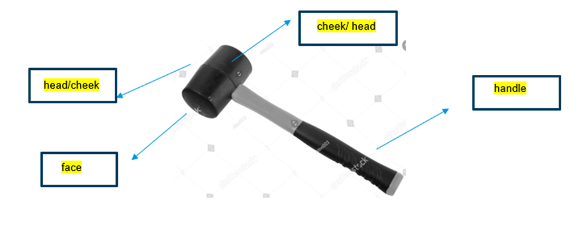

Question 6b.
Mark | 0 | 1 | Average
% | 32 | 68 | 0.7
To gently tap timber construction joints together.

Question 7
Mark | 0 | 1 | 2 | Average
% | 20 | 45 | 35 | 1.2
Where two faces are level with each other and without any distortion. For example, where the faces of the stile and rails on a cabinet door meet or where the top surfaces of a drawer runner and front rail intersect.
Marks were awarded as follows:
- 1 mark for explanation
- 1 mark for providing an example.

Question 8a.
Mark | 0 | 1 | Average
% | 90 | 10 | 0.1
Stopped housing / housing
No marks were awarded for corner housing joint or domino joint.

Question 8b.
Mark | 0 | 1 | Average
% | 80 | 20 | 0.2
6 mm or half the thickness in depth

Question 8c.
Mark | 0 | 1 | 2 | Average
% | 95 | 1 | 5 | 0.1

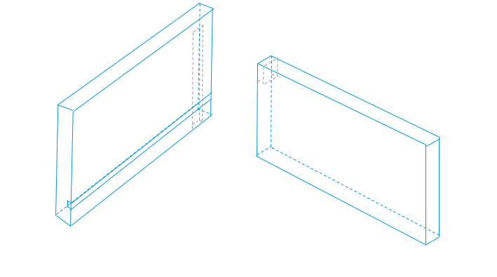

Question 9
Mark | 0 | 1 | 2 | 3 | 4 | Average
% | 83 | 4 | 3 | 2 | 8 | 0.5

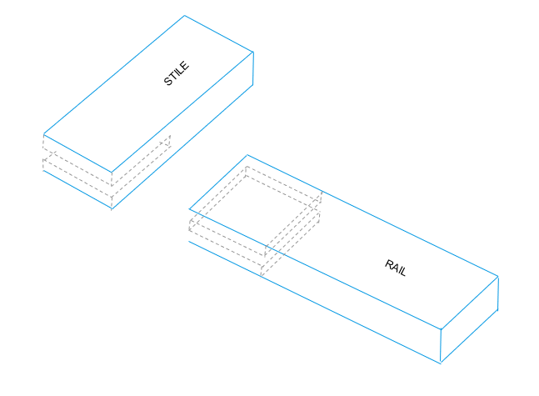
Marks were awarded as follows:
- 1 mark – one component with square markings
- 2 marks – both components with square markings
- 3 marks – slightly wrong offcut or placing
- 4 marks – correct.
Students should know about different joinery construction methods, from traditional hand skills to the use of machines. They should know where each joinery method could be used when making furniture, as well as the processes, procedures and advantages and disadvantages of each method.

