NHT General Mathematics MA163

2025 NHT Assessment Guide

VCAA Marking Policies and Procedures

Consistency of Marking
The Assessment Guide indicates the basis for awarding marks for each item. This may involve either counting correct answers/features of a response or marking holistically, whereby making a judgement about the overall quality/qualities of a response.
The Assessment Guide will demonstrate how marks are to be awarded for a response, not where or how marks are to be deducted. The Assessment Guide will address specific examples and relevant application where appropriate. The following table provides a list of common concerns that all assessors should follow for consistent approaches to marking VCE external examinations.
Assessors should contact the Chief Assessor in cases where they believe that by following any of the directions below, a student will not be marked fairly.
Assessors must use the final version of the Assessment Guide as confirmed at the end of the Assessor Training Meeting.
Concern | Advice
Responses ‘off task’ or contradictory | A response that does not address the subject of the question cannot be awarded any marks.  If contradictory responses are given (i.e.: the response conflicts with earlier comments or working out) full marks cannot be awarded.
Responses not addressed in the Assessment Guide | Assessors should refer the matter to the Chief Assessor for determination.
Spelling | Unless otherwise instructed in the Assessment Guide (i.e.: as part of a criteria), incorrect spelling should not affect the scoring of a student’s response.
Specified Number of Examples/Reasons | Where a student provides more than the required number, the assessor should only assess the required number of responses, and these should be assessed in the order in which they appear.
Working Out | Where a question explicitly requires the student to show working out, and this is specified in the examination instructions or in the question, full marks should be awarded if:  - The response is correct and the working out is correct  - Two sets of working out are shown, both attempts are correct, and the answer is correct  Where a question explicitly requires the student to show working out, partial marks should be awarded for correct completion of key steps required to produce the correct answer.
Consequential Errors | If a question requires a series of argued/sequential steps to arrive at the correct response, the Assessment Guide will allocate marks for the key steps required to produce the correct response.  In these cases, the effect of a consequential error on a subsequent response will be considered.
Half Marks | Half marks must not be awarded for a response or carried over to subsequent questions.
Crossing Out | If a student response has been crossed out, the part crossed out should not be considered. If the entire response is crossed out, this is awarded zero (‘0’).
Modules | Where a student responds to more modules than required, the assessor must assess all responses.
Options | Where a student responds to more than one option, the assessor must assess all responses according to the Assessment Guide and award the student the highest score, indicating the option selected.
Not Attempted vs Zero (0) | Where a student has not made a genuine attempt to respond to the question, assessors should score the response as ‘Not Attempted’. This may include:  - Blank responses  - ‘I don’t know’  - Repeating the question, task, source material, or any other text directly from the examination  - A response with no relevance to the task.  Where a student has made a genuine attempt to respond to the question, assessors should score the response as ‘0’ (zero) where:  - The student has crossed out their whole response or  - The student’s response does not meet the assessment criteria to be awarded any marks.

Student Concern
Occasionally, assessors encounter a response that may raise concerns about the welfare of the student. Examples may include:
- suggestions or claims of abuse or neglect
- indications of distress or self-harm
- threats of violence, harm, or criminal acts involving others.
In such cases, assessors should assess the student work in accordance with the Assessment Guide and send the student script/item to be reviewed according to the instruction on the next page.
Any matter of concern that an assessor believes requires urgent attention should be referred to the VCAA immediately via call to the VCAA Helpdesk on 1800 820 122 or email to vcaa.assessment.operations@education.vic.gov.au.

Sending student responses to review
During marking assessors may identify student responses to be escalated for review by the Chief Assessor or to be noted by VCAA staff. The review categories are:
Category | Description
Illegible response | You are unable to read the student’s response.
Incomplete student work | The student appears to be missing part of their response or has indicated it continues in another area that is not attached as an attachment.
Possible connection to student | You recognise the student’s work. Please provide details.
Student concern | There is evidence of student distress.
Technical Issue (VOSS Helpdesk) | You are not able to continue scoring this exam or item due to a technical issue. Only use this category if you have contacted VOSS support on 1800 820 122.
Below is a list of common issues that may arise, and how to respond to these:
Issue | Action
Evidence of student distress or concern.  Note: Unfinished work or work that is off-task is not considered a ‘student concern’. | Assess the student response using the Assessment Guide.  Send the student response for review, selecting the ‘student concern’ review category.
The student’s handwriting is too faint to read, and you are unable to read and score the student response accurately.  Note: Some student responses may include different handwriting or typed responses. This is usually due to Special Examination Arrangements and therefore does not need to be reported to the VCAA. | Make every effort to read the student’s work. If unable to read the response, send the script for review, selecting the ‘illegible response’ review category.
The student’s response appears to be unfinished, or they have indicated their response continues on another page that is not attached. | Refer to the Assessment Guide and score this as the student’s response, and send the student response for review, selecting ‘incomplete student work’ review category.
The control of the mechanics of language is not sufficient to communicate a coherent response. | Refer to the Assessment Guide and score this as the student’s response. You may contact the Chief Assessor for advice on how best to score the response.
Responses in Languages other than English | Unless otherwise stated, responses in a language other than English should not be awarded marks and should be scored zero (0).

Core A – Data Analysis
Q | Guide | Answer | Mark | Additional
1a | 15 – 1 | 14 | A1
1b | (16 + 16 + 7 + 4 + 4 +1)/200 | 24% | A1
1ci | UF = 6 + 1.5 × (6 – 2) = 12, 15 > 12 |  | A1 | Must see both parts
1cii | 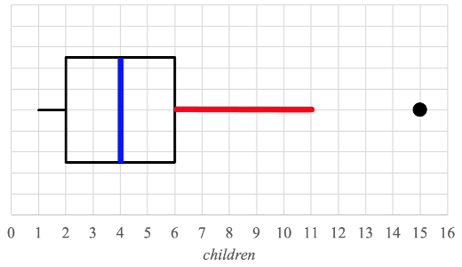  Median – blue line |  | A1
1ciii | Upper whisker – red line |  | A1
2 | Q1 = 1.71  Q3 = 1.80 |  | A1  A1 | ***Rounding to 2 dp applies
3a |  |  | A1  A1 | Any 2 correct numbers
   | Number of brothers
  Daughter height | None | One or more
  Taller | 62.5 | 39.6
  Equal to | 12.5 | 16.5
  Shorter | 25.0 | 43.9
  TOTAL | 100 | 100
3b | YES. The percentage of taller daughters with no brothers (62.5%) was greater than the percentage of taller daughters with one or more brothers (39.6%) |  | A1  H1 | Yes or statement of affirmation and mention difference/comparison  Correct percentages of taller daughters for both situations with proportion or correct percentages of shorter daughters (25% and 43.9%)  ***Ignore minor rounding errors
3c |  |  | A1  A1 | Evidence of correct "numbers" in any order  All correct
  daughter = | 1.25 | + | 0.228 | × mother

Q | Guide |  | Answer |  | Mark |  | Additional
4a | son's height |  |  |  | A1
4b | 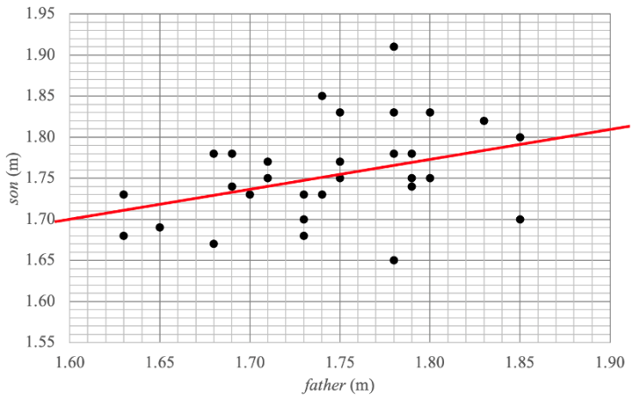 |  |  | A1 |  | suggested margins of error for axis intercepts.  (left side: 1.695 – 1.705  right side: 1.81 – 1.82)  **key points:  (1.60, 1.70)  (1.74, 1.75)  (1.90, 1.81)  (1.85, 1.79)
4c | 0.37442 = .14017 ≈ 14%, 100 – 14 = | 86% |  | A1 |  | ***Whole number rounding applies
4d |  |  |  | A1 |  | In this order
  weak
  positive
4e |  |  |  | A1
  3.75
4f | Predict = 1.10 + 0.375 × 1.85 = 1.79375  Residual = Actual – Pred = 1.70 – 1.79 | – 0.09 |  | A1  A1 |  | Correct calculation and/or predicted value  ***Rounding to 2 dp applies
4g | Father's height  CD(Father/son) > CD(Mother/son), 14% > 9.5% |  |  | A1 |  | Accept r(F/S) > r(M/S)  0.3744 > 0.3082  ***Ignore minor rounding
5a | 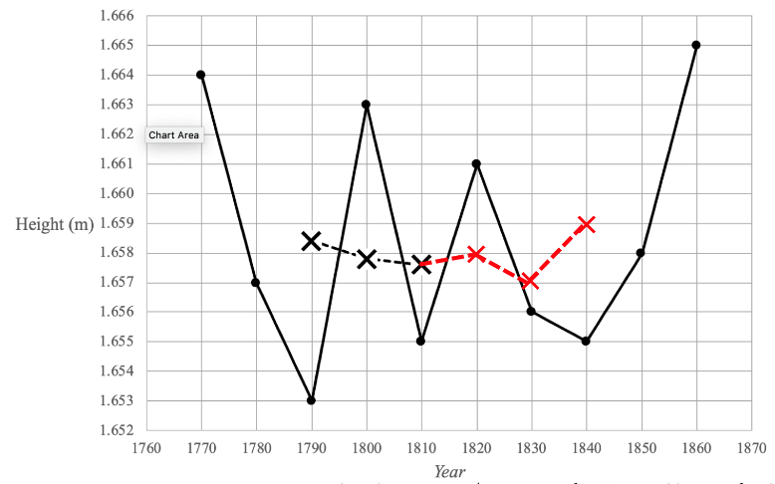 |  |  | A1  A1 |  | Key values  Any two values correctly plotted  All points correctly plotted, and joined.
  1820 | 1830 | 1840
  1.658 | 1.657 | 1.659
5b | increase in height over 100 years  = 1.822 – 1.665 = 0.157 m  increase per decade  = 0.157 ÷ 10 = 0.0157 mm  2040 height = 1960 height + 8 decades  = 1.822 + 8 × 0.0157 | 1.948 |  | A1 |  | ***Rounding to 3 dp applies

Recursion and financial modelling
Q | Guide |  |  | Answer | Mark | Additional
6a |  |  |  | 9% | A1
6b | Plot point at (5, 44 000) |  |  |  | A1 | Must show correct coordinates
6c |  |  |  | 10 years | A1
7a | = 0.25% |  |  |  | A1 | ***Show that question
7b |  |  |  | $824.69 | A1
7c | V0 = 300 000 Vn+1 = 1.0025 × Vn – 1570.58 |  |  |  | A1 | Both parts must be correct
7d |  |  |  | 260 | A1
8a |  | Final payment  = $1285.12 + $0.30 |  | $1285.42 | A1 | ***Rounding to nearest cent applies
  N =  I% =  PV =  PMT =  FV =  P/Y & C/Y = | 96  5.4  100 000  – 1285.12  – 0.2984  12
8b | B0 = 42 623.31 Bn+1 = 1.0045 × Bn – 2470.48 |  |  |  | A1  A1 | Any two values correct  Fully correct recurrence relation
9 |  |  |  |  | A1  A1 | ***Round to 1 dp applies  ***Rounding to nearest dollar  applies
  N =  I% =  PV =  PMT =  FV =  P/Y & C/Y = | 26  2.8000  –25098.84  0  25452.60  52
  N =  I% =  PV =  PMT =  FV =  P/Y & C/Y = | 26  2.8  –24749.9977  0  25098.84  52
  Interest rate
  2.8%
  Original investment
  $24 750

Matrices
Q | Guide |  |  | Answer | Mark | Additional
10a |  |  |  |  | A1
  460 | 890
  520 | 950
  610 | 1100
10bi |  |  |  |  | A1
10bii |  |  | 1.02 |  | A1
10c |  |  |  |  | A1
11a |  |  |  |  | A1
11b |  |  |  |  | A1
  m = | 22.3 | n = | 220
12a | M – D – C – N |  |  |  | A1
12b | D – M – D  D – P – D  D – C – D |  |  |  | A1
13a | No (0) resorts are classified as Budget one year and then Luxury the next. |  |  |  | A1 | Or similar wording
13b | There won't be any resorts classified as Budget. |  |  |  | A1 | Or similar wording
13c | f = 0.1  0.1×40+0.6×120+d×90+0.1×70 = 119  90d = 36 |  | 0.4 |  | A1
13d |  | diff = 115 – 40 = 75  % = | 187.5% |  | A1

Networks and decision mathematics
Q | Guide | Answer | Mark | Additional
14ai | P – S – B – T – M – H – L – G |  | A1 | In this order
14aii | Hamiltonian Path |  | A1 | Accept Hamilton Path
14b | Three landmarks are connected directly from B. |  | A1
14c |  |  | A1 | Also accept HG or LB
  G | and | H
  B | and | L
15a | 12 + 10 + 12  (4 and 8 are directed backwards) | 34 | A1
15b | Minimum cut is 8 + 12 + 9 | 29 | A1
16a |  |  | A1 | Must have ALL correct
  Q | N, P
  R | P
  S | M, Q
16b | N – Q – T – W or P – Q – T – W  or P – R – U – W | 15 weeks | A1
16c | Critical paths are P – R – U – W – Y, N – Q – T – W – Y, P – Q – T – W – Y each taking 29 weeks.  Activity X has 12-week duration | 17 weeks | A1
16d | Activities NOT on any critical path | M, S, V, X | A1 | In any order
16ei | New critical path is M – S | 25 weeks | A1
16eii | Reduce: M, N, P, Q, R, S, W, Y  gives 8 × $2000  Do not reduce T, U, V, X  ALL paths now take 25 weeks | $16 000 | A1

