Art Creative Practice – School-assessed Task Criterion examples
This document provides teachers with information to support the assessment of the School-assessed Task. The following examples are examples of how the assessment criteria and descriptors can be unpacked for students. This material is only support material for the School-assessed task. Teachers can use this information to develop their own resource presentations for students.
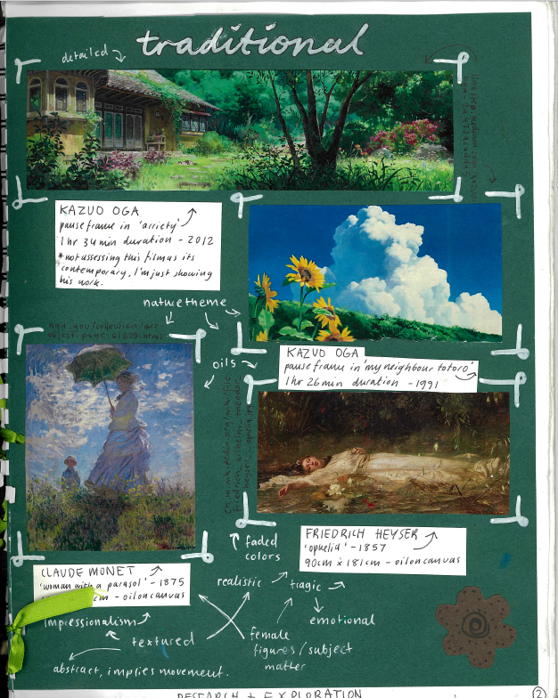
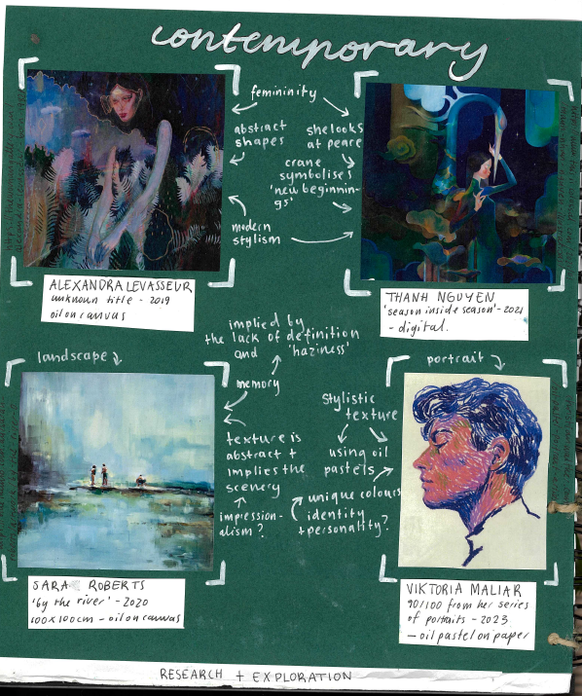
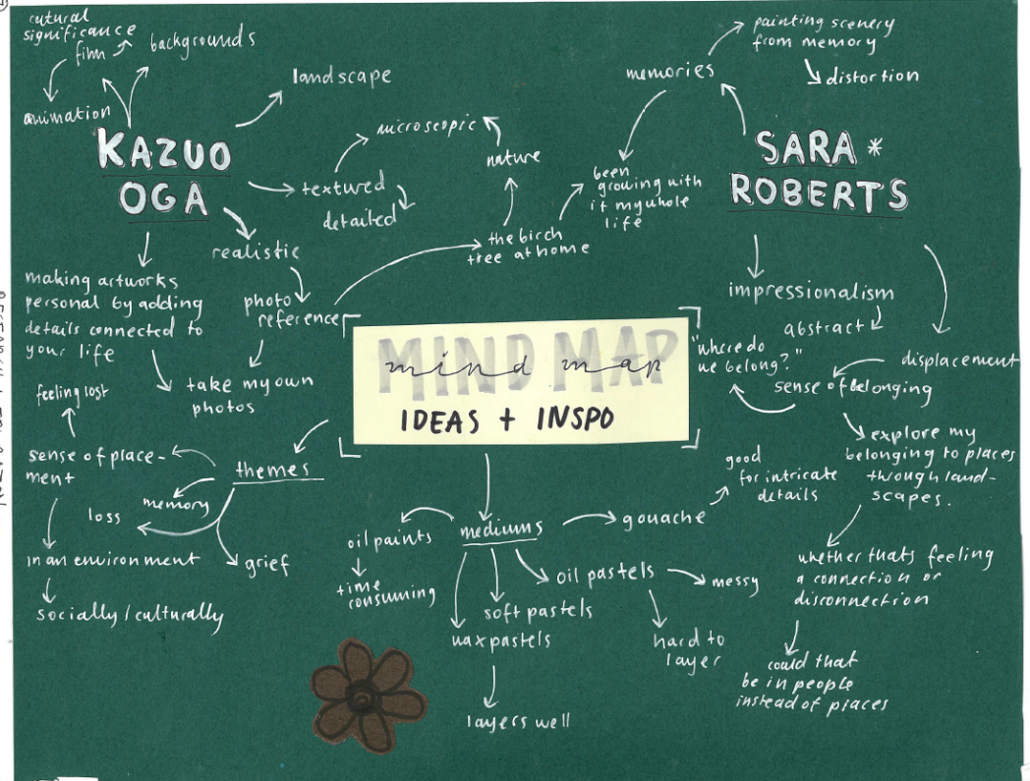

Lili Hodgson

Criterion 1
Unit 3 Outcome 1
Research and analyse the ideas and issues explored by artists in their practice.
Lili researched a range of artworks from different periods of time and cultures, investigating the ideas and issues represented in the artworks. She annotated the main ideas in an overview of images. From her research Lili generated a rough overview of their ideas using a brainstorm map

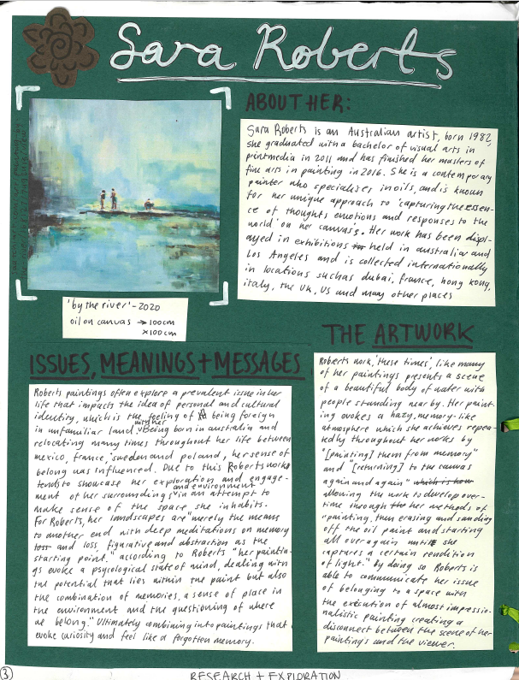
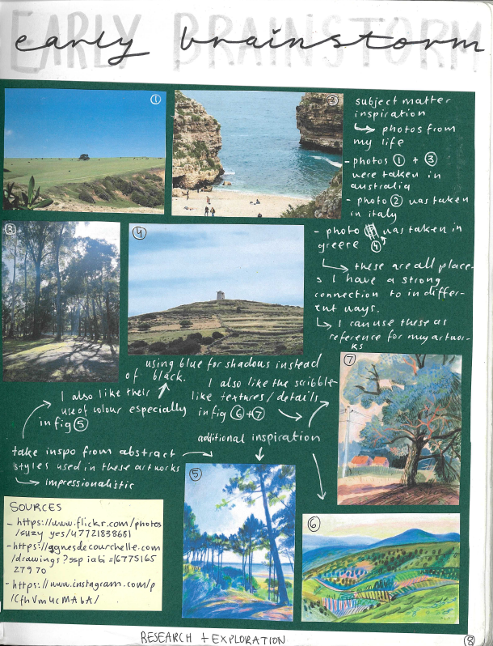
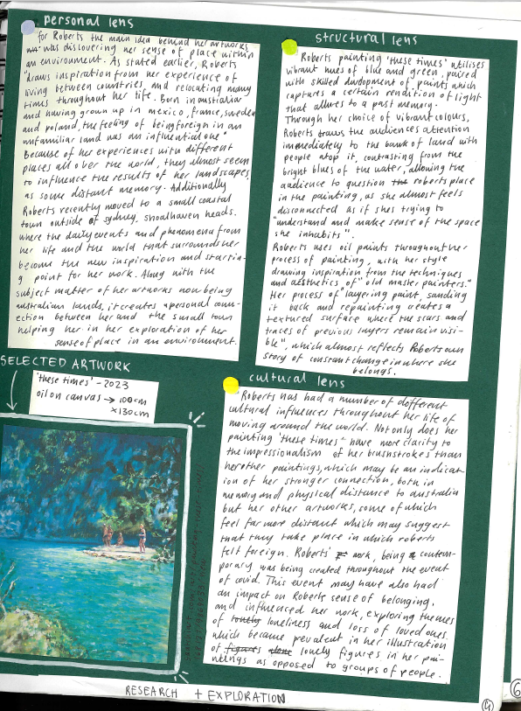

Criterion 1
Unit 3 Outcome 1
Research and analyse the ideas and issues explored by artists in their practice.
Lili analysed the work of three artists applying each Interpretive Lens. From her analysis she then completed a brainstorm to explore ideas and subject matter in her own artworks.
Lili Hodgson

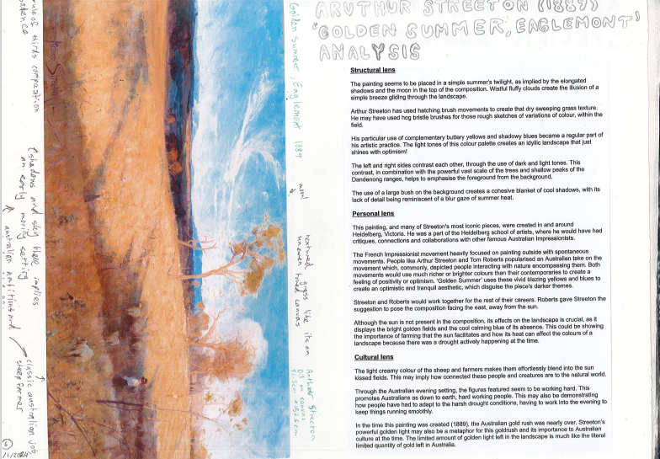
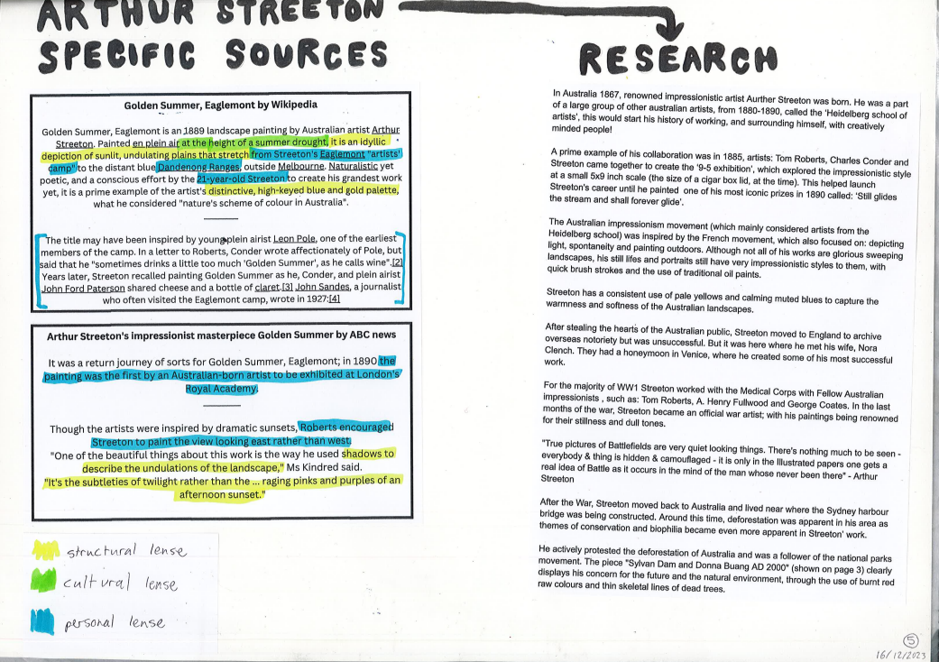

Escher McLaverty
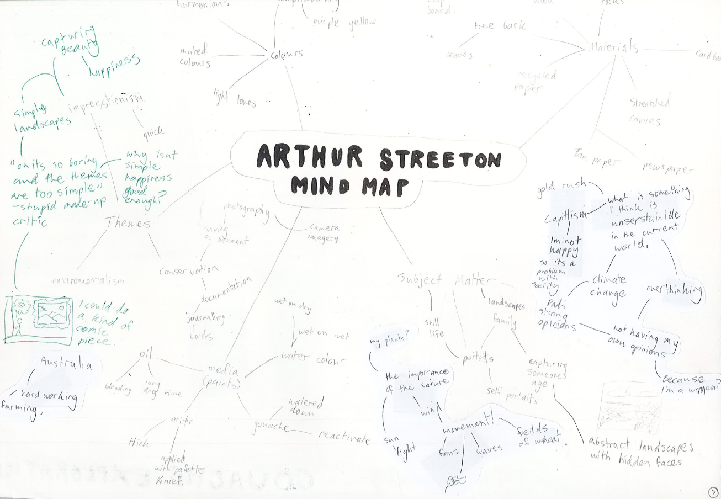

Criterion 1
Unit 3 Outcome 1
Research and analyse the ideas and issues explored by artists in their practice.
Escher focused on the idea of landscape and researched a series of Australian artists. Escher listed the source of the image and information that they researched. They then analysed each artwork using the Interpretive Lenses. The analysis is supported by a copy of the artwork with annotations identifying key characteristics of the image.
From their research Escher then completed a mind map of ideas for their artwork. The mind map has headings such as ‘Themes’, ‘Subject matter’, ‘materials’ and ‘media’. Escher also wrote some inquiry questions to direct the generation and development of their artwork that responded to their research.

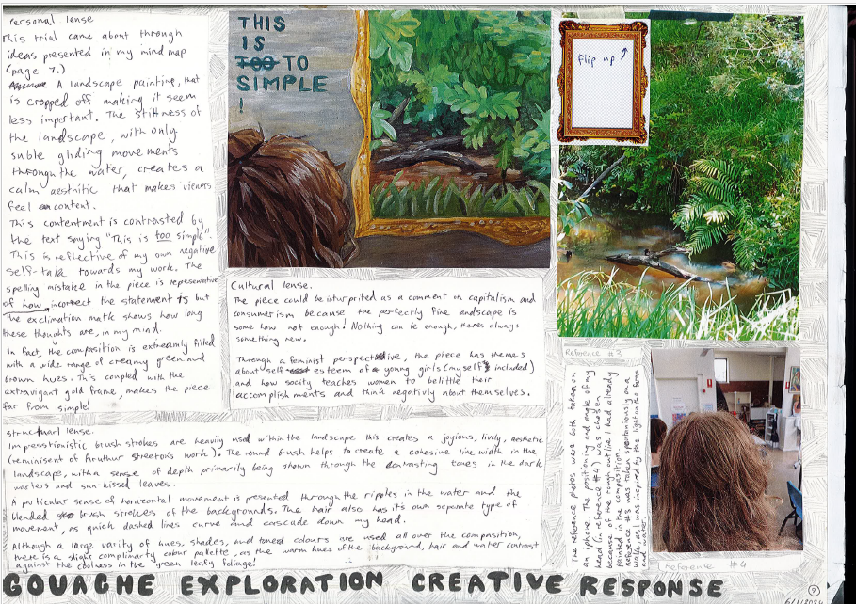
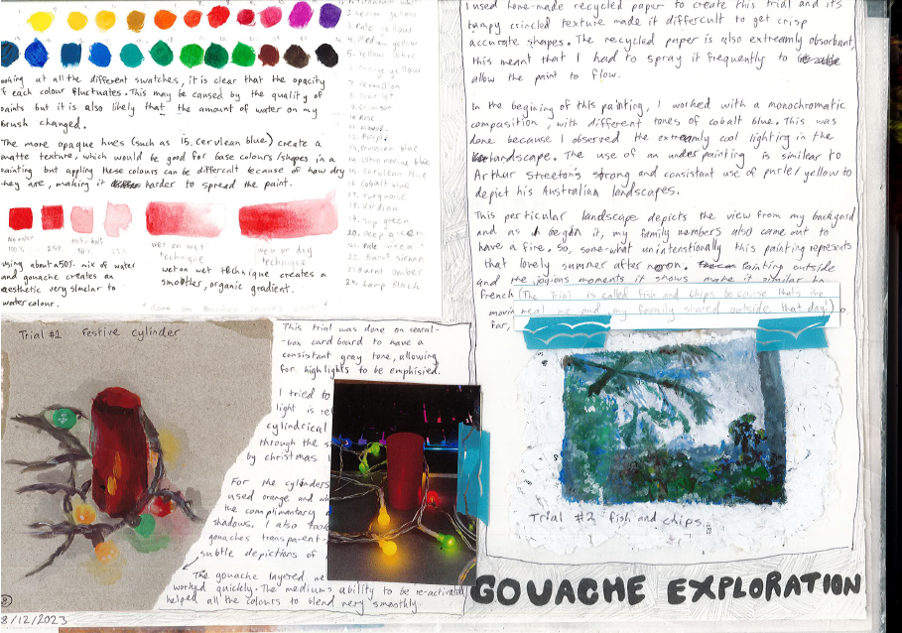

Escher McLaverty
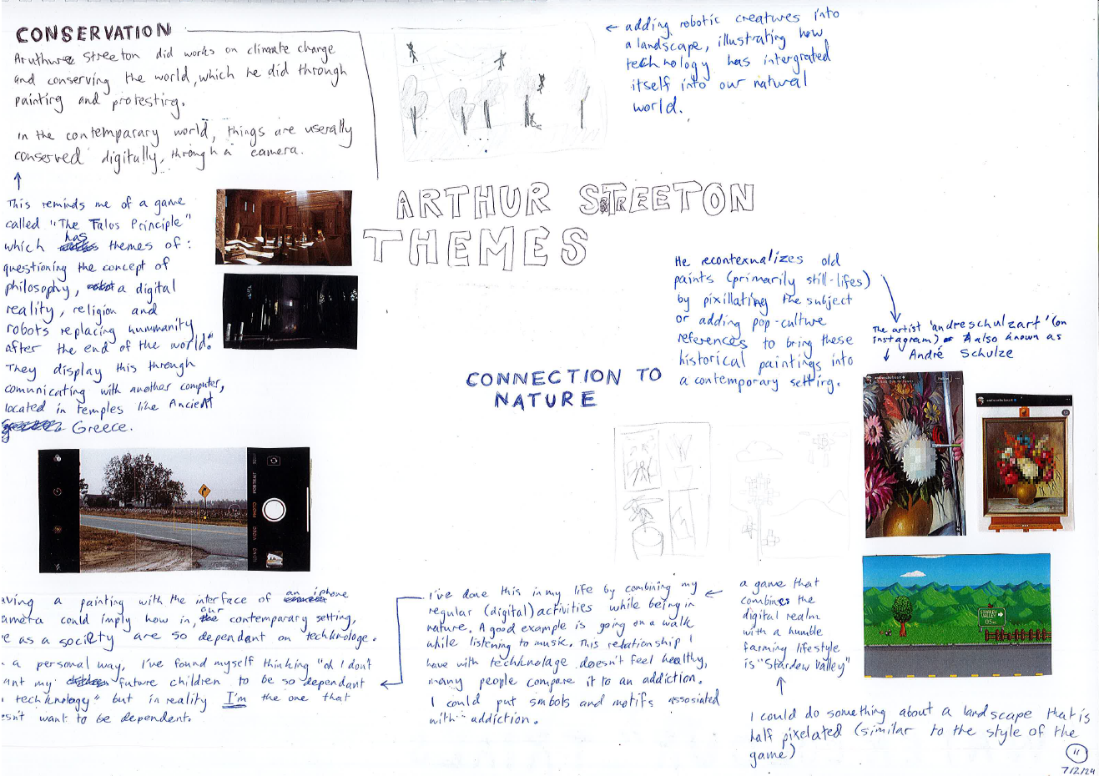

Criterion 2
Explore materials, techniques and processes in the Creative Practice to develop a visual language.
Escher commenced their exploration based on their research. They brainstormed some themes that they gathered from the research and analysis of Streeton’s work.
Using gouache and different papers they explored techniques and subject matter that was similar to the work of Streeton.
Escher developed their visual language by exploring different techniques with gouache paint. They also identified the art elements and principles, and how these, combined with their techniques, expressed their ideas about a connection with nature.
Escher developed their work by taking photographs to construct the composition of the artwork. Escher reflected upon and evaluated their experimentations and development.

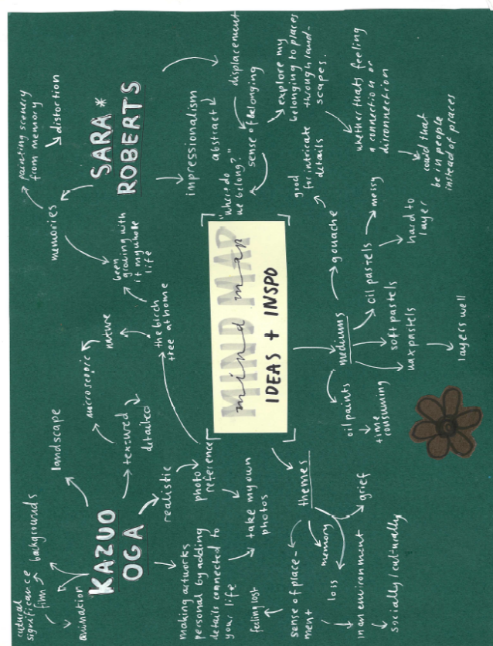
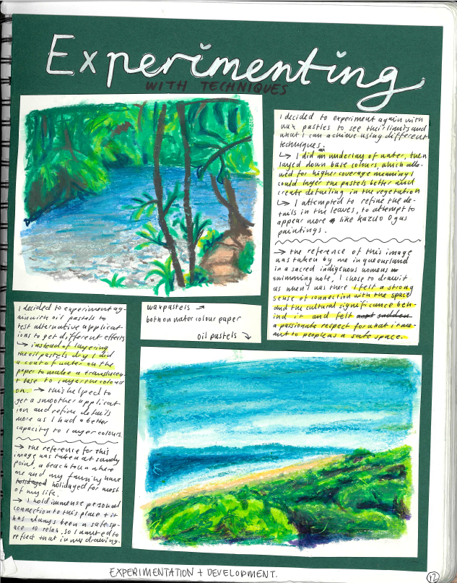
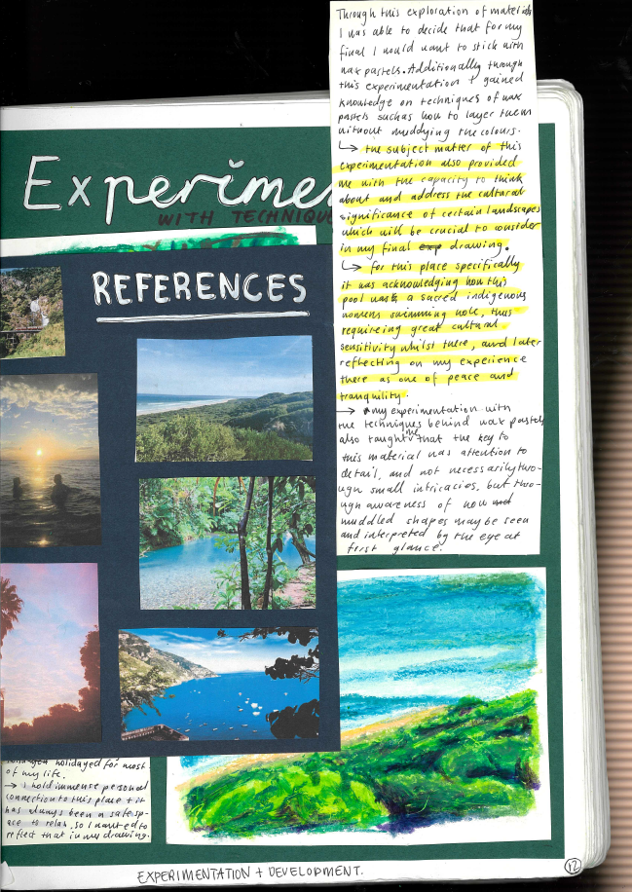
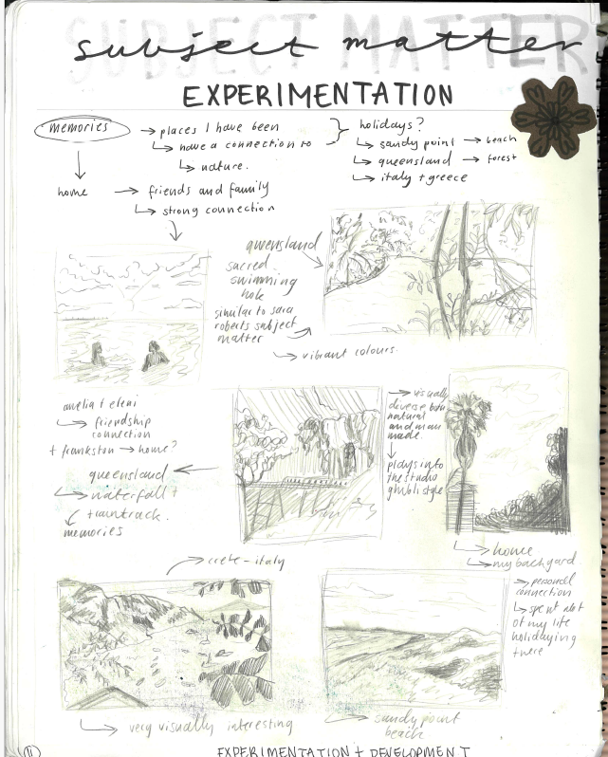
Lili Hodgson

Criterion 2
Explore materials, techniques and processes in the Creative Practice to develop a visual language
Lili commenced the exploration of her final artwork by creating a mind map of the ideas and inspiration from the research of her two artists.
She then created small thumbnail sketches as a personal response. She took photographs as a source. Her annotations describe her personal response to the images.
She then further explored some of the images using oil pastel and documented the experimentation referring to the Structural and Personal lenses.

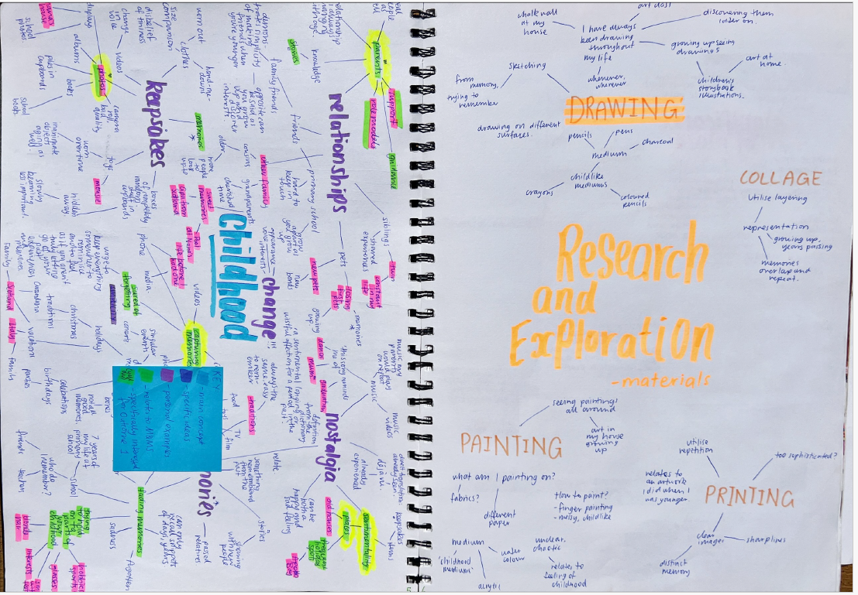

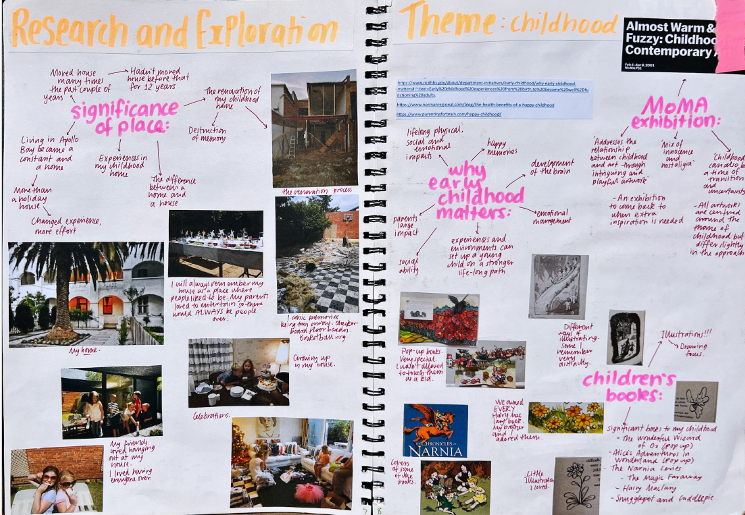

Abby Langhammer

Criterion 2
Explore materials, techniques and processes in the Creative Practice to develop a visual language
To commence her exploration, Abby researched the theme of childhood based on her research of the practice and artworks of Michael Andrew. Abby also brainstormed the art forms that would best represent her ideas.
She also researched other sources of inspiration such as the use of place, early childhood memories and children’s literature as inspiration for her artwork.

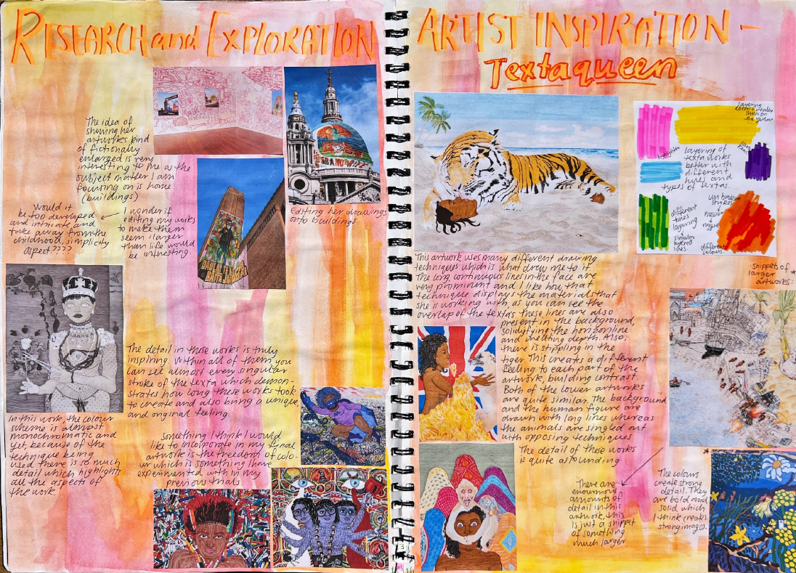
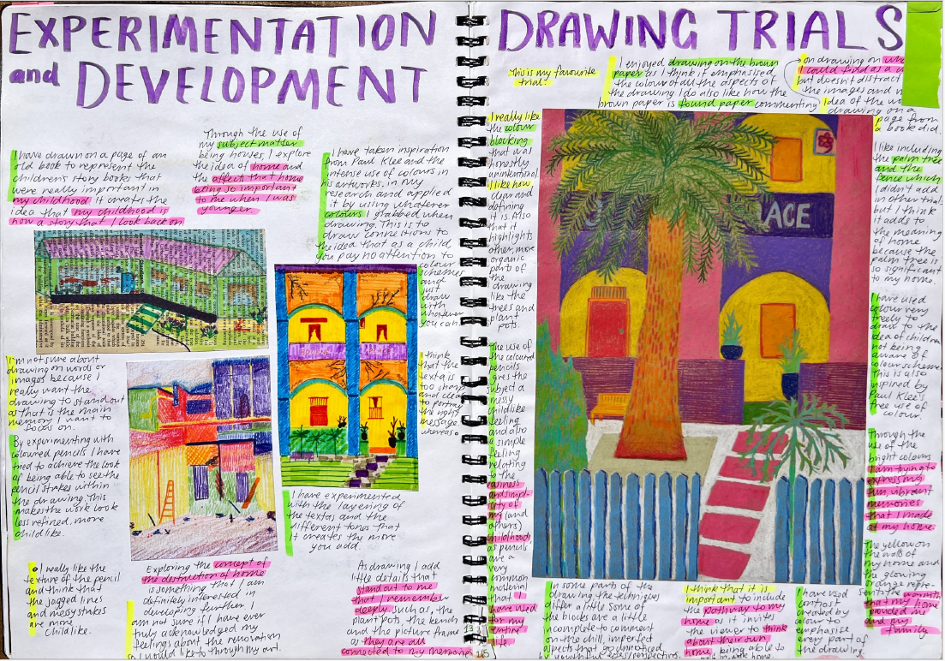
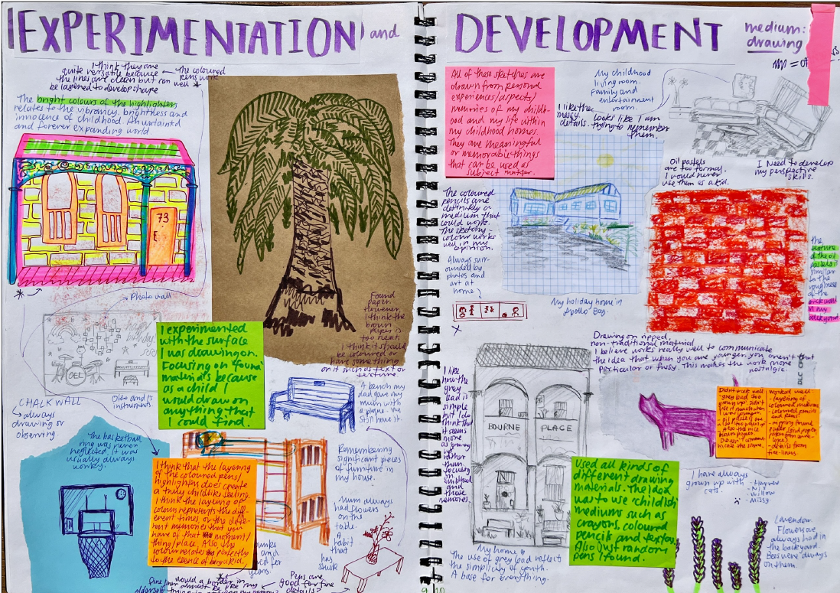

Criterion 2
Explore materials, techniques and processes in the Creative Practice to develop a visual language.
Abby’s research, experimentation and development was focused on visual language. She explored a range of techniques with different materials, and using the Structural Lens, evaluated how successful they were in communicating her ideas. She also completed additional research into the subject matter of her artwork looking at symbols from Eastern cultures. As she selected markers to complete her final artwork, she researched artists who had used similar techniques in their artworks.

Abby Langhammer

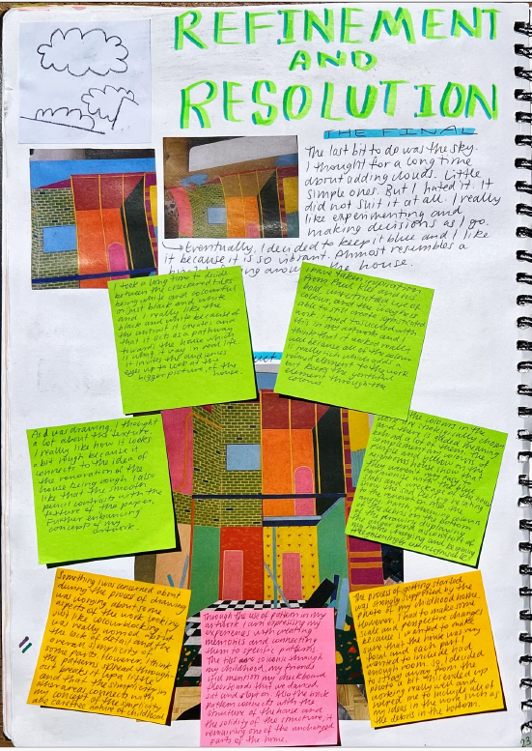
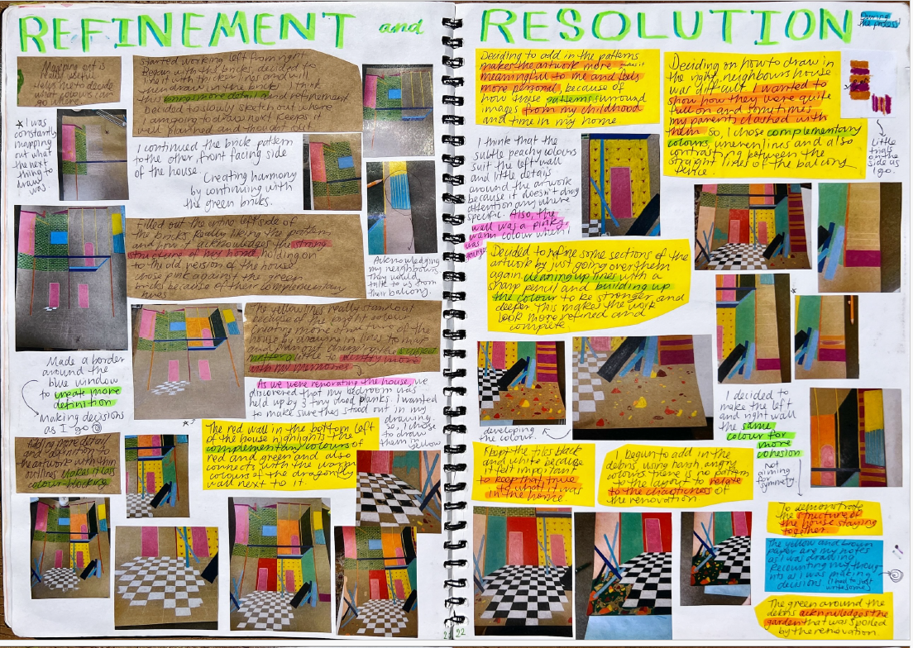
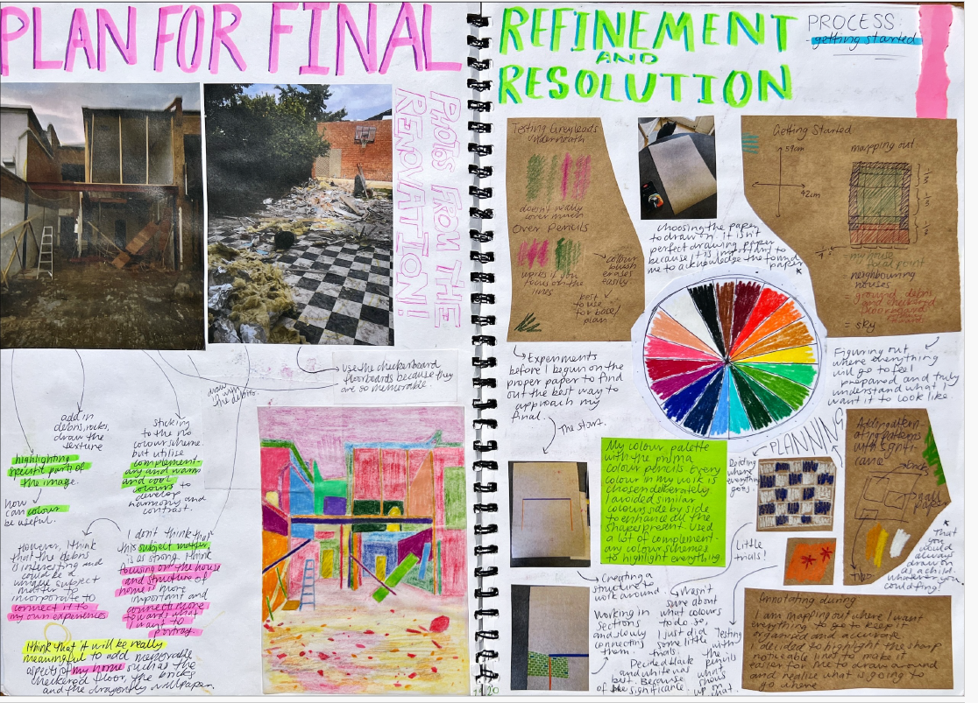
Abby Langhammer

Criterion 3
Document and evaluate the Creative Practice using Interpretive Lenses to develop and refine at least one finished artwork responding to the practice of an artist.

Abby used the Creative Practice to structure her practice. She provided visual and written documentation of the process at all stages with annotations that documented the use of the Interpretive Lenses, her development of visual language and her use of materials, techniques, and processes.
All aspects of her practice were focused on her ideas, and she evaluated the use of visual language to communicate them.
From her exploration and experimentation, Abby focused on an idea, took photos of her subject matter, and then developed and refined her work, documenting her selected choice of media, art elements and art principles.
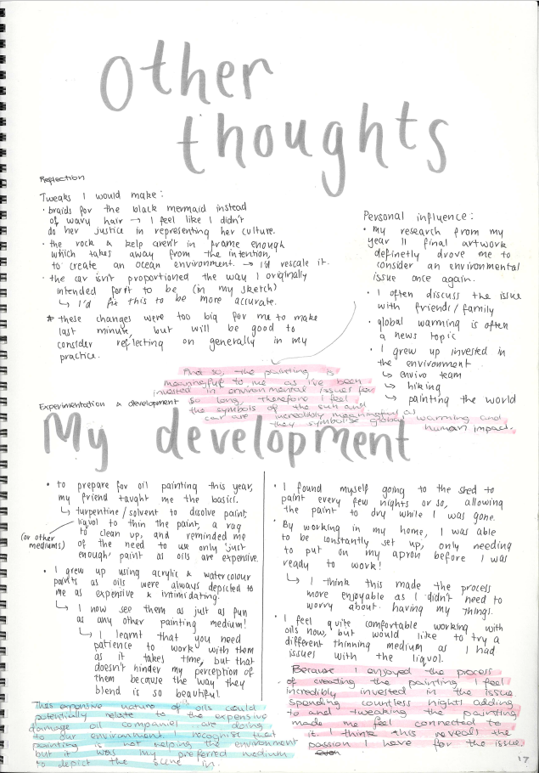
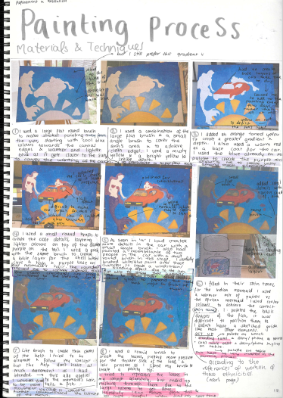
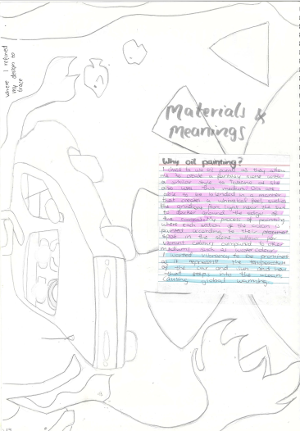
Jen Charlton

Criterion 3
Document and evaluate the Creative Practice using Interpretive Lenses to develop and refine at least one finished artwork responding to the practice of an artist.
Jen documented her painting process using visual and written reflections. She discussed each step of the process, explained how the Interpretive Lenses influenced the development of her artwork. Jen also described the development of her visual language using materials, techniques and processes.
Once she completed her exploration and experimentation Jen refocused her thought and reflected on how she would develop her final artwork for Unit 3. Her annotations described the changes she intended to make to the subject matter, her selection of materials and techniques, and the process of refinement of the final work.
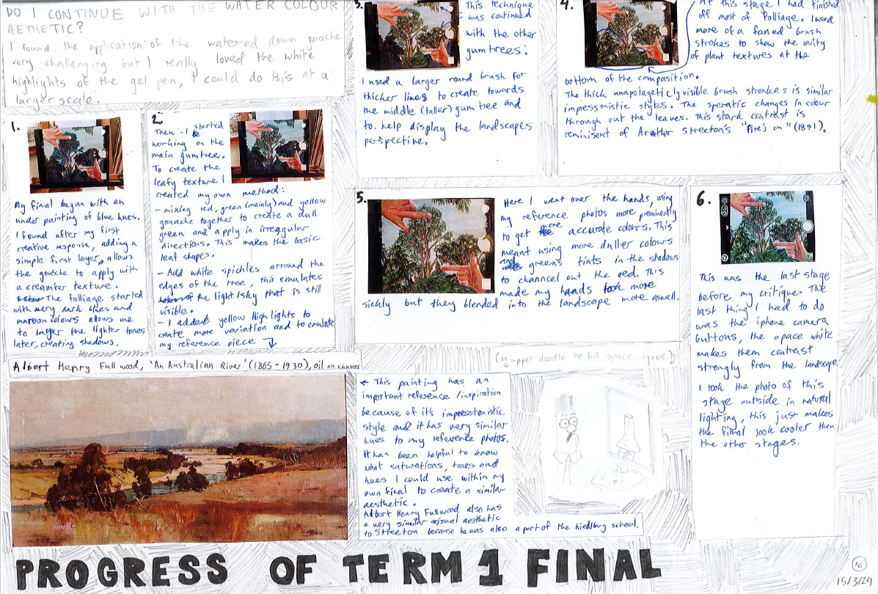
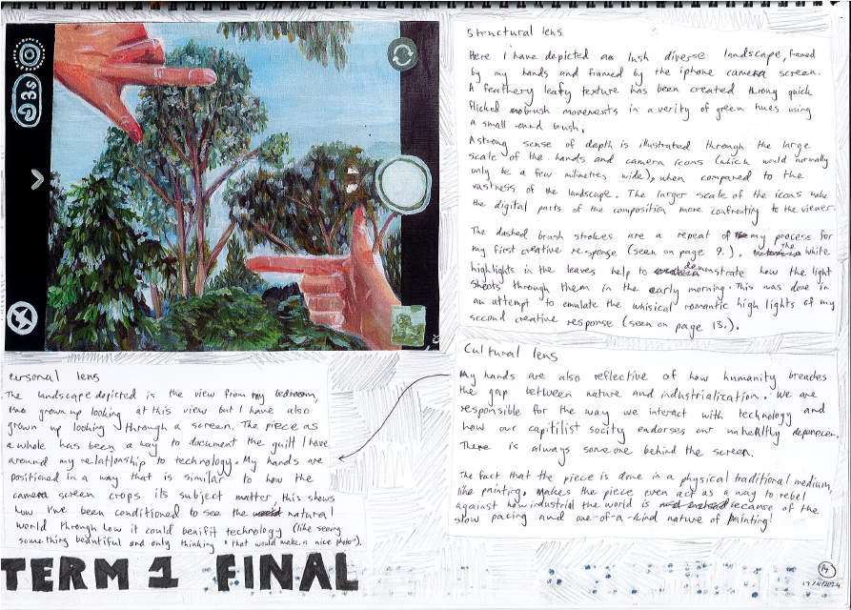
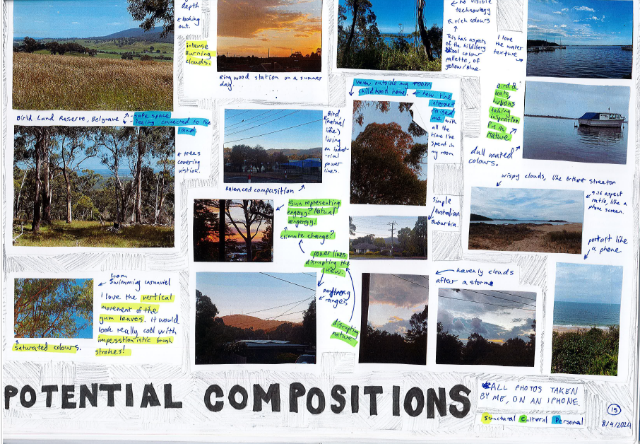
Escher McLaverty

Criterion 3
Document and evaluate the Creative Practice using Interpretive Lenses to develop and refine at least one finished artwork responding to the practice of an artist.
Escher developed her final artwork by applying, documenting, and evaluating the Creative Practice. From her research of Australian landscape and water colour, she took some photographs of potential compositions and selected a suitable image as subject matter, by evaluating the selection using the Interpretive Lenses and the use of Visual language. She documented the process of making the work evaluating her use of water colour techniques.
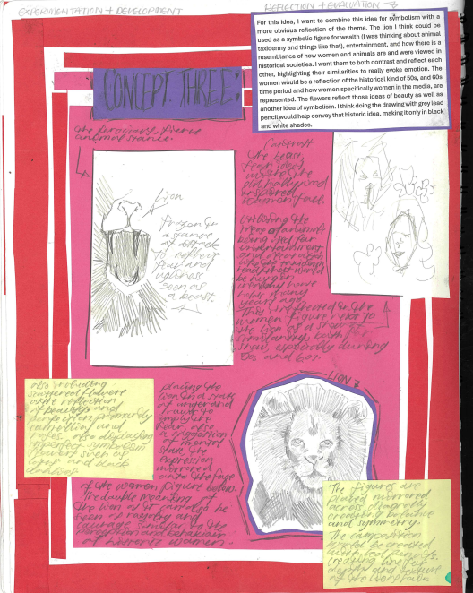
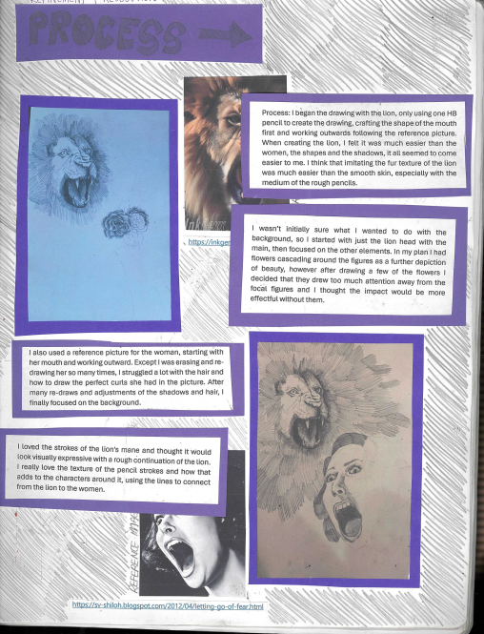
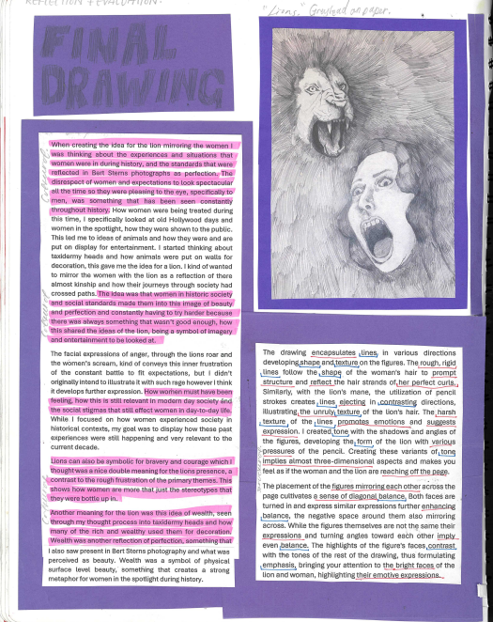

Ella Sheppard

Criterion 4
Unit 3 Outcome 1
Present a critique to explain the use of the Creative Practice to develop and refine one finished artwork.
Ella documented the process of developing a personal response from a concept that was derived from her research. She discussed the use of materials, techniques and processes and the influences on her ideas. She discussed the use of visual language to communicate her ideas.
Ella presented the final drawing and discussed how a photograph was the influence for the final work. She also discussed her use of materials and techniques, art elements and principles to communicate her ideas. She highlighted the use of the Cultural lens referring to views of the way women are treated and viewed in society.

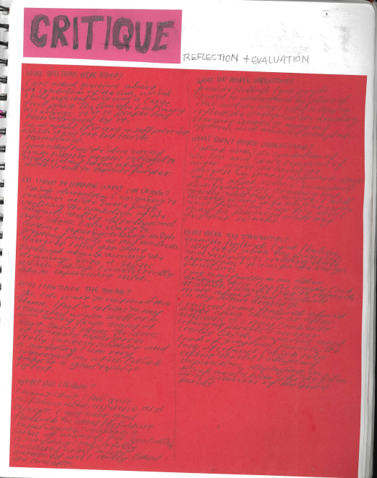
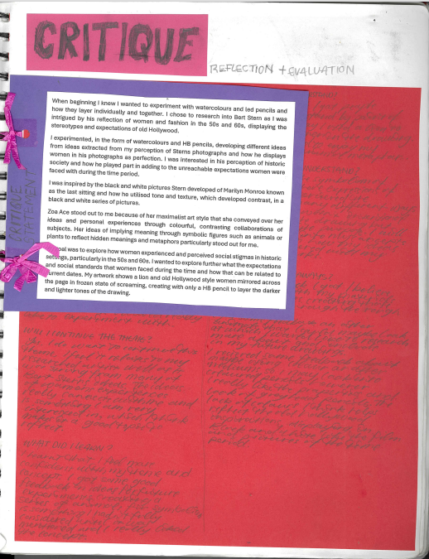

Ella Sheppard

Criterion 4
Unit 3 Outcome 1
Present a critique to explain the use of the Creative Practice to develop and refine one finished artwork.
Ella discussed in a critique how she responded to an artwork she had researched, and her use of materials and techniques. She also discussed the theme of her artwork and how she communicated her ideas using visual language.
She presented her reflection on her work with headings that were drawn from the feedback from her peers:
- What questions were asked?
- What responses she got from her peers?
- What they felt about the work.
- What she needs to change?
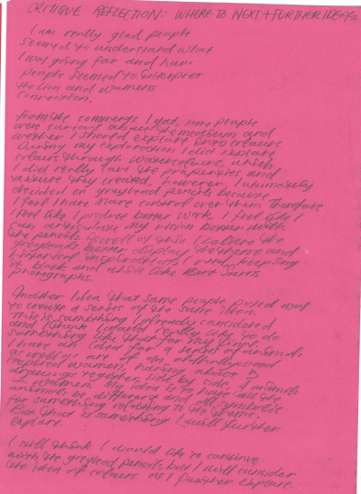
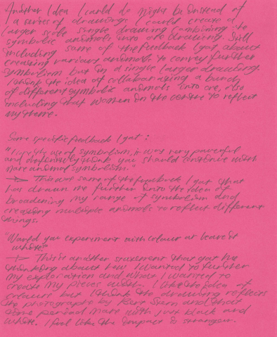

Criterion 4
Unit 3 Outcome 1
Present a critique to explain the use of the Creative Practice to develop and refine one finished artwork.
Ella then summarised her ideas discussing her theme and audience feedback in order to refine her work further. She included quotes from her peers and labelled them under headings that from the structure of the Art Creative Practice and Interpretive Lenses.

Ella Sheppard

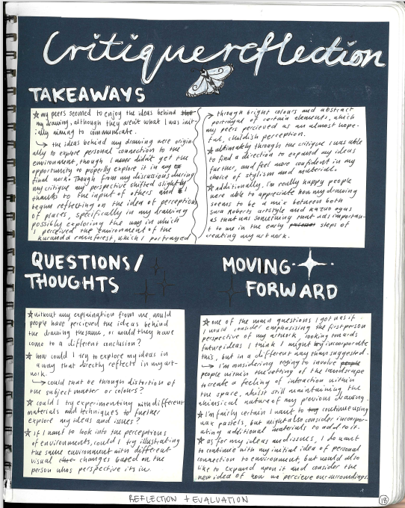
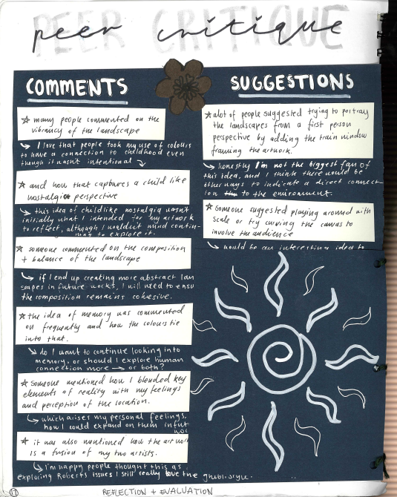
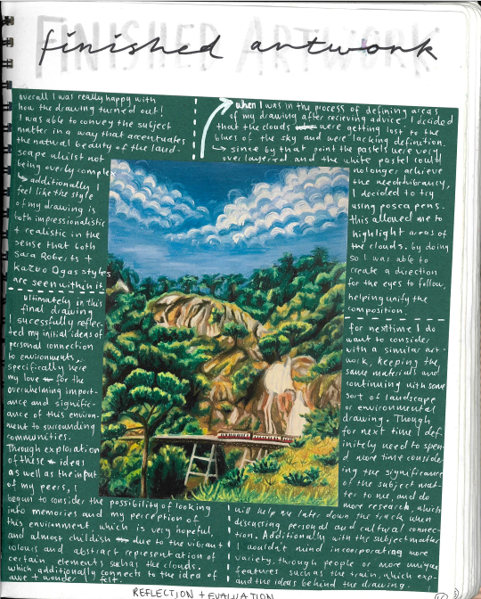

Lilli Hodgson

Criterion 4
Present a critique to explain the use of the Creative Practice to develop and refine one finished artwork.
Lilli presented her artwork in a critique. She presented a range of comments that she gathered and reflected upon. From the ‘Peer critique’ she wrote a reflection on the comments, developed further questions about her work, and made some recommendations for the next stage of her Creative Practice.

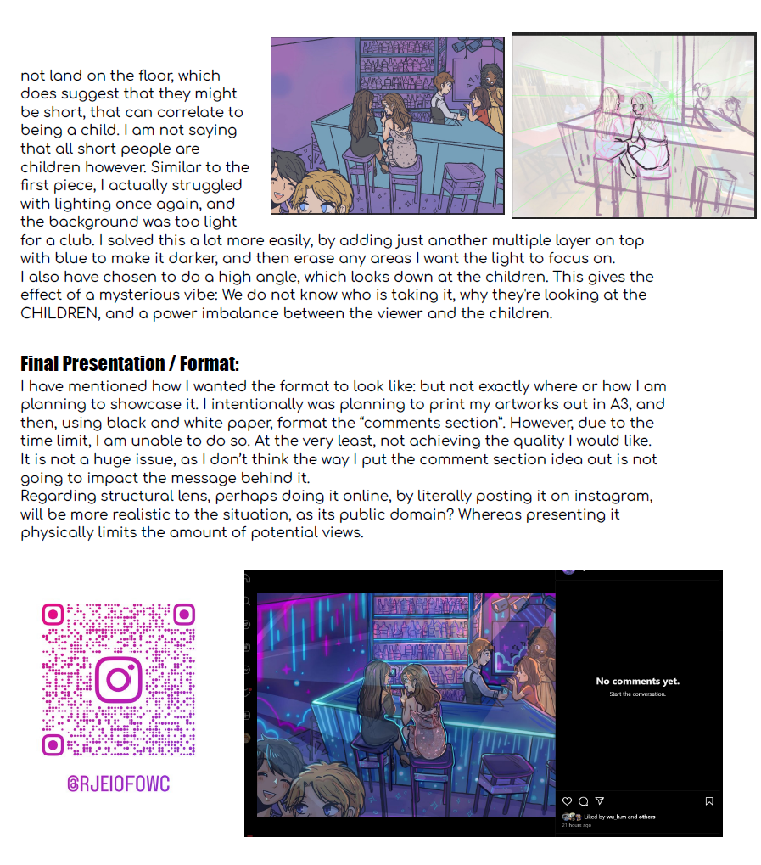
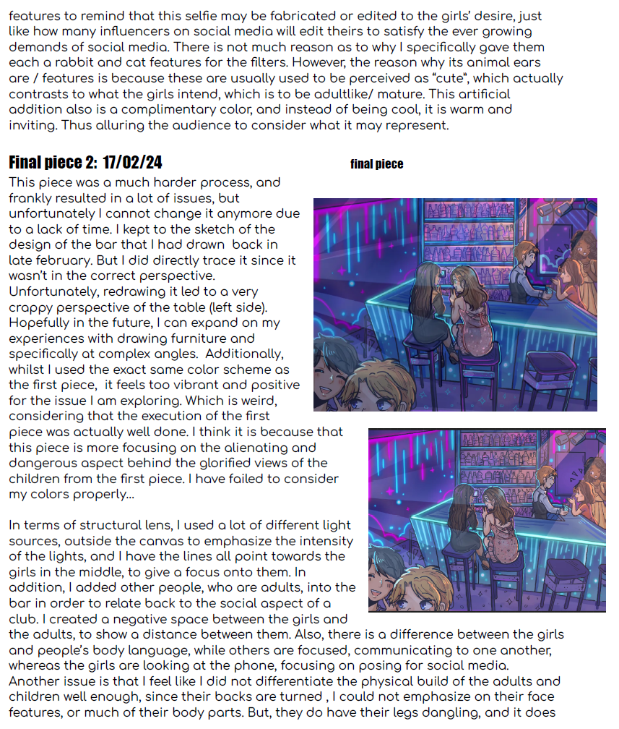
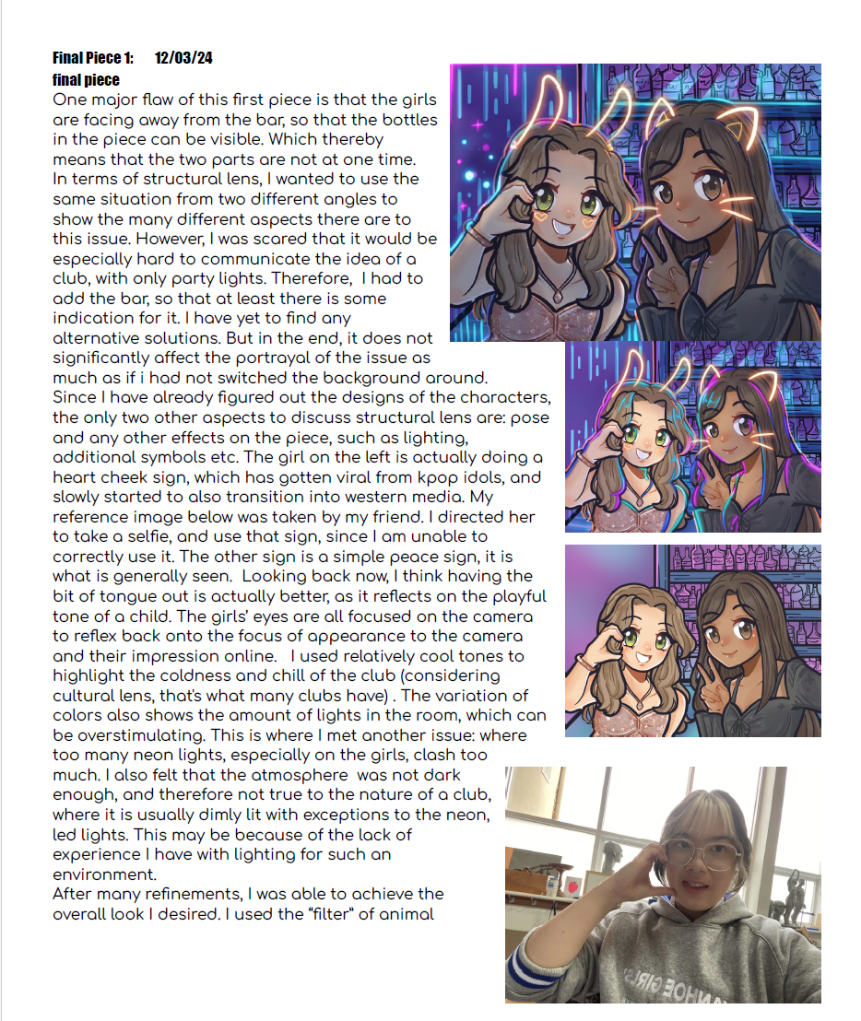

Criterion 4
Present a critique to explain the use of the Creative Practice to develop and refine one finished artwork.
Anna discussed the process of making her final artworks in her critique. She discussed the Creative Practice and her use of visual language to communicate ideas. Anna also discussed the use of the Structural Lens in conveying the meaning of the works to her audience. She discussed the location and presentation of her work and how she intended the audience to interpret the artwork.
Anna Lee

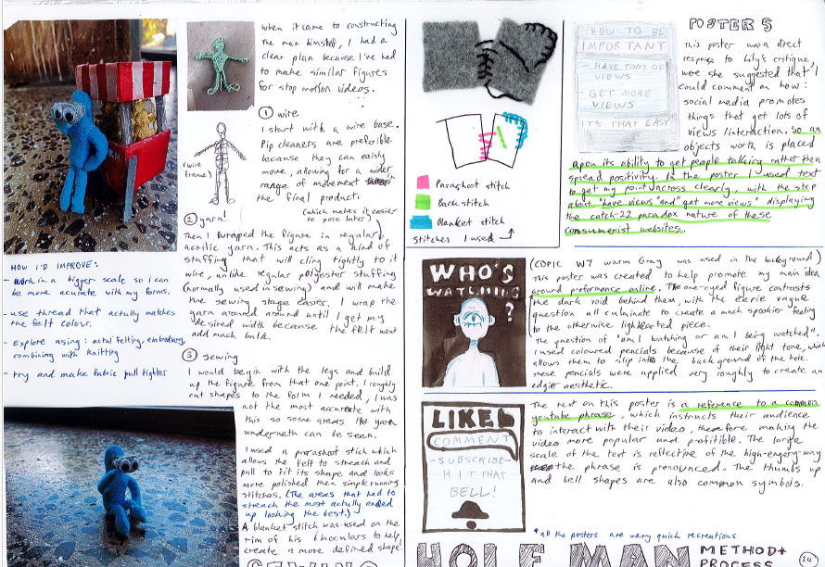
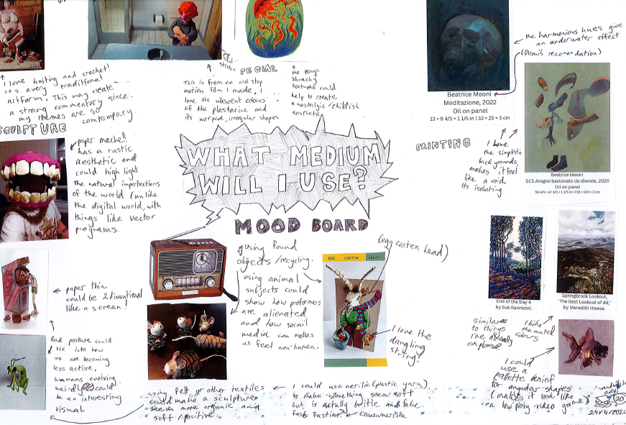

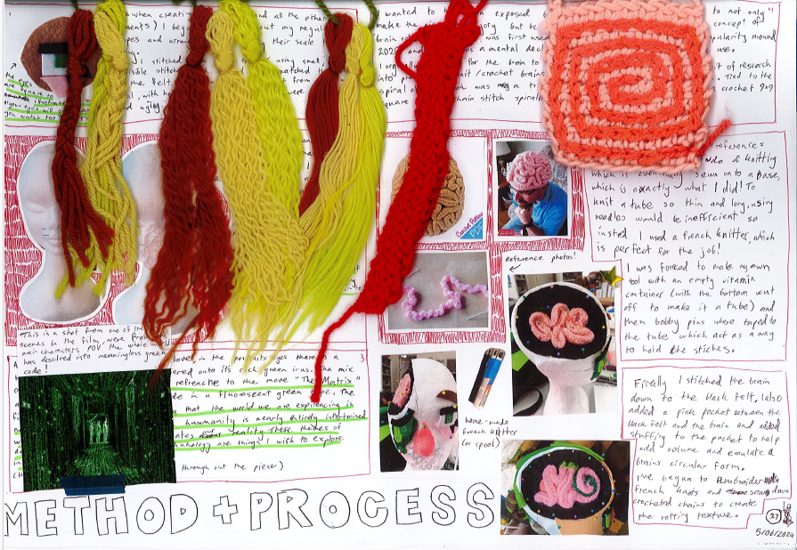
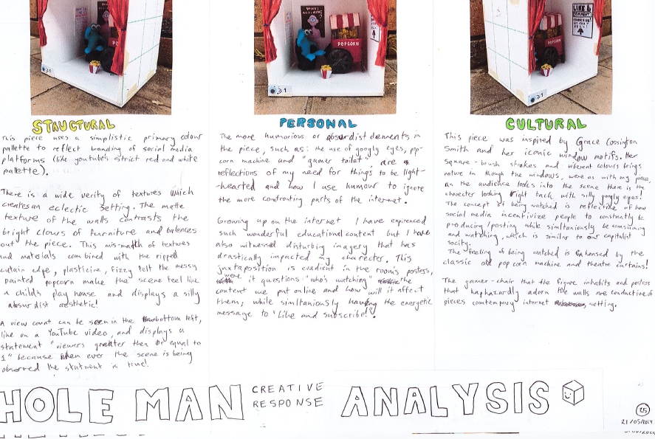

Escher McLaverty

Criteria 5 and 6
Apply and manipulate materials, techniques and processes to develop personal responses and a visual language using the Creative Practice.
Document, reflect and evaluate the development of personal responses using the Creative Practice and the Interpretive Lenses.
After the critique Escher gathered their thoughts in a brainstorm (mood board) with images. From this initial generation of ideas, they experimented with materials and techniques to make several small artworks. They documented and evaluated the process of making the artworks using the Interpretive Lenses.

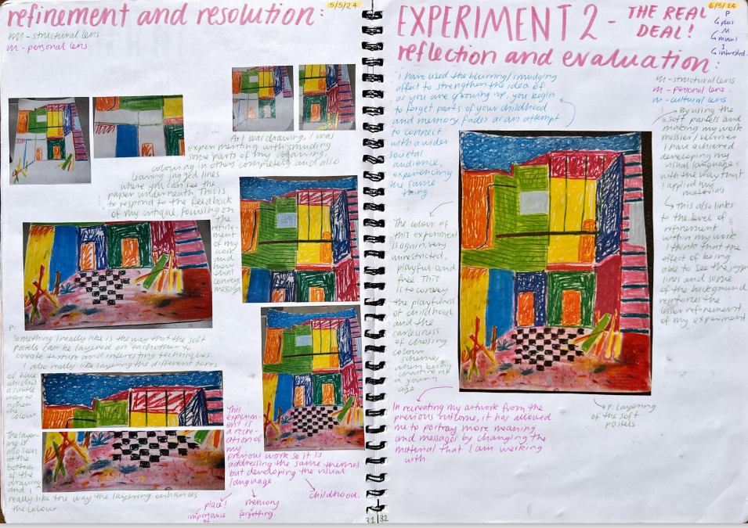
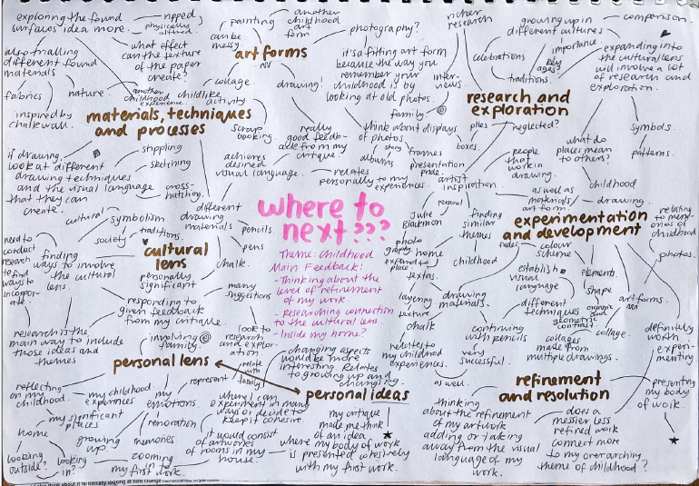
‘’’

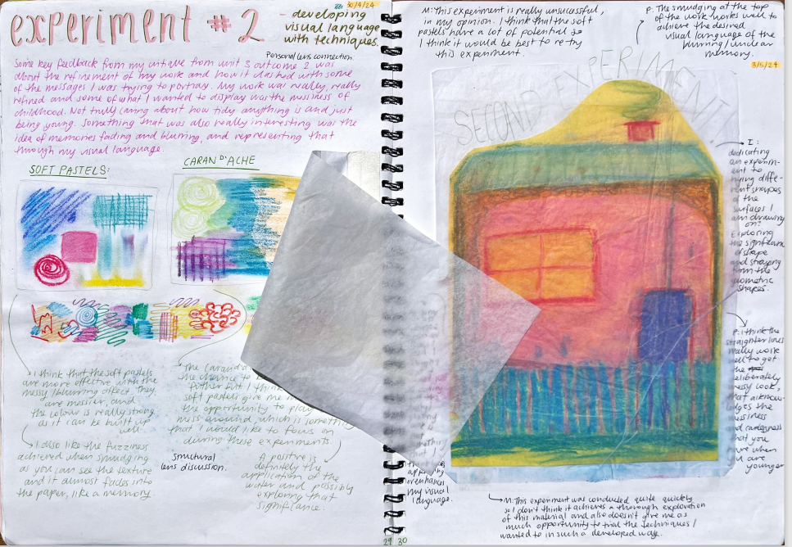

Criteria 5 and 6
Apply and manipulate materials, techniques and processes to develop personal responses and a visual language using the Creative Practice.
Document, reflect and evaluate the development of personal responses using the Creative Practice and the Interpretive Lenses.
Abby structured her planning for Outcome 2 by brainstorming to generate ideas based on the Interpretive Lenses and the stages of the Creative Practice. She completed a series of experiments focusing on materials and techniques. She then applied them to her subject matter to further refine the work. She then reflected on each experiment. The interpretive lenses (Structural and Personal) are colour coded. Abby conducted about 5 different experiments with a similar subject matter of interior spaces and her personal experiences of her home.

Abby Langhammer

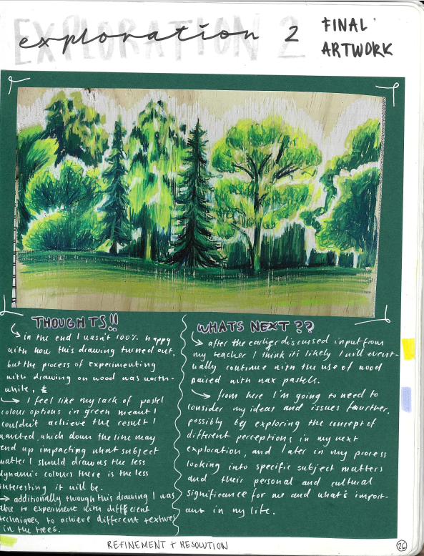
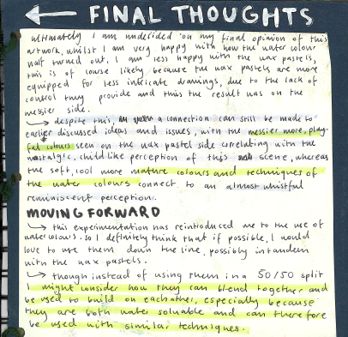
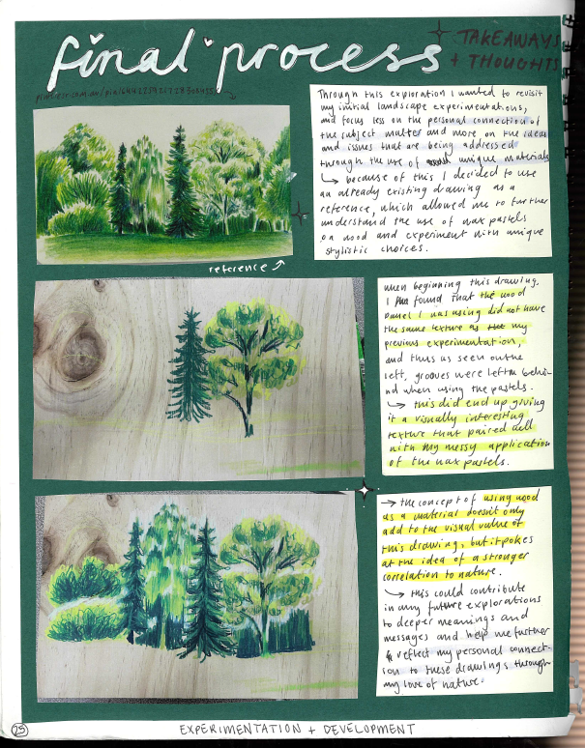

Lilli Hodgson

Criterion 7
Unit 4 Outcome 1
Present a critique of the use of the Creative Practice from Unit 3 and use feedback and reflection to resolve a body of work
Lilli created a series of artworks that she reflected upon for her critique. She documented the process and the exploration of each work. She reflected on her final work and what she intended to expand on further in Unit 4. She discussed her use of visual language to communicate her ideas referring to the materials and techniques. She discussed the ideas that she would develop and unit for and her selection of subject matter. Overall Lilli completed four small works by the end of Unit 3.

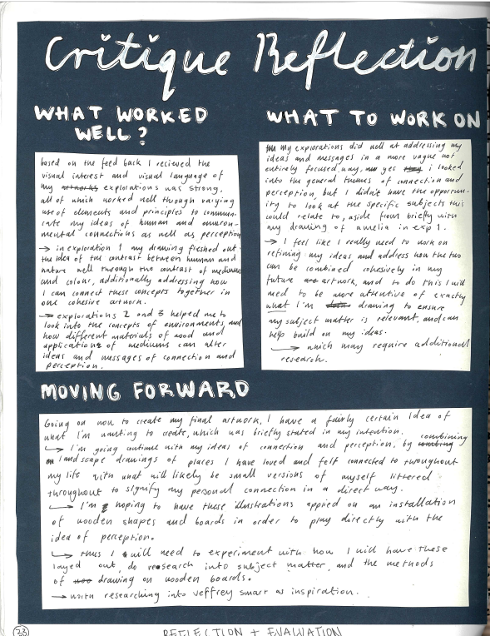
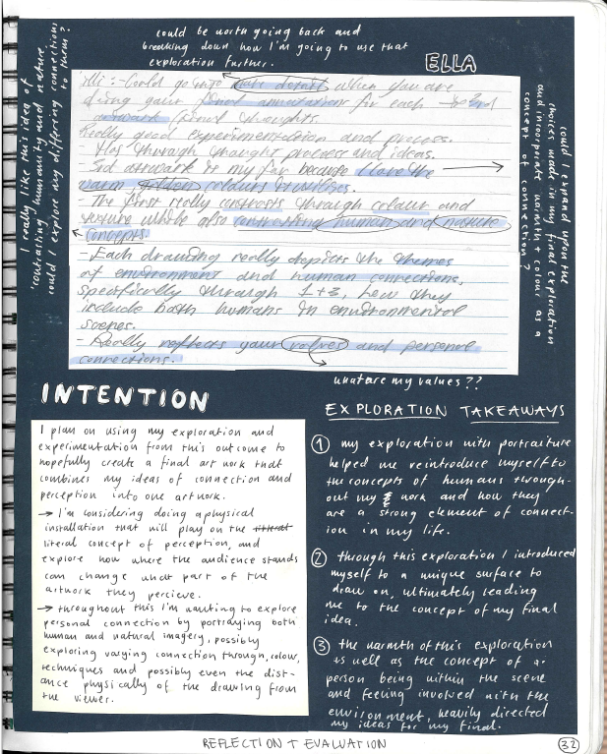
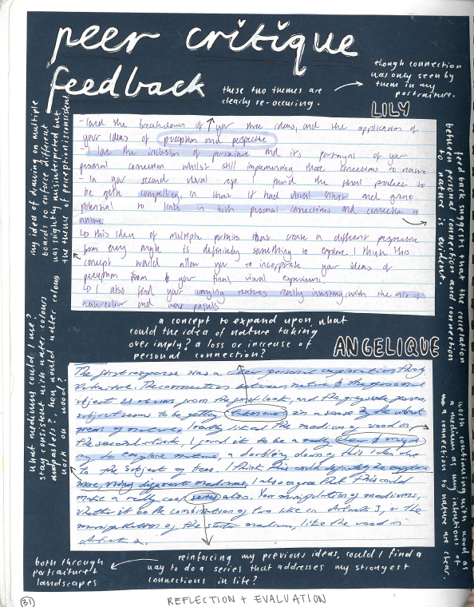

Lilli Hodgson

Criterion 7
Unit 4 Outcome 1
Present a critique of the use of the Creative Practice from Unit 3 and use feedback and reflection to resolve a body of work
Lili collated the feedback from her critique and then highlighted key points to reflect upon. She focused on her use of visual language to communicate ideas and which of those could be expanded upon in Unit 4. She then summarised these points and reflected on them to develop a plan to develop her Body of Work in Unit 4.

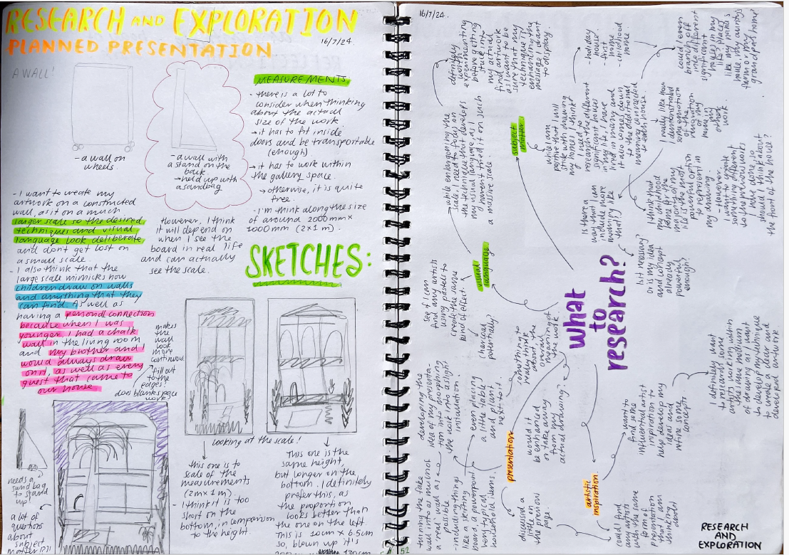
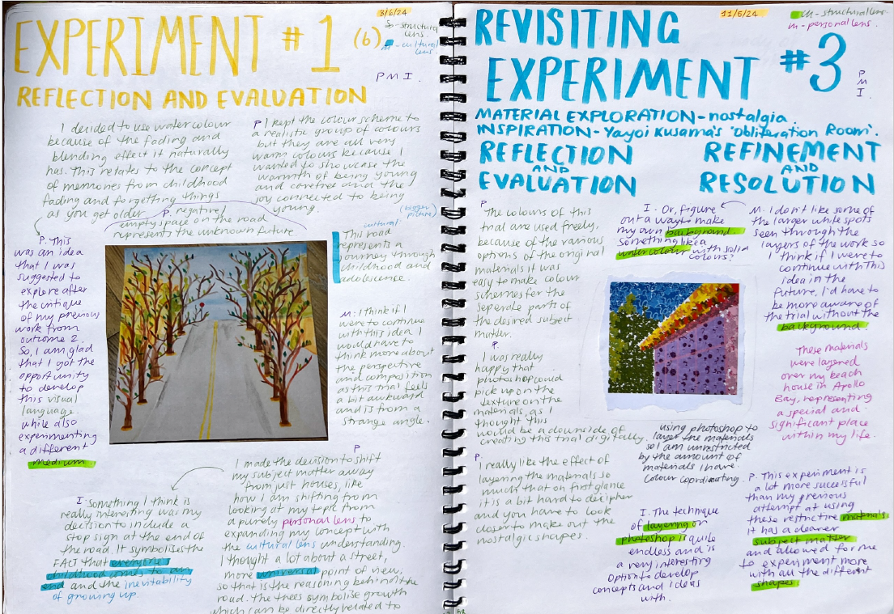

Abby Langhammer

Criterion 7
Unit 4 Outcome 1
Present a critique of the use of the Creative Practice from Unit 3 and use feedback and reflection to resolve a body of work
Abby also created a series of explorations in Unit 3 that she reflected on individually. She applied the Interpretive Lenses to reflect on each artwork. Abby collected feedback and summarised it. She then created a mind map of what she was going to research and explore in Unit 4, including subject matter, visual language, inspiration and the presentation of the Body of Work.

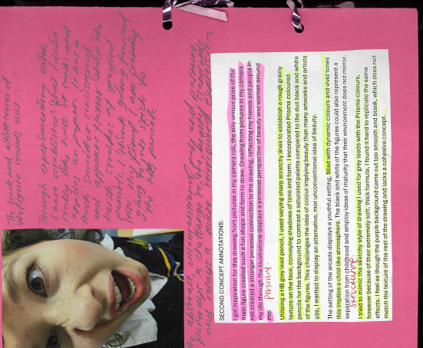
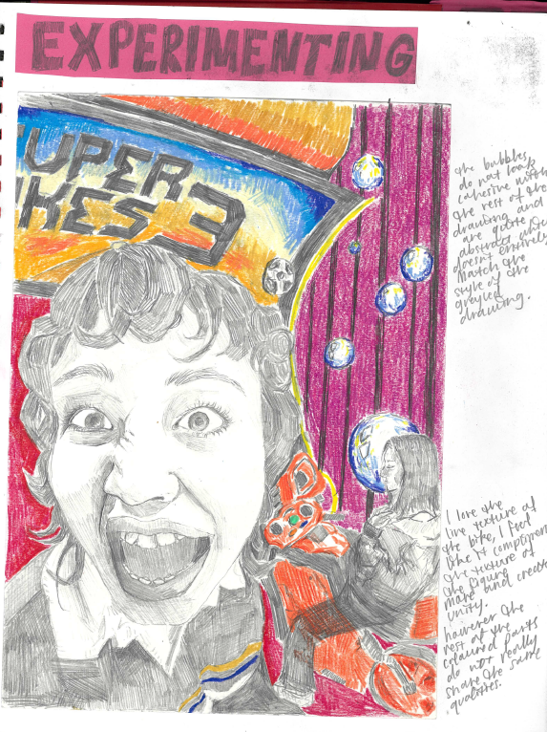
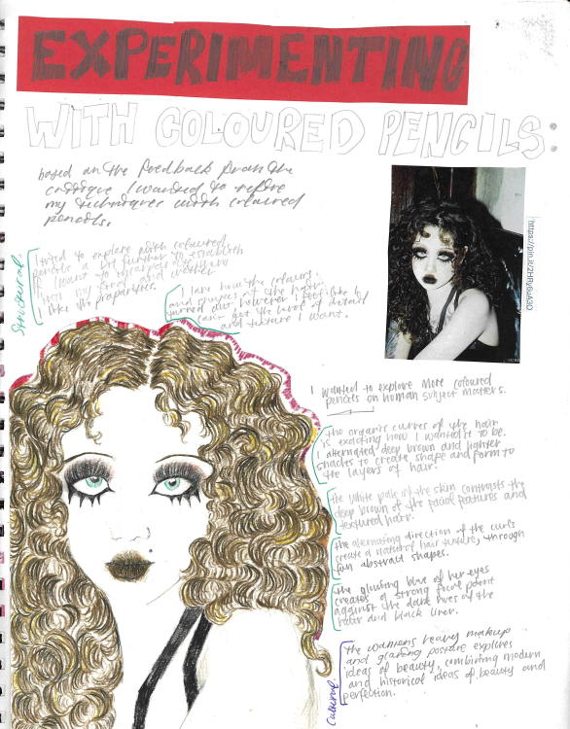
Ella Sheppard

Criteria 8 and 9
Unit 4 Outcome 1
Document, annotate and evaluate the refinement and resolution of the Body of Work
Refine and resolve a Body of work using the Creative Practice.
Ella continued to experiment and explore ideas in Unit 4 with a variety of materials, demonstrating her understanding of the Exploring and Experimenting stages of the Creative Practice. Based on the feedback from her critique, she continued to explore the use of colour pencil in her work. She annotated the exploration of ideas and experimentation of materials and techniques, applying the Interpretive Lenses

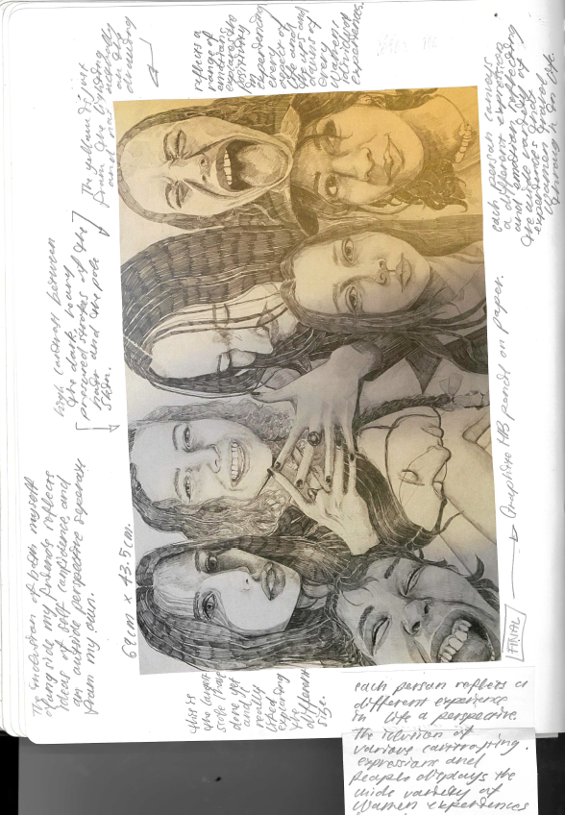
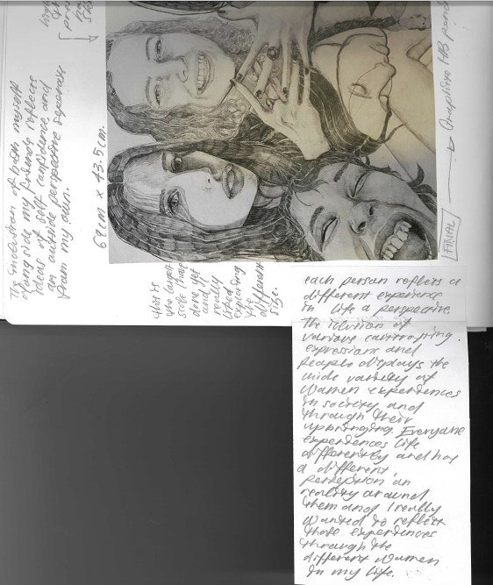
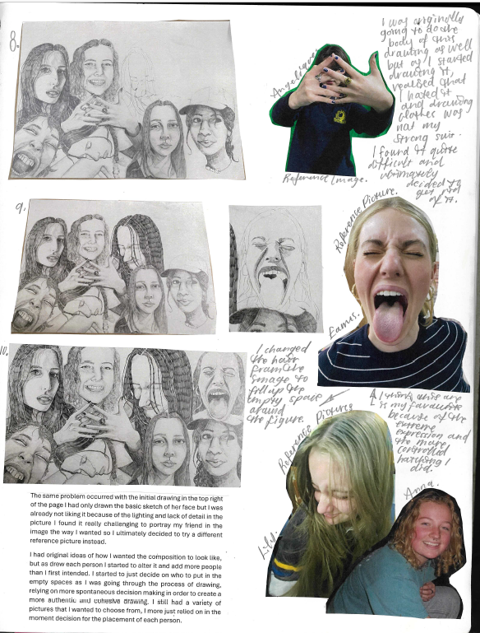
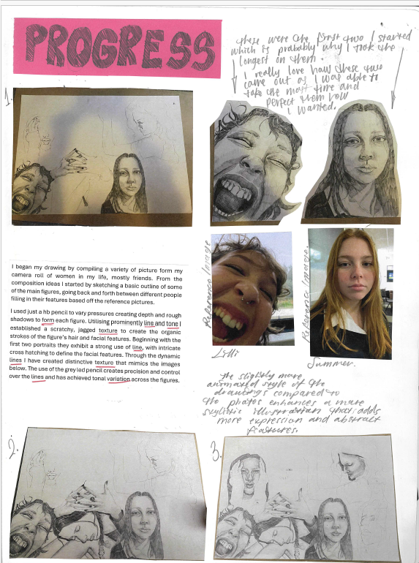

Criteria 8 and 9
Unit 4 Outcome 1
Document, annotate and evaluate the refinement and resolution of the Body of Work
Refine and resolve a Body of work using the Creative Practice.
From her exploration Ella commenced one of her final works. She documented the process of the drawing and evaluated all the components of it. She reflected on why she had chosen the images for the subject matter and how she organised the various poses of the figures for the composition of the work, and to represent her ideas. She also discussed the use of art elements and principles in her visual language throughout the development, refinement, and resolution stages of the Creative Practice.
Ella Sheppard

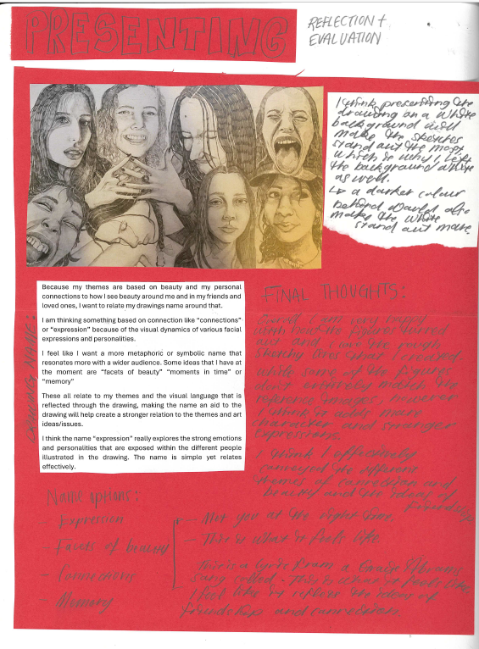
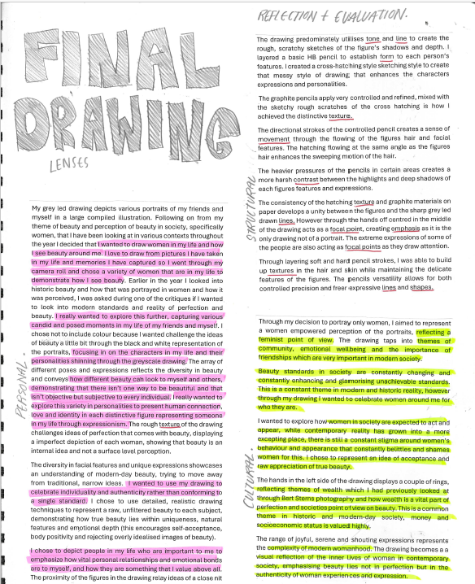

Ella Sheppard

Criteria 8 and 9
Unit 4 Outcome 1
Document, annotate and evaluate the refinement and resolution of the Body of Work.
Refine and resolve a Body of work using the Creative Practice.
For the reflection and evaluation stage of the Creative Practice, Ella evaluated the final work by applying the Interpretive lenses. She also reflected on the presentation of the artwork discussing the themes, use of materials and techniques and visual language. She considered how the presentation of the work would best communicate her ideas and meanings to the audience. She also reflected on her practice using the structure of the Exploration, Development, Refinement and Resolution stages of the Creative Practice.

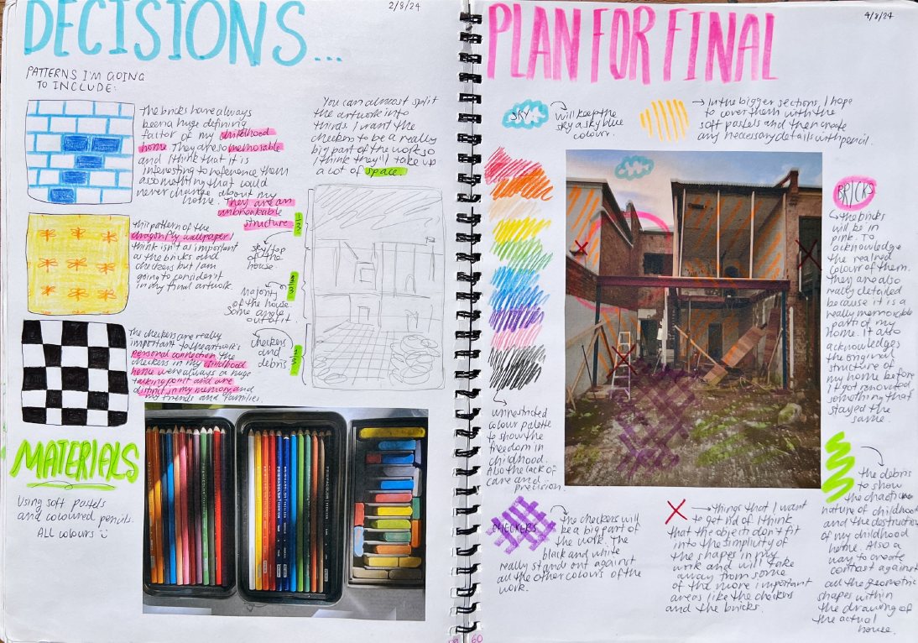
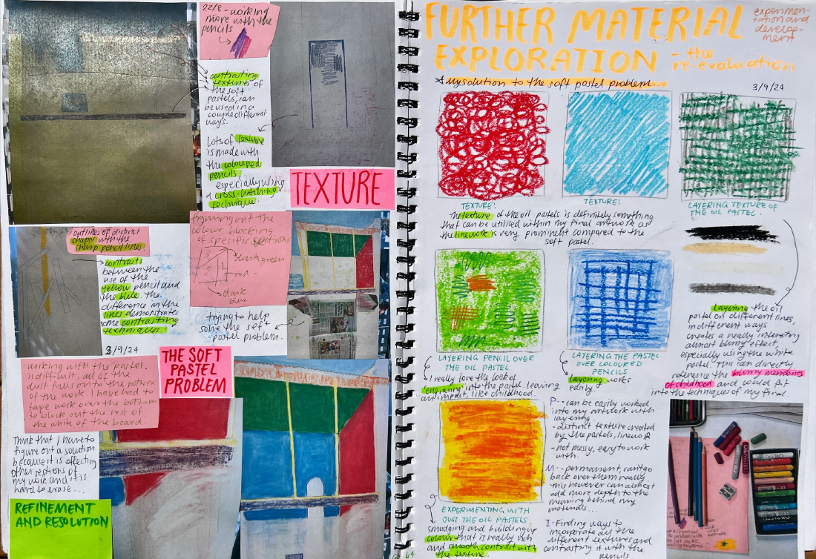

Criterion 8 and 9
Unit 4 Outcome 1 and 2
Document, annotate and evaluate the refinement and resolution of the Body of Work
Refine and resolve a Body of work using the Creative Practice.
Abby used the stages of the Creative Practice to refine and resolve the artworks in her body of work. From her critique she further researched her ideas using further inspiration. She explored ideas by creating a mind map of the ideas she would explore further. She then experimented with materials and techniques with her selected subject matter. Her process of development and refinement was documented focusing on the use of materials and techniques, and art elements principles. This effective use of visual language communicated her ides.
Abby documented the development of her final artwork including the selection of materials, use of design elements and principles, and the process of making the artwork. The application of the Interpretive Lenses is identified using colour coding throughout her annotations.

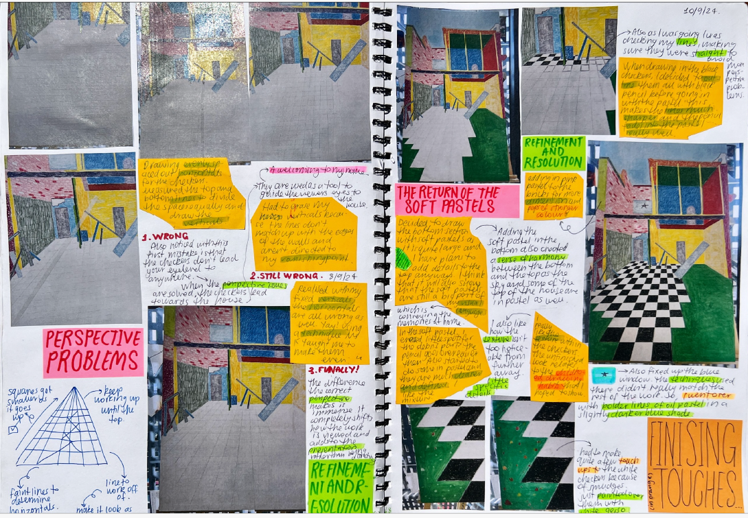

Abby Langhammer

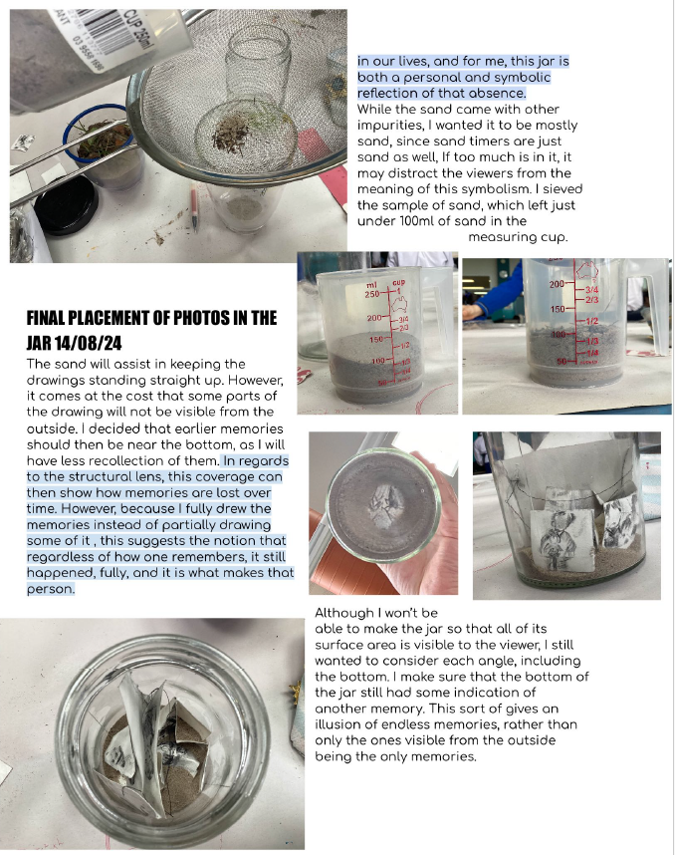
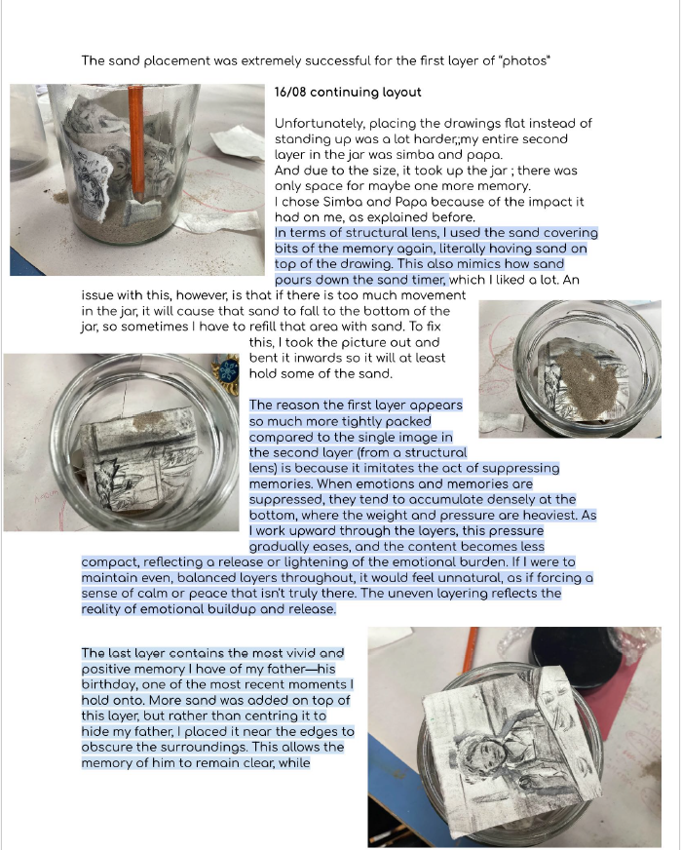
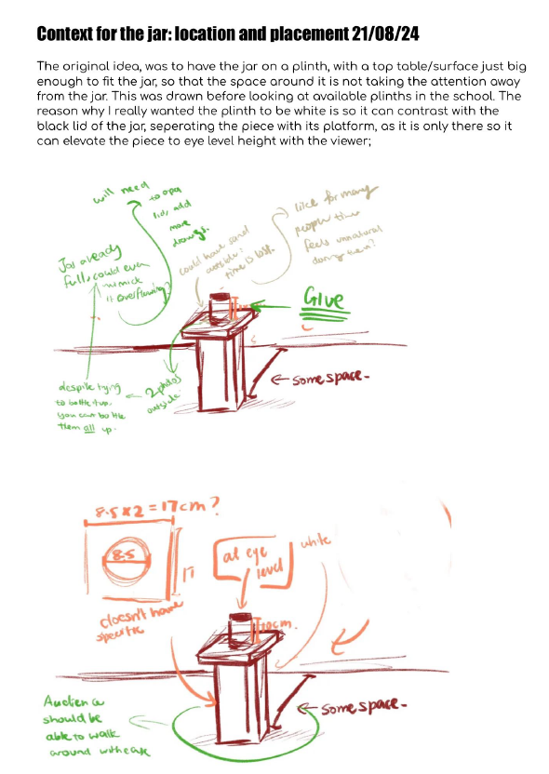

Anna Lee

Criterion 10
Unit 4 Outcome 2
Present a Body of Work to communicate ideas and meaning to a viewer or audience.
In refining her Body of Work, Anna refined one work considering the context (location and placement) of the artwork. She documented the refinement of the work and how the use of materials and techniques (components of an installation work). She included images of the work and diagrams of the presentation, including scale and the placement of components. Her reflection considers the use of visual language to communicate meanings and messages.

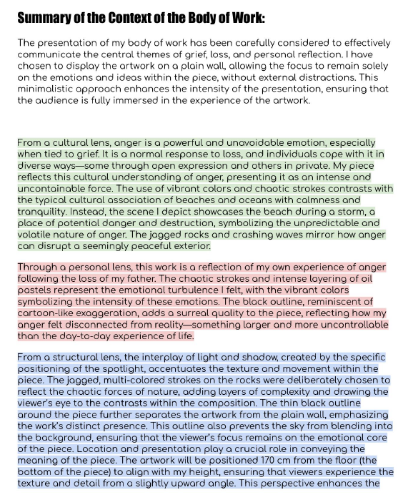
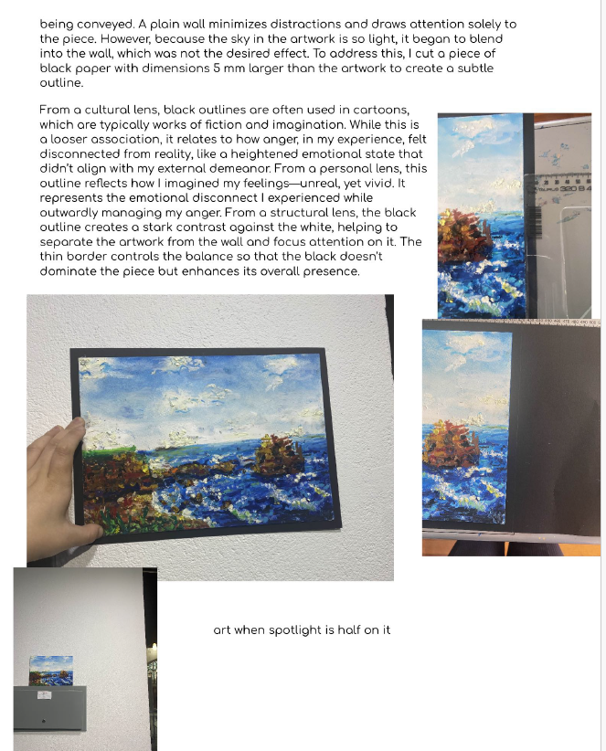
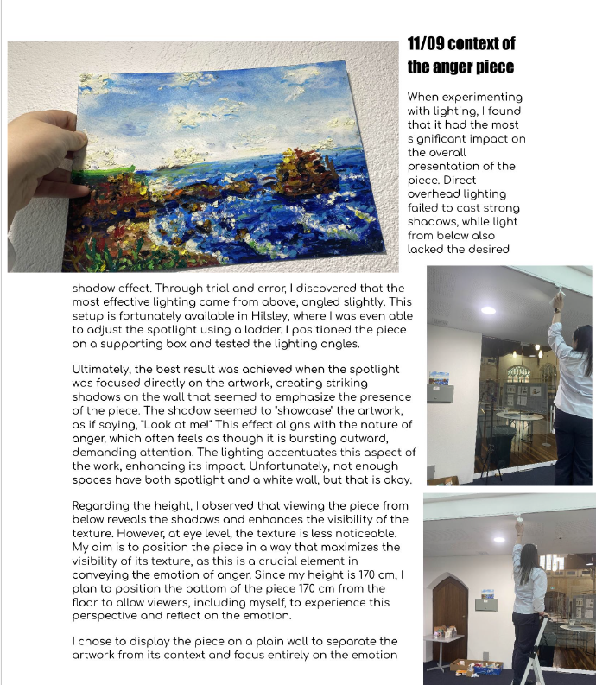
Anna Lee

Criterion 10
Unit 4 Outcome 2
Present a Body of Work to communicate ideas and meaning to a viewer or audience.
Once she had refined both her artworks, Anna then explored where her works were to be presented. She documented the exploration and considered placement and lighting of the artworks. She applied the Interpretive Lenses to considering the meanings and messages of the works and the most effective communication of meanings and messages.

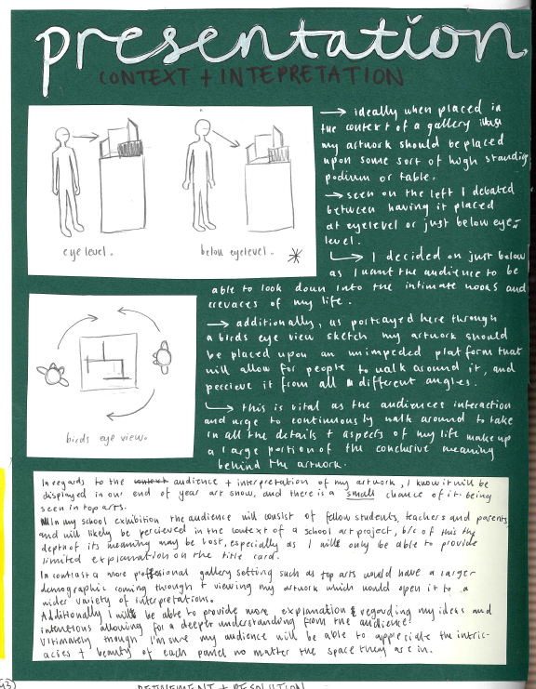
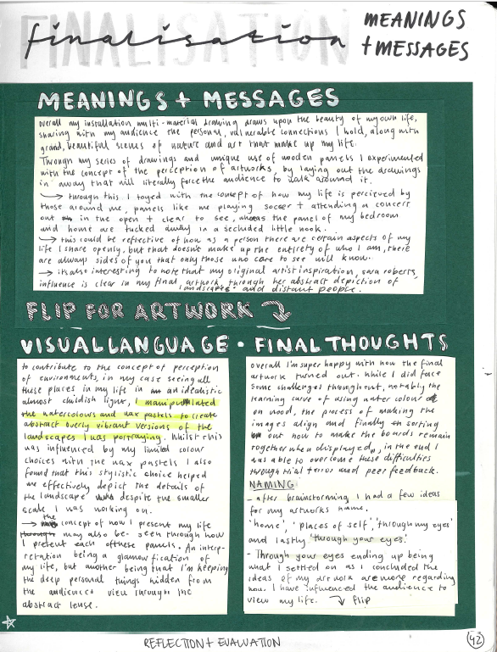
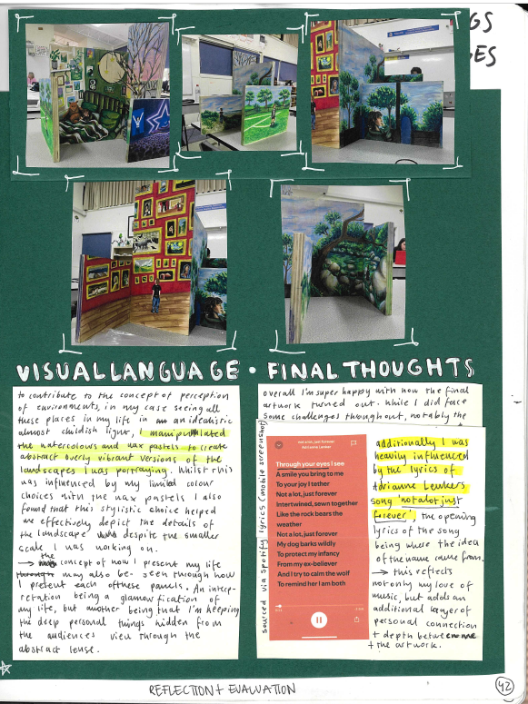

Lilli Hodgson

Criterion 10
Unit 4 Outcome 2
Present a Body of Work to communicate ideas and meaning to a viewer or audience.
Lilli planned the presentation of her Body of Work by initially evaluating the meanings and messages and her use of Visual language. She then considered the presentation of her artworks and drew several diagrams explaining her planning. She considered the relationships of the artworks in the Body of Work and how they communicated the meanings and messages.

