Art Making and Exhibiting – School-assessed Task Criterion examples – Updated 2025

Annotated Folio pages
This document provides teachers with information to support the assessment of the School-assessed Task. The following are examples of how the assessment criteria and descriptors can be unpacked for students. This guidance is only support material for the School-assessed task. Teachers can use this information to develop their own resource presentations for students.
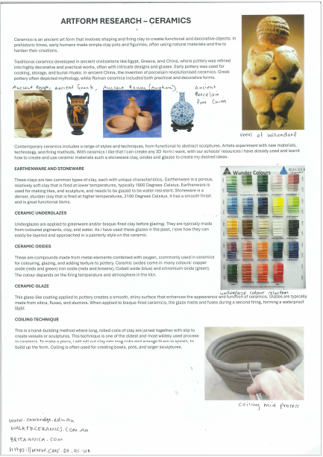
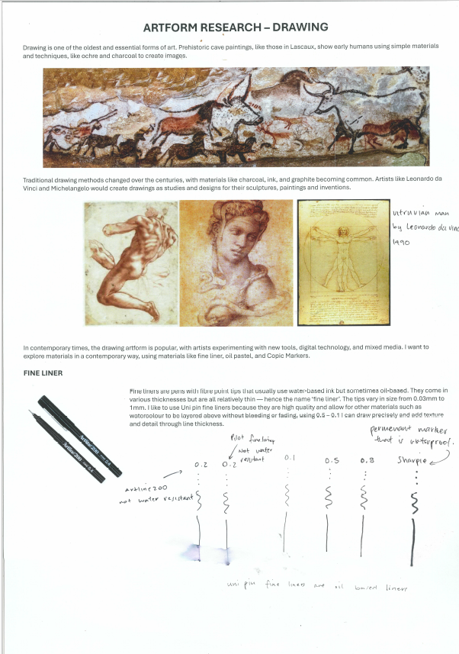

Criterion 1
Unit 3 Outcome 1
Explore and evaluate artworks, artistic influences and inspiration in specific artforms

Art form inspiration
Owen researched two art forms investigating and documenting the use of materials, techniques, and processes. He investigated the characteristics of the materials and their application in each art form.
Both art forms are historical, and Owen investigated art works in their historical context investigating the materials and techniques that were used in the period in which they were made. He then compared them with more contemporary techniques.
Owen critically evaluated the art forms to develop his own ideas and subject matter based on the artworks he researched.

Owen Mueller
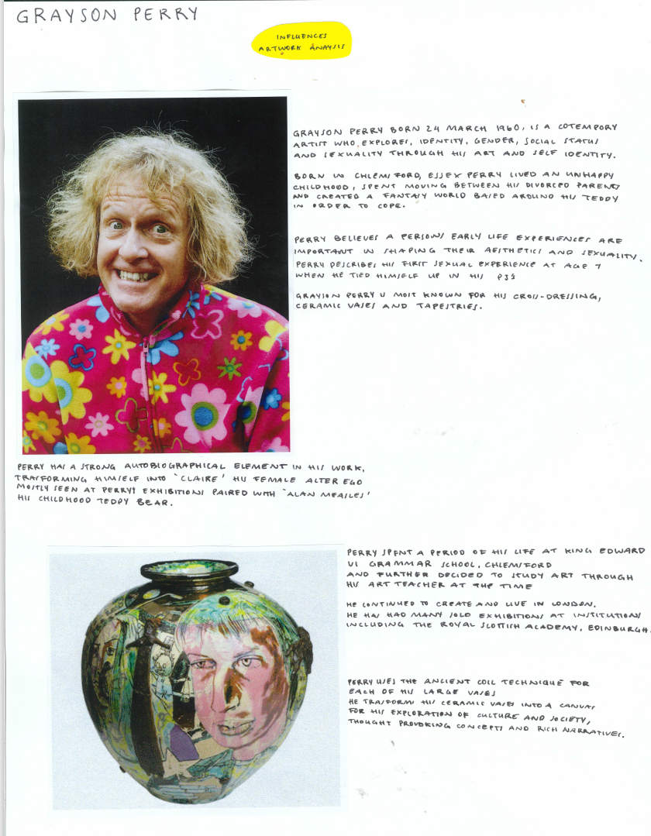
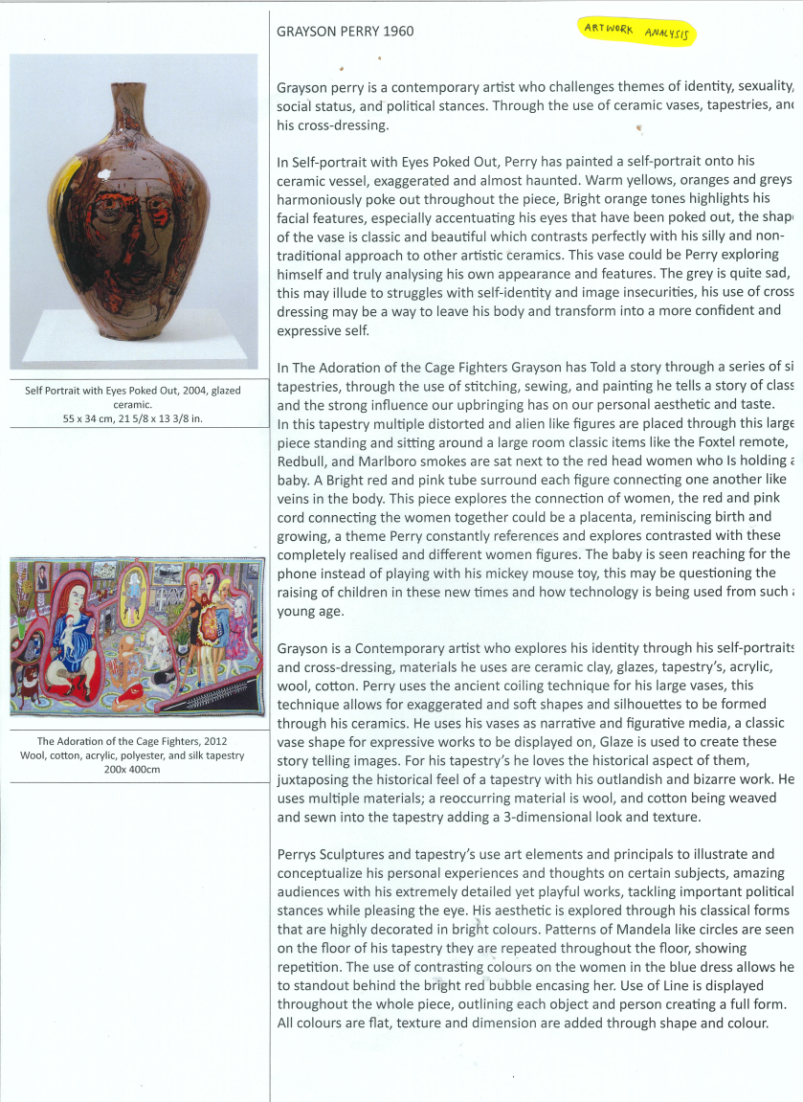
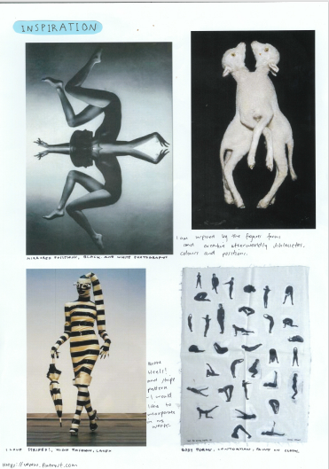

Criterion 1
Unit 3 Outcome 1
Explore and evaluate artworks, artistic influences and inspiration in specific artforms

Artist and artwork research
Owen investigated a range of artists working in different art forms to research the materials and techniques he was interested in. Owen wrote about two artists and then analysed at least two artworks by each artist.
Owen focused the annotations on key indicators such as materials and techniques, ideas and subject matter, and aesthetic qualities. Owen placed the source of the image next to the artwork to demonstrate where the artwork was located and all the information about its size.

Owen Mueller

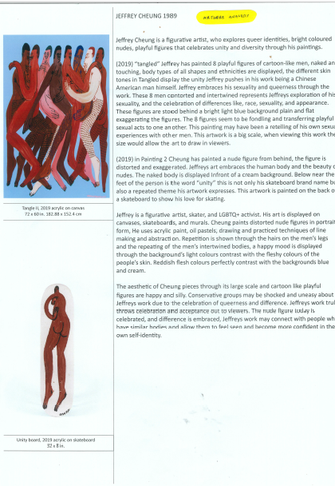
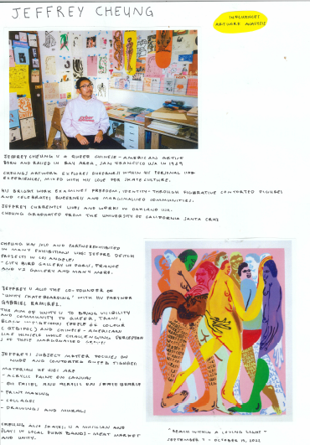

Owen Mueller

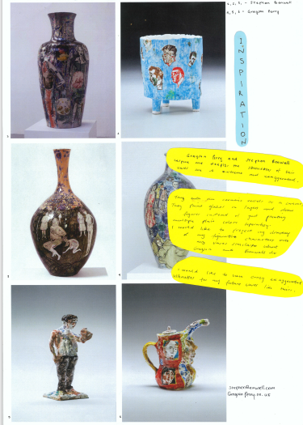
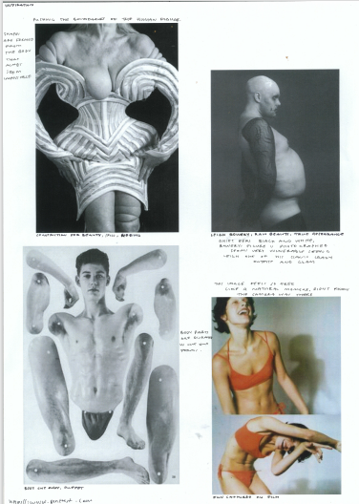
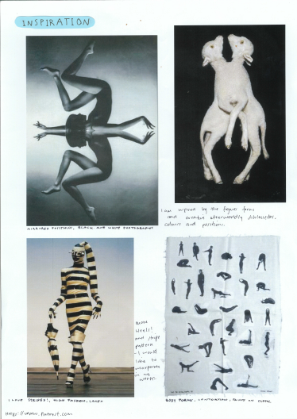

Criterion 1
Unit 3 Outcome 1
Criterion 1
Explore and evaluate artworks, artistic influences and inspiration in specific artforms
Artist and artwork research
Owen brainstormed a range of artworks and focused on the human body as his subject matter. The selection of his subject matter and the artworks was inspired by the artforms and ideas of the three artists he researched.

Owen Mueller

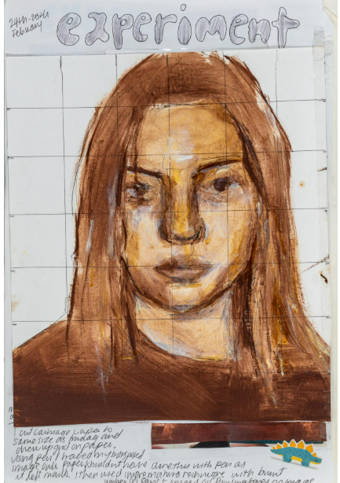
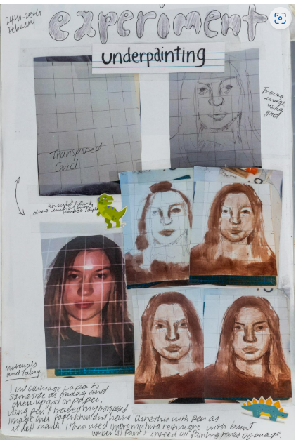
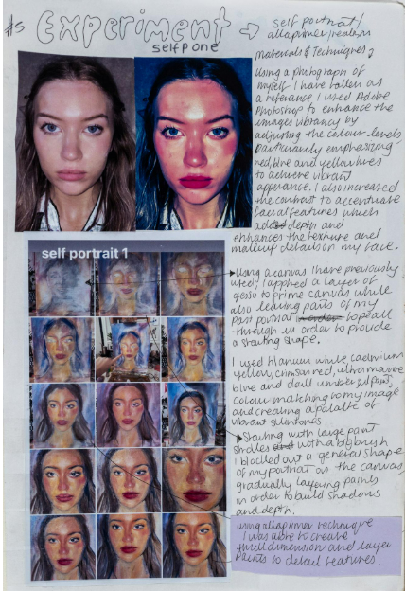
Matilda Dixon

Criterion 2
Unit 3 Outcome 1
Explore artistic influences and experiment with materials techniques and processes in specific artforms
Matilda decided to focus on portraiture in Unit 3, conducting photoshoots to develop her subject matter. She used a Photo Editing program to enhance the contrast of hues to help develop her painting techniques. She demonstrated her process through thumbnails of the steps of the painting process. For each she discussed the step in the process.
Inspired by artists Chuck Close and Jenny Saville, Matilda explored the grid method to draw her portrait. She explored her the representation of her ideas through her subject matter and she used underpainting techniques for the portrait. She documented her developing visual language and her experimentation. She also identified, analysed, and evaluated the characteristics and properties of oil paint by referring to specific images and visual examples of her techniques and processes.

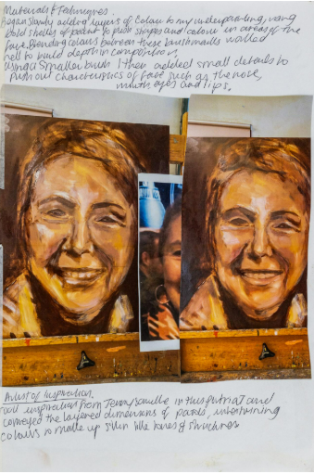
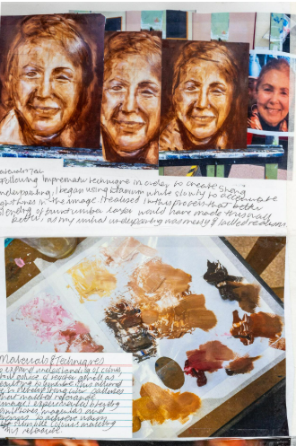
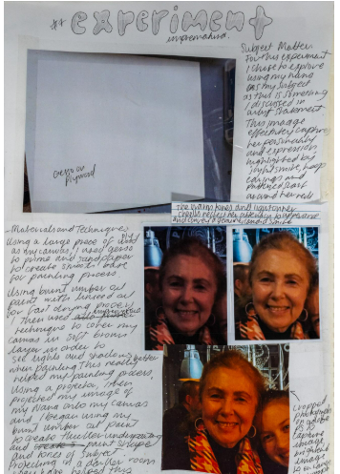
Matilda Dixon

Criterion 3
Unit 3 Outcome 1
Document and evaluate individual art making.
Matilda documented her experimentation focusing on the depiction of her subject matter and the use of materials and techniques. She evaluated her use of materials, techniques and processes so she could begin to conceptualise her artworks. She drew on her evaluation, annotating the techniques that were successful, and those that she planned to develop. She analysed the connections between her inspiration of Jenny Saville’s work, and her own personal images of her grandmother and her relationship with her.

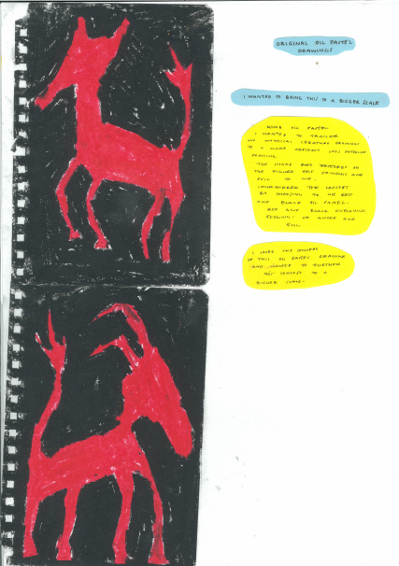
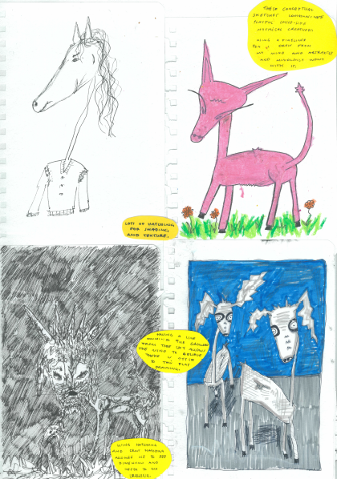
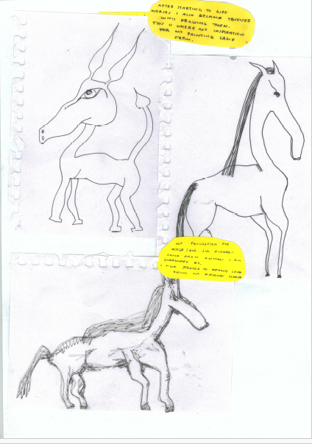
Owen Mueller

Criterion 4
Unit 3 Outcome 2
Develop and make artworks in specific art forms
The development for one of Owen’s artworks started with some drawings of horses. He developed the subject matter further and trialed different materials and techniques. He selected the pastel drawing because he liked the sharp approach (aesthetic qualities). He discussed how he was enlarging it on a larger scale. He referred to materials, techniques and processes and how the subject matter was developed. Owen also demonstrated an understanding of visual language to represent his ideas and communicate meaning in the art works.

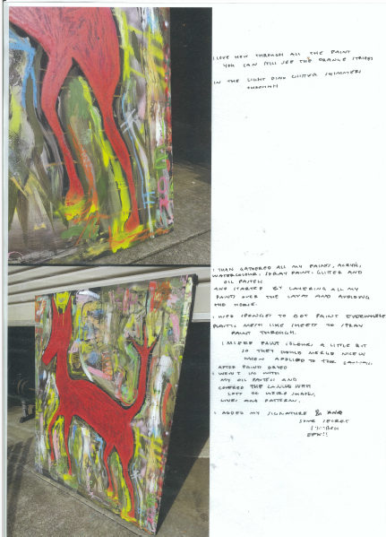
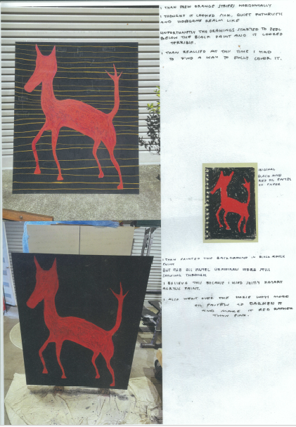
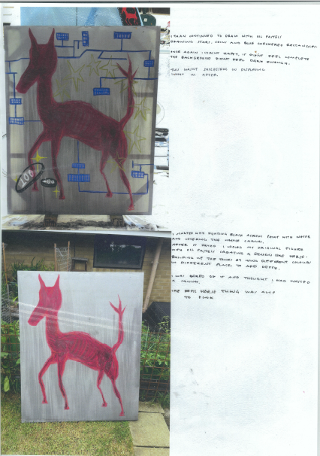
Owen Mueller

Criterion 4
Unit 3 Outcome 2
Develop and make artworks in specific art forms
Owen continued to develop one artwork from his exploration of subject matter and materials. He focused on a combination of drawing and painting, by documenting the application of materials and techniques to convey meaning in his work. He also considered visual language.

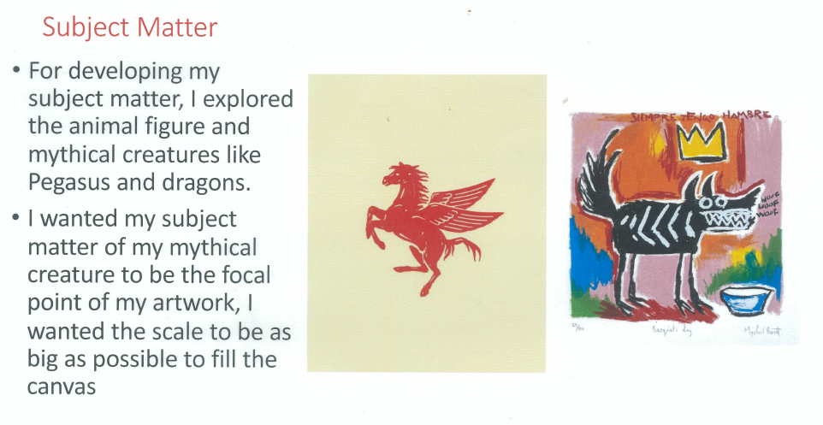
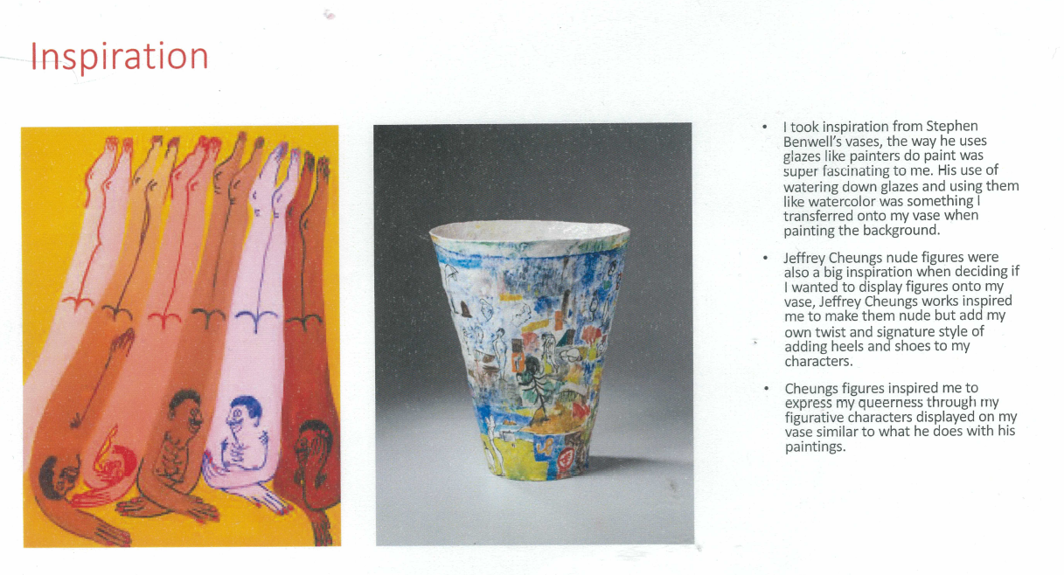
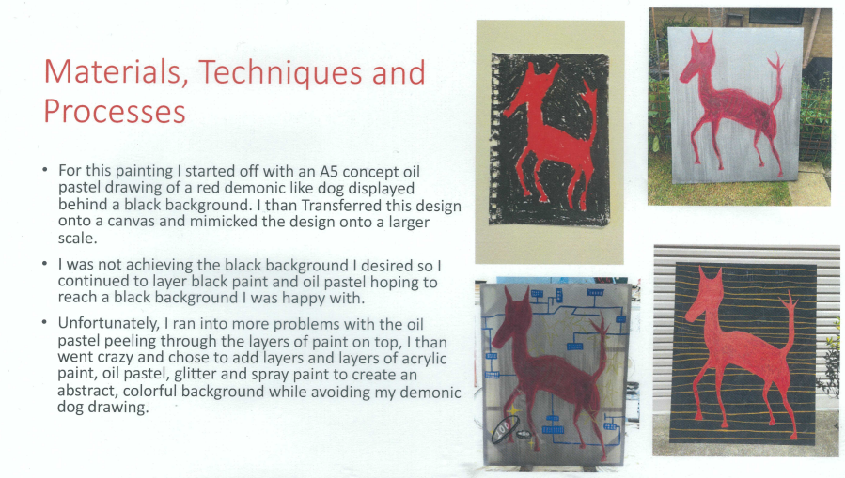
Owen Mueller

Criterion 5
Unit 3 Outcome 2
Present a critique of art making and reflect on feedback.
THE CRITIQUE
In his critique Owen evaluated how he developed two artworks. The inspiration for his artworks was based on his research of artists Stephen Bentwell and Jeffrey Chung. Owen discussed his depiction of subject matter, and the materials, techniques, and processes he used to make the artworks.

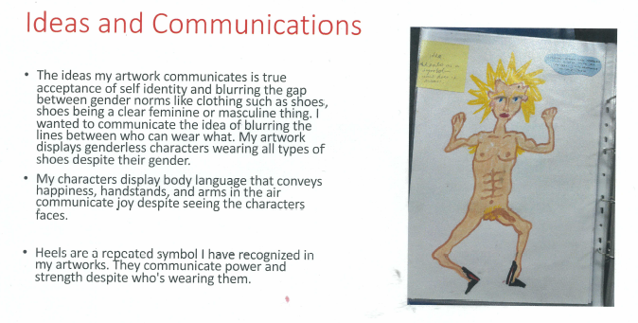
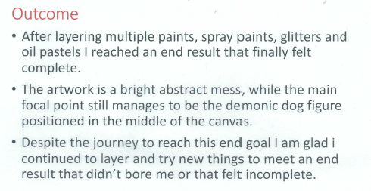
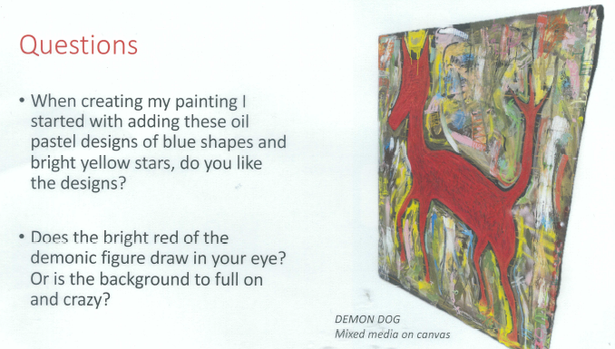

Owen Mueller

Criterion 5
Unit 3 Outcome 2
Present a critique of art making and reflect on feedback.
THE CRITIQUE
Owen also evaluated the processes he used to create the artworks, and the ideas he was intending to express in his work using visual language (art elements and principles, materials, techniques, and processes).
He developed some specific questions for feedback based on visual language and how communicated meanings and messages.

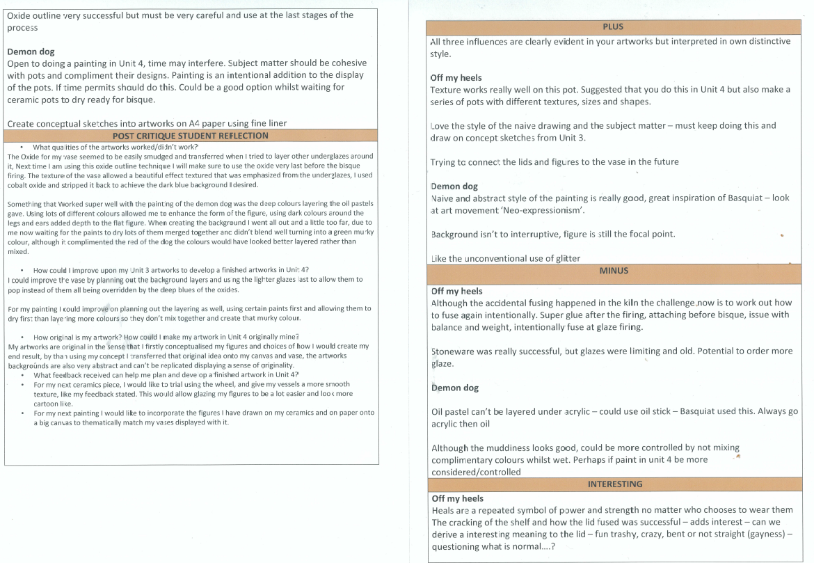

Owen Mueller

Criterion 5
Unit 3 Outcome 2
Present a critique of art making and reflect on feedback.
THE CRITIQUE
To expand on his ideas and artmaking for Unit 4 Owen reflected on both artworks with three key questions. He evaluated how his work reflected his person ideas, what did not work, and what he could improve on Unit 4. To reflect on the feedback from his peers, who had responded to the same three questions, Owen he used a PMI (Plus, Minus, Interesting) model.

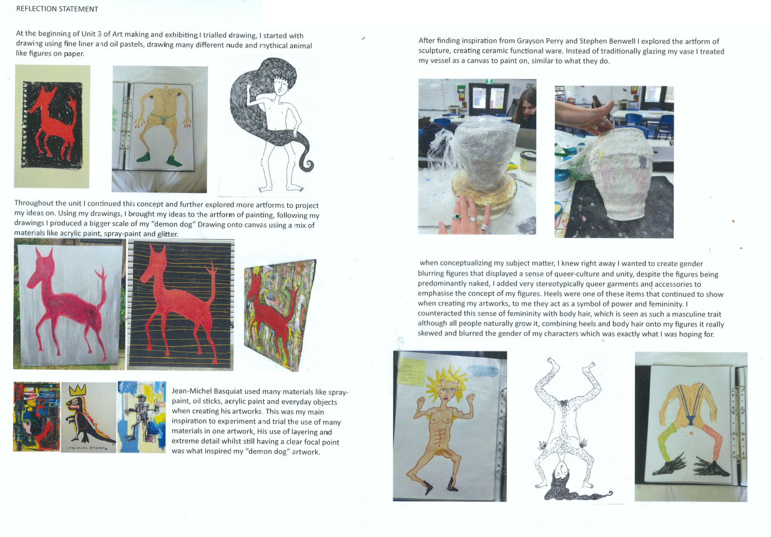
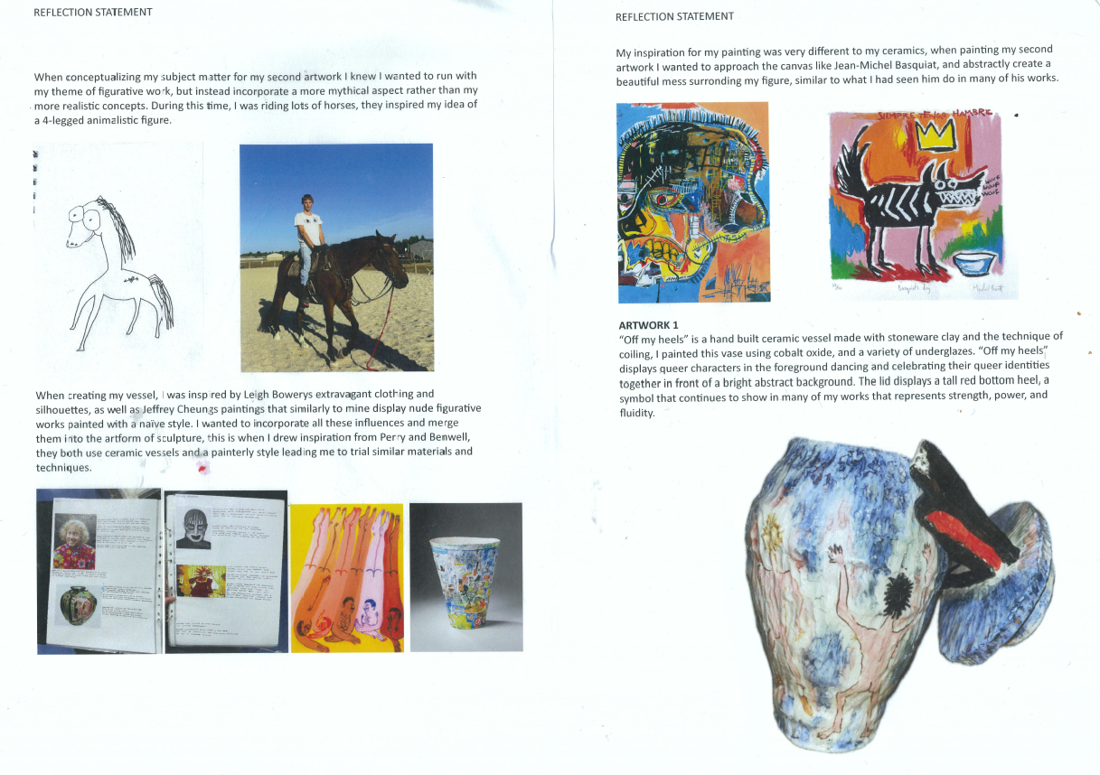

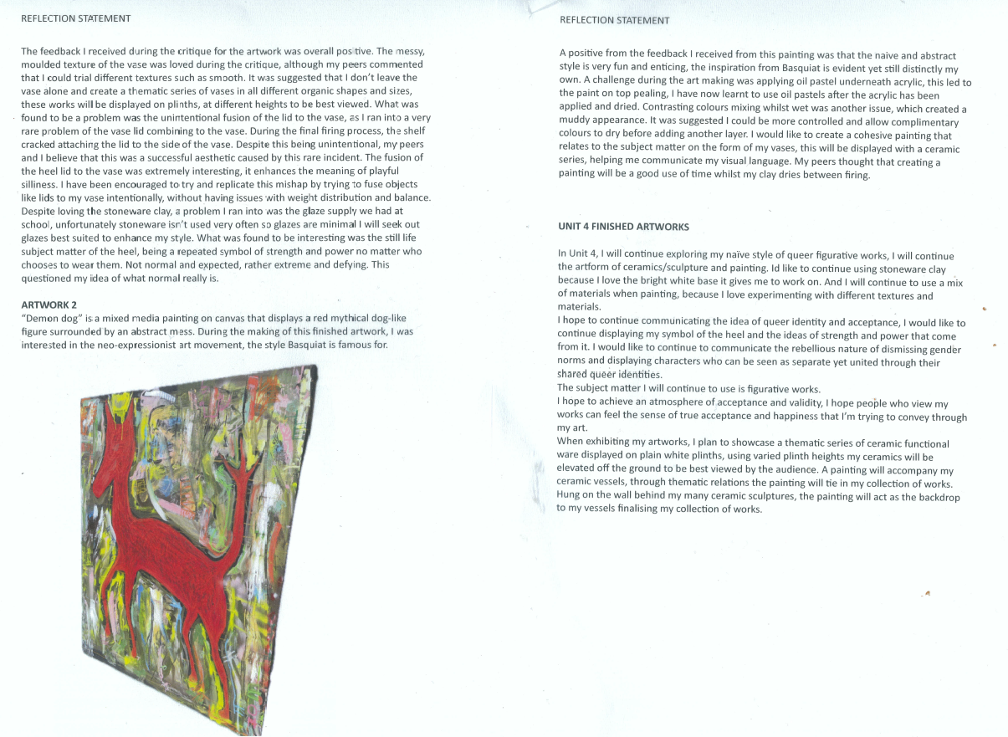
Owen Mueller

Criterion 5
Unit 3 Outcome 2
Present a critique of art making and reflect on feedback.
THE CRITIQUE
Before commencing Unit 4, Owen reflected further on the critique and discussed the artworks he would make. He identified his personal inspiration, the artworks that inspired him and how he would develop two artworks in different art forms in Unit 4 using materials, techniques and processes.

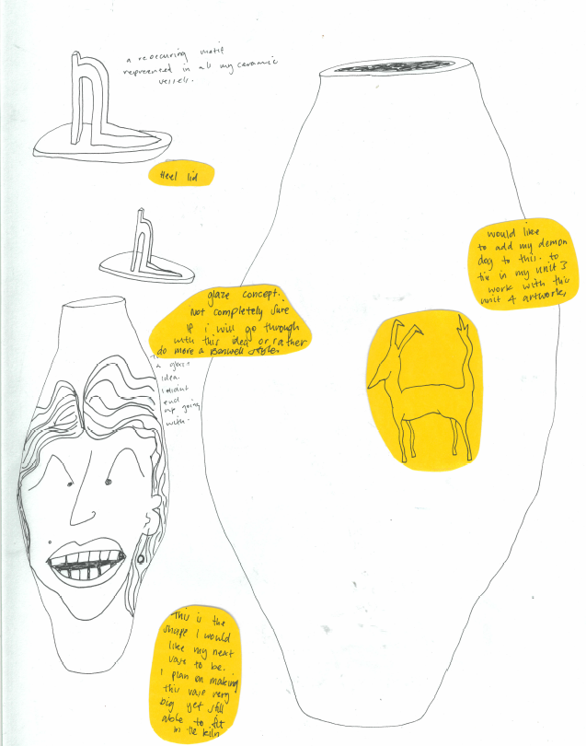
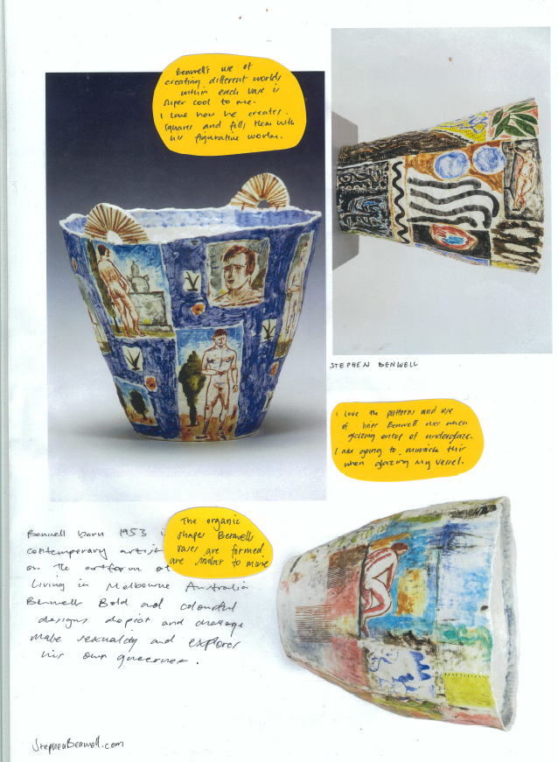
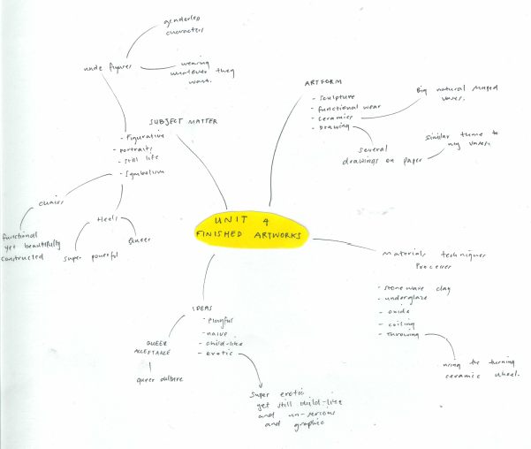

Criterion 6
Unit 4 Outcome 1
Extend and resolve ideas explored in Unit 3 in at least one finished artwork in a specific art form
Owen synthesised his ideas from Unit 3 in a brainstorming map. He then returned to his inspiration to further resolve his ideas and subject matter.
Drawing on his ideas, ceramics and paintings from Unit 3, Owen sketched out some ideas for a ceramic work. He used his exploration of ceramic techniques to design the vessel and the subject matter from his paintings to design the form and the surface decoration.

Owen Mueller

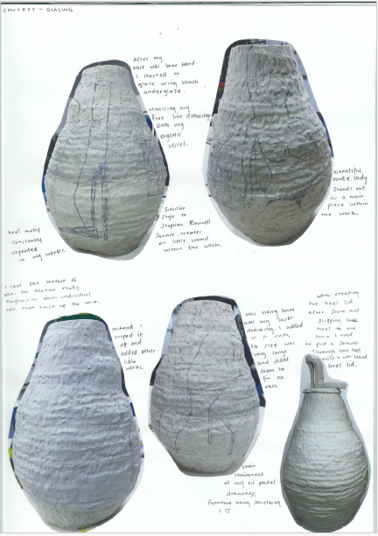
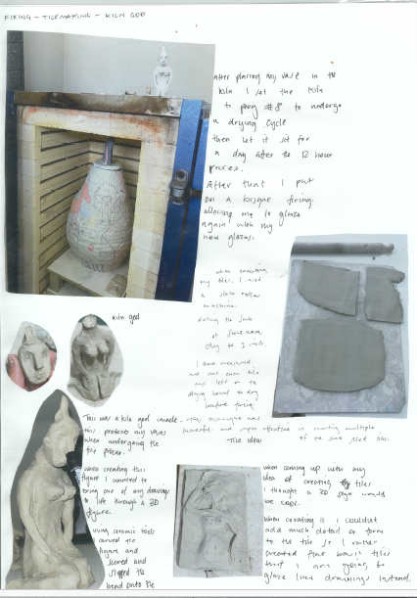
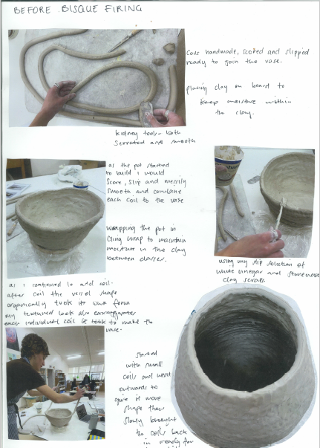
Owen Mueller

Criterion 8
Unit 4 Outcome 1
Document and record art making and the refinement and resolution of at least one finished artwork in a specific art form.
Owen progressively documented each step in the process from hand building to firing. The annotations are evaluative as they explain the development of the work and the expansion of ideas from Unit 3.
Owen discussed drying techniques and kiln temperatures which demonstrate his knowledge of conservation methods for Ceramic artworks.

Criterion 7
Unit 4 Outcome 1
Refine and resolve materials, techniques, and processes in at least one finished artwork in a specific art form.
Owen refined the materials, techniques, and processes for one of the ceramic vessels that he made as a final artwork.
He documented his knowledge of materials, techniques and processes, such as the properties of clay, hand building techniques and firing, using images and annotations.

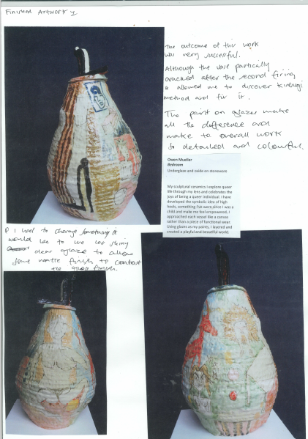
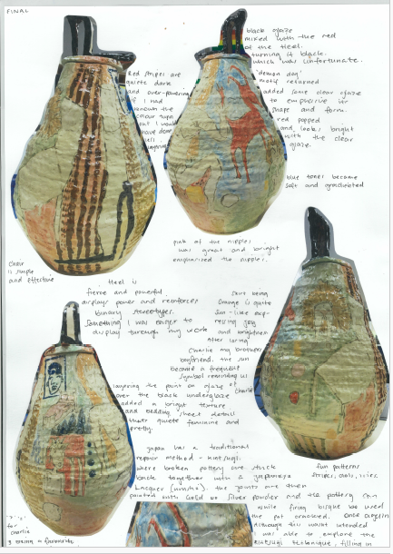

Owen Mueller

Criterion 8
Unit 4 Outcome 1
Document and record art making and the refinement and resolution of at least one finished artwork in a specific art form.
Owen progressively documented each step in the process from hand building to firing. The annotations are evaluative as they explain the development of the work and the expansion of ideas from Unit 3.
Owen discussed drying techniques and kiln temperatures which demonstrate his knowledge of conservation methods for Ceramic artworks.

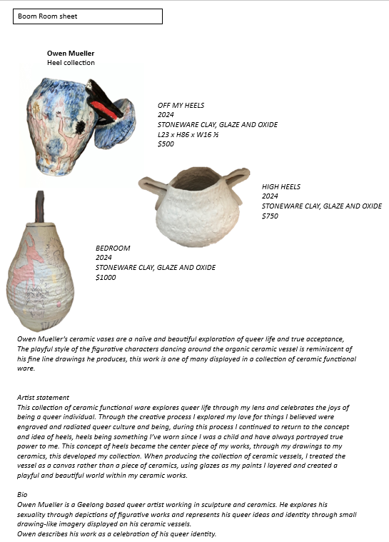
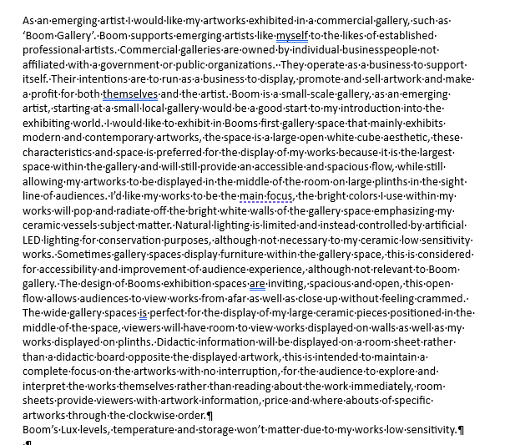

Owen Mueller

Criterion 9
Unit 4 Outcome 2
Plan the display of at least one finished artwork in a specific art form.
To plan the exhibition of his final artworks, Owen researched an exhibition space that he felt would best suit the presentation of his artwork. He analysed the presentation of work in the space and the conservation of the artwork.
Owen also investigated how information was provided for individual artworks and he wrote an artist statement for his artworks. The statement explains the ideas, why he selected Ceramics as an art form, and how his subject matter and use of visual language communicates his ideas and meanings for an audience.

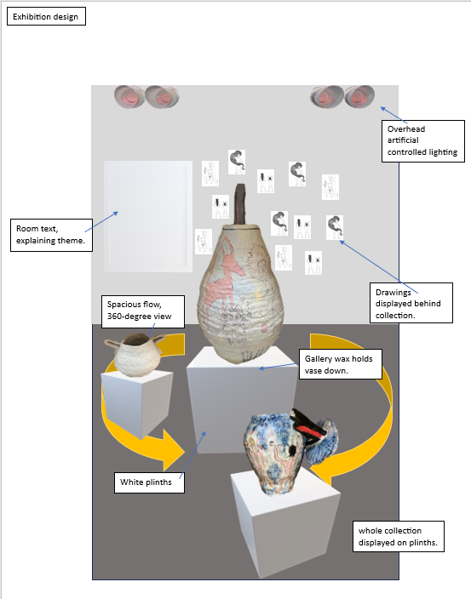
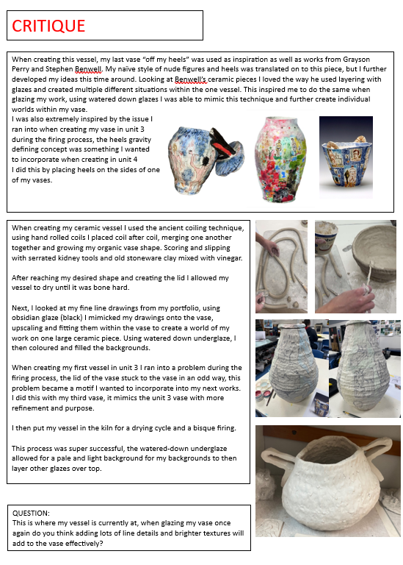

Owen Mueller

Criterion 10
Unit 4 Outcome 2
Prepare and present art making and at least one finished artwork in a specific art form.
Owen presented his final artworks in a critique. He included an image of the artworks in an exhibition space with annotations to explain lighting, movement of viewers, placement of plinths, and the positioning of artworks and room text on the walls.
His critique was accompanied by written documentation and images. Owen explained his inspiration, use of materials, techniques and processes for the specific art form, and how he used visual language to communicate ideas and meaning for the audience.
Before he finally refined his artworks, Owen asked for feedback from his peers on the decoration of his vessel and the techniques he intended to use to refine it.

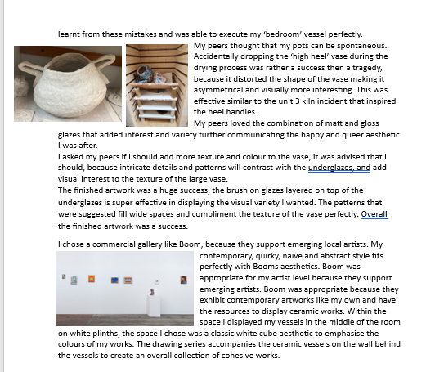
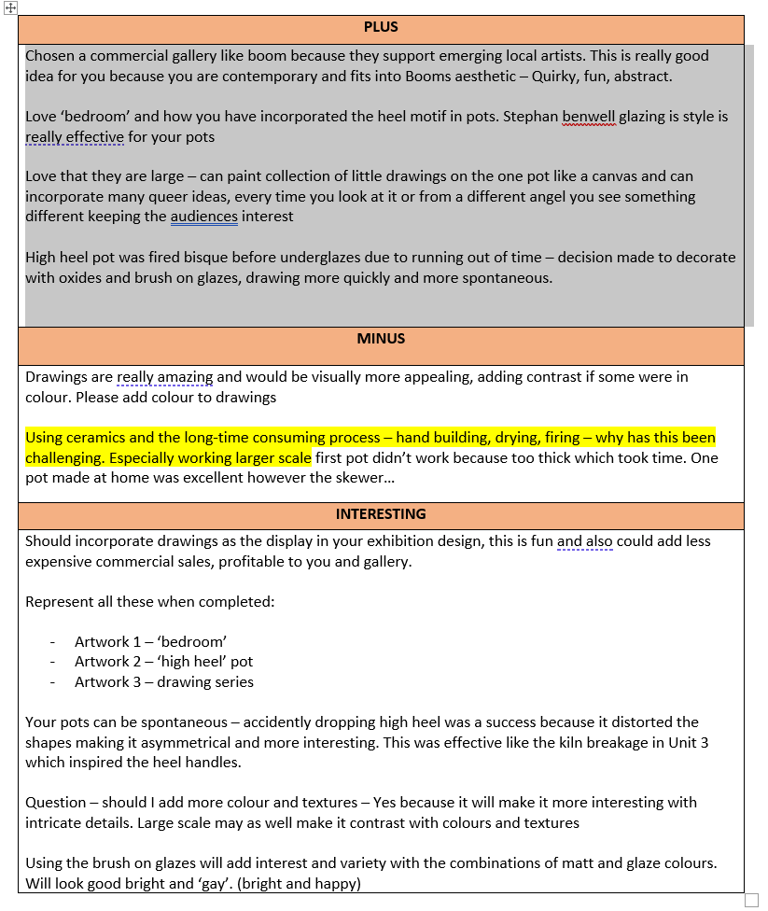
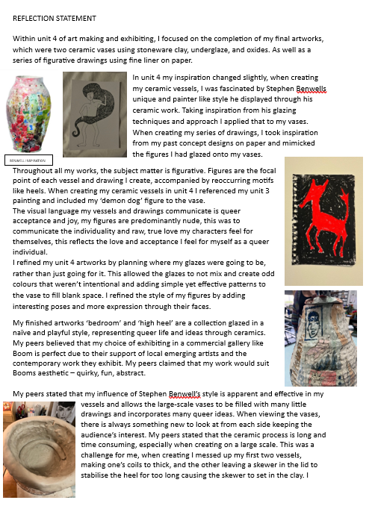
Owen Mueller

Criterion 10
Unit 4 Outcome 2
Prepare and present art making and at least one finished artwork in a specific art form.
After the critique, Owen collated the feedback from his peers and further refined his final artworks based on the feedback. He adjusted glazes on the final artwork and the reconsidered the presentation of his artworks.
Owen then wrote a reflection evaluating his final artworks. He discussed his influences, subject matter and how his use of visual language conveyed meaning and messages. Owen then explained the full art making process and the decisions he made to present his final artworks.

