VCE Media – School-assessed Task Criterion examples
This document provides teachers with information to support the assessment of the School-assessed Task. The following are examples of how the assessment criteria and descriptors can be unpacked for students. This material provides a guide for the School-assessed task that teachers can use to develop their own resource presentations for students.
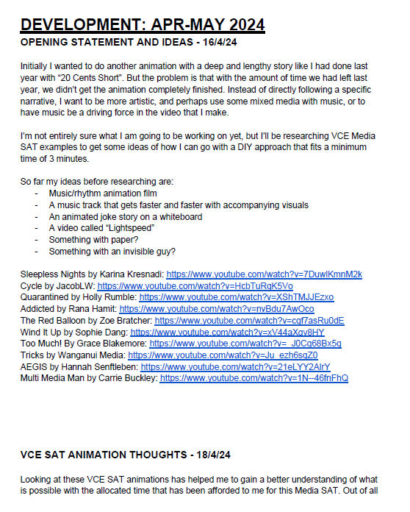

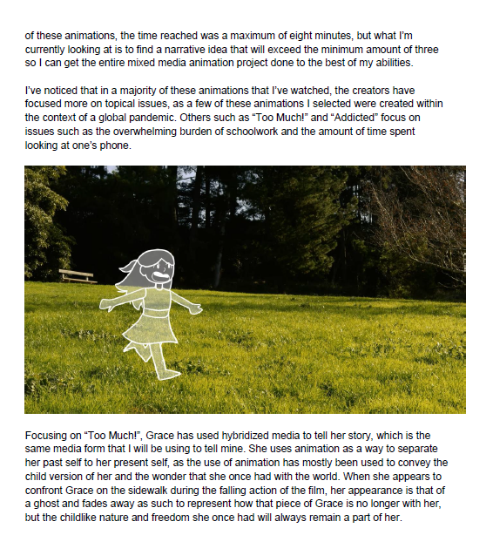

Brinners, SOUNDINE AND JITWUB

Criterion 1
Unit 3 Outcome 2
Criterion 1
Research and analyse media forms and products to develop and inform a media production.
Brinners researched a range of animations, including those by past Top Screen students, to gain inspiration for his own animation. He analysed the narrative of each and how it conveyed meaning to the audience. He focused on specific scenes of the genre of animation he wanted to produce.

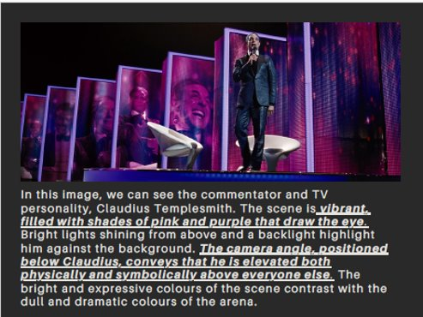
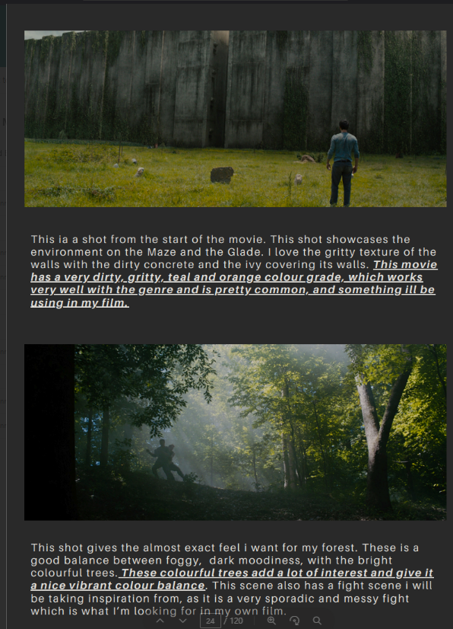
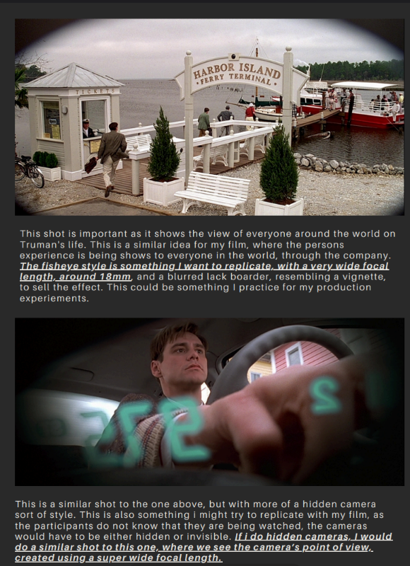

Jackson Bertram, The Culling

Criterion 1
Unit 3 Outcome 2
Research and analyse media forms and products to develop and inform a media production.
For his production ‘The Culling’, Jackson analysed a range of films such as the Hunger Games, Maze Runner and The Truman Show to understand how camera angles, lens types and colour grading were symbolic to the narrative he wanted to create.

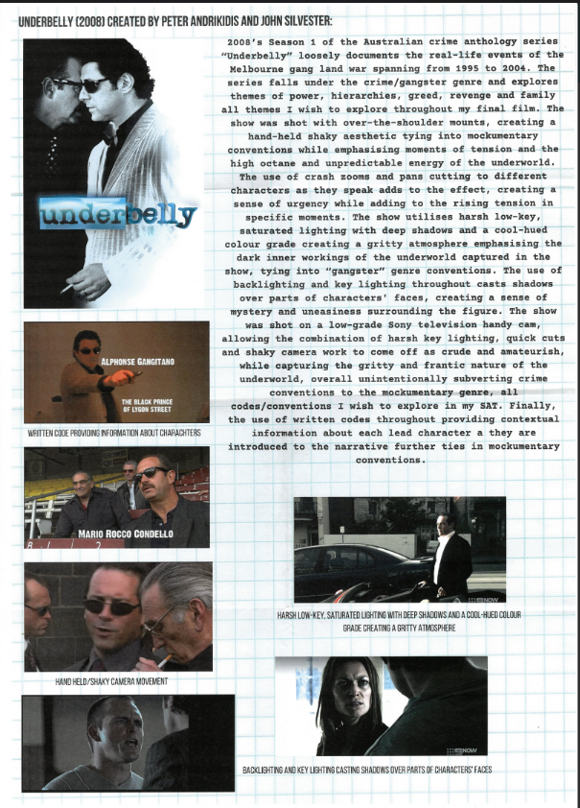
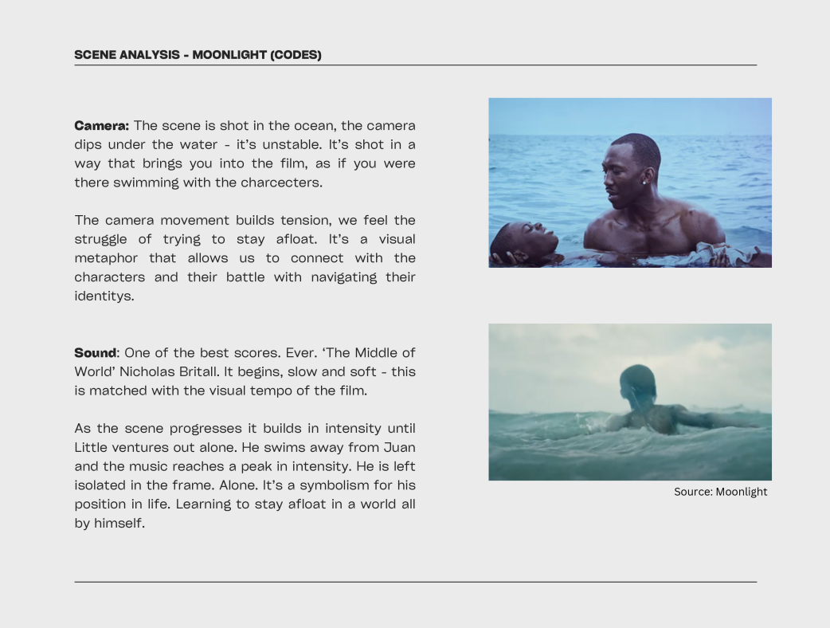
William Genat, A Family Affair
Ethan Sculley, The Flames Within

Criterion 1
Unit 3 Outcome 2
Research and analyse media forms and products to develop and inform a media production.
In researching his film ‘The Flames Within’ Ethan analysed each scene of the film ‘Saltburn’ investigating the codes and conventions used to convey meaning.
For ‘A Family Affair’ William researched films such as Underbelly, ‘Wolf of Wall Street’ and ‘Breaking Bad.’ These films all use the genre of crime as a vehicle to explore a dysfunctional family and their greed. After analysing these titles, he decided to use a handheld cinema verité style of camerawork to create a visceral and kinetic feeling for his audience whilst also suggesting real events were unfolding in the film.

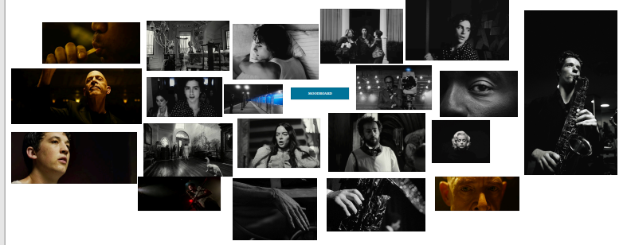

Criterion 1
Unit 3 Outcome 2
Research and analyse media forms and products to develop and inform a media production.
Mind mapping and curating mood boards helped Ryan plan the development of his film ‘The Solo’. He explored ideas, codes and conventions, genre and style using written and visual documentation.

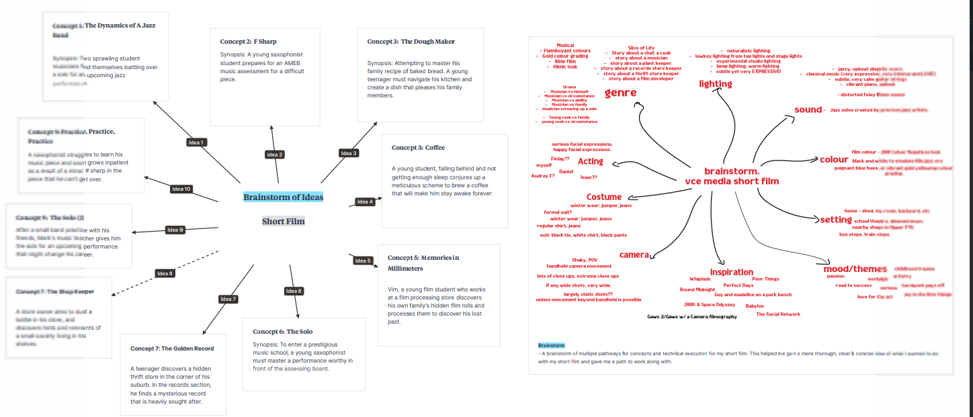

Ryan Ma, THE SOLO

Ryan Ma, THE SOLO
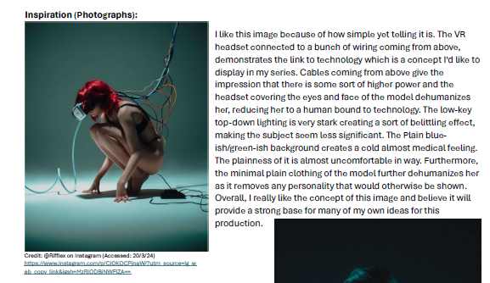
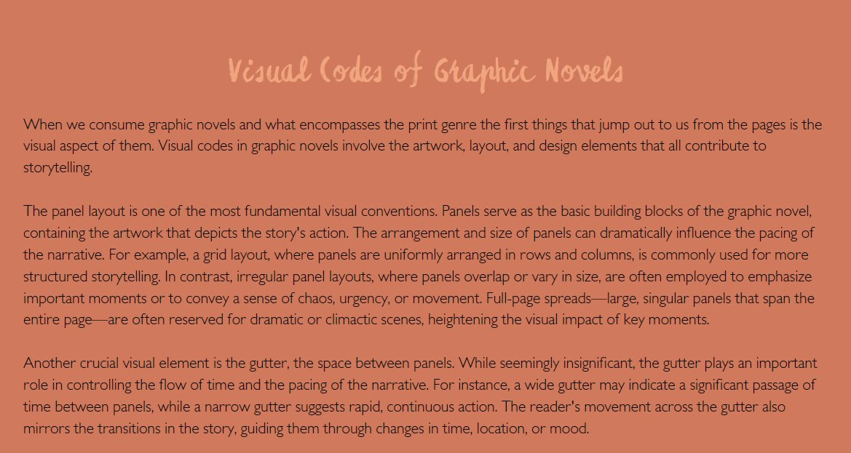

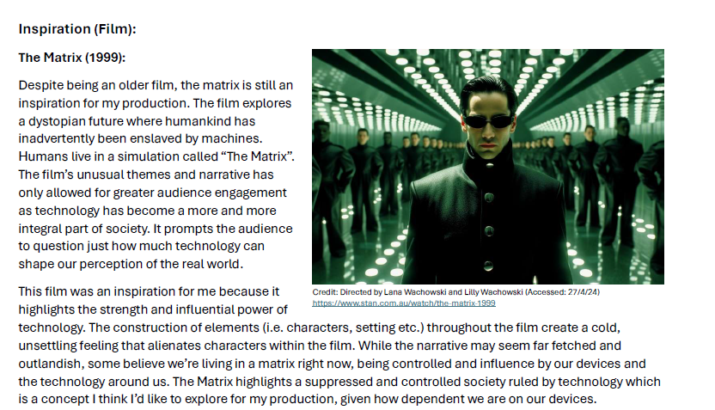

Lulu Dumergue Smith, Petrichor

Alexander Keep, Disconnected Dependency

Criterion 1
Unit 3 Outcome 2
Research and analyse media forms and products to develop and inform a media production.
Lulu researched the specific visual codes of graphic novels for her Print production ‘Petrichor’. These visual codes included layout, the colours used, the angles in each pane, and the representation of characters. She also researched the text conventions such as font types and how they related to the composition of the images.
For his photographic series Alex researched different photographic styles investigating the codes and conventions used in photographic images of a specific genre. He also researched the ideas for his series by analysing films that were dystopian and those that portrayed themes such the influences of technology on society.

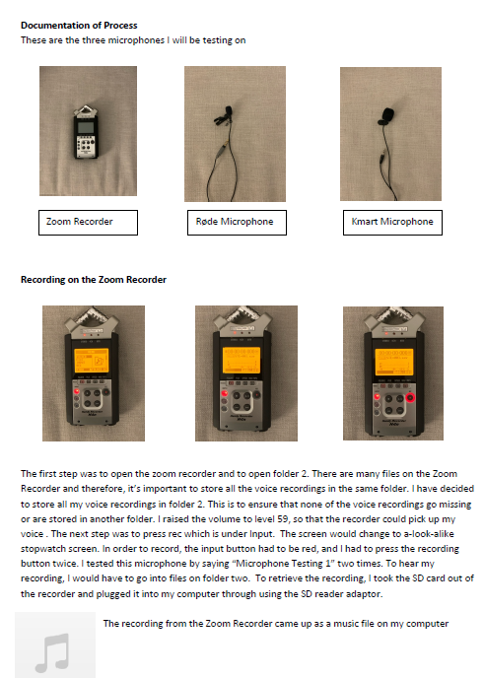
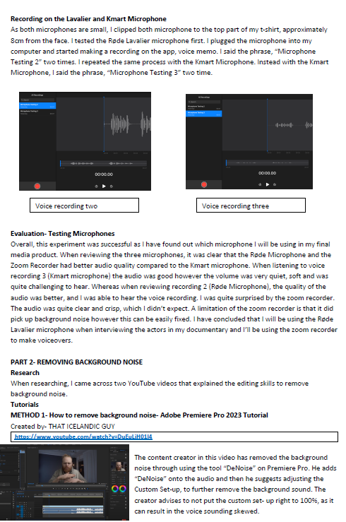
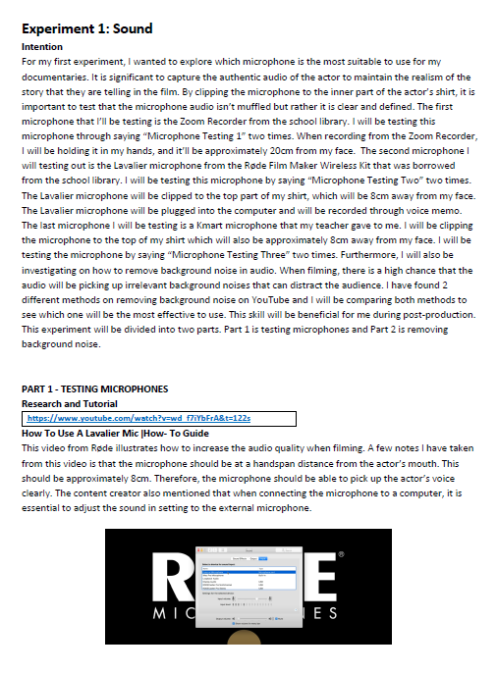

Giorgie Zafiropoulos, Pappoú

Criterion 2
Unit 3 Outcome 2
Explore and document skills using media equipment, technologies, and processes in a selected media form for a proposed product.
In her preparation to shoot her documentary ‘Pappou’, Georgie investigated a range of microphones and audio editing techniques. She completed a series of tutorials online and documented the steps in her learning. She provided images of the equipment and wrote the technical details and purpose of it in the production process. Georgie also discussed how she would use these audio techniques in interviews and recording in public spaces.

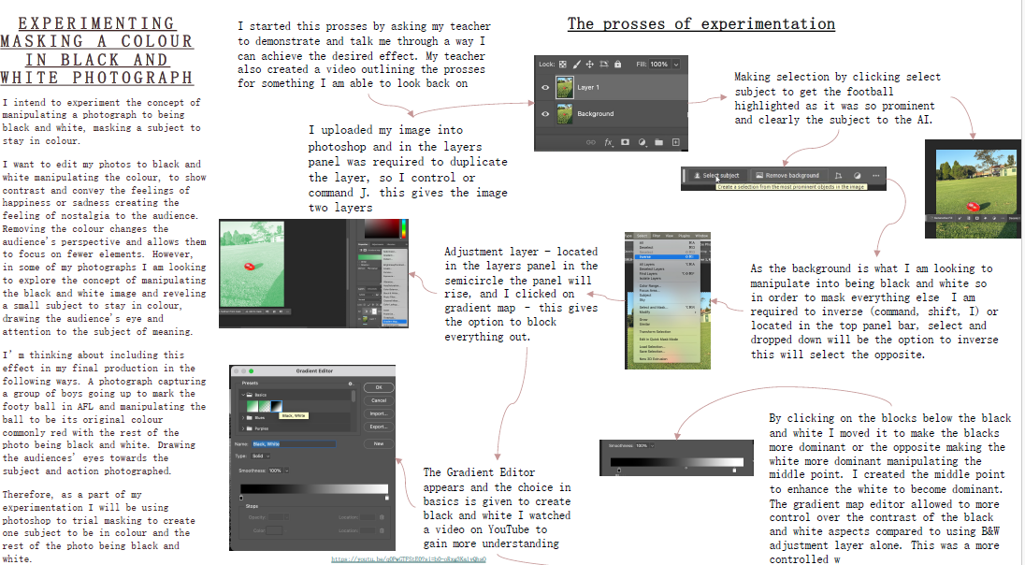
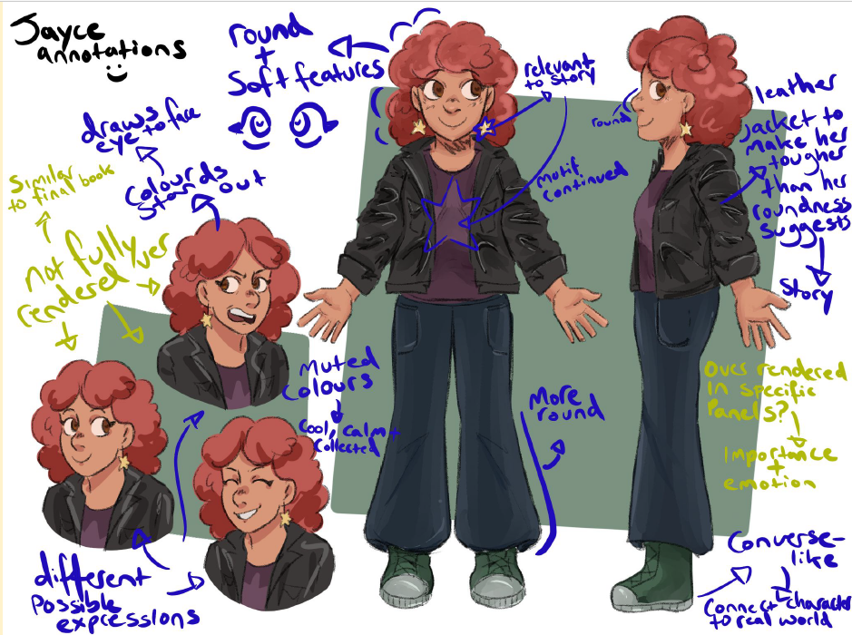

Violet Johnson, Echo

Jaida Cohen, Jayce and Xeno

Criterion 2
Unit 3 Outcome 2
Explore and document skills using media equipment, technologies, and processes in a selected media form for a proposed product.
For her graphic novel, Jaida documented the creation of the characters for the story. She explored drawing tools using computer software. To document the experiment, she annotated directly onto the page, highlighting how aspects of her character would contribute to the development of the narrative.
For her production experiments in photography, Violet explored colour masking using tools in PhotoShop. She referenced the code of colour and how she wanted to use it to provide a focus in her images. She demonstrated the effects of her experiment with an image, with ‘before’ and ‘after’ screen shots. Violet also documented each step in the process by providing screen shots of the adjustments and explaining the tools she used.

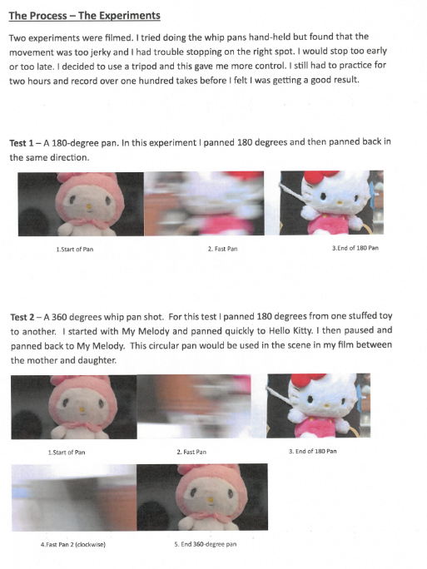
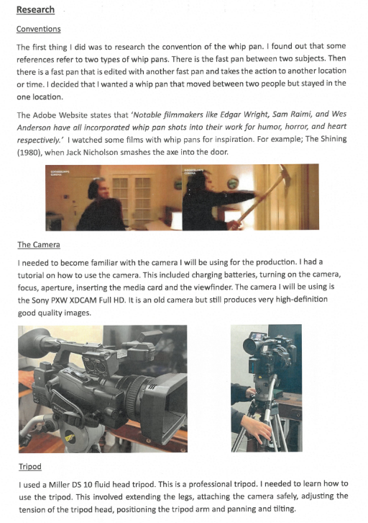

Thicia Acquisto, Abu Abu (The Mist)

Criterion 2
Unit 3 Outcome 2
Explore and document skills using media equipment, technologies, and processes in a selected media form for a proposed product.
Thicia explored ‘Whip Pans’ for one of her production experiments. She described how she wanted to enhance the dramatic energy and pacing of a dialogue scene by whipping from one character to another, and in the process, become familiar with the camera she would use. She researched The Shining and how the director Stanley Kubrick used a whip pan to increase the dramatic tension of the scene.

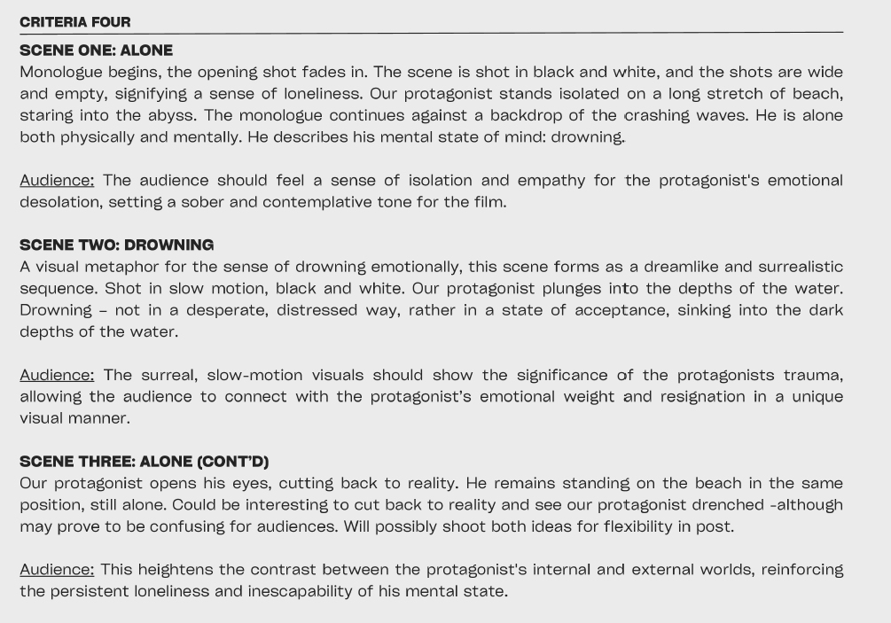
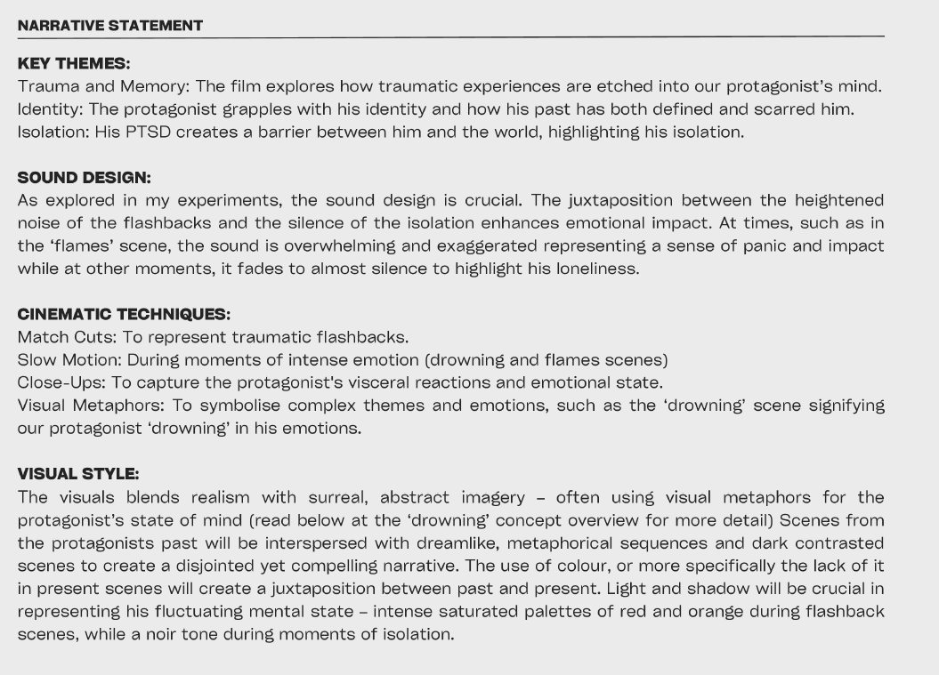
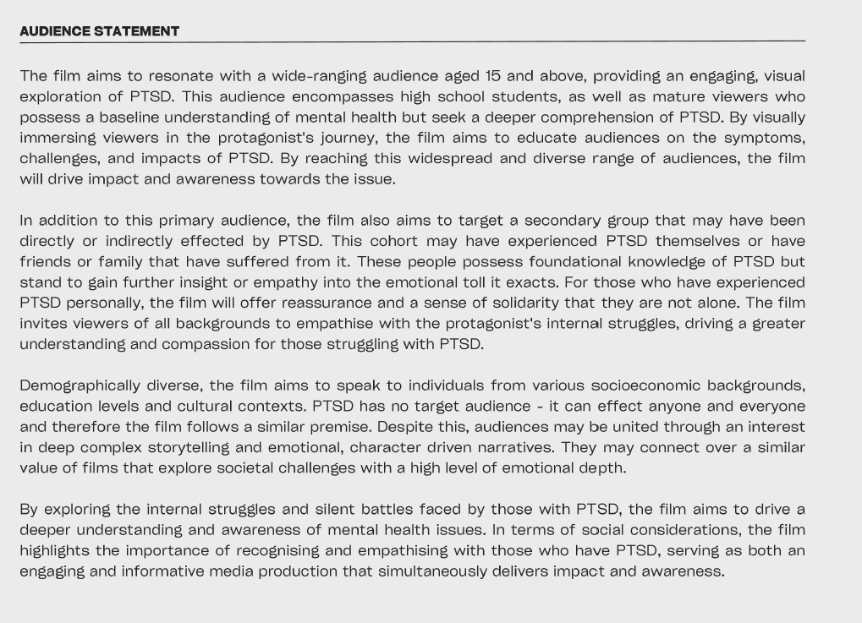
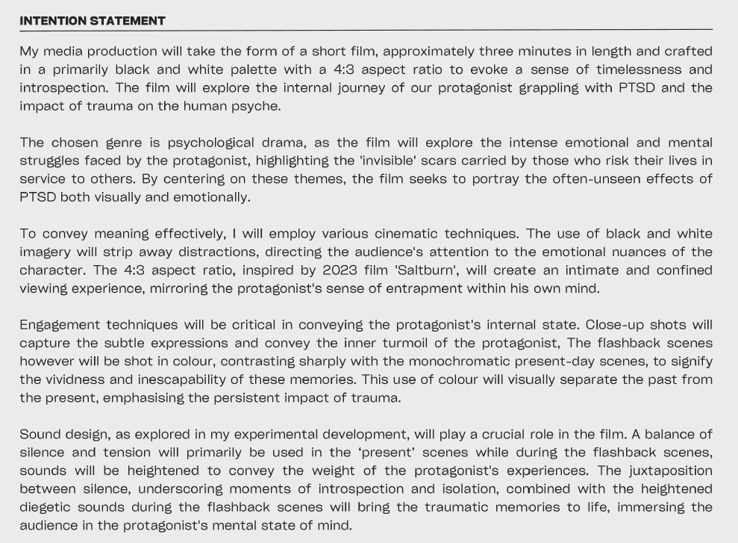

Criterion 3
Unit 3 Outcome 3
Develop and document the intention, audience and narrative of a proposed production in a selected media form.
For his film “The Flames Within” Ethan wrote clear intention, audience and narrative statements.
The intention statement includes an overview of the film Ethan intended to make and information about his selected media form. He referred to the genre of the film and the different techniques that he intended to use to make the film.
Ethan has clearly stated his audience characteristics by referring to their age, interests, socio economic status, where they might live and what their interests were. He referred to the codes and conventions he would use to engage the audience and communicate meaning.
Ethan explains an overview of the film and his narrative structure. He discussed the characters, setting and key themes or ideas of the film.

Ethan Sculley, The Flames Within

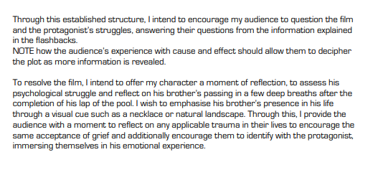
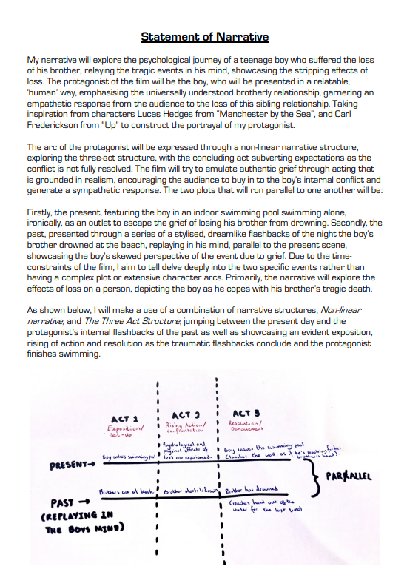

Alex Feehan, Survivor

Criterion 3
Unit 3 Outcome 3
Develop and document the intention, audience and narrative of a proposed production in a selected media form.
In developing the narrative for his film ‘ The Survivor’, Alex created a multilinear narrative structure that had parallels between the past and the present. He explained the structure in the narrative statement with a diagram and written descriptions of scenes

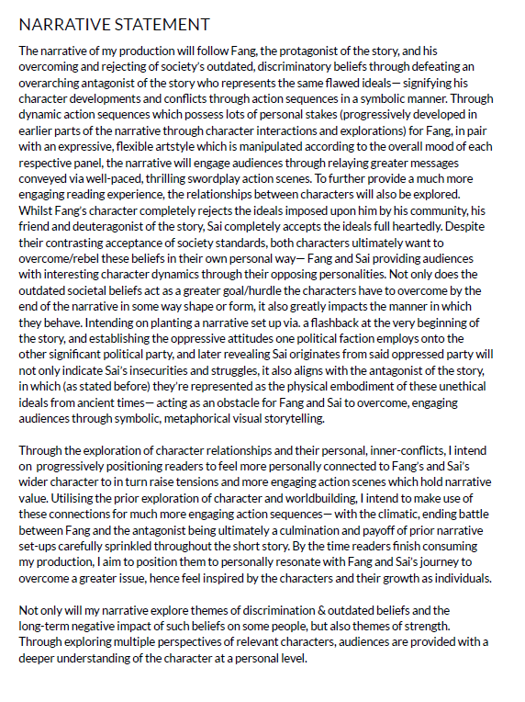
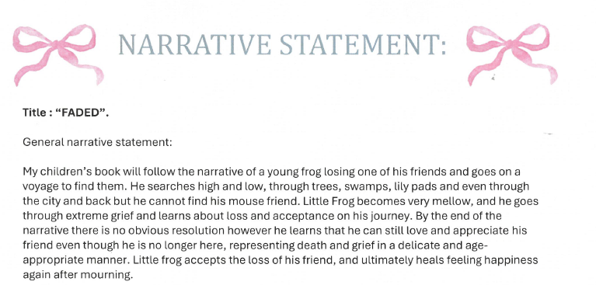

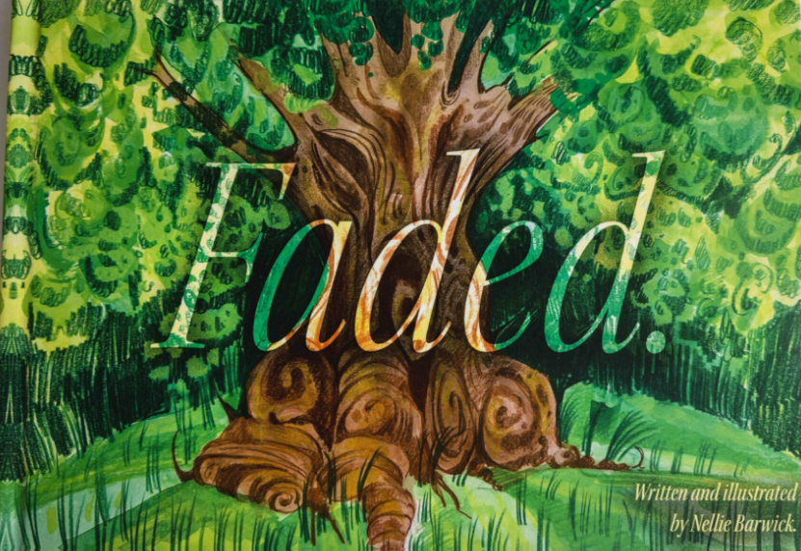

Matthew Jung, The Peerless
Nellie Barwick, Faded

Criterion 3
Unit 3 Outcome 3
Develop and document the intention, audience and narrative of a proposed production in a selected media form.
Matthew created a ‘webtoon’ for his media product, intending it to be viewed on a mobile device. He wrote a clear intention statement explaining the narrative and the genre of the product. He also described the ideas he was communicating through his narrative and selection of media form. Throughout his intention Mathew explained how selected codes and conventions would construct the narrative. His audience statement was clear and he explained how the use of codes and conventions would engage his audience. Finally, Matthew wrote his logline and narrative treatment explaining scene by scene how the narrative would unfold.
For her illustrated children’s book ‘Faded’, Nellie wrote a clear summary of her narrative outline and plot. She then wrote an outline of each page and a script for the book.

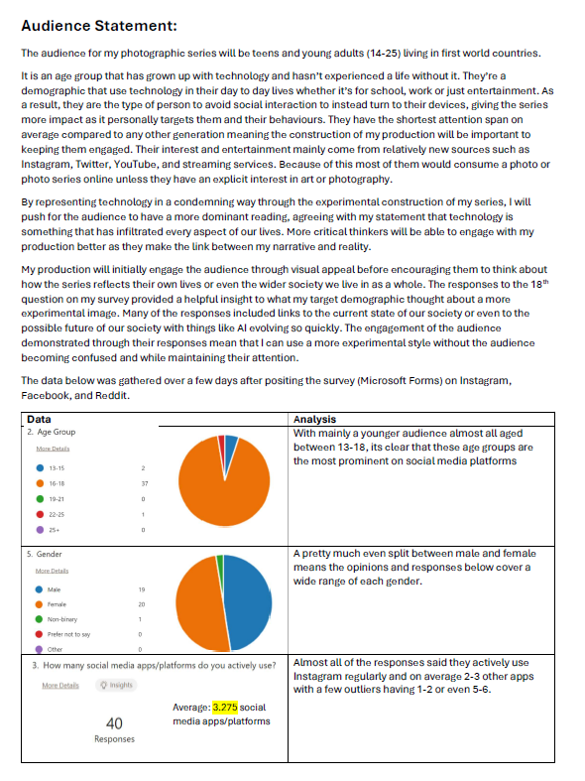
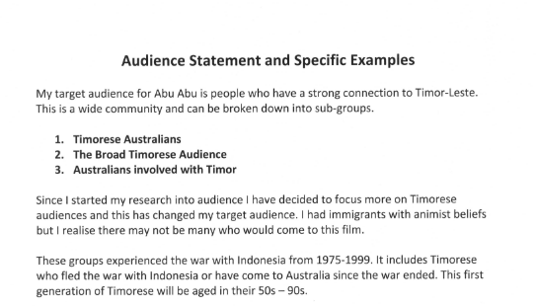

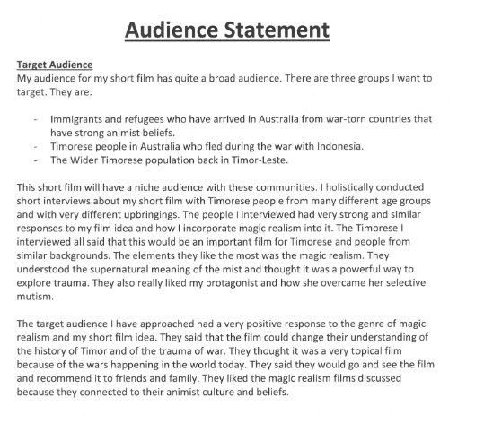

Violet Johnson, Echo
Thicia Acquisto, Abu Abu (The Mist)

Criterion 3
Unit 3 Outcome 3
Develop and document the intention, audience and narrative of a proposed production in a selected media form.
For her film ‘Abu, Abu’, Thicia researched her audience types. She researched the background of her specific audience. This research informed her audience statement. She described how she intended the audience to engage with the narrative.
To develop her audience statement for her photographic series, Violet created a survey that researched the age and gender of her audience, and how they engaged with photographic imagery through social media. She posted a form on several social media platforms to gain the views of her audience. She also posted images on social media platforms to understand how the audience engaged with the images and how they interpreted the meanings that were communicated using codes and conventions.

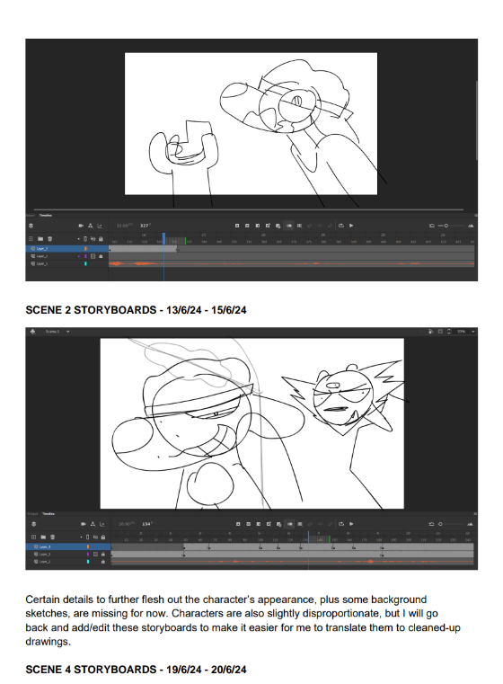
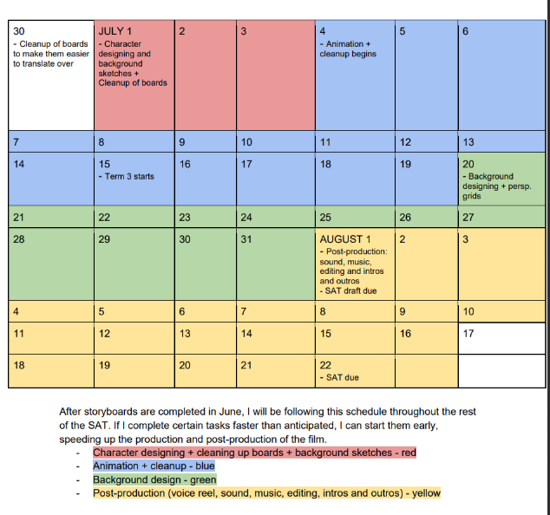

Brinners, SOUNDINE AND JITWUB

Criterion 4
Unit 3 Outcome 3
Plan and document a proposed production in a selected media form.
Brinners produced storyboards in Adobe Animate to create his animatic, and to help him determine the composition and pacing of each scene. The storyboards give a clear sense of composition, movement and mise en scene. He also annotated the story board for each scene planning the production process.
Brinners created a calendar outlining his production, including the dates for the completion of tasks. He used colour coding to identify each stage of the animation process, from character designs to completing backgrounds and creating the audio mix.

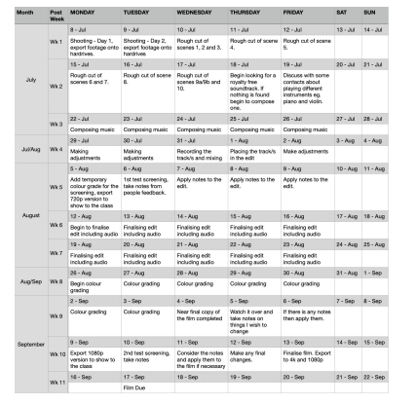
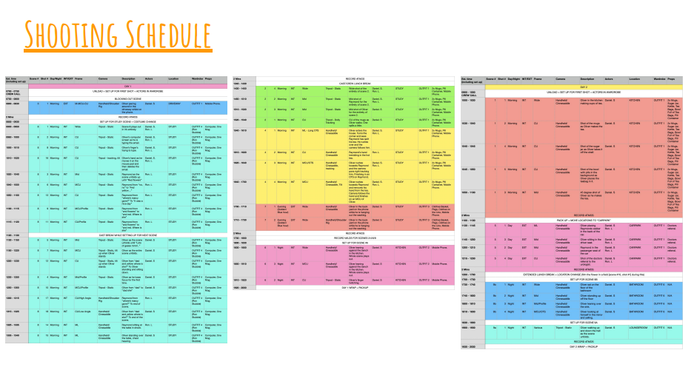

Perry Moon, Bloom

Criterion 4
Unit 3 Outcome 3
Plan and document a proposed production in a selected media form.
Perry created a shooting and post-production schedule to ensure he completed each stage with enough time to run test screenings and conduct additional filming if needed. He also scheduled breaks for his cast and crew during production.

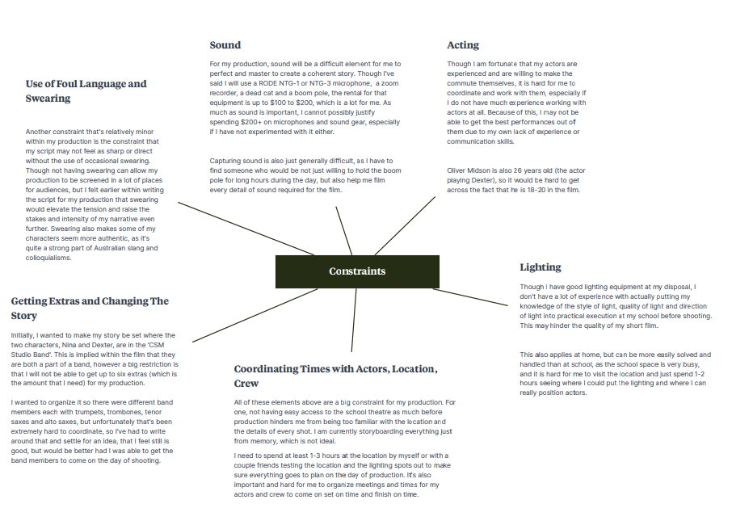
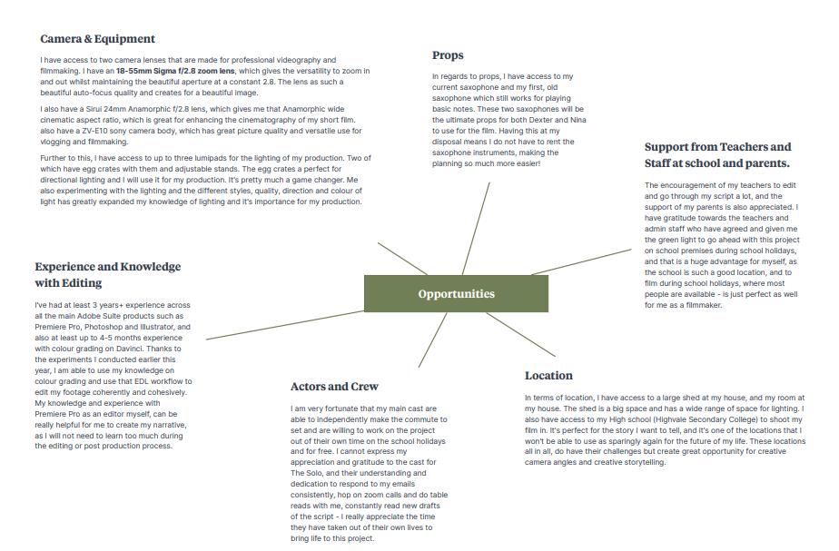

Ryan Ma, THE SOLO

Criterion 4
Unit 3 Outcome 3
Plan and document a proposed production in a selected media form.
For his film ‘The Solo’, Ryan considered the opportunities and constraints in his production planning. He considered factors such as location, lighting, props, and crew. These ‘spidergrams’ helped him plan the timeline of his production and the roles and responsibilities of cast and crew.

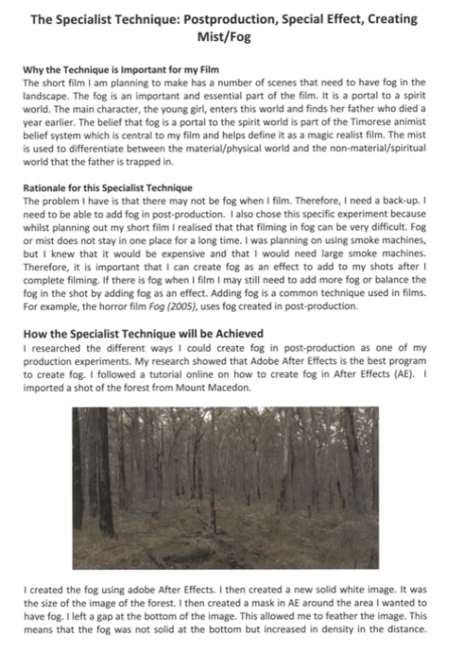
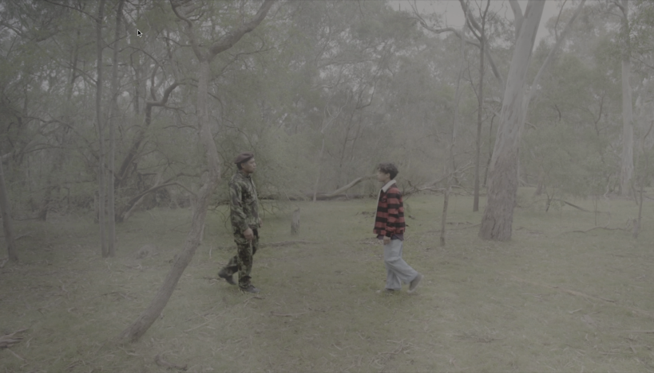

Thicia Acquisto, Abu Abu (The Mist)

Criterion 4
Unit 3 Outcome 3
Plan and document a proposed production in a selected media form.
Production documentation includes the use of materials and equipment. Thicia intended to create an effect of fog or mist in some of the scenes of her film. She documented how she used tools in Adobe After Effects in post-production to composite an overlay of fog in some scenes. This was a symbolic code to transfer the characters into the spirit world or ‘after life’.

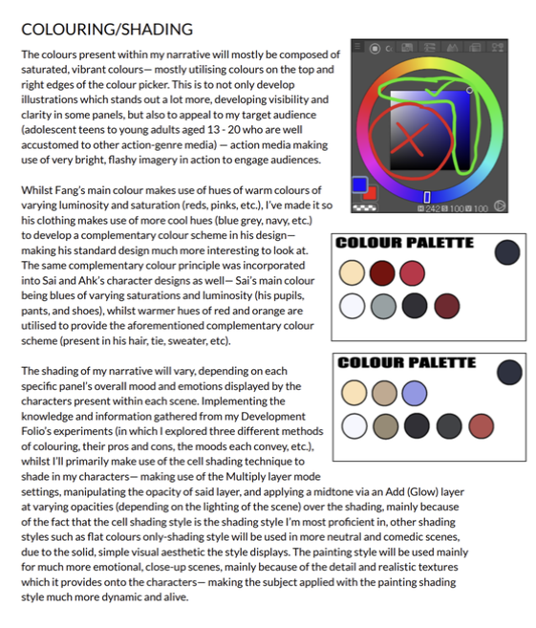
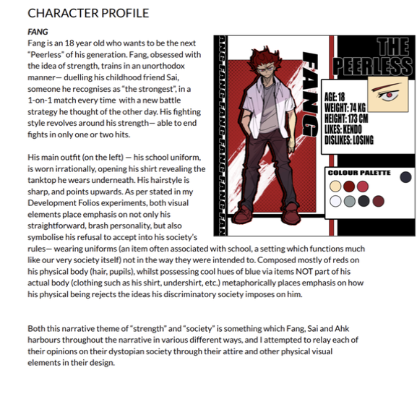

Matthew Jung, The Peerless

Criterion 4
Unit 3 Outcome 3
Plan and document a proposed production in a selected media form.
In the planning of his webtoon ‘The Peerless’, Matthew documented the characteristics of each character such as their stance, movement, and emotional expressions. He documented codes such as the setting of each scene, the colours and ‘props’ for each character.

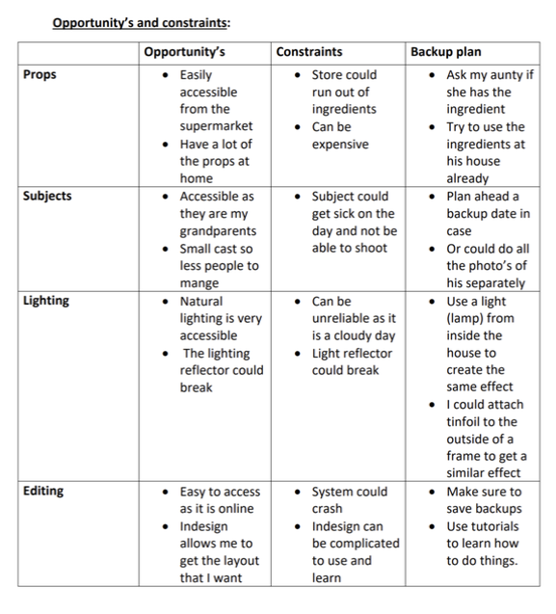
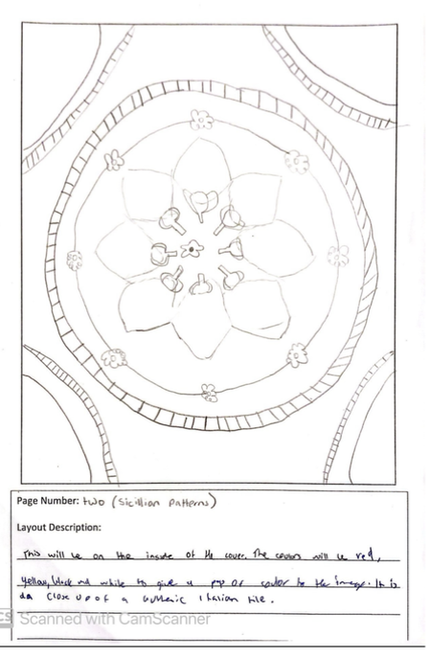

Jade Scolaro, La Dolce Vita

Criterion 4
Unit 3 Outcome 3
Plan and document a proposed production in a selected media form.
In the production planning of her cookbook, ‘La Dolce Vita’, Jade listed the crew members involved in the production, their roles and responsibilities. She wrote a table identifying opportunities, constraints, and a backup plan for each aspect of her production, including lighting, editing and sound.
She also planned the layout of each page of the book in a storyboard and provided details of the images, how they were to be photographed, and the codes and conventions that would engage the audience.

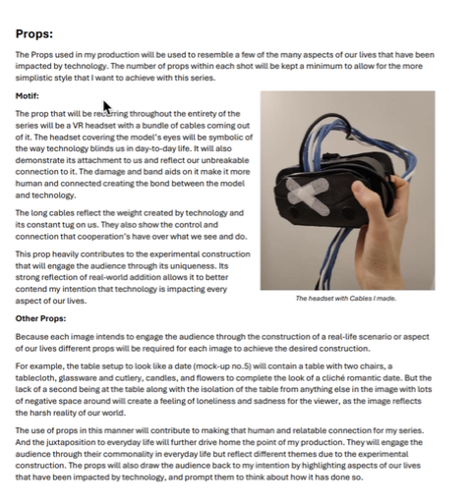
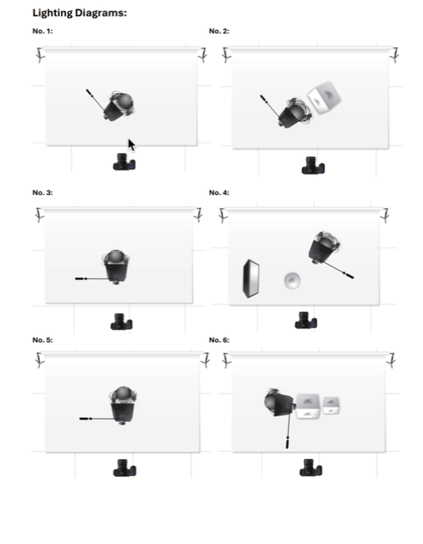
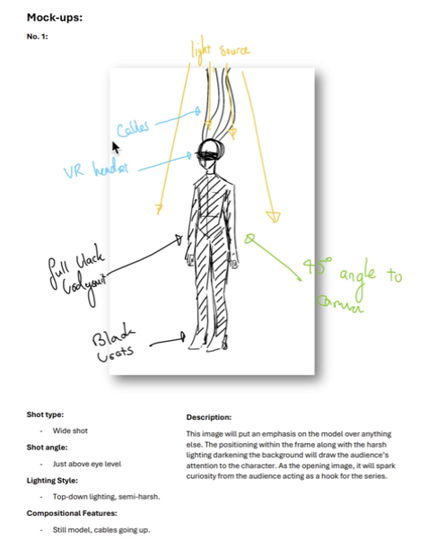

Alexander Keep, Disconnected Dependency

Criterion 4
Unit 3 Outcome 3
Plan and document a proposed production in a selected media form.
In his production plan for his photographic series Alex described the composition, shot type, angle and lighting of each image. He produced lighting diagrams and wrote descriptions of setting of each image, props, costuming, and makeup.

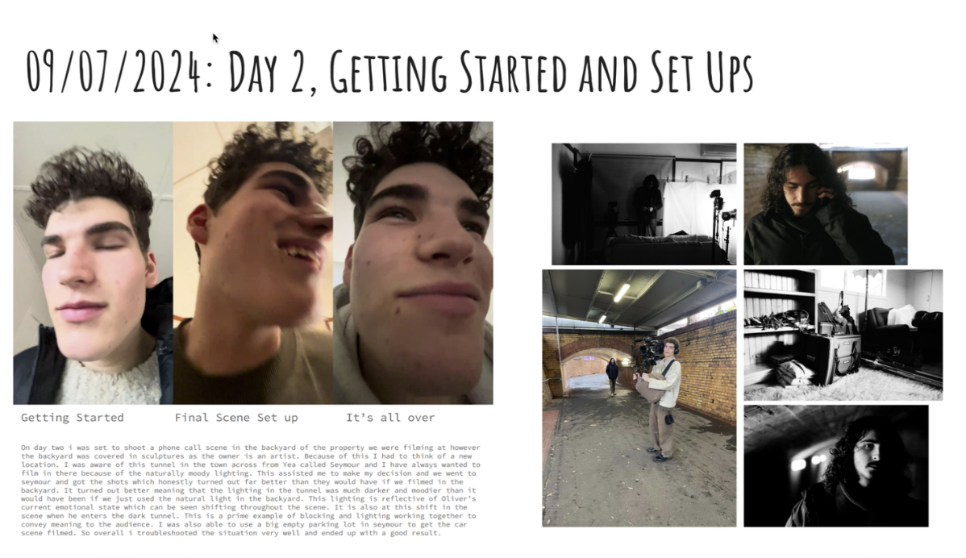
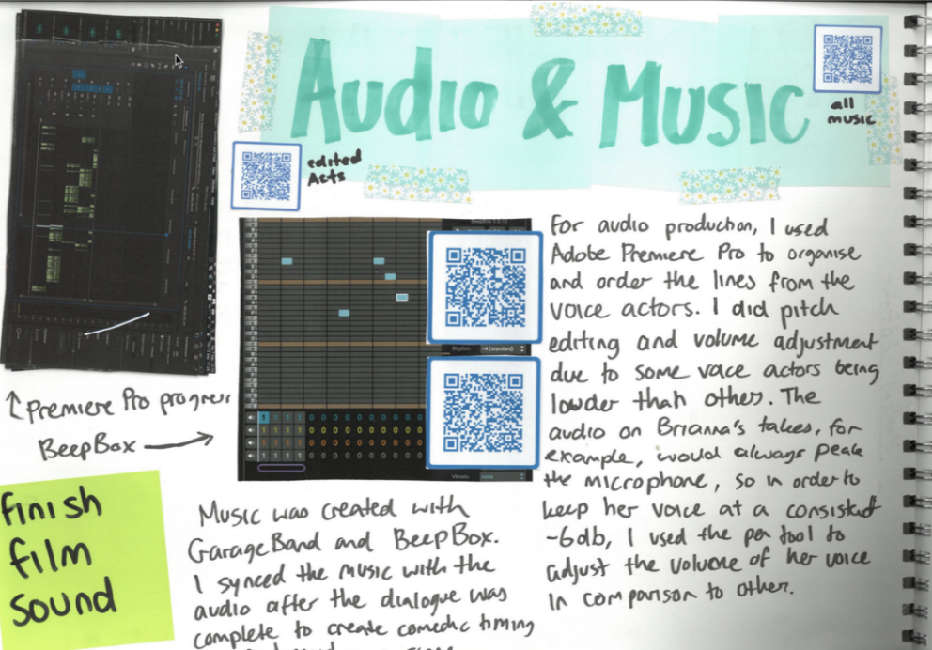

Perry Moon, Bloom
Mia Sattler, Where Did I Come From?

Criterion 5
Unit 4 Outcome 1
Use of equipment, materials and technologies in the production of a media product.
As part of her production journal documenting the processes for her animation “Where did I come from?”, Mia captured screen shots of each stage in her process. She annotated each shot discussing the codes and conventions that would best convey her intentions. She used a QR code that linked the production journal to the relevant aspects of her production design.
Perry documented the scripting for one of his shots discussing the significance of the setting. His inclusion of behind-the-scenes shots demonstrated his use of equipment and consideration of both natural and artificial lighting.

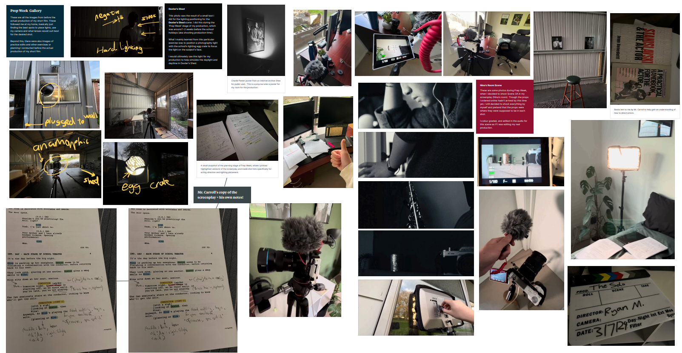
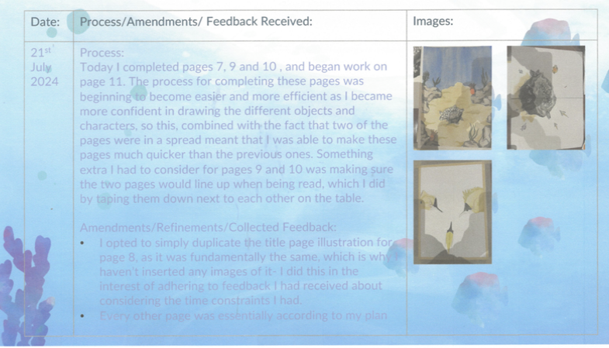
Claudia Bellsmith, Syd and the Unexpected Guest

Ryan Ma, THE SOLO

Criterion 5
Unit 4 Outcome 1
Use of equipment, materials and technologies in the production of a media product.
For her illustrated book ‘Syd and the unexpected guest’ Claudia had created mockups of each page. To document the equipment and materials she used, Claudia discussed what she completed each day in her production journal. She also used these templates to document audience feedback as each template was linked to a page in the book. She highlighted the feedback and the refinements and amendments she made to the page.
For his film ‘The Solo’, Ryan documented his camera set ups and marked up his scripts in his production journal. His annotations made a clear link to his original intentions, research, experiments, and pre-production, demonstrating the logical sequencing of his production and post-production processes.

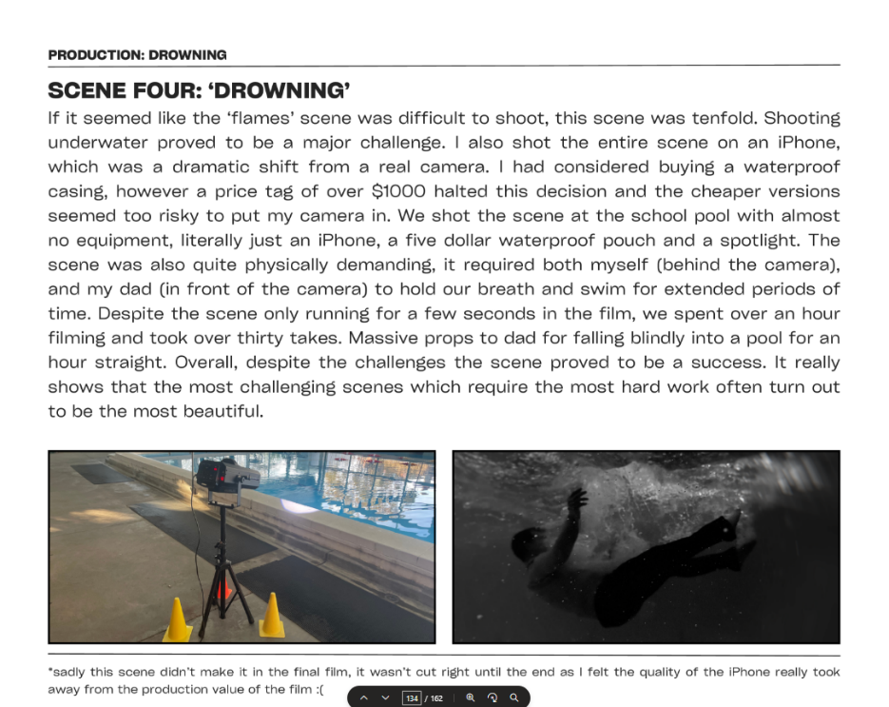
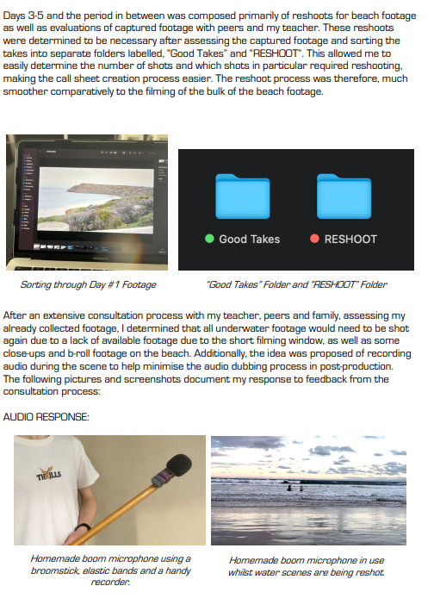
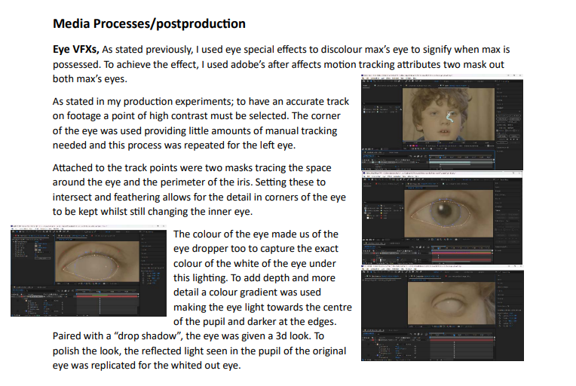

Tadhag Sheehan, Off the record
Alex Feehan, Survivor

Criterion 6
Document the development, refinement and resolution of a media product.
In his production journal Tadhag documented his use of VFX in post-production to convey a ‘possessed boy’ in his film ‘Off the Record’. He described each stage of the process and used images to document the effects.
Alex documented his production and use of equipment in a production diary. He improvised and made his own boom from household items. He documented the technical considerations he made when shooting his underwater sequences.
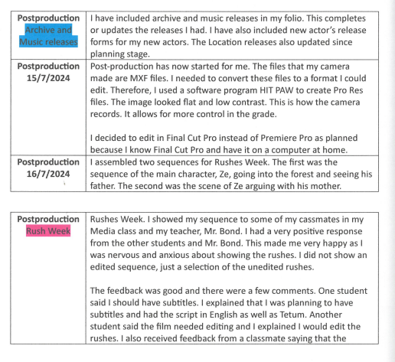
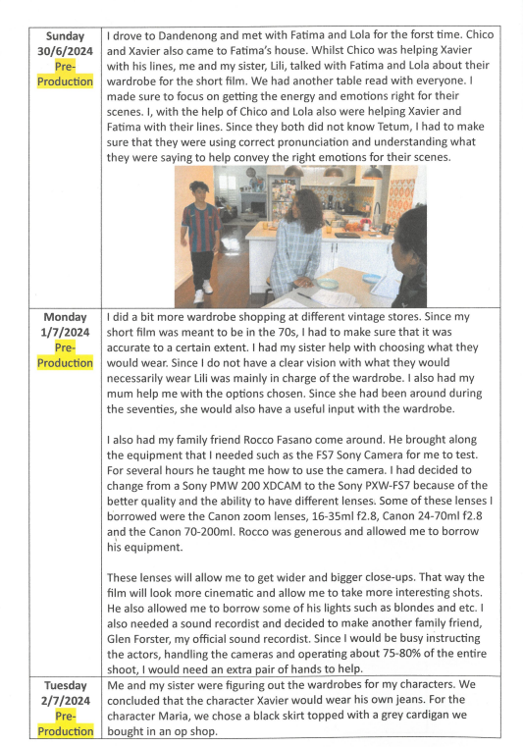
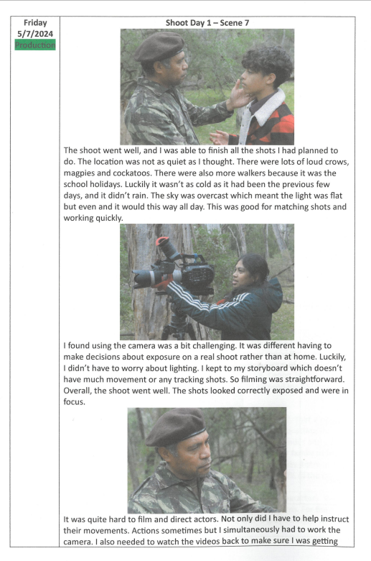
Thicia Acquisto, Abu Abu (The Mist)

Criterion 6
Document the development, refinement and resolution of a media product.
Thicia kept a journal documenting the three aspects of her production: Pre-production, Production and Post-production. She used timelines with dates and provided images from her preparation, filming and post-production work. She describes the preparation for filming discussing the setting, actors and props. Throughout filming Thicia discusses the issues and challenges that eventuated in relation to her original intention and how she used critical thinking and problem solving to resolve them. She also discussed the processes of Post-production and refinement of her film in relation to audience feedback.

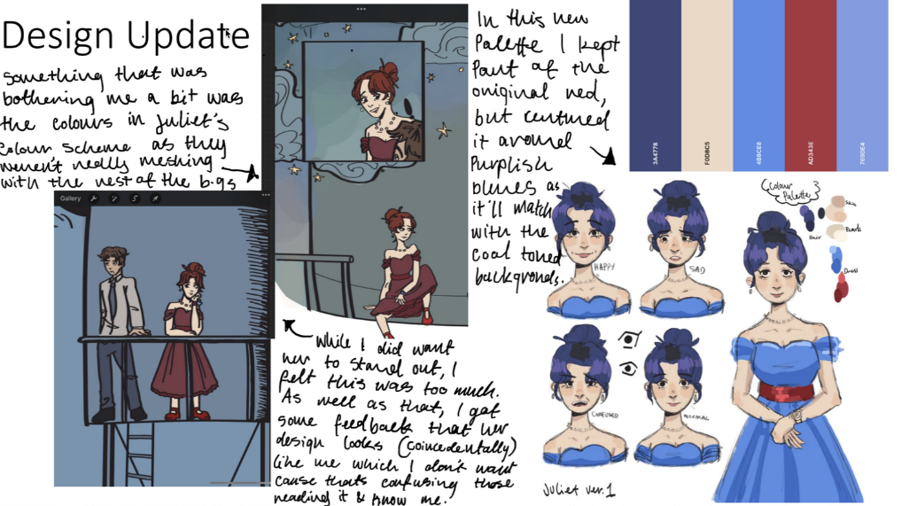
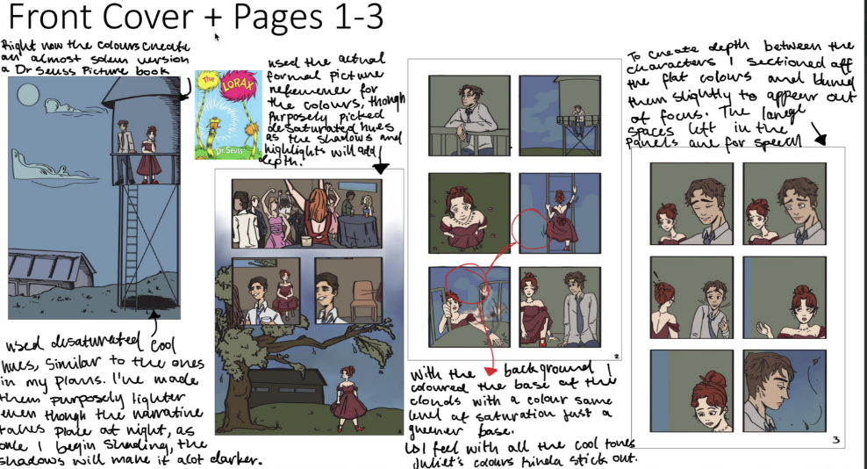
Emilia Perry, Prom 34

Criterion 6
Document the development, refinement and resolution of a media product.
To document her production process for her graphic novel ‘Prom 34’, in her production journal Emilia provided illustrations for each page with annotations. The pages included the characters, setting, composition and colours used. The use of each code and convention was evaluated discussing how they communicated meaning to the audience.

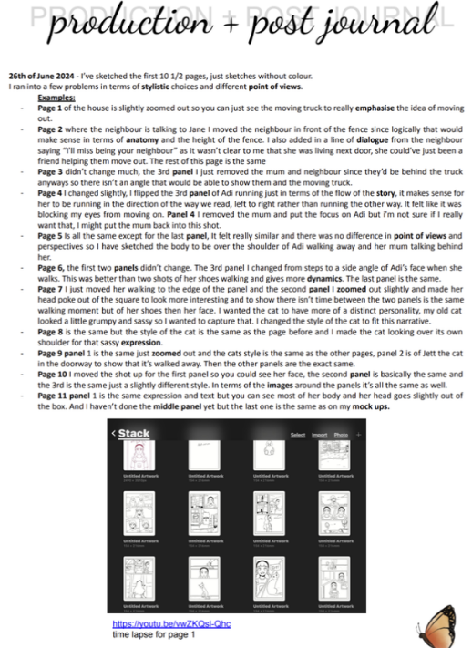
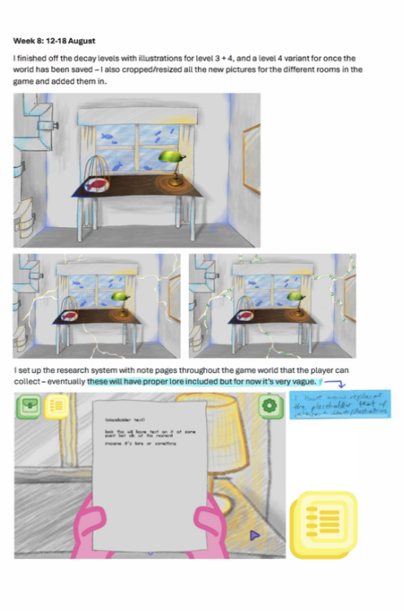
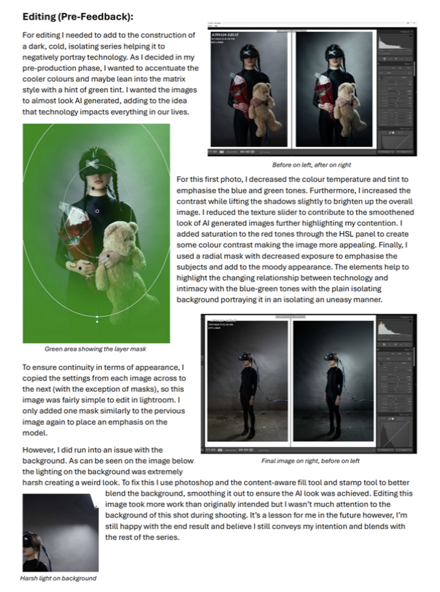

Addison Kemp, Lost and Found
Miles Steele, Torn Apart
Alexander Keep, Disconnected Dependency

Criterion 6
Unit 4 Outcome 1
Document the development, refinement and resolution of a media product.
For her illustrated book ‘Lost and Found’, Addison documented the main aspects of her production in her production journal. She discussed the changes she made to aspects of the production and why she changed them, referring to her intention and audience. She included a time lapse of the development and flow of the screens to illustrate how she was thinking about the structure of her narrative.
In developing and refining his online game ‘Torn Apart’, Miles documented all the steps of the process of refinement. He documented the illustrations for two levels of the game with notes on his refinement, explaining all aspects of the level. Using specific media language, he referred to the digital tools and software he used such as programming characteristics.
During production of his photographic series, Alex documented the shoot for one of his images discussing the equipment and materials he used, and how it successfully met his intentions. He then annotated the contact sheets keeping in mind the codes and conventions, and his intention for each image in the series. He edited the selected images in post-production in an editing program, discussing the digital software tools he used. Alex considered the ideas he was trying to communicate with the images and referred to his production design plan, his audience and their engagement, when he was selecting the most successful image.

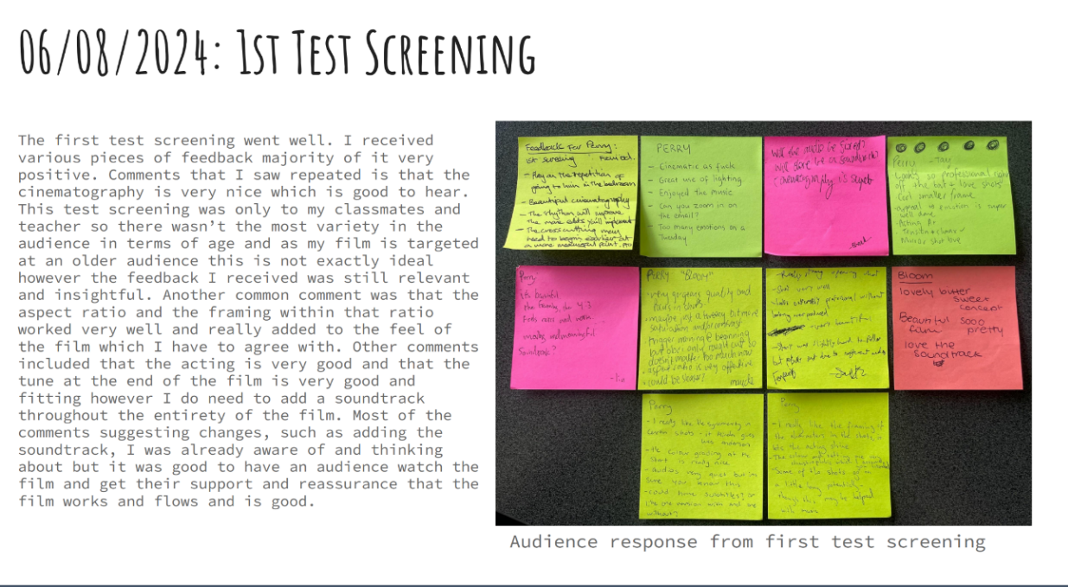
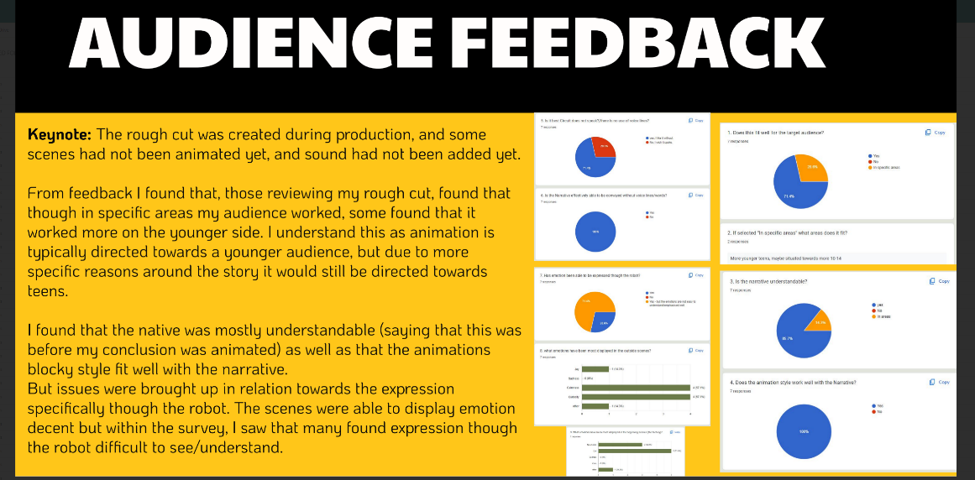
Perry Moon, Bloom
Keeley Blackwood, Circuit

Criteria 7
Unit 4 Outcome 1
Use of reflection and feedback to refine and resolve a media product
Keeley ran a rough cut of her animation ‘Circuit’ and documented her audience feedback through Google forms. She asked questions that targeted her audience and their engagement with the narrative. She also asked about specific aspects of her narrative such as the characters, use of dialogue, and colouring and sequencing of the frames in the animation. She also reflected on the feedback of ‘What worked well’ and ‘What needed improvement?’ drawing on her knowledge of codes and conventions, audience engagement and reading.
Perry ran test screenings of his film ‘Bloom’. He structured and documented the feedback in two forms; using Post-It notes and a Google form. He provided evidence of the feedback and documented aspects of the production he planned to refine such as the structure of the narrative that best would engage the audience and their reading.

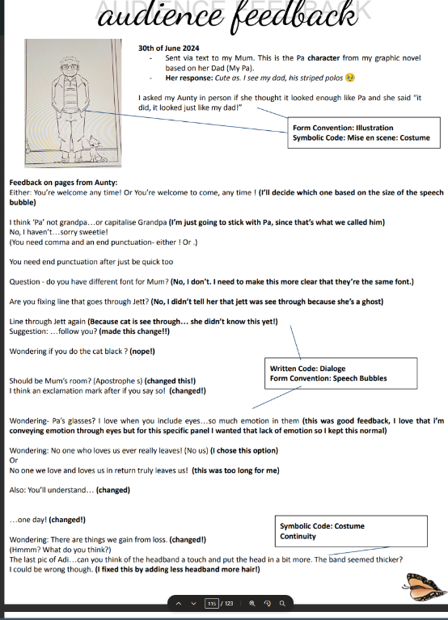
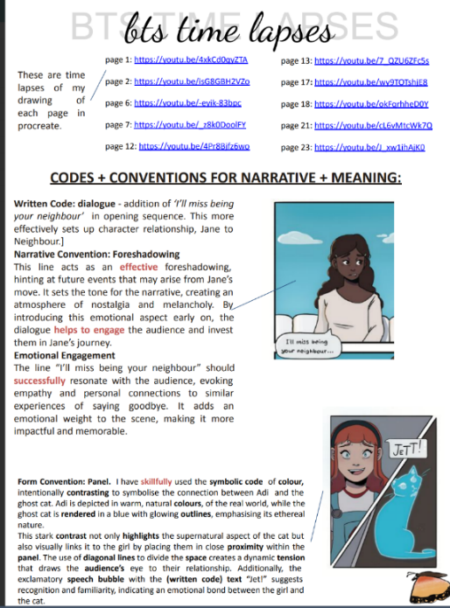

‘’’

Addison Kemp, Lost and Found

Criteria 7
Unit 4 Outcome 1
Use of reflection and feedback to refine and resolve a media product
Addison produced draft pages of her graphic novel ‘Lost and Found’, to collect feedback from her audience. She selected specific pages from her novel to document the codes and conventions and record the feedback. She used images from her novel to illustrate her reflection on the feedback and the refinements she intended to make. She also evaluated the codes and conventions that she thought best conveyed meaning to her audience.

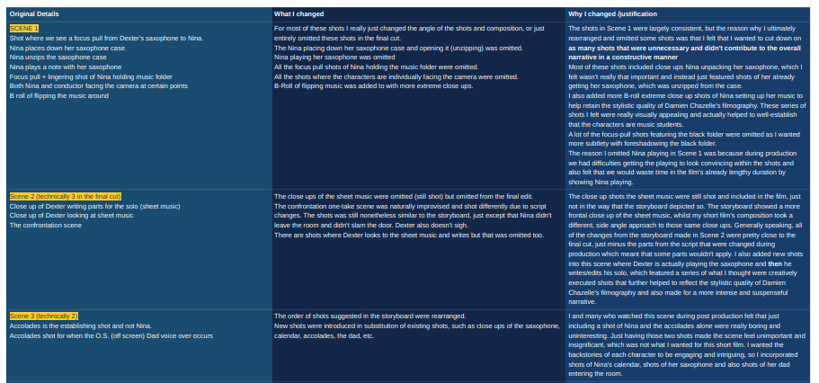
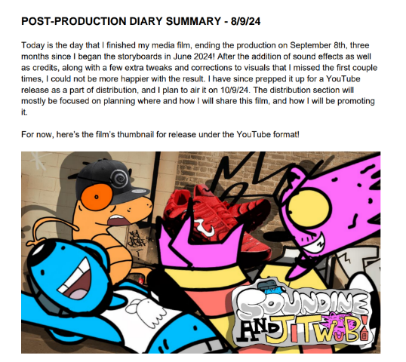
Ryan Ma, THE SOLO

Brinners, SOUNDINE AND JITWUB

Criterion 8
Unit 4 Outcome 1
Produce a media product that realises the media production plan
Brinners wrote an evaluation of his animation ‘Soundine and Jitwub’. HIs production process evolved from the initial creation of his two characters. Brinner’s reflection evaluated his audience feedback and explained where he intended to distribute the film. He discussed the similarities between another animation that formed his inspiration and his own production. Brinners also explained some of the processes he used in the production such as digital and traditional stop motion techniques.
In finalising ‘The Solo’, Ryan evaluated each scene he had refined after feedback from his peers. He also evaluated each aspect of the production such as his intention and his use of codes and conventions. One specific decision was to cut certain shots, whilst adding others, to align the structure of his narrative more closely to one of his key influencers, Damien Chazelle, the director of Whiplash and La Land fame.

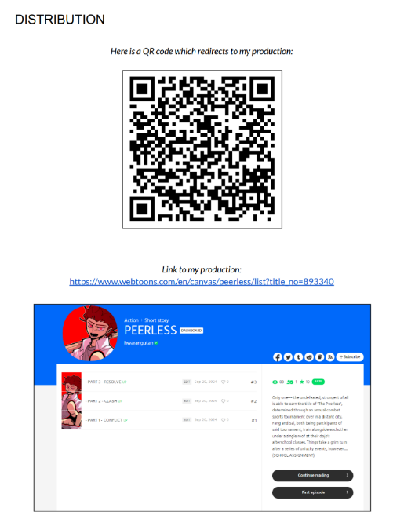
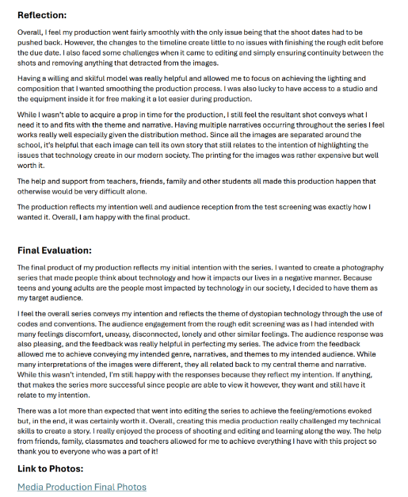

Matthew Jung, The Peerless
Alexander Keep, Disconnected Dependency

Criterion 8
Unit 4 Outcome 1
Produce a media product that realises the media production plan
For his photographic series ‘Disconnected dependency’, Alex reflected on the challenges he had in production and post-production. He gave specific examples such as his use of a model and props. He then evaluated how the series achieved his intention to communicate a theme of ‘dystopian technology’. He discussed the codes and conventions he used to engage his audience and the considerations he made in editing in post-production.
Matthew provided a QR code for the distribution of his ‘webtoon’. In his reflection he explained how he had refined his skills with equipment and technologies throughout the production process. Matthew reflected on the positives and areas where he could have improved his production processes and his overall product. He discussed how he would have refined his narrative to lessen the amount of illustrating work he had to complete. He explained how the characters and the style of his narrative met his initial intentions.

