2025 VCE Chemistry (NHT) external assessment report
This report provides sample answers, or an indication of what answers may have included. Unless otherwise stated, these are not intended to be exemplary or complete responses.

Section A – Multiple-choice questions
Question | Correct answer | Comments
1 | D | The energy available from 100 g of biscuits is given by  8.90 × 17 + 5.2 × 37 + 78.5 × 16 = 1.6 × 10³ kJ
2 | D | The half equation for the oxidation process is  C₆H₁₂O₆ + 6H₂O → 6CO₂ + 24H⁺ + 24e⁻  Therefore, for every 1 mol of glucose, 24 mol of electrons are produced.
3 | C | From the energy profile diagram  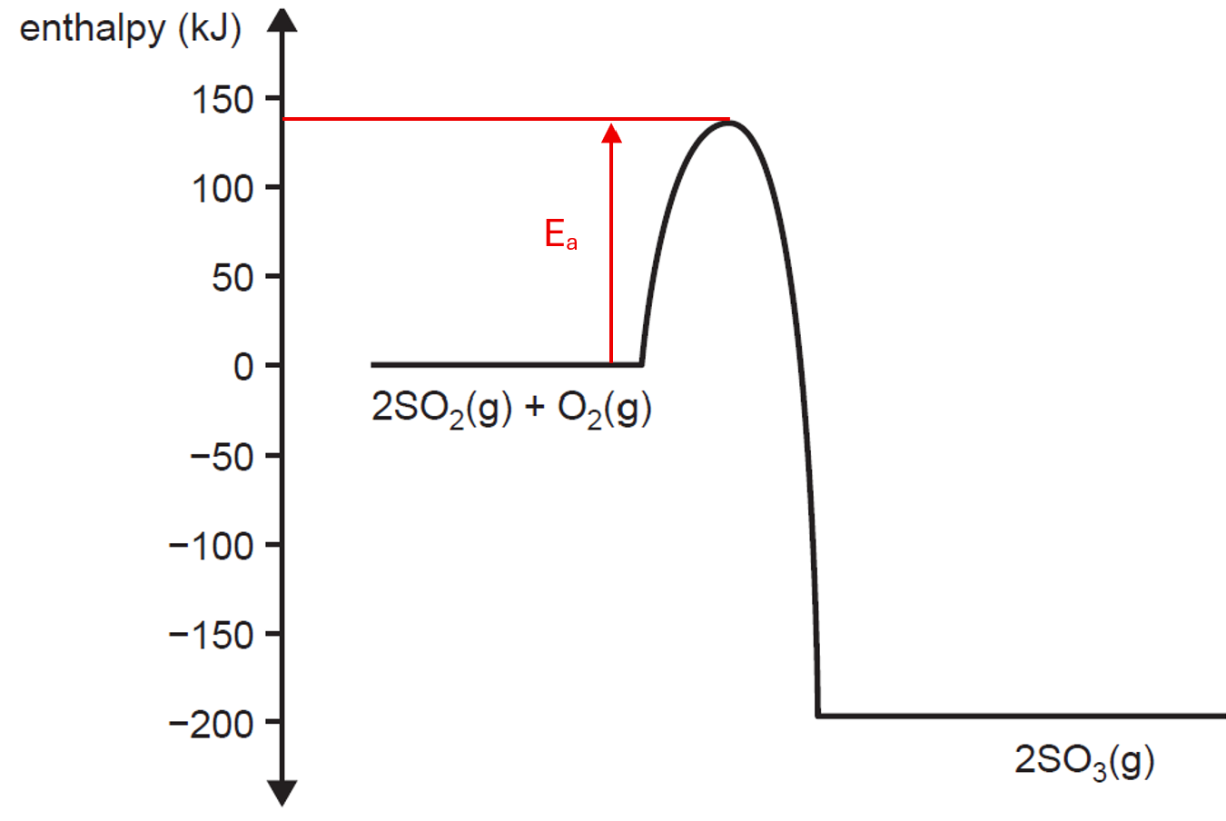  This profile shows that the E_{a} is approximately 140 kJ for every 2 mol of SO₃ produced.  Therefore, to produce 7.00 mol of SO₃, the activation energy needed would be approximately  140 × 7/2 = 490 kJ.  Response C is the closest value to this number.
4 | B | To create 250 MJ of energy (assuming 100% efficiency), the mass, in kg, is given by  mass of bioethanol_{(100% efficiency)} = 250/30 = 8.333 kg.  Allowing for the 25% efficiency, the mass of bioethanol is thus given by  mass of bioethanol_{(25% efficiency)} = 8.333/0.25 = 33 kg = 3.3 × 10¹ kg.
5 | D | At equilibrium, the rate of the forward reaction is equal to the rate of the backward reaction and is always a non-zero value.  The extent of a reaction (yield) is a measure of the relative quantity of product formed.  Therefore, neither statement I nor statement II is correct.
6 | B | The concentration–time graph shown indicates that there is no instantaneous change to any concentration. The stress clearly produces a gradual rather than an instantaneous change and thus suggests a temperature change.  As both the H₂ and N₂ have increased and the NH₃ has decreased, this indicates that a backward shift has occurred.  A backward shift for the exothermic equation given indicates that the temperature must have been increased, and this matches what is seen in the concentration vs time graph.
7 | A | Q is always a measure of the extent of a reaction at a specific point in time, as it is determined by the numerical ratio of products over reactants.
8 | B | An increase in the rate of the forward reaction (at constant temperature) can be instantaneously achieved by increasing the concentration of an individual reactant, or by increasing the concentration of all species.  However, when the system reaches a new equilibrium position, an increase in the rate of both forward and backward reactions can be achieved by increasing the concentration of any species, or by increasing the overall concentration of the system by reducing the volume. Hence, increasing the concentration of a product increases the rate of the forward reaction at its new equilibrium position.  Increasing the pressure by adding an inert gas does not alter the concentration of reactants or products and so will have no effect on the rate of either forward or backward reactions.  The equilibrium constant cannot be changed without changing the temperature; the stem of the question states that the temperature has been held constant.
9 | C | Statements I, II and III are all valid and correct.
10 | A | Al³⁺ + 3e⁻ → Al  For 2 mol of Al, 2 × 3 mol of electrons are required.  Since Q = nF, therefore Q = 2 × 3 × 96 500  Given that t = Q/I, therefore t = 2 × 3 × 96 500 / 7 seconds
11 | D | The average bond enthalpies are given in items 10 and 11 in the Data Book.  C≡C is 839 kJ and clearly smaller than that given for N≡N, which is 945 kJ.  Individual bonds for atoms within molecules vary depending on what they are attached to.  Silicon has four valence electrons.  The C-F has an average bond enthalpy of 492 kJ, whereas C-Cl has an average bond enthalpy of 324 kJ.
12 | A | Octane and 2-methylheptane have identical molar masses and are both non-polar molecules that can only form dispersion forces.  Octane is an unbranched molecule and so can form more intermolecular forces than the  2-methylheptane due to the branch reducing the opportunity for intermolecular forces to form. With a reduced number of intermolecular forces between its molecules, 2-methylheptane will have a lower melting point and a lower boiling point, as less energy is needed to break/disrupt these bonds.
13 | A | 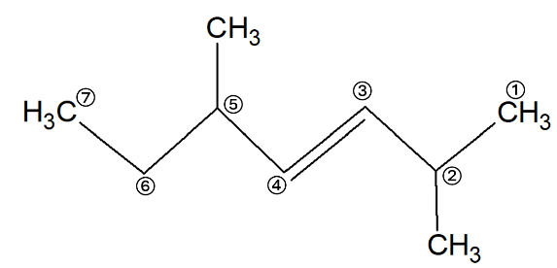  Response A can be redrawn as follows.  This diagram clearly shows that it is 2,5-dimethylhept-3-ene.  Response B is 2,5-dimethylhex-3-ene.  Response C is 2,6-dimethylhept-3-ene.  Response D would need to have a molecular formula of C₉H₁₈ to be correct.
14 | B | 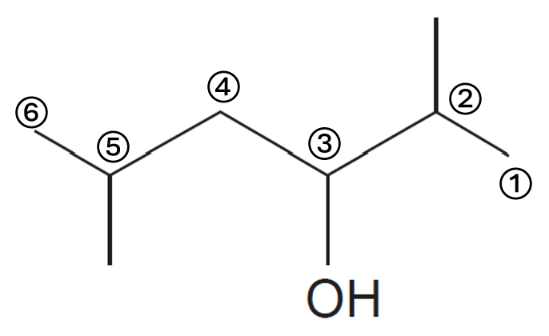  The International Union of Pure and Applied Chemistry (IUPAC) name for this molecule is  2,5-dimethylhexan-3-ol.
15 | C | Pentan-1-ol is a primary alcohol.  Pentan-5-ol (pentan-1-ol if named correctly) is a primary alcohol.  2-methylbutan-2-ol is a tertiary alcohol.
16 | C | Chemical J + C₂H₄ → X  Chemical J ≠ ethane because these two molecules do not react.  If Chemical J is oxygen gas, this could react with ethene but not via an addition reaction.  Chemical J could easily be iodine, as halogens readily react with C=C via addition reactions.  Chemical J ≠ glycerol because these two molecules do not react.
17 | B | A possible reaction can occur between H₂O and a primary haloalkane and will produce a primary alcohol and HCl.  Catalyst  That is, H₂O + CH₃Cl → CH₃OH + HCl  Cl₂, H₂O and KOH will not be products from this type of substitution reaction.
18 | C | Responses A and B have molecular formulas of C₅H₁₂O and hence are incorrect.  For the dichromate solution to remain orange, no reaction must have taken place.  This means Molecule G is not a primary or secondary alcohol.  Response D is a secondary alcohol.  Response C is a tertiary alcohol and hence would not react and no colour change would occur.
19 | B | To obtain a high atom economy, little to no waste can occur, as all the reactant atoms are ideally converted to the desired product.
20 | A | The limiting reagent in this reaction is the 4-aminophenol.  Therefore, the maximum mass of C₈H₉NO₂ will be given by  mass(C₈H₉NO₂)_{max} = n × M = 0.073 × 151 = 11.023 g  Given that the %yield is 60.7%, the actual mass of C₈H₉NO₂ will be given by  actual mass(C₈H₉NO₂) = 11.023 × 0.607 = 6.69 g
21 | A | The production of chemicals from industrial waste is sustainable because the supply of these materials is always going to be there (as long as the industry continues).  Lots of different catalysts can follow green chemistry principles – typically, natural soil-based catalysts such as zeolites.  ‘Safer chemicals’ relates to the potential harm caused by a chemical rather than its ability not to break down.  Solvents from fossil fuels are usually very detrimental to the environment (e.g., petrol), whereas plant materials often produce solvents that are readily broken down in the environment.
22 | D | To detect a C=C bond, halogens such as Br₂ or I₂ are typically used, as they readily decolourise.  To detect the carboxyl functional group, sodium hydrogen carbonate is frequently used, as it produces a gas in the presence of the carboxyl group.  Limewater only detects the evolution of carbon dioxide gas from a reaction.  Acidified dichromate is used to detect primary and secondary alcohols.
23 | A | Melting point range is an indication of purity. A pure sample will usually have a narrow melting point range (approximately <3 °C). An impure sample will tend to have a much broader melting point range.  If a sample is a mixture, it will have a broad melting point as well as usually having a depressed melting point. If the melting point is significantly lower than the expected value, there is a reasonable chance that it is not the material being sought after. It may be a different compound altogether.
24 | C | n(H₂O₂) = 10/1000 × 0.882 = 0.00882 mol  n(MnO₄⁻) : n(H₂O₂) is 2:5, therefore n(MnO₄⁻) = 0.00882 × 2/5 = 0.003528 mol  V = n/C = 0.003528 / 0.1 = 0.03528 L = 35.3 mL
25 | D | CH₃COCH₂CONH₂ contains a ketone and an amide group.  Amides absorb in the range 1630–1680 cm⁻¹.  Ketones absorb in the range 1680–1850 cm⁻¹.
26 | D | (CH₃)₂CHOH would be expected to produce a large doublet around 0.9–1.0 ppm, a small singlet around 1–6 ppm and a small multiplet around 3.3–4.5 ppm.  CH₃CH₂COOH would be expected to produce a triplet around 0.9–1.0 ppm, a quartet around 2.0 ppm and a small singlet around 9–13 ppm.  CH₃COOOCH₂CH₃ would be expected to produce a large triplet around 0.9–1.0 ppm, a quartet around 3.3–4.5 ppm and a large singlet at 2.0 ppm.  CH₃COCHClCH₃ would be expected to produce a large doublet around 0.9–1.0 ppm, a small quartet around 3.0–4.5 ppm and a large singlet at 2.0 ppm – this best matches the spectra.
27 | B | Determination of a quantity of substance present in an HPLC trace is based on establishing a calibration plot generated by a range of standards with known concentrations.  For this calibration plot to be accurate, the same conditions need to be maintained throughout the analysis, that is, pressure/flow rate needs to be constant.
28 | C | Distillation using a fractionating column should produce a pure sample of the lower boiling point material.  However, this will not occur if the temperature of the vapour travelling up the fractionating column is too high. When this happens, a mixture of materials can sometimes reach the condenser.  This most frequently occurs if the distilling flask is heated excessively and the temperature of the gases passing into the condenser exceeds the boiling point of the lowest boiling point material in the mixture.
29 | C | Taking samples at shorter time intervals will improve the level of detail being shown in the temperature vs time plot shown. This improvement in the plot will allow for a more precise measurement of the maximum temperature being reached.
30 | A | Clear outliers should be identified and these outliers should not be included in any analysis.  Outliers usually occur due to mistakes being made in an individual experiment or occasionally due to large random errors that may have occurred.  They will not be due to systematic errors, as any systematic error would shift all the results in the same direction.

Section B

Question 1a.i
Glucose.

Question 1a.ii
Zero.
The study design specifically states that, for VCE Chemistry, the ‘degree of unsaturation’ is to be considered in terms of the number of C=C bonds and neither the ring form nor open chain form of glucose contains a C=C bond.

Question 1a.iii
Hydrolysis / enzyme-catalysed hydrolysis.

Question 1b
The first mark was awarded for showing an understanding that altering the pH changes the protonation/deprotonation/ionisation and hence the bonding that can occur between polar groups in the enzyme.
The second mark was awarded for showing an understanding that altering the bonding of the polar groups changes/disrupts the secondary, tertiary or quaternary structure of the enzyme and hence changes the active site conformation.
The third mark was awarded for showing an understanding that the function of the enzyme will be reduced if the active site conformation changes. This is because the substrate will be unable to bind as effectively and therefore it will not be able to efficiently catalyse the reaction.

Question 1c.i
Hydroxyl group / hydroxy group or amino group.

Question 1c.ii
The first mark was awarded for showing an understanding that the inhibitor binds to the active site of the enzyme.
The second mark was awarded for showing an understanding that the substrate is then unable to bind to the enzyme because the active site is blocked. Therefore, the enzyme cannot catalyse the reaction.

Question 1c.iii
Four.

Question 2a
The first mark was awarded for the correct calculation of the amount of carbon dioxide.
n(CO₂) = 8 × n(C₈H₁₈) = 12.0 mol
The second mark was awarded for the subsequent calculation of the mass of carbon dioxide.
m(CO₂) = 12.0 × 44.0 = 528 g

Question 2b
The first mark was awarded for showing a clear understanding that in the combustion of octane, the energy needed to break reactant bonds is less than the energy produced by making new bonds. (No calculation was required, but marks were awarded if shown.)
The second mark was awarded for showing a clear understanding that this means that the energy from this process is released as heat. This release of heat causes the temperature to rise, which indicates that the combustion of octane is an exothermic process.

Question 2c.i
Carbon monoxide / CO.

Question 2c.ii
The first mark was awarded for showing a clear understanding that to completely combust octane, the theoretical molar ratio of octane to oxygen is 2:25 and the given experiment molar ratio was 2:21.
The second mark was awarded for linking this ratio back to the production of CO(g). Therefore, there is not enough O₂ for complete combustion/oxidation to occur and hence CO(g) will be produced (since no pure carbon was produced during this process).

Question 3a
One.

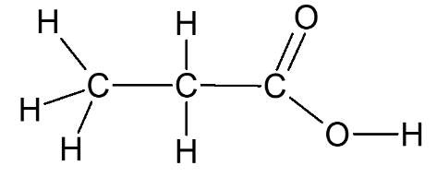
Question 3b

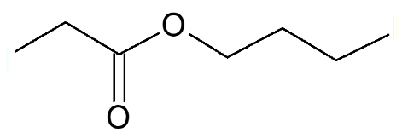
Question 3c

Question 3d.i
H₂SO₄(l) / sulfuric acid.

Question 3d.ii
Butyl propanoate.

Question 3e
Butan-1-ol / 1-butanol.

Question 3f
% atom economy =
The first mark was awarded for the substitution / use of correct molar masses of either reactants or products.
The second mark was awarded for using the molar masses to correctly calculate the % atom economy.

Question 3g
The first mark was awarded for the identification that propanoic acid / Compound Q has the highest boiling point.
The second mark was awarded for one of the following justifications:
- The carboxylic acid has more hydrogen bonding between molecules than the hydroxyl groups in the alcohol.
- Carboxylic acids form dimers, which have very high boiling points.
- With carboxylic acids, there are more sites for hydrogen bonding to occur.

Question 4a.i
 | [CO₂] | [CF₄] | [COF₂]
Initial | 1.00 | 1.00 | 0
Change | −x  (−0.26) | −x  (−0.26) | +2x  (+2 × 0.26)
Equilibrium | 0.74 | 0.74 | 0.52
The first mark was awarded for the correct calculation of the change in concentration of CF₄ or the amount of CF₄ that occurred.
∆[CF₄] = 0.26 M or ∆n(CF₄) = 0.52 mol
The second mark was awarded for determining that the equilibrium concentration of COF₂ = 0.52 M.
(Correct units were required for full marks to be awarded.)

Question 4a.ii
The first mark was awarded for the correct relationship and substitution of values into the equilibrium expression.
K = [COF₂]² / ([CO₂] × [CF₄]) = 0.52² / (0.74 × 0.74)
The second mark was awarded for the correct calculation of the K value based on the values used to calculate it.
K = 0.49 (Since this is a unitless expression, full marks could not be awarded if units were given.)

Question 4b.i
Q decreases or Q < K.

Question 4b.ii
The first mark was awarded for the correct understanding of the shift in equilibrium: equilibrium shifts to the right / forward.
The second mark was awarded for the correct understanding of this effect on the yield: the concentration/amount of the product increases so the yield is increased.
Valid arguments that used Q and K values were also accepted, but reference to relative concentration changes was required for full marks.

Question 5a.i
The first mark was awarded for the correct calculation of energy.
E = 2.1 × 374 = 785.4 J
The second mark was awarded for the correct calculation of time based on the value of energy determined.
t = 785.4/(4.85 × 1.80) = 90 s or 1.5 min
(Units for time had to be included.)

Question 5a.ii
The first mark was awarded for identifying that the heat capacity of water was required.
The second mark was awarded for showing an understanding that at least 418 J of energy would have been needed to heat 100 g of water by 1 °C.
The third mark was awarded for showing an understanding that since only 374 J of energy was needed to heat the calorimeter by 1 °C, there must have been less than 100 g (<89.5 g) of water present.
Responses that used a full mathematical calculation to show this were accepted if they also related their final answer back to the 100 g stated in the question stem.

Question 5b
The first mark was awarded for the correct calculation of n(H₂SO₄) required.
n(H₂SO₄)_{required} = n(NaOH)/2 = 0.060/2 = 0.030 mol
The second mark was awarded for the correct calculation of amount of n(H₂SO₄) originally available.
n(H₂SO₄)_{available} = 0.080 × 0.40 = 0.032 mol
The third mark was awarded for the correct calculation of n(H₂SO₄) in excess.
n(H₂SO₄)_{excess} = n(H₂SO₄)_{available} − n(H₂SO₄)_{required} = 0.032 − 0.030 = 0.002 mol

Question 6a
Cr₂O₇²⁻(aq) + 14H⁺(aq) + 6Fe²⁺(aq) → 2Cr³⁺(aq) + 7H₂O(l) + 6Fe³⁺(aq)
The first mark was awarded for the correct reactants and products.
The second mark was awarded for providing a correctly balanced equation.

Question 6b.i
Cr₂O₇²⁻ / dichromate ion.

Question 6b.ii
The oxidation number of Cr decreased from +6 to +3.
An explanation based on the Fe undergoing oxidation from +2 to +3, and therefore the dichromate being the oxidising agent/species being reduced, was also accepted.
The use of ‘6+’, ‘3+’, ‘6’ or ‘3’ were not accepted as valid oxidation numbers.

Question 6c.i
The first mark was awarded for the correct calculation of n(Cr³⁺).
n(Cr³⁺) = 1/3 × 1.00 = 0.333 mol
The second mark was awarded for the subsequent calculation of m(Cr³⁺).
m(Cr³⁺) = 0.333 × 52 = 17 g (two significant figures)
(Significant figures must be correctly stated to be awarded full marks.)

Question 6c.ii
The first mark was awarded for recognising that changing the chemical composition of the electrode could be used to increase the potential of the cell, as the new electrode could then take part in the overall chemical reaction.
The second mark was awarded for recognising that any metal lower than +0.77 V on the electrochemical series would produce this effect. However, due to the electrode being placed in an aqueous solution, Li, Na and K were not accepted due to their violent reactivity with water.
Higher-scoring responses recognised that the solution in half-cell B would also have to be altered to remove the Fe³⁺ ions. Otherwise, a spontaneous reaction would occur, and thermal energy would be evolved as well as the extra voltage.

Question 7a.i
Negative.

Question 7a.ii
Ag + 2OH⁻ → AgO + H₂O + 2e⁻

Question 7a.iii
Zn(OH)₂ + Ag → Zn + H₂O + AgO

Question 7a.iv
The first mark was awarded for recognising that the half reaction of the first step,
Ag₂O + H₂O + 2e⁻ ⇌ 2Ag + 2OH⁻, must be located lower on the standard electrode potential table than +0.80 V in order to preferentially occur. (This was needed for the Data Book reference.)
The second mark was awarded for recognising that for the recharging of this cell, the recharge potential needs to be slightly greater than the sum of 1.22 V and the Eº of the electrode X reaction. (This was needed for the reference to electrode Y recharging potential.)
The third mark was awarded for either of the following:
- overall recharging voltage must be less than 2.02 V
- hydroxide ions must be present to ensure that this reaction takes place.

Question 7b.i
Light/sunlight.

Question 7b.ii
2H⁺(aq) + 2e⁻ → H₂(g)
The equation 2H₂O(l) + 2e⁻ → H₂(g) + 2OH⁻(aq) was not accepted, as acidic conditions were specifically mentioned in the question stem.

Question 7b.iii
Reducing agent / reductant / source of electrons.

Question 8a.i
Compound Z is unsaturated or contains at least one C=C bond.

Question 8a.ii
Addition reaction.

Question 8b.i
C₆H₁₂

Question 8b.ii
[C₄H₇]⁺

Question 8c
The first mark was awarded for the correct calculation of n(Z) based on the molar mass of Z.
n(Compound Z) = 1.19 mol
The second mark was awarded for the subsequent determination of n(I₂).
n(I₂) = 1.19 mol
The third mark was awarded for the calculation of m(I₂) with units.
m(I₂) = 1.19 × (2 × 126.9) = 302 g

Question 8d
The first mark was awarded for indicating that Compound Z had six carbons present but had only produced four peaks, which means that there were four unique carbon environments in Compound Z.
The second mark was awarded for then showing an understanding that this indicates that several carbons are present in identical environments, and therefore there is some symmetry present in the molecule / branched structure / not straight-chained.

Question 8e
The first mark was awarded for showing an understanding that the ratio of hydrogens present in each environment is 1:2:3 (or 2:4:6), and therefore half/six of the H atoms are at 1.0 ppm and the 1.0 ppm chemical shift is typical for a methyl group, R-CH₃.
The second mark was awarded for showing an understanding that this means that there are two R-CH₃ groups with the same hydrogen environment in Compound Z.

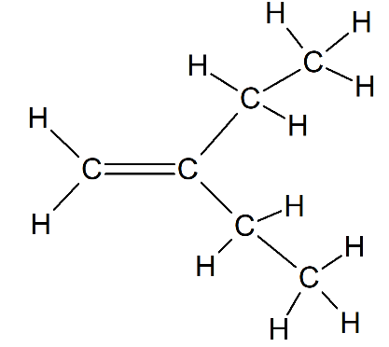
Question 8f
The first mark was awarded for any structural drawing of a compound representing C₆H₁₂ with correct bonding.
The second mark was awarded for the correct structure of 2-ethylbut-1-ene.

Question 9a.i
To reduce the effect of random errors.
Taking an average does not alter the random error that has occurred during the collection of data. Therefore, it is incorrect to say ‘taking the average reduces random error’.

Question 9a.ii
The first mark was awarded for identifying that the chloride ions in CuCl₂ can be oxidised to chlorine gas, which is unsafe as it is a toxic chemical. (A reference for safer choice.)
The second mark was awarded for either one of the following:
- The concentration of chloride ions in solution is 2 M (non-standard conditions). Therefore, Cl⁻ ions may be preferentially oxidised to chlorine gas instead of water undergoing oxidation.
- A 6 V potential difference is sufficiently high for Cl⁻ to be oxidised to chlorine gas in addition to the water being oxidised to oxygen gas.

Question 9a.iii
The student is trying to control the copper ion concentration in the electrolyte.

Question 9b.i
The student has assumed that the current remained constant throughout the trials.

Question 9b.ii
The first mark was awarded for recognising that the mass change at the negative electrode is further away from the expected value, and therefore is less accurate.
The second mark was awarded for using the qualitative observations that this electrode had lost a portion of its mass, and that mass was now lying on the bottom of the beaker.

Question 9c.i
The first mark was awarded for identifying that the hypothesis is not supported.
The second mark was awarded for the justification that the data showed an inversely proportional relationship between charge and amount reacted, not a directly proportional relationship.
 | Cu | Ag
Ratio of n(metal)_{lost} | 1 | 2
Charge on ion | +2 | +1

Question 9c.ii
The amount of substance (mol) reacted at the positive electrode is inversely proportional to the charge on the metal cation formed.

Question 10a.i
C₆₃H₉₈O₆(l) + 3C₂H₆O(l) ⇌ 3C₂₂H₃₆O₂(l) + C₃H₈O₃(l)
(This equation was accepted in any form, for example, semi-structural.)

Question 10a.ii
The first mark was awarded for discussing one of the conditions that increase the reaction rate:
- Increasing the concentration of reactants. This increases the number and frequency of collisions between reactant particles, therefore increasing the frequency of successful collisions.
- Using a catalyst. This provides a reaction pathway with a lower activation energy, therefore increasing the proportion of collisions that exceed the activation energy.
- Increasing the surface area. Because of the two phases, mixing/agitation will increase the surface area / contact and hence increase the frequency of collisions between C₆₃H₉₈O₆ and C₂H₆O.
- Gently heating the reaction mixture. Heating causes an increase in the reaction rate due to the increase in energy of collisions and the increase in frequency of successful collisions. Just stating ‘heating’ was not accepted since, if it was too high, this would significantly decrease the yield.
The second mark was awarded for understanding the conditions required to increase the yield (but not decrease the rate). These were adding excess reactants / increasing the ratio of ethanol to triglyceride which, according to Le Chatelier’s principle, means a forward reaction is favoured to partially oppose this change. Subsequently, this produces more products, thereby improving the yield.
The third mark was awarded for understanding the conflict arising from changing temperature in relation to an exothermic equilibrium reaction:
- Since the forward reaction is exothermic, lower yields are obtained at higher temperatures OR increasing the temperature would favour the reverse reaction, as it is endothermic.
- When lower temperatures are used to increase the yield of biodiesel, the reaction rate decreases, because the average kinetic energy of the reactants is lowered and the number of successful collisions is reduced.
The fourth mark was awarded for explaining how this conflict is resolved. For an optimal rate and yield, the transesterification process requires an excess of reagents, a moderate temperature and a catalyst (such as KOH) to increase the reaction rate.

Question 10b
The first mark was awarded for a reference to changing levels of CO₂ and how this relates to effects on the climate. Typical examples could have included any of the following:
- Biodiesel is a renewable alternative to conventional fossil fuels, such as diesel derived from petroleum. When used in transportation and other sectors, biodiesel results in a significantly reduced contribution to overall greenhouse gas levels, including CO₂ and CH₄, which are major contributors to climate change.
- By displacing fossil fuel consumption, biodiesel helps mitigate global warming and supports efforts to limit the rise in global temperatures.
- Biodiesel can be used as the energy source for the transport and production of more biodiesel. As the CO₂ absorbed by plants via photosynthesis is more than the CO₂ released from its use, this reduces its impact on atmospheric greenhouse gas levels and therefore will reduce the impact on global warming.
No mark was awarded if students stated that biodiesel produces less CO₂ or less greenhouse gas emissions when combusted.
The remaining two marks could be awarded for any two points relating to climate or sustainability, for example:
- Biodiesel is renewable but often unsustainable due to deforestation for crop production, which hinders Sustainable Development Goal 13.
- If produced without deforestation and from non-food crops, biodiesel has minimal net CO₂ impact.
- Combustion of all carbon-based fuels emits fine particulate matter, contributing to general atmospheric pollution and hence affecting the environment. Therefore, any carbon-based fuel is a concern in terms of long-term sustainability.
- For biodiesel to be sustainable, it must be produced in quantities that do not cause environmental harm, ensuring negligible contributions to global warming.
Sustainable production must ensure:
- no tree cutting or land clearing, preserving carbon sinks
- that greenhouse gases from production phases do not increase net emissions.

