2025 VCE VET Furnishing external assessment report
Note: Student responses reproduced in this report have not been corrected for grammar, spelling or factual information.
This report provides sample answers, or an indication of what answers may have included. Unless otherwise stated, these are not intended to be exemplary or complete responses.
The statistics in this report may be subject to rounding resulting in a total of more or less than 100 per cent.

Section A
The table indicates the percentage of students who chose each option. Grey shading indicates the correct response.
Question | Correct answer | % A | % B | % C | % D | Comments
1 | C | 13 | 0 | 87 | 0 | Answered well, students were aware of the acronym CAD.
2 | B | 4 | 67 | 3 | 26
3 | B | 0 | 99 | 0 | 1
4 | B | 14 | 34 | 17 | 34 | Students need to be familiar with timber mouldings.
5 | D | 11 | 24 | 10 | 54
6 | C | 11 | 4 | 81 | 3 | The calculation question was answered well.
7 | D | 29 | 27 | 7 | 37 | Students need to know how to look after and clean tools.
8 | C | 0 | 0 | 100 | 0
9 | A | 54 | 26 | 10 | 10
10 | D | 1 | 0 | 0 | 99 | The work health and safety (WHS) question was answered well.
11 | A | 61 | 0 | 39 | 0 | Students need to be familiar with the Domino machine.
12 | A | 63 | 29 | 0 | 9
13 | C | 0 | 0 | 60 | 40
14 | D | 39 | 7 | 17 | 37 | Students need to be familiar with fasteners.
15 | C | 4 | 10 | 86 | 0
16 | B | 19 | 41 | 21 | 17
17 | A | 56 | 43 | 0 | 1
18 | B | 0 | 41 | 26 | 33
19 | D | 41 | 0 | 0 | 56
20 | A | 31 | 34 | 30 | 4 | Students need to be familiar with timber seasoning.

Section B

Question 1a.
Mark | 0 | 1 | Average
% | 37 | 63 | 0.6
Marking gauge, adjustable square, steel ruler or combination square and pencil.
No marks were awarded for try square or set square.

Question 1b.
Mark | 0 | 1 | Average
% | 48 | 52 | 0.5
He should mark a centre line, working off the face of the chosen boards.
Some students discussed marking out on the face of the boards; however, they needed to show an understanding of marking the horizontal centre line on the edge of the timber.

Question 2
Mark | 0 | 1 | 2 | Average
% | 7 | 22 | 70 | 1.7
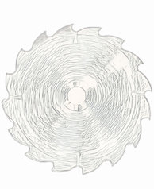
One mark was awarded for a circular blade showing teeth.
One mark was awarded for the teeth and arrow corresponding and showing the correct direction of rotation.
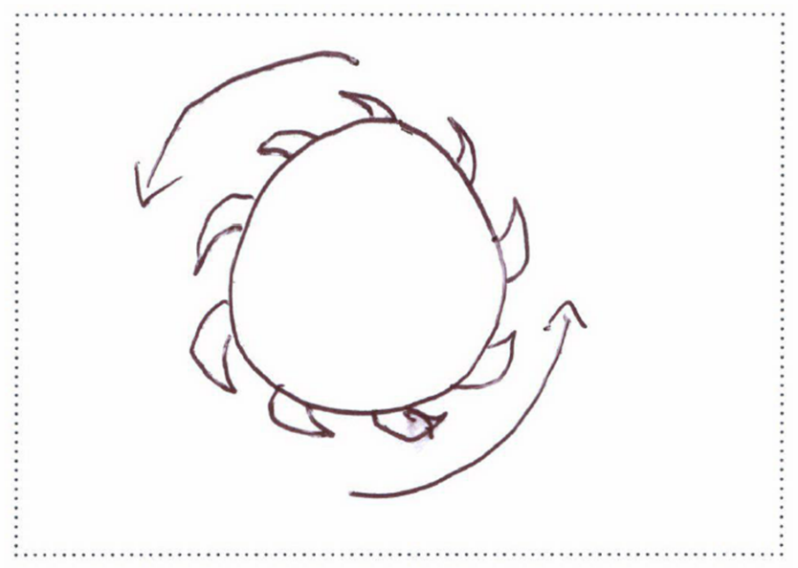
The following is an example of a high-scoring response:

Question 3
Mark | 0 | 1 | 2 | Average
% | 17 | 74 | 9 | 0.9
Reason 1: So the frame doesn’t move and slide.
Reason 2: To ensure a tight joint with no gaps between the top and frame.
Some students discussed the placement of the frame on the top; however, the clamps stop the frame from moving horizontally and vertically.

Question 4
Mark | 0 | 1 | 2 | 3 | 4 | Average
% | 24 | 22 | 12 | 8 | 34 | 2.1

Area of rectangle: Length 1300 mm, Width 1100 mm
Area = length x width: 1.300 x 1.100 = 1.43 m²

Area of circle: 1100 mm diameter
Area = π r²: 3.142 x .550 x .550 = 0.951 m²

Surface area of the tabletop: 1.43 m² + 0.951 m² = 2.381 m²

Allowable variance: 2.375 m² – 2.385 m²
One mark was awarded for the rectangle working out with correct dimensions.
One mark was awarded for the circle working out with correct radius/diameter and including π r².
One mark was awarded for an incorrect but close answer (e.g. rounding up or down, wrong unit of measurement).
Two marks were awarded for the correct answer.
The following is an example of a high-scoring response:
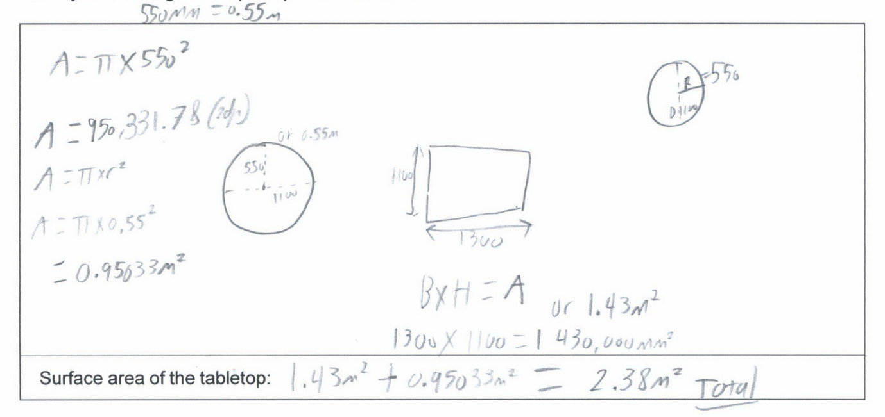

Question 5a.
Mark. | 0 | 1 | Average
% | 54 | 46 | 0.5
Use an iron and a damp cloth.
Students need to read the question carefully. The question asked for an alternative method to filing or sanding, so these could not be given as correct answers.

Question 5b.
Mark | 0 | 1 | 2 | Average
% | 53 | 6 | 41 | 0.9
Apply a small amount of water to the dent, heating with an iron to create steam and therefore swell the fibres of timber to reduce or remove the dents.
One mark was awarded for a basic description of the method or process. Two marks were awarded for a complete explanation.
The following is an example of a high-scoring response:
Lay the damp cloth over the dent and run the hot iron over the dent making sure to not stay in the same spot too long to avoid burning the wood.

Question 6
Mark | 0 | 1 | 2 | 3 | Average
% | 53 | 36 | 6 | 5 | 0.7
Clamp: Sash clamp
Reason: Because the timber rests on a flat surface, limiting twists and winds.
No marks were awarded for clamp or F clamp. No marks were awarded for ‘pressure’ as the reason, as any type of clamp can add pressure. One mark was awarded for naming the correct clamp. Up to two marks were awarded for a valid reason why this clamp is most suitable for the task.
Students need to take into consideration the length and width of the project and which clamp will successfully hold the timber flat and give an even pressure throughout the joints.

Question 7
Mark | 0 | 1 | 2 | Average
% | 4 | 67 | 29 | 1.3
Any two of:
- removing nails from timber
- straightening nails that have been bent when hammering them in
- pulling apart timber by wedging in between the two pieces.
The answers need to be related to furniture or timber.

Question 8
Mark | 0 | 1 | 2 | Average
% | 8 | 53 | 40 | 1.3
The boxes should be cut up, stored flat and put into a recycling bin or taken to a recycling facility.
Students needed to provide a clear description, explanation or identification of the process, taking into consideration how the cardboard and polystyrene could be recycled or reused. One mark was awarded for simply stating ‘recycle’.

Question 9a.
Mark | 0 | 1 | Average
% | 42 | 58 | 0.6
570 – 90 = 480 mm

Question 9b.
Mark | 0 | 1 | Average
% | 60 | 40 | 0.4
2.88 L/M or 2.8 L/M

Question 10
Mark | 0 | 1 | 2 | 3 | Average
% | 68 | 29 | 4 | 0 | 0.4
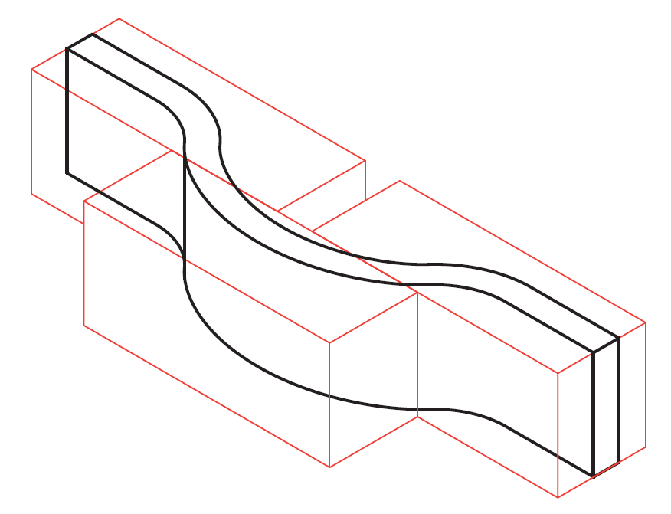
One mark was awarded for three pieces placed left to right. Two marks were awarded for pieces set in and out in a different line. Two marks were awarded for pieces overlapped as shown above.
Students need to be familiar with curved timber pieces and where to place/join the timber following the grain structure for maximum strength.

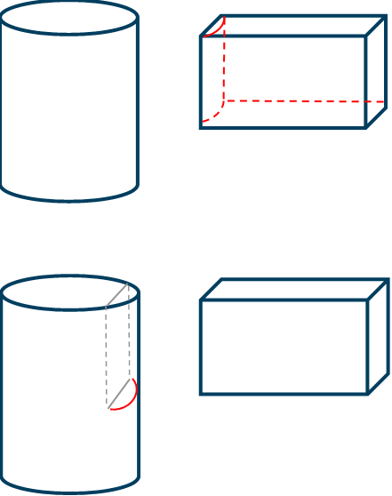
Question 11a.
Mark | 0 | 1 | Average
% | 49 | 51 | 0.5

Question 11b.
Mark | 0 | 1 | Average
% | 53 | 47 | 0.5

Question 11c.
Mark | 0 | 1 | 2 | Average
% | 44 | 28 | 27 | 0.8
The joint where the shoulder is cut out for the legs.
Because the checked-out shoulder provides a solid surface for the rails to sit on.
One mark was awarded for identifying the correct joint. Two marks were awarded for identifying the correct joint and providing justification.
Students need to be aware that they are not reiterating the question about strength.

Question 12
Mark | 0 | 1 | 2 | Average
% | 89 | 5 | 6 | 0.2
After squirting the polyvinyl acetate into the dowel holes, use a small stick, small brush or pencil to spread the glue evenly on the walls of the cavity.
To achieve limited glue wastage (sustainability) and the maximum gluing strength, the dowel hole needs glue evenly spread on it.
Many students responded that if the glue comes out when the dowel is inserted that is when you know you have put in enough glue. This technique is wasteful and does not guarantee maximum gluing strength.

Question 13a.
Mark | 0 | 1 | Average
% | 68 | 32 | 0.3
Cross halving or halving
No marks were awarded for housing.

Question 13b
Mark | 0 | 1 | 2 | Average
% | 37 | 12 | 52 | 1.2

One mark was awarded for the top rail correct. One mark was awarded for the bottom rail correct.
Students should know about different joinery construction methods, from traditional hand skills to the use of machines, where each joinery process could be used when making furniture, as well as the relevant processes, procedures and the advantages and disadvantages.
The following is an example of a high-scoring response:
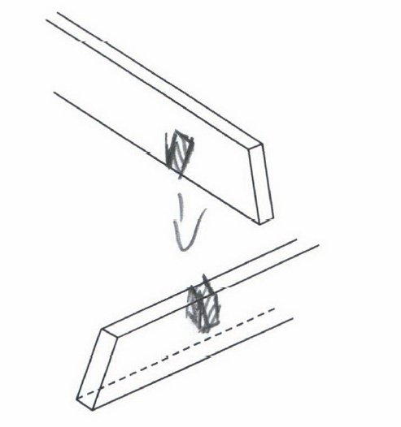

Question 14a.
Mark | 0 | 1 | 2 | Average
% | 7 | 35 | 58 | 1.5
Any two of:
- ruler
- spacer
- f clamps
- tape measure
- adjustable square
- combination square.
No marks were awarded for set square or carpenter square.

Question 14b.
Mark | 0 | 1 | Average
% | 20 | 80 | 0.8
Marcus should use a spacer to evenly place the slats and use a ruler to measure and adjust the overhang on each side.

Question 14c.
Mark | 0 | 1 | 2 | 3 | Average
% | 4 | 0 | 7 | 88 | 2.8
Height, width and length.
This question was answered well; students demonstrated their awareness of the measurements.

Question 15
Mark | 0 | 1 | 2 | 3 | Average
% | 89 | 0 | 7 | 4 | 0.3

Component | Dimensions | Lineal metres
top | 450 mm x 3 x 6 = | 8.100 L/M
leg | 700 mm x 4 x 6 = | 16.800 L/M
rail | 336 mm x 4 x 6 = | 8.064 L/M
One mark was awarded for each correct answer.
Many students labelled the table with working out like a cutting list, placing the length, width and thickness for each component under the dimensions column. Then students multiplied the length, width and thickness together, which gave them an incorrect answer.
Students should know about calculating lineal metres and converting millimetres to metres.

Section C
Questions in Section C are derived from the case study, which is the working drawing and specifications.

Question 1
Mark | 0 | 1 | 2 | 3 | 4 | 5 | Average
% | 3 | 1 | 23 | 26 | 30 | 17 | 3.3
Item 2. Bottom: Length = 1835
Item 5. Back panel: Thickness = 4
Item 6. Adjustable shelf: Material = Queensland maple VPB
Item 10. Solid edging: Material = Queensland maple
Item 18. Front: Width = 185

Question 2
Mark | 0 | 1 | 2 | 3 | Average
% | 24 | 4 | 8 | 64 | 2.1
- Front elevation
- Side elevation
- Plan or top view

Question 3a.
Mark | 0 | 1 | Average
% | 43 | 57 | 0.6
One-metre ruler, try square, panel square, T-square, a square, carpenter square, roofing square or panel square.
No marks were awarded for set square.

Question 3b.
Mark | 0 | 1 | 2 | Average
% | 43 | 26 | 30 | 0.9
Measure the start points on the ground line and then with the try square or panel square and straight edge resting on the line, square the lines up the paper to the required lengths.

Question 4a.
Mark | 0 | 1 | Average
% | 76 | 24 | 0.3
Using a 6 mm spline.
The case study specifications state that the 6 mm spline is used to hold the rattan in place.

Question 4b.
Mark | 0 | 1 | Average
% | 45 | 55 | 0.6
Either a router or smaller trimmer and a 6 mm straight cutter bit.

Question 4c.
Mark | 0 | 1 | 2 | Average
% | 64 | 18 | 19 | 0.6
Once the straight router bit is placed and tightened in the chuck with a spanner, adjust the height so that the cutter depth is 6 mm beneath the bottom plate.

Question 4d.
Mark | 0 | 1 | 2 | Average
% | 11 | 31 | 57 | 1.5
Ear protection (earmuffs or ear plugs) and safety glasses.
One mark was awarded for each valid PPE named.
No marks were awarded for ‘glasses’ (needed to be safety glasses).

Question 4e.
Mark | 0 | 1 | Average
% | 36 | 64 | 0.7
A jig or fixture (that holds the door firm from either the inside or outside or of the frame, no higher than its face).
F clamps, g clamps, quick action clamp or quick grip clamp were also accepted.
Students need to be familiar with a range of timber materials and their fixing methods.

Question 5
Mark | 0 | 1 | 2 | 3 | Average
% | 2 | 6 | 36 | 56 | 2.5
Any three of:
- dust in eyes
- breathing in dust (or dust in nose)
- dust can cause floors to become slippery
- dust can cause machines not to operate effectively and jam mechanisms
- when finishing items, dust can affect the final product.
One mark was awarded if risks were related (e.g. sneezing, asthma, difficulty breathing).
The work health and safety (WHS) question was answered well. However, some risks were repeated.

Question 6a.
Mark | 0 | 1 | Average
% | 73 | 27 | 0.3
Taper so it has square ends to begin the cutting process.

Question 6b.
Mark | 0 | 1 | 2 | Average
% | 54 | 23 | 23 | 0.7
Set up the drop saw / compound saw on the required angle by adjusting the mitre locking handle and fixing it before cutting.
No marks were awarded for panel saw, table saw or circular saw.

Question 7a.
Mark | 0 | 1 | Average
% | 36 | 64 | 0.7
2 x 107 degrees concealed hinges
Students needed to use the information from the Case Study specifications.

Question 7b.
Mark | 0 | 1 | 2 | 3 | Average
% | 45 | 37 | 15 | 3 | 0.8

Step no. | Description of step
1. | Mark out the height of the hinges on the door.
2. | Square a line back from the edge.
3. | Mark the centre of the hole.
4. | Insert the drill bit into the pedestal drill.
5. | With the Forstner bit in the pedestal drill, drill the holes.
Responses could have also included:
- PPE
- safety glasses
- clamp work down.
Students should be familiar with these commonly used hinges, and know how to mark out, install and adjust them to fit a cabinet.

Question 8a.
Mark | 0 | 1 | 2 | 3 | Average
% | 21 | 6 | 22 | 51 | 2.1
One mark was awarded for each correct veneer.

Question 8b.
Mark | 0 | 1 | Average
% | 40 | 60 | 0.6
The alternating direction of the grain provides added strength to the plywood.

Question 9
Mark | 0 | 1 | 2 | Average
% | 43 | 30 | 27 | 0.9
Plywood or veneered medium density fibreboard (MDF).
Plywood has strength or a decorative edge.
Veneered MDF is the new particle board.
No marks were awarded for chipboard (particle board and chipboard are the same product).
Students need to be familiar with a range of timber materials including manufactured boards.

Question 10
Mark | 0 | 1 | 2 | 3 | Average
% | 44 | 6 | 18 | 32 | 1.4

19 mm x 4 divisions = 76 mm 19 mm x 2 sides = 38 mm 76 mm + 38 mm = 114 mm
1835 mm – 114 mm = 1721 mm
1721 mm / 5 = 344.2 mm
Allowable variance 344 mm – 345 mm
One mark was awarded for drawing. One mark was awarded for showing all 19 mm divisions in drawing or working out. One mark was awarded for correct measurements.

The following is an example of a high-scoring response:
