2025 VCE VET Integrated Technologies external assessment report
This report provides sample answers or an indication of what answers may have included. Unless otherwise stated, these are not intended to be exemplary or complete responses.
The statistics in this report may be subject to rounding, resulting in a total more or less than 100 per cent.

Section A – Multiple-choice questions
Correct answers in the following table are in bold type.
Question | Correct answer | % A | % B | % C | % D | Comments
1 | B | 0 | 100 | 0 | 0
2 | A | 83 | 0 | 0 | 17
3 | B | 0 | 67 | 17 | 17 | A Cat 6 ethernet cable has four twisted pairs of wires, which is not to be confused with having eight individual wires.
4 | D | 17 | 0 | 17 | 67
5 | A | 50 | 17 | 33 | 0 | Extra-low voltage is not greater or equal to 120 V DC, 50 V AC.
6 | D | 33 | 0 | 0 | 67 | Decimal number 15 expressed in binary-coded decimal is 0001 0101, while straight binary is 0000 1111.
7 | D | 0 | 0 | 17 | 83
8 | A | 67 | 17 | 17 | 0 | Australian AC mains frequency is nominally 50 Hz.
9 | C | 0 | 50 | 50 | 0 | Refer to the resistor colour codes in the Formula Sheet.
10 | C | 0 | 17 | 33 | 50 | Waveform is pulsating DC as it remains only in the positive sector.
11 | B | 0 | 100 | 0 | 0
12 | C | 0 | 50 | 50 | 0 | The heat in a reflow oven can cause the surface-mount device components to sit up vertically. This is called the tombstone effect.
13 | D | 0 | 17 | 17 | 67 | 4.7 pF or 4p7 F. To convert μF to pF, multiply μF x 1000.
14 | A | 100 | 0 | 0 | 0
15 | B | 0 | 83 | 0 | 17 | Peak voltage = 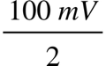, RMS voltage = 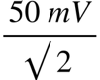= 35.4 mV
16 | B | 0 | 0 | 17 | 83 | A loudspeaker can also be used as a microphone to convert sound waves into electrical wave signals, as used in intercoms and walkie talkies. The process requires some conversion of mechanical sound waves into electrical wave signals that can then be amplified.
17 | C | 33 | 33 | 33 | 0 | The middle tag (wiper connection) on a 10 kΩ logarithmic potentiometer will produce this waveform as the knob is turned, which increases the resistance.
18 | B | 67 | 33 | 0 | 0 | For a 10:1 scale, the dimensions of the drawing are 10 times larger than the actual item.
19 | C | 0 | 0 | 100 | 0
20 | D | 17 | 0 | 17 | 67 | V_{RMS} = 0.707 x V_{peak} = 0.707 x 141.4 V = 100 V_{RMS}

Section B

Question 1a.
Mark | 0 | 1 | 2 | 3 | 4 | 5 | 6 | Average
% | 0 | 0 | 0 | 0 | 9 | 0 | 91 | 5.8
This question required students to identify the flow chart symbols by entering the matching allocated letter into the table. The question was well answered by the majority of students.
Function of symbol | Symbol (letter)
process | C
input or output | D
terminator (start or stop) | A
connector (to another flow) | F
decision | B
database | E

Question 1b.
Mark | 0 | 1 | 2 | Average
% | 0 | 18 | 82 | 1.8
This question required students to describe a situation in which a decision symbol would be used in a flow chart. This question was well answered, with many suitable answers provided. High-scoring responses included:
- Inputs are fed into the ‘decision’ symbol box in order to satisfy a particular decision status.
- Specific inputs are included, and commonly the condition is satisfied (Yes) or not satisfied (No).
- Is a temperature status achieved? Yes or No.
- An example within the decision box is ‘> 20 °C’. Yes or No.

Question 1c.
Mark | 0 | 1 | 2 | Average
% | 18 | 0 | 82 | 1.6
This question required students to provide two examples of situations where the use of a connector symbol would be beneficial within a flow chart. Two examples were required to state the specific benefit to the flow chart. Correct answers included:
- where there is insufficient space on the page allowing the flow diagram to restart on the next page, the adjacent column, or on another page
- using a connector as a connection point to another part, making the chart easier to read
- where the same flow might be used several times/places in the overall process flow, but it is more compact and easier to follow.

Question 2a.
Mark | 0 | 1 | Average
% | 17 | 83 | 0.8
This question required students to name one component device that could be placed on the track locations to detect the presence of the model train. This question was well answered and many different acceptable answers were given, such as:
- optodetector
- microswitch
- reed switch (if the wheels / carriage are metal)
- IR detection
- proximity detector
- ambient light LDR.

Question 2b.
Mark | 0 | 1 | Average
% | 0 | 100 | 1
This question required students to state a common electrical power supply output used to operate model trains. All the student responses provided were acceptable, such as:
- 3–15 V DC
- a battery.

Question 2c.
Mark | 0 | 1 | 2 | 3 | 4 | Average
% | 0 | 0 | 0 | 83 | 17 | 3.2
For ease of interpretation, this single-sided PCB was shown from the screen-printed component side. This question required students to interpret a circuit schematic diagram and draw in the four missing tracks on the PCB. A significant proportion of students were awarded 3 marks because they shorted out track No. 4 by directly crossing over the other track connection, between the capacitor and the base of the other BC547, rather than routing it around and under the 47 k and 560 resistors.
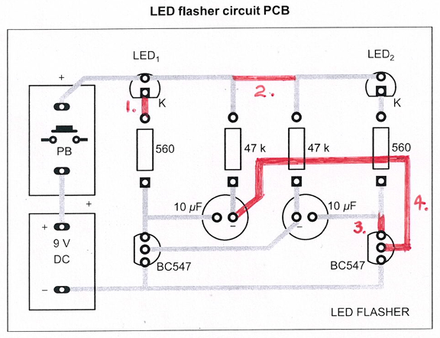

Question 3a.
Mark | 0 | 1 | 2 | 3 | 4 | Average
% | 36 | 9 | 27 | 18 | 9 | 1.5
Students were asked to describe the purpose and function of the optocoupler used in a circuit. A range of responses were given.
Purpose:
- The optocoupler achieves complete electrical separation between the microcontroller and relay side of the circuit.
- It electrically isolates and separates the 5 V DC circuit from the 12 V DC circuit.
- The LED within the optocoupler converts the microcontroller’s electrical output into light to activate the other circuit.
Function:
- When the light strikes, the optocoupler is switched on, and the 12 V DC in the other circuit is turned on by the relay, which switches on to power the two solenoids.

Question 3b.
Mark | 0 | 1 | Average
% | 18 | 82 | 0.8
This question required students to state the function of the 510 Ω resistor connected to output D3. Most students correctly identified it as the current-limiting resistor for the LED within the optocoupler.

Question 3c.
Mark | 0 | 1 | Average
% | 36 | 64 | 0.6
This question required students to describe the electronic term describing how the diode is connected across the relay coil. The correct and most common response was that the diode was connected reversed biased configuration. A flyback diode connection was also an acceptable answer.

Question 3d.
Mark | 0 | 1 | 2 | Average
% | 18 | 9 | 73 | 1.5
This question required students to describe why the diode was used with this type of reversed biased connection. The majority of students provided an acceptable two-part answer, such as.
- The collapsing magnetic field within the coil can induce a high voltage spike; the diode provides a discharge path from the coil.
- The back EMF produced could damage or interfere with the surrounding components.
- The induced spike from the coil has a discharge path, so damage is avoided.

Question 3e.
Mark | 0 | 1 | 2 | 3 | 4 | 5 | Average
% | 0 | 0 | 0 | 27 | 45 | 27 | 4
This question required students to determine the current flowing through the 1 kΩ resistor, showing the formula used and all working out, with the answer given in the preferred sub-unit. Many students had difficulty converting 0.0095 A to mA. Students are advised to familiarise themselves with how to move the decimal point three places to the right, or to multiply by 1000 to convert from A (Amps) to milli-Amps (mA).
V_{d} = 12 – 1.5 – 0.3 – 0.7 (all V_{d} values are identified correctly and expressed in base units)
V_{d} = 9.5 V

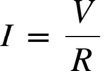
= 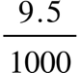
= 0.0095 A
= 9.5 mA

Question 3f.
Mark | 0 | 1 | Average
% | 27 | 73 | 0.7
This question required students to state the purpose of LED₃ connected to the optocoupler. Students provided a variety of acceptable answers, such as.
- It indicates that the optocoupler is active and operating.
- It shows that the power is on.
- It displays that current is flowing in that circuit.

Question 3g.
Mark | 0 | 1 | Average
% | 36 | 64 | 0.6
This question required students to state why a relay was used to operate the boom gate solenoids, instead of the microcontroller output being used directly to drive this. A range of responses that demonstrated understanding of the circuit were accepted, such as:
- The microcontroller outputs have insufficient power to directly drive solenoids.
- A higher power-rated relay operates the boom gate solenoids.
- The higher power 12 V DC section of the circuit requires this.
A discussion of switching higher voltages and/or currents was also accepted.

Question 3h.
Mark | 0 | 1 | 2 | 3 | 4 | Average
% | 55 | 0 | 18 | 9 | 18 | 1.4
This question required students to specify what the NC and NO connections are on relay, and when they apply. Many students were unable to correctly name the NC and NO contacts, and also state that it applies to the unenergised or unpowered relay status.
- NC, Normally Closed. When the relay is unenergised, these contacts remain closed.
- NO, Normally Open. When the relay is unenergised, these contacts remain open.

Question 4.
Mark | 0 | 1 | 2 | 3 | 4 | 5 | 6 | Average
% | 0 | 0 | 0 | 0 | 17 | 0 | 84 | 5.7
This question required students to complete the flow chart by entering the matching letter (A–F) for the missing command instructions. While students were not penalised for including extra words rather than the required single letter (A–F), they are advised to follow the instructions. While some students swapped the final two command instructions, the majority of students were awarded full marks.
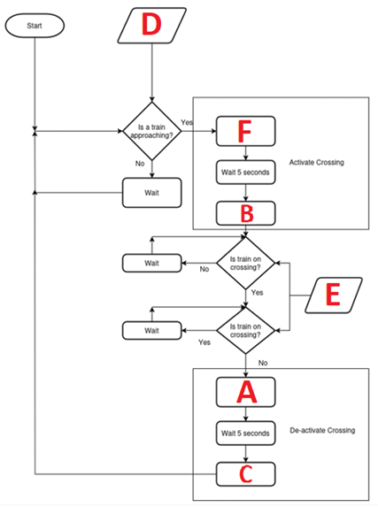

Question 5.
Mark | 0 | 1 | 2 | 3 | 4 | 5 | Average
% | 0 | 0 | 0 | 17 | 67 | 17 | 4
This question required students to complete a table of possible faults by writing ‘Yes’ or ‘No’. Careful circuit analysis enabled most students to determine four of the five possible faults.
Fault | Possible faults?  Yes or No
R₁ open | Yes
R₂ open | No
R₃ open | No
R₁ shorted out | No
R₂ shorted out | No
R₃ shorted out | No
power supply failed | Yes

Question 6a.i.
Mark | 0 | 1 | 2 | 3 | 4 | 5 | 6 | Average
% | 0 | 0 | 0 | 0 | 0 | 0 | 100 | 6
This question required students to determine the total resistance of the elements connected in three different configurations, showing all working out and expressing the answers in correct units.
Element connection  configuration | Total resistance calculation  for each configuration | Heat level setting  (high, medium or low)
Parallel – elements 1 and 2 are connected in parallel | Parallel: element 1 // element 2  R_{Total} = 200 Ω//200 Ω  R_{Total} = 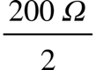  R_{Total} = 100 Ω  Any parallel resistor calculations could be applied finding R_{Total} = 100 Ω was accepted. (2) | High
Series – elements 1 and 2 are connected in series | Series: element 1 + element 2  R_{Total} = 200 Ω + 200 Ω  R_{Total} = 400 Ω | Low
Single – only element 1 is connected, element 2 remains off | Single: element 1  R_{Total} = 200 = 200 Ω | Medium

Question 6a.ii.
Mark | 0 | 1 | 2 | 3 | Average
% | 0 | 33 | 0 | 67 | 2.3
This question required students to state the corresponding heat level setting for each configuration. The answers are given in the right-hand column in the table above.
Some students did not recognise that the lowest element resistance would allow the highest current to flow and would therefore be the highest power output, or that the highest resistance would allow the lowest current to flow and consequently be the lowest power setting. The students consistently answered the medium setting correctly.

Question 6b.
Mark | 0 | 1 | 2 | 3 | 4 | Average
% | 0 | 0 | 0 | 33 | 67 | 3.6
This question required students to calculate the power when the electric blanket operated on the high setting, showing all working out and giving answers using correct units. Some students responded incorrectly that the 400 Ω element resistance would produce the highest power setting, but were not penalised if their 400 Ω power calculations were correct.
Power could be calculated after referring to the Formula Sheet or by finding the current and then applying
P = VI. The correct maximum power output or the highest power setting would occur when the total resistance of the elements connected in parallel was 100 Ω, being the lowest resistance.
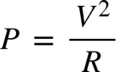
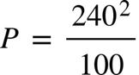

Question 7a.
Mark | 0 | 1 | 2 | 3 | Average
% | 0 | 17 | 33 | 50 | 2.3
This question required students to provide three benefits of using a microprocessor controller instead of a heat selector switch with three heat settings. The responses were generally good, producing a large selection of acceptable answers, such as:
- It is safer, as DC ELV is operating within the controller and is not mains (240 V) operated.
- An infinite variable heat setting is available, not just three settings.
- It can shut off automatically (if left on).
- It can turn on automatically at selected times (both shorter and longer periods).
- Preset limits could be programmed in / programmable flexibility.
- It is generally safer (multiple reasons given).

Question 7b.
Mark | 0 | 1 | 2 | 3 | Average
% | 33 | 50 | 0 | 17 | 1


This question required students to identify the symbol above and describe what this means for the appliance and the appearance of the mains power plug used. This question was generally only answered partially. Correctly addressing all three aspects of the question was required to be awarded the available 3 marks. The three-part acceptable responses are given below.
- The symbol shows that the appliance is classified as double insulated.
- It provides the equivalent of two layers of insulation to protect against electric shock.
The appliance has no exposed metal parts requiring an earth connection.
- No earth pin is required on the plug.
Commonly having two pins rather than the usual Australian three-pin plug.
The earth pin is removed or otherwise disconnected.

Question 7c.
Mark | 0 | 1 | 2 | Average
% | 33 | 42 | 25 | 0.9
This question required students to explain the meaning of the term ‘intermittent electrical fault’ with regard to a circuit or device. A comprehensive two-part description was required, such as:
- a fault that comes and goes and is not consistently apparent, and consequently is difficult to diagnose because of its irregular nature
- it is unpredictable when the fault will occur. The fault can be impacted by heat, cold, movement or many other unknown factors.

Question 7d.
Mark | 0 | 1 | 2 | Average
% | 33 | 33 | 33 | 1
This question required students to provide two possible causes of an intermittent electrical fault on a microprocessor controller electric blanket. This question was often answered only partially or not at all. High-scoring responses provided two different viable causes of intermittent faults. The following list of possible answers is not exhaustive:
- circuit damage due to rough handling or dropping
- damage to components from water exposure
- thermal expansion
- damaged or burnt-out components
- faulty soldering (e.g. dry joints)
- ageing of components, mechanical inputs, buttons or switches
- breakdown of electronic components affected by dirty connections, moisture, cold or heat.

Question 8a.
Mark | 0 | 1 | Average
% | 17 | 83 | 0.8
This question required students to state that the purpose of the thermistor is to read the temperature and convert it to an electrical signal. The majority of students provided relevant discussion about it being a temperature-sensing device.

Question 8b.
Mark | 0 | 1 | Average
% | 67 | 33 | 0.3

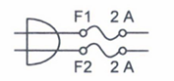
This question required students to identify and state what the two input components are. One-third of students correctly identified them as two fuses (2A rating).

Question 8c.
Mark | 0 | 1 | 2 | Average
% | 75 | 8 | 17 | 0.4
This question required students to explain why the input used two fuses rather than one fuse. Students needed to identify any aspect of increased safety in using two fuses, with both the active and neutral supply wires fused, such as if these connections were incorrectly swapped over in the plug or socket.

Question 8d.
Mark | 0 | 1 | 2 | 3 | 4 | 5 | 6 | Average
% | 0 | 17 | 33 | 0 | 17 | 17 | 17 | 3.3
This question required students to look at the three images of the component devices taken from the circuit schematic diagram and to name the component devices and provide their respective functions. The correct response is provided in the table below for each question, with a mark awarded for each correct response.
Component device | Name | Function
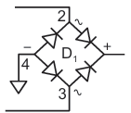 | A full wave bridge rectifier | Rectifies the 12 V AC into pulsating DC.
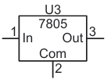 | A 7805 5 V voltage regulator  While students were only required to name it as a regulator, some students specified it was 5 V. If the device was only named as an ‘IC’, no mark was awarded. | This regulates the raw DC supply to a specified fixed (5 V DC) voltage.  Students were not required to specify voltage regulation values for a mark to be awarded.
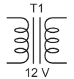 | A transformer | As an AC device, the diagram indicates that it is stepping down the mains voltage supplied to 12 V.  Students were not penalised for describing the function as either stepping up or stepping down the AC supply voltage, as this was not specifically stated.

Question 8e.
Mark | 0 | 1 | Average
% | 83 | 17 | 0.2

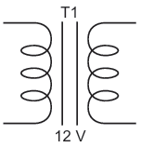
This question required students to explain what the two vertical lines represent in the transformer symbol above. Most responses did not correctly interpret the vertical lines, which represents the iron core or steel laminations within the transformer.

