2025 VCE Algorithmics (HESS) external assessment report
The statistics in this report may be subject to rounding resulting in a total of more or less than 100 per cent.

Section A – Multiple-choice questions
The table below indicates the percentage of students who chose each option. The correct answer is indicated by bold text and shading.
Question | Correct answer | % A | % B | % C | % D | Comments
1 | A | 86 | 0 | 14 | 0
2 | C | 1 | 1 | 98 | 0
3 | A | 82 | 9 | 6 | 3
4 | D | 3 | 2 | 10 | 85
5 | B | 18 | 58 | 10 | 14
6 | B | 3 | 95 | 0 | 1
7 | C | 10 | 8 | 67 | 16
8 | A | 97 | 2 | 0 | 0
9 | A | 69 | 3 | 26 | 1
10 | D | 4 | 2 | 4 | 90
11 | B | 8 | 82 | 4 | 6
12 | C | 5 | 6 | 79 | 9
13 | A | 86 | 3 | 3 | 8
14 | D | 10 | 5 | 37 | 48 | Many students confused the Entscheidungs problem with the equivalence of expressing computable functions using lambda calculus and Turing machines. Many students were unaware that the first proof of an undecidable problem was Alonzo Church’s proof of the undecidability of the equivalence of lambda expressions.
15 | ABCD |  |  |  |  | As a result of psychometric analysis and review, all four options were accepted as correct.
16 | B | 0 | 92 | 3 | 4
17 | D | 3 | 6 | 5 | 86
18 | C | 2 | 0 | 40 | 57 | Many students gave the answer D to this question. Although this answer correctly identified the purpose of the training and test data sets, it was incorrect as it stated that re-sampling was required to train an algorithm.
19 | D | 0 | 8 | 16 | 76
20 | D | 10 | 42 | 10 | 38 | Most students answered B to this question. This answer incorrectly assumes that ‘randomised search’ has fewer hyperparameters to tune than ‘hill climbing’ on a heuristic function. Also, it fails to recognise that randomised search can be used when the heuristic function is not differentiable.

Section B – Short answer questions

Question 1
Marks | 0 | 1 | 2 | Average
% | 3 | 11 | 86 | 1.8
Sample response:
The isEqual response takes two inputs, both instances of the set data type, and returns a Boolean (True/False) value as output.
A common error was describing what the operation isEqual does, rather than what the signature meant.

Question 2
Marks | 0 | 1 | 2 | Average
% | 2 | 5 | 93 | 1.9

2
8
5
If students did not represent the stack as above, they should have made the top of the stack clear.

Question 3a.
Marks | 0 | 1 | 2 | Average
% | 18 | 70 | 12 | 0.9
Sample response:
Advantage: Using a list is simple to implement and is straightforward to access any step in the process.
Disadvantage: Using a list may lose opportunities to encode relationships between steps within the stored data.
Common errors were:
- confusing steps and processes
- when describing a disadvantage, not realising that the list had at most 20 items that represented the steps in the process.

Question 3b.
Marks | 0 | 1 | 2 | Average
% | 25 | 42 | 34 | 1.1
Sample response:
An alternative data structure that could be used is a graph in which nodes are process steps, and the edges represent the possible alternative paths to the next step. One advantage this would have over a list would be to allow for flow structure between steps to be encoded thereby reducing a possible duplication.
Many students were able to describe an alternative data structure. However, a common error was that students were unable to describe a suitable advantage of this alternative data structure

Question 4
Marks | 0 | 1 | 2 | Average
% | 16 | 15 | 69 | 1.5
Sample solution:
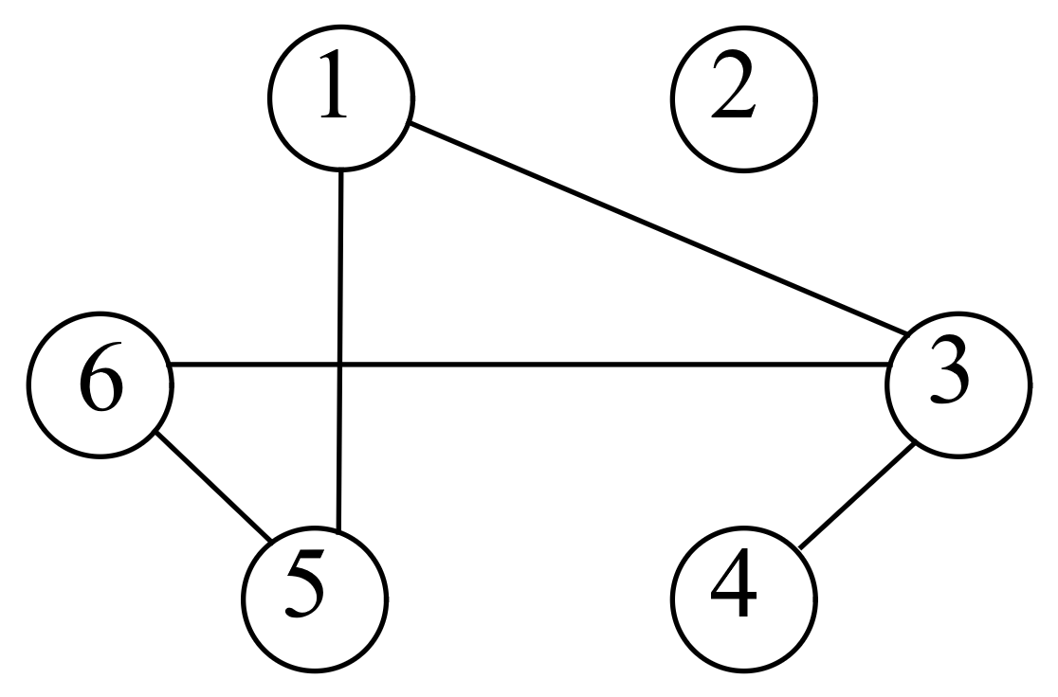
A common error was not including all the required edges.

Question 5a.
Marks | 0 | 1 | Average
% | 17 | 83 | 0.8
Positive infinity

Question 5b.
Marks | 0 | 1 | Average
% | 44 | 56 | 0.6
distance [u] + weight (u, v) < distance [v]
Most students answered this question correctly. However, errors included the following:
- getting the inequality the wrong way around
- not including the weight of the edge in the conditional statement
- having different conditions for line 8 and line 11
- not clearly expressing the condition in words.

Question 5c.
Marks | 0 | 1 | Average
% | 31 | 69 | 0.7
Sample solution:
Negative cost cycle
Other equivalent statements were also accepted.

Question 6a.
Marks | 0 | 1 | 2 | Average
% | 20 | 19 | 61 | 1.4
Sample response:
The algorithm remains unhelpful for finding larger Fibonacci numbers because the algorithm is still exponential in n. Even with a smaller base value, it will still grow exponentially.
A common error was to not state that Sophie’s time complexity of the algorithm was exponential.

Question 6b.
Marks | 0 | 1 | 2 | 3 | 4 | Average
% | 27 | 15 | 8 | 14 | 37 | 2.2
Sample solution:
Algorithm Fib (n):
If n < 2 Do:
Return 1
Let A be an array of length n.
A [0] $←$ 1
A [1] $←$ 1
For i in [2, …, n] Do:
A [i] $←$ A [i-1] + A [i-2]
Return A [n]
A common error was to provide an algorithm that was not a dynamic programming algorithm.

Question 7a.
Marks | 0 | 1 | Average
% | 5 | 95 | 1.0
Sample response:
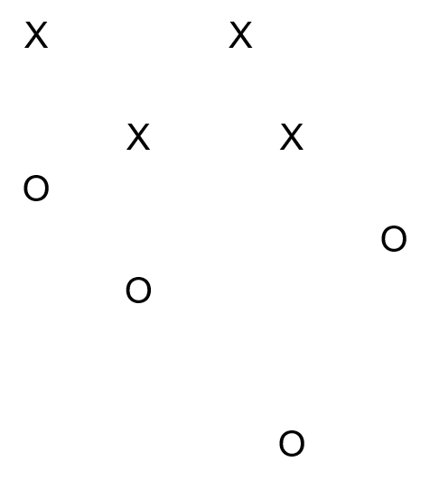

Question 7b.
Marks | 0 | 1 | Average
% | 18 | 82 | 0.8
Sample response:
Due to the X’s surrounding the O’s, a straight line can never separate the points so that the X’s lie on one side and the O’s lie on the other side of the line.

Question 8a.
Marks | 0 | 1 | Average
% | 8 | 92 | 0.9
Sample response:
Node | A | B | C | D | E | F | G
Shortest distance | 0 | 1 | 2 | 9 | 2 | 3 | 5

Question 8b.
Marks | 0 | 1 | 2 | 3 | Average
% | 45 | 27 | 11 | 16 | 1.0
Sample solution:
$$PR\left(F_{1}\right)=\left(\frac{1}{3}PR\left(B_{0}\right)+\frac{1}{2}PR\left(E_{0}\right)+\frac{1}{6}PR\left(D_{0}\right)\right)×0.8+\frac{1}{7}×0.2 \\ =\left(\frac{1}{3}×\frac{1}{7}+\frac{1}{2}×\frac{1}{7}+\frac{1}{6}×\frac{1}{7}\right)×\frac{4}{5}+\frac{1}{7}×\frac{1}{5} \\ =\left(\frac{1}{21}+\frac{1}{14}+\frac{1}{42}\right)×\frac{4}{5}+\frac{1}{35} \\ =\frac{1}{7} \\ =0.1428$$
A common error was not to include links from D to all the other nodes. Solutions that included a link from D to itself were accepted.

Question 9a.
Marks | 0 | 1 | 2 | Average
% | 0 | 33 | 67 | 1.7
Sample solution:
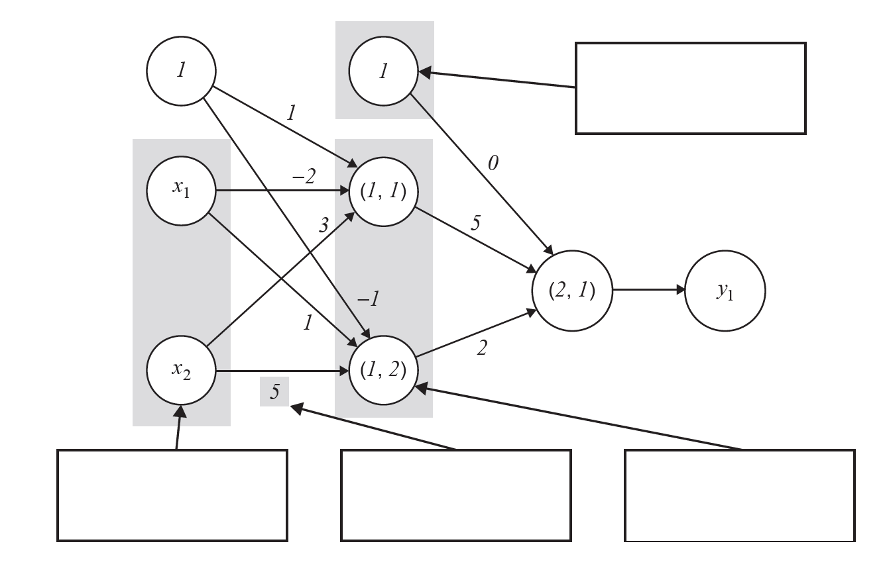
edge weight
bias node
hidden layer
input layer
The arrow to the ‘input layer’ and the arrow to the ‘hidden layer’ appear to be pointing to a node and not a layer. Other answers that correctly identified them as a ‘neural node’ were also accepted.

Question 9b.
Marks | 0 | 1 | 2 | Average
% | 35 | 26 | 40 | 1.1
Sample solution:
Activation of (1, 1): $1×1+3×-2+1×3=1-6+3=-2$
Output of (1, 1): 0
Activation of (1, 2): $1×-1+3×1+1×5=-1+3+5=7$
Output of (1, 2): $7$
Activation of (2, 2): $1×0+0×5+7×2=14$
Output of (2, 2): 14
$y_{1}=14$
A common error was not applying the activation function at a node.

Question 10
Marks | 0 | 1 | 2 | 3 | 4 | Average
% | 16 | 17 | 20 | 28 | 19 | 2.2
Sample response:
The grid can be modelled as a two-dimensional array with every value initialised to 0. The grid locations that are part of a (partially complete) space-filling walk are numbered 1 to n, where n is the current length of the walk. Given a particular grid location, the set of unvisited locations can be determined by testing the value of each of the four adjacent grid locations, and if their value is 0 then adding them to the set.
Common errors were to:
- provide a representation that did not allow for the complete recovery of all the information about the walk
- find all unvisited nodes and not just those next to a given grid location.

Question 11a.
Marks | 0 | 1 | 2 | Average
% | 21 | 14 | 65 | 1.4
Sample response:
An ADT can be created by using a graph with a node for every permutation of the numbers 1 to 5. Each edge in the ADT, between a node pair, corresponds to a rearrangement of a permutation of one node to the permutation of the other node that can be obtained by hopping one kangaroo.
A common error was giving an insufficient description of how all the required information was stored in the ADT or combination of ADTs.

Question 11b.
Marks | 0 | 1 | 2 | Average
% | 23 | 25 | 52 | 1.3
Sample response:
A breadth-first search algorithm could be used to search the entire graph from the final solution point. If the graph traverses every node, then the final solution point connects to every point and the game can be solved from any starting point. Otherwise, the game cannot be solved from any point that is not connected to the final solution point.
A common error was not to consider any possible starting point.

Question 12
Marks | 0 | 1 | 2 | 3 | Average
% | 36 | 36 | 18 | 9 | 1
Sample response:
Option 2 would have the greatest impact because it would enable O(1) time search for whether a key exists in the dictionary. This is faster than Option 1 that would allow for O(log(n)) binary search and Option 3 that would not improve search times at all.
A common error was not to provide time complexities for the various options.

Question 13
Marks | 0 | 1 | 2 | 3 | 4 | 5 | 6 | Average
% | 49 | 15 | 11 | 6 | 6 | 9 | 4 | 1.5
Sample solution:
Algorithm findWord (W, S, T, C):
If (C in W) and (T is empty) Do:
Return C
If T is empty Do:
Return “”
If C not in S Do:
Return “”
For t in T Do:
newC $←$ C + t
newT $←$ T with t removed
response = findWord (W, S, newT, newC)
If response is not empty Do:
Return response
Return “”
A common error was not to provide an algorithm that used a backtracking algorithm design pattern.

Question 14
Marks | 0 | 1 | 2 | 3 | 4 | Average
% | 13 | 27 | 29 | 13 | 19 | 2.0
Sample solution:
Let $r$ be the length of $read$.
Let $n$ be the length of $text$.
Let$s$ be the average length of sentences/elements of $text$.
Analyse Search
Line 6 runs len(A) = s times.
Line 7 takes r time proportional to the minimum of r and s.
Line 8 and 9 take constant time.
Overall running time $O(s⋅r)$ or $O\left(s^{2}\right)$
Analyse FindAndReplace
Line 1 runs n times
Lines 2, 4 and 5 run in constant time
Overall running time $O(n⋅s⋅r)$ or $O\left(n⋅s^{2}\right)$
A common error was not to consider the time complexity of comparing the equality of two strings.

Question 15a.
Marks | 0 | 1 | 2 | Average
% | 29 | 22 | 49 | 1.2
Sample response:
The first loop runs $n_{L}$ times and the second loop runs $n_{R}$ times. As the loops are nested, their time complexities are multiplied. The comparison and assignment in lines 16 and 17 run in constant time.
$$A\left(n_{L},n_{R}\right)=O\left(n_{L}n_{R}\right)$$
A common error was not to annotate the pseudocode.

Question 15b.
Marks | 0 | 1 | 2 | 3 | 4 | Average
% | 31 | 12 | 18 | 29 | 11 | 1.8
Sample solution:
Base case (lines 2–5): When $n≤2$, $B(n) = O(1)$
Recursive case (lines 6–12): When $n>2$, $B\left(n\right)=2B\left(\frac{n}{2}\right)+2⋅O\left(\frac{n}{2}\right)+A\left(\frac{n}{2}⋅\frac{n}{2}\right)$
$=2B\left(\frac{n}{2}\right)+O(n)+O\left(n^{2}\right)$
Applying the Master Theorem: $a=2, b=2, c=2$
$$B\left(n\right)=O\left(n^{2}\right)$$
A common error was not to consider the time complexity of creating the sub-lists.

Question 16
Marks | 0 | 1 | 2 | 3 | 4 | Average
% | 22 | 5 | 13 | 8 | 52 | 2.6
Sample response:
The NP-Complete problem is the intersection of NP and NP-Hard. However, there is no overlap between NP-Hard and NP, which implies there are no NP-Complete problems.
P problems are NP problems; hence they should not just intersect, but the problems in P should be solely within the problems in NP.
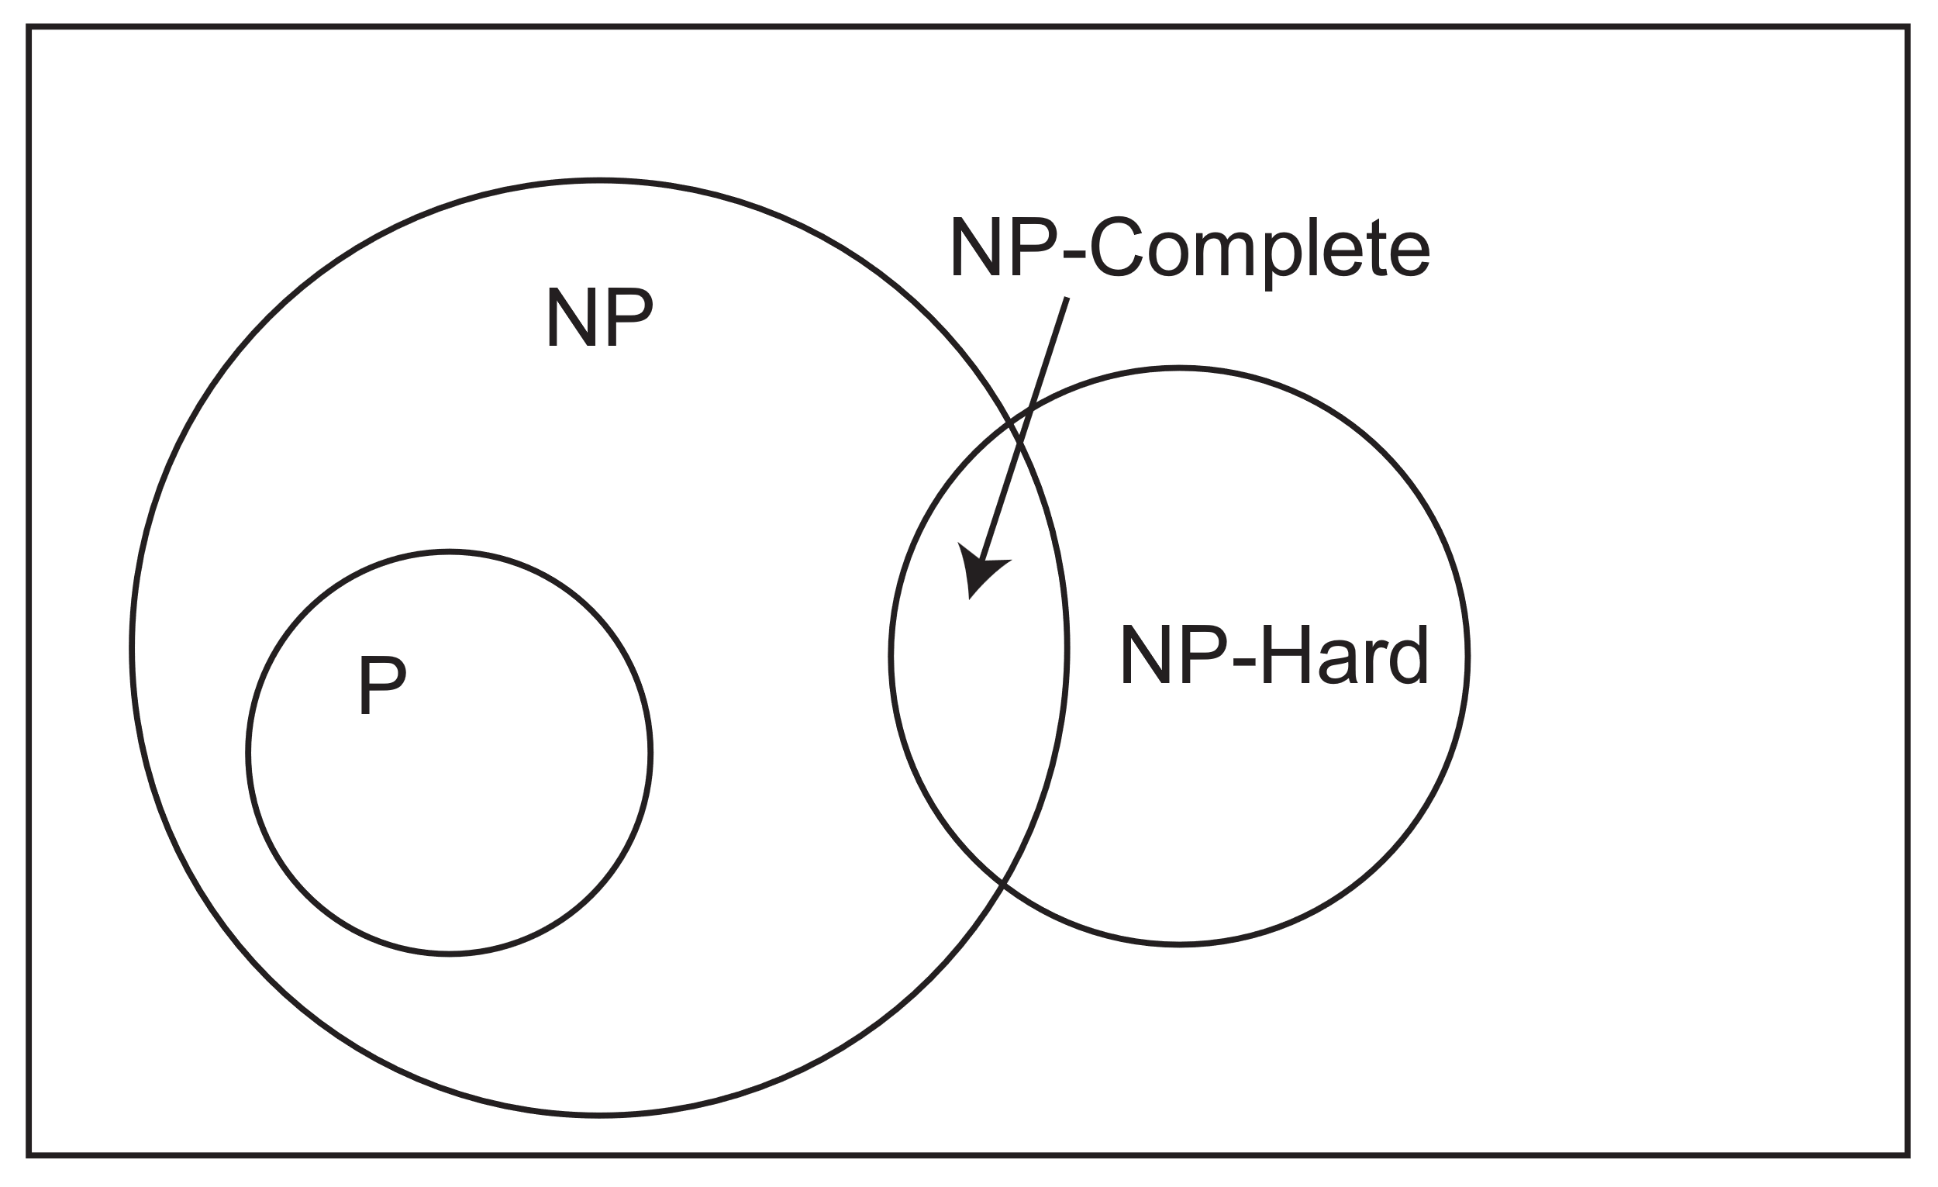
A common error was to not explain how the diagram was incorrect and simply state all the facts about these problem classes.

Question 17a.
Marks | 0 | 1 | 2 | Average
% | 45 | 14 | 41 | 1.0
Sample response:
One argument to the systems response is that the human agent could theoretically memorise the entire contents of the rulebooks, thus completely internalising the system. They could then go out into the world and interact with Chinese speakers. They would still, however, have no idea about the meaning of what they were saying. Thus, the system itself cannot be considered to understand Chinese.

Question 17b.
Marks | 0 | 1 | 2 | 3 | Average
% | 12 | 19 | 20 | 49 | 2.1
Sample response:
I disagree that this is the only valid response. Other responses include the ‘brain simulation reply’ and ‘other minds reply’.
Justification:
- Brain simulator reply: As the agent doing the natural language processing inside the room can in fact be any form of agent, if instead it was a detailed simulator of the brain, neuron by neuron, then it can gain understanding and therefore invalidate Searle’s argument.
- Other minds reply: We attribute understanding based on behaviour, for example, humans or animals understand something based on their behaviours. The Chinese Room setup has all the same characteristics and behaviours of understanding that we attribute to humans and animals. It follows that we must also conclude that the Chinese Room setup also understands Chinese, so why can’t we subscribe understanding to this setup also?

Question 18
Marks | 0 | 1 | 2 | 3 | 4 | 5 | Average
% | 20 | 34 | 19 | 8 | 8 | 11 | 1.8
Sample response:
Create a graph with a node for each possible traffic route through the intersection. Each entrance into the intersection has six nodes associated with it, representing the six possible exits for traffic entering through that entrance (including U-turns). For each node, add an edge to all other nodes representing intersecting traffic routes,
To determine the sets of traffic routes that the lights could cycle through, give each node a colour. Each colour denotes a set of non-intersecting routes that can be allowed through the intersection at the same time. This has reduced the problem to a graph-colouring problem, that is, to find the minimum number of colours to colour the graph so that adjacent nodes do not have the same colour.

By assigning each entrance a different colour and giving all the nodes associated with an entrance the colour of the entrance, we see that we can colour the graph using only six colours. Staring with k = 5, we search for a solution with k colours using backtracking. If we find a solution for k colours, we look for a solution using k-1 colours. If we cannot find a solution for k colours, we return k+1 as the minimum number of colours.
High-scoring responses made the connection between this problem and a graph-colouring problem. They also made the following points clear:
- what the nodes, edges and colours represented
- how to obtain an initial colouring of the graph
- details of the algorithm.
Common errors were not:
- describing what the nodes and edges represented
- representing intersecting traffic paths
- providing sufficient details of the algorithms.

Question 19a.
Marks | 0 | 1 | 2 | 3 | Average
% | 31 | 39 | 23 | 7 | 1.1
Sample response:
Assume that the algorithm produces a seating pattern with two students sitting the same subject adjacent to each other. The two students must either be side by side or one in front of the other.
Each time a new seat is assigned in line 5, j which is the subject, has increased by one or reset to 0. This means that students with the same subject are never side by side.
For two students with the same subject to be one in front of the other, the two rows must be aligned to each other. This will occur if the number of students is a factor of the row length. This would require s to be a factor of 13, but 13 is a prime number and s is greater than 1 and less than 13.
Since neither of these cases can be created by the algorithm, then the assumption must be incorrect, and the seating pattern is always valid.
A common error was not to consider both cases where students can be sitting adjacent to each other.

Question 19b.
Marks | 0 | 1 | 2 | 3 | 4 | 5 | 6 | 7 | Average
% | 23 | 17 | 18 | 15 | 14 | 11 | 2 | 0 | 2.2
Sample response:
Let sk be the number of students sitting subject k, where k = 1, …, n and n is number of subjects.
We assume that the total number of students is at most 390, otherwise there will be no solution. This gives the number of empty seats equal to e = 390 − (s1+…+sn).
The seating plan could be represented as a graph with 390 nodes connected by an edge if the corresponding seats are adjacent.
Assign each subject a different colour and the empty seats a colour that is different from all the subjects. Assign one of these colours to each node such that:
- sk nodes have the colour corresponding to the kth subject
- e nodes have the colour corresponding to the empty seats
- nodes that are adjacent have different colours, unless both nodes correspond to empty seats.
Finding a valid seating plan requires solving this graph colouring problem.
An initial colouring of the graph could be done by randomly assigning each node a colour so that:
- sk nodes have the colour corresponding to the kth subject
- e nodes have the colour corresponding to the empty seats.
Using the cost to be the total number of nodes, which are adjacent to another node with same colour corresponding to a subject, we could apply simulated annealing iteratively to improve a candidate colouring of the graph. At each stage of the algorithm, possible alternative candidate solutions could be formed by randomly swapping the colours between the pairs of nodes. This would ensure that alternative candidates also have sk nodes with colours corresponding to the kth subject, for k = 1, …, n.
However, as simulated annealing is not guaranteed to find a solution (if one exists), this algorithm might need to be executed several times with different initial candidate colourings of the graph to find a solution.
High-scoring responses made the connection between determining whether there was a valid seating plan and a graph colouring problem. They also made the following clear:
- what the relevant variables represented
- what the nodes, edges and colours represented
- how to deal with empty seats
- how the problem differed from a usual graph colouring problem
- how to obtain an initial colouring of the graph
- details of the algorithm, such as how to update feasible solutions.
Common errors were not:
- describing the abstract data types they used
- providing sufficient details of the algorithms
- dealing with empty seats.

