Structured Workplace Learning Recognition for VET in 2026

Enrolment and results processing and eligibility
From 2026 schools will be responsible for enrolling their own students in Structured Workplace Learning (SWL) Recognition for VET units on VASS. This gives VASS administrators full control of SWL Recognition for VET enrolment and resulting, consistent with all other VCE studies. It also enables schools to confirm students’ eligibility for these units in VASS before most 2026 SWL placements commence.

Eligibility
Adherence to the following requirements is essential to ensure compliance with the requirements set out in the Structured Workplace Learning Recognition for VET study design and Ministerial Order 1412.
The VCAA will monitor SWL Recognition for VET enrolments and results entry during 2026. Schools with enrolments or results that do not meet these requirements will be directed to make the necessary corrections with support where required.

Enrolment eligibility
To be enrolled in an SWL Recognition for VET unit in VASS, a student must be enrolled on VASS in:
- at least 180 nominal hours of units of competency (UoCs) in a VE1 or VE2 qualification
- the work health and safety (WHS) UoC specified in the applicable Workplace Learning Record (WLR), if the qualification is a VE1
- the WHS UoC specified in the student’s SBAT training plan, if the qualification is a VE2.

Satisfactory completion
To be awarded an ‘S’ result in VASS for an SWL Recognition for VET unit, a student must:
- be enrolled on VASS in at least 180 nominal hours of UoCs in a VE1 or VE2 qualification
- have an ‘S’ result in VASS for the WHS UoC specified in the applicable WLR, if the qualification is a VE1
- have an ‘S’ result in VASS for the WHS UoC specified in the student’s SBAT training plan, if the qualification is a VE2.

Confirming students’ eligibility
Schools are strongly encouraged to process SWL Recognition for VET enrolments by Friday 26 June.
Once enrolled, VASS administrators should:
- use the Structured Workplace Learning Recognition report (once available) to confirm that students enrolled in the study meet the requirements specified above (instructions on using this report effectively are provided under ‘Enrolment and results processing’ in this document)
- inform their VET coordinator of any ineligible students and ask them to address any unmet requirements as soon as possible.
SWL Recognition for VET results must be entered in VASS by Monday 16 November. Before processing these results, VASS administrators should use the Structured Workplace Learning Recognition report in VASS to identify whether students have met the requirements for satisfactory completion of the study specified above. A student enrolled in an SWL Recognition for VET unit who has not met these requirements cannot receive an ‘S’ result for the unit.

Enrolment and results processing

Enrolling students in SWL Recognition for VET
Schools can enrol students in SWL Recognition for VET units in VASS using the standard VCE enrolment process.
To enrol students:
- Add the relevant SWL Recognition for VET units to the ‘Select Units to be Assessed’ screen.
- Create the required class or classes.
- Enrol students via the ‘VCE Enrolment’ screen.
The unit codes for SWL Recognition for VET are:
- TA201 – SWL Recognition for VET Unit 1
- TA212 – SWL Recognition for VET Unit 2
When enrolling a student in an SWL Recognition for VET unit, schools will be required to select a Focus Area:
- For students undertaking a VE1 certificate, select the relevant program area (refer to the VCE VET pages on the VCAA website for program areas).
- For students undertaking a VE2 certificate (SBAT), select School-based Apprenticeship/Traineeship.
Students should not be enrolled in TA212 without first completing TA201.
Students undertaking a VE1 certificate may only complete one SWL Recognition for VET unit per year.
Students undertaking a VE2 certificate (SBAT) may complete up to two units per year.
Note that where a student is enrolled in two SWL Recognition for VET units within a single year, they must also be enrolled in at least 360 nominal hours of UoCs in a VE2 certificate on VASS.

Checking student eligibility
The Structured Workplace Learning Recognition report (STUDENT PROGRAM > VET Reports) displays all students currently enrolled in SWL Recognition for VET and can be used to identify students whose enrolments may not meet the study requirements.
VASS administrators should run this report:
- after enrolling students in SWL Recognition for VET
- at regular intervals during the year to monitor compliance
- before entering final results in VASS.
When reviewing the report, schools should pay particular attention to the following details:
- Missing certificate details
- Enrolments with fewer than 180 UoC hours (to be included in updated version of the report)
- Missing work health and safety UoCs

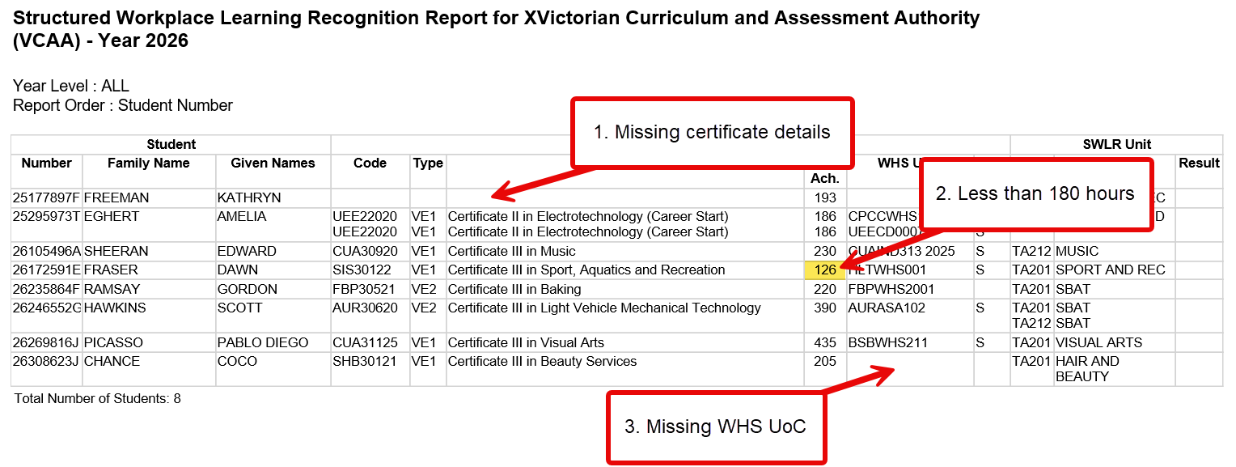

Missing certificate details
A student with missing certificate details is either:
- not enrolled in a VET certificate in VASS, or
- enrolled in a VE3 certificate.
Students enrolled in a VE3 certificate are not eligible for SWL Recognition for VET and should be withdrawn from the study.
Students who are not enrolled in any certificate must either:
- be enrolled in an eligible VE1 or VE2 certificate, or
- be withdrawn from SWL Recognition for VET.

Fewer than 180 hours enrolled¹
Students with fewer than 180 hours enrolled do not meet the minimum 180 nominal hours of UoCs required for enrolment in an SWL Recognition for VET unit.
These students are not eligible for an SWL Recognition for VET unit unless their enrolment is updated to meet this requirement.
Schools must either:
- enrol the student in additional UoCs so that the total nominal hours reaches at least 180, or
- withdraw the student from the SWL Recognition for VET unit.
¹This information can also be confirmed by the Student Full Details report

Missing WHS UoC
A student with a missing WHS UoC is not currently enrolled in the WHS UoC required for their VET program.
These students are not eligible for SWL Recognition for VET unless the required WHS UoC is added to their enrolment.
Schools must either:
- enrol the student in the appropriate WHS UoC, or
- withdraw the student from SWL Recognition for VET.
The report will not identify students who have already completed the required WHS UoC through a different certificate. This is acceptable and does not affect eligibility. Schools are encouraged to check the Student Full Details report to ascertain if a student has previously met the WHS UoC requirement in another certificate.

Entering results
SWL Recognition for VET unit results are entered in VASS via the ‘VCE Results Entry’ screen, consistent with all other VCE studies.
Each unit has two outcomes, as outlined in the study design. When entering results, schools must determine whether each student has satisfactorily achieved these outcomes.
In making this judgement, schools should consider whether the student has:
- completed 80 hours of structured workplace learning
- completed 20 hours of classroom instruction
- received an ‘S’ result for the aligned WHS UoC.
A student enrolled in SWL Recognition for VET who has not met these requirements must not be awarded an ‘S’ result and should be resulted as ‘N’.
SWL Recognition for VET results must be entered in VASS by Monday 16 November 2026.
Before entering results, VASS administrators should run the Structured Workplace Learning Recognition report to confirm that each student meets the requirements for satisfactory completion outlined in this document.
Students who have received an ‘N’ result for their WHS UoC, or who are not enrolled in the required WHS UoC, must be resulted as ‘N’.
