
SSMS Registration and Job Application Guide
  - SSMS (Sessional Staff Management System)
  - ‘How-to’ Guide
  - July 2026
Acknowledgement of Country
The Victorian Curriculum and Assessment Authority proudly acknowledges and pays respect to Victoria’s Aboriginal and Torres Strait Islander communities and their rich and enduring cultures.
We acknowledge Aboriginal and Torres Strait Islander people as Australia’s first peoples and as the Traditional Owners and custodians of the lands and waters on which we rely. We pay respect to Elders past and present of the lands where we conduct our work and recognise their ongoing contributions as the first educators on the land now known as Victoria.
Authorised and published by the Victorian Curriculum and Assessment Authority
Level 7, 200 Victoria Parade
East Melbourne VIC 3002
© Victorian Curriculum and Assessment Authority [2026]
No part of this publication may be reproduced except as specified under the Copyright Act 1968 or by permission from the VCAA. Excepting third-party elements, schools may use this resource in accordance with the VCAA educational allowance. For more information go to vcaa.vic.edu.au/footer/copyright
If you believe that material in this publication infringes your copyright, please email the Copyright Officer vcaa.copyright@education.vic.gov.au
Copyright in materials appearing at any sites linked to this document rests with the copyright owner(s) of those materials, and is subject to the Copyright Act. The VCAA recommends you refer to copyright statements at linked sites before using such materials.
The term VCAA and the VCAA logo are registered trademarks of the Victorian Curriculum and Assessment Authority.
Contact us if you need this information in an accessible format, for example, large print or audio.
Telephone (03) 9032 1629 or email vcaa.publications@education.vic.gov.au

Introduction
Sessional Staff Management System (SSMS) is an online portal used by the Victorian Curriculum and Assessment Authority (VCAA) to manage recruitment and hiring for casual and contract staff.
Through the SSMS portal, individuals can submit applications for roles in areas including, but not limited to:
- Examination Development Panels
- VCE Written, Oral and Performance Assessment
- GAT and NAPLAN Written Assessment
- Season of Excellence
- VCE State Reviewing
- Venue Coordination
- VCE, GAT, NAPLAN Security
- Miscellaneous Casual VCAA Administration and Processing roles
The SSMS Bulletin Board is located on the SSMS landing page. It provides updates on currently advertised jobs, scheduled maintenance and other important notices. Please check the Bulletin Board regularly throughout the year.
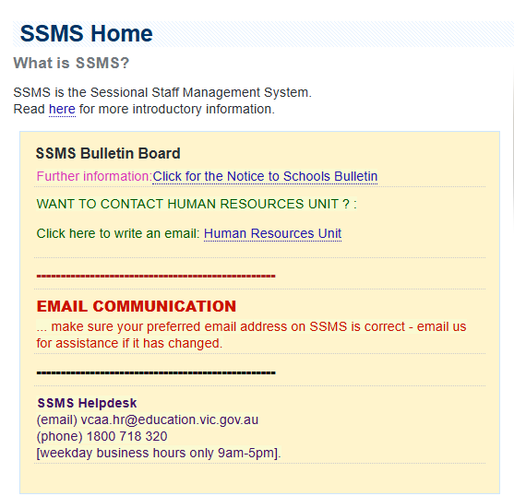
Upon registration, you will be assigned a unique VCAA five-digit ID number. Please refer to ‘New users to SSMS’ below for the registration process.
Your SSMS password will expire every 126 days. Please ensure you log in within this timeframe and reset your password every 126 days.
If you do not reset your password within 126 days, the system will automatically lock your account. If this occurs, please contact the VCAA HR Helpdesk (here) to be re-authenticated in the system.
When applying for a casual role with the VCAA, or if you currently work for the VCAA, it is important to keep your personal contact details in SSMS up to date.
Once you have registered and logged in to SSMS, your details can be updated under ‘User Profile’ in the left-hand menu.
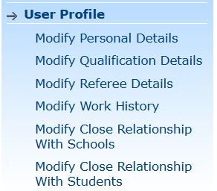
For general SSMS troubleshooting FAQs, please visit this checklist here
VCAA key contacts and helpdesk details can be found here
Further information can be found on the SSMS landing page side tool bar here, prior to log in:
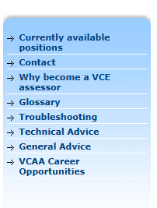

NEW USERS TO SSMS
If you have never applied for a job with the VCAA, or worked for the VCAA previously, then please follow these steps as a new SSMS user.
- Go to the SSMS website. The landing page should look like this:

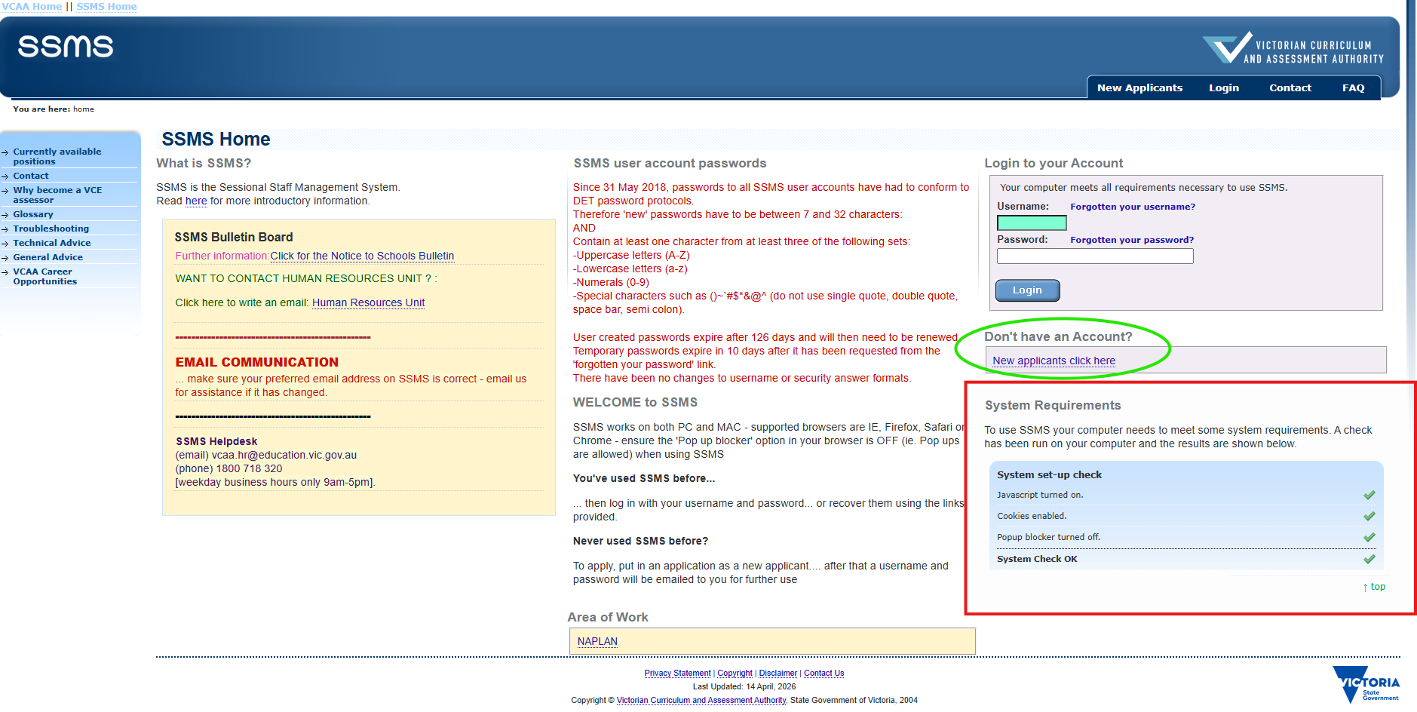
- SSMS runs an automatic systems check to ensure that your browser settings are compatible with the site. Double check that all green ticks are showing. It should look like this:

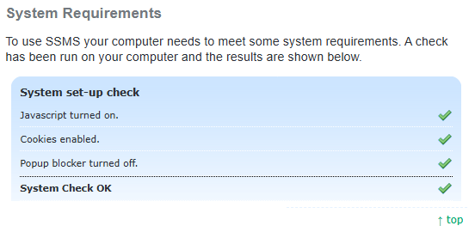
- If you do not see all four green ticks, please follow steps A-B here. If you do see all four ticks, proceed to Step 3. SSMS works best with either Google Chrome or Safari.

To turn off popup blocker on your computer you will need to follow these instructions:
Open Google Chrome.
At the top right, click the three dots > More > Settings.
Click Privacy and security > Site Settings > Pop-ups and redirects.
Choose the option ‘allow popups and re-directs’

To turn off popup blocker on your phone you will need to follow these instructions:
Go to the phone settings app.
Scroll down and click safari > Scroll down until you see General > then swipe ‘Block pop-ups’ to turn the setting off.

Open/refresh the window on the SSMS website, you should see 4 green ticks >>

- Below the login box on the homepage, select “New Applicants click here”
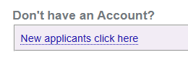
- On the New Applicants screen, once you have read all the information, click on the orange ‘New Applicants’ button at the bottom of the screen:
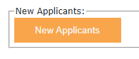
- This will take to a terms and conditions page

©
VCA
A

- Please read the information the tick the box if you agree to the terms
- Then click the next button to continue
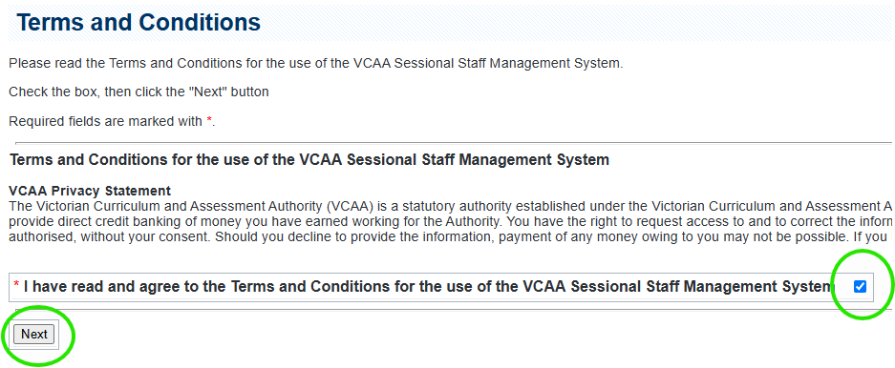
5. This brings you to the Vacancy Search Screen:
  - Select “Other”
  - Then click the search button (located towards the bottom of the screen)

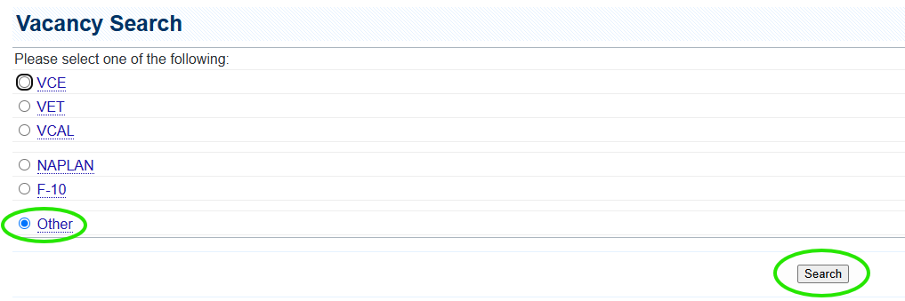
  - This will take you to the vacancy list table where you will see any available jobs.

    - Alternatively, if you have a job in mind already that you wish to apply for, click on the respective category (i.e. VCE, VET, VCAL, and so forth) instead and press ‘Search’.
    - For example: if you wanted to apply for a VCE position, you would select VCE and the relevant subject (if applicable):
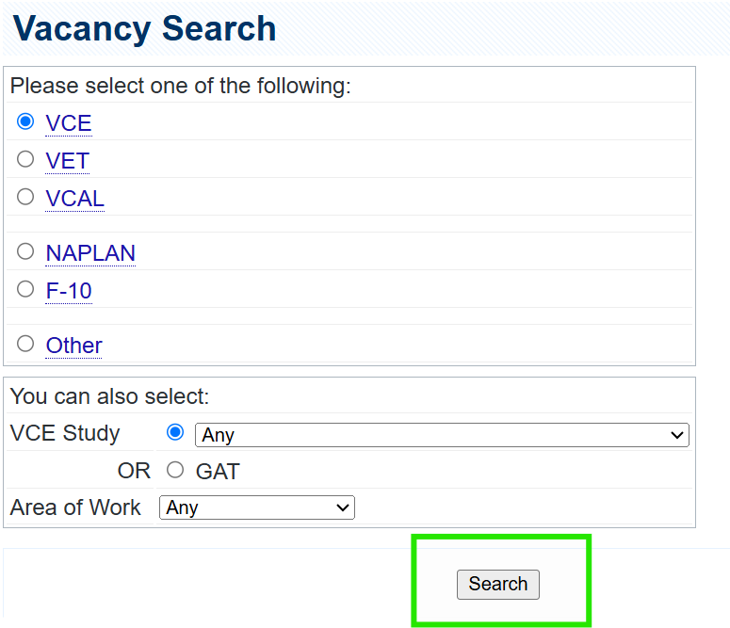
iii. Once you have applied your respective filters, click ‘Search’ and it will come up with the list of available vacancies for that selection:
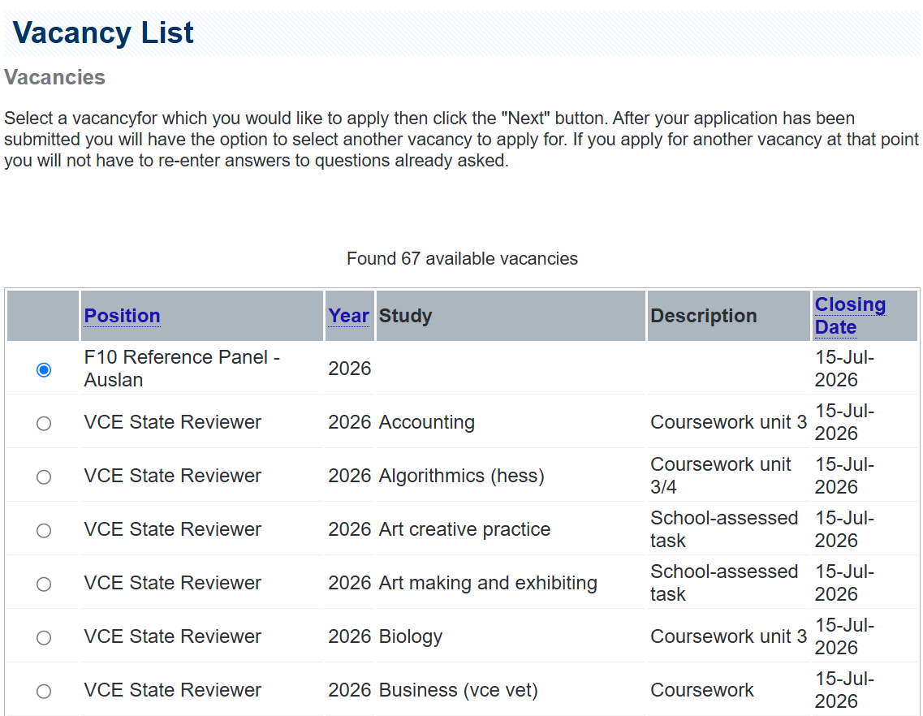
If you do not see the job you were intending to apply for on the list, please contact HR for assistance and the team will assist accordingly.

  - Select the option listed as “SSMS user registration” and click the next button
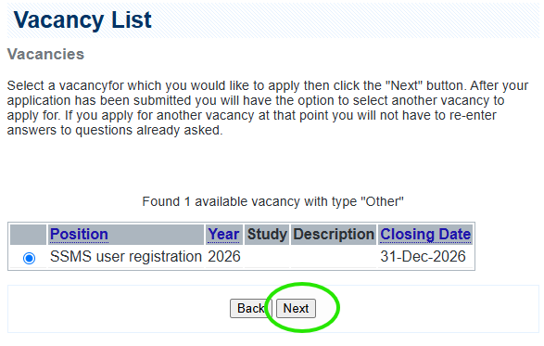
6. You are now in the process to register an SSMS user account. Click ‘Next’ at the bottom of the screen upon completion of each of the following steps:
- Read the “information for applicants”, and click the next button located at the bottom of the page
- Fill in your personal details - all fields with a red asterisk must be completed - then click next (make sure you provide a preferred email address to receive the automated messages from SSMS and in general from the VCAA)
- Tick the box acknowledging the VCAA criminal record check requirement and then click next
- List the areas of work you are interested in at the VCAA
- You need to supply details for at least one referee then click next
- You are now at the “Summary Page” review your information and then select “submit application” to complete your registration (SSMS will send an automated confirmation email to your preferred email address).
- You have now completed your registration and can exit the program (using the logout link to correctly leave the program).

Note: Always press the ‘Logout’ button on the top right of your screen at the conclusion of your session. Do not hard close the window (i.e. click the red ‘X’ at the top right of the screen).
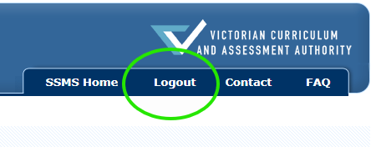

EXISTING SSMS USERS
If you have worked for the VCAA previously, or have applied for a VCAA role, you will most likely have an SSMS account already.
If you have forgotten your login details, please use the links on the homepage in the login box as circled below:
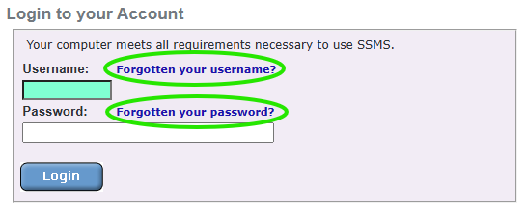
If you are unable to recover your login information via those links, it is most likely that your contact details attached to your account are outdated/no longer active.

Therefore, please contact the SSMS helpdesk via email or phone and we will assist accordingly.

(email) vcaa.hr@education.vic.gov.au
(phone) 1800 718 320
[weekday business hours only 9am-5pm].

