
© VCAA

NHT Assessment Guide

MA142 Mathematical Methods Exam 1
Written Examination

Q1 | Marks | Solutions | Mark allocation and notes
1a | 1 | $\frac{dy}{dx}=\sin\left(x\right)+x cos(x)$ | 1A, not y=, 𝑦′, 𝑓′ ok, ignore brackets around argument
1b | 2 | $\int_{0}^{\frac{π}{2}}{\left(x+\cos\left(x\right)\right)}dx={\left[\frac{x^{2}}{2}+\sin\left(x\right)\right]}_{0}^{\frac{π}{2}}$  $$=\left(\left(\frac{π^{2}}{8}+1\right)-\left(0-0\right)\right)$$  $$=1+\frac{π^{2}}{8}$$ | 1M – attempt to integrate  $\frac{x^{2}}{2}±\sin\left(x\right)$, ignore brackets  1A
2 | 2 | $f^{'}\left(x\right)={\left(3-x\right)}^{3}$  $f\left(x\right)=\int{{\left(3-x\right)}^{3}}dx$  $f\left(x\right)=\int{\left(-x^{3}+9x^{2}-27x+27\right)}dx$  $f\left(x\right)= -\frac{1}{4}x^{4}+3x^{3}-\frac{27}{2}x^{2}+27x+c$  $f\left(4\right)=\frac{5}{4}=-\frac{1}{4}{\left(4\right)}^{4}+3{\left(4\right)}^{3}-\frac{27}{2}{\left(4\right)}^{2}+27\left(4\right)+c$  $f\left(4\right)=\frac{5}{4}=-64+192-216+108+c$  $∴c=\frac{-75}{4}$  $f\left(x\right)=\frac{1}{4}x^{4}-3x^{3}+\frac{27}{2}x^{2}-27x+\frac{-75}{4}$  Alternative  Let $f\left(x\right)=f\left(u\right)=\frac{1}{4}u^{4}+c$ where $u=3-x$  $∴f^{'}\left(x\right)=f^{'}\left(x\right)∙u^{'}$ where $u^{'}=1$  $∴f\left(x\right)=\frac{-1}{4}{\left(3-x\right)}^{4}+c$  $f\left(4\right)=\frac{5}{4}=\frac{-1}{4}{\left(3-(4)\right)}^{4}+c$  $\frac{5}{4}=\frac{-1}{4}+c$  $∴c=\frac{6}{4}=\frac{3}{2}$  $f\left(x\right)=\frac{-1}{4}{\left(3-x\right)}^{4}+\frac{3}{2}$  _{OR}  ${∫(3-x)}^{3}dx= \frac{-1}{4}{(3-x)}^{4}$ | 1M – attempt to expand and integrate (must see polynomial degree 4 with all descending powers,  $-\frac{1}{4}x^{4},+27x$, ignore other coefficients and signs  1A Must have f or f(x), not y=, in final answer  1M – anti-differentiation  $±\frac{1}{4}{\left(3-x\right)}^{4}$.  1A Must have f or f(x)  1M, $±\frac{1}{4}{\left(3-x\right)}^{4}$.  1A must have f, f(x)

Q1 | Marks | Solutions | Mark allocation and notes
3a | 1 | $$\frac{27}{125}$$ | 1A, not  $$\frac{3^{3}}{5^{3}}$$
3b | 1 | $$\sqrt{\frac{18 }{25}}=\frac{3\sqrt{2}}{5}$$ | 1A
3c | 3 | $Pr\left(R=3|R≥2\right)=\frac{Pr\left(R=3\right)}{Pr\left(R≥2\right)}$  $=\frac{Pr\left(R=3\right)}{Pr\left(R=2\right)+Pr⁡(R=3)}$  $$=\frac{\frac{27}{125}}{3{\left(\frac{3}{5}\right)}^{2}\left(\frac{2}{5}\right)+\frac{27}{125}}$$  $$=\frac{\frac{27}{125}}{\frac{54}{125}+\frac{27}{125}}$$  $$=\frac{27}{125}×\frac{125}{81}$$  $$=\frac{1}{3}$$ | 1M for $\frac{27}{125}$ as numerator  (or their answer from a)  1M – for attempting to calculate 𝑃r (𝑅 ≥ 2) in either form, sum of two binomial terms with $\frac{2}{5}$  and $\frac{3}{5}$ , or 1- (2 terms), ignore 3  1A, or single fraction equivalent

Q1 | Marks | Solutions | Mark allocation and notes
4a | 2 | $g\left(\log_{2}{3}\right)=2^{2\log_{2}{3}}-9×2^{\log_{2}{3}}+20$  $$=2^{\log_{2}{9}}-9×2^{\log_{2}{3}}+20$$  $$=9-9×3+20$$  $$=2$$ | 1M for correct substitution of $\log_{2}{3}$ into g(x) and see either one of correct evaluation of $2^{\log_{2}{3}}$ or $2^{{2log}_{2}{3}}$  1A
4b | 2 | $0=2^{2x}-9×2^{x}+20$  Let $u=2^{x}$  $∴u^{2}-9u+20=0$  $\left(u-5\right)\left(u-4\right)=0$ or $\left(2^{x}-5\right)\left(2^{x}-4\right)=0$  $∴u=5 or u=4$  $∴2^{x}=5 or 2^{x}=4$  $$∴x=\log_{2}{5} or x=2$$ | 1M – a factorised quadratic equal 0.  1A(or equivalent $\frac{\log_{a}{5}}{\log_{a}{2}}$), not u
5a | 3 | $\int_{-∞}^{∞}{f\left(x\right)dx=1}$  $\int_{-d}^{d}{\left(\frac{x+c}{2}\right)dx=1}$  ${\left[\frac{x^{2}}{4}+\frac{cx}{2} \right]}_{-d}^{d}=1$ or ${\frac{1}{2}\left[\frac{x^{2}}{2}+cx \right]}_{-d}^{d}=1$  $\left(\left(\frac{d^{2}}{4}+\frac{cd}{2}\right)-\left(\frac{d^{2}}{4}-\frac{cd}{2}\right)\right)=1$ $\left(\frac{d^{2}}{2}+cd\right)-\left(\frac{d^{2}}{2}-cd\right)=2$  $cd=1$ $2cd=2$  $d=\frac{1}{c}$ | 1M – set up integral, apply correct endpoints, set equal to 1 at some stage, must have dx  Or trapezium  If symmetry, as above but (2* t=0) 1 mark/3  1M – correct integral result and attempt to substitute d, -d  1A not c=
5b | 3 | $\int_{-d}^{d}{\left(\frac{x^{2}}{2}+\frac{cx}{2}\right)dx}=\frac{1}{24}$  ${\left[\frac{x^{3}}{6}+\frac{cx^{2}}{4}\right]}_{-d}^{d}=1/24$  $\left(\left(\frac{d^{3}}{6}+\frac{cd^{2}}{4}\right)-\left(-\frac{d^{3}}{6}+\frac{cd^{2}}{4}\right)\right)=\frac{1}{24}$  $\frac{d^{3}}{3}=\frac{1}{24}$ or $\frac{1}{3c^{3}}=\frac{1}{24}$  $d^{3}=\frac{1}{8}$ or $c^{3}=8$  $∴d=\frac{1}{2} and c=2$ | 1M – set up integral x•f(x), with terminals either in d or their c, set equal to 1/24 at some stage  1M simplify to an equation with either only d^3 or c^3  1A (must have both answers)

Q1 | Marks | Solutions | Mark allocation and notes
6a | 1 | $$R\backslash \left\{1\right\}$$ | 1A or equivalent or forward
6b | 3 | 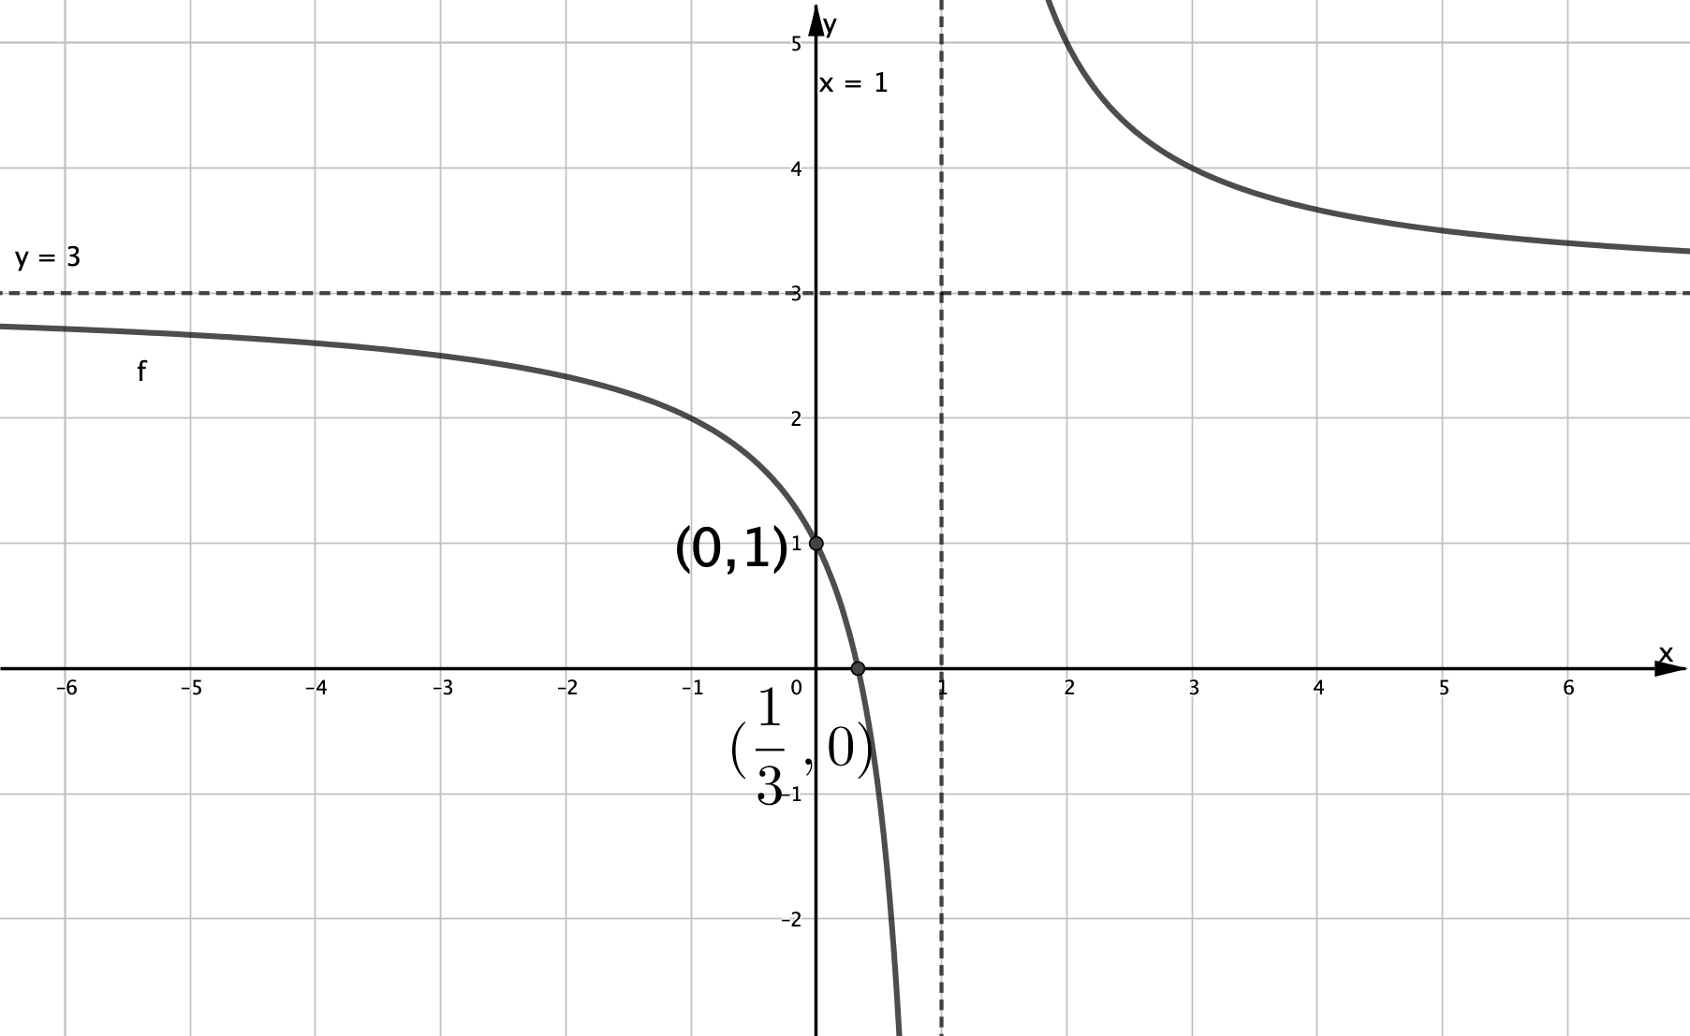 | 1M – shape--rectangular hyperbola in 1st and 3rd quadrants + include any translation from origin, asymptotic behaviour  1A asymptotes lines (dashed), labelled and correctly positioned  1A intercepts as coordinates, labelled and correctly positioned
6c | 2 | $f\left(x\right)=3+\frac{2}{x-1}$  $f\left(x\right)=3+2∙g(x-1)$  $∴h\left(x\right)=3+2x$  Alternative  $g\left(x-1\right)=\frac{1}{x-1}$  $h\left(g\left(x-1\right)\right)=3+2∙\left(\frac{1}{x-1}\right)$  $∴h\left(x\right)=3+2x$  Or  Or  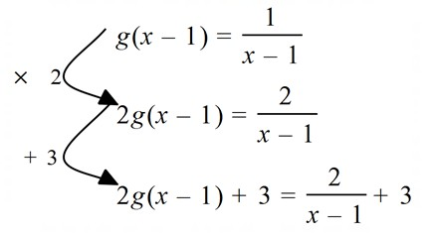 so ℎ(𝑥) = 3 + 2𝑥  Or  Need $h\left(\frac{1}{x-1}\right)=3+ \frac{2}{x-1}$  so $h\left(x\right)=3+2x$ | 1M – relate 1/(x-1) to  g(x-1)  1A must be named  $$h or h\left(x\right)$$  1M – relate 1/(x-1) to  g(x-1)  1A must be named  $$h or h\left(x\right)$$  1M for g(x-1)=1/(x-1)  1A must be named  $$h or h\left(x\right)$$

Q1 | Marks | Solutions | Mark allocation and notes
7a | 3 | $3+2x-x^{2}>0$  $x^{2}-2x-3<0$  $\left(x-3\right)\left(x+1\right)<0$  $∴x<3$and $x>-1$  $∴x∈\left(-1,3\right)$  Alternative  Graph of $3+2x- x^{2} or x^{2}-2x-3$, where $(-1,3)$ | 1M – set quadratic =0,  >0 either correct line 1 or  2 (or 3 with ±1 or ∓3  factors)  1M – factorise quadratic to get -1 and 3 as solutions or intercepts on graph  1A  1M – correct shape parabola (ignore axes label), with intercepts as  ±1 or ∓3  1M – -1 and 3 as intercepts  1A
7b | 1 | $$x=1$$ | 1A (or (1, ln(4)) correct)
7c | 2 | $\log_{e}\left(3+2x-x^{2}\right)=0$  $1=3+2x-x^{2}$  $x^{2}-2x-2=0$  ${\left(x-1\right)}^{2}-3=0$  $\left(x-1-\sqrt{3}\right)\left(x-1+\sqrt{3}\right)=0$  $∴x=1-\sqrt{3}$ and $x=1+\sqrt{3}$ | 1M remove log, obtain quadratic=1, equate to zero and attempt to complete the square or quadratic formula  1A

Q1 | Marks | Solutions | Mark allocation and notes
8a | 1 | Turning points of $f(x)$ don’t match x-intercepts of $g\left(x\right)$  Or  When $g\left(x\right)=0$ at x=0, it is clear that $f(x)$ is increasing | 1A – answers may vary, check for correctness of statement.
8b | 3 | $g\left(x\right)=\int{\left(\frac{1}{3}x^{2}+\sin\left(πx\right)\right)dx}$  $$=\frac{1}{9}x^{3}-\frac{1}{π}\cos\left(πx\right)+c$$  At the origin  $$0=\frac{1}{9}{\left(0\right)}^{3}-\frac{1}{π}\cos\left(0\right)+c$$  $$∴c=\frac{1}{π}$$  $∴g\left(x\right)=\frac{1}{9}x^{3}-\frac{1}{π}\cos\left(πx\right)+\frac{1}{π}$ | 1M - integrate to include  $\frac{1}{9}x^{3}±\left[ \right]\cos\left(πx\right)$, ignore  c  1M – attempt to find constant of integration using (0,0), leading to c=  1A must be named  $$g or g\left(x\right)$$
8c | 1 | Let $k(x)=m(x)+n(x)$  $k\left(-x\right)=m\left(-x\right)+n(-x)$  $=m\left(x\right)+n(x)$  $=k(x)$  $∴k(x)$ has property | Either $k\left(x\right)$ leading to  $k\left(-x\right)$ or vice versa, not both sides same time, for general case not specific  1A
8d | 3 | $\frac{1}{3}x^{2}$ is an even function for all $x$.  $sin\left(πx-c\right)$ has property (is a reflection in the y-axis), when the vertical intercept is one of the turning points  or recognise $sin=\left(θ+\frac{π}{2}\right)=sin(-θ+\frac{π}{2})$  Or Graphs of $\sin\left(πx-c\right)$ and $-\sin\left(πx+c\right)$ have period of 2, so when graphs are moved left ½ and right ½ respectively they are identical, so $c=\frac{π}{2}$  $∴c=\frac{π}{2}+kπ, k∈Z$ or $c=(2k+1)\frac{π}{2}, k∈Z$  $c=-\frac{π}{2}(2k+1)$  Alternative  $$h\left(x\right)=h\left(-x\right)$$  $$\frac{1}{3}x^{2}+\sin\left(πx-c\right)= \frac{1}{3}{(-x)}^{2}+sin(-πx-c)$$  - $\sin\left(πx-c\right)=\sin\left(-πx-c\right)$  $$\sin\left(πx-c\right)=-sin⁡(πx+c)$$  - $πx+c-\left(πx-c\right)=(2k+1)π, k∈Z$  $$2c=(2k+1)π$$  $c=\frac{π}{2}(2k+1)$ or $c=-\frac{π}{2}(2k+1)$ | 1M – recognise x^2 does not need to be considered and is only considering functions/graphs of  $sin\left(πx-c\right)$ and  $$sin\left(-πx-c\right)$$  1M – investigate when sin has the property and find one particular value of c, graphical ok.  1A accept equivalent forms, $k∈Z$  1M – recognise that x^2 does not need to be considered and equate sin or angles  1M – equate positive and negative sin and form difference of angles with an odd pi value  1A must have $k∈Z$

